

XCAM M480 SDK

|  |  |
| --- | --- |
| Version: | 1.0 |
| Date: | 6th Dec 2017 |
| Author: | LAU Yat Fei Jackson |

|  |  |  |
| --- | --- | --- |
| Revision | Date | Comment |
| 1.0 | 6 Dec 2017 | Original release |
|  |  |  |
|  |  |  |
|  |  |  |
|  |  |  |
|  |  |  |
|  |  |  |
|  |  |  |
|  |  |  |
|  |  |  |
|  |  |  |
|  |  |  |
|  |  |  |

**Contents**

FOUNDATION 3

User Application 3

Header 3

Software dependencies 3

Preprocessor Symbols 4

ThermalSensorAPI_M480.lib 4

XCAM Constant 4

Customised data structure 4

API 7

Sensor Connection 13

Build and Test 13

**XCAM FOUNDATION**

The documentation of the XCAM SDK.

The XCAM SDK basically contains functions provided by sample code, which supports for MCU **M480** series library. Below is the whole project structure of XCAM_M480.

m480-bsp-realchip_org

|---- Library

|---- CMSIS

|---- Device/Nuvoton/M480

|---- Include

|---- M480.h

|---- system_M480.h

|---- Source

|---- system_M480.c

|---- ARM/startup_M480.s

|---- StdDriver/src

|---- clk.c

|---- retarget.c

|---- sys.c

|---- i2c.c

|---- timer.c

|---- uart.c

|---- husbd.c

|---- ThermalAPI_inC

|---- KEIL/obj/**ThermalSensorAPI_M480.lib # SDK**

|---- **MI_XCAM.h**

|---- **ThermalSensor.h**

|---- defs.h

|---- M480.h

|---- SampleCode

|---- StdDriver/USBD_UVC_HTPA32_R1_32x32_UART

|---- KEIL/MI_XCAM_M480.uvproj

|---- KEIL/Nu_Link_Driver.ini

|---- KEIL/obj

|---- **MI_XCAM_M480.bin** **# Application binary**

|---- defs.h

|---- demo.h

|---- descriptors.c

|---- HUART.c

|---- main.c

|---- Table_UVC.c

|---- thermal_i2c.c

|---- thermal_i2c.h

|---- usbd_video.h

|---- usbd_video.c

**SDK Version: Release V2.00 171205**

## **Project Setting**

### **Header**

#include "ThermalSensor.h"

#include “MI_XCAM.h”

#include "M480.h" #include "usbd_video.h"

#include "thermal_i2c.h"

### **Software dependencies**

..\..\..\..\Library\CMSIS\Include

..\..\..\..\Library\Device\Nuvoton\M480\Include

..\..\..\..\Library\StdDriver\inc

..\..\..\..\Library\ThermalAPI_inC\KEIL

..\..\USBD_UVC_HTPA32_R1_32x32_UART

..\..\..\..\..\MI_Sensor

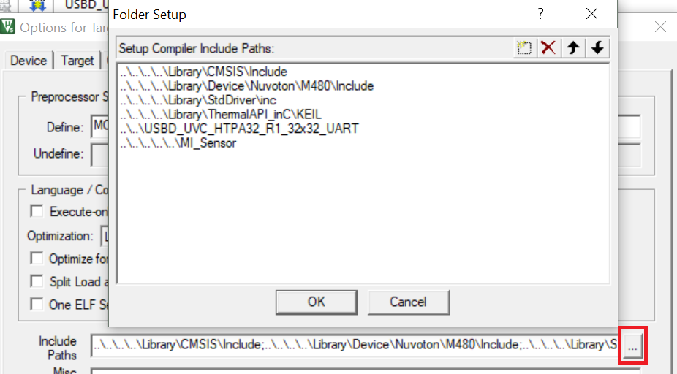

### **Preprocessor Symbols**

Define: MCU=480

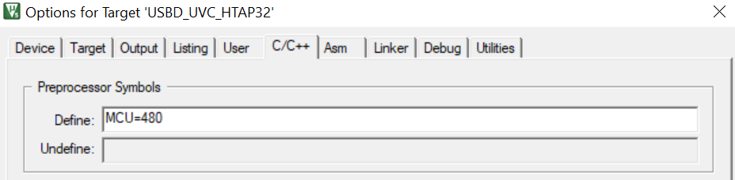

### **ThermalSensorAPI_M480.lib**

#### **XCAM Constant**

|  |  |  |
| --- | --- | --- |
| **Variables** | **Values** | **Usage** |
| TIME_FREQUENCY | 30 | Timer frequency |
| SENSOR_ADDRESS | 0x1A | Address of the sensor |
| EEPROM_ADDRESS | 0x50 | Address of EEPROM |
| WIDTH | 32 | Width of the sensor |
| HEIGHT | 32 | Height of the sensor |
| W_WIDTH | 2 | Width of temperature calculation window |
| W_HEIGHT | 2 | Height of temperature calculation window |

#### **Customised data structure**

|  |
| --- |
| REGISTERSETTING : Data structure storing the values of sensor register. |
| typedef struct REGISTERSETTING{  unsigned short MBIT;  unsigned short BIAS;  unsigned short CLOCK;  unsigned short BPA;  unsigned short PU;  } REGISTERSETTING; |

|  |
| --- |
| EEPROM: Data structure storing values read from EEPROM. |
| typedef struct EEPROM{  float PixCMin; // Minimum sensitivity coefficient, used for scaling  float PixCMax; // Maximum sensitivity coefficient, used for scaling  unsigned short gradScale; // Emissivity factor  unsigned short TableNumberSensor; // The look-up table number of sensor belongs  unsigned short epsilon; // Factor for fine tuning of the sensitivity for all Pixel  REGISTERSETTING calibRegister; // Sensor register values for calibration  unsigned short VddRef; // used supply voltage during calibration measured  float PTATGrad; // Factor of calculating ambient temperature (Ta)  float PTATOff; // Factor of calculating ambient temperature (Ta)  unsigned char VddScaling; // VddComp scaling coefficient  unsigned short VddScalingOff; // VddComp scaling coefficient  unsigned char GlobalOffset; // Factor for fine tuning of the sensitivity for all Pixel  unsigned short GlobalGain; // Factor for fine tuning of the sensitivity for all Pixel  REGISTERSETTING userRegister; // Sensor register values for user  unsigned short DevID; // Device ID  unsigned char NrOfDefPix; // Number of dead pixel(s)  unsigned short DeadPixAdr[MAXNROFDEFECTS]; // Array of dead pixel addr  unsigned char DeadPixMask[MAXNROFDEFECTS]; // Array of dead pixel mask  signed short VddGrad[ELAMOUNT]; // VddComp gradient  signed short VddOff[ELAMOUNT]; // VddComp offset  signed short ThGradN[Pixel]; // thermal gradient  signed short ThOffN[Pixel]; // compensate for any thermal drifts  unsigned long PixCN[Pixel]; // Sensitivity coefficients  } EEPROM; |

|  |
| --- |
| SENSORSETTING: Data structure storing sensor look-up table values for TO calculation. |
| typedef struct SENSORSETTING{  signed long TABLENUMBER;  signed long long PCSCALEVAL; // defined scaling coefficient  signed long NROFTAELEMENTS;  signed long NROFADELEMENTS;  signed long TAEQUIDISTANCE;  signed long ADEQUIDISTANCE;  signed long ADEXPBITS;  signed long TABLEOFFSET;  unsigned char MBITTRIMDefault;  signed long SensRv;  unsigned int* TempTable;  unsigned int* XTATemps;  unsigned int* YADValues;  } SENSORSETTING; |

#### **API**

**ThermalSensor.h**

void M480_InitSensor(void);

void M480_OpenSensor(void);

void M480_StartSensor(void);

**MI_XCAM.h**

void InitI2C(unsigned char mode);

void HighDensSequentialRead(unsigned short address,unsigned char* data, unsigned short numbytes);

void HighDensPageWrite(unsigned short address,unsigned char* data, unsigned short numbytes);

void ReadCalibDataN(void);

void InitSensorDev(unsigned short TN);

void InitMBITTRIMN(unsigned char user);

void InitBIASTRIMN(unsigned char user);

void InitBPATRIMN(unsigned char user);

void InitPUTRIMN(unsigned char user);

void InitCLKTRIMN(unsigned char user);

void GetImageData(void);

unsigned short GetTemp(unsigned int x, unsigned int y);

unsigned int CalcTO(unsigned int TAmb, signed int dig, signed long PiC, unsigned int dontCalcTA);

unsigned int StartStreaming(int Mode, char Temps,char Stream);

|  |  |
| --- | --- |
| void | InitI2C(unsigned char mode); |



Setup the EEPROM & Sensor address to the device.

Dependencies: 0🡪 Init I²C for Sensor (> 1000 kHz)

1🡪 Init I²C for EEPROM (max 400 kHz)

|  |  |
| --- | --- |
| void | HighDensSequentialRead(unsigned short address,unsigned char* data, unsigned short numbytes); |
| void | HighDensPageWrite(unsigned short address,unsigned char *data, unsigned short numbytes); |

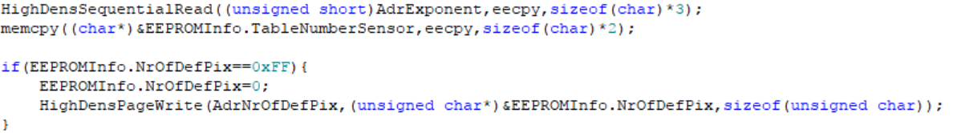

HighDensSequentialRead() & HighDensPageWrite() reads/writes multiple bytes from a high-density (>= 32 Kb) serial EEPROM device.

Dependencies: 'address' contains address word

'data' contains the reading result

'numbytes' contains the length of bytes to read

|  |  |
| --- | --- |
| void | ReadCalibDataN(void); |



Read all required calibration data from sensor EEPROM, details in TYPEDEF structure EEPROM.

|  |  |
| --- | --- |
| void | InitSensorDev (unsigned short TN); |



Open and setup the sensor device, pick up the setting corresponding to the type of optics.

|  |  |
| --- | --- |
| void | InitMBITTRIMN(unsigned char user); |



Dependencies: 0🡪 Setting during Calibration

1🡪 Setting from user

Range: 4 <= m <= 12

Initialization of Trim Register 1 MBIT/ (m+4) bit as ADC resolution to sensor register.

|  |  |
| --- | --- |
| void | InitBIASTRIMN(unsigned char user); |



Dependencies: 0🡪 Setting during Calibration

1🡪 Setting from user

Range: 0 to 31 🡺 1μA to 13μA

Initialization of Trim Register 2, adjust the bias current of the ADC.

|  |  |
| --- | --- |
| void | InitCLKTRIMN(unsigned char user); |



Dependencies: 0🡪 Setting during Calibration

1🡪 Setting from user

Range: 0 to 63 🡺 1MHz to 13MHz

Initialization of Trim Register 4, clock frequency setting CLK_TRM.

|  |  |
| --- | --- |
| void | InitBPATRIMN(unsigned char user); |



Dependencies: 0🡪 Setting during Calibration

1🡪 Setting from user

Range: 0 to 31 🡺 0.2μA to 4.0μA

Initialization of Trim Register 5, adjust the common mode voltage of the preamplifier.

|  |  |
| --- | --- |
| void | InitPUTRIMN(unsigned char user); |



Dependencies: 0🡪 Setting during Calibration

1🡪 Setting from user

Range: “1000” = 100 kOhm; “0100” = 50 kOhm; “0010” = 10 kOhm; “0001” = 1 kOhm

Initialization of Trim Register 7, select internal pull up resistor on SDA/SCL.

|  |  |
| --- | --- |
| Void | GetImageData(void); |



GetImageData() calculate voltage values of each pixels.

|  |  |
| --- | --- |
| unsigned short | GetTemp(unsigned int x, unsigned int y); |

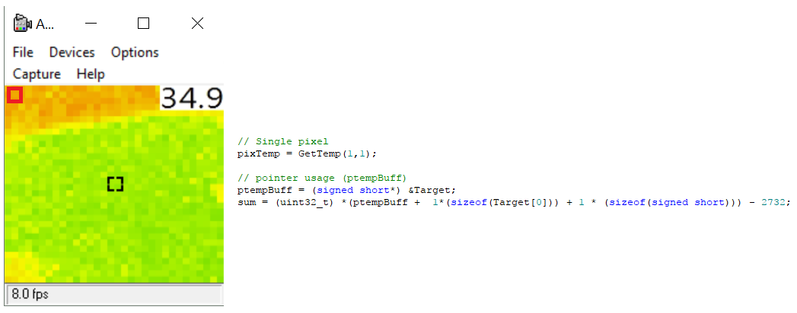

GetTemp(x,y) gets the calculated temperature from 2D-array sensor, in single pixel.

* P.S: If you want to get the whole 2D-array, you may use

* ptempBuff = (signed short*) &Target;

* pixTemp = *(ptempBuff + x*(sizeof(Target[0])) + y * (sizeof(signed short))) - 2732;

Dependencies: unsigned int x = x-coordinate of target pixel (0 < x < COLUMN)

unsigned int y = y-coordinate of target pixel (0 < y < ROW)

Return Code: Caelcius °C x 10 (e.g: 301 = 30.1°C)

998 Coordinate input ERROR

|  |  |
| --- | --- |
| unsigned int | CalcTO(unsigned int TAmb, signed int dig, signed long PiC, unsigned int dontCalcTA); |



CalcTO() calculate the object temperature via look-up table.

Dependencies: TAmb = ambient temperature

dig = pixel voltage

PiC = pixel sensitivity coefficients

Return: Object Temperature in dK

|  |  |
| --- | --- |
| unsigned int | StartStreaming(int Mode, char Temps, char Stream); |



StartStreaming() starts the streaming of the sensor, main sequence can be seen in the interrupt.

Dependencies: Mode = Initialize(1) or Normal streaming (0)

Temps: whether it is calculating temperature

Stream = whether it is streaming mode

Return: 0x0 / 0xFF

|  |  |
| --- | --- |
| void | M480_InitSensor(void); |

Open and setup the system environment for I2C.

|  |  |
| --- | --- |
| void | M480_OpenSensor(void); |

Initialization of sensor, mainly read calibration data and setup trim registers.

|  |  |
| --- | --- |
| void | M480_StartSensor(void); |

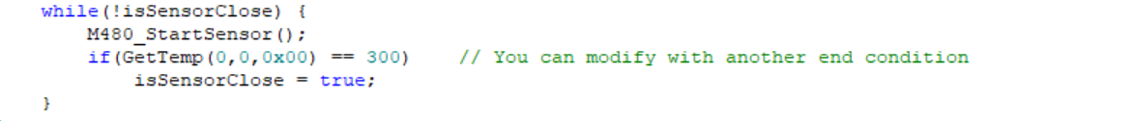XCAM start streaming

**Sensor Connection**

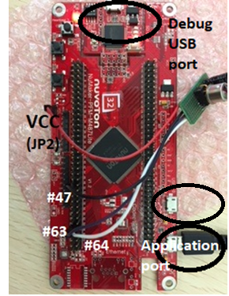

* Please connect the USB2.0 instead of 1.1

**Build and Test**

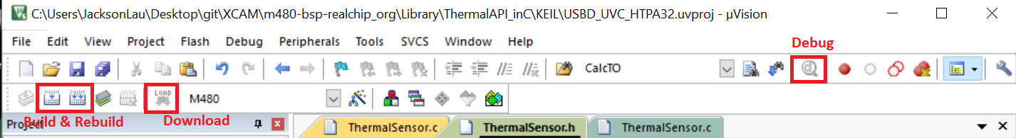

1. Build main project successfully
2. Download binary file(.bin) to MCU

Connect the USB debug port to PC, then click "Download".

1. Application:

Disconnect the debug USB port and connect the USB to application port, then open AMCAP/any camera application.

Debug:

Keep connecting the debug USB port and press “Debug” to get into debug mode.