A query that shows the name of the 10 actors that appears in the most movies that were at least released since 2016

PREFIX ex: <http://example.org/>
PREFIX rdf: <http://www.w3.org/1999/02/22-rdf-syntax-ns#>
PREFIX rdfs: <http://www.w3.org/2000/01/rdf-schema#>
PREFIX xsd: <http://www.w3.org/2001/XMLSchema#>

SELECT ?actor_name (COUNT(?movie) as ?movie_count)
WHERE {
?movie rdf:type ex:Movie .
?movie ex:releasedIn ?year .
FILTER (?year >= 2016) .
?movie ex:containsActorNamed ?actor .
?actor rdfs:label ?actor_name .
FILTER (?actor_name != "Unknown"@en) .

}
GROUP BY ?actor_name
ORDER BY DESC(?movie_count)
LIMIT 10

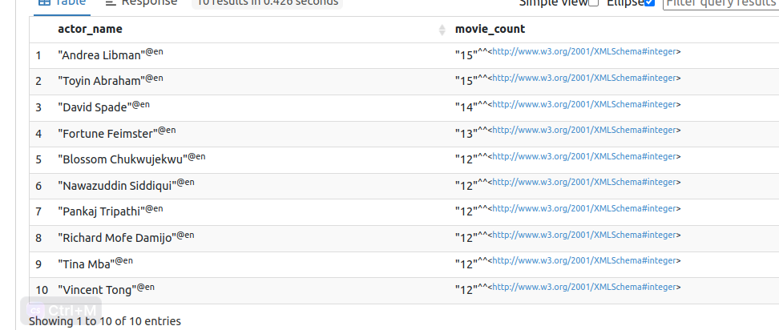

For Tv shows :

PREFIX ex: <http://example.org/>
PREFIX rdf: <http://www.w3.org/1999/02/22-rdf-syntax-ns#>
PREFIX rdfs: <http://www.w3.org/2000/01/rdf-schema#>
PREFIX xsd: <http://www.w3.org/2001/XMLSchema#>

SELECT ?actor_name (COUNT(?movie) as ?movie_count)
WHERE {
?movie rdf:type ex:TV_show .
?movie ex:releasedIn ?year .
FILTER (?year >= 2016) .
?movie ex:containsActorNamed ?actor .
?actor rdfs:label ?actor_name .
FILTER (?actor_name != "Unknown"@en) .

}
GROUP BY ?actor_name
ORDER BY DESC(?movie_count)
LIMIT 10

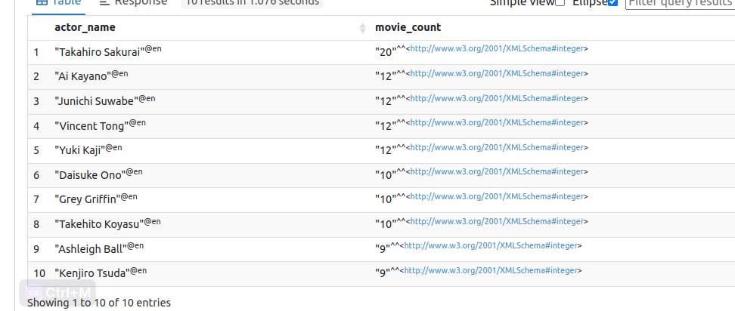

A query to display the 10 most occuring genre of TV_shows :

PREFIX ex: <http://example.org/>
PREFIX rdf: <http://www.w3.org/1999/02/22-rdf-syntax-ns#>
PREFIX rdfs: <http://www.w3.org/2000/01/rdf-schema#>
PREFIX xsd: <http://www.w3.org/2001/XMLSchema#>

SELECT ?genreLabel (COUNT(?tv_show) AS ?tvShowCount)
WHERE {
?tv_show rdf:type ex:TV_show .
?tv_show ex:hasGenre ?genre .
?genre rdfs:label ?genreLabel .
}
GROUP BY ?genreLabel
ORDER BY DESC(?tvShowCount)
LIMIT 10

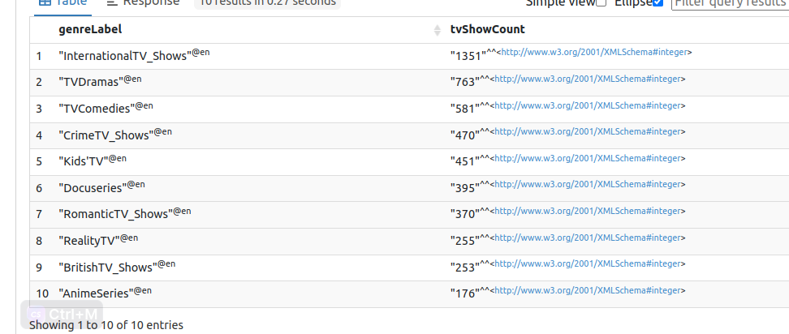

A query that shows all movies directed by Steven Spielberg present on the Netflix

PREFIX ex: <http://example.org/>
PREFIX rdf: <http://www.w3.org/1999/02/22-rdf-syntax-ns#>
PREFIX rdfs: <http://www.w3.org/2000/01/rdf-schema#>
PREFIX xsd: <http://www.w3.org/2001/XMLSchema#>

SELECT ?media ?title
WHERE {
?media a ex:Movie ;
ex:directedBy ?director .
?director rdf:type ex:Person.
?director rdfs:label "Steven Spielberg"@en .
?media rdfs:label ?title
}

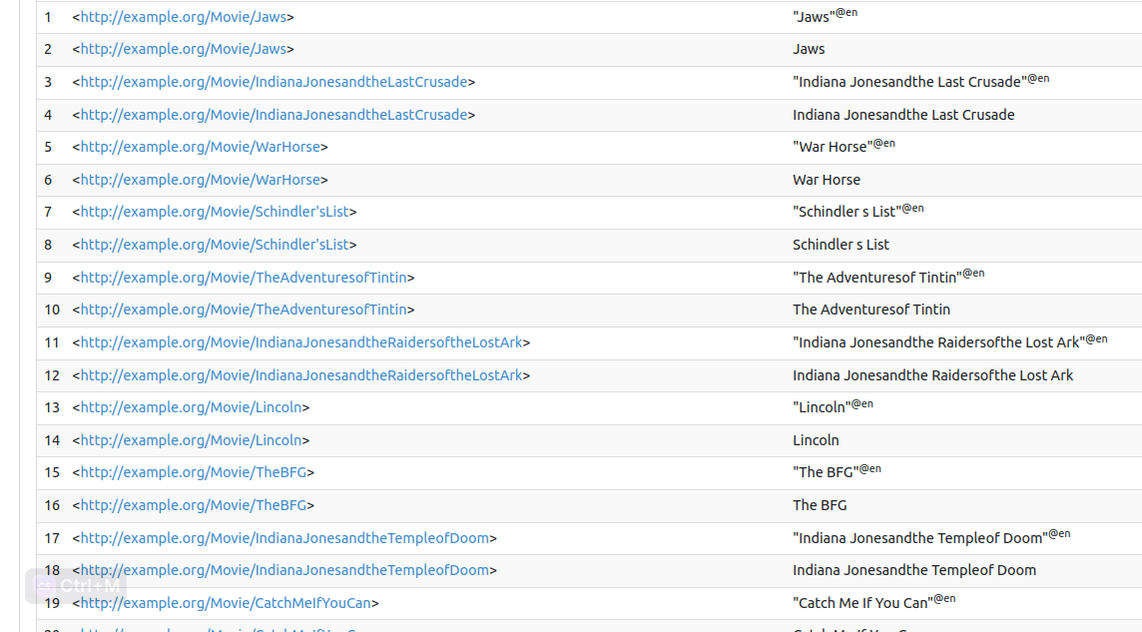

A query to display all the « Dramas » movies produced in France :

PREFIX ex: <http://example.org/>
PREFIX rdf: <http://www.w3.org/1999/02/22-rdf-syntax-ns#>
PREFIX rdfs: <http://www.w3.org/2000/01/rdf-schema#>
PREFIX xsd: <http://www.w3.org/2001/XMLSchema#>

SELECT DISTINCT ?movie ?title
WHERE {
?movie rdf:type ex:Movie .
?movie rdfs:label ?title .
?movie ex:producedIn ?country .
?country rdfs:label "France"@en.
?movie ex:hasGenre ?genre .
?genre rdfs:label "Dramas"@en .
}

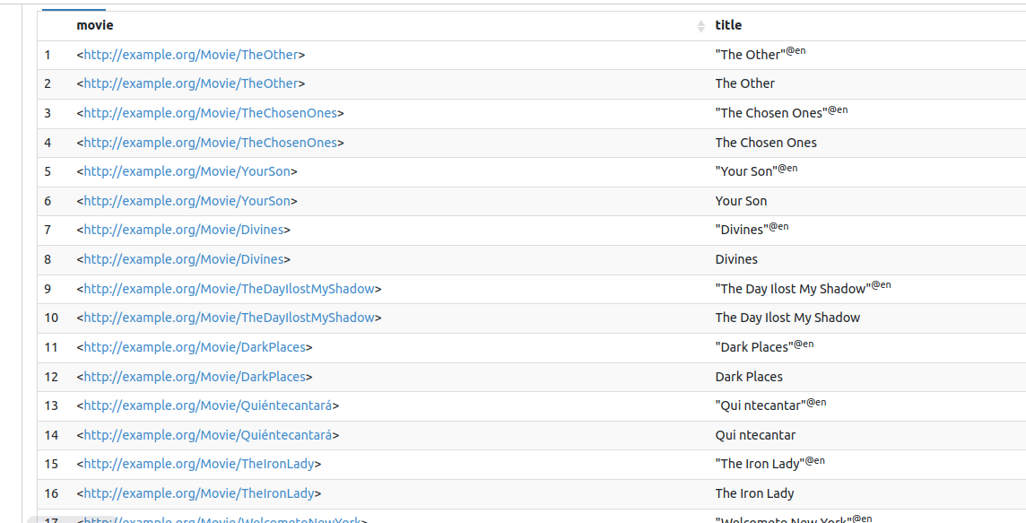

A query to display the five dates where the most movies were added on the platform

SELECT ?date (COUNT(?media) as ?movieCount)
WHERE {
?media rdf:type ex:Media .
?media ex:addedOnNetflixIn ?date .
}
GROUP BY ?date
ORDER BY DESC(?movieCount)
LIMIT 5

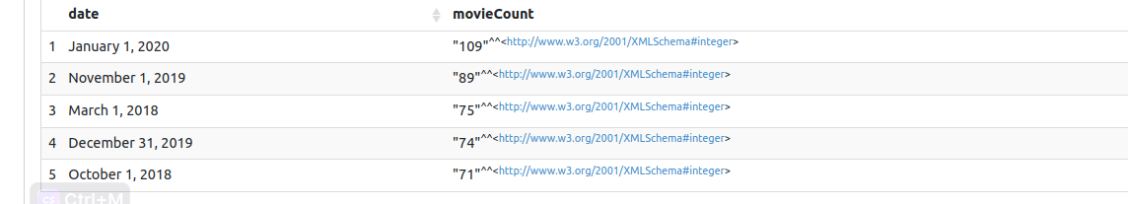

SPARKLIS

A query to retrieve all the movies added on June 19 2021 on Netflix

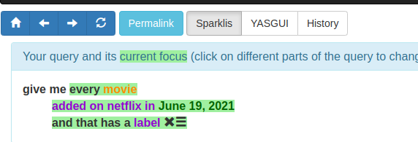

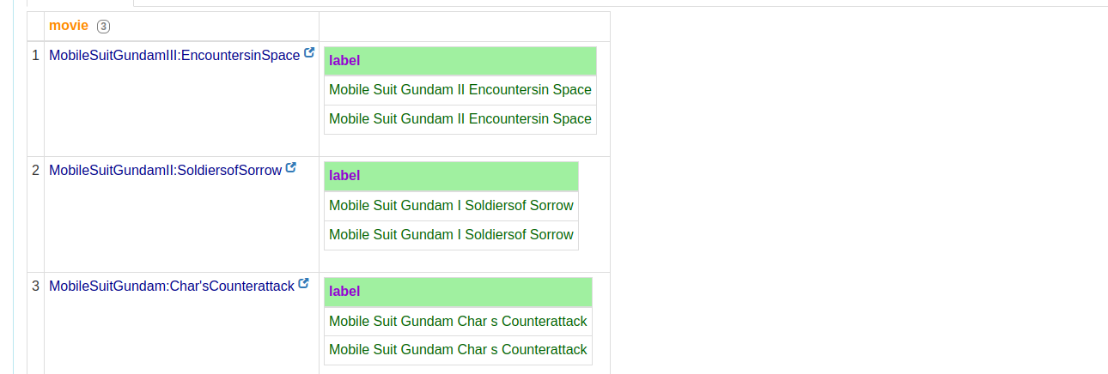

A query that displays all the TV- shows for each director in the dataset

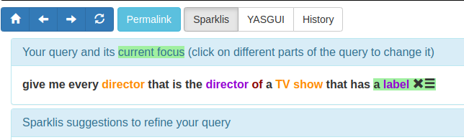
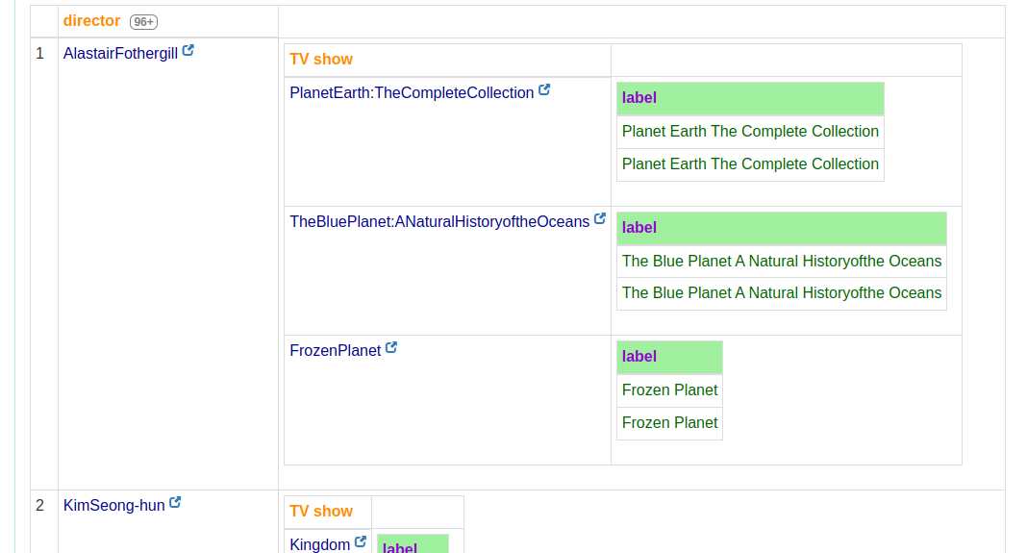

A query to name every actor that has already played in a movie directed by Steven Spielberg

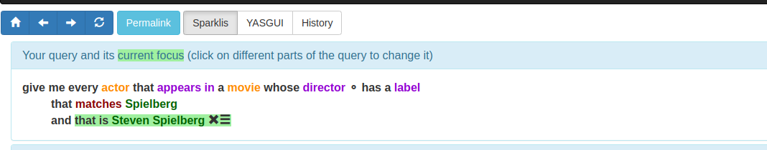

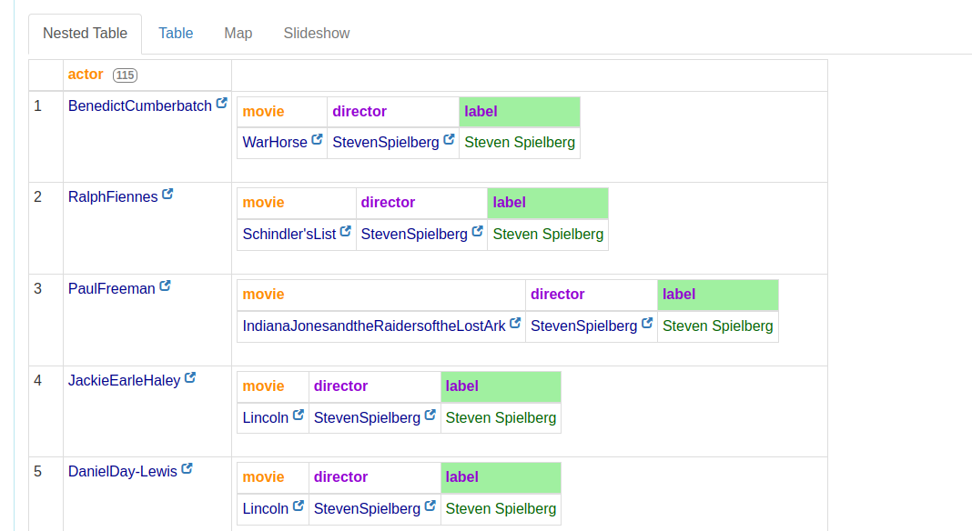

second way of doing it :

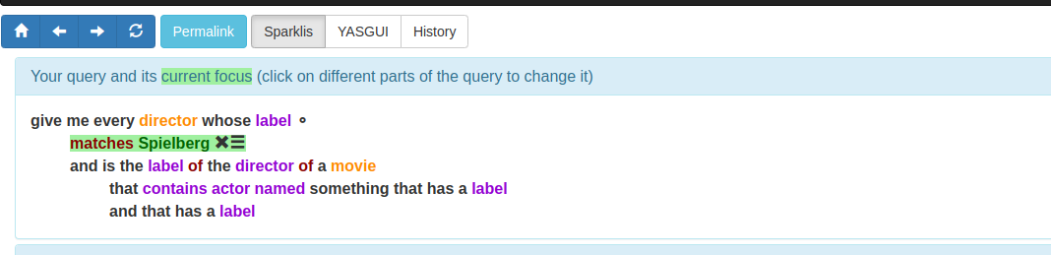

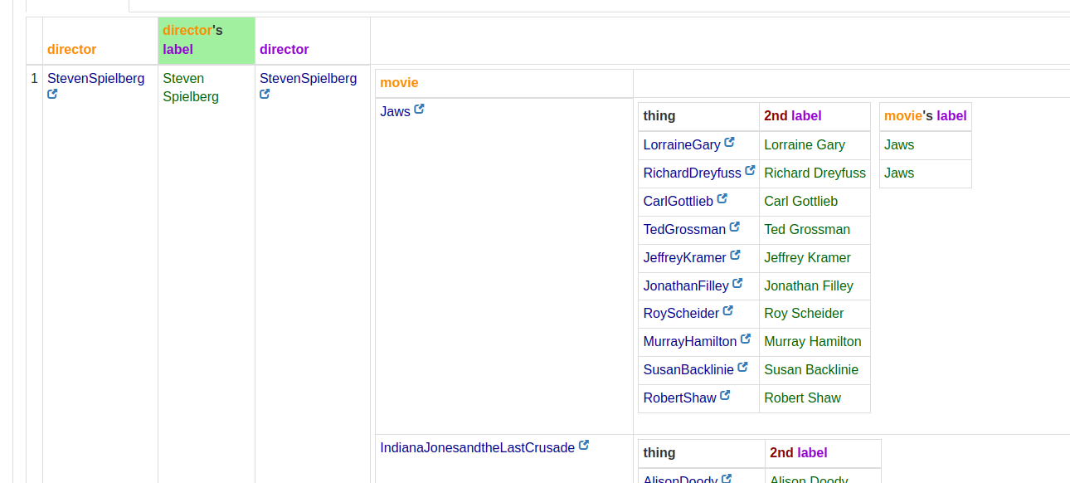
A query that outputs the name of the movie in which a director appeared in as an actor.

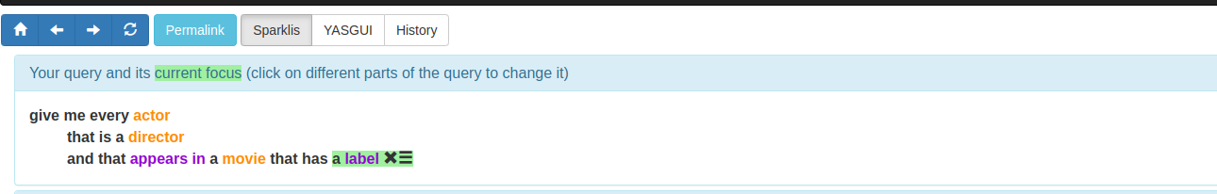

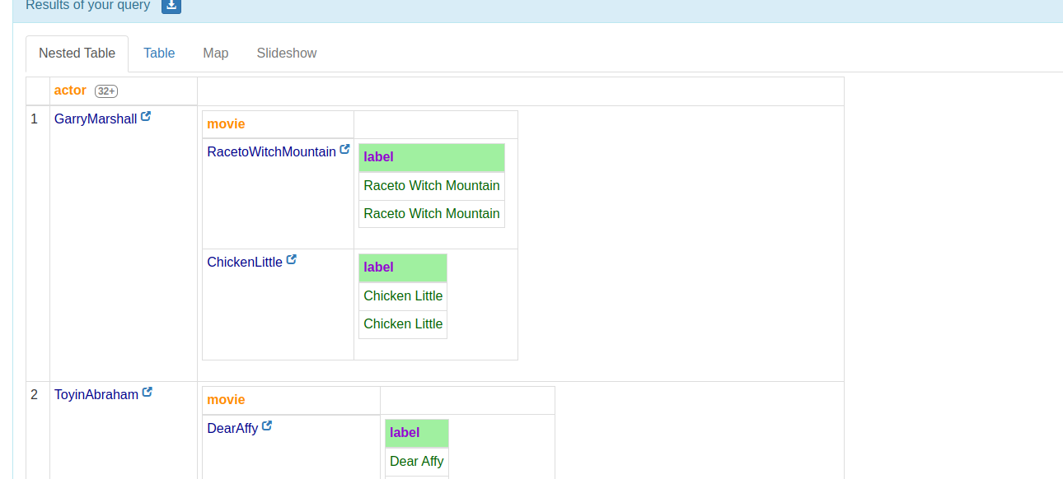

A query that gives the name of every international TV-show produced in the United Kingdom which age category is TV-MA

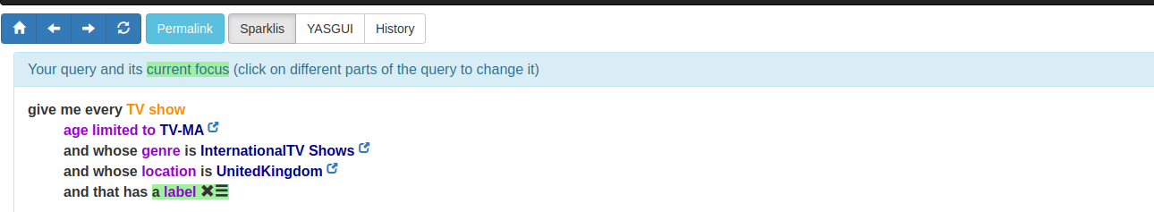

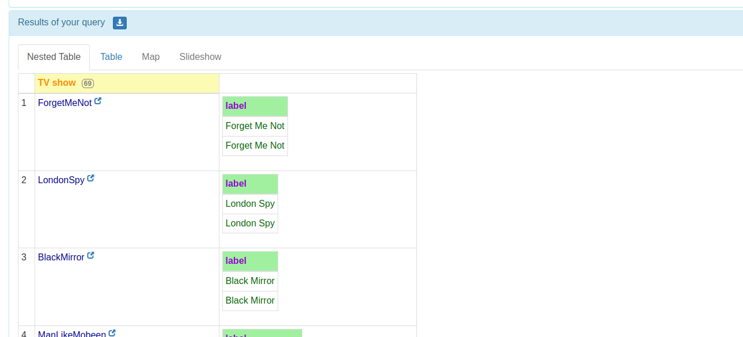

A query to dsiplay the category of all the movies directed by Angelina Jolie

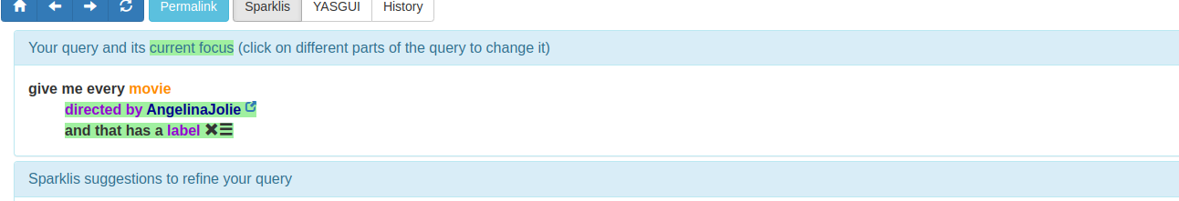

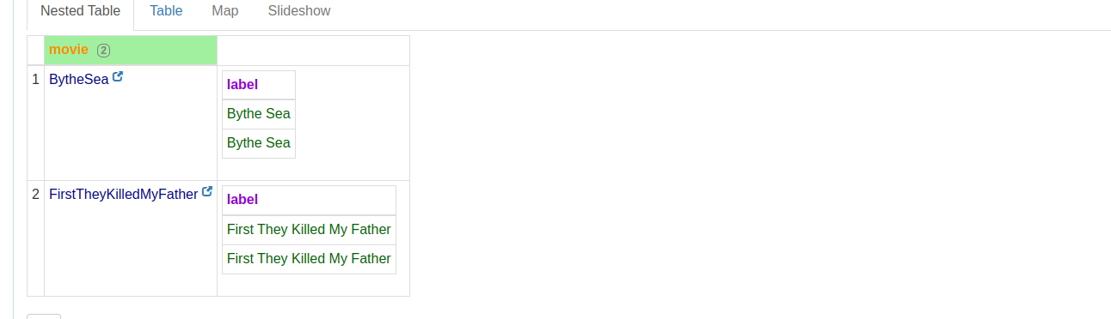

What is the average duration (in minutes) of all the Documentaries ?

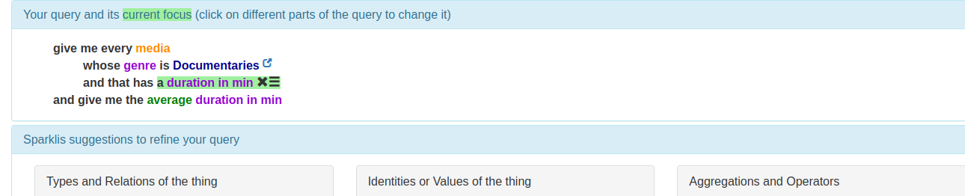

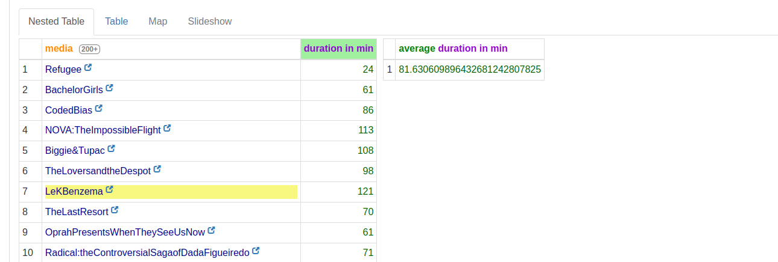

In which movie did Brad Pitt figured in with Cate Blanchett ? Who directed the movie ? What is the genre of the movie ? Where was it produced and how long does it last ?

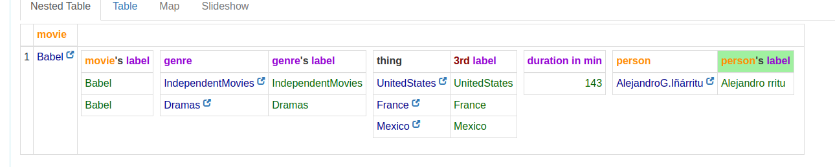

Same question but with Brad Pitt and Mélanie Laurent

