

American International University-Bangladesh (AIUB)
Department of computer science
Faculty of Science & Technology (FST)
Semester: FALL 2025-26
Course: Software Quality And Testing
Section : A
Assignment Title : Assignment on Automated Testing Tool
Subject : Selenium Testing for Bus Ticket Booking System

Supervised By:
Abhijit Bhowmik

Submitted By :
Name | ID
Merin Taj | 23-50865-1

Submission Date : 09-12-2025

Abstract
This assignment represents the process of configuring and executing Selenium based automation testing for a web application. The work started with installation of Python, followed by the setup of the Selenium framework installation, ChromeDriver, and additional supporting libraries such as PyMySQL and WebDriver Manager. The system environment variables were also configured to ensure proper integration of ChromeDriver with Selenium during script execution.
After the environment setup was completed, I developed and executed multiple automation scripts to test several core functionalities of my Web Technologies project. These included the Login module, Signup/Registration process, updating user information ,logout, and the administrative feature for adding a new bus company. For each test case the outcomes of both valid and invalid inputs were observed and documented. Additionally, database states were examined before and after execution to validate that the system correctly handled data insertion and updates.

Visual studio Code version :
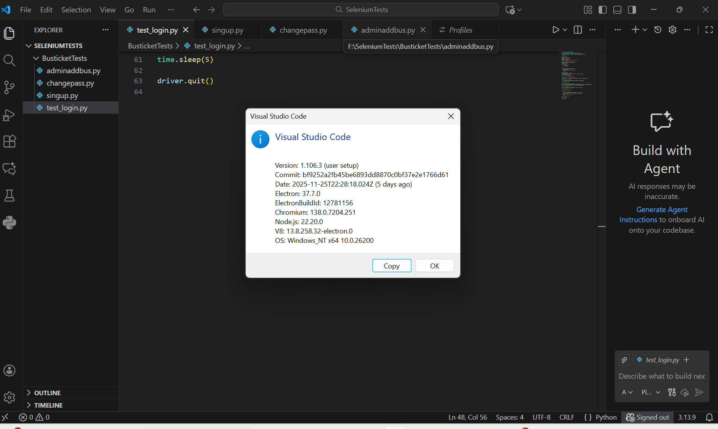

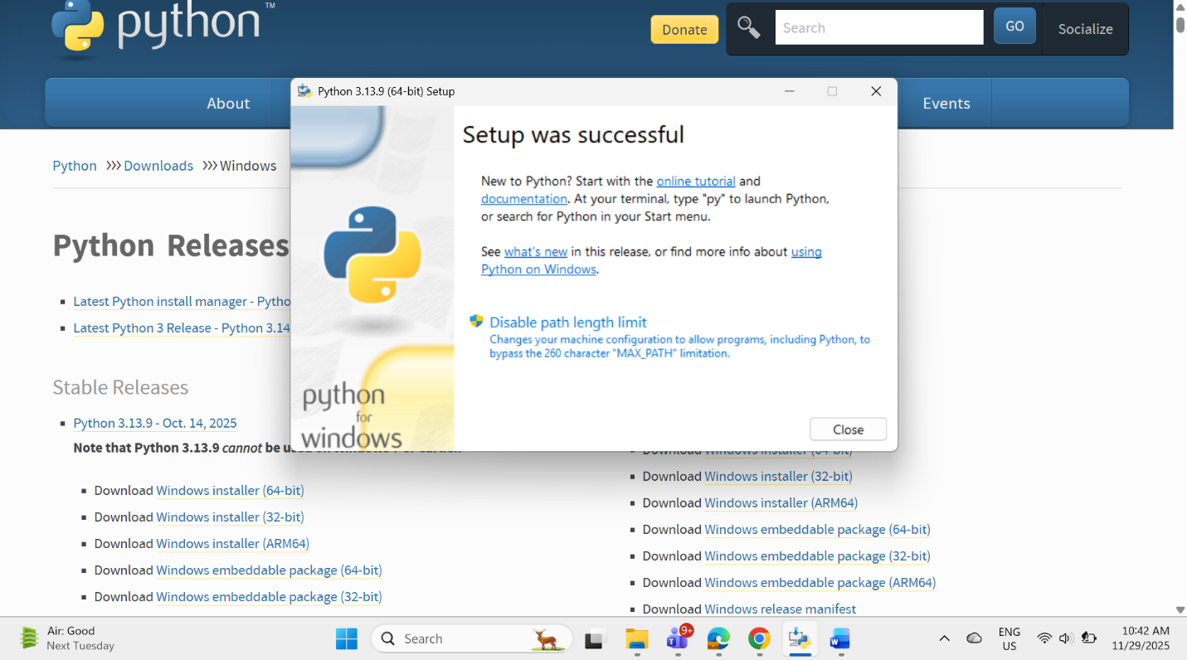
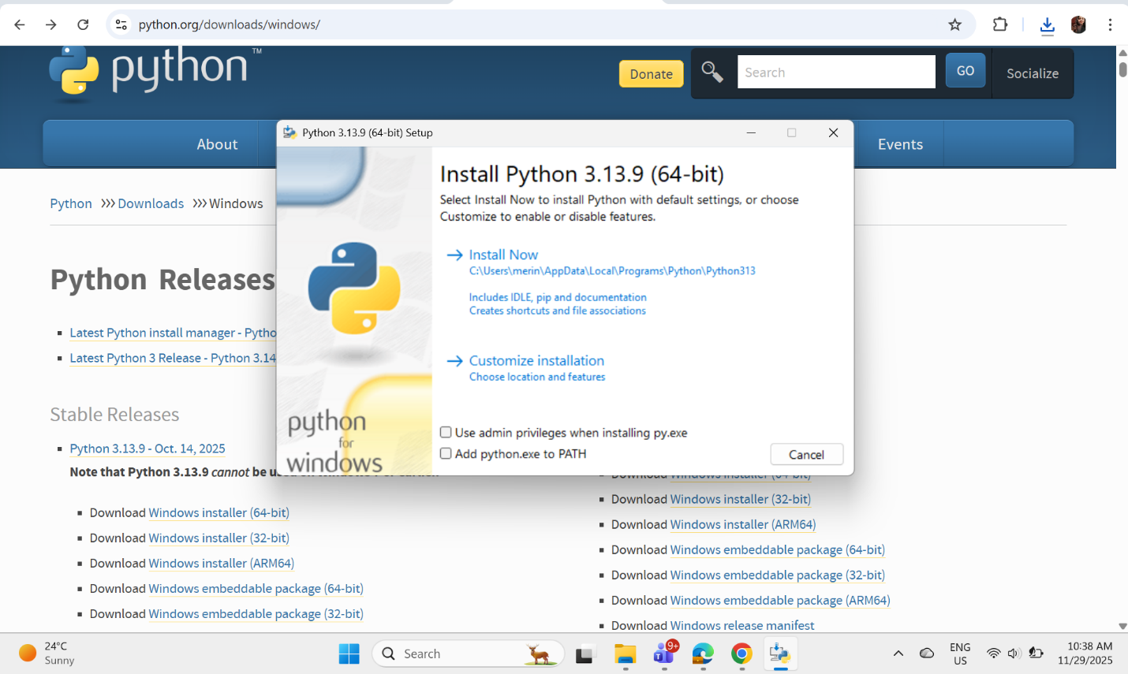
Installing Python :

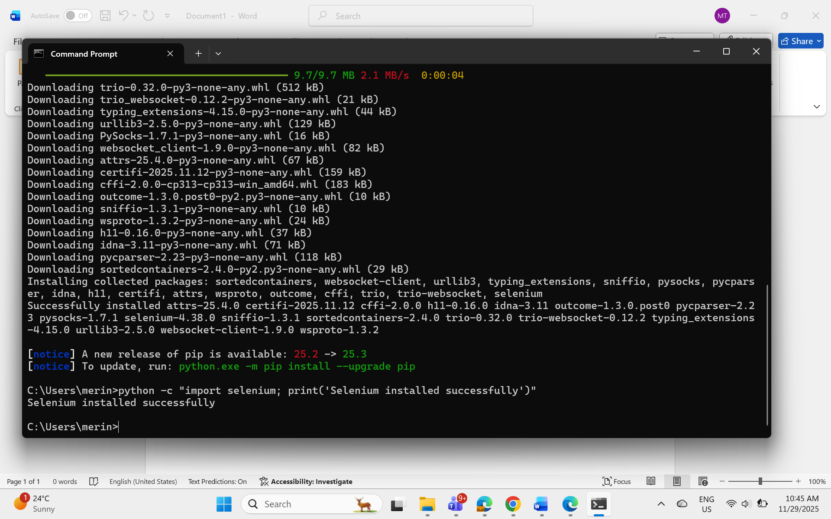
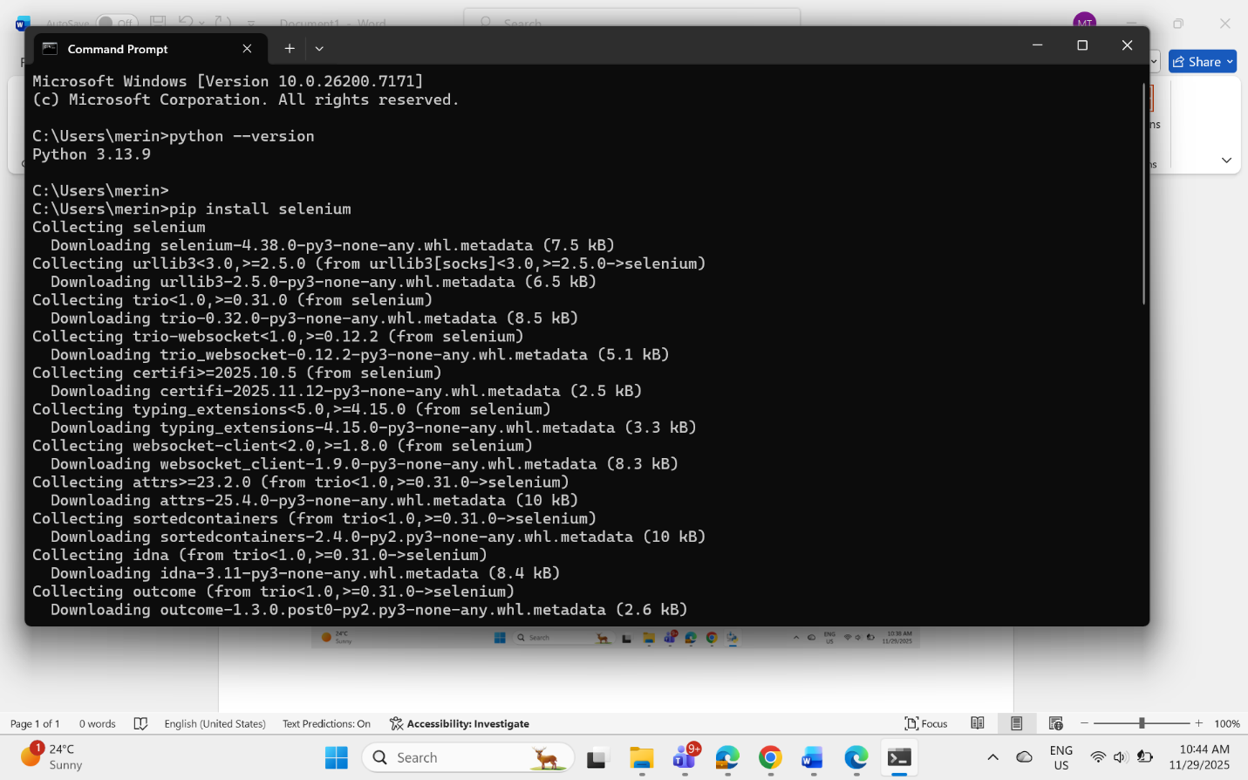
Installing Selenium :

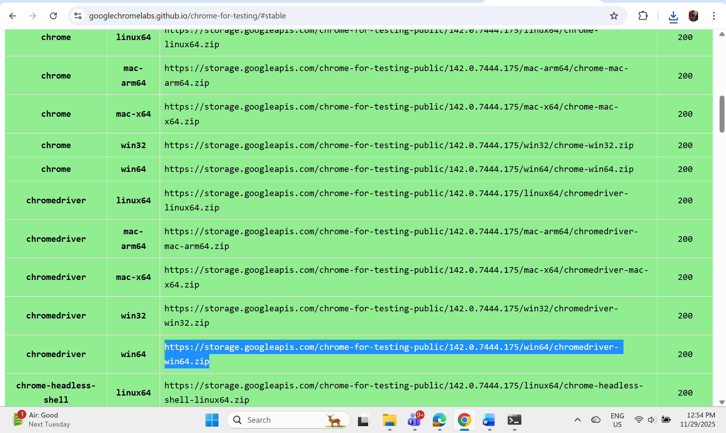
Installing ChromeDriver :

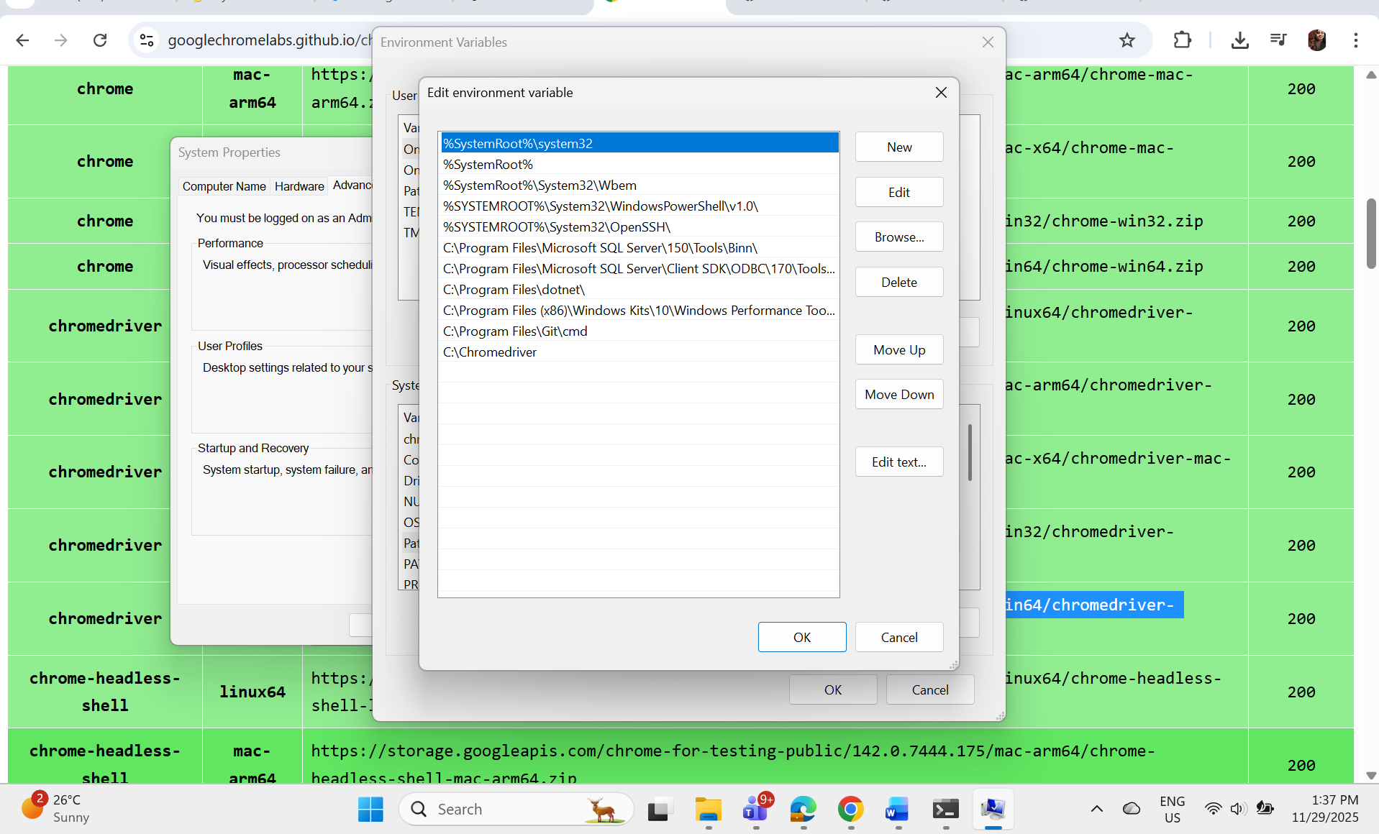
Editing environment variable for chrome driver:
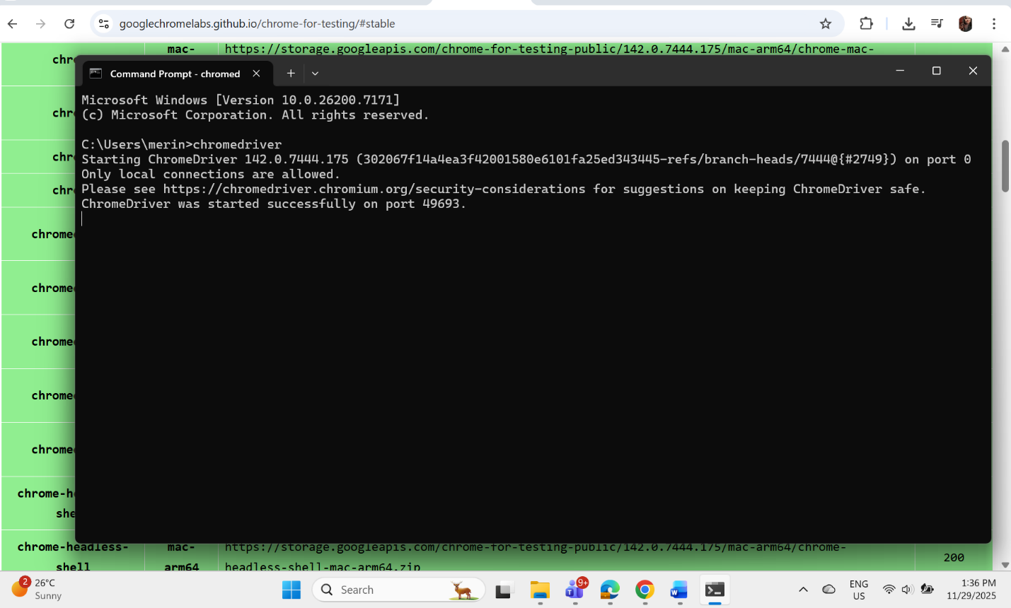
ChromeDriver Installation successful :

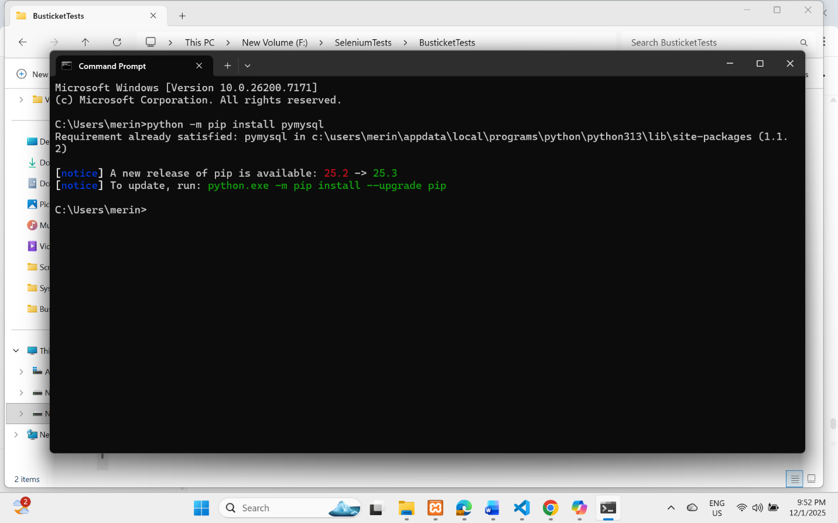
Installing pymysql (Database for python):

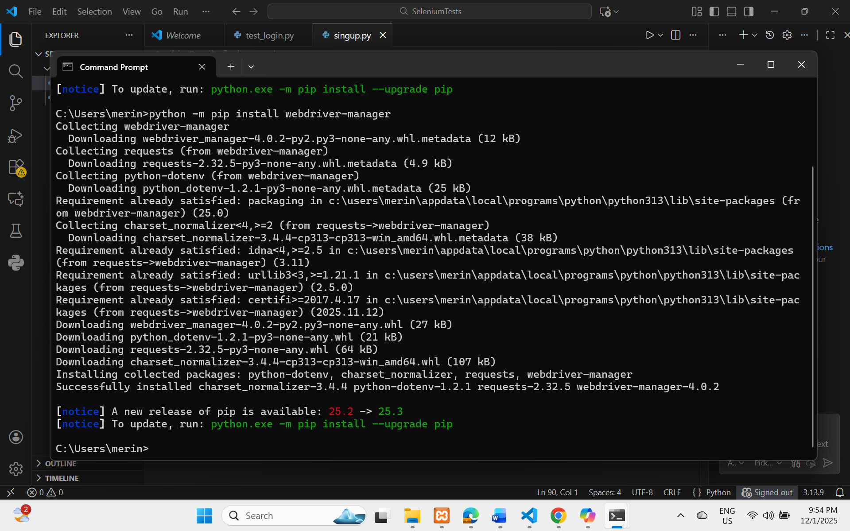
Installing WebDriver-manger :

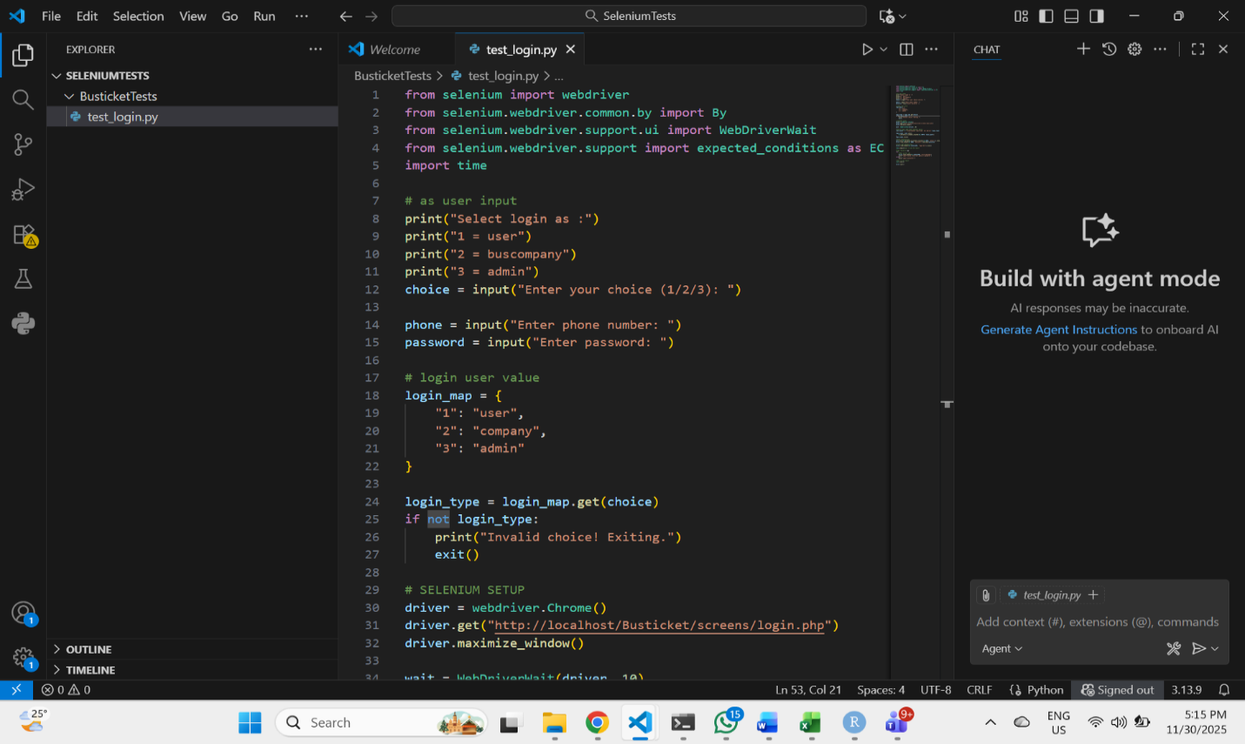
Test 1 : login test
Figure 1: selenium Script for login

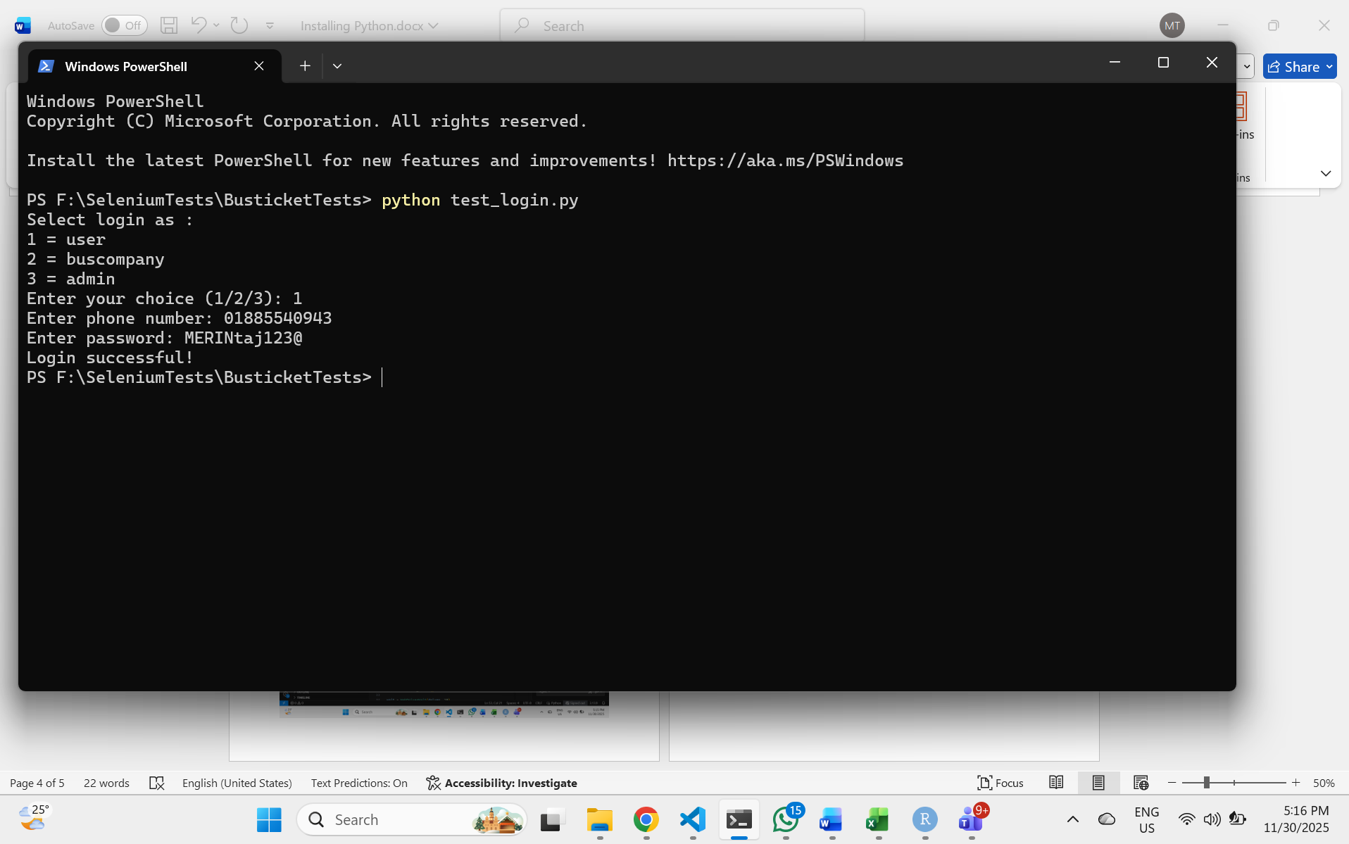
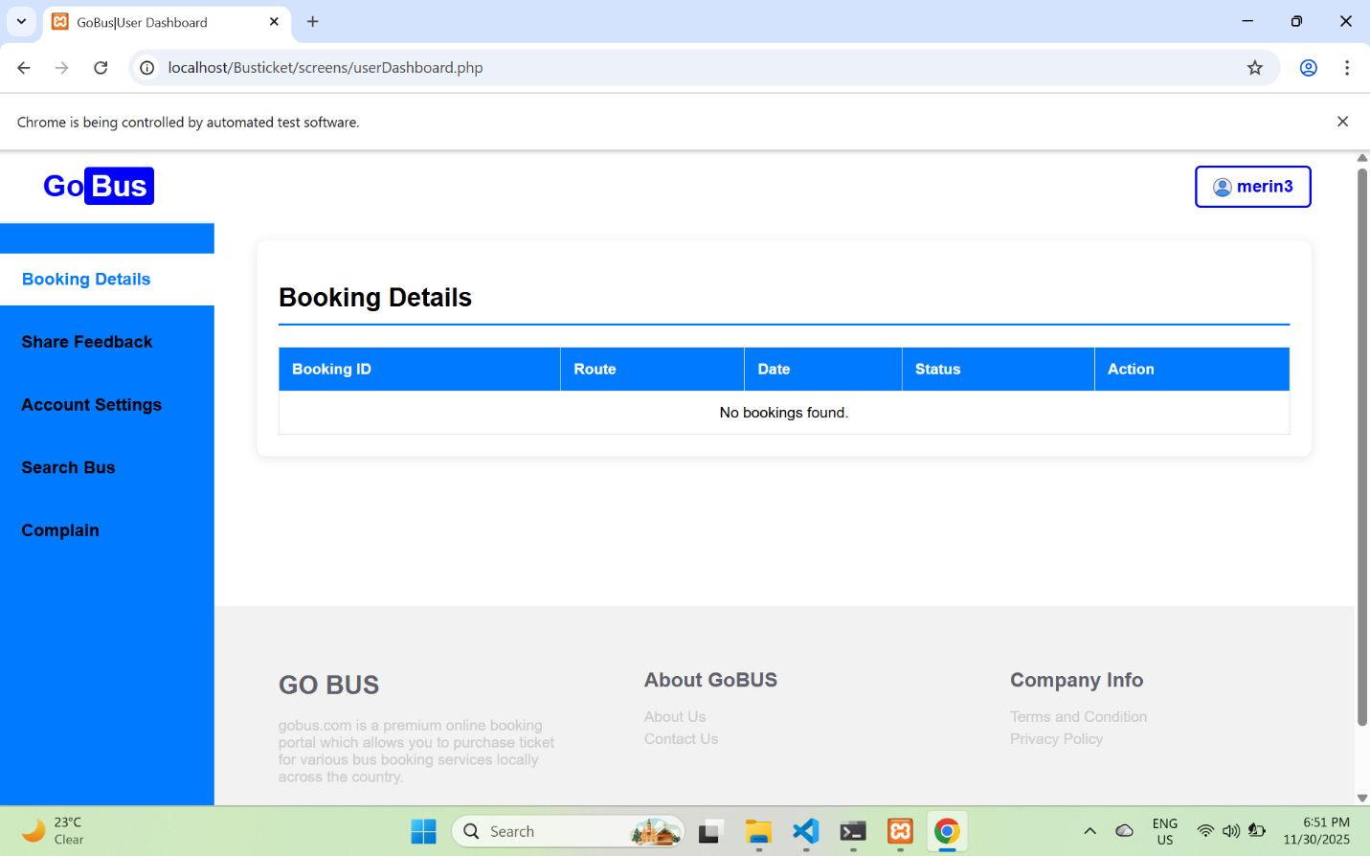
Figure 2 : Using correct Phone number and password (auto login in to dashboard)
Figure 3 : Web view auto login in to user dashboard
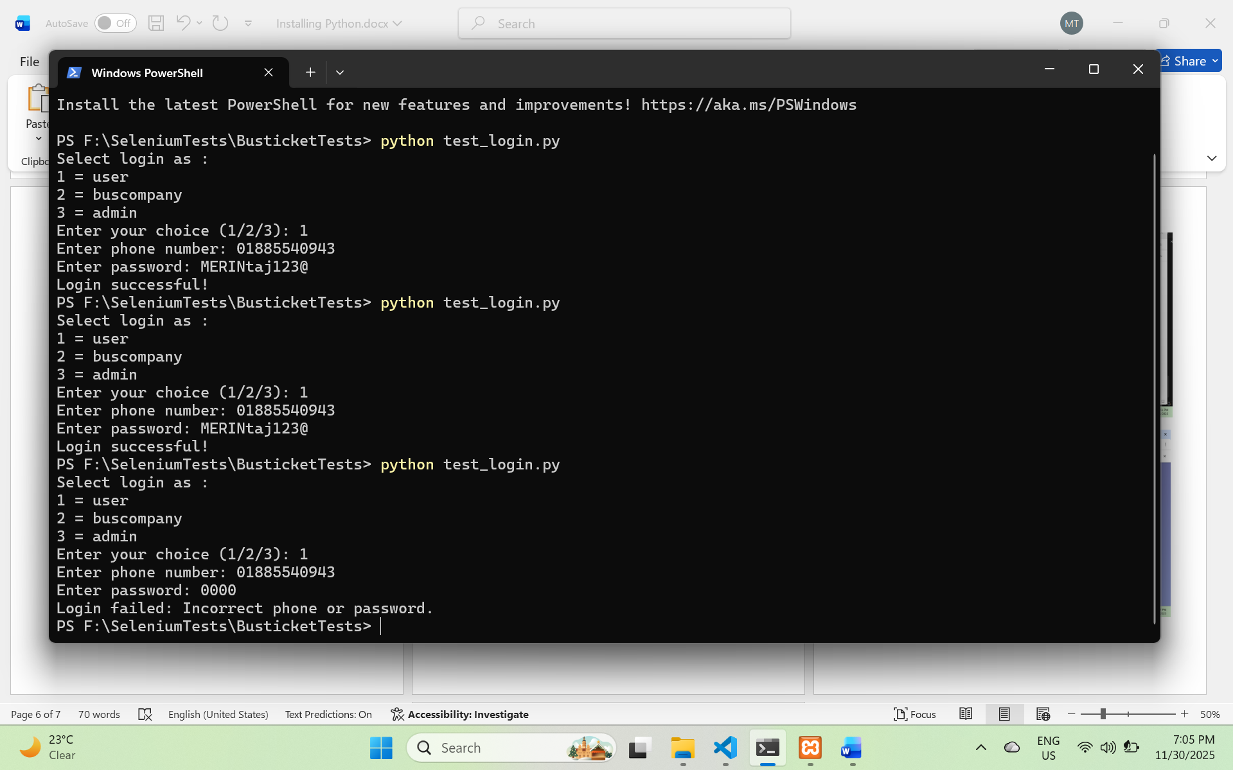
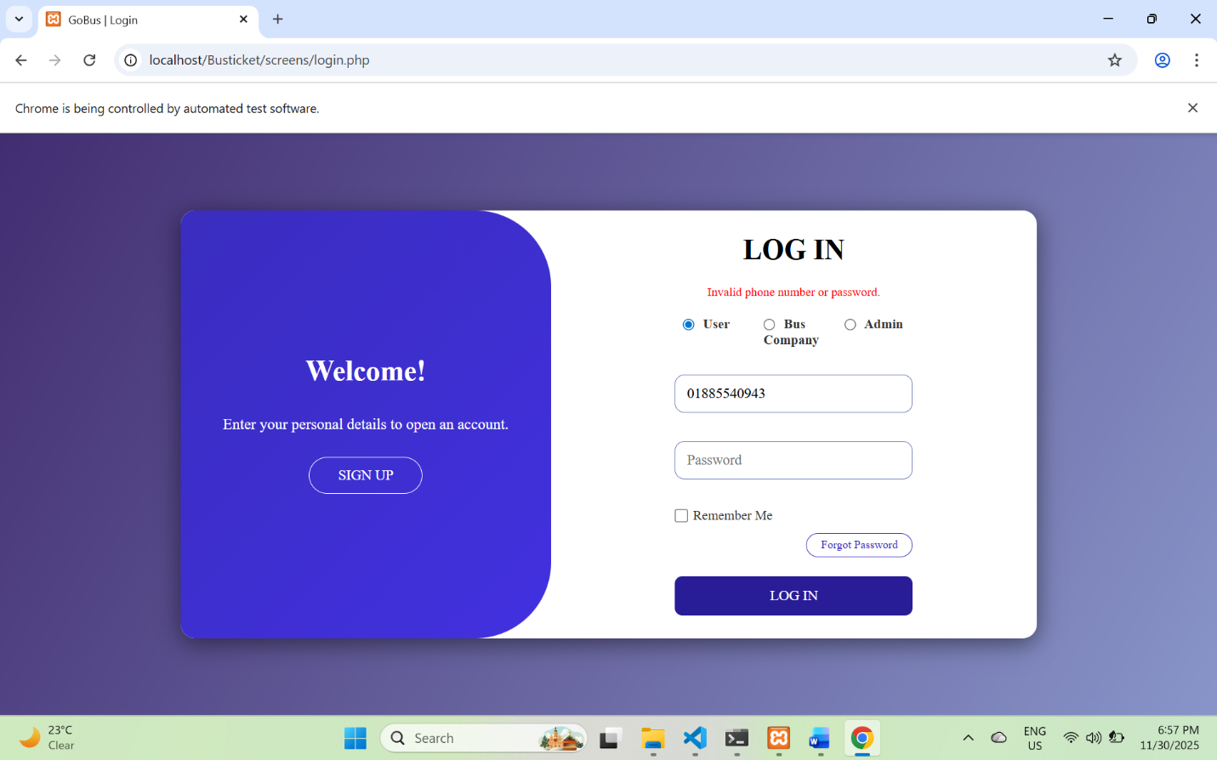
Figure 4 : Using wrong Phone number and password (auto login failed)
Figure 5 : Web view auto login Failed

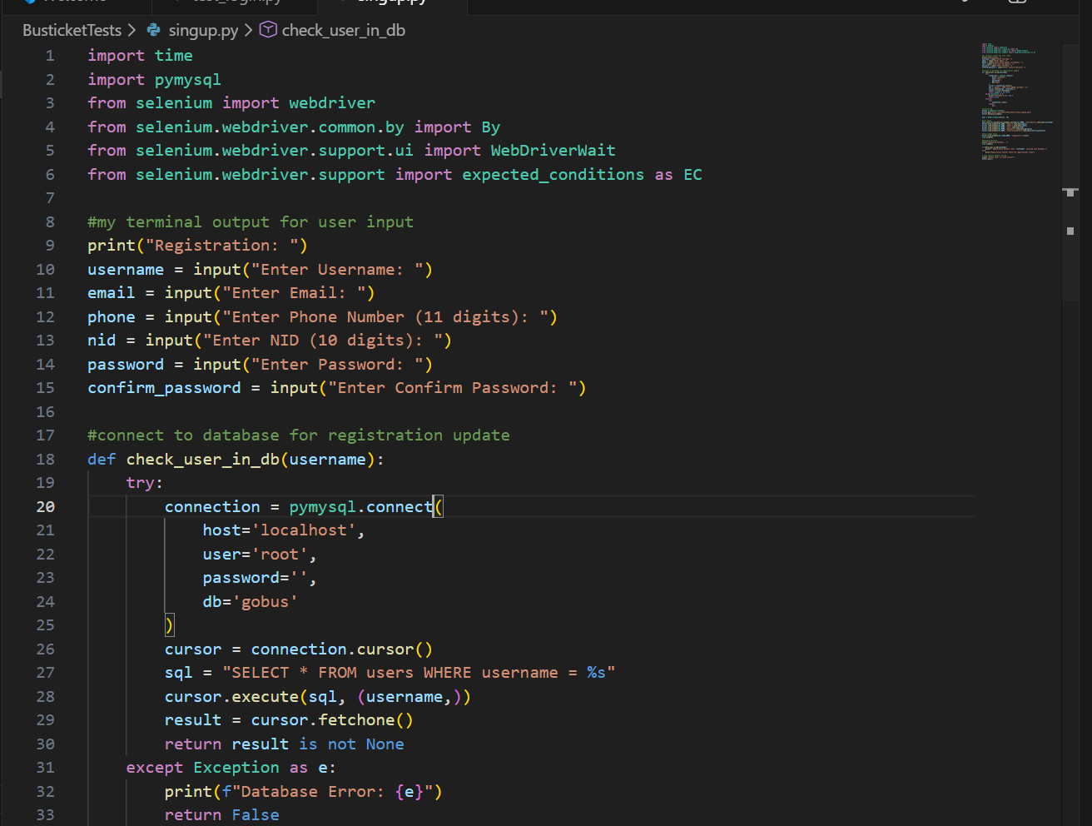
Test 2 : Signup /Registration test
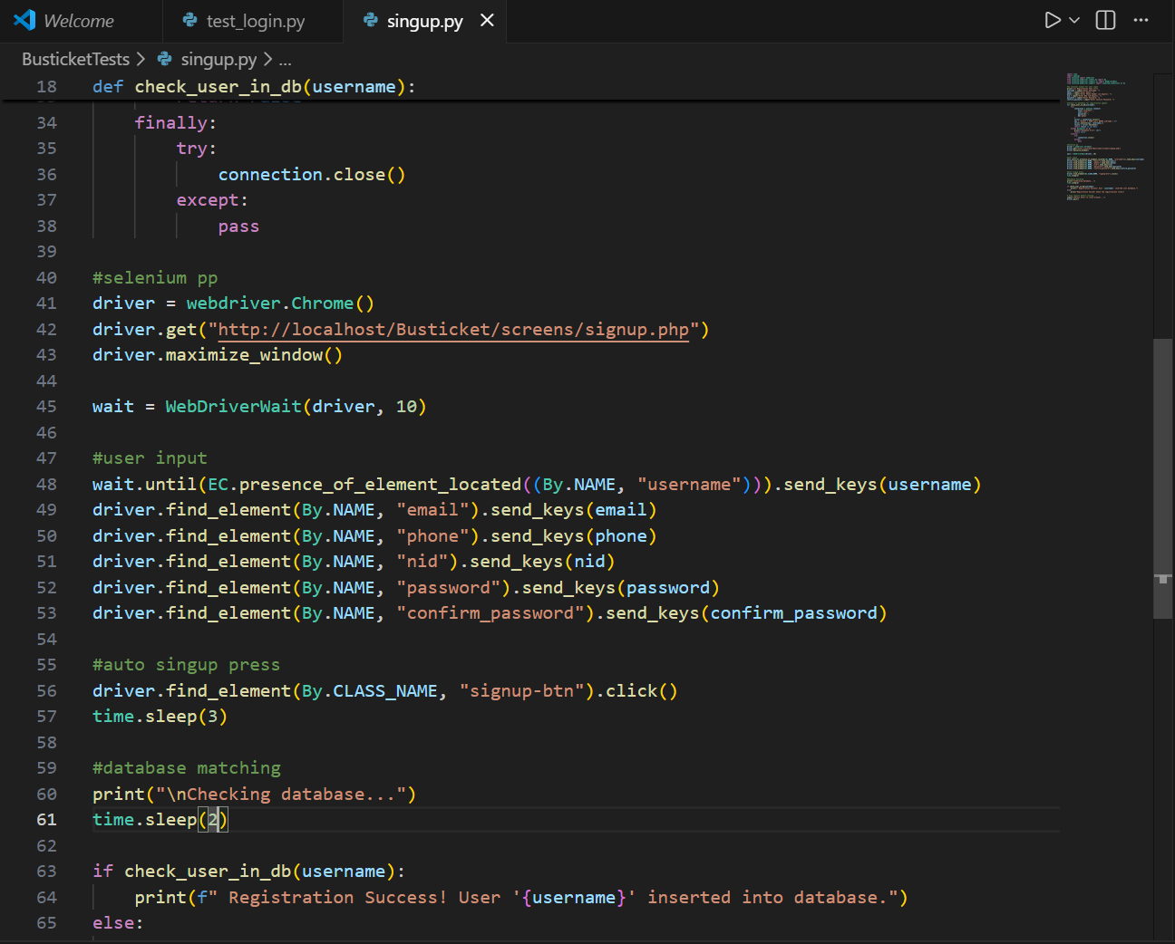
Figure 6 : selenium Script for Signup Test
Figure 7 : selenium Script for Signup Test

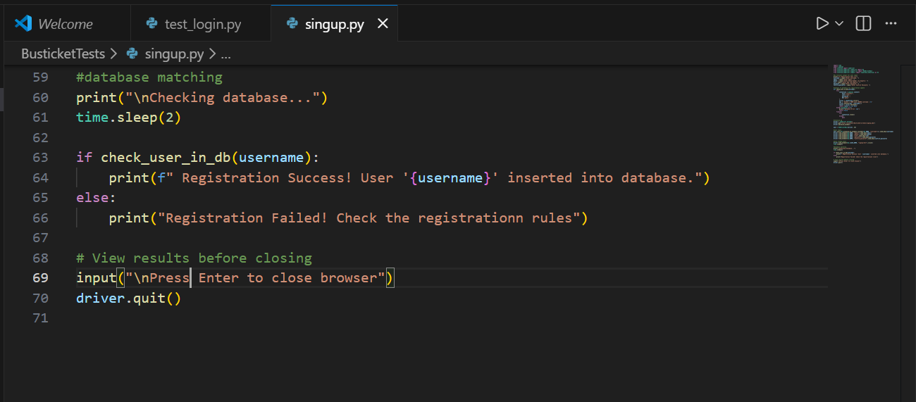
Figure 8 : selenium Script for Signup Test
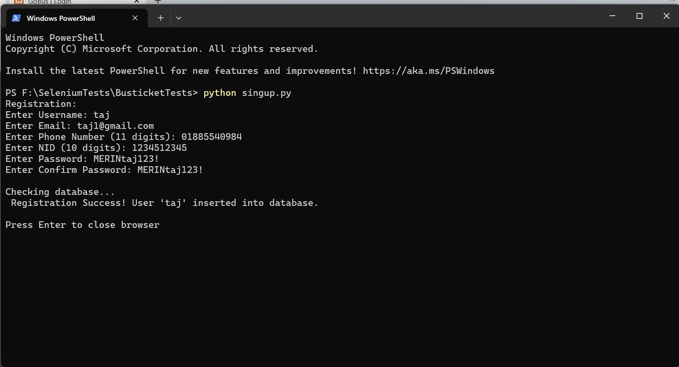
Figure 9 :Terminal View of registration/sign up

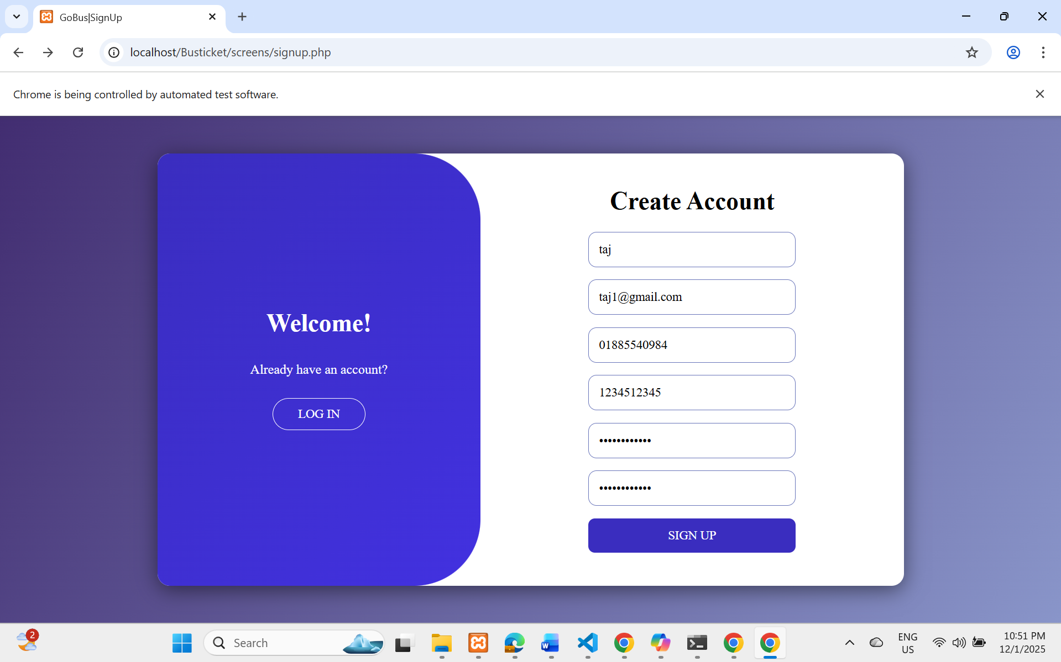
Figure 10 : Web view before auto signup
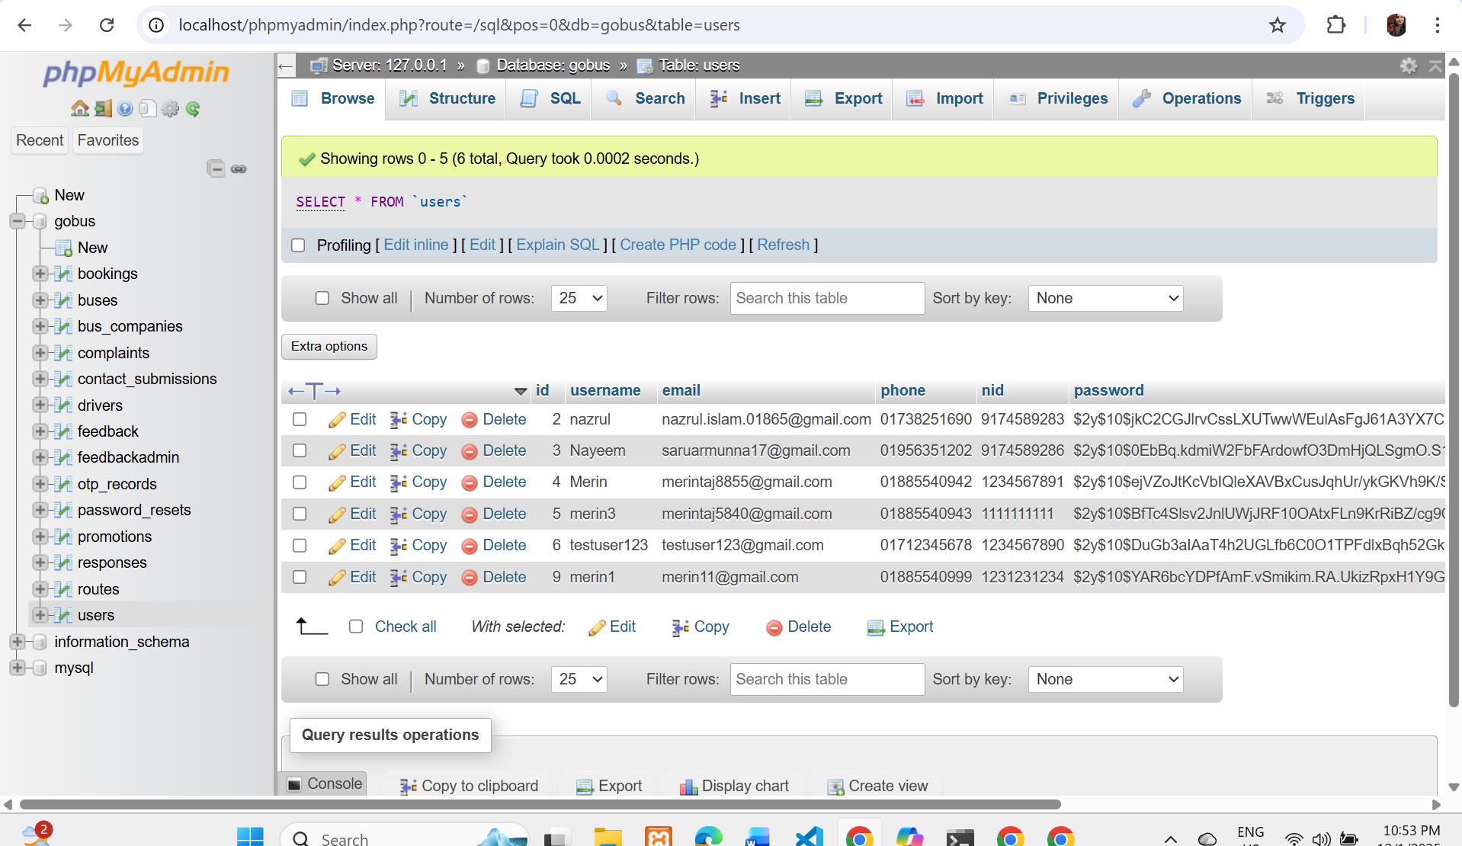
Figure 11 : Database view Before register
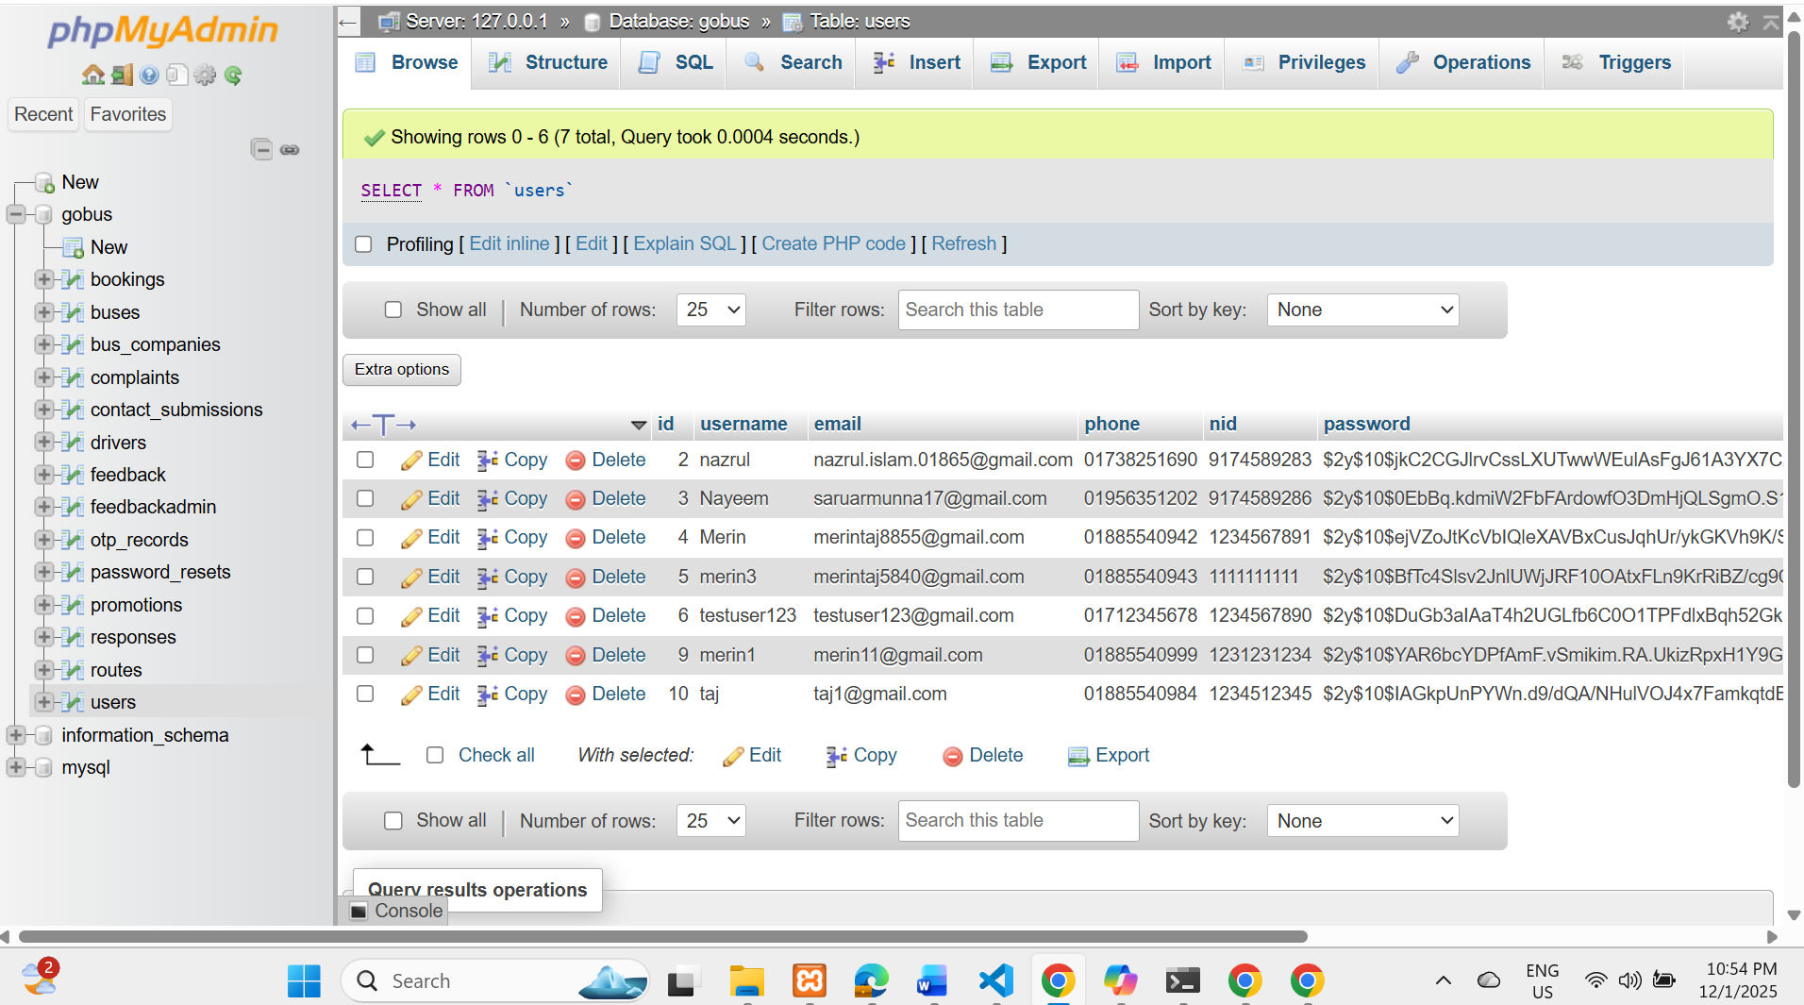
Figure 12 : Database view After register successfully update new user details
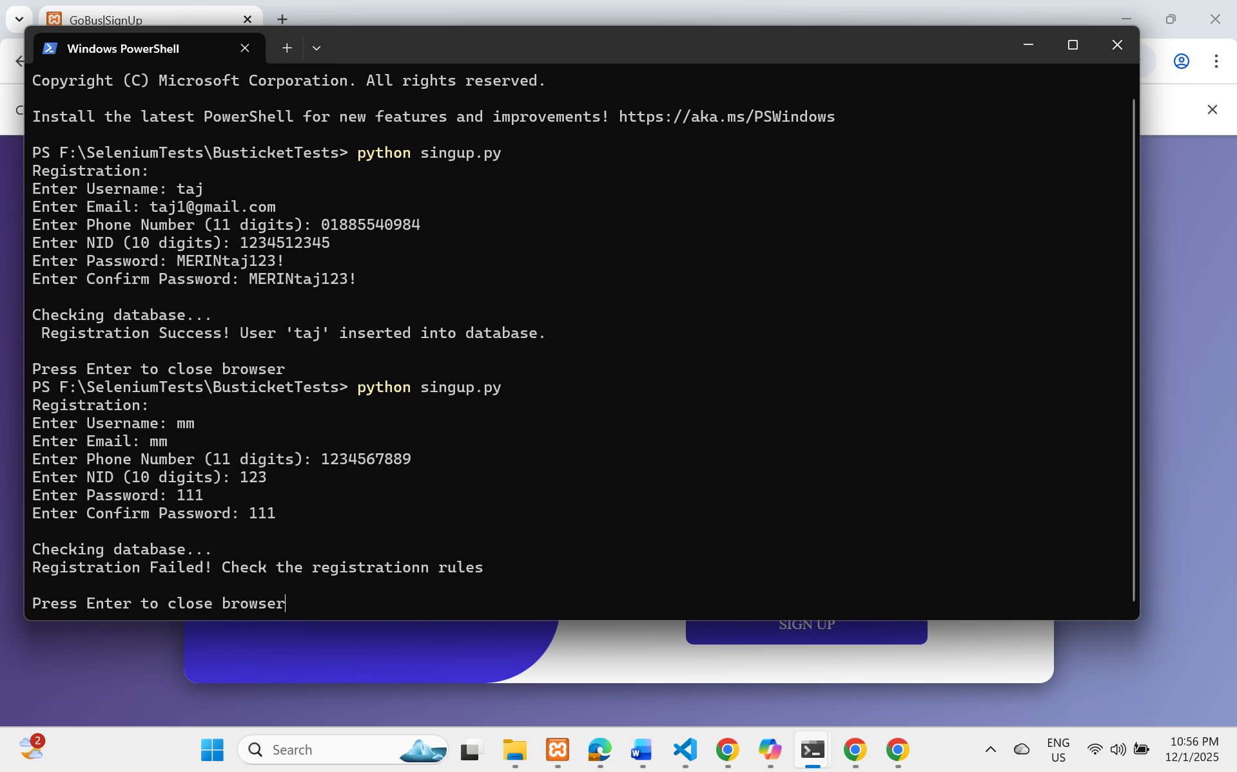
Figure 13 : Terminal view after wrong input (registration failed)

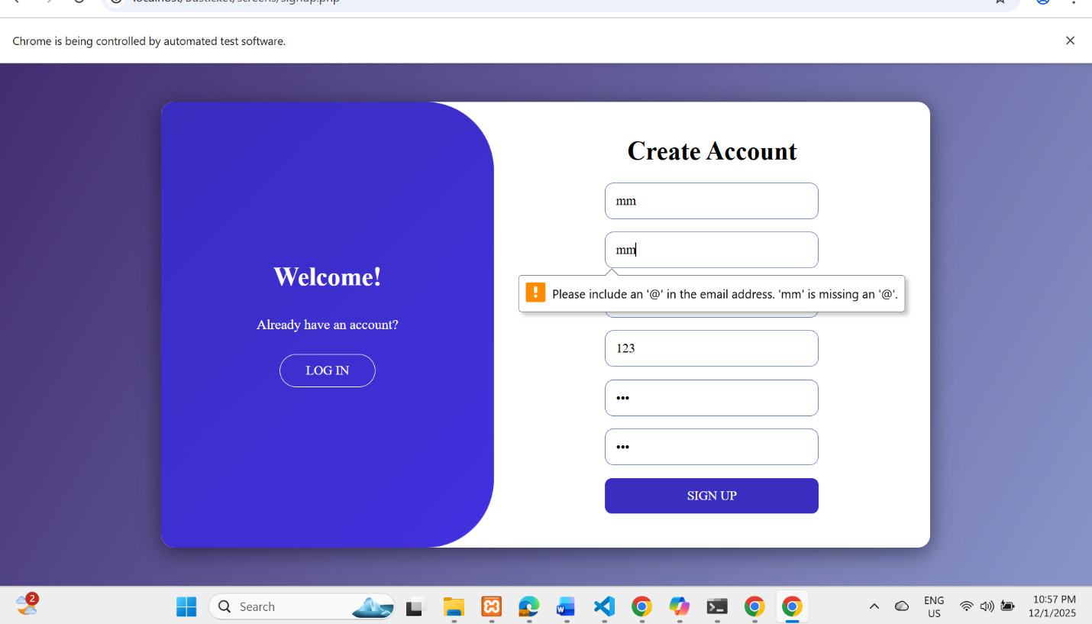
Figure 14 : Web view after wrong input (registration failed)
Test 3 : Change details 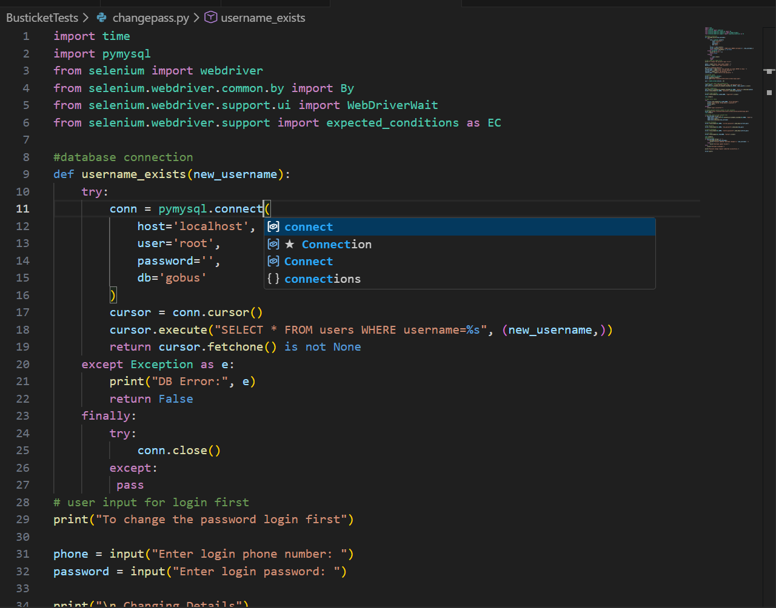
Figure 15 : Change details selenium script
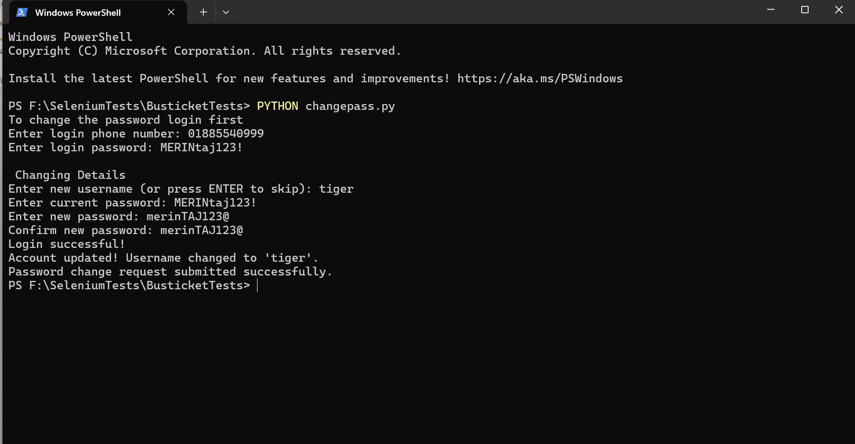
Figure 16 : Terminal view after login and change details successfully
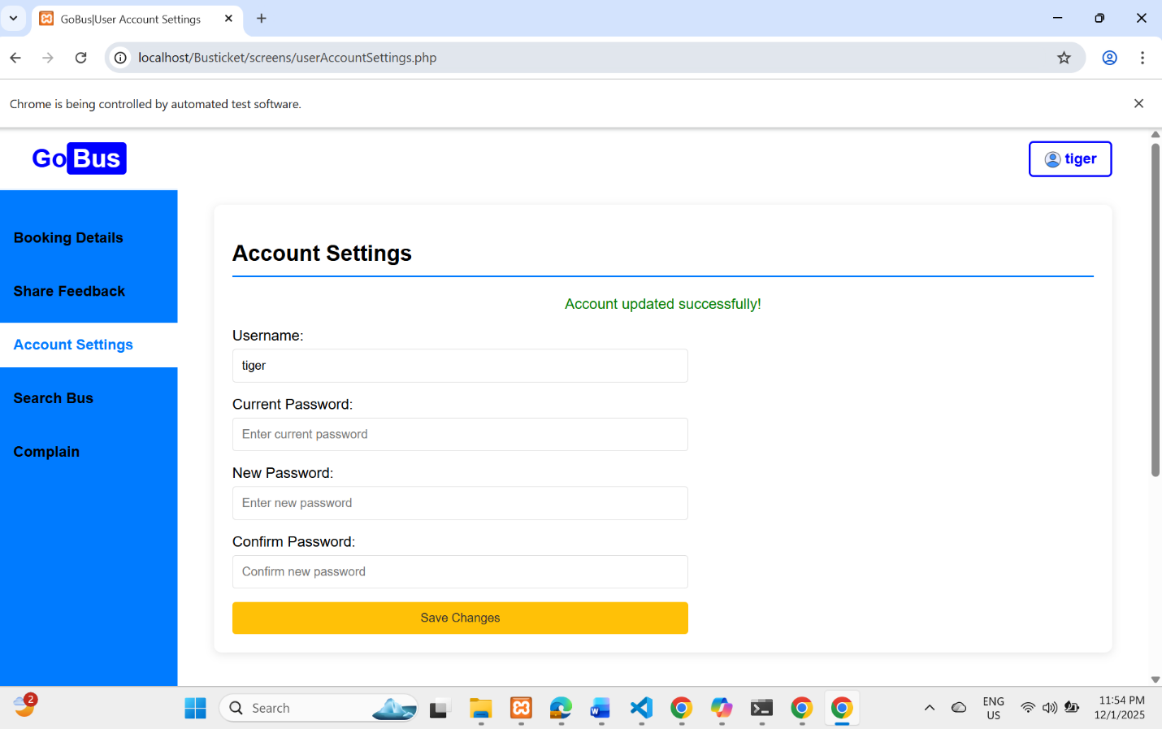
Figure 17: After login new password and username updated successfully

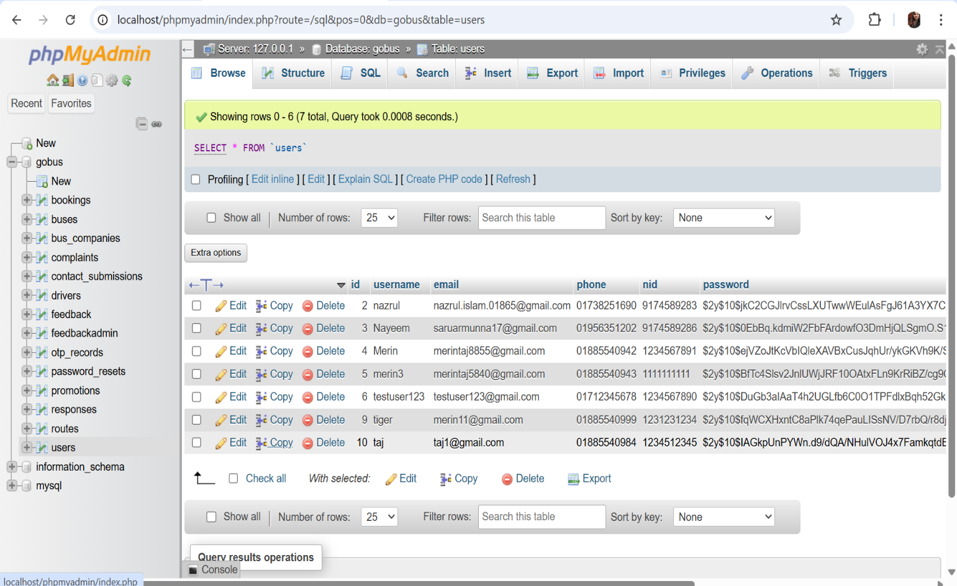
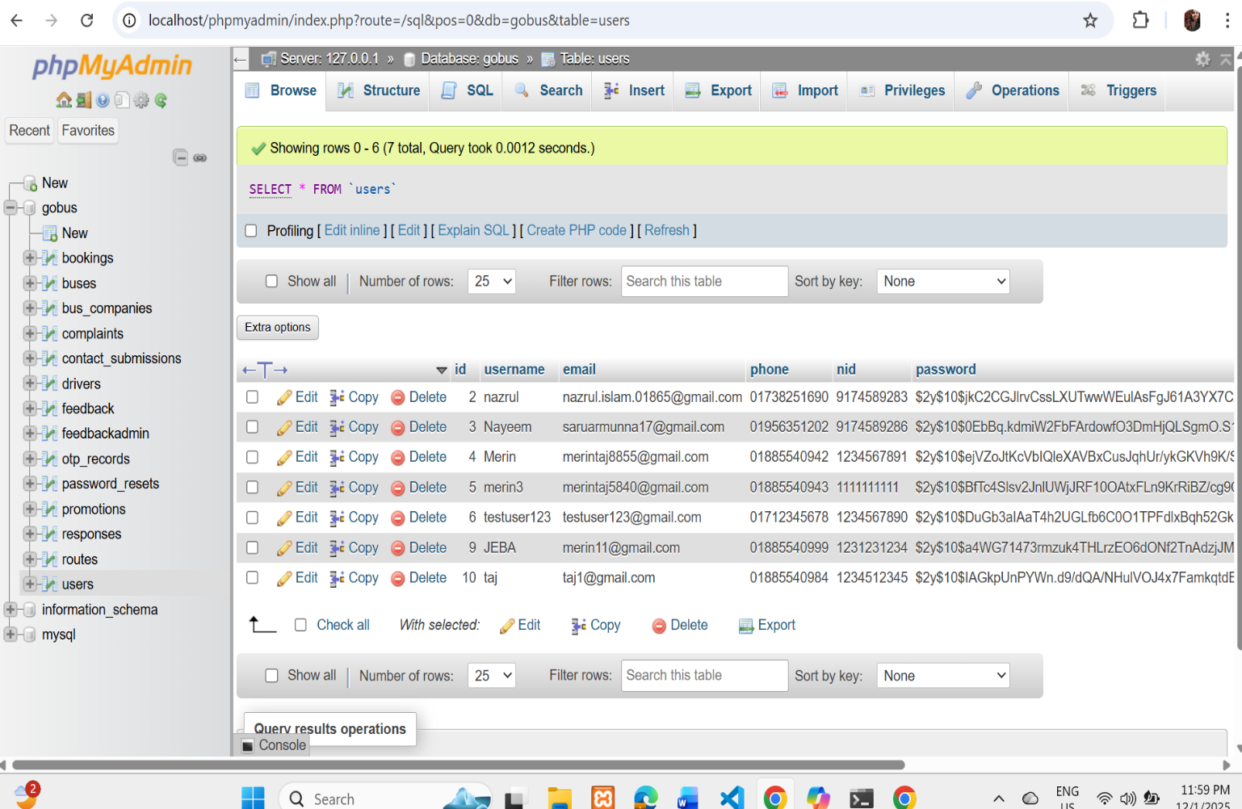
Figure 18: Database view before update (for id 9)
Figure 19: Database view after update (for id 9)
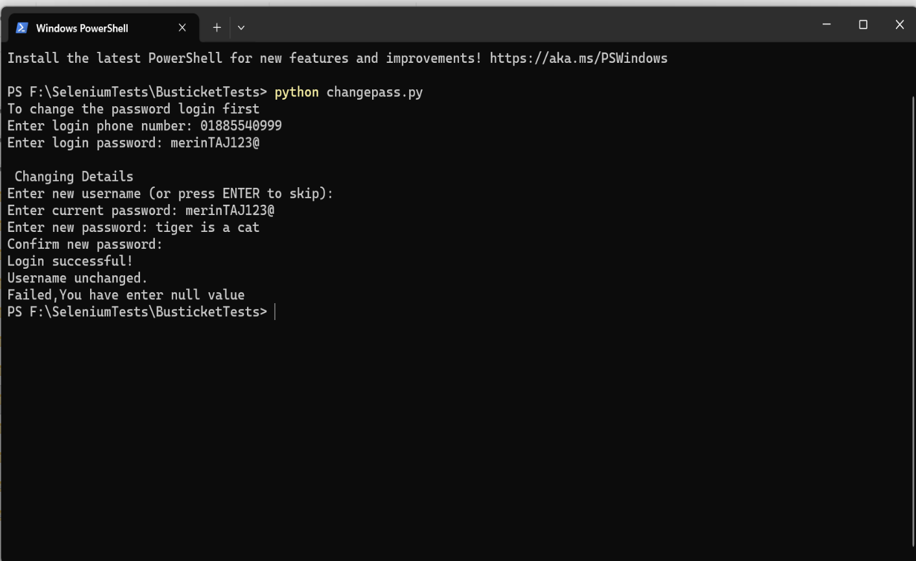
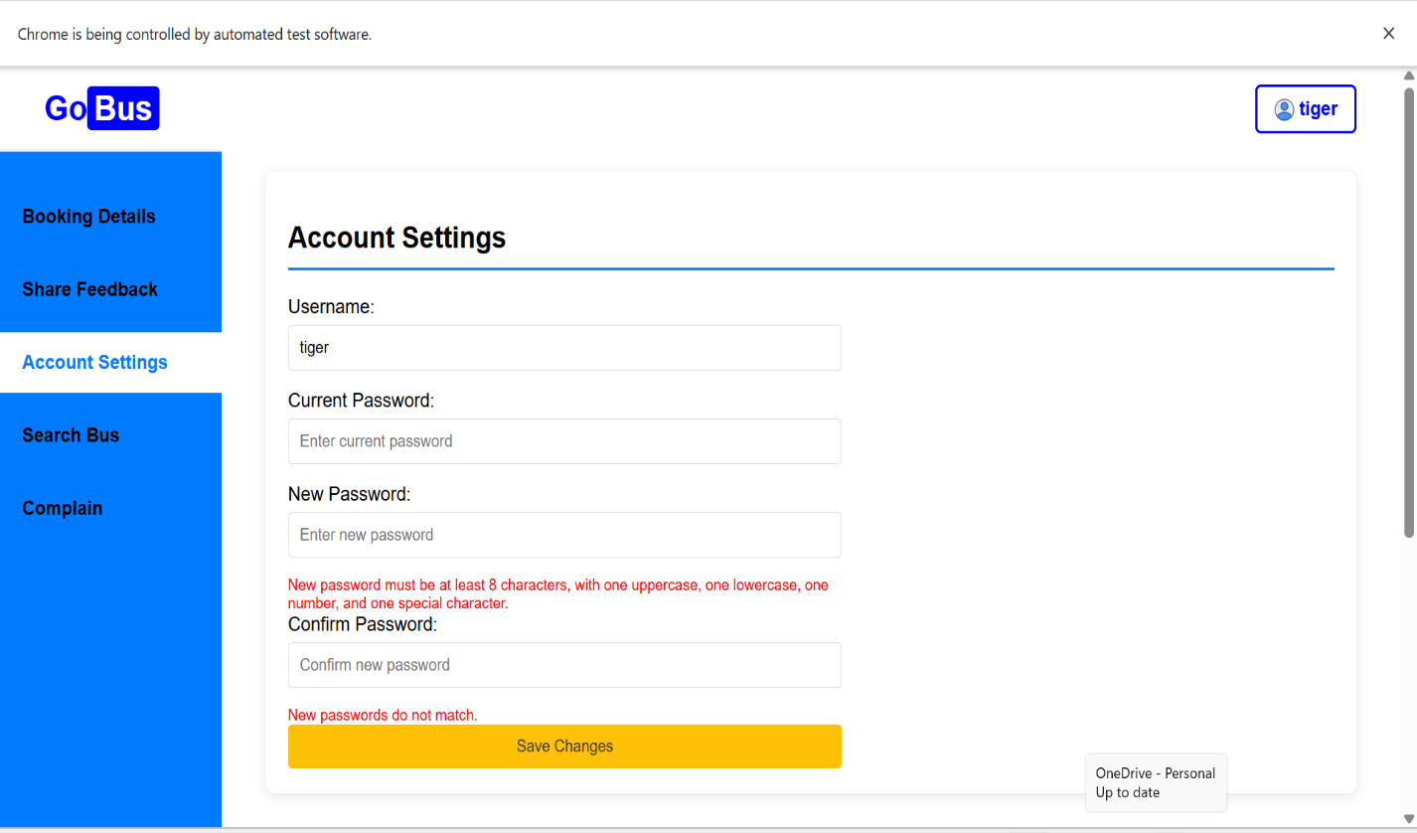
Figure 20 :Terminal after entering null value unsuccessful
Figure 21: Web view after putting null value unsuccessful
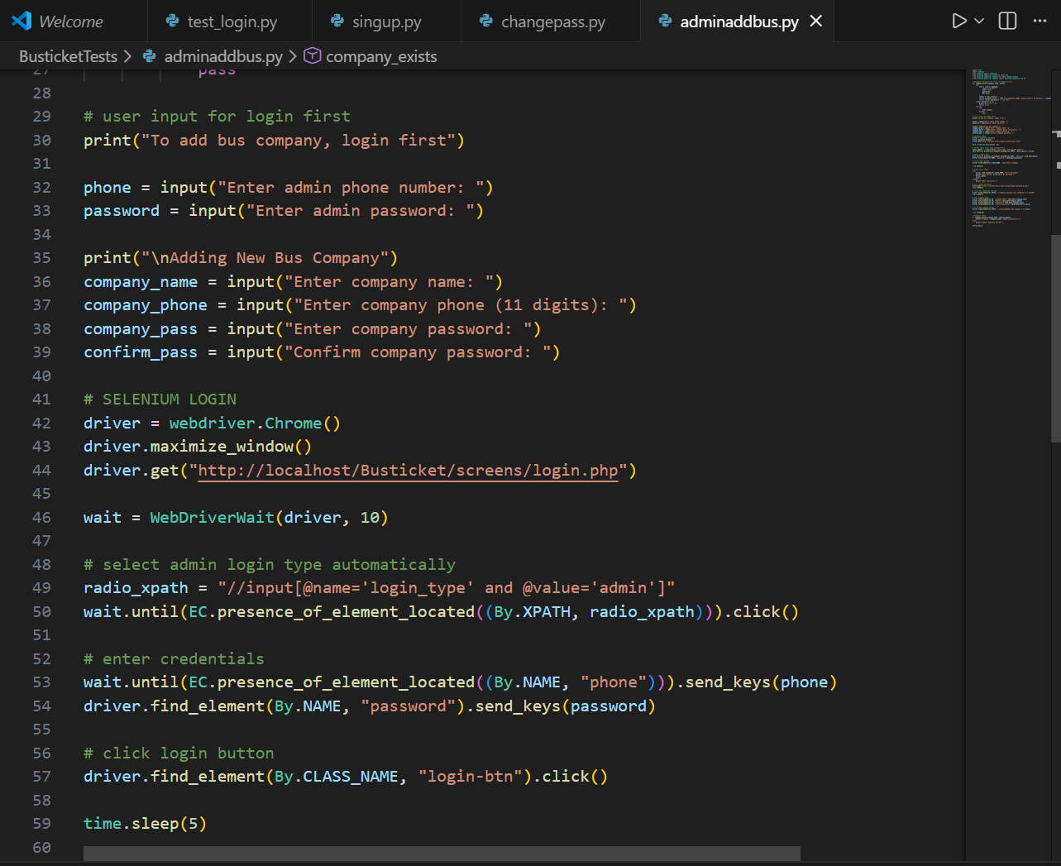
Test 4 : Admin add new bus company
Figure 22 : Admin add new bus company selenium script
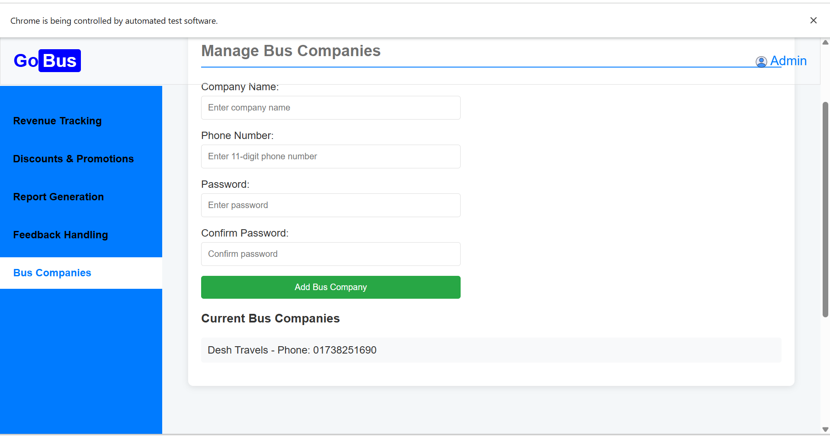
Figure 23: Web view before add a Bus company
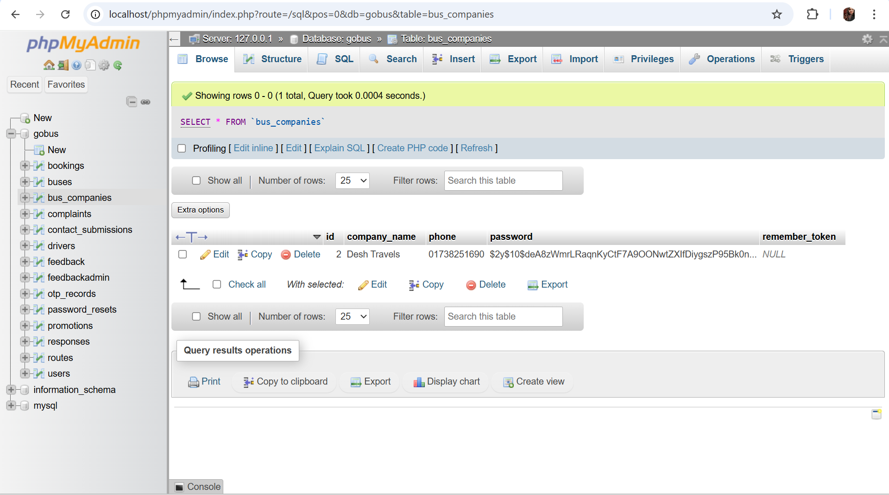
Figure 24 : Database view before added a company
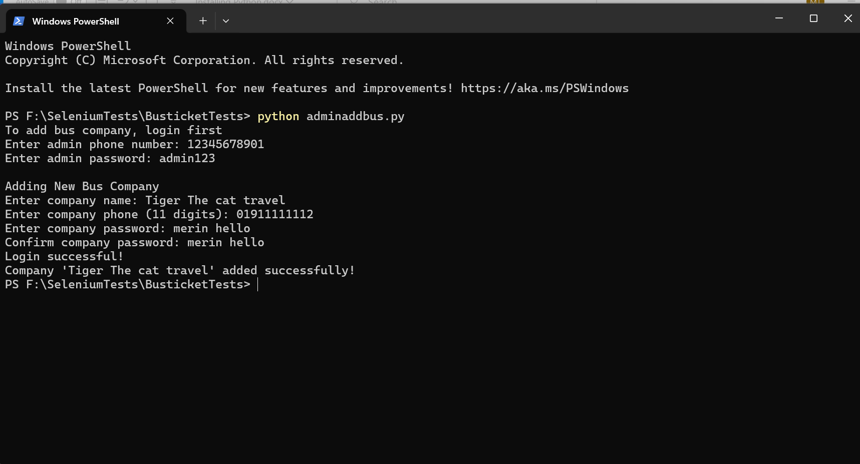
Figure 25: terminal view after successfully add company
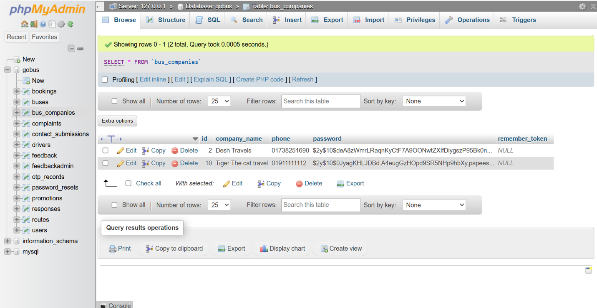
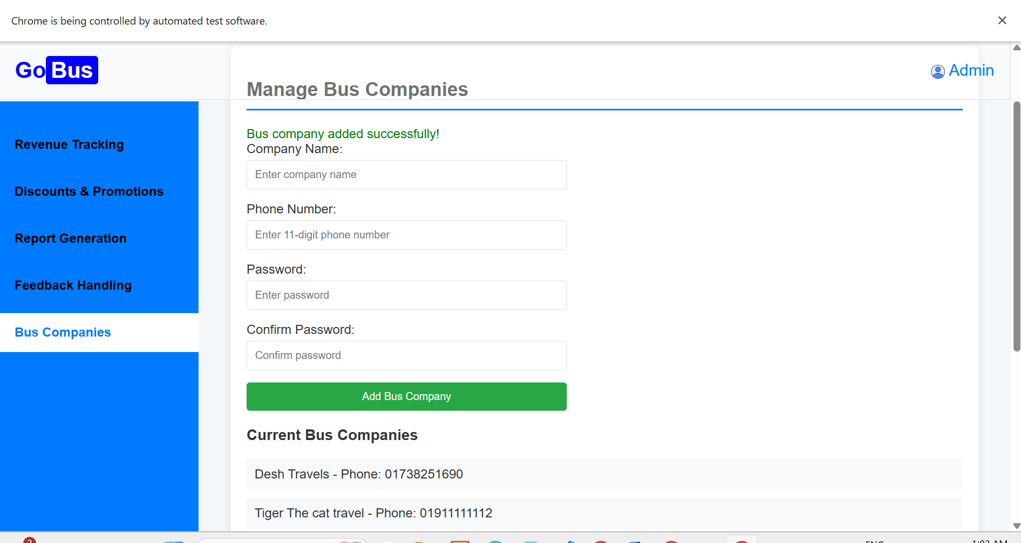
Figure 26 : Web view after successfully add company
Figure 27: Database view after successfully add company

Test 5 : Logout
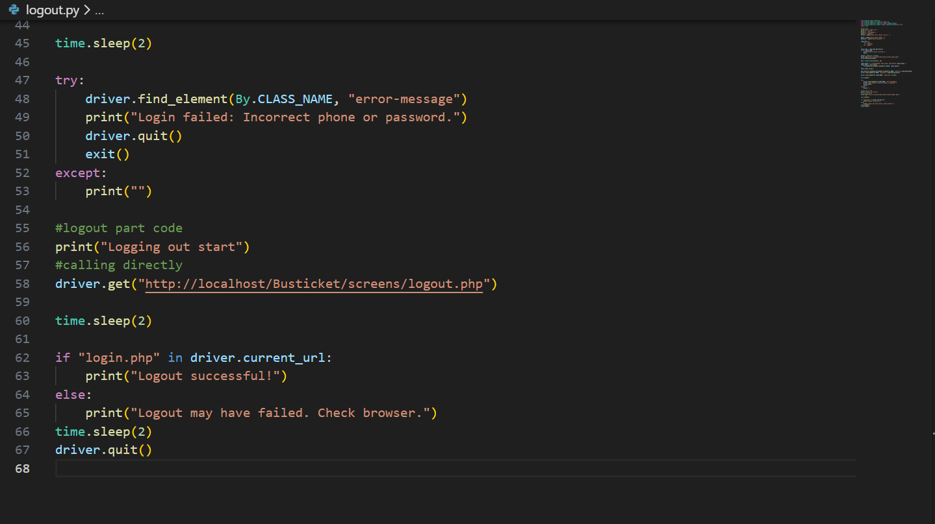
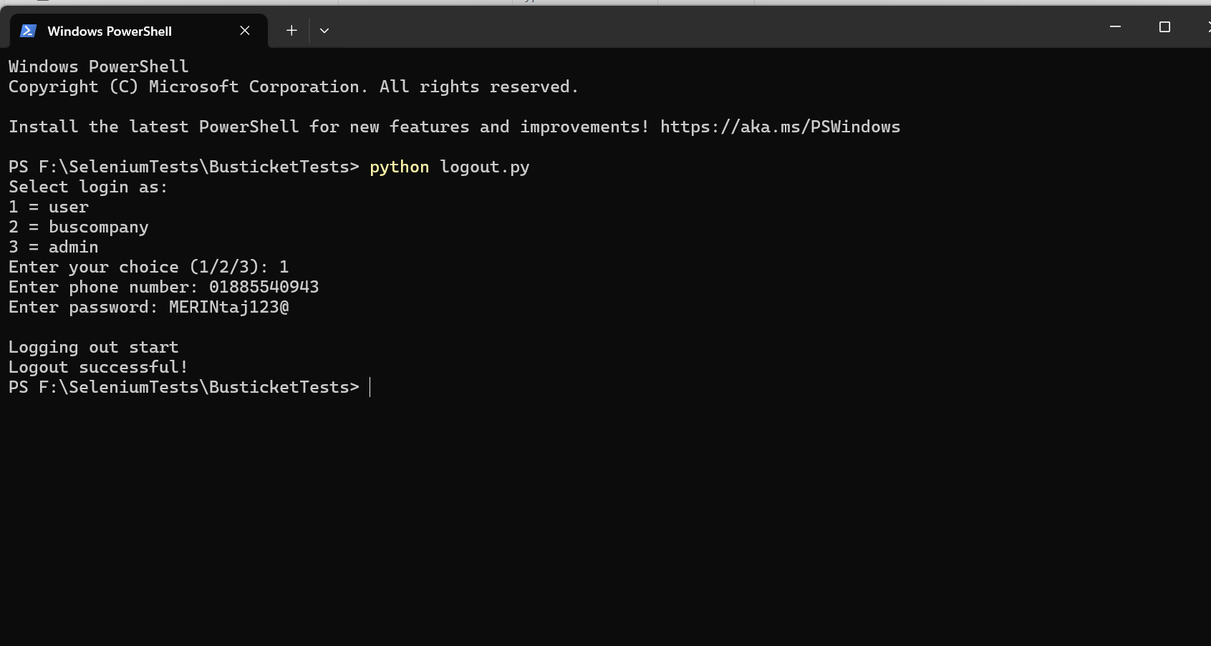
Figure 28 : Selenium script At first login then logout code
Figure 29 : Terminal View of logout successful
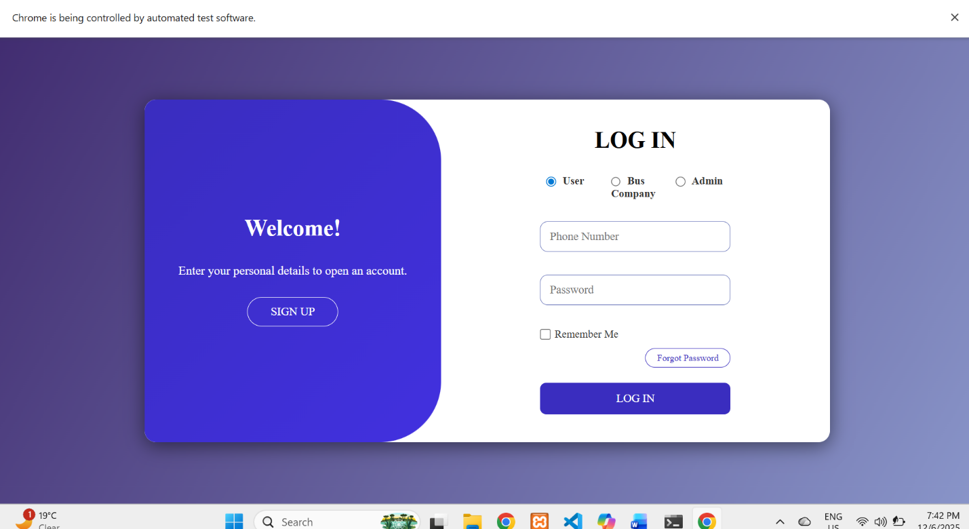
Figure 30 : Web View of logout successful

-----------------------------------------------------------------------------

