1. What is an Operator in Java?Types of operators.
2. What is Expression in Java?
3. What is the result of relational operator when it is used in looping or branching statement?

Ans: The result of all relational operators is always of a boolean type. It returns always true or false.

1. Length and breadth of a rectangle are 5 and 10 respectively. Write a program to calculate the area and perimeter of the rectangle.
2. Write a program to add 8 to the number 2345 and then divide it by 3. Now, the modulus of the quotient is taken with 5 and then multiply the resultant value by 5. Display the final result.

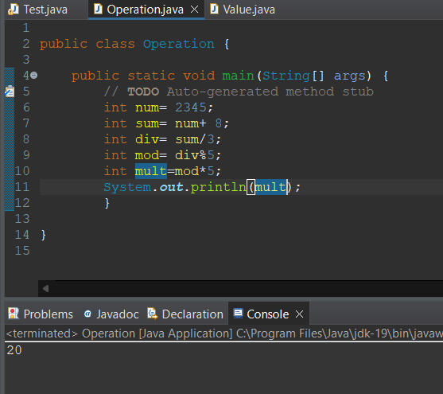

1. Given A=50, and B=40. Write program to increase the value of A by 1 and decrease the value of B by 1.

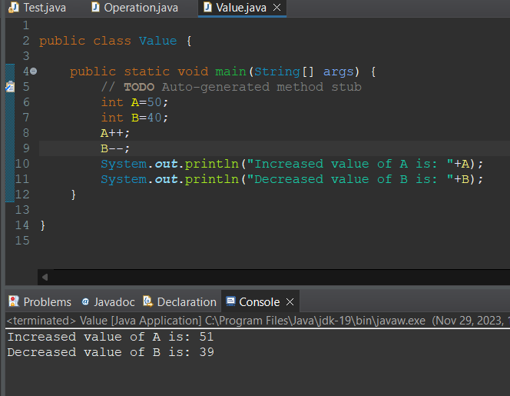

1. Examine the following code. What is the value of a after it completes?

int a = 40; int modu = 25

a /= 2; modu %= 2

Output: 20 output: 1

1. Given:

expr1 = (5>3), expr2 = (8>5) -> use it for Logical AND.

expr1 = (5>3), expr2 = (2>5) -> use it for Logical OR.

expr1 = (!(5==10)) -> use it for Logical NOT.

Write a program for computing above data using all the comparison operators given in the slides.

1. String methods

* compareTo() - Compare ‘s1 and s2’ , ‘s1 and s3’ ,‘s1 and s4’ , ‘s1 and s5’

String s1="hello";

String s2="hello";

String s3="harry";

String s4="nepal";

String s5="flag";

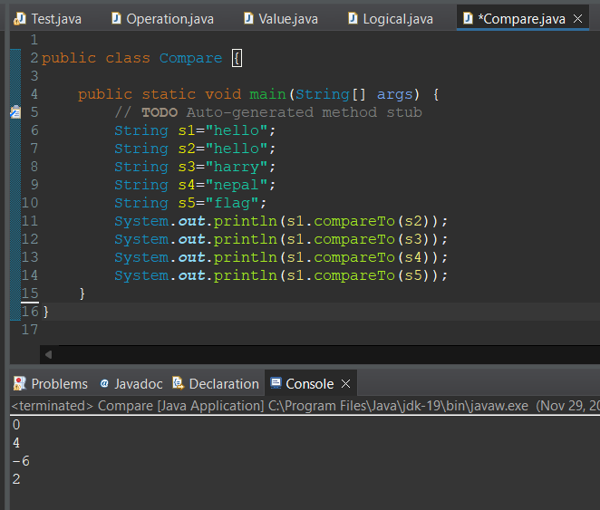

* concat() - perform concat() on following string

String s1 = "Herald College";

String s2 = s1.concat("is located in Naxal Kathmandu");

Print s1,s2 and observe the result

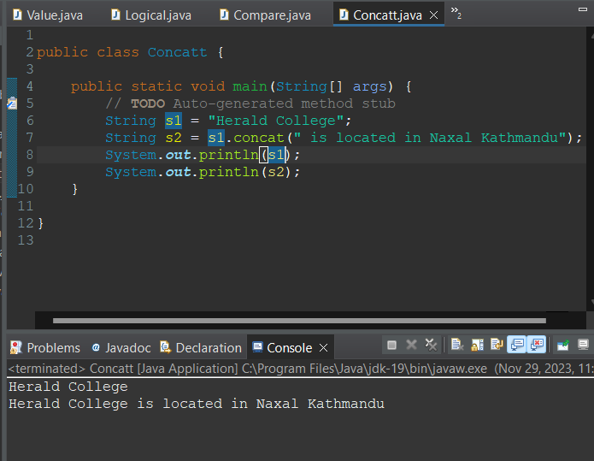

* equals() - perform equals() on ‘s1 and s2’, ‘s1 and s3’ , ‘s1 and s4’

String s1="hello";

String s2="hello";

String s3="harry";

String s4="Nepal";

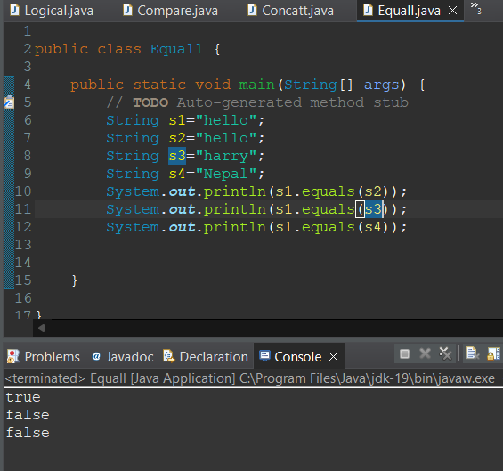

* length() - Calculate the length of

String s1 = "Herald College";

String s2 = s1.concat("is located in Naxal Kathmandu");

* charAt() - Find the character at 2, i.e. ‘charAt(2)’ for string below

String name="java";

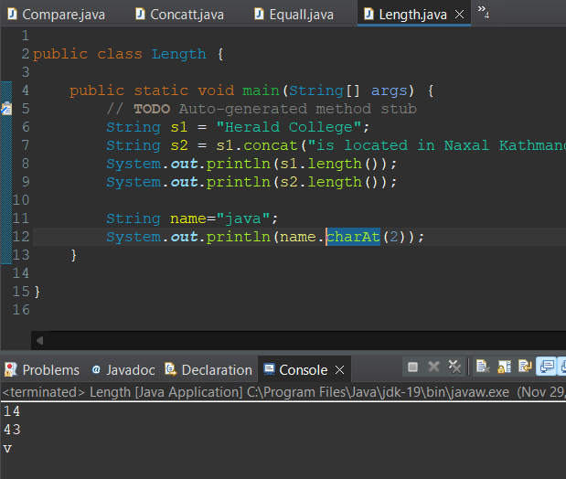

* substring() -Find the result using substring(),’substring(0,4) for string below

String name="Bachelors";

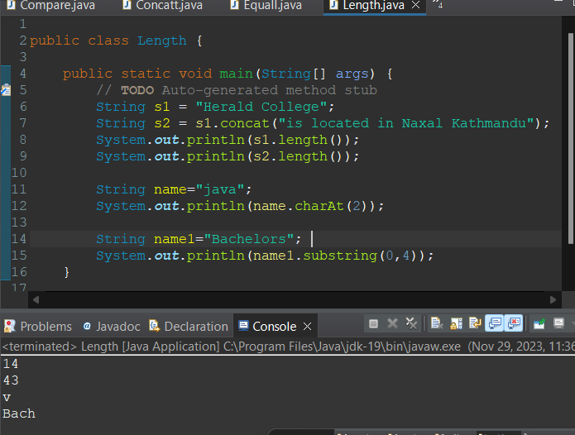

1. Write a program to find maximum between two numbers.

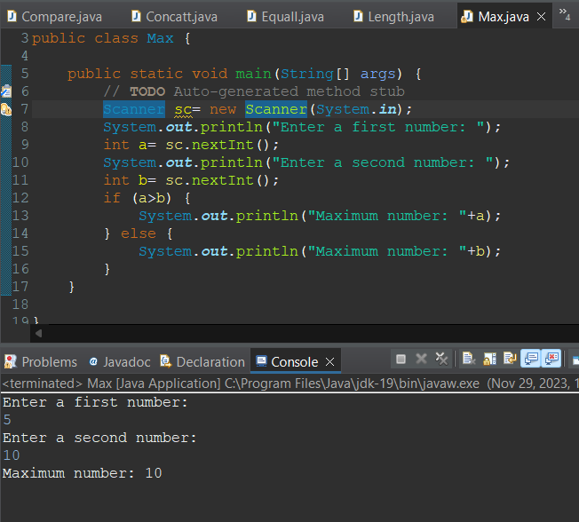

1. Given age = 19. Write a program to check the age as 17 and print the age is greater than 17.

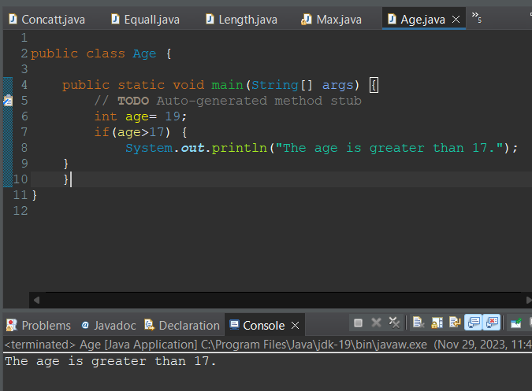

1. If num1 = 20 and num2 = 30.Write a program to find which number is greater between two numbers given.

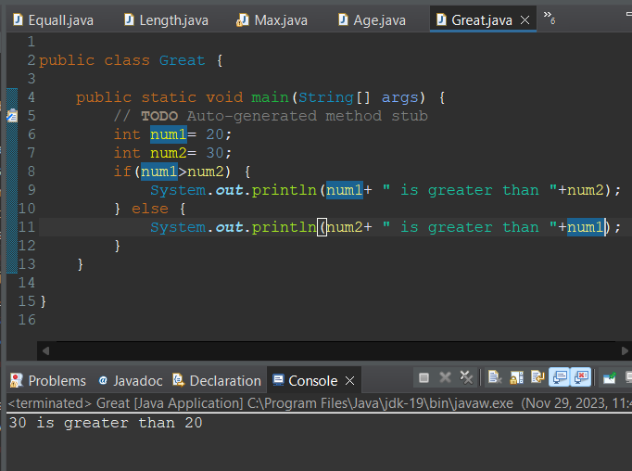

1. Find the grade of the student using following data.Using if-else-if ladder.

int internalMarks=65;

Condition1: (internalMarks<50) -> print(fail)

Condition2: ( internalMarks>=50 && internalMarks<60) -> print(“C grade”)

Condition3: (internalMarks>=60 && internalMarks<70) ->print(“B grade”)

Condition4: print(“A grade”)

