Architecture Design

# Amazon sales Prediction

|  |  |
| --- | --- |
| **Written By** | Author 1, Author 2 |
| **Document Version** | 0.3 |
| **Last Revised Date** |  |

**DOCUMENT CONTROL**

## Change Record:

|  |  |  |  |
| --- | --- | --- | --- |
| **VERSION** | **DATE** | **AUTHOR** | **COMMENTS** |
| 0.1 | 19- May -  2021 | Author 1 | Introduction and architecture defined |
| 0.2 | 20 - May -  2021 | Author 2 | Architecture & Architecture description appended and  updated. |
|  |  |  |  |
|  |  |  |  |

**Reviews:**

|  |  |  |  |
| --- | --- | --- | --- |
| **VERSION** | **DATE** | **REVIEWER** | **COMMENTS** |
| 0.2 | 21- May -  2021 | Author 3 | Unit test cases to be added |

**Approval Status:**

|  |  |  |  |  |  |
| --- | --- | --- | --- | --- | --- |
| **VERSION** | **REVIEW**  **DATE** | **REVIEWED BY** |  | **APPROVED BY** | **COMMENTS** |
|  |  |  |  |  |  |

**Contents**

1. Introduction 04
   1. What is Architecture Design Document? 04
   2. Scope 04
2. Architecture 05
   1. Tableau Architecture 05
   2. Tableau Server Architecture 05
   3. Gateway/Load Balancer 06
   4. Application Server 06
   5. VIZQL Server 07
   6. Data Engine 07
   7. Backgrounder 07
   8. Data Server 07
   9. Tableau Communication Flow 07
3. Deployment 08
   1. Deployment Options in Tableau 09
   2. Single Node Architecture 10
   3. Three Node Architecture 11
   4. Five Node Architecture 12

# Introduction

## What is Architecture design document?

Any software needs the architectural design to represents the design of software. IEEE defines architectural design as “the process of defining a collection of hardware and software components and their interfaces to establish the framework for the development of a computer system.” The software that is built for computer-based systems can exhibit one of these many architectures.

Each style will describe a system category that consists of :

* A set of components (eg: a database, computational modules) that will perform a function required by the system.
* The set of connectors will help in coordination, communication, and cooperation between the components.
* Conditions that how components can be integrated to form the system.
* Semantic models that help the designer to understand the overall properties of the system.

## Scope

Architecture Design Document (ADD) is an architecture design process that follows a step-by-step refinement process. The process can be used for designing data structures, required software architecture, source code and ultimately, performance algorithms. Overall, the design principles may be defined during requirement analysis and then refined during architectural design work.

# Architecture

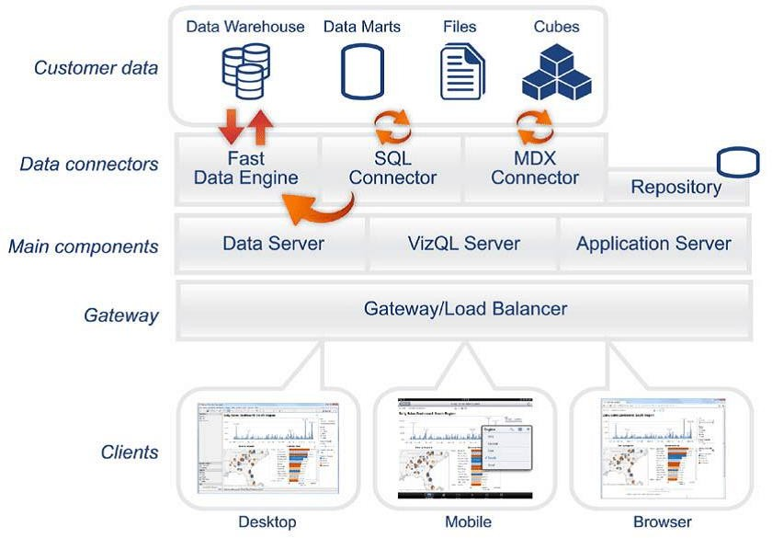

## Microsoft Power BI Architecture:

Power BI is a business platform that includes various technologies to work together. It delivers outstanding business intelligence solutions. Power BI Architecture contains four steps. They are:

1. Data Integration
2. Data Transforming
3. Report & Publish
4. Creating and Dashboard

.

### Shape Description automatically generated with low confidenceARCHITECTURE DESIGN

**6**

The following diagram shows Tableau Server’s architecture:

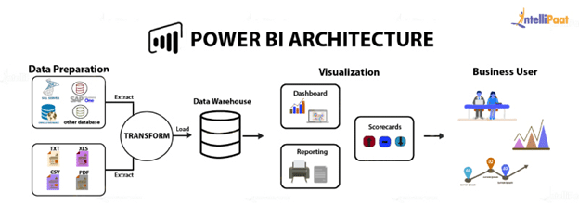

MsPowerBI is internally managed by the multiple server processes.

### ****Sourcing data****

Power BI extracts data from various servers, Excel sheets, CSV files, and databases. The extracted information can be directly imported to Power BI, or a live service link is established to receive it. If you directly import the data in Power BI, it will only be compressed up to 1 GB. Post that, you can only run live queries on your chunky datasets.

### ****Transforming the data:****

Before visualizing the data, cleaning and preprocessing it should be done. This means removing useless or missing values from rows or columns. Following that, certain rules will be applied to transform and load the datasets into the [warehouse](https://intellipaat.com/blog/tutorial/data-warehouse-tutorial/).

### ****Report and publish****

After cleaning and transforming the data, reports will be created based on requirements. A report is a visualization of the data with different filters and constraints presented in the form of graphs, pie charts, and other figures.

### ****Creating dashboards****

[Power BI Dashboards](https://intellipaat.com/blog/power-bi-dashboard/) are created by pinning individual elements or pages of live reports. Dashboards should be created after you have published your reports to the BI service. When the reports get saved, the visual maintains the filter settings chosen so that the user can apply filters and slicers

**Deployment Description**

## Deployment options in PowerBI

