**Arithmetic Expression Evaluator**

Test Case

Version 1.0

*[Note: The following template is provided for use with the Unified Process for EDUcation. Text enclosed in square brackets and displayed in blue italics (style=InfoBlue) is included to provide guidance to the author and should be deleted before publishing the document. A paragraph entered following this style will automatically be set to normal (style=Body Text).]*

*[To customize automatic fields (which display a gray background when selected), select File>Properties and replace the Title, Subject and Company fields with the appropriate information for this document. After closing the dialog, automatic fields may be updated throughout the document by selecting Edit>Select All (or Ctrl-A) and pressing F9, or simply click on the field and press F9. This must be done separately for Headers and Footers. Alt-F9 will toggle between displaying the field names and the field contents. See Word help for more information on working with fields.]*

Revision History

| **Date** | **Version** | **Description** | **Author** |
| --- | --- | --- | --- |
| 12/1/2023 | 1.0 | Worked on with group | TFI |
|  |  |  |  |
|  |  |  |  |
|  |  |  |  |

Table of Contents

1. Purpose 4

2. Test case identifier 4

3. Test item 4

4. Input specifications 4

5. Output specifications 4

6. Environmental needs 4

6.1.1 Hardware 4

6.1.2 Software 4

6.1.3 Other 4

7. Special procedural requirements 5

8. Intercase dependencies 5

**Test Case**

# Purpose

***NOTE: for sections 2, 3, 4, and 5: It is OK to use a table like the one proposed in class, also suggested on the project part 5 description.***

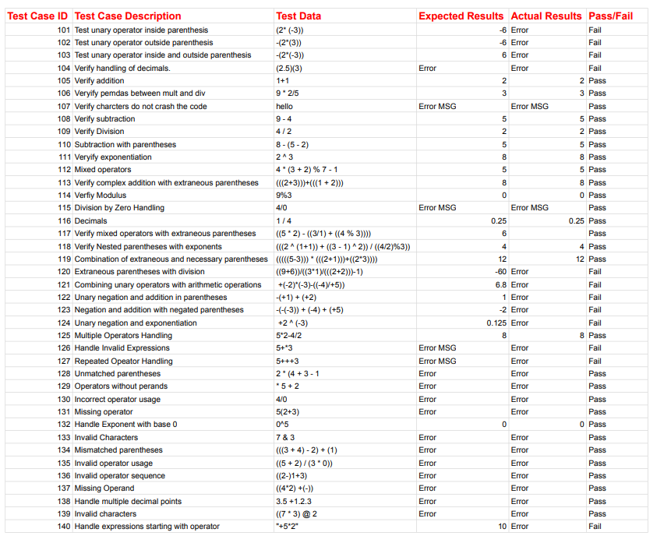

# Environmental needs

### Hardware (nothing particular for the arithmetic expression project)

*Specify the characteristics and configurations of the hardware required to execute this test*

### Software (nothing particular for the arithmetic expression project)

*Specify the system and application software required to execute this test case. This may include system software such as operating systems, compilers, simulators, and test tools. In addition, the test item may interact with application software.*

### Other

*Specify any other requirement.*

# Special procedural requirements

*Describe any special constraints on the test procedures that execute this test case. These constraints may involve special set up, operator intervention, output determination procedures, and special wrap up.*

# Intercase dependencies

*List the identifiers of test cases that must be executed prior to this test case. Summarize the nature of the dependencies.*