**Sentiment Analysis for Marketing:**

|  |  |
| --- | --- |
| Date | 28 September 2023 |
| TEAM ID | Proj_212173_Team_1 |
| Project Name | Sentiment analysis for Marketing |

Sentiment analysis, also known as opinion mining, is a natural language processing (NLP) technique that uses machine learning to identify and extract opinions and emotions from text. It is a powerful tool for marketing teams, as it can be used to understand how customers and the public feel about a brand, its products or services, and its marketing campaigns.

**Modules for sentiment analysis in marketing**

Sentiment analysis can be used to measure and track customer sentiment over time, and to identify trends and patterns. This information can then be used to improve marketing campaigns, develop new products or services, and make better business decisions.

Here are some specific modules that can be used for sentiment analysis in marketing:

* **Social media monitoring:** This module can be used to track customer sentiment on social media platforms such as Twitter, Facebook, and Instagram. This information can be used to identify customer concerns, praise, and suggestions, as well as to track the impact of marketing campaigns.
* **Customer review analysis:** This module can be used to analyze customer reviews of products and services. This information can be used to identify customer pain points, areas for improvement, and key selling points.
* **Product feedback analysis:** This module can be used to analyze customer feedback on products or services. This information can be used to identify features that customers love and hate, as well as areas for improvement.
* **Market research analysis:** This module can be used to analyze market research data, such as surveys and interviews. This information can be used to understand customer needs and preferences, as well as to identify opportunities for new products or services.

**Benefits of sentiment analysis in marketing**

Sentiment analysis offers a number of benefits for marketing teams, including:

* **Improved understanding of customer sentiment:** Sentiment analysis can help marketing teams to better understand how customers and the public feel about their brand, its products or services, and its marketing campaigns. This information can then be used to improve marketing campaigns, develop new products or services, and make better business decisions.
* **Real-time insights:** Sentiment analysis tools can provide marketing teams with real-time insights into customer sentiment. This information can be used to quickly identify and address customer concerns, as well as to track the impact of marketing campaigns.
* **Data-driven decision making:** Sentiment analysis can help marketing teams to make more data-driven decisions. By understanding customer sentiment, marketing teams can make more informed decisions about where to allocate resources, what products or services to develop, and how to position their brand.

Overall, sentiment analysis is a valuable tool for marketing teams that can be used to improve marketing campaigns, develop new products or services, and make better business decisions.

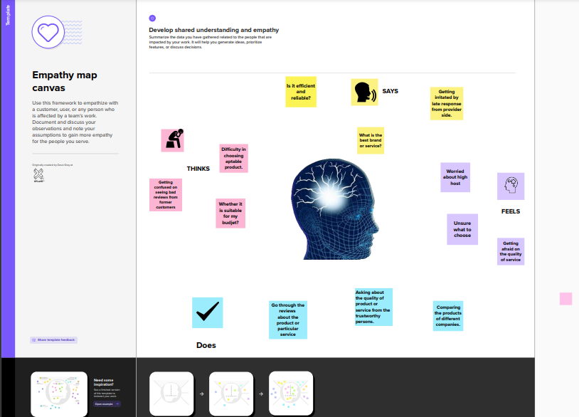

**Design Thinking:**

**1.Problem Definition:**

By understanding customer sentiments, companies can identify strengths and weaknesses in competing products, thereby improving their own offerings. This project requires utilizing various NLP methods to extract valuable insights from customer feedback.

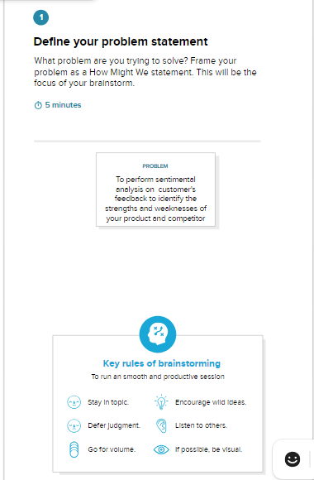

**2.Brainstorming:**

Brainstorming is a group creativity technique by which efforts are made to find a conclusion for a specific problem by gathering a list of ideas spontaneously contributed by its members.

It is a way to generate a large number of ideas in a short period of time.

Brainstorming is often used in business and education to solve problems, develop new products, and come up with new ideas.

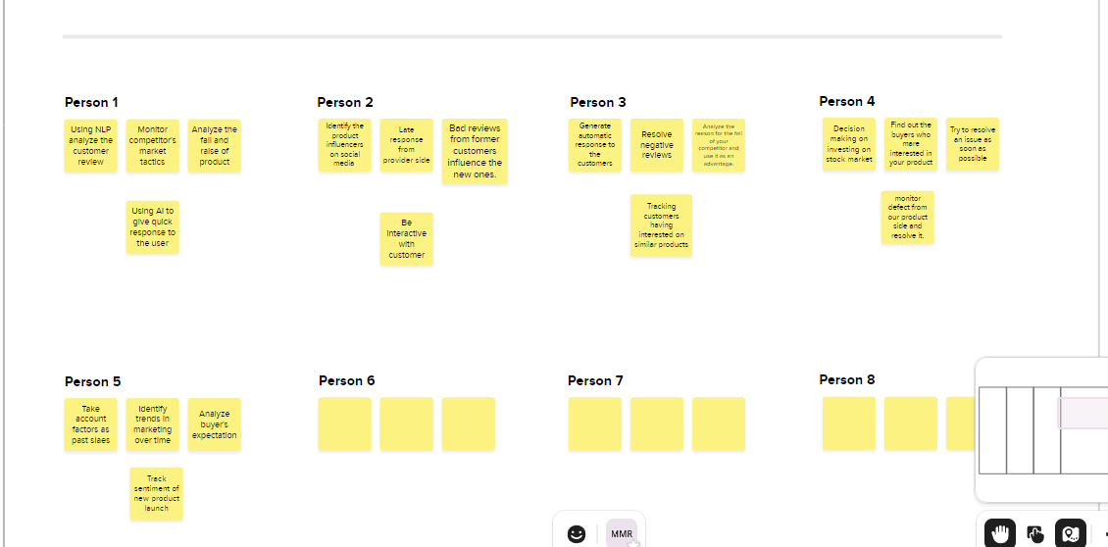

**3.Grouping Ideas:**

Grouping ideas is a process of organizing ideas into categories or clusters based on their similarities. This can be done manually or using a variety of tools and techniques.

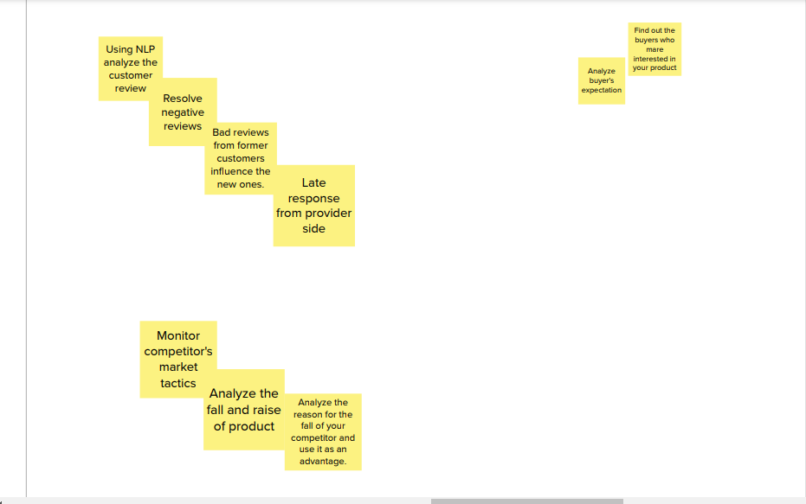

**4.Prioritizing ideas**

Idea prioritization is the process of evaluating and ranking ideas based on their potential value and feasibility, to determine which should be pursued and which should be set aside.

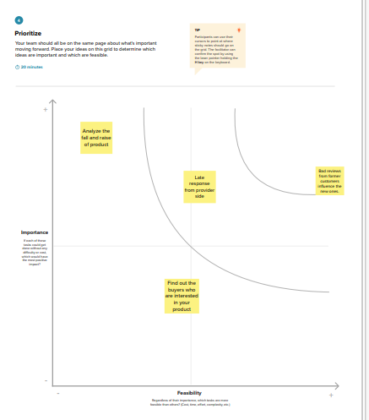

**Problem Analysis:**

Airline service sentimental analysis is the process of using natural language processing (NLP) and machine learning to identify the sentiment of customer feedback about airline services. This can include feedback from social media, customer reviews, surveys, and other sources.

Sentiment analysis can be used to understand customer satisfaction with airline services, identify areas for improvement, and track customer sentiment over time. It can also be used to identify and respond to customer complaints, and to improve marketing campaigns.

Here are some examples of how airlines can use service sentimental analysis:

* **Identify common customer complaints**. Airlines can use sentiment analysis to identify common customer complaints, such as delayed flights, lost baggage, and rude staff. This information can be used to improve customer service and operations.
* **Track customer satisfaction over time.** Airlines can use sentiment analysis to track customer satisfaction over time. This information can be used to identify trends and to measure the effectiveness of customer service initiatives.
* **Identify and respond to customer complaints**. Airlines can use sentiment analysis to identify customer complaints on social media and other online platforms. This information can be used to respond to customer complaints promptly and to resolve issues.
* **Improve marketing campaigns.** Airlines can use sentiment analysis to understand how customers perceive their marketing campaigns. This information can be used to improve the effectiveness of future marketing campaigns.