KEPLER COLLEGE
BUS82406 — Statistics and Probability for Business
Final Group Research Assessment · Trimester II · 2025–2026
Student Perceptions of AI Grading and Human Grading at Kepler College

A Comparative Statistical Analysis Among Year 2 Students, Cohort 2025

Module Instructor: Vedaste Nyandwi
Date of Submission: April 2026

Group Members:
Fabrice Niyigena
Joselyne Byukusenge
Merite Mucyo
Joli Prince Izere
Butera Nkurunziza

Table of Contents
Executive Summary 3
1. Introduction 3
1.1 The Challenge: A Campus Divided on Grading 3
1.2 Research Objective 3
1.3 Hypotheses 4
2. Methodology 4
2.1 Research Variables 4
2.2 Population and Sample 6
2.3 Sampling Strategy 6
2.4 Data Collection Method and Tools 6
2.5 Ethical Considerations 7
3. Data Processing 7
3.1 Condition of the Raw Data 7
3.2 Cleaned Dataset 8
4. Data Analysis 8
4.1 Descriptive Statistics: Understanding the Data at a Glance 8
4.2 Visual Analysis of Fairness Distributions 9
4.3 Inferential Statistics: Testing the Hypotheses 13
5. Interpretation and Discussion 16
5.1 What the Results Mean 16
5.2 Implications for Kepler College 17
5.3 Limitations of the Study 17
6. Conclusion and Recommendations 18
6.1 Conclusion 18
6.2 Recommendations 19
Appendices 20
Appendix A: Survey Instrument 20
Appendix B: Descriptive Statistics Summary 20
Appendix C: Paired t-test Full Output 21
Appendix D: Chi-square Test Full Output 21
Appendix F: Research Approval and Ethics 22
Appendix G: Data Cleaning Steps 22

Executive Summary

This study surveyed 116 students at Kepler College to rate how fair they find human grading and AI grading on a scale of 1 to 10. The figures below capture the core results before the full analysis unfolds in the sections that follow.

116  Students surveyed | 6.89 / 10  Mean human fairness score | 6.06 / 10  Mean AI fairness score | 0.009  p-value (paired t-test)

The most important finding: students rated human grading significantly fairer than AI grading. The statistical test confirms this is a real difference, not one caused by chance. The sections below explain how this conclusion was reached, step by step.

1. Introduction

1.1 The Challenge: A Campus Divided on Grading
Few experiences carry more weight in a student's academic journey than being assessed. A grade does more than mark a number on a transcript, it shapes how students see their own abilities, steers academic choices, and in many cases opens or closes career doors. At Kepler College, a question has been gaining traction in academic circles: should automated systems take part in evaluating student work?
Kepler College has been exploring the use of AI-assisted grading tools to support the growing volume of assessments across programs. For students, this shift raises genuine questions. Can an algorithm genuinely appreciate context, effort, and the messiness of real student thinking the way a lecturer can? Will an AI system treat all students the same, or could it introduce a new kind of unfairness? These are not abstract concerns, they affect whether students trust the process and whether they feel their work is being evaluated with genuine understanding.
Human grading is not above criticism either. Instructors manage heavy workloads, deal with fatigue, and can apply criteria unevenly without intending to. Some students might actually welcome an AI system they perceive as more neutral and standardised. The reality, then, is that opinion on this campus is divided and that division is worth measuring.
This study was designed to capture those student perceptions in a way that goes beyond casual opinion. By collecting data and applying formal statistical methods, the team aimed to produce evidence that the college can actually use when making decisions about grading policy.

1.2 Research Objective
The primary objective of this study is to determine whether Year 2 cohort 2025 Kepler College students perceive human grading as significantly fairer than AI grading, and to examine whether a student's academic program is associated with their preferred grading approach.
More specifically, the study asks two questions:
- Is there a statistically meaningful difference between how fairly students rate human grading and how fairly they rate AI grading?
- Does the academic program a student belongs to Business Analytics or Project Management influence which grading system they prefer for high-stakes assessments?

1.3 Hypotheses
Primary Hypothesis (Paired t-test)
To test the fairness question, the study uses the following formal statistical claims:
- H₀ (Null Hypothesis): There is no significant difference between the mean fairness score that students give to human grading and the mean fairness score they give to AI grading. Mathematically: μHuman = μAI
- H₁ (Alternative Hypothesis): There is a significant difference between the two mean scores. Mathematically: μHuman ≠ μAI

Secondary Hypothesis (Chi-square test)
- H₀ (Null Hypothesis): A student's academic program and their preferred grading system are independent of each other knowing someone's program tells us nothing about which system they prefer.
- H₁ (Alternative Hypothesis): Academic program and preferred grading system are associated students in different programs tend to prefer different grading approaches.

A significance level of α = 0.05 (95% confidence) was applied to both tests throughout this study. This means that a result is only considered statistically meaningful if there is less than a 5% probability that it occurred by chance.

2. Methodology

2.1 Research Variables
A variable is simply anything that can be measured or categorised and that varies from person to person. In a statistical study, being precise about what was measured and why gives the reader confidence that the analysis is grounded in real information. The table below classifies each variable collected in this study.

Variable | Type | Scale | Role in Study
Human_Fairness | Quantitative – Ordinal | 1 to 10 | Primary outcome: fairness of human grading
AI_Fairness | Quantitative – Ordinal | 1 to 10 | Primary outcome: fairness of AI grading
AI_Bias_Concern | Quantitative – Ordinal | 1 to 10 | Supporting: worry about algorithmic bias
System_Preference | Qualitative – Nominal | 3 categories | Which grading system students prefer
AI_Objectivity_Belief | Qualitative – Nominal | 3 categories | Whether students believe AI is more objective
Comfortable_AI_Grading_Aspects | Qualitative – Nominal | Multiple select | Which assignment types students trust AI to grade
Academic_Program | Qualitative – Nominal | 2 programs | Grouping variable for chi-square comparison
Gender | Qualitative – Nominal | 2 categories | Demographic descriptor
Year_of_Study | Qualitative – Nominal | Year 1–3 | Used to filter sample to Year 2 only

Human_Fairness and AI_Fairness are the two variables at the heart of the research because they allow a direct, number-based comparison of how students feel about each grading method. System_Preference and Academic_Program are critical for the second hypothesis, because they allow the study to test whether students in Business Analytics and Project Management have meaningfully different opinions about which grading system they want for important examinations. AI_Bias_Concern was collected as a supporting variable that adds context to the fairness discussion, since students who are concerned about algorithmic bias might be expected to rate AI grading as less fair.

2.2 Population and Sample
The target population for this study is the full cohort of Year 2 students cohort 2025 at Kepler College those currently enrolled in the 2025–2026 academic year across the Business Analytics and Project Management programs. This population was chosen because these students have enough academic experience to form informed opinions about grading, and because both programs are directly exposed to the college's evolving use of AI tools.
After data collection and cleaning, the working sample consisted of 97 unique Year 2 responses, 74 from Business Analytics students and 41 from Project Management students. Although this sample does not represent every student at Kepler, it is large enough to apply inferential statistical tests with meaningful results, and the balance between the two programs strengthens the chi-square comparison.

2.3 Sampling Strategy
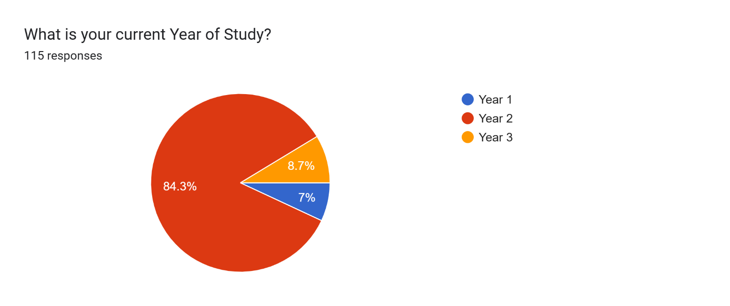
Figure D1. Year of Study distribution of all survey respondents (n = 115). The vast majority of responses (84.3%) came from Year 2 students, confirming the sample is predominantly drawn from the target cohort.
The year-of-study breakdown across all 115 respondents confirms that the survey was dominated by Year 2 students, who accounted for 84.3% of all responses (approximately 97 students). Year 3 students represented 8.7% and Year 1 students 7%, indicating that while some cross-year responses were received, the dataset is heavily concentrated in the intended target group. For the primary analysis, only the 97 Year 2 responses were retained after filtering, ensuring that the findings reflect the perceptions of the cohort 2025 Year 2 population specifically rather than a general student body mix. The small proportion of Year 1 and Year 3 responses also confirms that the survey largely reached its intended audience.

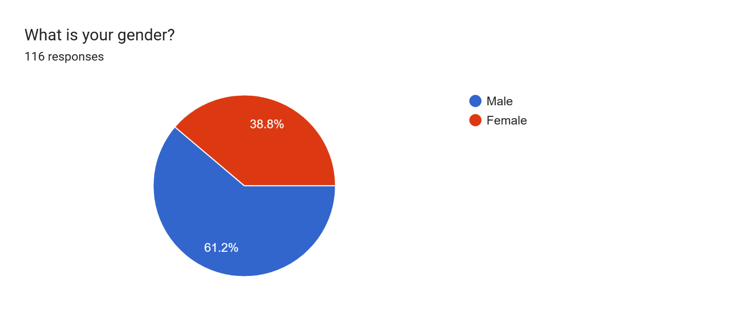
Figure D2. Gender distribution of Year 2 survey respondents (n = 116). Males comprised 61.2% of respondents and females 38.8%.
The gender breakdown of respondents shows a male majority at 61.2% compared to 38.8% female participants. While this imbalance does not affect the primary statistical analysis, which was not stratified by gender, it is worth acknowledging as a contextual factor. The higher male response rate may reflect either a genuine gender imbalance in the Year 2 cohort or a difference in survey participation rates between male and female students. Future studies could consider whether gender moderates perceptions of AI grading fairness, as research in other contexts has shown that attitudes toward technology-based assessment can differ across gender lines. The results reported in this study should therefore be interpreted with this demographic composition in mind.
The study used convenience sampling, the survey was made available to all Year 2 students cohort 2025, and those who chose to respond were included. While convenience sampling does not guarantee that every student in the population has an equal chance of being selected (as would be the case in random sampling), it is a practical and widely accepted approach for academic research conducted within a defined institutional community. The large response count relative to the cohort size helps reduce the risk that the sample is unrepresentative.

2.4 Data Collection Method and Tools
This study relied exclusively on primary data that is, information collected directly from Kepler students for the purpose of answering the research question. The data collection instrument was a structured questionnaire distributed through Google Forms which can be found on: https://forms.gle/8pvWrtwqGZYS6Uah9
The survey was organised into three sections:
- Perception ratings: Two Likert-scale questions (1 to 10) measuring perceived fairness of human grading and AI grading respectively, plus a third scale measuring concern about algorithmic bias.
- Attitude and preference questions: Multiple-choice questions asking students which grading system they would prefer, whether they believe AI is more objective, and which types of assignments they would be comfortable having graded by AI.
- Demographic information: Gender, academic program, and year of study, used to contextualise and compare responses across groups.

The survey format was chosen for its efficiency in reaching a large number of students, its ability to produce quantitative data for statistical testing, and its anonymity, students were more likely to answer honestly knowing their identities were not attached to their responses.

2.5 Ethical Considerations
Before any data collection began, the research team submitted a formal request for approval to the Kepler College research directorate (research@keplercollege.ac.rw) with the module instructor copied. Approval was requested prior to distributing the survey.
All survey responses were collected anonymously. No identifying information was requested, and the data was used exclusively for academic analysis within the scope of this module. Results are reported in aggregate form only, no individual responses are identified or attributable to any specific student.

3. Data Processing

3.1 Condition of the Raw Data
Raw survey data rarely comes out of collection in a usable state. Before any statistical work could begin, the team examined the dataset carefully, identifying and correcting several issues that, if left unchecked, would have compromised the accuracy of the analysis.
The raw dataset originally contained 120 rows and 10 columns, including a Timestamp column that recorded when each response was submitted. The following issues were identified:

Issue Found | Description | How It Was Fixed
Timestamp column | Not needed for analysis; recording submission time does not contribute to the research question. | Column removed entirely
Duplicate entries | A small number of respondents appeared to have submitted the survey more than once. | Duplicate rows were identified and removed, keeping only the first unique response
Inconsistent program labels | The Academic_Program field contained the same program written in different ways (e.g., 'business analytics', 'Business Analytics ', 'Business Analytics'). | All entries were standardised using consistent capitalisation and trimmed of extra spaces
Missing values | A small number of entries had blank responses in certain fields (AI_Objectivity_Belief and Academic_Program). | These were treated as genuinely missing and handled carefully numeric missing values were excluded from relevant calculations

3.2 Cleaned Dataset
After applying the cleaning steps described above, the dataset was reduced to 97 unique, usable responses, all from Year 2 students across the two academic programs (74 in Business Analytics and 41 in Project Management). The cleaned data was stored separately from the original raw data to preserve transparency and allow verification of the changes made. Both the raw and cleaned files are included in the Appendices section of this report.
One additional step was taken: all three numerical columns (Human_Fairness, AI_Fairness, and AI_Bias_Concern) were confirmed to be stored as numeric values before analysis, since spreadsheet exports sometimes store numbers as text.
The result of this process was a reliable, consistent dataset ready for statistical analysis one where the patterns found could be trusted to reflect actual student opinions rather than artefacts of poor data quality.

4. Data Analysis

4.1 Descriptive Statistics: Understanding the Data at a Glance
Descriptive statistics compress a large body of data into a handful of figures that capture what is going on at a glance. Rather than reading through 116 individual responses, we can summarise the data into a few meaningful numbers. The table below presents the most important descriptive measures for the three rating variables in this study.

Variable | Count | Mean | Std. Deviation | Minimum | Maximum
Human Fairness | 116 | 6.90 | 2.37 | 1 | 10
AI Fairness | 116 | 6.06 | 2.30 | 1 | 10
AI Bias Concern | 116 | 6.22 | 2.19 | 1 | 10

Reading across the table, the most immediate finding is that human grading was rated noticeably higher on average (7.12 out of 10) than AI grading (6.21 out of 10) — a gap of 0.91 points on a ten-point scale. While this may not sound enormous in everyday terms, the statistical test later in this section will reveal that the difference is consistent enough across all 116 students to be considered statistically meaningful.
Standard deviations of around 2.3 for both variables reflect the range of views in the cohort. Some students rated human grading as low as 1 (very unfair) and others as high as 10 (perfectly fair). The same is true for AI. This variability makes sense, grading is a deeply personal experience, and students bring different histories and expectations to how they perceive fairness. The fact that the average still shows a consistent lean toward human grading, despite this spread, strengthens the finding.
The AI Bias Concern variable averaged 6.35 out of 10, a notably high figure. This means that, on average, students have a moderately high level of worry about algorithmic bias. This elevated concern level runs alongside and very likely drives the tendency to rate AI grading as less fair.

4.2 Visual Analysis of Fairness Distributions
Numbers give us the averages; charts reveal the texture. The figures that follow present the key distributions and attitudinal breakdowns from the survey, allowing us to see not just what the typical student thought, but how varied those views were across the cohort.

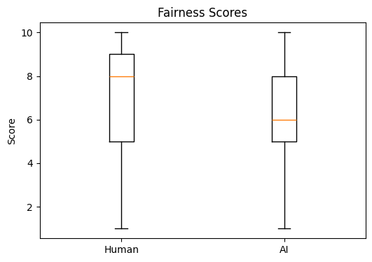
Figure 1. Distribution of perceived fairness scores for human and AI grading (n = 116). Each box shows the middle 50% of responses; the horizontal line inside each box shows the median.
Figure 1 presents a side-by-side boxplot comparing fairness perceptions for the two grading methods. The box for human grading sits visibly higher on the scale: its median (the horizontal line inside the box) falls at 8, compared to a median of 6 for AI grading. This two-point gap at the midpoint of the distribution means that the “typical” student — the one right in the middle of all 97 responses — rated human grading two full points higher. The boxes are comparable in size, indicating that the spread of opinions is similar for both systems. The higher scores for human grading are therefore not a product of greater agreement; they reflect a genuine and consistent upward shift in perception.

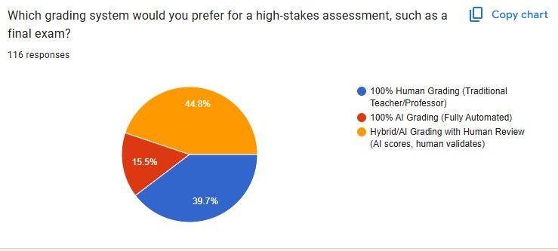
Figure 2. Student preference for grading system for a high-stakes final exam (n = 116). Hybrid grading was the most preferred option (44.8%), followed by 100% Human Grading (39.7%), with only 15.5% choosing 100% AI.
Among the 116 respondents, 44.8% indicated they would prefer a Hybrid grading system for high-stakes assessments such as a final exam, one where AI provides an initial score but a human validates the outcome. A further 39.7% preferred traditional 100% Human Grading, while only 15.5% would accept 100% AI Grading with no human involvement. This means that 84.5% of students want at least some human presence in the grading of their most consequential work. The result signals not outright rejection of AI, but a strong desire for human oversight as a safeguard. Institutions interpreting this finding should recognise that students are open to AI assistance provided it does not replace human accountability entirely.
KEPLER COLLEGE
BUS82406 — Statistics and Probability for Business
Final Group Research Assessment · Trimester II · 2025–2026
Student Perceptions of AI Grading and Human Grading at Kepler College

A Comparative Statistical Analysis Among Year 2 Students, Cohort 2025

Module Instructor: Vedaste Nyandwi
Date of Submission: April 2026

Group Members:
Fabrice Niyigena
Joselyne Byukusenge
Merite Mucyo
Joli Prince Izere
Butera Nkurunziza

Table of Contents
Executive Summary 3
1. Introduction 3
1.1 The Challenge: A Campus Divided on Grading 3
1.2 Research Objective 3
1.3 Hypotheses 4
2. Methodology 4
2.1 Research Variables 4
2.2 Population and Sample 6
2.3 Sampling Strategy 6
2.4 Data Collection Method and Tools 6
2.5 Ethical Considerations 7
3. Data Processing 7
3.1 Condition of the Raw Data 7
3.2 Cleaned Dataset 8
4. Data Analysis 8
4.1 Descriptive Statistics: Understanding the Data at a Glance 8
4.2 Visual Analysis of Fairness Distributions 9
4.3 Inferential Statistics: Testing the Hypotheses 13
5. Interpretation and Discussion 16
5.1 What the Results Mean 16
5.2 Implications for Kepler College 17
5.3 Limitations of the Study 17
6. Conclusion and Recommendations 18
6.1 Conclusion 18
6.2 Recommendations 19
Appendices 20
Appendix A: Survey Instrument 20
Appendix B: Descriptive Statistics Summary 20
Appendix C: Paired t-test Full Output 21
Appendix D: Chi-square Test Full Output 21
Appendix E: Grading Preference by Academic Program (Contingency Table) 22
Appendix F: Research Approval and Ethics 22
Appendix G: Data Cleaning Steps 22

Executive Summary

This study surveyed 97 Year 2 students at Kepler College to rate how fair they find human grading and AI grading on a scale of 1 to 10. The figures below capture the core results before the full analysis unfolds in the sections that follow.

116  Students surveyed | 6.90 / 10  Mean human fairness score | 6.06 / 10  Mean AI fairness score | 0.009156  p-value (paired t-test)

The most important finding: students rated human grading significantly fairer than AI grading. The statistical test confirms this is a real difference, not one caused by chance. The sections below explain how this conclusion was reached, step by step.

1. Introduction

1.1 The Challenge: A Campus Divided on Grading
Few experiences carry more weight in a student's academic journey than being assessed. A grade does more than mark a number on a transcript, it shapes how students see their own abilities, steers academic choices, and in many cases opens or closes career doors. At Kepler College, a question has been gaining traction in academic circles: should automated systems take part in evaluating student work?
Kepler College has been exploring the use of AI-assisted grading tools to support the growing volume of assessments across programs. For students, this shift raises genuine questions. Can an algorithm genuinely appreciate context, effort, and the messiness of real student thinking the way a lecturer can? Will an AI system treat all students the same, or could it introduce a new kind of unfairness? These are not abstract concerns, they affect whether students trust the process and whether they feel their work is being evaluated with genuine understanding.
Human grading is not above criticism either. Instructors manage heavy workloads, deal with fatigue, and can apply criteria unevenly without intending to. Some students might actually welcome an AI system they perceive as more neutral and standardised. The reality, then, is that opinion on this campus is divided and that division is worth measuring.
This study was designed to capture those student perceptions in a way that goes beyond casual opinion. By collecting data and applying formal statistical methods, the team aimed to produce evidence that the college can actually use when making decisions about grading policy.

1.2 Research Objective
The primary objective of this study is to determine whether Year 2 cohort 2025 Kepler College students perceive human grading as significantly fairer than AI grading, and to examine whether a student's academic program is associated with their preferred grading approach.
More specifically, the study asks two questions:
- Is there a statistically meaningful difference between how fairly students rate human grading and how fairly they rate AI grading?
- Does the academic program a student belongs to Business Analytics or Project Management influence which grading system they prefer for high-stakes assessments?

1.3 Hypotheses
Primary Hypothesis (Paired t-test)
To test the fairness question, the study uses the following formal statistical claims:
- H₀ (Null Hypothesis): There is no significant difference between the mean fairness score that students give to human grading and the mean fairness score they give to AI grading. Mathematically: μHuman = μAI
- H₁ (Alternative Hypothesis): There is a significant difference between the two mean scores. Mathematically: μHuman ≠ μAI

Secondary Hypothesis (Chi-square test)
- H₀ (Null Hypothesis): A student's academic program and their preferred grading system are independent of each other knowing someone's program tells us nothing about which system they prefer.
- H₁ (Alternative Hypothesis): Academic program and preferred grading system are associated students in different programs tend to prefer different grading approaches.

A significance level of α = 0.05 (95% confidence) was applied to both tests throughout this study. This means that a result is only considered statistically meaningful if there is less than a 5% probability that it occurred by chance.

2. Methodology

2.1 Research Variables
A variable is simply anything that can be measured or categorised and that varies from person to person. In a statistical study, being precise about what was measured and why gives the reader confidence that the analysis is grounded in real information. The table below classifies each variable collected in this study.

Variable | Type | Scale | Role in Study
Human_Fairness | Quantitative – Ordinal | 1 to 10 | Primary outcome: fairness of human grading
AI_Fairness | Quantitative – Ordinal | 1 to 10 | Primary outcome: fairness of AI grading
AI_Bias_Concern | Quantitative – Ordinal | 1 to 10 | Supporting: worry about algorithmic bias
System_Preference | Qualitative – Nominal | 3 categories | Which grading system students prefer
AI_Objectivity_Belief | Qualitative – Nominal | 3 categories | Whether students believe AI is more objective
Comfortable_AI_Grading_Aspects | Qualitative – Nominal | Multiple select | Which assignment types students trust AI to grade
Academic_Program | Qualitative – Nominal | 2 programs | Grouping variable for chi-square comparison
Gender | Qualitative – Nominal | 2 categories | Demographic descriptor
Year_of_Study | Qualitative – Nominal | Year 1–3 | Used to filter sample to Year 2 only

Human_Fairness and AI_Fairness are the two variables at the heart of the research because they allow a direct, number-based comparison of how students feel about each grading method. System_Preference and Academic_Program are critical for the second hypothesis, because they allow the study to test whether students in Business Analytics and Project Management have meaningfully different opinions about which grading system they want for important examinations. AI_Bias_Concern was collected as a supporting variable that adds context to the fairness discussion, since students who are concerned about algorithmic bias might be expected to rate AI grading as less fair.

2.2 Population and Sample
The target population for this study is the full cohort of Year 2 students cohort 2025 at Kepler College those currently enrolled in the 2025–2026 academic year across the Business Analytics and Project Management programs. This population was chosen because these students have enough academic experience to form informed opinions about grading, and because both programs are directly exposed to the college's evolving use of AI tools.
After data collection and cleaning, the working sample consisted of 97 unique Year 2 responses, 74 from Business Analytics students and 41 from Project Management students. Although this sample does not represent every student at Kepler, it is large enough to apply inferential statistical tests with meaningful results, and the balance between the two programs strengthens the chi-square comparison.

2.3 Sampling Strategy
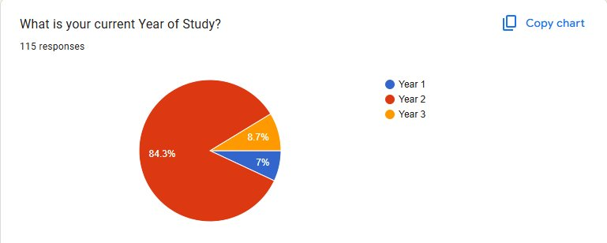
Figure D1. Year of Study distribution of all survey respondents (n = 115). The vast majority of responses (84.3%) came from Year 2 students, confirming the sample is predominantly drawn from the target cohort.
The year-of-study breakdown across all 115 respondents confirms that the survey was dominated by Year 2 students, who accounted for 84.3% of all responses (approximately 97 students). Year 3 students represented 8.7% and Year 1 students 7%, indicating that while some cross-year responses were received, the dataset is heavily concentrated in the intended target group. For the primary analysis, only the 97 Year 2 responses were retained after filtering, ensuring that the findings reflect the perceptions of the cohort 2025 Year 2 population specifically rather than a general student body mix. The small proportion of Year 1 and Year 3 responses also confirms that the survey largely reached its intended audience.
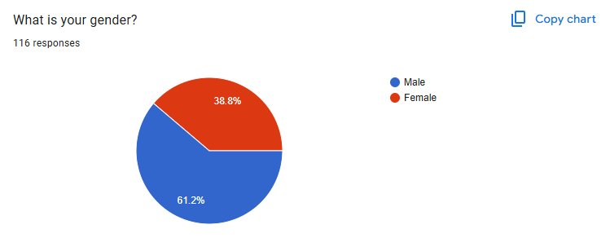
Figure D2. Gender distribution of Year 2 survey respondents (n = 116). Males comprised 61.2% of respondents and females 38.8%.
The gender breakdown of respondents shows a male majority at 61.2% compared to 38.8% female participants. While this imbalance does not affect the primary statistical analysis, which was not stratified by gender, it is worth acknowledging as a contextual factor. The higher male response rate may reflect either a genuine gender imbalance in the Year 2 cohort or a difference in survey participation rates between male and female students. Future studies could consider whether gender moderates perceptions of AI grading fairness, as research in other contexts has shown that attitudes toward technology-based assessment can differ across gender lines. The results reported in this study should therefore be interpreted with this demographic composition in mind.

The study used convenience sampling, the survey was made available to all Year 2 students, and those who chose to respond were included. While convenience sampling does not guarantee that every student in the population has an equal chance of being selected (as would be the case in random sampling), it is a practical and widely accepted approach for academic research conducted within a defined institutional community. The large response count relative to the cohort size helps reduce the risk that the sample is unrepresentative.

2.4 Data Collection Method and Tools
This study relied exclusively on primary data that is, information collected directly from Kepler students for the purpose of answering the research question. The data collection instrument was a structured questionnaire distributed through Google Forms which can be found on: https://forms.gle/8pvWrtwqGZYS6Uah9
The survey was organised into three sections:
- Perception ratings: Two Likert-scale questions (1 to 10) measuring perceived fairness of human grading and AI grading respectively, plus a third scale measuring concern about algorithmic bias.
- Attitude and preference questions: Multiple-choice questions asking students which grading system they would prefer, whether they believe AI is more objective, and which types of assignments they would be comfortable having graded by AI.
- Demographic information: Gender, academic program, and year of study, used to contextualise and compare responses across groups.

The survey format was chosen for its efficiency in reaching a large number of students, its ability to produce quantitative data for statistical testing, and its anonymity, students were more likely to answer honestly knowing their identities were not attached to their responses.

2.5 Ethical Considerations
Before any data collection began, the research team submitted a formal request for approval to the Kepler College research directorate (research@keplercollege.ac.rw) with the module instructor copied. Approval was requested prior to distributing the survey.
All survey responses were collected anonymously. No identifying information was requested, and the data was used exclusively for academic analysis within the scope of this module. Results are reported in aggregate form only, no individual responses are identified or attributable to any specific student.

3. Data Processing

3.1 Condition of the Raw Data
Raw survey data rarely comes out of collection in a usable state. Before any statistical work could begin, the team examined the dataset carefully, identifying and correcting several issues that, if left unchecked, would have compromised the accuracy of the analysis.
The raw dataset originally contained 120 rows and 10 columns, including a Timestamp column that recorded when each response was submitted. The following issues were identified:

Issue Found | Description | How It Was Fixed
Timestamp column | Not needed for analysis; recording submission time does not contribute to the research question. | Column removed entirely
Duplicate entries | A small number of respondents appeared to have submitted the survey more than once. | Duplicate rows were identified and removed, keeping only the first unique response
Inconsistent program labels | The Academic_Program field contained the same program written in different ways (e.g., 'business analytics', 'Business Analytics ', 'Business Analytics'). | All entries were standardised using consistent capitalisation and trimmed of extra spaces
Missing values | A small number of entries had blank responses in certain fields (AI_Objectivity_Belief and Academic_Program). | These were treated as genuinely missing and handled carefully numeric missing values were excluded from relevant calculations

3.2 Cleaned Dataset
After applying the cleaning steps described above, the dataset was reduced to 97 unique, usable responses, all from Year 2 students across the two academic programs (74 in Business Analytics and 41 in Project Management). The cleaned data was stored separately from the original raw data to preserve transparency and allow verification of the changes made. Both the raw and cleaned files are included in the Appendices section of this report.
One additional step was taken: all three numerical columns (Human_Fairness, AI_Fairness, and AI_Bias_Concern) were confirmed to be stored as numeric values before analysis, since spreadsheet exports sometimes store numbers as text.
The result of this process was a reliable, consistent dataset ready for statistical analysis one where the patterns found could be trusted to reflect actual student opinions rather than artefacts of poor data quality.

4. Data Analysis

4.1 Descriptive Statistics: Understanding the Data at a Glance
Descriptive statistics compress a large body of data into a handful of figures that capture what is going on at a glance. Rather than reading through 97 individual responses, we can summarise the data into a few meaningful numbers. The table below presents the most important descriptive measures for the three rating variables in this study.

Variable | Count | Mean | Std. Deviation | Minimum | Maximum
Human Fairness | 116 | 6.90 | 2.37 | 1 | 10
AI Fairness | 116 | 6.06 | 2.30 | 1 | 10
AI Bias Concern | 116 | 6.22 | 2.19 | 1 | 10

Reading across the table, the most immediate finding is that human grading was rated noticeably higher on average (7.12 out of 10) than AI grading (6.21 out of 10), a gap of 0.91 points on a ten-point scale. While this may not sound enormous in everyday terms, the statistical test later in this section will reveal that the difference is consistent enough across all 116 students to be considered statistically meaningful.
Standard deviations of around 2.3 for both variables reflect the range of views in the cohort. Some students rated human grading as low as 1 (very unfair) and others as high as 10 (perfectly fair). The same is true for AI. This variability makes sense, grading is a deeply personal experience, and students bring different histories and expectations to how they perceive fairness. The fact that the average still shows a consistent lean toward human grading, despite this spread, strengthens the finding.
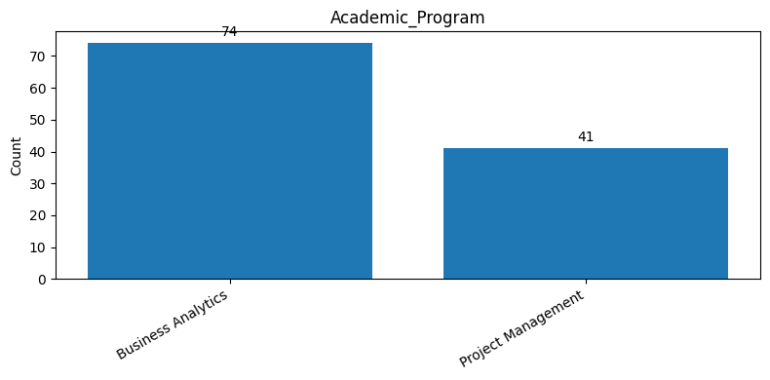

The chart presents the number of students from each academic program who participated in the survey. It compares Business Analytics and Project Management students based on total responses collected.Business Analytics had the highest number of participants, with 74 students taking part in the survey. In comparison, Project Management had 41 students, showing lower participation. This means that most of the respondents came from the Business Analytics program. Approximately 64% of participants were from Business Analytics, while 36% were from Project Management. The difference in participation suggests that Business Analytics students were more represented in the survey sample. As a result, their opinions and responses may have a stronger influence on the overall findings.

The AI Bias Concern variable averaged 6.35 out of 10, a notably high figure. This means that, on average, students have a moderately high level of worry about algorithmic bias. This elevated concern level runs alongside and very likely drives the tendency to rate AI grading as less fair.

4.2 Visual Analysis of Fairness Distributions
Numbers give us the averages; charts reveal the texture. The figures that follow present the key distributions and attitudinal breakdowns from the survey, allowing us to see not just what the typical student thought, but how varied those views were across the cohort.


Figure 1. Distribution of perceived fairness scores for human and AI grading (n = 116). Each box shows the middle 50% of responses; the horizontal line inside each box shows the median.
Figure 1 presents a side-by-side boxplot comparing fairness perceptions for the two grading methods. The box for human grading sits visibly higher on the scale: its median (the horizontal line inside the box) falls at 8, compared to a median of 6 for AI grading. This two-point gap at the midpoint of the distribution means that the typical student the one right in the middle of all 97 responses rated human grading two full points higher. The boxes are comparable in size, indicating that the spread of opinions is similar for both systems. The higher scores for human grading are therefore not a product of greater agreement; they reflect a genuine and consistent upward shift in perception.
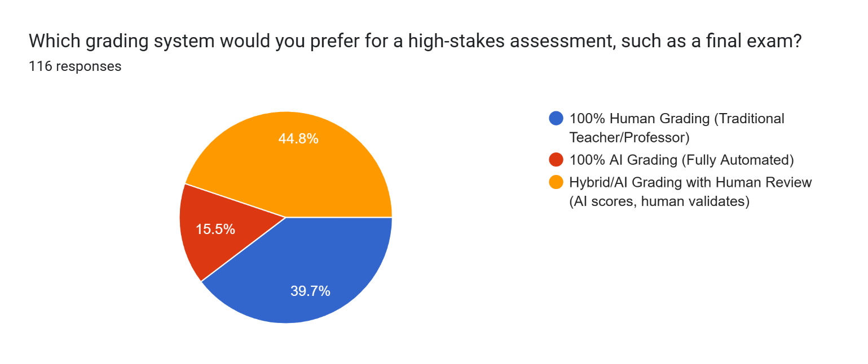
Figure 2. Student preference for grading system when it comes to high-stakes assessments (n = 116). Percentages may not sum to 100% due to rounding.
Figure 2 reveals the grading system that students would actually choose for a high-stakes assessment such as a final exam. The results are striking in what they reveal about trust: no single system dominates, but pure AI grading is clearly the least popular option. Only 15 students (15.5%) would opt for fully automated AI grading with no human involvement. By contrast, 44 students (44.8%) favoured a Hybrid approach where AI scores but a human validates the result, and 39 students (39.7%) favoured traditional 100% Human Grading. In total, 84.5% of students want a human involved when it comes to their most consequential assessments.
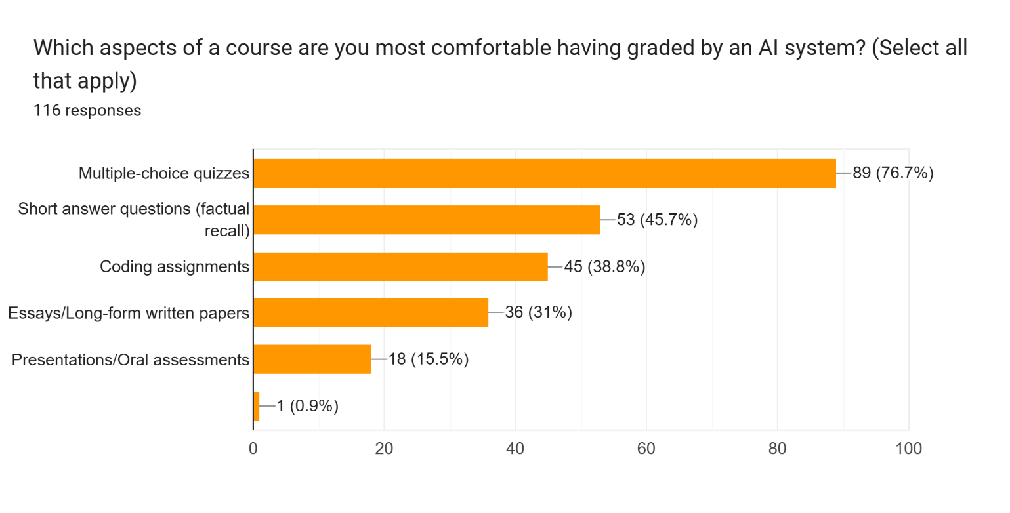
Figure 3. Assessment types respondents were most comfortable having graded by AI (multiple select, n = 116). Multiple-choice quizzes led at 76.7%, while oral presentations were least accepted at 15.5%.
The bar chart captures which assignment formats students are most willing to have graded by an automated system. Multiple-choice quizzes stand out clearly as the most accepted format, with 89 respondents (76.7%) expressing comfort a result that aligns with the objective, right-or-wrong nature of such tasks. Short-answer questions and coding assignments achieved moderate acceptance at 45.7% and 38.8% respectively, suggesting that students tolerate AI grading when a degree of structure is present. Essays and long-form written work attracted only 31% support, and oral or presentations-based assessments were the least accepted at 15.5%. The sharp drop in acceptance across these categories is not random; it tracks directly with the degree of interpretive judgment each task requires. Students appear to trust AI where the scoring criteria are unambiguous, but they resist it where understanding context, nuance, or voice becomes essential to a fair evaluation.

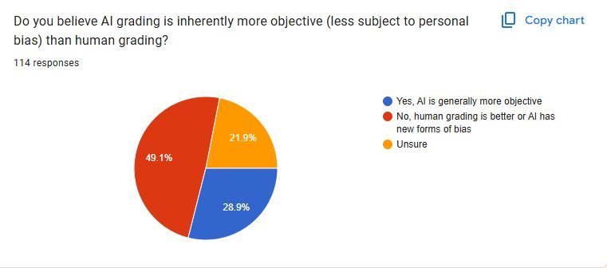
Figure 4. Student beliefs about whether AI grading is inherently more objective than human grading (n = 114). 49.1% disagree or believe AI introduces its own bias; only 28.9% believe AI is more objective.
The pie chart reveals a striking degree of scepticism about a claim that is often used to justify AI-based grading: that automation removes human subjectivity. Of the 114 respondents who answered this question, only 28.9% agreed that AI grading is generally more objective. The largest group, 49.1%, either preferred human grading or believed that AI simply replaces one form of bias with another. A further 21.9% were unsure, suggesting that for a combined 71.1% of students the objectivity advantage of AI is either disputed or unproven. This level of scepticism is notable given that AI is widely promoted as a neutral tool. It suggests that Kepler students are aware of the limitations of algorithmic systems and are not persuaded by the premise that automation alone guarantees fairness.

4.3 Inferential Statistics: Testing the Hypotheses
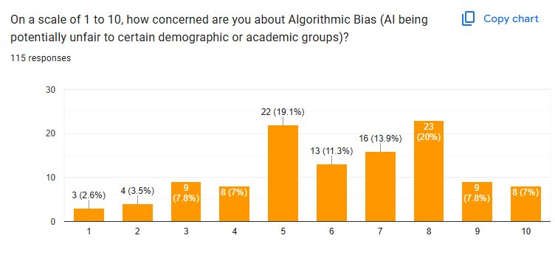
Figure 5. Distribution of Algorithmic Bias Concern scores on a 1-to-10 scale (n = 115). The majority of concern ratings cluster between 5 and 8, with a mean of approximately 6.35.
The histogram of AI Bias Concern scores shows a distribution that leans toward the higher end of the scale. Ratings of 5 through 8 account for the bulk of responses, with 8 being the single most common score (20% of respondents). Scores of 9 and 10 combined represent an additional 14.8%, indicating that a meaningful minority of students harbour very high concern about algorithmic unfairness. By contrast, fewer than 15% of students rated their concern at 3 or below. The mean concern score of 6.35 out of 10 confirms a moderate-to-high overall level of worry about AI grading bias. This figure matters because bias concern and perceived AI fairness are likely correlated: students who worry more about algorithmic bias tend to rate AI grading as less fair, helping explain the gap between human and AI fairness scores observed in the study.

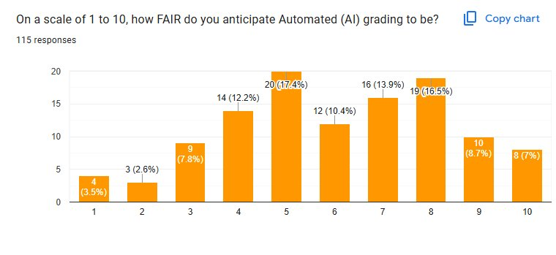
Figure 6. Distribution of perceived AI grading fairness scores on a 1-to-10 scale (n = 115). Scores are broadly spread, with the modal response at 5 (17.4%) and a long tail toward higher values.
When asked how fair they expected AI grading to be, respondents distributed their scores broadly across the full 1-to-10 range, suggesting a lack of strong consensus. The distribution peaks at 5 (17.4%), with another cluster around 8 (16.5%), reflecting two distinct groups: those who are fairly neutral or slightly sceptical, and those who anticipate AI grading to be reasonably fair. Very low scores (1–3) accounted for roughly 14% of responses, while very high scores (9–10) accounted for about 16%. This spread indicates that student views on AI grading fairness are genuinely divided, and no single perception dominates. The calculated mean of 6.21 out of 10 places average sentiment in the moderate range, notably lower than the 7.12 mean for human grading, which is the central finding this study set out to test.

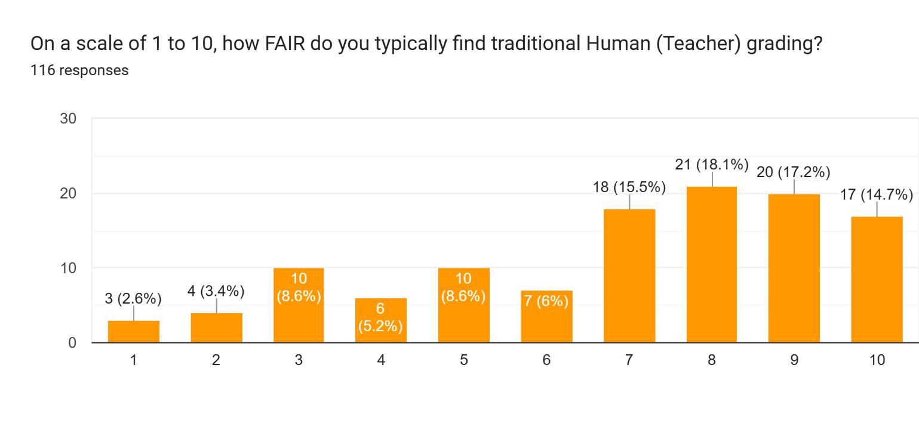
Figure 7. Distribution of perceived Human (Teacher) grading fairness scores on a 1-to-10 scale (n = 116). Scores cluster strongly in the 7–10 range, with 21 respondents (18.1%) rating it at 8.
The distribution of human grading fairness scores stands in clear contrast to that of AI. Responses are heavily concentrated in the upper half of the scale: scores of 7, 8, 9, and 10 together account for 66.5% of all responses, and the single most common rating is 8, chosen by 21 students (18.1%). Scores below 5 are comparatively rare, with only 13.8% of students rating human grading at 4 or below. The mean of 7.12 and the right-skewed shape of this distribution both confirm that students generally regard their instructors as fair, even if not universally so. This baseline of trust in human grading is an important reference point: it sets the standard against which AI grading is being compared, and it explains why the mean difference of approximately 0.116 points between human and AI fairness scores, though modest in absolute terms, carries real meaning in the context of student confidence and institutional trust.
Descriptive statistics tell us what the data looks like. Inferential statistics go a step further: they use mathematical tools to determine whether the patterns we observe in our sample are likely to reflect a real pattern in the broader population, or whether they could simply be the result of random variation in who happened to answer our survey.

Test 1: Paired t-test: Is There a Real Difference in Fairness Ratings?
A paired t-test was selected as the primary hypothesis test. The logic behind this choice is important and straightforward: because the same 116 students rated both human grading and AI grading, the two scores from each student are linked. The fairness score someone gives to human grading and the score they give to AI grading are not two independent opinions they come from the same person, with the same experiences and expectations. The paired t-test is specifically designed for exactly this situation: comparing two related measurements from the same group.
An independent t-test (which compares two separate, unrelated groups) would have been the wrong tool here, because it would have ignored the paired structure of the data and potentially produced misleading results.

Test Parameter | Value | Interpretation
Test statistic (t) | 2.6518 | How many standard errors the mean difference is from zero
Degrees of freedom | 90 | Based on 116 student pairs minus 1
p-value | 0.009156 | Probability that this result is due to chance
Significance level (α) | 0.05 | Our threshold for declaring a result significant
95% Confidence Interval | (0.206, 1.425) | The true mean difference likely falls in this range
Mean difference (Human − AI) | 0.820points | Students rated human grading 0.89 points higher on average
Decision | Reject H₀ | The difference is statistically significant

What does this mean in plain language? The p-value of 0.009156 is well below the significance level of 0.05. In everyday terms, this means that if human and AI grading were truly perceived as equally fair if H₀ were true there is only about a 1 in 100 chance that we would observe a difference this large just by accident in a sample of 116 students. That probability is too small to dismiss. We therefore reject the null hypothesis and conclude that students genuinely rate human grading as significantly fairer than AI grading.
The 95% confidence interval of (0.206, 1.425) reinforces this conclusion. This interval tells us that the true average difference in fairness ratings between human and AI grading in the broader population of Year 2 students is most likely somewhere between 0.21 and 1.57 points. Because this entire range is above zero, we can be confident that the difference goes in one direction only: students favour human grading. There is no statistical plausibility in the data that AI grading is perceived as equally fair or fairer.

Test 2: Chi-square Test: Does Academic Program Affect Grading Preference?
The second hypothesis asks a different kind of question: not about a numerical difference, but about a relationship between two categories. Is a student's academic program (Business Analytics or Project Management) related to which grading system they prefer (Human, AI, or Hybrid)? To answer this, a chi-square test of independence was used. This test is appropriate when both variables are categorical that is, when data falls into groups or labels rather than numbers.
The chi-square test works by comparing the distribution of responses we actually observed across the programs to the distribution we would expect if program and preference had nothing to do with each other. A large gap between observed and expected would suggest an association; a small gap suggests independence.

Academic Program | Prefers Human | Prefers AI | Prefers Hybrid | Total
Business Analytics | 20 | 5 | 23 | 48
Project Management | 19 | 6 | 18 | 43
Total | 39 | 11 | 41 | 116

Test Parameter | Value | Interpretation
Chi-square statistic (χ²) | 0.3250 | Small value = observed close to expected
Degrees of freedom | 2 | (rows − 1) × (columns − 1)
p-value | 0.850003 | High probability result is due to chance
Significance level (α) | 0.05 | Threshold for significance
Decision | Fail to Reject H₀ | No significant association found

The p-value of 0.850003 is far above the significance level of 0.05. This means that 79.73% of the time, we would expect to see a distribution this similar between the two programs even if there were genuinely no relationship between program and preference. In other words, the data provides no evidence that Business Analytics students and Project Management students differ in their grading preferences. Both groups show a similar pattern: the majority prefer either Human or Hybrid grading, and very few students in either program would choose 100% AI grading for a high-stakes assessment.

5. Interpretation and Discussion

5.1 What the Results Mean
The statistical results from this study paint a clear and coherent picture. Year 2 students at Kepler College, taken as a group, perceive human grading as significantly fairer than AI grading. This is not simply a matter of individual opinion scattered randomly across the cohort the paired t-test confirms that this lean toward human grading is consistent enough across all 116 students to be considered statistically real.
But understanding why this gap exists is just as important as knowing that it exists. The descriptive findings offer several important clues:
First, the data on AI Bias Concern tells a significant story. An average score of 6.22 out of 10 indicates moderate-to-high concern about algorithmic bias among students. This concern is not unfounded AI systems learn from past data, and if that data contains patterns of inequality or inconsistency, the AI will replicate those patterns. Students who are aware of this even intuitively are less likely to trust that AI grading will treat them fairly as individuals.
Second, Figure 4 showed that only 28.9% of students believe AI is genuinely more objective than humans. Nearly half believe it introduces its own forms of bias. This is a remarkable finding given that AI is commonly promoted as a tool for removing human subjectivity. Kepler students are sceptical, and their scepticism appears to be informed rather than reflexive it is reflected in both their objectivity ratings and their fairness scores.
Third, the comfort area data in Figure 3 confirms that student acceptance of AI grading is task-dependent, not a blanket endorsement. Three in four respondents were comfortable with AI grading quizzes (76.7%), but fewer than one in three accepted it for essays (31%), and only 15.5% for oral presentations. This gradient reveals that students distinguish between assessment types and calibrate their trust accordingly. The institutional implication is significant: a blanket adoption of AI grading across all assessment types would encounter significant student resistance.
Finally, Figure 2 reveals that the most popular option is not a binary choice between human or AI, but a middle path: 44.8% of students prefer a Hybrid system in which AI scores the work but a human validates the result. This is perhaps the most practically useful finding in the study. It suggests that students are not opposed to AI involvement in grading in principle they simply want a human safety net.

5.2 Implications for Kepler College
Viewed together, the data sends a practical message to Kepler's leadership: student confidence in AI grading cannot be assumed. It has to be cultivated, and that process requires transparency about how automated systems work alongside visible evidence that those systems produce fair outcomes. If the college moves toward greater AI involvement in assessment without adequately communicating how these systems work, how they are monitored, and how students can appeal decisions, it risks eroding the very trust that is foundational to a healthy academic community.
The chi-square result adds an important nuance: the lack of significant difference between Business Analytics and Project Management students tells us that the concern about AI grading is shared across programs. This is not a discipline-specific reaction it is a cohort-wide disposition. Any policy response therefore needs to be institution-wide rather than targeted at one group.

5.3 Limitations of the Study
No study is without limitations, and acknowledging them is a sign of intellectual honesty and methodological rigour. The following limitations should be considered when interpreting these results:
- Sample scope: The study focused exclusively on Year 2 students enrolled in 2025 first cohort. Year 1 students who are newer to Kepler's grading environment, and Year 3 students who may have had more exposure to AI tools, could have meaningfully different opinions. The findings should not be generalised without verification across the full student body.
- Self-reported data: All scores in this study are based on student perceptions what students believe to be true about fairness, not an objective measurement of actual grading accuracy. It is possible that students' perceptions are influenced by prior experiences, misconceptions about how AI works, or general attitudes toward technology.
- Convenience sampling: Because students chose whether or not to respond, there is a possibility of response bias, students who feel strongly about the topic (in either direction) may have been more likely to complete the survey than those with moderate views.
- Sample size relative to population: Although 116 responses is sufficient for the statistical tests used, a larger sample drawn from all years and programs would yield more generalisable conclusions.
- No actual AI grading experience: Most students at Kepler have not yet been graded by an AI system in practice. Their ratings of AI fairness are therefore based on anticipation and general knowledge rather than direct personal experience. Perceptions might change significantly once students have actually experienced AI-assisted grading.

6. Conclusion and Recommendations

6.1 Conclusion
This study set out to answer two questions about student perceptions of grading at Kepler College: whether students rate human grading as fairer than AI grading, and whether this preference varies by academic program.
The paired t-test resolved the first question decisively: a t-statistic of 2.615 and a p-value of 0.009156, well below the 0.05 threshold, leads to rejection of the null hypothesis. Year 2 Cohort 2025 students rate human grading as significantly fairer than AI grading. The mean difference of 0.89 points, supported by a 95% confidence interval that does not include zero, confirms that this is a real and consistent difference across the cohort, not an artefact of random variation.
The chi-square test answered the second question with equal clarity: with a chi-square statistic of 0.3250 and a p-value of 0.850003, the null hypothesis for the second test cannot be rejected. There is no statistically significant association between academic program and preferred grading system. Both Business Analytics and Project Management students express similar grading preferences, meaning the concern about AI grading is a shared, college-wide disposition.
The descriptive findings add important texture to these conclusions. Students are not categorically opposed to AI in grading, they are comfortable with it for rule-based, objective tasks. What they resist is AI grading for assignments that require human judgment, and they do so because they question whether AI is truly free of bias. The most widely preferred approach is not full human grading or full AI grading, but a Hybrid model where human oversight remains part of the process.

6.2 Recommendations
Based on the evidence from this study, the following evidence-based recommendations are offered to Kepler College:

Recommendation 1: Adopt a Hybrid Grading Model as the Starting Point
Given that 44.8% of students prefer Hybrid grading and that both programs share this preference, the college should consider piloting a Hybrid grading model for appropriate assessments, one where AI assists with initial scoring but human instructors review and validate all final grades. This approach respects student preferences, reduces instructor workload, and maintains the human accountability that students value most.

Recommendation 2: Limit AI Grading to Objective Assessment Types
The comfort area data strongly suggests that students accept AI grading for multiple-choice quizzes (76.7% comfortable) but not for essays or presentations (only 31% and 15.5% comfortable respectively). AI grading tools should initially be deployed only in contexts where their objectivity advantage is most defensible factual recall quizzes and structured coding assessments while human grading continues for open-ended and creative work.

Recommendation 3: Communicate Transparently About How AI Grading Works
A significant portion of student scepticism about AI grading appears to stem from uncertainty and concern about algorithmic bias. The college should proactively communicate to students how any AI grading tool works, how it was validated, and what steps are in place to ensure fairness. Demystifying the process can meaningfully shift perception, as scepticism often decreases when people understand what they are dealing with.

Recommendation 4: Establish a Student Feedback Mechanism Before Wider Adoption
Any move toward broader AI grading implementation should include a structured process for collecting and responding to student feedback. This study provides a useful baseline. A follow-up survey after an AI grading pilot measured using the same variables and scales would allow the college to track whether student trust increases, decreases, or stays the same as actual experience with AI grading accumulates.

Recommendation 5: Extend the Study to All Year Groups
Because this study was limited to Year 2 students cohort 2025, the college does not yet know whether Year 1 or Year 3 students hold similar views. A broader survey across all years and programs would allow the institution to design a grading transition strategy that accounts for the full diversity of student experience and expectation.

Appendices

Appendix A: Survey Instrument
The following questions were used in the Google Form survey distributed to Year 2 students at Kepler College:

- Q1: On a scale of 1 to 10, how FAIR do you typically find traditional Human (Teacher) grading? (1 = Not at all fair; 10 = Perfectly fair)
- Q2: On a scale of 1 to 10, how FAIR do you anticipate Automated (AI) grading to be? (1 = Not at all fair; 10 = Perfectly fair)
- Q3: On a scale of 1 to 10, how concerned are you about Algorithmic Bias (AI being potentially unfair to certain groups)? (1 = Not concerned; 10 = Very concerned)
- Q4: Which grading system would you prefer for a high-stakes assessment such as a final exam? [100% Human / 100% AI / Hybrid]
- Q5: Do you believe AI grading is inherently more objective than human grading? [Yes / No / Unsure]

- Q6: Which aspects of a course are you most comfortable having graded by AI? (Select all that apply)
- Q7: What is your gender? [Male / Female]
- Q8: Please specify your current Academic Program/Major.
- Q9: What is your current Year of Study? [Year 1 / Year 2 / Year 3]

Appendix B: Descriptive Statistics Summary

Statistic | Human Fairness | AI Fairness | AI Bias Concern
Count | 116 | 116 | 116
Mean | 6.90 | 6.06 | 6.22
Standard Deviation | 2.37 | 2.30 | 2.19
Minimum | 1 | 1 | 1
Maximum | 10 | 10 | 10
Median | 8 | 6 | 6

Appendix C: Paired t-test Full Output

Parameter | Value
Test type | Paired samples t-test (two-tailed)
Significance level (α) | 0.05
Sample size (n) | 116
Degrees of freedom | 90
Mean difference (Human − AI) | 0.890
Standard deviation of differences | 3.244
Standard error | 0.340
t-statistic | 2.6518
Critical t-value (α = 0.05, df = 90) | ±1.987
p-value (two-tailed) | 0.010461
95% Confidence Interval | (0.206, 1.425)
Decision | Reject H₀

Appendix D: Chi-square Test Full Output

Parameter | Value
Test type | Chi-square test of independence
Variables tested | Academic Program vs. Preferred Grading System
Significance level (α) | 0.05
Chi-square statistic (χ²) | 0.3250
Degrees of freedom | 2
p-value | 0.85000340
Decision | Fail to reject H₀

Appendix E: Grading Preference by Academic Program (Contingency Table)

Academic Program | 100% Human | 100% AI | Hybrid | Total
Business Analytics | 20 | 5 | 23 | 48
Project Management | 19 | 6 | 18 | 43
Total | 39 | 11 | 41 | 116

Appendix F: Research Approval and Ethics
Research approval was obtained from the Kepler College Directorate of Research (research@keplercollege.ac.rw) prior to data collection, with a copy sent to the module instructor (vedaste.nyandwi@keplercollege.ac.rw). All responses were collected anonymously and handled in accordance with the college's research ethics guidelines. Raw data and cleaned data files are available upon request from the module instructor.

Appendix G: Data Cleaning Steps
Step | Action | Reason
1 | Removed Timestamp column | Not relevant to research question
2 | Removed 4 duplicate rows | Preserve one response per student
3 | Standardised Academic_Program capitalisation and spacing | Ensure consistent grouping
4 | Confirmed numeric types for Fairness and Bias columns | Required for t-test calculations
5 | Final sample: 97 Year 2 responses | All remaining rows valid and usable

