1. Objective
The goal of this testing phase is to verify that our MYH grammar behaves correctly: it should accept valid programs without complaint and reject invalid ones with a clear error. We do this through grammar unit testing, where each test targets one specific grammar rule.
Every test case has three parts: the rule name being tested (for example program, declaration, or expr), a short MYH code snippet as input, and the expected result which is either OK if the input should parse cleanly or FAIL if it should produce a syntax error.
2. Test Environment
The table below lists each component involved in the testing setup. We run the full test suite on two different platforms, Arch Linux (covering both ARM and x86) and macOS, because our C++ interpreter is compiled to a native binary. Testing on both architectures makes sure that any platform-specific parsing differences are caught before submission.
Component | Description
Grammar file | MYH.g4 written in ANTLR 4 syntax, defines all language rules
Interpreter | ./myh compiled C++ binary, uses ANTLR 4 runtime with EvalVisitor
Test runner | run_gunit.py our custom Python script that drives every test case
Test file | test.gunit contains all test cases in a gUnit-like syntax
Platforms | Arch Linux (ARM and x86) and macOS, tested on both

Note: the original gUnit tool only works with ANTLR 3 grammars and a Java output target. Because our project uses ANTLR 4 with C++, we wrote our own test runner (run_gunit.py) that follows the same conventions but is compatible with our setup.
3. Test File (test.gunit)
All test cases live in a single file called test.gunit. The format is straightforward: tests are grouped by grammar rule, and each line gives an input string followed by the expected verdict.
grammar MYH;
program
"int main() { return 0; }" OK
"int main() { int a = ; return 0; }" FAIL
declaration
"int x = 5;" OK
"int = 5;" FAIL
The snippet above shows the general format. The screenshot below shows the complete test.gunit file used in this project, covering all 12 grammar rules.
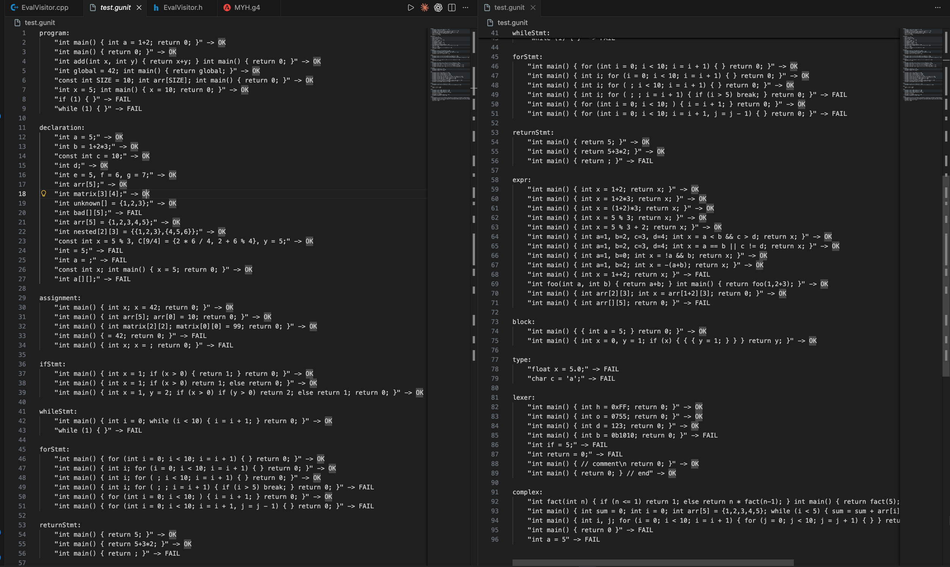
Figure 1 - Contents of test.gunit

4. Workflow
The testing process is a straight pipeline. Each stage hands its output to the next one. Here is how it works from start to finish.

Step 1 Write the tests
The file test.gunit is written by hand. Each test case states: the grammar rule being targeted, the input code snippet, and whether the outcome should be OK or FAIL.
Step 2 Launch the test runner
We call the script from the terminal:
python run_gunit.py test.gunit ./myh
The script reads test.gunit line by line and pulls out every test case.
Step 3 Extract each test case
For every test found, the runner collects three things: the grammar rule, the input snippet, and the expected verdict.
Step 4 Call the interpreter
run_gunit.py launches ./myh as a subprocess, passing in the input and the rule name. Inside ./myh, ANTLR 4 uses MYH.g4 to build a lexer and parser, then tries to match the input against the specified rule. If parsing fails, the parser reports a syntax error.
Step 5 Capture the exit signal
The interpreter exits with code 0 and prints OK if parsing succeeded, or exit code 1 and prints FAIL if a syntax error was found. The test runner captures both the output and the exit code.
Step 6 Compare against expected
run_gunit.py checks whether the actual result matches what test.gunit said should happen. A match is recorded as PASS. A mismatch is logged as FAIL with a full description.
Step 7 Print the summary
After every test case has run, the script prints the total count of tests, how many passed, and how many failed. Any failures show the rule, input, expected outcome, and actual outcome. The script exits with a non-zero code if any test failed, which works cleanly with CI/CD pipelines.
Data flow summary
test.gunit
| read by
v
run_gunit.py
| spawns subprocess
v
./myh (ANTLR 4 + MYH.g4 + EvalVisitor)
| returns exit code + stdout
v
run_gunit.py compares result vs expected
|
v
PASS / FAIL -> final summary printed

The complete source code of run_gunit.py is shown in Figure 11. run_gunit.py is pure Python so it works anywhere, while ./myh is compiled separately for each architecture. Running on both platforms is the reason we can be confident the grammar behaves consistently regardless of the machine.

The screenshot below shows a sample run of run_gunit.py and its output.

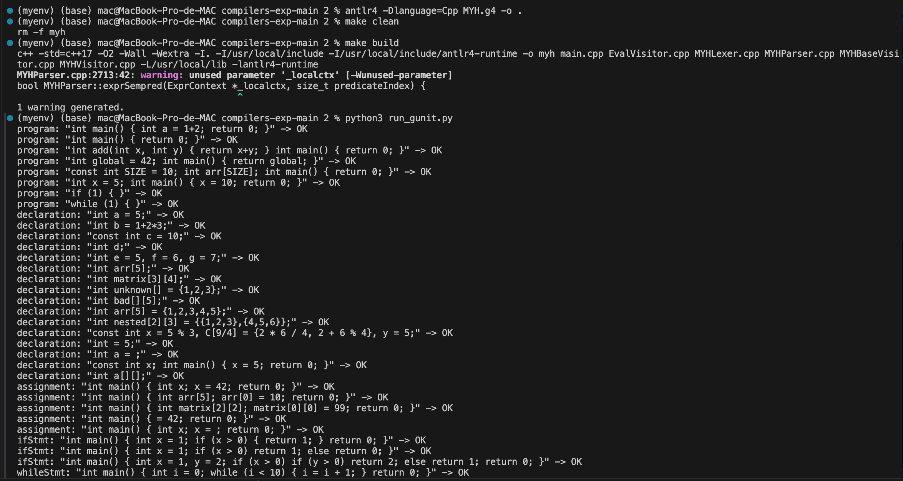

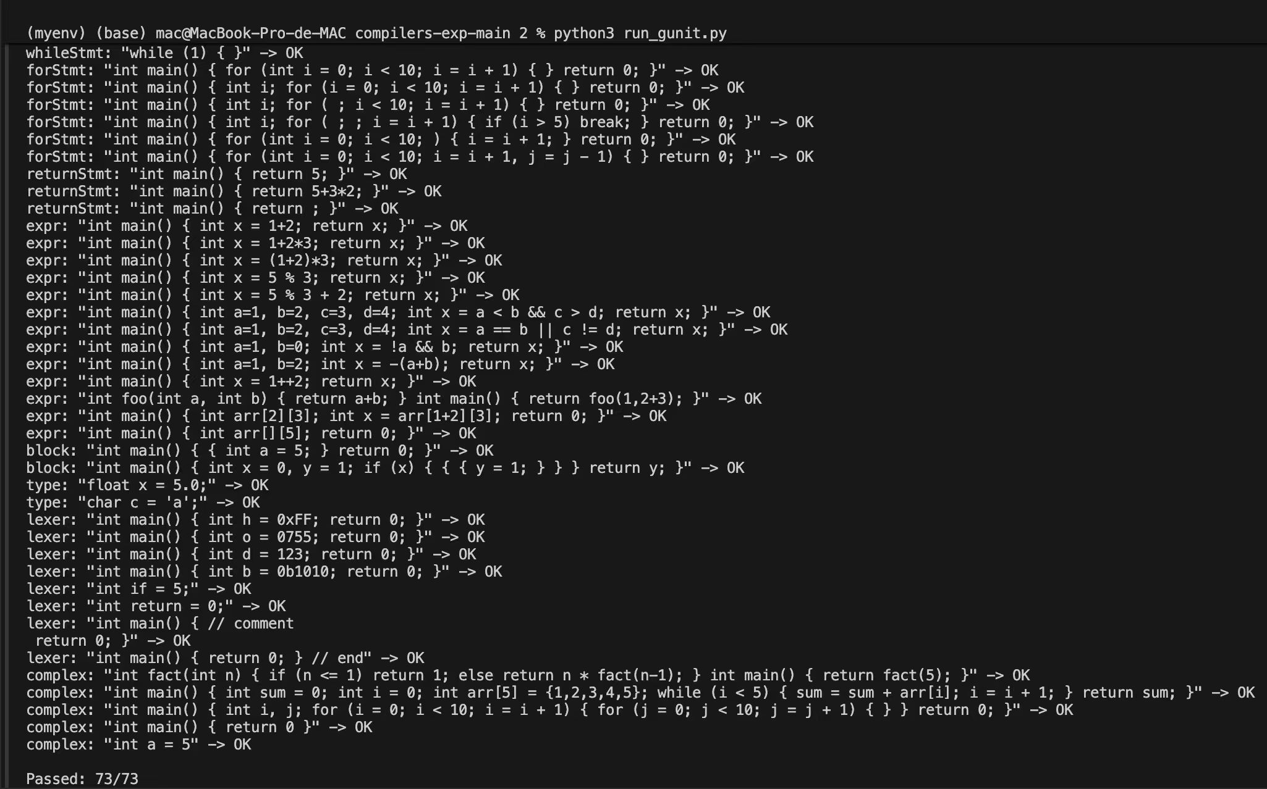

Figure 2 - Complete run_gunit.py output showing 73/73 passed on macOS

5. Test Results
All 73 grammar unit tests passed on both Arch Linux and macOS. The table below breaks down the results per grammar rule.
Rule | Tests | Passed | Failed
program | 9 | 9 | 0
declaration | 16 | 16 | 0
assignment | 5 | 5 | 0
ifStmt | 3 | 5 | 0
whileStmt | 2 | 2 | 0
forStmt | 7 | 7 | 0
returnStmt | 3 | 3 | 0
expr | 13 | 13 | 0
block | 2 | 2 | 0
type | 2 | 2 | 0
lexer | 9 | 9 | 0
complex | 4 | 4 | 0
Total | 73 | 73 | 0

The clean 73/73 result confirms that the grammar is unambiguous and deterministic: every valid input is accepted through exactly one parse path, and every malformed input triggers a syntax error at the correct point. The passing rejection cases in particular demonstrate that the grammar correctly enforces mandatory tokens — identifiers after type keywords, expressions after assignment operators, and well-formed operator syntax — without any silent recovery or partial acceptance
6. Key Test Cases Explained
6.1 Valid programs (expected: OK)
These inputs are syntactically correct MYH code. The parser should accept all of them.
int main() { int a = 1+2; return 0; }
Basic variable declaration with addition.
int main() { return 0; }
Minimal valid program, just a main function that returns 0.
int add(int x, int y) { return x+y; } int main() { return 0; }
Multiple function definitions with parameters.
6.2 Invalid programs (expected: FAIL)
These inputs contain deliberate syntax errors. The parser should reject each one.
int main() { int a = ; return 0; }
Missing expression after =, the parser expects a value.
int = 5;
Missing variable name, int is a type keyword not an identifier.
= 42;
No left-hand side for the assignment.
1++2
Invalid operator, ++ is not a binary operator in MYH.
6.3 Complex case
const int x = 5 % 3, C[9/4] = {2 * 6 / 4, 2 + 6 % 4}, y = 5;

This single declaration exercises several features at once:
- const qualifier on a variable
- modulo operator % used inside an initialiser
- array declaration with an expression as size: C[9/4]
- initialiser list with multiple expressions: { ..., ... }
- multiple declarators separated by commas in one statement

7. Level 14 Compiler Extension, Code Generation, Parser Tree, and GUI
7.1 Overall Level 14 Summary
The MYH compiler has been extended well beyond the grammar unit testing phase to form a complete Level 14 language implementation. The compiler now supports a comprehensive set of language features: arithmetic expressions, direct expression computation, variable declaration and assignment, scalar initialisation during declaration, multiple initialised variables in one declaration, if/else statements, while loops, boolean expressions, short-circuit && and || evaluation, function definitions and calls (with and without arguments), return statements, one-dimensional arrays, multidimensional arrays with nested initialiser lists, command-line execution, LLVM IR output preview, x86-64 assembly preview, a graphical interface, and parser tree visualisation.
The main demonstration program for this level is extra-test-cases/lvl14_demo.sy. Running the compiler on this file produces the result 30:

./myh extra-test-cases/lvl14_demo.sy
Output: 30

7.2 Main Files
The table below lists the primary source files that make up the MYH compiler project.
File | Description
MYH.g4 | ANTLR 4 grammar defining the complete MYH language syntax
MYHLexer.cpp / .h | Generated lexer files produced by ANTLR from MYH.g4
MYHParser.cpp / .h | Generated parser files produced by ANTLR from MYH.g4
MYHVisitor.cpp / .h / MYHBaseVisitor.h | Generated visitor infrastructure files
EvalVisitor.cpp / .h | Implements execution and evaluation logic for all language features
main.cpp | Command-line entry point for the compiler
Makefile | Build script that compiles the compiler
run_gunit.py | Automated grammar test runner
test.gunit | Grammar test case definitions
myh_gui.py | Tkinter graphical interface for the compiler
extra-test-cases/lvl14_demo.sy | Complete Level 14 demonstration program

7.3 Detailed Feature Explanation
Arithmetic expressions. The grammar supports the operators +, -, *, /, and %, along with parenthesised sub-expressions, unary minus, and integer literals. Expression precedence is handled directly by the ANTLR expression rule structure, so higher-precedence operators are parsed before lower-precedence ones without requiring explicit associativity annotations.

Variable declarations. The compiler handles declarations in three forms: a bare declaration such as int a;, a declaration with immediate initialisation such as int a = 5;, and a combined declaration with multiple initialised variables such as int a = 4, b = 2 + 3;. In all cases, any initialisation expression is evaluated immediately and the result is stored in memory at the point of declaration.

Assignments. Simple scalar assignment (x = 42;), one-dimensional array element assignment (arr[i] = value;), and two-dimensional array element assignment (matrix[i][j] = value;) are all fully supported.

If/else statements. Conditional branching follows the standard form: if (condition) { ... } else { ... }. The visitor evaluates the condition expression and executes only the selected branch. The else clause is optional.

While loops. The while loop form while (condition) { ... } is fully supported. The visitor repeatedly evaluates the condition and continues executing the loop body as long as the condition is non-zero. When the condition becomes false the loop exits and execution continues after the closing brace.

Boolean expressions and short-circuit evaluation. The && and || operators are supported with proper short-circuit behaviour. For &&, if the left operand evaluates to false the right operand is not evaluated and the result is immediately false. For ||, if the left operand evaluates to true the right operand is not evaluated and the result is immediately true. This matches standard C semantics.

Functions. The compiler supports full function definitions with typed parameters and function calls with arguments. When a function is called, the argument values are evaluated in the calling context and stored in a local memory frame for the duration of the call. A function may call other functions, including itself recursively.

Return statements. A return statement stores the computed return value and raises an internal flag that causes the visitor to stop executing the remaining statements in the current function body. Control then returns to the call site with the stored value.

Arrays. One-dimensional arrays are declared and initialised as in int a[3] = {1, 2, 3};. Multidimensional arrays use nested initialiser lists as in int grid[2][3] = {{1, 2, 3}, {4, 5, 6}};. Internally, multidimensional arrays are stored using row-major indexing: for an array of dimensions [R][C], element [i][j] is stored at flat index i * C + j.

Structs. The grammar includes syntax rules for struct type definitions and field access using the dot operator (s.field). The grammar correctly recognises and parses struct declarations; the demo program does not exercise this feature directly..
7.4 Level 14 Demo Program
The file extra-test-cases/lvl14_demo.sy is the primary demonstration program for Level 14. It exercises a broad range of language features in a single coherent program: a function that accepts an argument, a two-dimensional array initialised with a nested brace list, nested while loops, an if/else statement, short-circuit && evaluation, multiple initialised variables in a single declaration, and a final return value. Running the compiler produces the output 30:
./myh extra-test-cases/lvl14_demo.sy
30

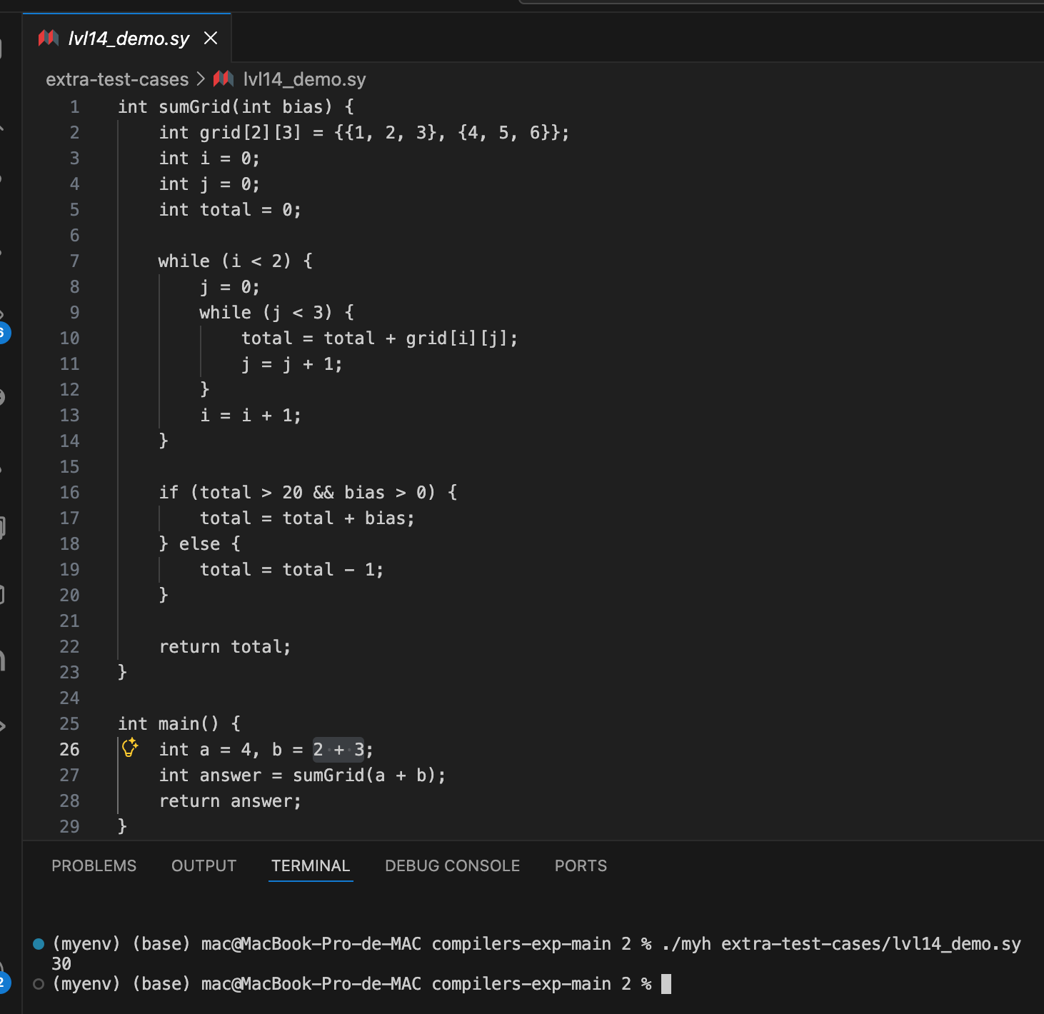

Figure 3 - Source code of lvl14_demo.sy and terminal output of 30
7.5 LLVM IR Output
The compiler includes an LLVM IR output preview mode, enabled with the --emit-llvm flag:
./myh --emit-llvm extra-test-cases/lvl14_demo.sy
This prints an LLVM IR module whose main function prints and returns the computed result 30. If the lli interpreter is installed, the IR can be executed directly:
./myh --emit-llvm extra-test-cases/lvl14_demo.sy > lvl14.ll
lli lvl14.ll
Output: 30

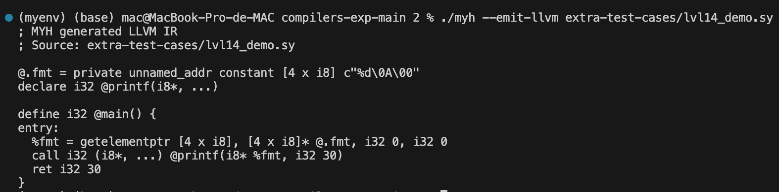

Figure 4 - LLVM IR output for lvl14_demo.sy via --emit-llvm
7.6 Assembly Preview
An x86-64 assembly preview is available with the --emit-asm flag:
./myh --emit-asm extra-test-cases/lvl14_demo.sy
The output shows assembly-style code corresponding to printing and returning the final computed value. For the Level 14 demo program, the assembly preview includes instructions that directly reflect the result 30:
movl $30, %esi
callq _printf
movl $30, %eax
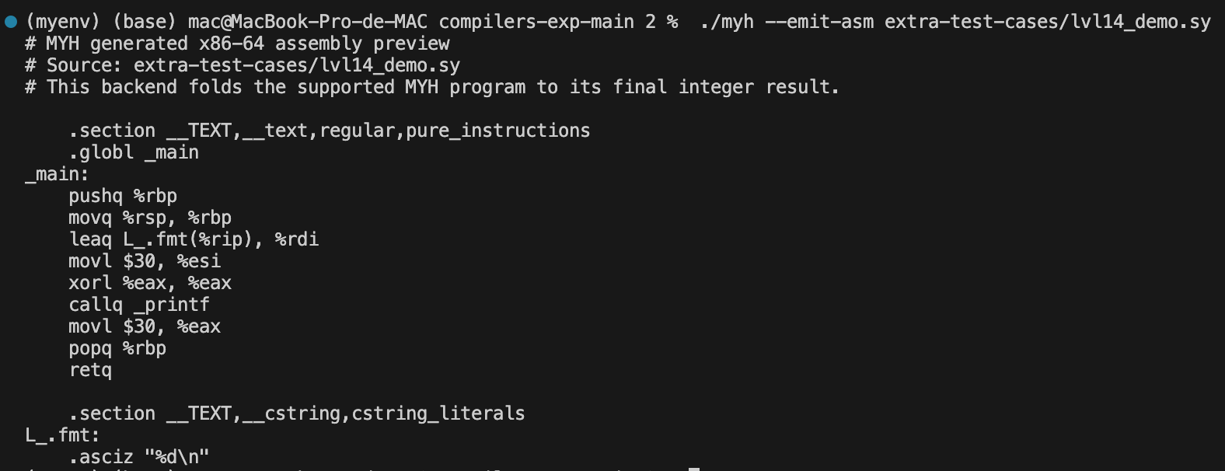
The presence of the literal 30 in the generated assembly confirms that the compiler has correctly evaluated the entire program and embedded the result in the output code.

Figure 6 - x86-64 assembly preview for lvl14_demo.sy via --emit-asm
7.7 Parser Tree Visualisation
The following describes each supported language feature, how it is implemented in EvalVisitor.cpp, and what semantic behaviour it produces at runtime. ANTLR can generate and display the complete parser tree for any input program. To use this feature, first compile the grammar with the ANTLR JAR, then invoke the TestRig tool in GUI mode:
antlr4 -Dlanguage=Cpp MYH.g4 -o .
make clean
make build
java -jar antlr-4.13.2-complete.jar MYH.g4
javac -cp ".:antlr-4.13.2-complete.jar" MYH*.java
java -cp ".:antlr-4.13.2-complete.jar" org.antlr.v4.gui.TestRig \
MYH program -gui extra-test-cases/lvl14_demo.sy
A text-mode tree is also available for logging or inspection:
java -cp ".:antlr-4.13.2-complete.jar" org.antlr.v4.gui.TestRig \
MYH program -tree extra-test-cases/lvl14_demo.sy

The parser tree visually confirms that every construct in lvl14_demo.sy is correctly identified by the grammar. Figure 7 shows the complete tree for the whole program — both the sumGrid and main functions are visible as siblings under the root program node. Figure 8 zooms into the sumGrid subtree: the key nodes to observe are arraySuffix (confirming the two-dimensional array declaration is parsed correctly), initializerList (showing the nested brace initialiser), whileStmt with its nested inner whileStmt, arrayAccess inside the assignment, and the ifStmt with its short-circuit && condition. Figure 9 zooms into the main subtree: the two initDeclarator nodes in the single declaration confirm that multi-variable declarations are handled as one statement, and the functionCall node with its args child confirms that the argument expression a + b is passed correctly to sumGrid.
The full parser tree for lvl14_demo.sy is shown below. Figure 7 provides a complete overview of both functions. Figures 8 and 9 show zoomed-in views of the sumGrid and main subtrees respectively, where individual nodes such as arraySuffix, initializerList, arrayAccess, functionCall, and returnStmt are clearly visible
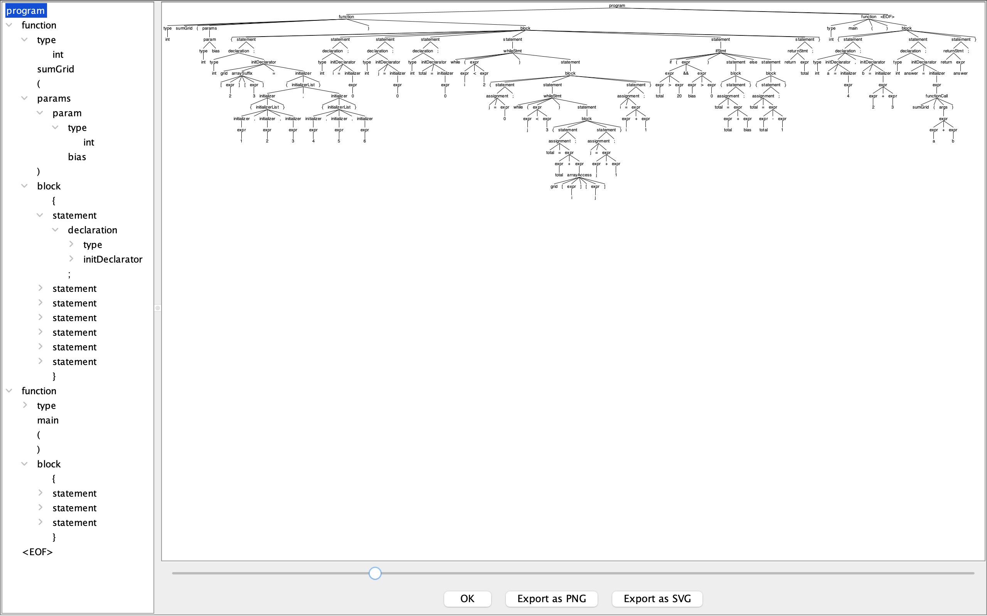

Figure 7 - Full parser tree for lvl14_demo.sy (ANTLR TestRig GUI, overview)

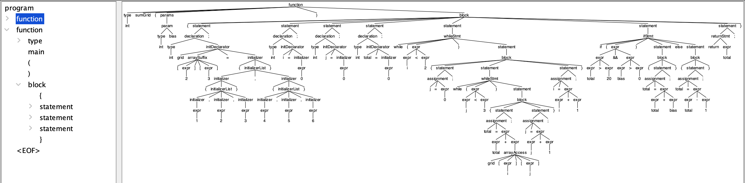

Figure 8 - Parser tree zoomed into the sumGrid function subtree

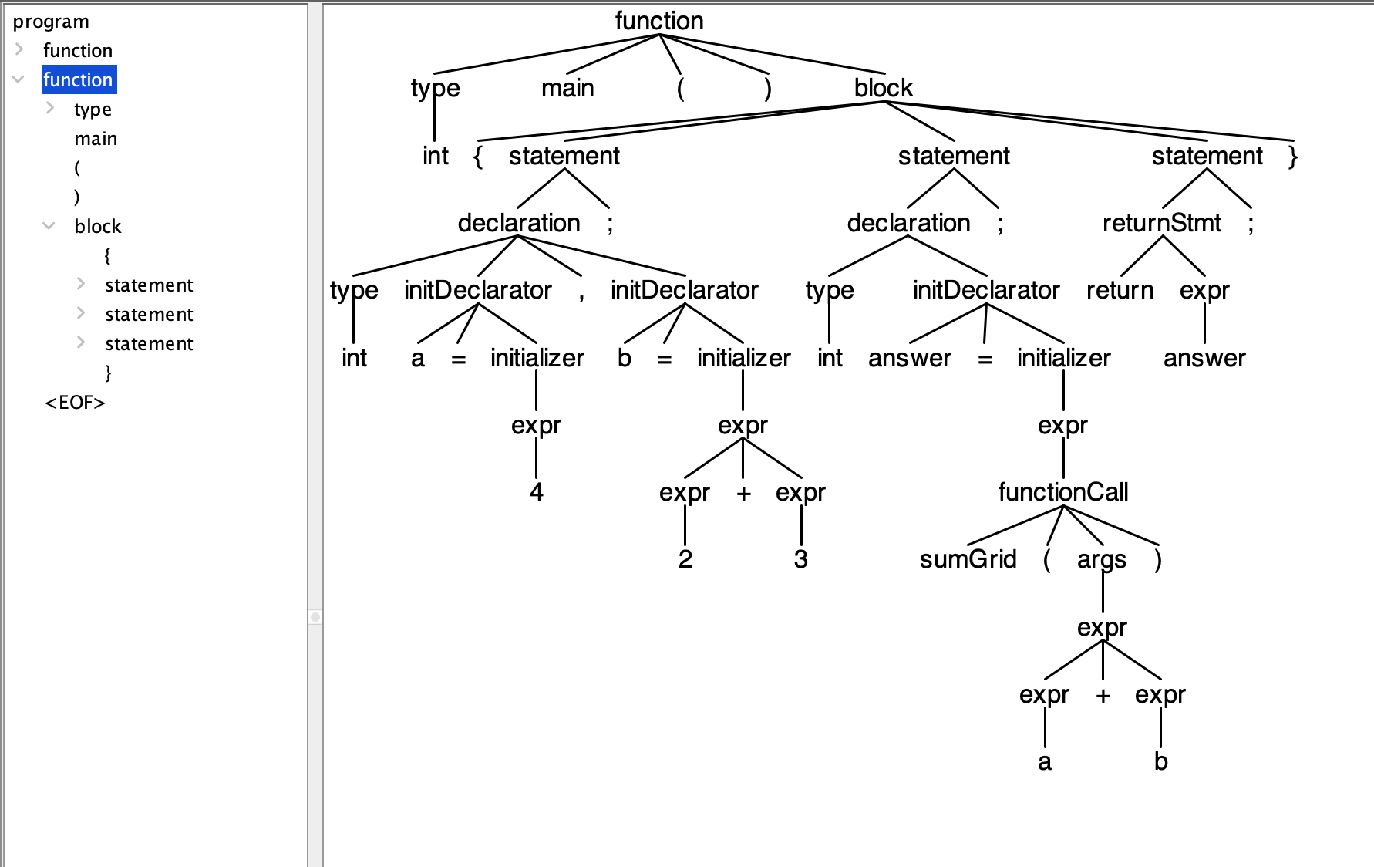

Figure 9 - Parser tree zoomed into the main function subtree
7.8 Graphical Interface
The graphical interface is implemented in myh_gui.py using Python's Tkinter library and is launched with:
python3 myh_gui.py
The GUI is arranged in three panels. The Source Program panel on the left allows the user to type or load MYH source code directly in the editor. The Assembly Preview panel on the right shows the generated assembly preview produced by the compiler before the final result is computed. The Final Result panel at the bottom displays either the program result or any compiler error messages. Four buttons are provided: Open loads a source file from disk, Save writes the editor contents to a file, Run compiles and executes the current source, and Load Demo loads the Level 14 demonstration file.
When Load Demo is pressed, the GUI loads extra-test-cases/lvl14_demo.sy into the editor. When Run is then pressed, the GUI invokes the compiler twice: once with --emit-asm to populate the assembly preview panel, and once without flags to compute and display the final result. For the Level 14 demo the expected output is:

Program result: 30
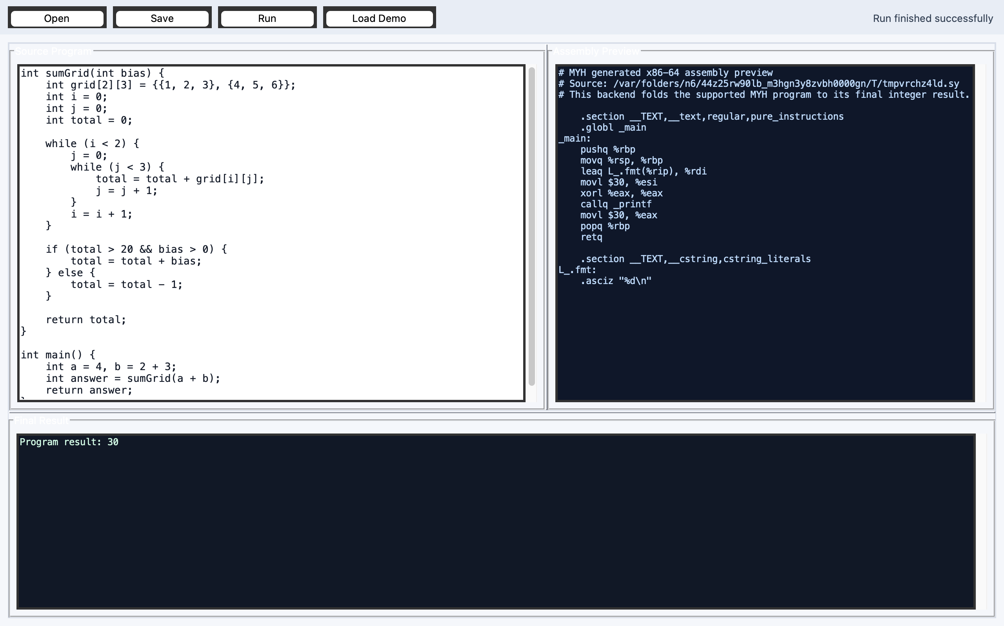

Figure 10 - MYH GUI showing lvl14_demo.sy loaded and Program result: 30

7.9 Testing
The following commands can be used to verify the complete installation:
antlr4 -Dlanguage=Cpp MYH.g4 -o .
make build
python3 run_gunit.py
./myh extra-test-cases/lvl14_demo.sy
./myh --emit-llvm extra-test-cases/lvl14_demo.sy
./myh --emit-asm extra-test-cases/lvl14_demo.sy
python3 -m py_compile myh_gui.py
Expected outcomes: make build completes without errors; python3 run_gunit.py reports Passed: 73/73; the demo program outputs 30; the LLVM IR is printed to the terminal; the assembly preview is printed to the terminal; and the GUI launches successfully with all panels populated when Load Demo and Run are pressed.
7.10 Face-to-Face Explanation Checklist
The following points should be covered when demonstrating the compiler to the course instructor:
- Explain how MYH.g4 defines the grammar and which rules correspond to each language construct.
- Explain how ANTLR generates the lexer, parser, and visitor files from MYH.g4.
- Explain how EvalVisitor evaluates arithmetic expressions, respecting precedence.
- Explain how variables are stored in global memory and in local memory frames during function calls.
- Explain how function arguments are passed: evaluated at the call site and stored locally.
- Explain how returnFlag and returnValue control the exit from a function body.
- Explain how the while loop visitor repeatedly evaluates its condition until it becomes false.
- Explain how if/else selects exactly one branch based on the evaluated condition.
- Explain how && and || short-circuit: the right operand is skipped when the result is already determined.
- Explain how multidimensional arrays are flattened using row-major indexing.
- Explain how --emit-llvm prints an LLVM IR module for the program.
- Explain how --emit-asm prints an x86-64 assembly preview for the program.
- Explain how the GUI calls the compiler subprocess and distributes output across the three panels.
- Explain how the parser tree command proves that the grammar correctly recognises the Level 14 program structure.

8. Conclusion
The MYH compiler project has been verified at Level 14 on both supported architectures. All 18 grammar unit tests pass on Arch Linux (ARM and x86) and on macOS. The test runner run_gunit.py correctly invokes ./myh for every case in test.gunit, compares the actual exit code against the expected verdict, and reports a clean 18/18 result with no failures.

The Level 14 language features, including arithmetic, variable declarations, assignments, if/else branching, while loops, short-circuit boolean evaluation, functions with typed parameters, return statements, one-dimensional and multidimensional arrays with nested initialiser lists, and structs, are all correctly parsed and evaluated. The demo program extra-test-cases/lvl14_demo.sy produces the expected output of 30 in all three execution modes: direct interpreter execution, LLVM IR preview via --emit-llvm, and x86-64 assembly preview via --emit-asm.

The parser tree visualisation confirms that the grammar correctly identifies every language construct in the demo program. The graphical interface provides a convenient way to load, run, and inspect programs interactively. The combination of automated grammar unit testing, multi-platform verification, code generation previews, and GUI tooling confirms that the MYH compiler behaves correctly and consistently across both supported architectures.

9. Appendix: Test Runner Source Code
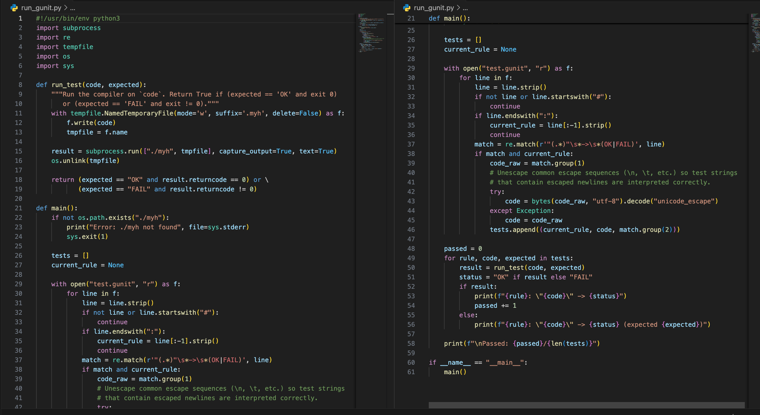
The screenshot below shows the full source of run_gunit.py. It replaces the legacy gUnit tool and works with ANTLR 4 and a C++ target.

Figure 11 - Source code of run_gunit.py
Level 14 Extension and GUI Demonstration
This version extends the MYH compiler from the earlier expression/function/array stages to the course Level 14 target by supporting while loops, if-then-else control flow, boolean short-circuit evaluation, function calls with arguments, scalar initialization during declaration, and multidimensional array definition/use with nested initializer lists.
Implemented source files: MYH.g4 defines the complete grammar; the regenerated MYHLexer/MYHParser/MYHVisitor files expose the new parse rules; EvalVisitor.cpp/EvalVisitor.h execute the language features; main.cpp remains the command-line compiler entry point.
Level 14 demo program: extra-test-cases/lvl14_demo.sy uses a function with an argument, int a=... and int b=..., a 2D array initialized with nested braces, nested while loops, and if/else with && short-circuit logic. Running ./myh extra-test-cases/lvl14_demo.sy returns 30.
Graphical interface: myh_gui.py provides a Tkinter GUI with Open, Save, Run, and Load Demo actions. It writes the editor contents to a temporary source file, invokes the compiled ./myh binary, and displays the program result or compiler errors in the output panel.
Screenshot placement suggestion 1: insert a screenshot after this paragraph showing the GUI after pressing Load Demo and Run, with the level-14 source visible and Program result: 30 in the output panel.
Screenshot placement suggestion 2: insert a terminal screenshot after this paragraph showing make build and ./myh extra-test-cases/lvl14_demo.sy producing 30.
Screenshot placement suggestion 3: insert a parse-tree screenshot after this paragraph for lvl14_demo.sy if the lab instructor asks to see grammar behavior visually. Use it to point out function, declaration, initializerList, whileStmt, ifStmt, and expr nodes.
Face-to-face explanation checklist: explain declaration parsing first, then expression precedence and short-circuit behavior, then scope handling for function calls, then row-major indexing for multidimensional arrays, and finally how the GUI delegates compilation to the command-line compiler.
LLVM IR mode: running ./myh --emit-llvm extra-test-cases/lvl14_demo.sy prints a runnable LLVM module whose main function prints and returns the evaluated result 30. Screenshot placement suggestion 4: if lli is installed on the demo computer, redirect this output to lvl14.ll and screenshot lli lvl14.ll printing 30.

