TỔNG LIÊN ĐOÀN LAO ĐỘNG VIỆT NAM

**TRƯỜNG ĐẠI HỌC TÔN ĐỨC THẮNG**

**KHOA CÔNG NGHỆ THÔNG TIN**



**ĐỒ ÁN CUỐI KỲ**

**MÔN CÔNG NGHỆ PHẦN MỀM**

**PHẦN MỀM QUẢN LÝ BÁN THỰC PHẨM CHỨC NĂNG**

*Người hướng dẫn*: **TS. PHẠM THÁI KỲ TRUNG**

*Người thực hiện*: **Hoàng Minh Tân - 519H0129**

**Tô Trọng Phúc - 519H0341**

Khoá  **: 23**

**THÀNH PHỐ HỒ CHÍ MINH, NĂM 2021**

**ĐỒ ÁN ĐƯỢC HOÀN THÀNH**

**TẠI TRƯỜNG ĐẠI HỌC TÔN ĐỨC THẮNG**

Tôi xin cam đoan đây là sản phẩm đồ án của riêng tôi / chúng tôi và được sự hướng dẫn của Phạm Thái Kỳ Trung;. Các nội dung nghiên cứu, kết quả trong đề tài này là trung thực và chưa công bố dưới bất kỳ hình thức nào trước đây. Những số liệu trong các bảng biểu phục vụ cho việc phân tích, nhận xét, đánh giá được chính tác giả thu thập từ các nguồn khác nhau có ghi rõ trong phần tài liệu tham khảo.

Ngoài ra, trong đồ án còn sử dụng một số nhận xét, đánh giá cũng như số liệu của các tác giả khác, cơ quan tổ chức khác đều có trích dẫn và chú thích nguồn gốc.

**Nếu phát hiện có bất kỳ sự gian lận nào tôi xin hoàn toàn chịu trách nhiệm về nội dung đồ án của mình.** Trường đại học Tôn Đức Thắng không liên quan đến những vi phạm tác quyền, bản quyền do tôi gây ra trong quá trình thực hiện (nếu có).

*TP. Hồ Chí Minh, ngày tháng năm*

*Tác giả*

*Hoàng Minh Tân*

*Tô Trọng Phúc*

PHẦN ĐÁNH GIÁ CỦA GIẢNG VIÊN

_______________________________________________________________________________________________________________________________________________________________________________________________________________________________________________________________________________________________________________________________________________________________________________________________________________

Tp. Hồ Chí Minh, ngày tháng năm

(kí và ghi họ tên)

# 1. Introduction

**1.1. Purpose and Scope**

-The warehouse management will be better and help the goods to be more stable, reducing the amount of inventory significantly. If the company is using the traditional method of warehouse management, it will take a lot of time and effort in taking notes. Sometimes it also leads to errors, confusion and not being proactive in terms of time. Management software will help limit many risks for the company

**1.2. Product Overview (including capabilities, scenarios for using the product, etc.)**

- Software was created with the belief that it would replace manual methods. With features such as import and export, buy, sell, statistics. We believe that this software will make the sales management of companies and agents more convenient and time-saving. Information will be saved in the data so it will avoid information loss.

# 2. Project Management Plan

-Risk management is essential to prevent damage from occurring during product completion. Risk assessment methods can sometimes be used to identify and reduce a risk. Processes include:

+ Plan and implement risk management.

+Manage project risk profile.

+ Perform risk analysis.

+ Perform risk treatment.

+ Perform risk monitoringe

+ Evaluate risk management process.

**2.1. Project Organization**

-The implementation of the report is conceptualized and implemented under the contribution of two members throughout the process.

**2.2. Lifecycle Model Used**

-Because this is a small project, we use the waterfall model to get the job done as efficiently and as quickly as possible.

-This is a model with a 6-stage sequential and sequential design process.

+Requirement Analysis: The team does a search for requirements, functions, and constraints related to the project.

+Design: Define design goals, system logic, and implementation.

+Development: Products are built to support design or built-in units for testing and subsequent integration.

+Test: The entire system is tested to find defects and ensure design goals.

+Deployment: Deploying the system, making the system accessible to users.

+Maintenance: Solve customer problems encountered during use. Repair and upgrade patches and errors to perfect the system.

**2.3. Risk Analysis**

**2.4. Hardware and Software Resource Requirements**

(Do not forget to describe what *new* software or hardware each team member learned during the project)

-Hardware Requirements:

+OS: recommended window 10

+CPU: Intel or ADM processor with 64-bit support

+GPU: Any

+Disk Storage: 10 GB of free disk space

+Internet: Need have internet connection

-Software Requirements:

+SQL Server

+Visual Studio to do winform

+StarUML to draw diagram

2.5. Deliverables and Schedule

|  |  |  |  |
| --- | --- | --- | --- |
| Task | Person Responsible | Deliverable | Due Date |
| Meeting online | All team member | Review project, schedule, plan | 1st December |
| Write the report | All team member | Part 1 | 2nd December |
| Write the report | All team member | Part 2 | 3rd - 4th December |
| Write the report | All team member | Part 3 | 5th – 10th December |
| Write the report | All team member | Part 4 | 10th- 12th December |
| Write the report | All team member | Part 5 | 12th – 17th December |
| Do the project | All team member | Start research and implement the project | 17th December – 1st January |
| Write the report | All team member | Part 6 | 2nd – 3rd January |
| Write the report | All team member | Part 7 | 4th January |
| Prepare for the presentation | All team member | Overview | 5th January |

# 3. Requirement Specifications

**3.1. Stakeholders for the system**

**3.1.1 Business partner**  
The company's main customers will be distribution agents. Customers will be businesses that distribute products abroad, supermarkets, and small grocery stores.

**3.1.2 Accountant**  
The accounting function records the history, receives, processes and provides information about the financial performance of the company.

**3.1.3 Other stakeholders**  
There will be 3 payment methods:

* Paying with cash will have to go to the store
* Payment by bank transfer with the company's bank information is available
* Pay by scanning QR code momo

**3.2. Use case model**

**3.2.1. Graphical use case model**

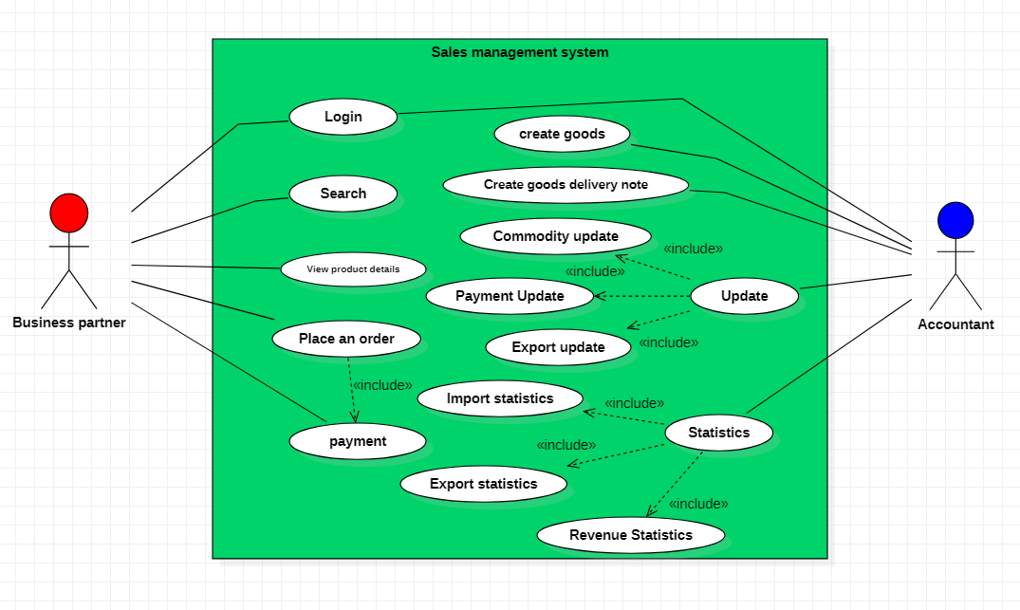

**3.2.2. Textual Description for each use case**

|  |  |
| --- | --- |
| Title | Login |
| Description | This use case allows a business partner/accountant to log into an account already provided by the company. |
| Primary Actor | business partner, Accountant |
| Preconditions | if the login account has not been provided, the business partner/accountant will have to contact the company for support |
| Postconditions | Account saved in database |
| Main Success Scenario | 1. Each business partner/accountant is provided with a separate account by the company 2. Use the provided account to log in to the system |
| Extensions | Database error  Network error |
| Status | Actived |
| Priority | 1 |

|  |  |
| --- | --- |
| Title | Search |
| Description | This use case allows a business partner to search for a product they want to buy |
| Primary Actor | business partner |
| Preconditions |  |
| Postconditions | The product must be in stock |
| Main Success Scenario | After logging in to the system, business partners will find the "Purchase" section, then enter the product code that they want to order and then proceed to place an order. |
| Extensions | Database error  Network error |
| Status | Actived |
| Priority |  |

|  |  |
| --- | --- |
| Title | View product information |
| Description | This use case allows the business partner to see the details of the product they want to buy |
| Primary Actor | business partner |
| Preconditions |  |
| Postconditions | The product must be in stock |
| Main Success Scenario | After searching for the product they want to buy with the product code, they will click on the product to see its details. |
| Extensions | Database error  Network error |
| Status | Actived |
| Priority |  |

|  |  |
| --- | --- |
| Title | Place an order |
| Description | This use case allows a business partner to order a product of their choice |
| Primary Actor | business partner |
| Preconditions |  |
| Postconditions | The product must be in stock |
| Main Success Scenario | After choosing the product and the number of products you want to buy, then:  1. Enter your business partner's information and address  2. Press the "Place Order" button |
| Extensions | Database error  Network error |
| Status | Actived |
| Priority |  |

|  |  |
| --- | --- |
| Title | Payment |
| Description | This use case allows a business partner to pay when an order is placed |
| Primary Actor | business partner |
| Preconditions | If paying online, the payment account must have enough money |
| Postconditions |  |
| Main Success Scenario | There are 3 ways to pay for goods such as: direct payment, payment by bank transfer, payment by scanning QR code. Particularly for payment by scanning QR code:  1. Enter the order number received after purchase  2. The system will automatically display the ordered information along with the QR code for payment  3. Check information and scan QR code to pay |
| Extensions | Database error  Network error |
| Status | Actived |
| Priority |  |

|  |  |
| --- | --- |
| Title | Import product |
| Description | This use case allows the accountant to enter the goods into the system when the goods arrive |
| Primary Actor | accountant |
| Preconditions | Must have product information |
| Postconditions |  |
| Main Success Scenario | 1. Enter product code 2. Enter product name 3. Enter a detailed product description 4. Enter the price for the product 5. Click the "Add" button to enter the inventory for the product |
| Extensions | Network error |
| Status | Actived |
| Priority |  |

|  |  |
| --- | --- |
| Title | Create goods delivery note |
| Description | This use case allows the accountant make delivery notes to deliver goods to business partners |
| Primary Actor | accountant |
| Preconditions | Must have information about sold products |
| Postconditions |  |
| Main Success Scenario | 1. Enter the invoice code that has been ordered previously 2. Enter the product code that you want to issue a coupon 3. Press the "Add" button to add the products you want to export and then press the "Confirm Export" button to export |
| Extensions | Network error  Database errors |
| Status | Actived |
| Priority |  |

**3.3. Functional requirements**

+ Business partners can log in and buy goods, After the purchase is complete, they can pay in many ways.

+ Purchase information will be clearly displayed and will be accompanied by a delivery note

+ The accountant can review the imported goods, the accountant can make the delivery note

**3.4. Non-functional requirements**

* Business partners can only post to the system when they already have an account of the supplier company
* The system requires the user to have a network connection
* The delivery note can only be made if the business partner has already paid
* Items are only visible on the web while in stock.

# 4. Architecture

**4.1. Architectural style(s) used**

We use MVC Architecture. Model view controller (MVC) is a software design pattern commonly used for developing user interfaces that divide the related program logic into three interconnected elements. This is done to separate internal representations of information from the ways information is presented to and accepted from the user

**4.2. Architectural model**

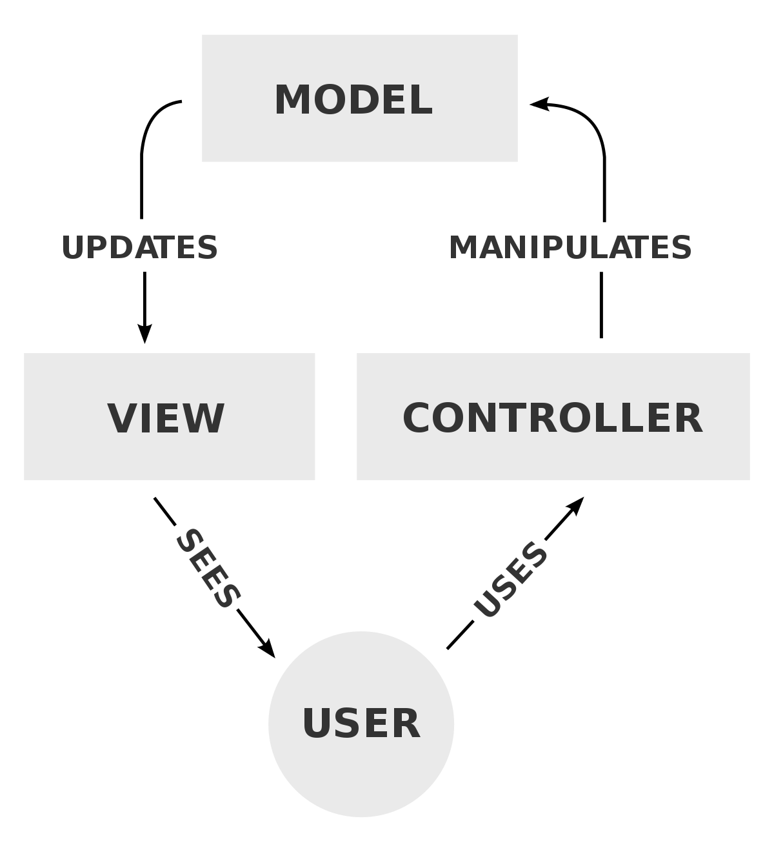

**4.3. Technology, software, and hardware used**

-Software Requirements:

+SQL Server

+Visual Studio to do winform

+StarUML to draw diagram

**4.4. Rationale for your architectural style and model**

* MVC is an architectural pattern which means it rules the whole architecture of the applications. Even though often it is known as design pattern but we may be wrong if we refer it only as a design pattern because design patterns are used to solve a specific technical problem, whereas architecture pattern is used for solving architectural problems, so it affects the entire architecture of our application.
* It is known as the lowest level which means it is responsible for maintaining data. Handle data logically so it basically deals with data. The model is actually connected to the database so anything you do with data. Adding or retrieving data is done in the model component. It responds to the controller requests because the controller never talks to the database by itself. The model talks to the database back and forth and then it gives the needed data to the controller. Note: the model never communicated with the view directly.

# 5. Design

**5.1. Database design**

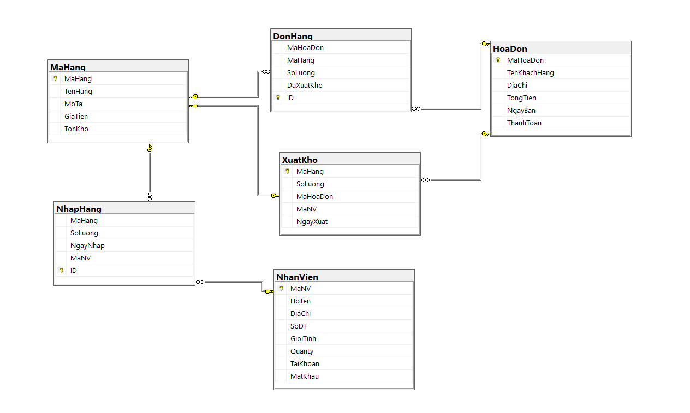

**5.2. Static model – class diagrams**

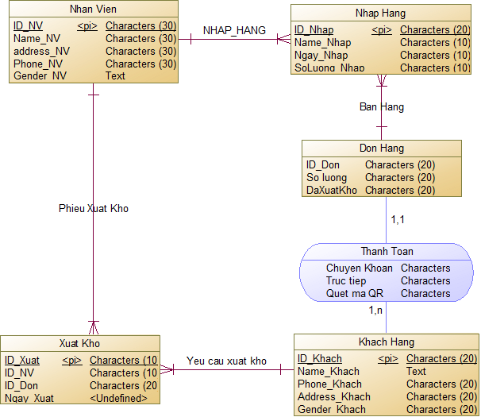

**5.3. Dynamic model – sequence diagrams**

**Import Function**

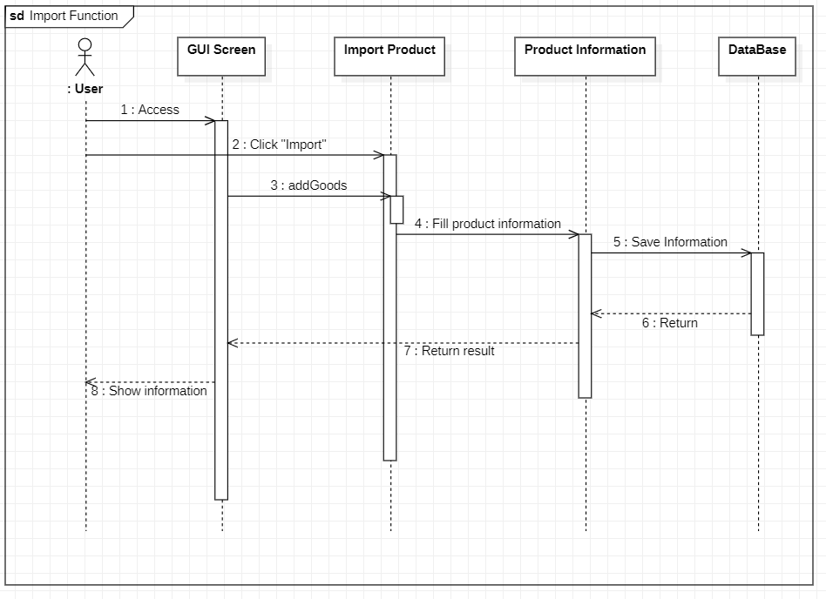

**Update Product**

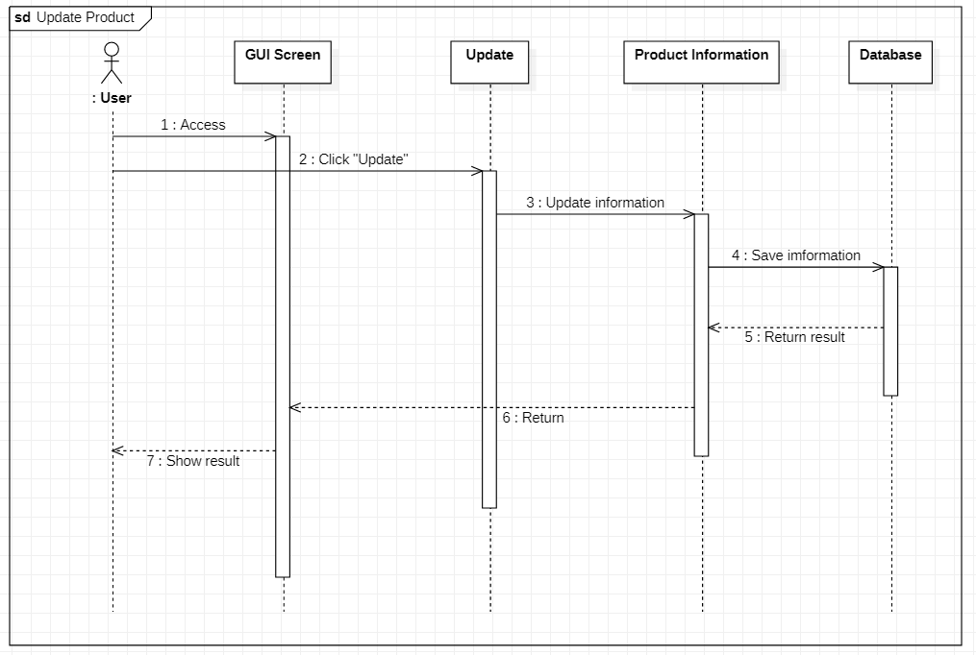

**Export**

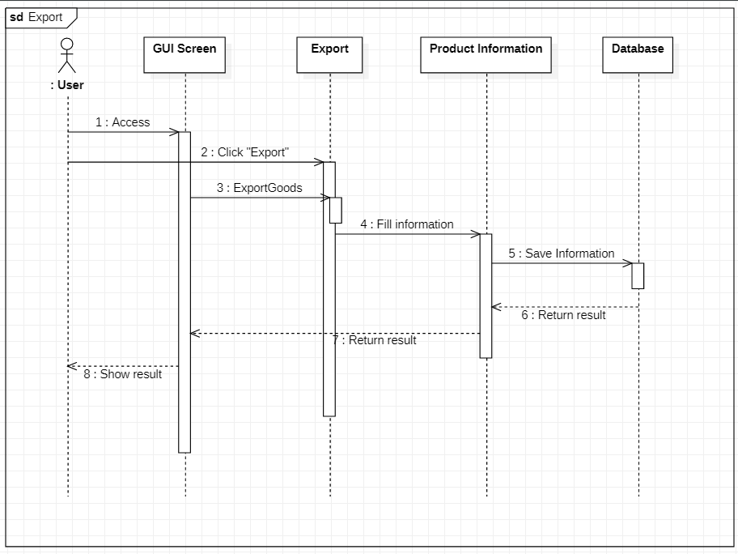

**Buy Product**

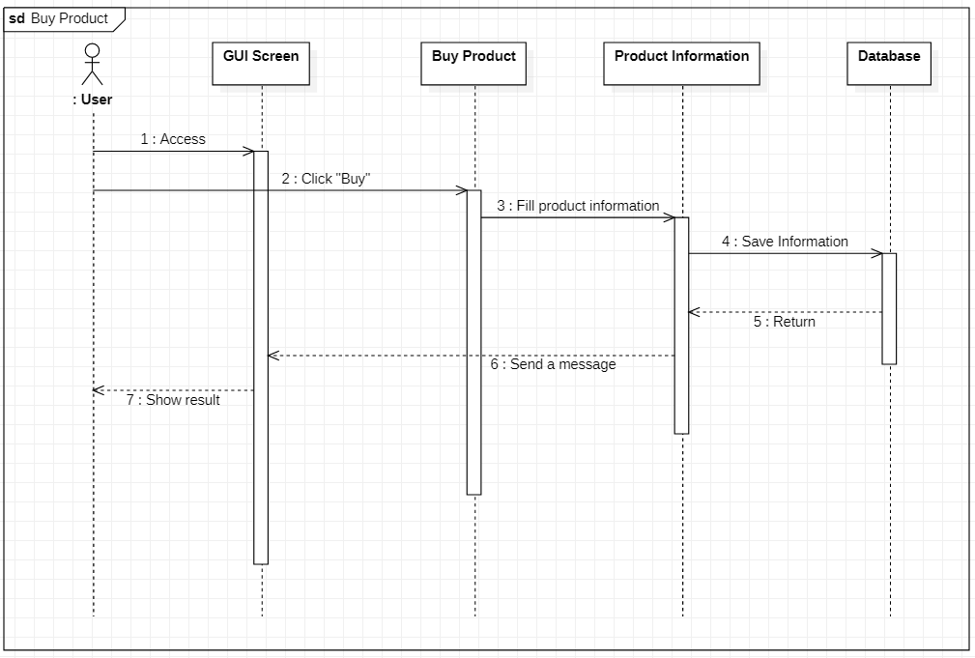

**Pay Money**

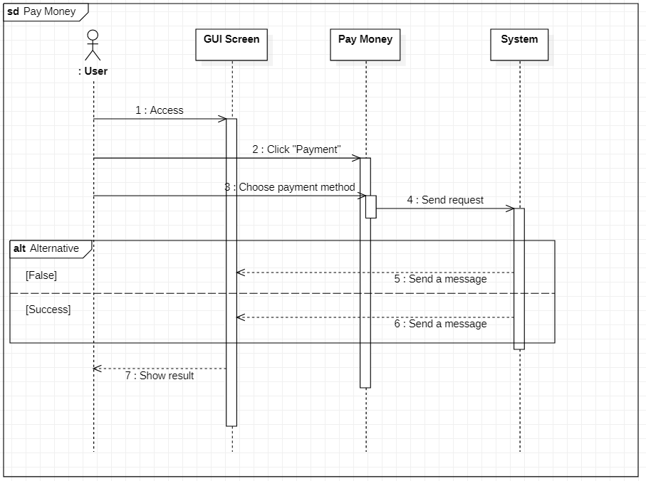

**Statistical**

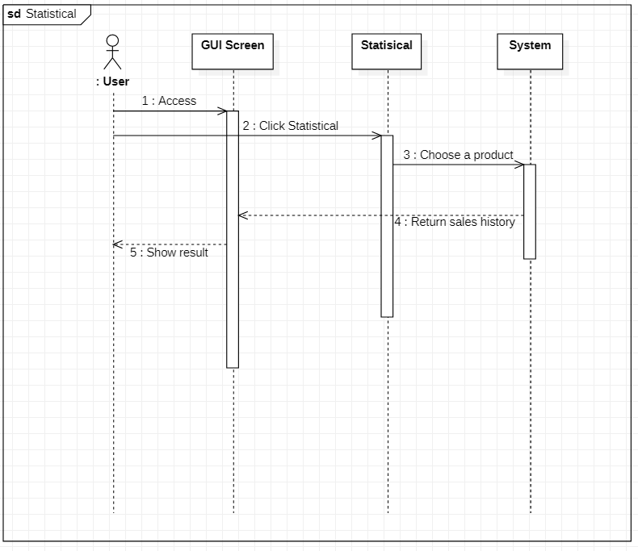

# 6. Demo

**6.1. Database**

**(In attached filles)**

**6.2. Source code**

**(In attached filles)**

**6.3. Testing**

