Assignment 3 — Cloud Computing and Microservices Resilience
AITU Digital Student Services Platform | Technical work report
Academic year 2026–2027 | Synthetic case study | Version 1.0
Submission note: This report uses fictional operational inputs from the supplied assignment. Experiment outputs are reproducible deterministic simulations, NOT observed Kubernetes cluster measurements. Personal fields must be completed by the student.

Submission information
Field | Entry
Student name | [enter your name]
Student ID / group | [complete]
Instructor / date | [complete]
Instructor-assigned variant | [complete if provided]
Repository / commit | [add after repository upload]
Work period | [record actual start and completion times]
Tools used | Python 3; python-docx; matplotlib; Kubernetes YAML; deterministic simulation model

Scenario and design requirements
The university platform serves 10,000 synthetic users with an assumed peak of 500 requests/second. Required service availability is at least 99.9%, maximum API latency is 500 ms, RTO at most 15 minutes and RPO at most 5 minutes. The architecture contains Load Balancer → API Gateway → Auth/Course/Registration → Database. Three application components and the database have two instances each.
Important scope limitation: neither the 500 req/s capacity nor 500 ms latency is established by the availability formulas. They require load testing of a deployed application; no such measurements are claimed here.

Part A — Architecture analysis (5 points)
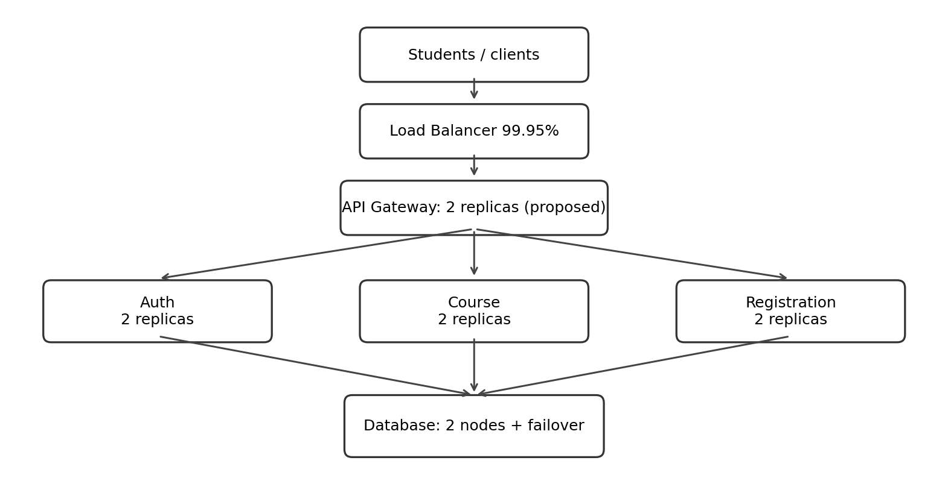
Figure 1. Proposed logical topology; two gateway replicas are the proposed improvement, not part of the baseline inputs.
Component | Example failure | Impact | Mitigation
Load Balancer | Process or network path fails | All traffic may be blocked | Health monitoring, standby load balancer / managed multi-zone routing
API Gateway | Single gateway crashes | All API endpoints unavailable | Introduce two gateway replicas behind load balancer
Auth | One authentication pod crashes | Login capacity reduces | Two replicas, readiness, restart, rolling deployment
Course | One course pod crashes | Course browsing slows or retries | Two replicas, readiness and idempotent retries
Registration | One registration pod crashes | Registration capacity drops | Two replicas, health checks, Service routing
Database | Primary node unavailable | State-changing requests fail until failover | Replicated DB, leader election, backups, tested recovery
Architectural decision: duplicate API Gateway because its baseline 99.90% availability is the largest single-point bottleneck. Database redundancy only helps if failover and consistency are configured; the mathematical model assumes functioning failover.

Part B — Availability calculation (7 points)
For two independent identical units: Rparallel = 1 − (1 − R)^2. For sequentially required subsystems: Rseries = product of their availabilities. This is the requested simplified end-to-end model, not a full traffic-weighted multi-service SLO.
Subsystem | Configuration | Availability
Auth | 2 × 99.50% | 99.9975%
Course | 2 × 99.50% | 99.9975%
Registration | 2 × 99.50% | 99.9975%
Database | 2 × 99.70% | 99.9991%
Load Balancer | 1 × 99.95% | 99.9500%
API Gateway | 1 × 99.90% | 99.9000%
End-to-end baseline | 0.9995 × 0.999 × 0.999975³ × 0.999991 | 99.8417%
Improved API Gateway | 2 × 99.90% | 99.9999%
Improved end-to-end | 0.9995 × 0.999999 × 0.999975³ × 0.999991 | 99.9415%
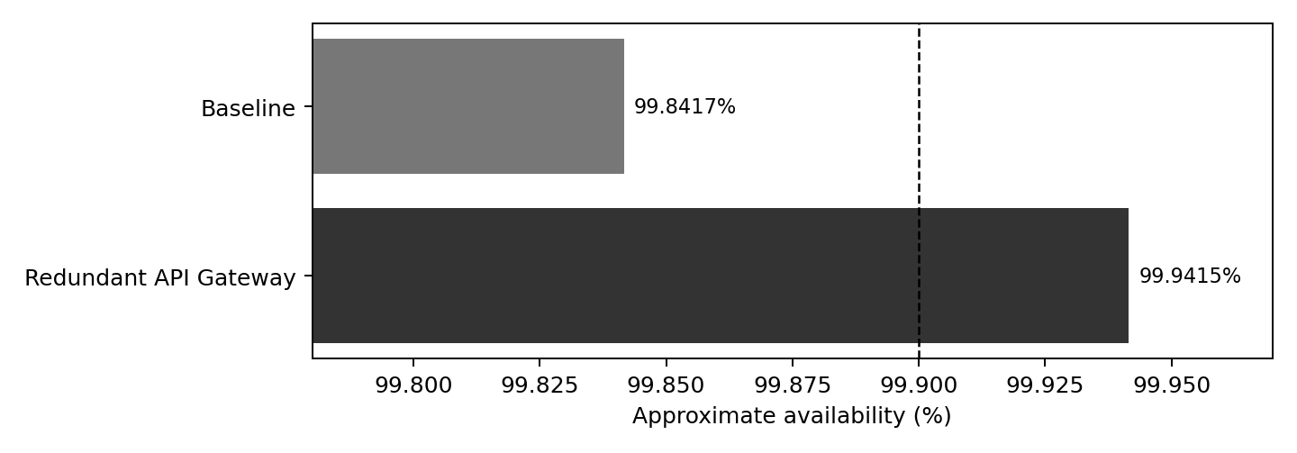
Answer 1: baseline does NOT meet 99.9%; improved design meets the mathematical target. Answer 2: the gateway is the lowest-availability individual stage at 99.90%, followed by the load balancer at 99.95%. Answer 3: adding a redundant gateway yields about +0.09984 percentage points to the end-to-end model. The load balancer remains the next major risk.
Assumptions: independent failures; no correlated zone, deployment or configuration incidents; replicas adequately provisioned and failover correctly wired; every stage required for the modeled request. These assumptions can overstate production availability.

Part C — Kubernetes resilience design (7 points)
Configuration reference: config/registration-deployment.yaml and config/namespace.yaml. Application reference: config/registration-demo-app.py and config/Dockerfile. The image registration-demo:1.0.0 is locally buildable and must be made accessible to the Kubernetes cluster; it is not a published image.
Mechanism | Implemented? | Purpose / setting
Replicas | Yes | Deployment replicas: 2; tolerates one replica loss
Liveness | Yes | GET /healthz; 10 s period; 3 failed checks triggers kubelet restart
Readiness | Yes | GET /readyz; 5 s period; 2 failures excludes unhealthy pod
Resources | Yes | 100m/128Mi requests, 500m/256Mi limits per pod
Rolling update | Yes | maxSurge: 1, maxUnavailable: 0
Automatic restart | Yes | Deployment pod restart via kubelet and controller reconciliation
Service discovery | Yes | ClusterIP registration.aitu-demo.svc.cluster.local
Chosen tuning: maxUnavailable: 0 avoids intentionally reducing the two available replicas during rollout. A readiness probe that depends on database availability removes unhealthy backends from routing; during a full DB outage this means all endpoints may become unready. This is deliberate fail-closed behavior for this demonstration.
Validation constraints: YAML can be parsed offline, but readiness behavior, pod scheduling, rolling update and 500 req/s performance require a running cluster. No real AITU endpoint or credential is used.

Part D — Failure simulations (6 points)
Method: run python experiments/run_simulations.py. Outputs are written to experiments/evidence. This is a deterministic event-timeline MODEL, not empirical Kubernetes telemetry. All timing assumptions are documented in that script; do not submit the traces as authentic pod logs.
Experiment | Failure injected | Detection | Recovery | Student impact
1 | One Registration replica fails | 10 s (model) | 20 s (model) | Second pod serves requests; less capacity and possible brief errors
2 | Both Registration replicas fail | 10 s (model) | 25 s (model) | Registration unavailable until first new pod ready
3 | Database unavailable | 10 s (model) | 185 s (model) | DB-dependent requests fail; registration endpoints unready
Interpretation: a single pod fault can be masked by a healthy replica. Both replica failures create a true service outage; the controller must create functioning replacements. Database failure defeats service replication unless the database itself has an effective failover mechanism.
Model limitation: chosen detection/recovery durations are scenario assumptions rather than measured cluster performance. A real experiment should record injection timestamp, Kubernetes events, kubectl get pods -w output, pod health checks, request status and recovery timestamp. Example commands are included in README.md.

Part E — RPO/RTO and disaster recovery (5 points)
Mechanism | Frequency | Target RPO | Estimated recovery | Purpose
Database log shipping / PITR | Continuous; lag monitored < 5 min | ≤ 5 min if replication and backups validated | Primary failover target ≤ 3 min | Minimize lost committed transactions
Database base backup | Daily; restore tested weekly | Alone: up to 24 h (insufficient) | Restore varies; must test | Provides recoverable base image; pair with WAL/log shipping
Replica configuration backup | On configuration change + daily export | Config state ≤ 24 h; not transactional RPO | Target ≤ 10 min | Recreate Deployment/Service manifests
Full disaster recovery | Monthly drill / restore verification | ≤ 5 min design target | ≤ 15 min design target | Restore data, manifests, networking and validate service
High availability reduces the impact of routine instance failures with redundancy and automatic failover; disaster recovery rebuilds service and state after larger outages, deletion or corruption. A replica is not a substitute for offline/immutable backups because deleted or corrupted data may replicate too.
RTO and RPO above are target engineering plans, not experimentally verified service-level guarantees. Proving them requires full restoration drills and monitoring replication lag. In the given model, a 185-second DB outage is below the 15-minute RTO target, but does not establish the RPO.

Final architecture decision and personal analysis
The highest-leverage initial change is to make API Gateway redundant. Under independent-component assumptions this increases modeled availability from 99.8417% to 99.9415% (+0.09984 percentage points), crossing the 99.9% target. This does not remove load-balancer, common-mode and database failover risks.
One limitation: the simple series model assumes every request needs Auth, Course and Registration in sequence, while real user journeys may call only one microservice. A better production estimate would use per-journey SLOs plus dependency and traffic traces.
Individual work statement: replace this paragraph with details of what you personally executed, the YAML option you changed, the obstacle you actually encountered and how you resolved it. Do not claim to have operated a Kubernetes cluster unless you have done so.

Evidence index and reproducibility
Evidence item | Path
Architecture drawing | diagrams/architecture.png
Availability chart | diagrams/availability_comparison.png
Kubernetes workload and Service | config/registration-deployment.yaml
Namespace | config/namespace.yaml
Minimal runnable demo service | config/registration-demo-app.py, config/Dockerfile
Simulation source | experiments/run_simulations.py
Machine-readable model results | experiments/evidence/simulated_results.csv and .json
Per-scenario event traces | experiments/evidence/model_trace_1.txt through _3.txt
Execution and verification guide | README.md

Oral defense — compact explanation
We modeled a student-services platform with redundant microservices. With two identical independent instances, subsystem uptime is 1 − (1 − R)². The original topology gets 99.8417%, so it misses the 99.9% requirement. The gateway is the dominant single point of failure, and redundancy raises modeled availability to 99.9415%. Kubernetes keeps two Registration pods, probes them for health, updates without planned loss of available pods and exposes a stable Service name. Our included experiments are deterministic simulations: one pod failure is masked, both pod failures cause temporary loss, and a DB outage affects requests despite app-level replicas. HA is not DR; for disasters we need transaction-log recovery, backed-up state and tested restoration within RTO/RPO targets.

Final checklist
Completed: architecture/table; calculations; YAML/demo code; explicitly labeled simulation model/results; RPO/RTO strategy; final rationale; defense notes. Must be completed by student: identity, assigned variant, real work timestamps, actual Kubernetes deployment screenshots/logs if instructor requires real-cluster evidence, actual load/latency testing, personal incident and signature.
Academic integrity note: all operational platform data are synthetic per the assignment, and every modeled observation is clearly labeled. No real AITU system, real user, credentials or infrastructure was accessed.

