Software Requirements Specification
SkillMiner — automated mapping of IT job postings to the ESCO model for analysing the evolution of IT skills
Item | Value
Project / course | Team project #31 “SkillMiner for IT skill evolution”, course Tímový projekt
Customers | Deutsche Telekom IT Solutions; Sektorová rada pre IT a telekomunikácie
Version / status | 0.1 — draft
Date | 2026-10-27

Team members
Name | Department
Karpliuk Oleksii | KPI
Matsko Rostyslav | UUI
Mukosii Veronika | KPI
Slobodian Mark | KPI
Suhak Nikita | UUI

Draft. Numeric targets are marked initial and must be agreed with the customer. The project is done by a team of five students with no budget, so the stack and scope are deliberately minimal: “free and local first”.

1. Introduction

1.1 Purpose
This document specifies SkillMiner, a tool that automatically collects IT job postings from Slovakia, extracts skills, seniority and specialisation, maps them to the ESCO classification and provides analytics, a chat interface and a demand forecast. Readers: the team, the course supervisor, customer representatives.

1.2 Scope
In scope are the seven customer goals. They are the main goals: every task in 3.2 is grouped under one of them.
ID | Goal
G1 | Automated extraction of key information from job portals (profesia.sk, linkedin.com, etc.)
G2 | Classification: skill type, seniority, specialisation, technologies
G3 | AI quality control of extraction and domain-correct normalisation
G4 | Fuzzy map between postings and the ESCO model (occupations, skills)
G5 | Querying the DB/model (chatbot, API)
G6 | Analyses, views and BI insights
G7 | Forecasting and estimating real demand (portal data, company annual reports)

Out of scope: candidate matching and CV processing; non-IT occupations; changing ESCO itself and mapping to qualifications (ESCO v1.2 publishes only Occupations and Skills [3]); a mobile app and a production SLA.

1.3 Definitions, acronyms and glossary
Term | Definition
ESCO | European multilingual classification of occupations and skills; v1.2 — 3,039 occupations and 13,939 skills, 28 languages [3]
ISCO-08 | International classification of occupations; ESCO occupations carry ISCO codes
Canonical posting | One record for a group of duplicates/reposts of the same job
NER / LLM | Named entity recognition / large language model
RAG | Answer generation grounded in retrieved data
Embedding | Vector representation of text for semantic search
Fuzzy / μ | Many-to-many mapping with a match degree μ ∈ [0,1]
Golden set | Manually annotated postings used to measure quality
HITL | Human-in-the-loop review of AI results
M / S / C | MoSCoW: Must / Should / Could — task priority
Sector Council | IT & Telecommunications Sector Council — responsible for the IT-sector skills strategy

1.4 References
- [1] Assignment “Deutsche Telekom IT Solutions + Sektorová rada IT” (context_TP.txt).
- [2] ESCO web service API — https://esco.ec.europa.eu/en/use-esco/use-esco-services-api/esco-web-service-api ; https://ec.europa.eu/esco/api/doc/esco-api-doc.pdf
- [3] ESCO v1.2 — https://esco.ec.europa.eu/system/files/2024-05/V1.2%20Launch%20-%20ESCO%20SEC%20combined%20-%20final%20clean.pdf
- [4] SkiLLens (EACL 2026, industry track) — https://preview.aclanthology.org/credits/2026.eacl-industry.65
- [5] Semantic Synergy: Unlocking Policy Insights… (arXiv:2503.10094) — https://arxiv.org/html/2503.10094v1
- [6] SlovakBERT (arXiv:2109.15254) — https://arxiv.org/pdf/2109.15254
- [7] ITAS: Stav IT trhu na Slovensku v r. 2024 — https://itas.sk/wp-content/uploads/2025/10/Stav-IT-trhu-na-Slovensku-v-r.2024.pdf
- [8] OWASP Top 10 for LLM Applications — https://owasp.org/www-project-top-10-for-large-language-model-applications/

2. Overall description

2.1 Context and problem statement
The IT Sector Council is responsible for the skills strategy of the Slovak IT sector. Its experts rely on open data (e.g. from the Social Insurance Agency) and questionnaires filled in by IT companies. This is imprecise and does not reflect real needs: according to these sources demand for IT skills looks too low, which conflicts with reality [1].
The sector is large: over 23,000 IT companies in 2024 [7]. Job postings are a public, timely demand signal, but unstructured and full of duplicates. To compare them they are mapped to a shared taxonomy — ESCO.
Lessons from the literature: (1) SkiLLens [4] — separate candidate retrieval from ESCO linking, refine with an LLM, keep a human in the loop; (2) Semantic Synergy [5] — embeddings + similarity search; its high F1 was obtained on synthetic data, so quality must be measured on our own golden set; (3) SlovakBERT [6] — an open Slovak model for NER/embeddings.
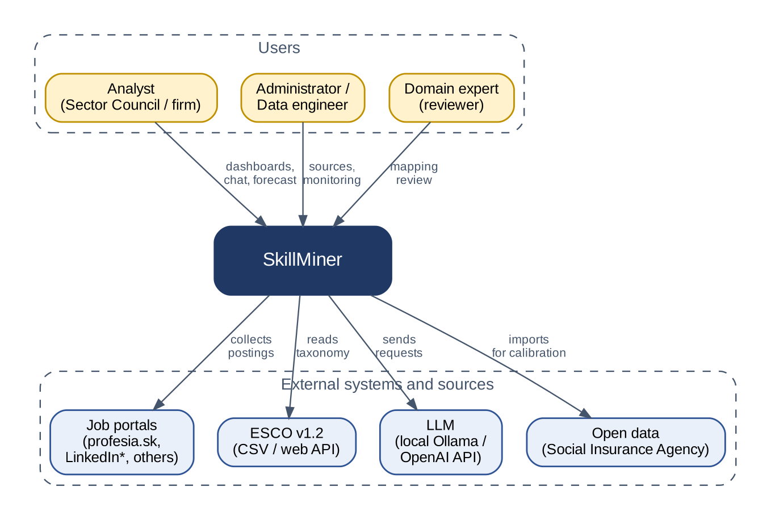
Figure 1 — Context diagram. *LinkedIn — only with legal clearance (R-01)

2.2 Users and stakeholders
Role | What they need
Analyst (Sector Council / firm) — primary user | Demand dashboards, chatbot, forecast, export; clarity on where every number comes from.
Administrator / data engineer (firm) — primary user | Source and schedule setup, run status, errors and LLM cost, users.
Others: domain expert, customer, supervisor | The expert reviews doubtful mappings; the customer accepts the result; the supervisor watches quality.

2.3 Assumptions, dependencies and constraints
Dependencies:
- Portal HTML (changes break parsers); the ESCO web API/CSV [2]; open-source Python libraries and local LLMs (Ollama).
Constraints:
- A team of five students, one semester — scope is cut by MoSCoW priorities; every module has an owner (8.2).
- Zero budget → “free and local first”: open-source libraries, local LLMs (Ollama) on laptops/a university server, no GPU required; a paid API only optionally and under a hard spending cap.
- Legal: public pages only, no login or circumvention; GDPR compliance (BR-11, BR-12).
- Technologies suggested by the customer (Python, pandas, PyTorch, Playwright, OpenAI/Ollama, LlamaIndex/LangChain, vector/relational DBs, NER, scikit-learn) are used as recommended.

2.4 Interaction with other systems
System | Interface and purpose
profesia.sk, LinkedIn*, others | HTTP(S)/HTML: posting sources; robots.txt and ToS; *LinkedIn disabled by default
ESCO v1.2 | CSV dump (the base, reproducible) + REST web API (HAL JSON, selectedVersion parameter) for reference lookups [2]
LLM | OpenAI-compatible HTTP API: local Ollama or (optionally) OpenAI
Open data and annual reports | CSV/XLSX/PDF import for demand calibration (Social Insurance Agency; format — TBC)

3. Functional requirements

3.1 User stories / use cases
Scenarios are shown as user flows of three roles: what the user does from log-in to the result. The expert is a supporting role, but their review is what makes the data quality acceptable.
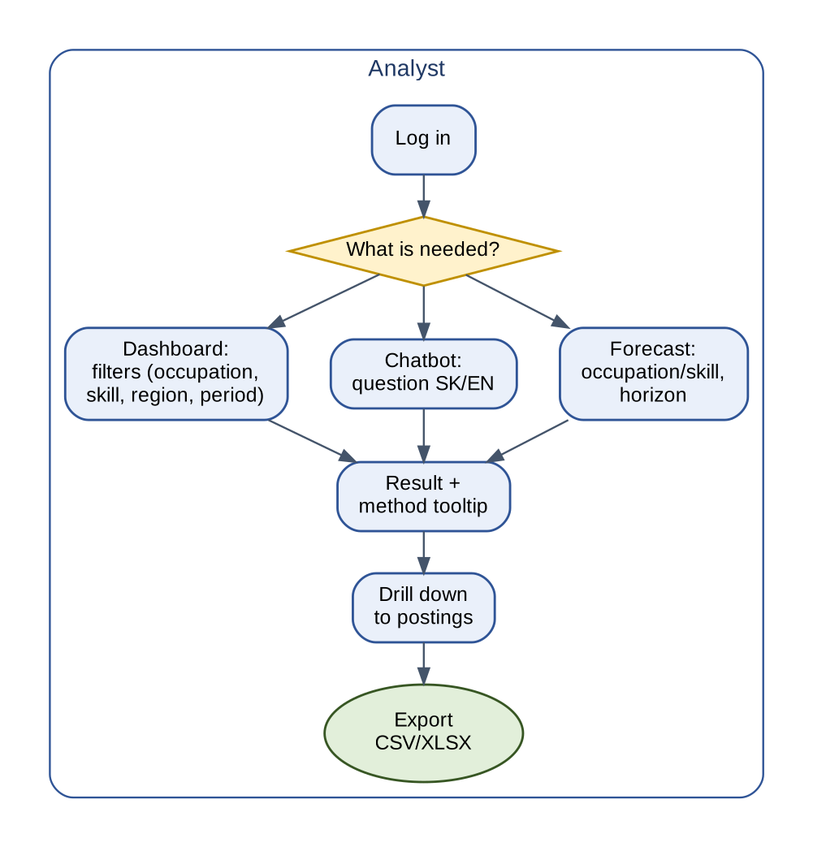
Figure 2 — User flow: analyst
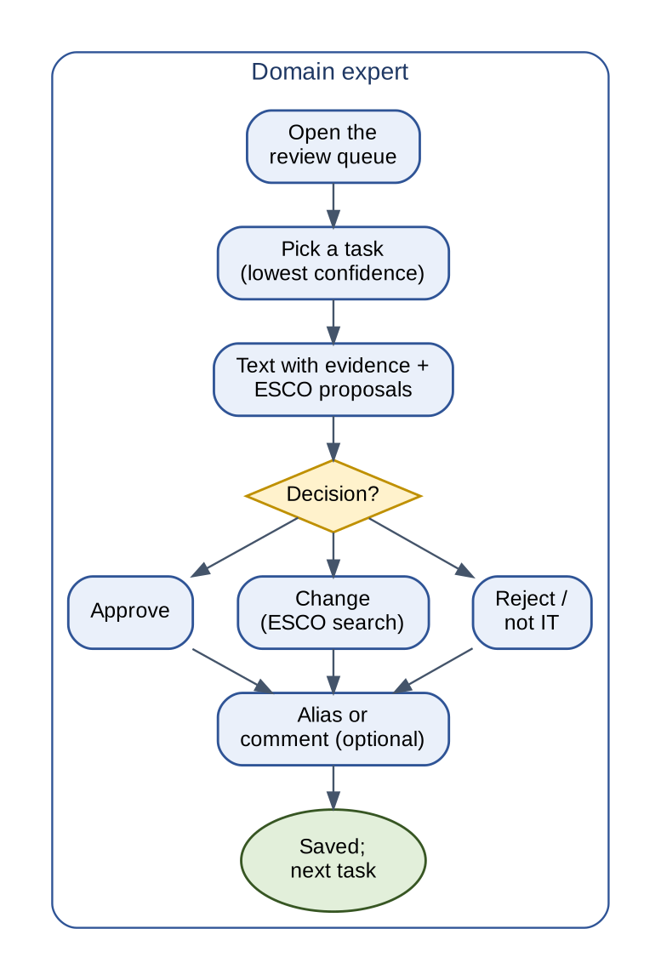 | 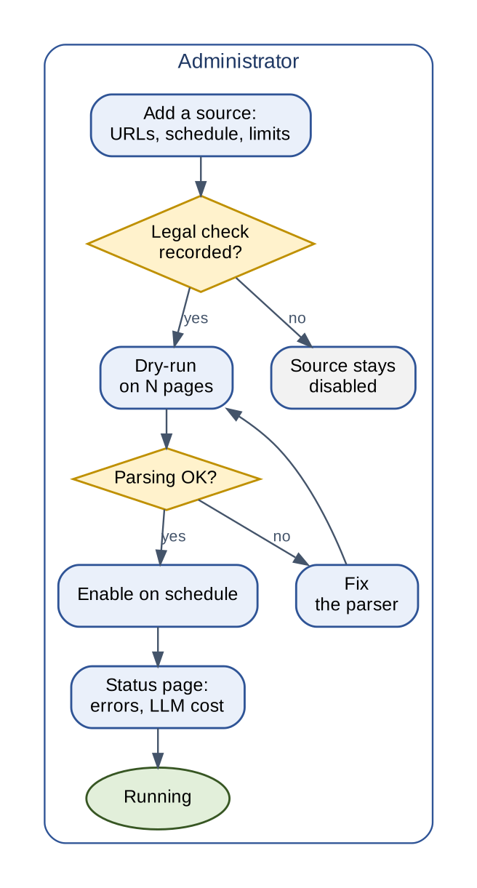
Figure 3 — User flow: expert | Figure 4 — User flow: administrator

3.2 Priority and acceptance criteria
A single task list (TODO). Every task is written once and sits under its goal. [M] Must · [S] Should · [C] Could. Each goal has a “Done when…” line; numeric targets live only in 7.3, rules and thresholds only in 3.3.
G1 — Collect postings
Done when: profesia.sk data is collected on schedule without violating robots.txt; every record links to its raw document; duplicates are merged.
☐ 1.1 profesia.sk source connector (list + detail pages), config-driven: URLs, schedule, limits; other portals = new connectors [M]
☐ 1.2 Polite incremental crawling: robots.txt, rate limit, backoff, identifiable User-Agent, no circumvention [M]
☐ 1.3 Store the raw page snapshot (URL, time, SHA-256) [M]
☐ 1.4 Parse fields: title, employer, location, contract, salary, remote, date, description; strip personal data [M]
☐ 1.5 Deduplication: reposts and cross-portal copies → one canonical posting [M]
☐ 1.6 A second source — only after a legal check (LinkedIn disabled by default) [C]
G2 — Extract and classify
Done when: Every skill has evidence in the text; seniority and specialisation are set; names are canonical.
☐ 2.1 Extract skills, technologies, tools, certifications with an evidence span (NER + LLM) [M]
☐ 2.2 Classify seniority, specialisation, skill type [M]
☐ 2.3 Normalise names via an alias dictionary (k8s → Kubernetes) maintained by the expert [M]
☐ 2.4 Language detection (SK/EN/CS), salary and region normalisation [S]
G3 — Quality control
Done when: Unsupported LLM items never reach the data; doubtful cases go through the review queue.
☐ 3.1 LLM validator: check each item against the text, flag unsupported ones, confidence [M]
☐ 3.2 Review queue for doubtful cases; the expert's decision wins and feeds the golden set [M]
☐ 3.3 Golden set: annotate ≥ 300 postings by the whole team, frozen test part [M]
G4 — Map to ESCO
Done when: Every posting has top-k ESCO occupations with scores, every skill an ESCO match or an entry in the emerging-skills registry; versions are stored.
☐ 4.1 Import the pinned ESCO v1.2 (sk/en labels, essential/optional relations, ISCO codes) + embeddings [M]
☐ 4.2 Fuzzy-map skills → ESCO skills (top-k with scores) [M]
☐ 4.3 Fuzzy-map postings → ESCO occupations (μ, thresholds) [M]
☐ 4.4 Emerging-skills registry (no ESCO match) [S]
☐ 4.5 Mapping versioning (ESCO and model version) and re-mapping [M]
G5 — Query: API and chatbot
Done when: An analyst gets an answer from the API and chatbot with links to data and the executed query.
☐ 5.1 REST API: postings, mappings, trends, forecast [M]
☐ 5.2 Chatbot (RAG + safe text-to-SQL) SK/EN, answer with source and query [M]
G6 — Analytics and BI
Done when: All slices (occupation, skill, region, seniority, time) are available and explained; export works.
☐ 6.1 Dashboards: demand by occupation, skill, region, seniority, time + drill-down to postings [M]
☐ 6.2 Skill trends, co-occurrence, emerging-skills view [S]
☐ 6.3 Export CSV/XLSX [S]
G7 — Demand estimate and forecast
Done when: Demand is estimated without double counting; the forecast has intervals and a baseline comparison.
☐ 7.1 Demand estimation: canonical postings, positions, weighted attribution [M]
☐ 7.2 Forecast with intervals: baseline + 1–2 models, selection by rolling-origin CV [M]
☐ 7.3 Calibrate portal coverage against open data (Social Insurance Agency) [S]
☐ 7.4 Indicators from company annual reports as extra regressors [C]
Platform (cross-cutting)
Done when: The system starts with one command; access is role-based.
☐ P.1 Authentication and roles (analyst, expert, admin) [M]
☐ P.2 Docker Compose, README, configuration via environment variables [M]
☐ P.3 Run log and a status page in the admin UI (errors, LLM cost, quality) [S]
☐ P.4 CI: linter and tests on every PR [M]

3.3 Business rules
ID | Rule
BR-01 | Only IT occupations are mapped: ESCO occupations with ISCO-08 codes in groups 25, 35 and 1330; the rest is “out of scope”.
BR-02 | One job counts once: the same employer + similar title/location (similarity ≥ 0.9, 30-day window) or an equal hash → one canonical posting; a repost only extends activity.
BR-03 | Number of positions v = n if n positions are stated, otherwise 1.
BR-04 | Attribution: demand is split among ≤ 3 occupations with μ ≥ 0.5 proportionally to μ; a posting's weights sum to 1 (no inflation).
BR-05 | Thresholds (initial): μ ≥ 0.75 — auto; 0.50–0.75 — review; < 0.50 — unmapped (candidate for the emerging-skills registry). Calibrated on the golden set.
BR-06 | Every skill has an evidence span in the text; inferred (implicit) skills are labelled separately.
BR-07 | Mapping results keep the ESCO and model version; re-mapping adds a new version and never overwrites the old one.
BR-08 | An expert decision overrides the automatic one and feeds the golden set; the frozen test part is never used for tuning.
BR-09 | The chatbot answers only from system data; every number is backed by an executable query.
BR-10 | A forecast always carries an interval and the method name; with history below the minimum (initial: 26 observations) only the baseline with a warning.
BR-11 | Public pages only, no login or circumvention; a source is enabled after a recorded legal assessment (ToS, robots.txt).
BR-12 | Personal data (recruiter names, phones, e-mails) is not stored — removed at parsing.

3.4 Error and exception handling
Situation | Behaviour
Portal layout changed | Schema validation → record FAILED; many errors → source auto-paused and an alert; the snapshot is kept for debugging.
403 / 429 / CAPTCHA | Backoff and a lower rate; pause after N attempts; protection is never circumvented.
LLM unavailable or slow | Retries with backoff, a task queue, fallback to a local model; no data is lost.
Invalid LLM output / no evidence | Schema validation, one stricter retry, then the item is dropped or sent to review (BR-06).
Instruction injection in posting text | Text is data (see 4.2); suspicious cases → review.
ESCO API unavailable | We use the local copy of the pinned version.
Chatbot with no data / unsafe SQL | “Insufficient data” answer; SELECT only; anything else is rejected. Too little history for a forecast — BR-10.

4. Non-functional requirements
A deliberately minimal set for a five-student, zero-budget team. Targets are initial; the measurable ones are verified in 7.3.

4.1 Performance
- Collection ≥ 1,000 postings/h per source at a polite rate (≤ 1 request/s); batch processing on a laptop with a local LLM ≥ 5 postings/min (corpus re-mapping may run overnight).
- Dashboards p95 ≤ 3 s up to 100k postings (with aggregates); API p95 ≤ 1 s; chatbot ≤ 30 s.

4.2 Security
- Login with roles (analyst, expert, admin); secrets only in environment variables; HTTPS when the service is reachable from outside.
- Chatbot SQL: read-only DB role, schema allow-list, timeout and row limit. Posting text is untrusted input for the LLM (prompt injection [8]): structured output, an extractor without tools.
- Public data only, no personal data (BR-12).

4.3 Reliability and availability
- Pipeline stages are idempotent and re-runnable; a daily DB dump (RPO 24 h); best-effort availability in working hours (pilot).

4.4 Scalability
- Designed for up to 500k postings in one PostgreSQL; a new source takes at most 2 person-days.

4.5 Usability (UX, accessibility, localization)
- UI in Slovak and English; a method tooltip next to every number; basic accessibility (contrast, keyboard).

4.6 Maintainability and testability
- Modules with clear interfaces (Source, Parser, Extractor, Mapper, Forecaster); typed Python, linter, CI (P.4); core test coverage ≥ 60 %; reproducible runs (seeds, pinned versions).

4.7 Compatibility and portability
- Docker Compose on Linux/Windows/macOS; Python ≥ 3.11; PostgreSQL ≥ 15 + pgvector; modern browsers; LLM via an OpenAI-compatible API (Ollama ↔ OpenAI); open formats CSV/JSON.

5. Interface requirements

5.1 User interface
A Streamlit web app on top of the REST API. Screens follow the user flows (3.1):
- Dashboards and posting explorer (analyst, admin); Chatbot; Forecast;
- Review queue (expert): text with highlighted evidence, ESCO proposals, alias dictionary;
- Admin: sources, runs, status, users.

5.2 API and integrations
REST API (FastAPI, OpenAPI), /api/v1 prefix, JSON, Bearer token, problem+json errors. External integrations — see 2.4.
Endpoint | Purpose
GET /postings, /postings/{id} | Postings with filters; card: skills with evidence, mapping with scores, raw document
GET /occupations, /skills | ESCO reference
GET /trends/skills | Aggregates by period and slices
GET /forecast | Forecast with intervals
POST /chat | Question → answer, table, SQL, sources
GET/POST /review/tasks | Review queue and expert decision
POST /admin/sources, /admin/runs | Source and run management

5.3 Hardware and software interfaces
- One machine: ≥ 16 GB RAM, ≈ 50 GB disk (a laptop or a university server); a GPU is optional (small quantised models also run on CPU).
- Docker, Chromium (Playwright), outbound HTTPS to portals and ESCO.

6. Data and architecture

6.1 Data model
One DBMS — PostgreSQL with pgvector (relational data + vectors). ESCO relations are stored in tables. ER notation is crow's foot: a bar = exactly one, a circle + fork = zero or many; the line runs from the parent table to the child.
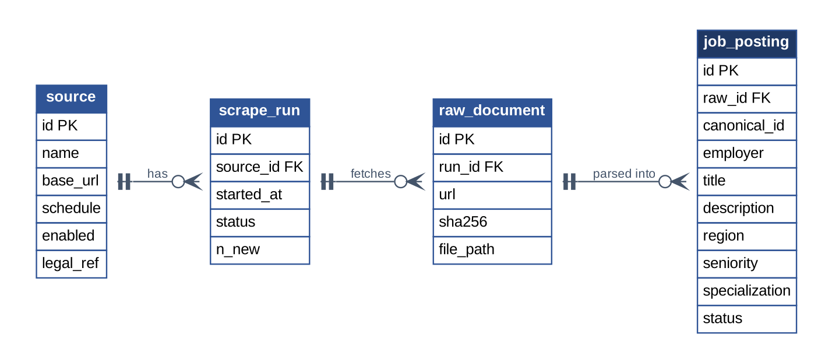
Figure 5 — ER: collection and postings
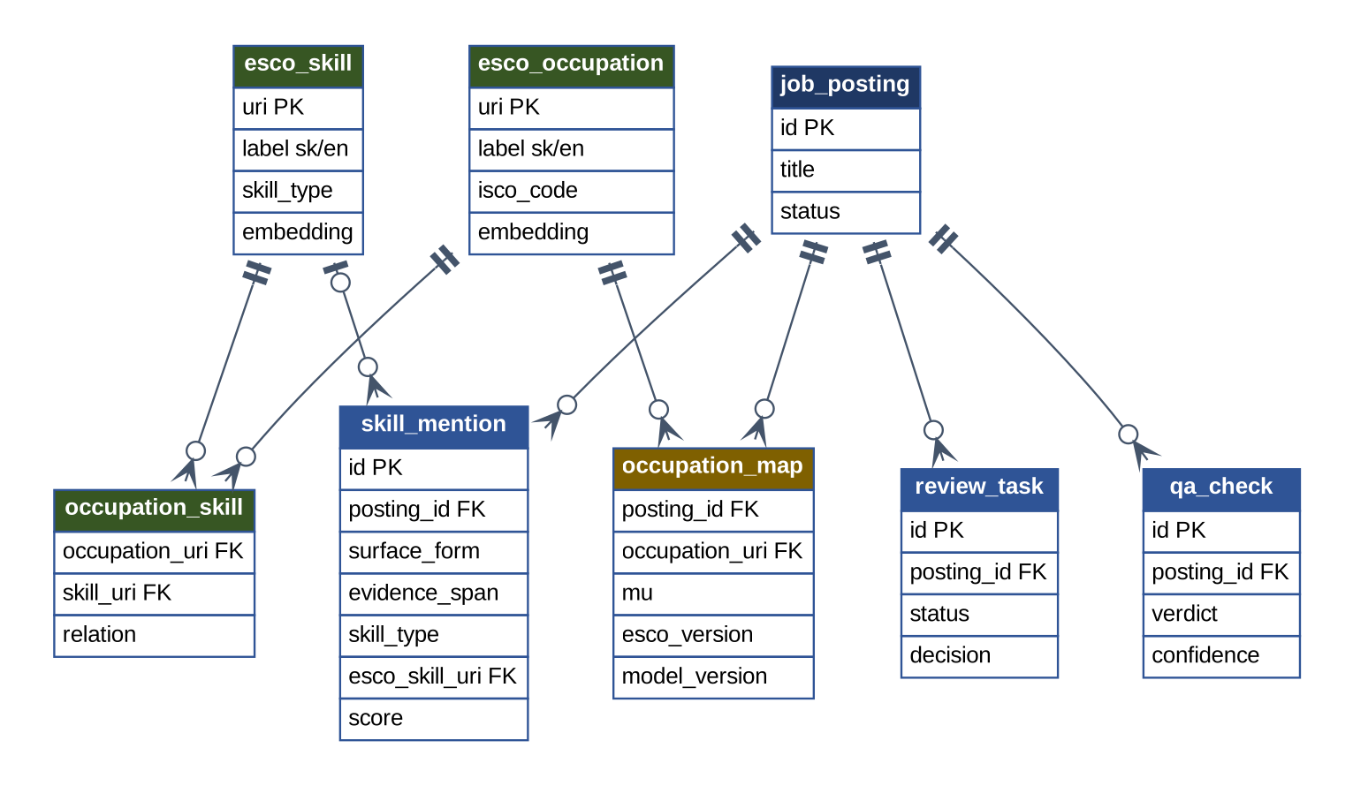
Figure 6 — ER: skills, checks, mapping and ESCO
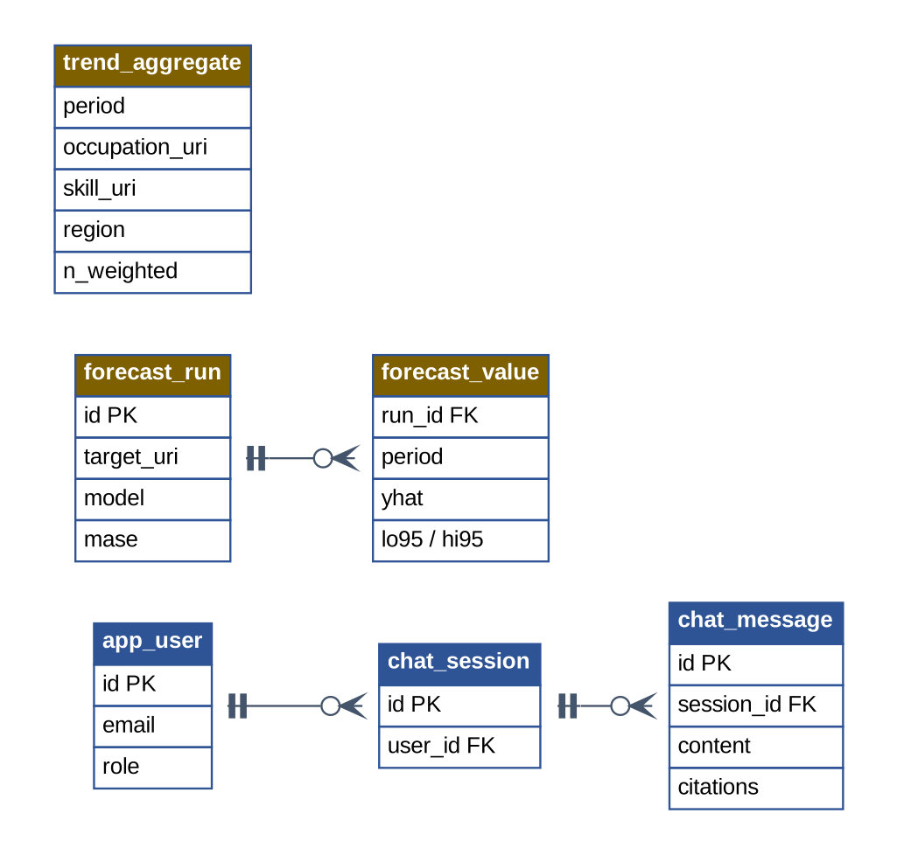
Figure 7 — ER: users, chat, aggregates, forecasts
- Raw documents are immutable (hash); the mapping is a separate “posting × occupation” table with a score and ESCO/model versions (BR-07); skill mentions keep the evidence span (BR-06); dashboard aggregates are computed incrementally.

Fuzzy mapping model
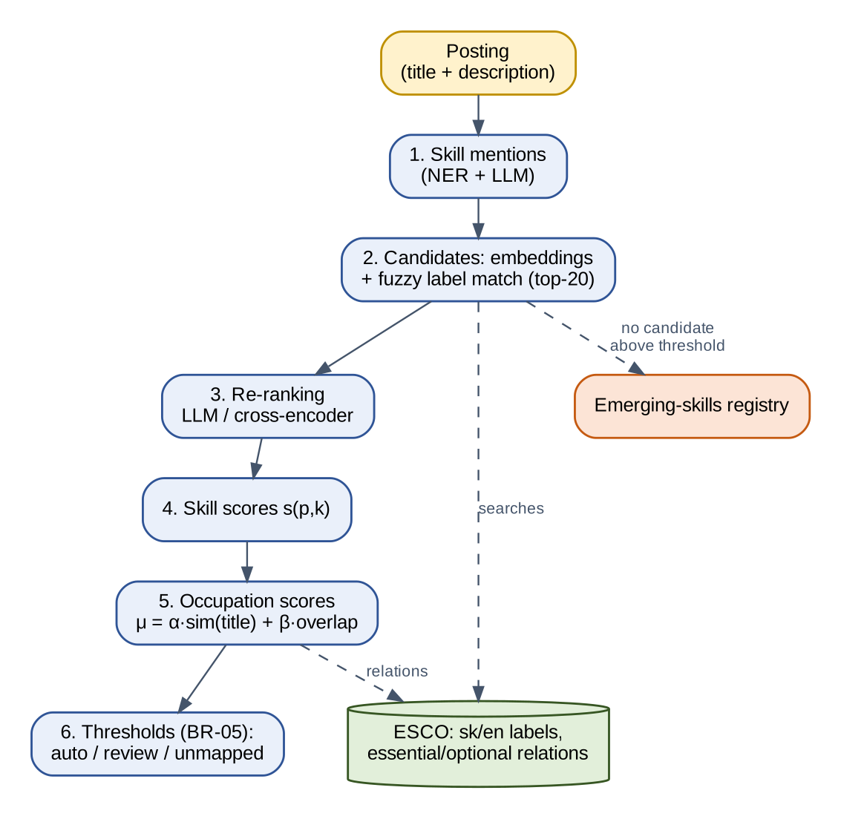
Figure 8 — ESCO mapping pipeline
- Mentions → ESCO skills. top-20 candidates by embedding cosine similarity and fuzzy label match; an LLM/cross-encoder re-ranks with context; s(p,k) is a calibrated combination of signals.
- Skills → occupations. μ(p,o) = α·sim(title, o) + β·overlap(p,o); overlap = min(1, Σ s(p,k)·r(o,k) / τ), where r = 1 for an essential and 0.5 for an optional ESCO relation, τ ≈ 10; α, β, τ are tuned on the development part of the golden set (initially 0.4 / 0.6).
- Thresholds are in BR-05. Example (illustrative): μ = 0.82; 0.64; 0.41 → the first two are used, weights 0.56 and 0.44 (BR-04).

Demand estimation and forecasting model
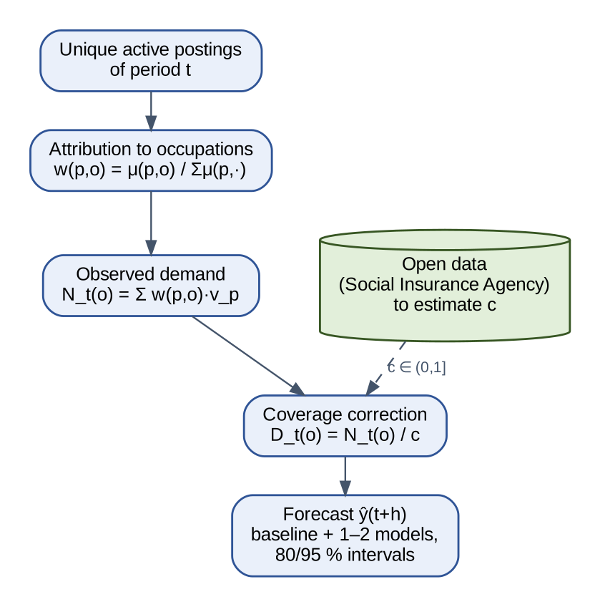
Figure 9 — From postings to estimated demand and forecast
- Demand: N_t(o) = Σ_p w(p,o)·v_p over canonical active postings of period t (rules BR-02…BR-04).
- Coverage: D_t(o) = N_t(o)/c, where c ∈ (0,1] is the share of vacancies that reach the portals; estimated by comparing with open data (task 7.3). Before calibration we show only N_t(o) and call it “portal demand”.
- Forecast: seasonal-naive as the baseline + 1–2 models (ETS/SARIMA from statsmodels, Prophet if needed); selection by rolling-origin cross-validation; 80/95 % intervals (BR-10).

6.2 Architecture and technology stack
A modular monolith (API + UI) and a batch pipeline of idempotent stages. Everything is free and open source.
Layer | Technology
Collection | Python, Playwright, httpx + BeautifulSoup
Scheduling | cron / APScheduler (Prefect — if needed)
Storage | PostgreSQL 16 + pgvector; raw documents as files
NLP / NER | spaCy, Hugging Face Transformers, SlovakBERT [6]
Embeddings | multilingual-e5 / BGE-M3 (sentence-transformers)
LLM | Ollama (local Mistral-class 7B quantised models); OpenAI — optional, capped
Chat / RAG | LlamaIndex or LangChain
Analytics, forecast | pandas, scikit-learn, statsmodels
API / UI | FastAPI, Streamlit (Plotly)
DevOps | Docker Compose, GitHub Actions, pytest, ruff

Key decisions:
- Local and free first: small models + a cache by text hash; a paid API only for sampled checks.
- Hybrid extraction: NER (fast) + an LLM with structured output; the validator looks for evidence in the text rather than guessing.
- Two-stage fuzzy mapping (candidates → re-rank) after SkiLLens; the result is a score μ, not a hard label.
- pgvector instead of separate vector and graph DBs — simpler deployment; ESCO pinned to v1.2.

6.3 Diagrams (context, component, UML)
Context is in 2.1, user flows in 3.1, ER in 6.1; sequence, activity and state in 9.1. An arrow in the component and deployment diagrams means “uses / passes data to”.
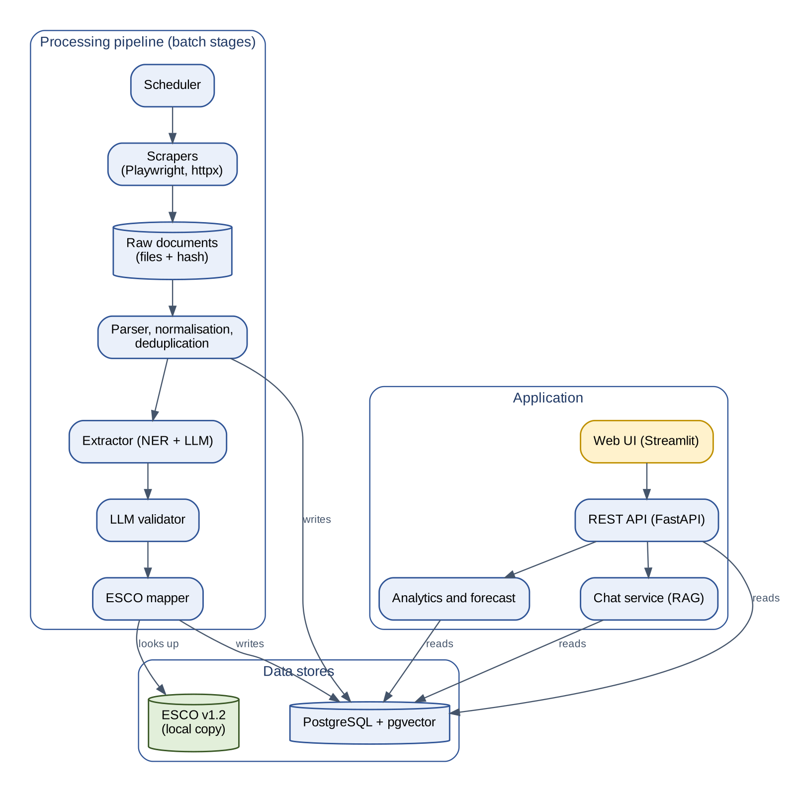
Figure 10 — Component diagram
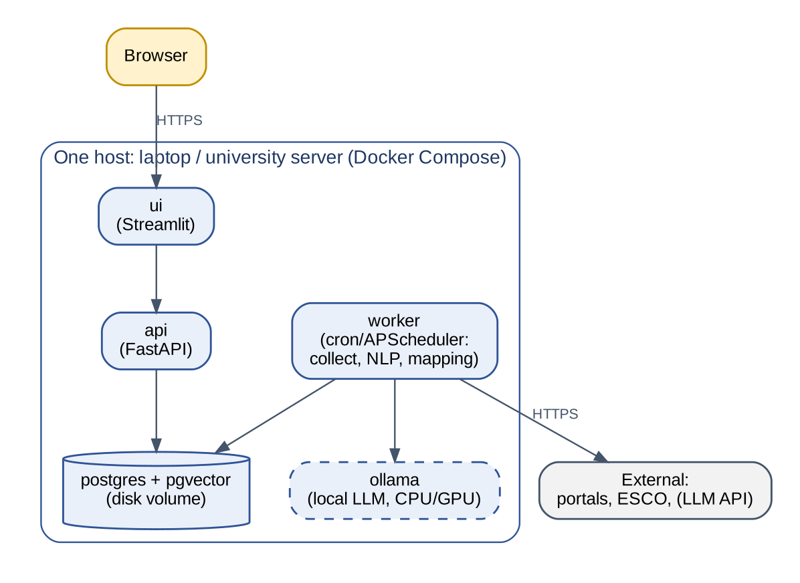
Figure 11 — Deployment diagram

7. Quality and testing

7.1 Test strategy
- Unit and integration (pytest): parsers on saved HTML pages, normalisation, deduplication, formulas for μ, weights and demand.
- Model evaluation on the golden set: extraction, classification, deduplication, mapping, chatbot questions, forecast backtests; results are compared with the previous version.
- End-to-end: one automated happy-path script + manual checks of the three user flows. Security: the SQL allow-list and ≥ 20 prompt-injection samples.
Golden set: ≥ 300 postings across seniorities, specialisations and languages; each annotated by two of the five members, disputes settled by discussion or the customer's expert; split 70/30 into a development and a frozen test part. Separately: 30 chatbot questions and ≈ 100 duplicate pairs.

7.2 Acceptance criteria
- All [M] tasks of 3.2 are done and the “Done when” lines of goals G1–G7 and the platform are met.
- The metrics of 7.3 are met on the frozen test part.
- A demo on real profesia.sk data and a UAT with a customer representative are passed.
- The documentation of 8.4 is delivered; deployment from scratch via the README takes ≤ 1 h.

7.3 Quality metrics
The only place with numeric targets (initial); measured on the frozen test part.
Metric | Target
Collection and parsing: share of fully parsed postings | ≥ 95 %
Deduplication: precision / recall | ≥ 0.95 / ≥ 0.85
Skill extraction: F1 | ≥ 0.80
Seniority / specialisation classification: macro-F1 | ≥ 0.75 / ≥ 0.70
LLM validator: share of injected errors detected | ≥ 85 %
Skill mapping (auto-accepted): top-1 precision | ≥ 0.80
Occupation mapping: top-1 accuracy / top-5 recall | ≥ 0.70 / ≥ 0.90
Chatbot: expert-rated correct answers of 30 questions; numbers traceable to a query | ≥ 80 %; 100 %
Forecast: MASE versus seasonal-naive (with enough history) | < 1

8. Project management aspects

8.1 Milestones and schedule
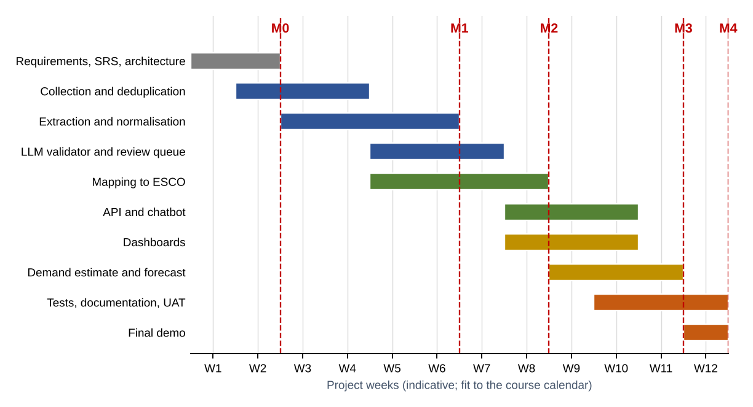
Figure 12 — Indicative schedule (project weeks)
Milestone | End of week | Deliverable
M0 | W2 | SRS agreed; legal assessment of profesia.sk; golden-set annotation started
M1 | W6 | Collection, parsing, deduplication and extraction work on real data (G1, G2)
M2 | W8 | LLM validator, review queue and ESCO mapping (G3, G4)
M3 | W11 | API, chatbot, dashboards, demand estimate and forecast (G5–G7)
M4 | W12 | Tests, UAT, documentation, final demo

8.2 Resources and team roles
The team is five students (see the first page), so roles are combined: five “hats”, one per person; every module has an owner and a backup. All five annotate the golden set and do code review. The team decides who takes which role.

Role | Owns (tasks of 3.2) | Assignee
1. Lead + Backend/DevOps | P.1–P.4, 5.1, 6.3; customer contact | Mark Slobodian
2. Data engineer | 1.1–1.6, 4.1 | Veronika Mukosii
3. NLP engineer A | 2.1–2.4, 3.1 | Oleksii Karpliuk
4. NLP/ML engineer B | 3.3, 4.2–4.5, 5.2 | Matsko Rostyslav
5. Analytics + UI | 3.2, 6.1–6.3, 7.1–7.4 | Suhak Nikita

- Zero-cost resources: GitHub (free), Docker, local LLMs on own laptops/a university server; a paid API only with the team's consent and a hard cap (TBC).
- From the customer: ≈ 2 h/week of a domain expert for annotation and review (TBC).

8.3 Risks and mitigation
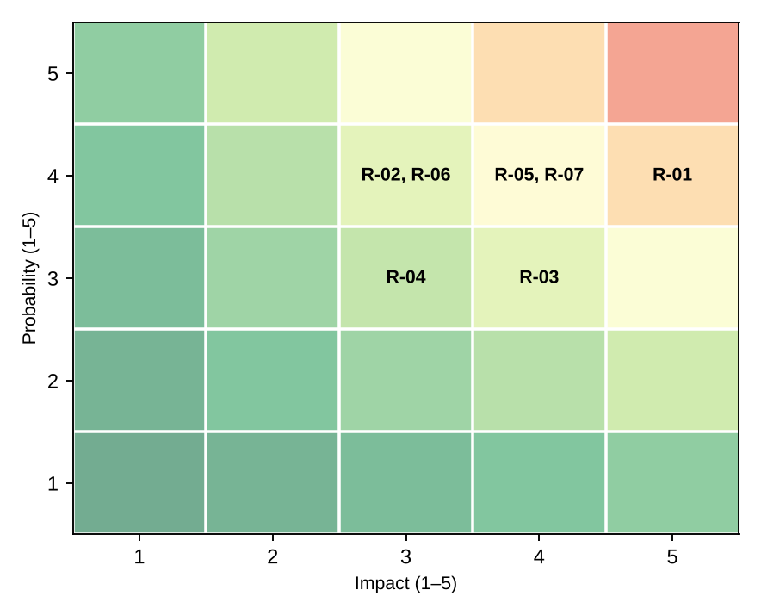
Figure 13 — Risk matrix (probability × impact)
ID | Risk | P×I | Mitigation
R-01 | Legal limits (portal ToS, LinkedIn, GDPR) | 4×5 | Legal assessment of each source before enabling (BR-11); start with profesia.sk; LinkedIn disabled; personal data removed (BR-12); consult the customer.
R-02 | Blocking and layout changes of portals | 4×3 | Polite limits and cache; parser tests on saved HTML; source auto-pause and alert; no circumvention.
R-03 | LLM errors and hallucinations | 3×4 | Evidence rule (BR-06); LLM validator; structured output; review queue; golden set.
R-04 | Weak Slovak processing and ESCO gaps | 3×3 | Multilingual embeddings and SlovakBERT; alias dictionary; emerging-skills registry; per-language metrics.
R-05 | Short data history and portal coverage bias | 4×4 | Start collecting as early as possible; call the figure “portal demand” until calibrated; forecast with a warning (BR-10).
R-06 | No budget or strong hardware for LLMs | 4×3 | Local small models (Ollama), cache by text hash; a paid API only for a sample and under a hard spending cap.
R-07 | Limited time and capacity of a 5-student team | 4×4 | M/S/C priorities; an early end-to-end MVP; every module has an owner; weekly review.

8.4 Deployment, documentation and training
- Deployment: Docker Compose, one command, configuration in `.env`; a pilot on a university server or a laptop.
- Documentation: the SRS, README, architecture diagrams, OpenAPI (generated), a short SK/EN user guide, a legal-assessment record per source.
- Training: one demo session for analysts and administrators + a one-page guide; a hand-over at the end.

9. Appendices

9.1 Supporting diagrams and examples
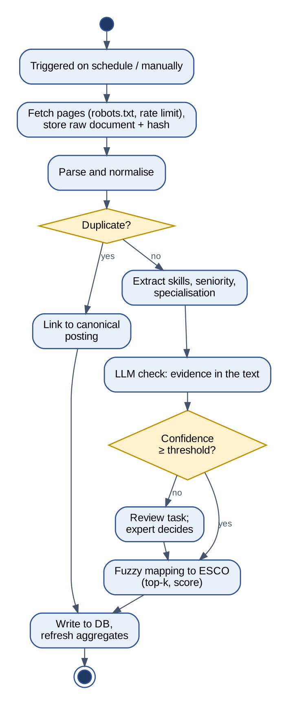
Figure 14 — Activity diagram: processing one posting
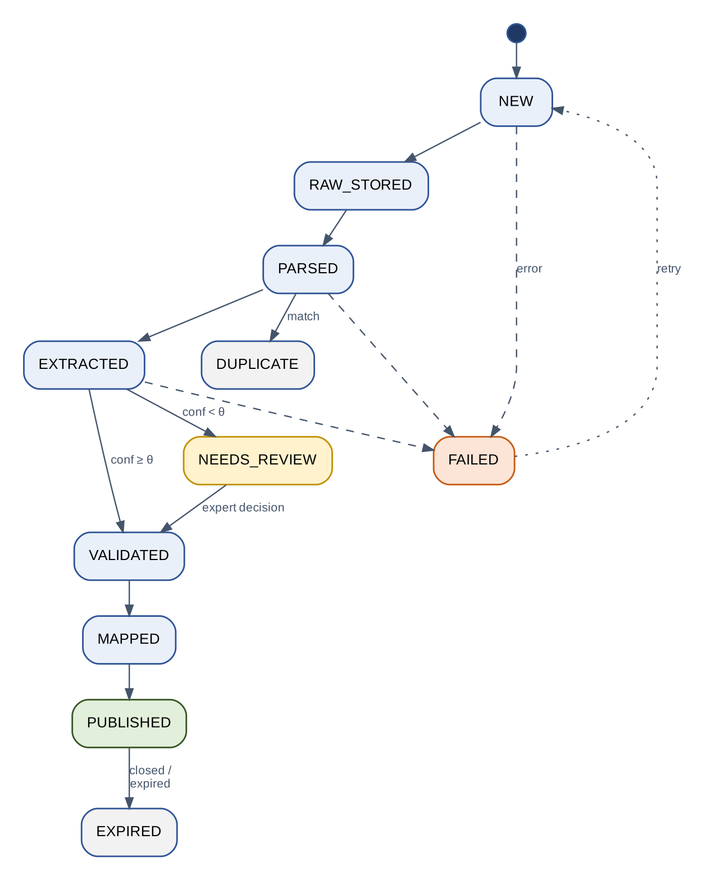
Figure 15 — Posting state diagram (θ — confidence threshold)
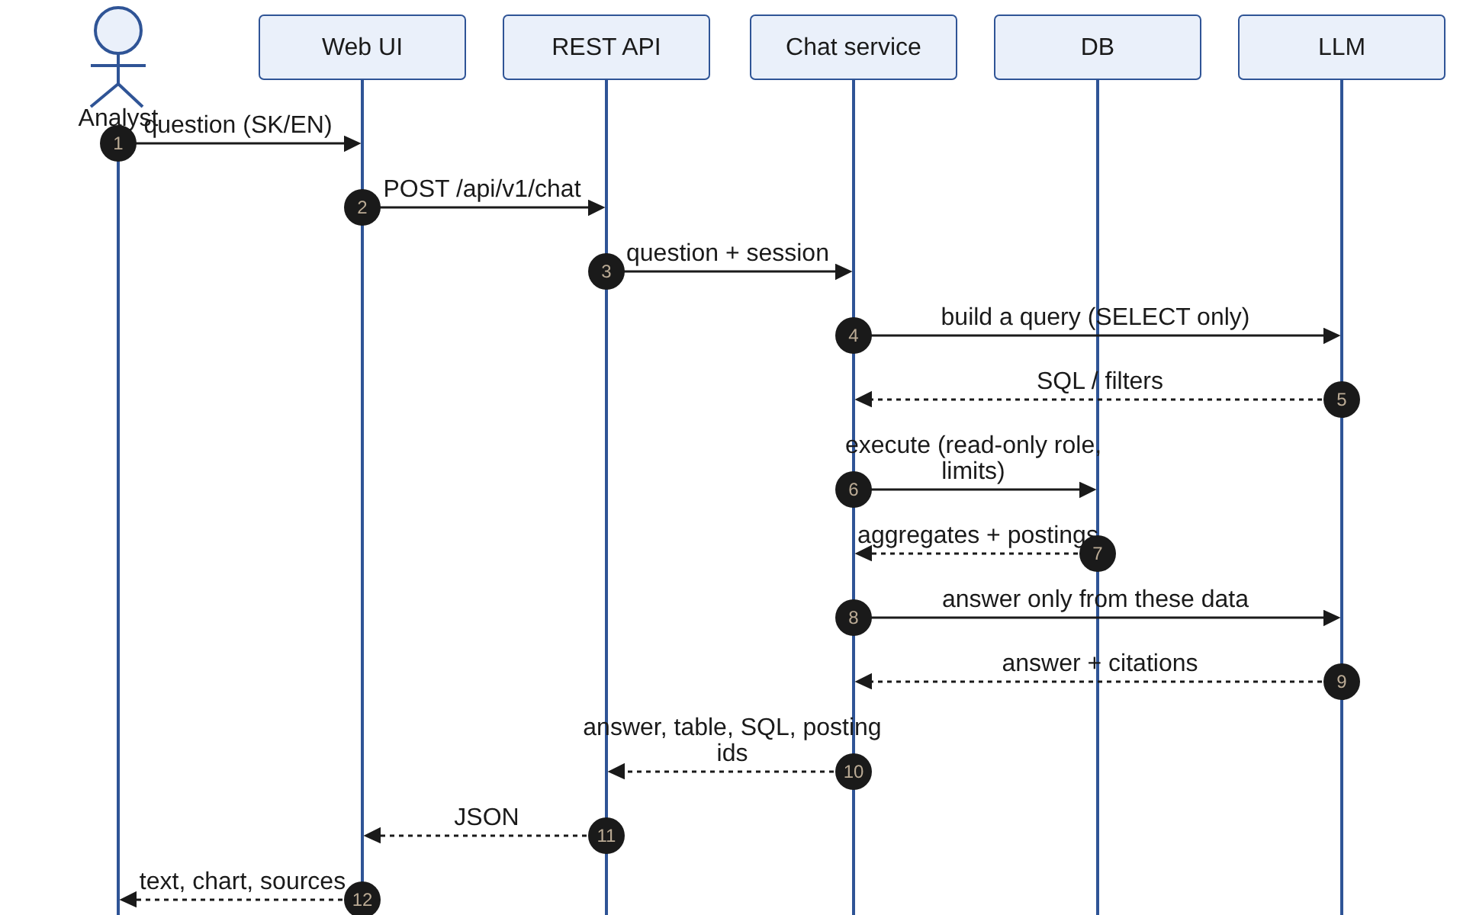
Figure 16 — Sequence diagram: a chatbot query
Example of a processed posting (illustrative, invented data):
{
"source": "profesia.sk", "lang": "sk", "title": "Senior DevOps Engineer",
"employer": "Example s.r.o.", "region": "Košický kraj",
"seniority": "senior", "specialization": "devops",
"skills": [{"surface": "k8s", "canonical": "Kubernetes", "type": "technology",
"evidence": "skúsenosti s k8s a Helm", "esco_uri": null}],
"qa": {"verdict": "supported", "confidence": 0.91},
"occupation_map": [{"occupation": "<ESCO occupation A>", "mu": 0.82, "status": "auto"},
{"occupation": "<ESCO occupation B>", "mu": 0.64, "status": "review"}],
"versions": {"esco": "1.2", "mapper": "m-0.3"}
}

Example chatbot questions: “Which skills are most often mentioned in senior-developer postings in the Košice region?”; “How has demand for cloud technologies changed over a year?”; “Which new technologies appear in postings but not yet in ESCO?”

