23CSE111 OBJECT ORIENTED PROGRAMMING
S2 B.Tech CSE
Department of Computer Science and Engineering
Amrita School of Computing, Amritapuri Campus
CASE STUDY
PHASE – 2 (Design)
Architectural Modelling (CO2)

Group No : 6
Team Members :
Roll No | Student Name
AM.SC.U4CSE25243 | Rajiv A R
AM.SC.U4CSE25252 | Sreerag T C
AM.SC.U4CSE25206 | Aaryan Rajesh
AM.SC.U4CSE25249 | Shreyas Rajesh Nair

Problem Title : Event Management System
STRUCTURAL DESIGN
2. Class diagram (draw class diagram that shows different classes and their relationships. Use UML notations)
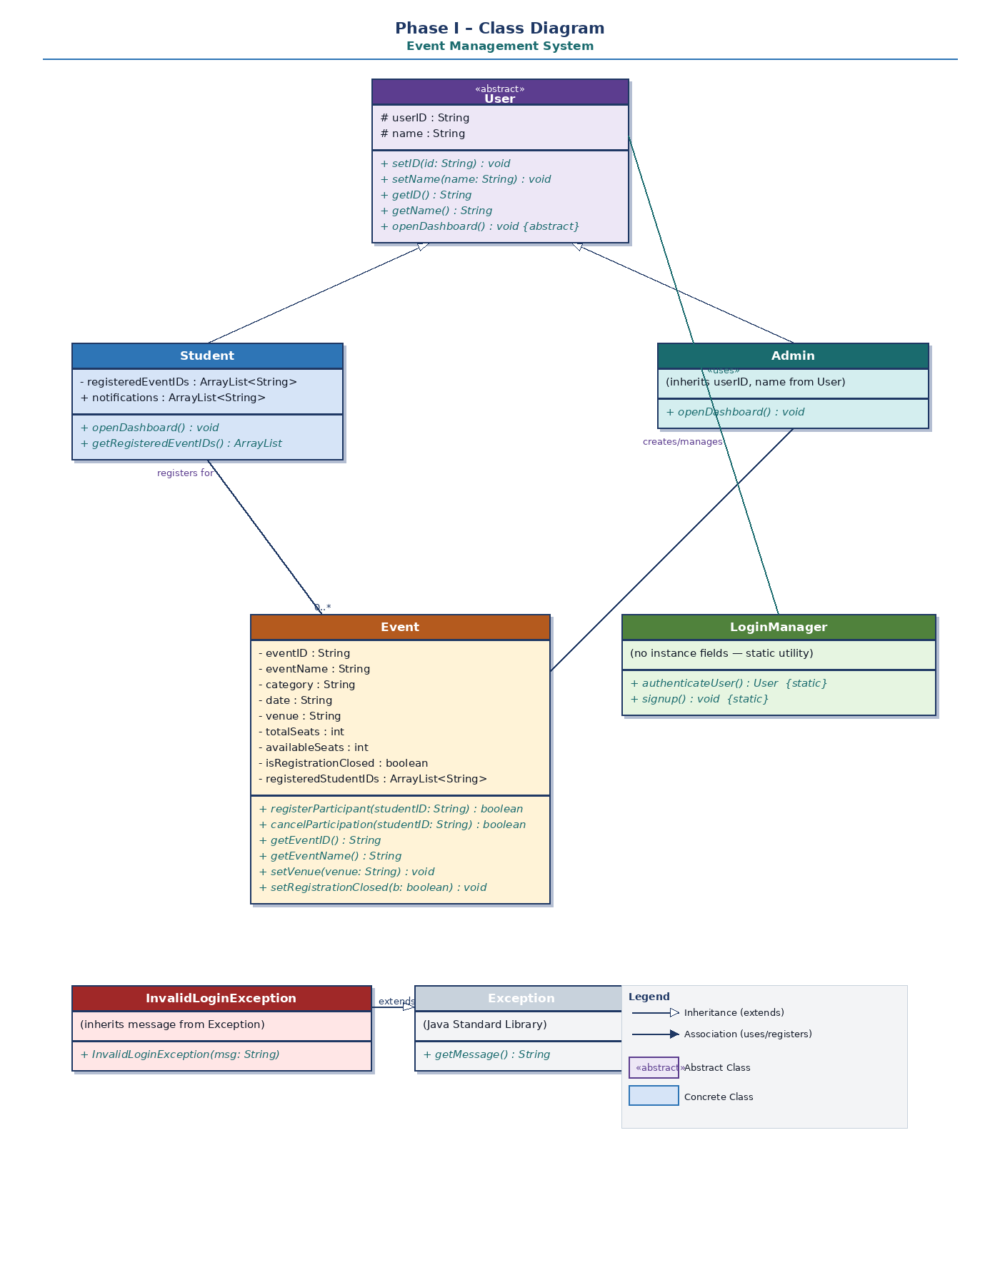
BEHAVIOURAL DESIGN
3. Use-case diagram
a. List of actors
  - Student / User
  - Organizer / Admin

b. List of use-cases
1. View registered events – user can view all events that the user has registered for.
2. Register for event – user can register for a specific event.
3. Update available seats – user cannot interact with this directly. When they register for an event, one seat is automatically reduced from number of available seats.
4. Browse events – user can see all available events to register for.
5. Cancel Participation – user can cancel their participation for a specific event.
6. Register/Login – user/admin can login/sign up to their dashboard.
7. Manage Participation lists – admin can manage participants for a particular event.
8. Monitor registrations – admin can see statuses and participants of all events.
9. Close registrations – close admission of participants for a particular event.
10. Verify participants – admin can see all participants for an event.
11. Create and update events – admin can create/update an event.

c. Use case diagram
(use UML notations)
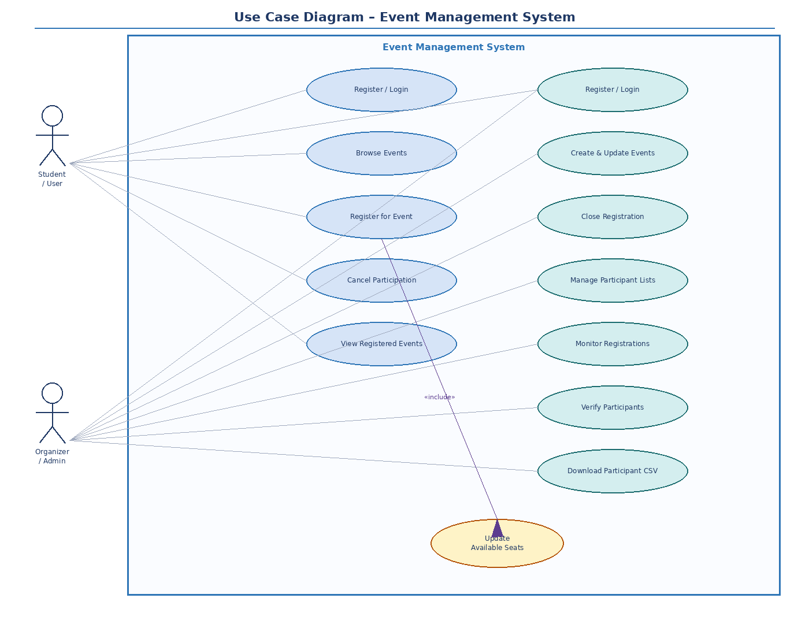
4. Sequence diagram (use UML notations)
a. Choose key use cases and draw their sequence diagram. First describe the scenario in few sentences. Then draw the sequence diagram.
ORGANIZER CREATES AN EVENT
Organizer chooses method createEvent() and enters event information (event ID, name, category, date, venue, seat limit). The system validates the date format and checks for duplicate event IDs. An event object is thus created and saved to the events database. Admin gets message that event is successfully created.
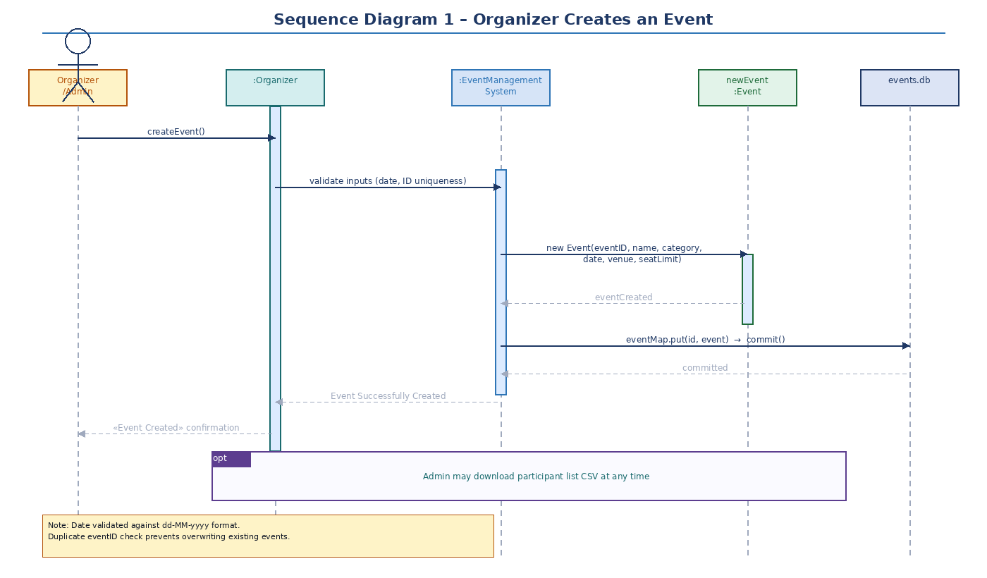
b. Choose key use cases and draw their sequence diagram. First describe the scenario in few sentences. Then draw the sequence diagram.
STUDENT REGISTERS FOR AN EVENT
Student chooses to register for an event by entering the event ID. The available seat count for the specific event is retrieved. The system checks three conditions: (1) registration is not closed, (2) seats are available (> 0), and (3) student has not already registered. If any condition fails, the student receives a registration failed message. Otherwise, a Registration object is created, available seats are decremented by 1, changes are committed to both databases, and the student receives a registration successful confirmation.
