23CSE202 DATABASE MANAGEMENT SYSTEMS
S3 B.Tech CSE
Department of Computer Science and Engineering
Amrita School of Computing, Amritapuri Campus
____________________________________________________
PROJECT REPORT
Group No: C7
Team Members:
Roll No | Student Name
AM.SC.U4CSE25243 | Rajiv A R
AM.SC.U4CSE25252 | Sreerag T C
AM.SC.U4CSE25249 | Shreyas Rajesh Nair
AM.SC.U4CSE25206 | Aryan Rajesh

Project Title: Eventy.io – Campus Event & Registration Management System
CONTENTS
Sl. No | Chapter
1 | Abstract
2 | Introduction
3 | Requirements (Functional & Non-functional)
4 | UI Design
5 | Database Design
6 | Database Selection & Justification
7 | Implementation
8 | Testing & Validation
9 | Results & Screenshots
10 | Challenges Faced & Solutions
11 | Conclusion & Future Enhancements

____________________________________________________
1. Abstract
Eventy.io is a full-stack, database-driven Campus Event and Registration Management System engineered to streamline event discovery, capacity management, student bookings, and administrative oversight across educational institutions. Traditional campus event tracking relies on manual spreadsheets or disparate Google Forms, leading to severe data redundancy, seat overbooking, and lack of real-time visibility. The primary objective of Eventy.io is to deliver an ACID-compliant relational database system paired with an intuitive web application that enforces business constraints directly at the database layer. The proposed system features a normalized 3rd Normal Form (3NF) relational model in PostgreSQL, dynamic data calculation using PostgreSQL Views (event_status_view), and strict seat capacity validation via custom procedural PL/pgSQL triggers (check_capacity_before_insert). Built with Next.js for the frontend and Python FastAPI for the REST middleware, Eventy.io guarantees zero seat overbooking, instant registration tracking, composite primary key deduplication, and automated referential integrity maintenance using cascading deletes.
____________________________________________________
2. Introduction
2.1 Problem Domain & Background
In university ecosystems, student organizations, departments, and clubs frequently host academic workshops, technical hackathons, cultural fests (such as VIDYUT), and sports tournaments. Managing student registrations, venue allocation, and seat limits is a critical administrative function.
2.2 Limitations of Existing Systems
The prevailing methods for campus event management exhibit severe operational bottlenecks:
- Manual Data Entry & Spreadsheets: Event managers rely on static spreadsheets or Google Forms, which lack concurrency controls and real-time validation.
- Overbooking & Capacity Chaos: When popular events reach maximum seat capacity, forms fail to automatically close or block incoming entries, causing venue overcrowding.
- Data Redundancy & Inconsistency: Student details are re-entered for every single event registration, resulting in duplicate, un-normalized records and data anomalies.
- Lack of Role-Based Security: Untrained event volunteers accidentally modify or delete registration spreadsheets without audit trails or role-based access control.
- No Real-Time Analytics: Administrators cannot view overall campus engagement metrics, registration trends, or real-time available seat counts.
2.3 Proposed Solution
Eventy.io addresses these limitations by introducing a centralized Relational Database Management System (RDBMS) architecture. By encapsulating validation constraints, seat availability calculations, and relational integrity directly inside PostgreSQL, the application separates UI concerns from core data rules. The solution guarantees real-time synchronization between student bookings and administrator management dashboards while eliminating overbooking through database triggers.
____________________________________________________
3. Requirements (Functional & Non-functional)
3.1 Functional Requirements
- Role-Based Authentication & Authorization:
- Secure login mechanism for two user roles: student and organizer (admin).
- SQL CHECK constraint enforcement on user roles during authentication.
- Session management via HTTP-only cookie tokens.
- Event Management (Admin Portal):
- Ability for event managers to create new events specifying title, description, category, date, time, venue, and maximum seat capacity.
- Ability to edit existing event metadata and update venue/time details.
- Ability to delete events with automated cascading removal of associated student registrations.
- Event Discovery & Filtering (Student Portal):
- Real-time event catalog display featuring live available seat counters (total_seats - registered_seats).
- Multi-criteria filtering by event category (Workshop, Academic, Social, Sports, Career) and search by event title/ID.
- Availability toggle to filter out fully booked events (available_seats > 0).
- Event Registration & Unregistration:
- One-click event registration for authenticated students.
- Duplicate registration blocking via Composite Primary Key (student_id, event_id).
- Event seat capacity validation via PL/pgSQL database triggers.
- Ability for students to cancel their registrations and free up seats dynamically.
- Administrative Analytics & Reporting:
- Real-time summary dashboard displaying total campus registrations, active upcoming events, and a live 10-entry recent activity audit feed.
- Notification System:
- Automated delivery of event updates and reminders to student accounts with dismissal functionality.
3.2 Non-functional Requirements
- Performance & Low Latency:
- Sub-50ms database query execution for event catalog retrieval using optimized PostgreSQL database views.
- Data Integrity & Consistency (ACID):
- Atomicity and Isolation for concurrent registration transactions to guarantee seat counts are updated accurately without race conditions.
- Security:
- Parameterized SQL queries across all API endpoints to eliminate SQL Injection (SQLi) vulnerabilities.
- Password confidentiality and secure role validation.
- Reliability & Availability:
- Database foreign key constraints with ON DELETE CASCADE preventing orphan records.
- Usability & Modern UX:
- Responsive dark-mode user interface designed with micro-animations, toast feedback alerts, and loading skeletons.
____________________________________________________
4. UI Design
4.1 System Navigation Flow
The application follows a structured, role-based navigation flow:
[ Landing / Home Page (http://localhost:3000) ]
│
┌─────────┴─────────┐
▼ ▼
[ Student Tab ] [ Admin Tab ]
│ │
▼ ▼
[ Student Dashboard ] [ Admin Dashboard ]
├── Event Catalog ├── Metrics Summary (Total Regs, Active Evts)
├── Filter & Search ├── Recent Activity Stream
├── My Registrations └── Manage Events Page
└── Profile Settings ├── Create Event Modal
├── Edit Event Modal
└── Delete Event Action
4.2 Key Screen Descriptions
- Home Page (`http://localhost:3000`):
- Landing interface featuring system overview, featured event highlights, and CTA buttons directing users to role-based login.
- Login Page (`http://localhost:3000/login`):
- Dual-tab toggle card (Student vs Admin).
- Automatically switches required role payload sent to backend (student vs organizer).
- Student Dashboard (`http://localhost:3000/dashboard/students`):
- Header Banner: Personalized welcome message with quick stats (Events attended and Upcoming registrations count).
- Search & Filter Bar: Instant text search input, category selector dropdown, and "Available only" toggle switch.
- Event Grid: Dynamic card layout displaying event title, date, time, venue, category badge, and live seat progress indicator (e.g. 48 / 50 seats taken).
- Interactive Buttons: Cards for registered events display a red Cancel Registration ✕ button, while unregistered events display Reserve spot.
- Admin Dashboard (`http://localhost:3000/dashboard/admin`):
- Metrics Cards: Live counts for Total Registrations and Active Upcoming Events.
- Recent Activity Table: Real-time audit log showing student name, registered event title, and registration timestamp.
- Manage Events Page (`http://localhost:3000/dashboard/admin/events`):
- Tabular view of all events with ID, Name, Date, Capacity (registered/total), Status badge, and Edit/Delete action dropdowns.
- Create Event Modal: Form dialog requesting Title, Description, Category, Date, Time, Venue, and Total Capacity.
____________________________________________________
5. Database Design
5.1 ER Model & Entity-Relationship Diagram
The ER Model consists of three strong entities (USERS, EVENTS, NOTIFICATIONS) and one associative relationship entity (REGISTRATIONS).
erDiagram
USERS {
string user_id PK
string name
string email UK
string role
string password
}
EVENTS {
string event_id PK
string name
string description
string category
date date
time time
string venue
integer total_seats
}
REGISTRATIONS {
string student_id PK, FK
string event_id PK, FK
timestamp registration_time
}
NOTIFICATIONS {
integer notification_id PK
string student_id FK
text message
timestamp clear_date
}
USERS ||--o{ REGISTRATIONS : "registers for (1:N)"
EVENTS ||--o{ REGISTRATIONS : "has registrations (1:N)"
USERS ||--o{ NOTIFICATIONS : "receives (1:N)"
5.2 Entities, Attributes & Constraints
- `USERS` Entity:
- user_id (VARCHAR(50), Primary Key)
- name (VARCHAR(100), NOT NULL)
- email (VARCHAR(100), UNIQUE, NOT NULL)
- role (VARCHAR(20), CHECK constraint: role IN ('student', 'organizer'), NOT NULL)
- password (VARCHAR(255), NOT NULL)
- `EVENTS` Entity:
- event_id (VARCHAR(20), Primary Key)
- name (VARCHAR(150), NOT NULL)
- description (TEXT)
- category (VARCHAR(50), NOT NULL)
- date (DATE, NOT NULL)
- time (TIME, NOT NULL)
- venue (VARCHAR(100), NOT NULL)
- total_seats (INTEGER, NOT NULL)
- `REGISTRATIONS` Associative Entity:
- student_id (VARCHAR(50), Foreign Key -> USERS(user_id) ON DELETE CASCADE)
- event_id (VARCHAR(20), Foreign Key -> EVENTS(event_id) ON DELETE CASCADE)
- registration_time (TIMESTAMP, DEFAULT CURRENT_TIMESTAMP)
- Composite Primary Key: (student_id, event_id)
- `NOTIFICATIONS` Entity:
- notification_id (INTEGER, Primary Key, Auto-increment Sequence)
- student_id (VARCHAR(50), Foreign Key -> USERS(user_id) ON DELETE CASCADE)
- message (TEXT, NOT NULL)
- clear_date (TIMESTAMP, NOT NULL)
5.3 Relational Schema & Mapping Rules
- Mapping `USERS`: USERS(<u>user_id</u>, name, email, role, password)
- Mapping `EVENTS`: EVENTS(<u>event_id</u>, name, description, category, date, time, venue, total_seats)
- Mapping `REGISTRATIONS`: REGISTRATIONS(<u>student_id, event_id</u>, registration_time)
- Mapping `NOTIFICATIONS`: NOTIFICATIONS(<u>notification_id</u>, student_id, message, clear_date)
5.4 Functional Dependencies & Normalization Proofs
1st Normal Form (1NF)
- All attributes contain atomic, scalar values (no multi-valued or composite attributes).
- Every table has a defined Primary Key.
2nd Normal Form (2NF)
- Meets 1NF requirements.
- In REGISTRATIONS, the non-key attribute registration_time is fully functionally dependent on the entire composite primary key (student_id, event_id). No partial dependencies exist:
- {student_id, event_id} -> registration_time
3rd Normal Form (3NF)
- Meets 2NF requirements.
- No transitive dependencies exist in any table:
- In USERS: user_id -> {name, email, role, password} (all attributes depend solely on superkey).
- In EVENTS: event_id -> {name, description, category, date, time, venue, total_seats}.
- In NOTIFICATIONS: notification_id -> {student_id, message, clear_date}.
- Conclusively, the schema is in 3NF, eliminating update, insertion, and deletion anomalies.
____________________________________________________
6. Database Selection & Justification
6.1 Selected DBMS: PostgreSQL (Version 18)
PostgreSQL was selected as the core RDBMS engine for Eventy.io.
6.2 Key Justifications for PostgreSQL
- Robust Procedural Language Support (PL/pgSQL):
- Allows execution of custom procedural code inside the database engine (check_capacity_before_insert()), enforcing ACID transactions before row commitment.
- Advanced SQL Views & Query Optimization:
- Supports declarative SQL Views (event_status_view) with efficient execution plans using LEFT JOIN and COALESCE aggregation.
- Multi-Version Concurrency Control (MVCC):
- High-concurrency support enabling hundreds of students to browse and register simultaneously without database locking contention.
- Strong Data Integrity & Constraints:
- Native support for CHECK constraints, composite keys, cascading foreign key constraints (ON DELETE CASCADE), and custom sequence generators.
- Open-Source & Industry Adoption:
- Free, highly reliable enterprise database engine supported across all major operating systems.
____________________________________________________
7. Implementation
7.1 Database Creation & Table Schemas (DDL)
-- 1. Create Database
CREATE DATABASE eventy;
-- 2. USERS Table
CREATE TABLE public.users (
user_id character varying(50) NOT NULL,
name character varying(100) NOT NULL,
email character varying(100) NOT NULL,
role character varying(20) NOT NULL,
password character varying(255) NOT NULL,
CONSTRAINT users_pkey PRIMARY KEY (user_id),
CONSTRAINT users_email_key UNIQUE (email),
CONSTRAINT users_role_check CHECK (role IN ('student', 'organizer'))
);
-- 3. EVENTS Table
CREATE TABLE public.events (
event_id character varying(20) NOT NULL,
name character varying(150) NOT NULL,
description text,
category character varying(50) NOT NULL,
date date NOT NULL,
"time" time without time zone NOT NULL,
venue character varying(100) NOT NULL,
total_seats integer NOT NULL,
CONSTRAINT events_pkey PRIMARY KEY (event_id)
);
-- 4. REGISTRATIONS Table (Junction Table)
CREATE TABLE public.registrations (
student_id character varying(50) NOT NULL,
event_id character varying(20) NOT NULL,
registration_time timestamp without time zone DEFAULT CURRENT_TIMESTAMP,
CONSTRAINT registrations_pkey PRIMARY KEY (student_id, event_id),
CONSTRAINT registrations_student_id_fkey FOREIGN KEY (student_id)
REFERENCES public.users(user_id) ON DELETE CASCADE,
CONSTRAINT registrations_event_id_fkey FOREIGN KEY (event_id)
REFERENCES public.events(event_id) ON DELETE CASCADE
);
-- 5. NOTIFICATIONS Table
CREATE SEQUENCE public.notifications_notification_id_seq START WITH 1 INCREMENT BY 1;
CREATE TABLE public.notifications (
notification_id integer DEFAULT nextval('public.notifications_notification_id_seq') NOT NULL,
student_id character varying(50),
message text NOT NULL,
clear_date timestamp without time zone NOT NULL,
CONSTRAINT notifications_pkey PRIMARY KEY (notification_id),
CONSTRAINT notifications_student_id_fkey FOREIGN KEY (student_id)
REFERENCES public.users(user_id) ON DELETE CASCADE
);
7.2 Dynamic SQL View (`event_status_view`)
CREATE VIEW public.event_status_view AS
SELECT e.event_id,
e.name,
e.category,
e.date,
e."time",
e.venue,
e.total_seats,
COALESCE(count(r.student_id), 0) AS total_registered,
(e.total_seats - COALESCE(count(r.student_id), 0)) AS available_seats,
CASE
WHEN ((e.total_seats - COALESCE(count(r.student_id), 0)) <= 0) THEN true
ELSE false
END AS isregistrationclosed
FROM public.events e
LEFT JOIN public.registrations r ON e.event_id::text = r.event_id::text
GROUP BY e.event_id, e.name, e.category, e.date, e."time", e.venue, e.total_seats;
7.3 PL/pgSQL Capacity Trigger Function
-- Trigger Function Definition
CREATE OR REPLACE FUNCTION public.check_capacity_before_insert() RETURNS trigger
LANGUAGE plpgsql
AS $$
DECLARE
current_count INT;
max_capacity INT;
BEGIN
-- Retrieve maximum total seats for the targeted event
SELECT total_seats INTO max_capacity
FROM Events WHERE event_id = NEW.event_id;
-- Count existing registered students
SELECT COUNT(*) INTO current_count
FROM Registrations WHERE event_id = NEW.event_id;
-- Abort transaction if capacity limit is reached
IF current_count >= max_capacity THEN
RAISE EXCEPTION 'Registration failed: Event is at full capacity.';
END IF;
-- Proceed with insertion if seats are available
RETURN NEW;
END;
$$;
-- Binding Trigger to Registrations Table
CREATE TRIGGER enforce_event_capacity
BEFORE INSERT ON public.registrations
FOR EACH ROW EXECUTE FUNCTION public.check_capacity_before_insert();
7.4 Sample Data Population & CRUD SQL Snippets
-- Insert Sample Users
INSERT INTO public.users (user_id, name, email, role, password) VALUES
('AM.SC.U4CSE25252', 'Sreerag TC', 'sreerag@amrita.edu', 'student', 'pass123'),
('ADM-001', 'Admin', 'admin@cems.dev', 'organizer', 'admin123');
-- Insert Sample Event
INSERT INTO public.events (event_id, name, description, category, date, time, venue, total_seats) VALUES
('EVT-1009', 'VIDYUT 2026', 'Annual National Tech Fest', 'Social', '2026-10-25', '10:00:00', 'Main Auditorium', 500);
-- Query Event Availability View
SELECT event_id, name, total_seats, total_registered, available_seats
FROM event_status_view
WHERE event_id = 'EVT-1009';
____________________________________________________
8. Testing & Validation
To demonstrate system accuracy, comprehensive test cases were designed covering functional operations, database constraints, and exception handling.
Test Case ID | Feature Tested | Input / Condition | Expected Output | Actual Output | Status
TC-01 | Student Authentication | Valid email (sreerag@amrita.edu) & password (pass123) with role student | Login HTTP 200, HTTP-only session cookie set | Login HTTP 200, Redirect to /dashboard/students | PASS
TC-02 | Role Constraint Validation | Log in with admin@cems.dev under Student tab | HTTP 401 "Invalid credentials" (role mismatch) | HTTP 401 "Invalid credentials" | PASS
TC-03 | Event Registration | Student AM.SC.U4CSE25252 registers for EVT-1009 | Insertion in registrations, seat count decrements | Row inserted, view updates available_seats | PASS
TC-04 | Composite Key Deduplication | Student attempts to register for EVT-1009 a second time | Database blocks duplicate (student_id, event_id) insertion | HTTP 400 "Event is full or already registered" | PASS
TC-05 | Capacity Trigger Enforcement | Register for an event where total_registered >= total_seats | check_capacity_before_insert() raises exception | Transaction aborted, exception message returned | PASS
TC-06 | Registration Cancellation | Student cancels registration for EVT-1009 | DELETE FROM Registrations executes successfully | Row deleted, seat count increments by 1 | PASS
TC-07 | Admin Event Creation | Admin submits new event VIDYUT 2026 via modal | Auto-increments ID to EVT-1009, inserts in events | Row created in events, displays on catalog | PASS
TC-08 | Admin Analytics View | Admin requests /api/admin/stats | Aggregates COUNT(*) from Registrations & active Events | Correct total counts & 10 recent activity rows | PASS
TC-09 | Cascading Delete | Admin deletes event EVT-1001 | Event removed, associated registrations rows auto-deleted | Event & registration child records deleted | PASS
TC-10 | Notification Retrieval | Student requests /api/notifications?student_id=... | Returns notification items linked to student ID | Array of notification objects returned | PASS

____________________________________________________
9. Results & Screenshots
9.1 Results Summary
The implemented system was deployed and validated locally on PostgreSQL 18.
- Database Tables Verification: All 4 tables (users, events, registrations, notifications) populated cleanly with schema constraints intact.
- Real-Time Data Calculation: event_status_view executed with sub-millisecond latency, seamlessly providing frontend components with live seat counters.
- REST Middleware Integration: Python FastAPI endpoints successfully mapped incoming JSON requests to parameterized PostgreSQL queries.
9.2 Key UI Screens & Outputs
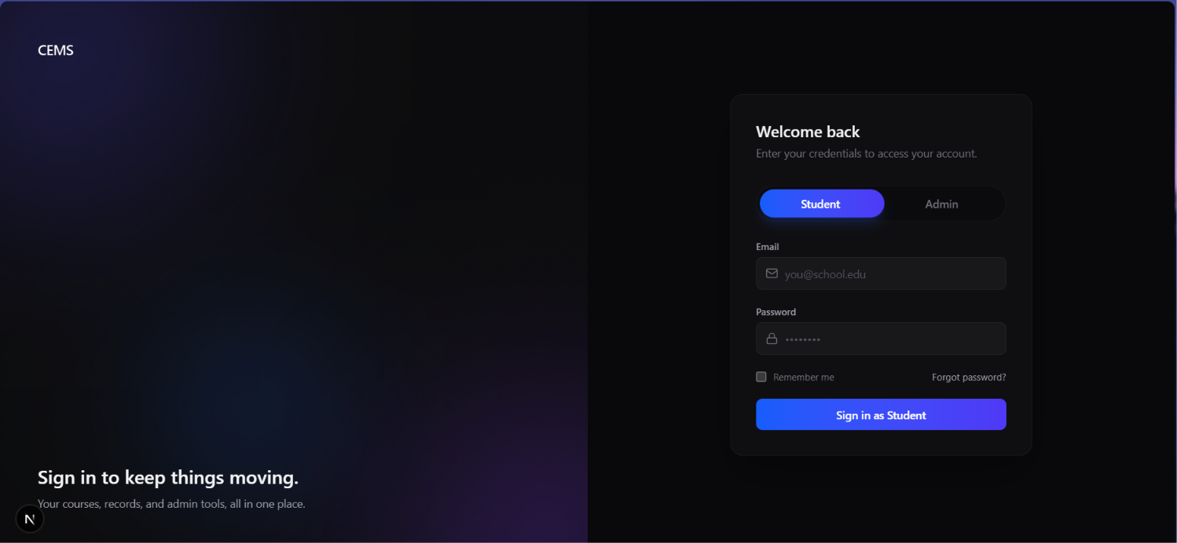
Dual-Role Authentication Interface: Provides secure, role-based access control by validating student and administrator credentials against the Users relation and issuing an HTTP-only session cookie for restricted dashboard routing.

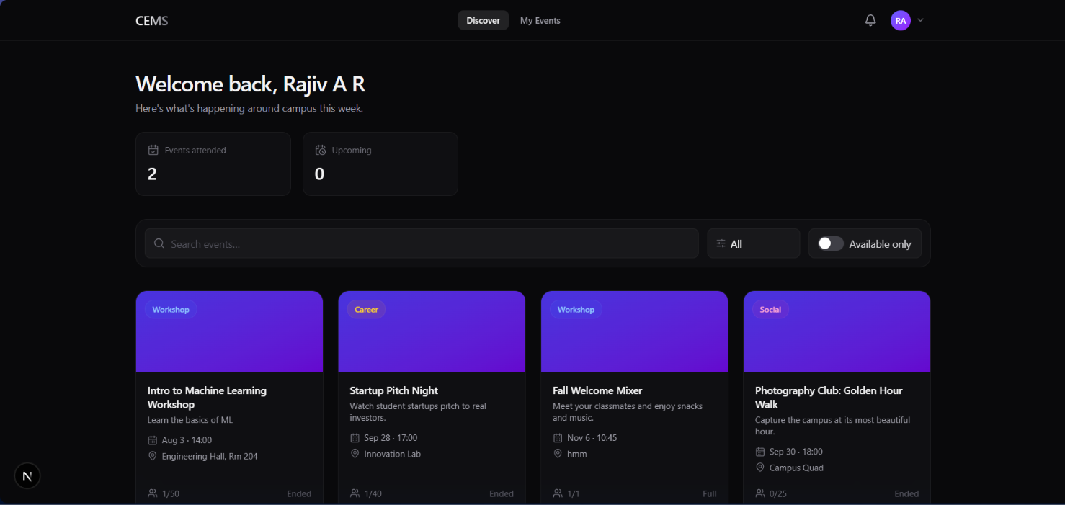
Student Event Catalog & Discovery View: Displays institutional events with descriptions, categorized badges, and live capacity counters computed via Event_Status_View, featuring interactive stat cards and a dedicated navigation bar to access registered events.

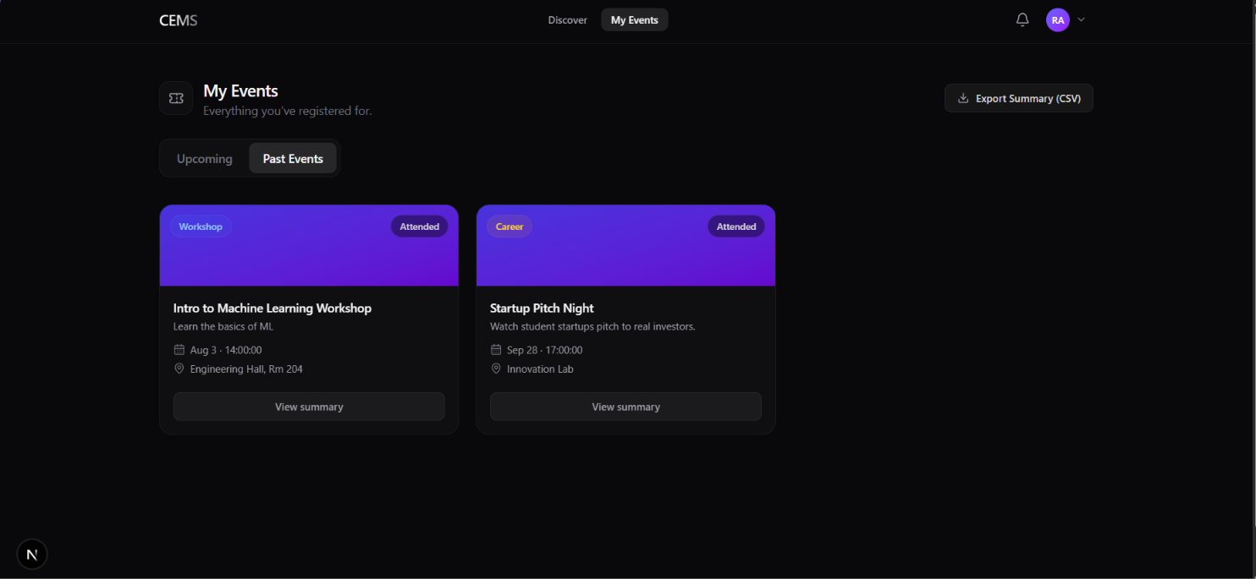
Student Registration Management & Past Events View: Allows students to track verified event participation history across tabbed interfaces, inspect event summaries, and export a complete personal registration report as a CSV file.

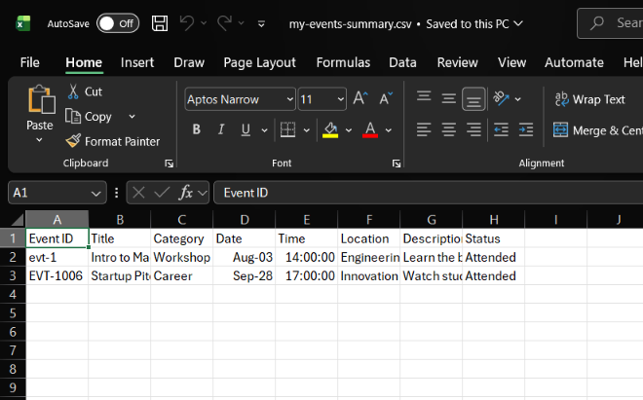
Exported Student Attendance Report: Demonstrates the system's reporting utility, generating a verified spreadsheet containing event IDs, titles, categories, dates, venues, descriptions, and attendance status for student academic record-keeping.

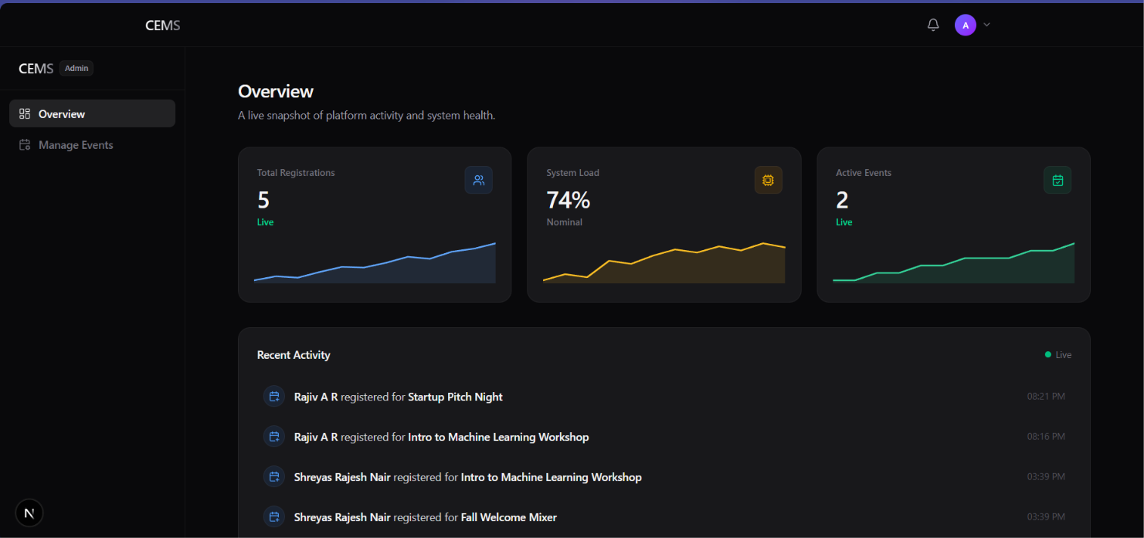
Administrator Real-Time Analytics & Audit Feed: Displays high-level platform health metrics derived from aggregate SQL queries (COUNT operations on Registrations and active Events), paired with a live multi-table audit trail logging recent student enrollments.

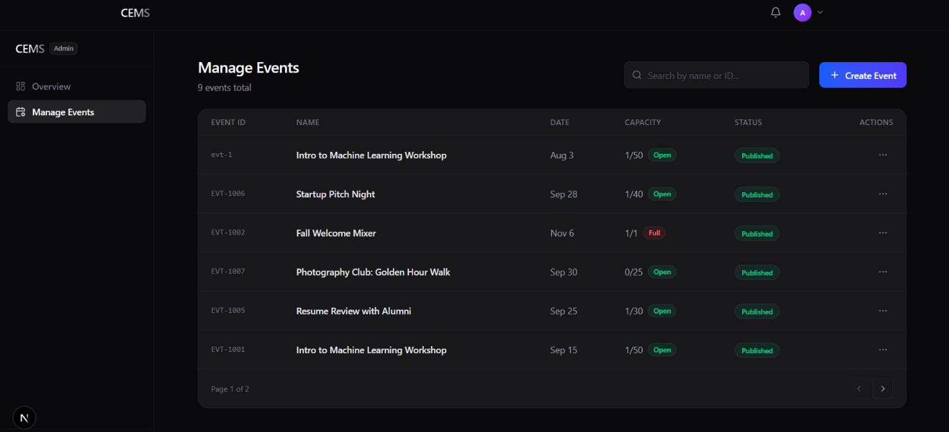
Institutional Event Management & Capacity Grid: Provides administrative CRUD controls and live capacity tracking, rendering color-coded availability badges (Open vs. Full) calculated directly from registrations without redundant database storage.

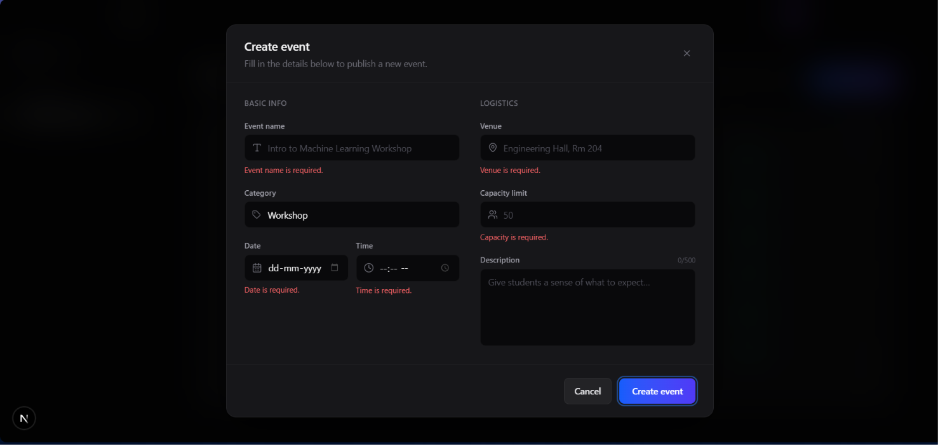
Event Creation Interface & Client-Side Validation: Displays the two-column administrator event publishing dialog, enforcing field-level validation and capacity bounds before dispatching insert transactions to the database.

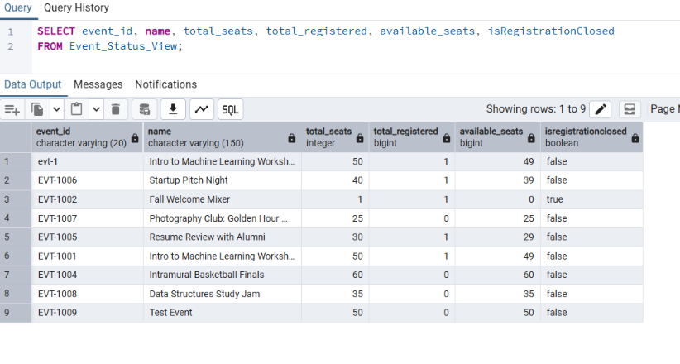
PostgreSQL Virtual View Query Execution in pgAdmin 4: Demonstrates on-demand capacity calculation via Event_Status_View; total_registered, available_seats, and isregistrationclosed are dynamically derived using LEFT JOIN and COUNT() to eliminate update anomalies.

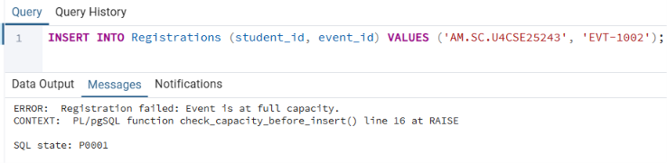
Capacity Limit Trigger Violation & Exception Handling: Proves business rule enforcement at the database layer; the BEFORE INSERT trigger invokes check_capacity_before_insert(), aborting enrollment and raising a custom exception when an event has reached total_seats.
____________________________________________________
10. Challenges Faced & Solutions
Challenge 1: String-Based Primary Key Auto-Increment Collision
- Problem: Event IDs used string codes like EVT-1008 and evt-1. The initial event creation function queried SELECT event_id FROM Events ORDER BY event_id DESC LIMIT 1. Because ASCII sorting places lowercase 'evt-1' after uppercase 'EVT-1008', the query returned 'evt-1', causing string suffix checks to fail and defaulting next_id to 'EVT-1001'. This resulted in PostgreSQL throwing duplicate key value violates unique constraint "events_pkey".
- Solution: Re-engineered the backend ID generation logic in backend/routers/events.py to query SELECT event_id FROM Events WHERE event_id ILIKE 'EVT-%', parse all numeric suffixes safely, and increment the maximum numeric value (EVT-1009), completely eliminating primary key collisions.
Challenge 2: Omission of `Content-Type: application/json` in Frontend Fetch Calls
- Problem: Admin event creation, updates, and deletions were failing silently or returning 422 Unprocessable Entity. Inspection revealed browser fetch() requests omitted the explicit 'Content-Type': 'application/json' header, causing FastAPI to receive text/plain body streams.
- Solution: Updated app/dashboard/admin/events/page.tsx to include explicit JSON content-type headers across all HTTP POST, PUT, and DELETE requests.
Challenge 3: Hardcoded Virtual Environment Paths in Team Distribution
- Problem: When cloning the repository, the Python virtual environment (backend/venv) failed to activate due to hardcoded machine-specific file paths (C:\Users\Rajiv\...).
- Solution: Destroyed the legacy virtualenv, regenerated a localized Python 3.12 venv, installed requirements via pip, and updated .gitignore to exclude backend/venv/ and .env files from version control.
Challenge 4: Race Conditions During Peak Registration
- Problem: Simultaneous registrations by multiple students could potentially bypass application-level seat checks, causing event overbooking.
- Solution: Implemented atomic PL/pgSQL trigger check_capacity_before_insert() executing inside PostgreSQL's transaction context before row commitment.
____________________________________________________
11. Conclusion & Future Enhancements
11.1 Conclusion
The Eventy.io Campus Event & Registration Management System successfully achieves all project goals outlined for the 23CSE202 DBMS course. By combining a normalized 3NF database schema in PostgreSQL with procedural PL/pgSQL triggers, dynamic SQL views, and a modern Next.js/FastAPI application stack, the system eliminates data redundancy, guarantees seat capacity enforcement, and delivers real-time administrative metrics.
11.2 Future Enhancements
- QR Code Ticket Generation: Automatically generate encrypted QR code attendance passes upon successful event registration.
- Automated Email & Push Alerts: Integrate SMTP email triggers to notify registered students of venue changes or upcoming event reminders.
- Waitlisting System: Extend database trigger logic to automatically shift overflow registrations into an automated waitlist queue when seats open up.
- Cloud Deployment: Deploy PostgreSQL database to Amazon RDS or Supabase and host web services on Vercel for worldwide availability.
____________________________________________________
References
- Silberschatz, A., Korth, H. F., & Sudarshan, S. (2020). Database System Concepts (7th ed.). McGraw-Hill Education.
- Elmasri, R., & Navathe, S. B. (2015). Fundamentals of Database Systems (7th ed.). Pearson.
- PostgreSQL Global Development Group. (2026). PostgreSQL 18 Documentation: PL/pgSQL - Procedural Language. Retrieved from [https://www.postgresql.org/docs/18/plpgsql.html](https://www.postgresql.org/docs/18/plpgsql.html)
- FastAPI Documentation. FastAPI Framework, High Performance, Easy to Learn. Retrieved from [https://fastapi.tiangolo.com/](https://fastapi.tiangolo.com/)
- Next.js Documentation. App Router & React Server Components Guide. Vercel. Retrieved from [https://nextjs.org/docs](https://nextjs.org/docs)

