**FTP**

**Experiment:** 6

**Aim:** To create and configure FTP Server

**Description:**

FTP Server

File Transfer Protocol (FTP) is a TCP protocol for downloading files between computers. In the past, it has also been used for uploading but, as that method does not use encryption, user credentials as well as data transferred in the clear and are easily intercepted. So, if you are here looking for a way to upload and download files securely, FTP works on a client/server model. The server component is called an *FTP daemon*.

It continuously listens for FTP requests from remote clients. When a request is received, it manages the login and sets up the connection. For the duration of the session, it executes any of commands sent by the FTP client

**Port No:** 21

**Package name:** vsftpd

**Configuration file:** /etc/vsftpd.conf

**Procedure:**

1. Install the vsftpd - FTP Server Installation in the ubuntu operating system

$sudo apt install vsftpd

2. By default, vsftpd is *not* configured to allow anonymous download. If you wish to

enable anonymous download edit /etc/vsftpd.conf by changing:

$anonymous_enable=YES

3. During installation a *ftp* user is created with a home directory of /srv/ftp. This is

the default FTP directory.

If you wish to change this location, to /srv/files/ftp for example, simply create a

directory in another location and change the *ftp* user’s home directory:

$sudo mkdir -p /srv/files/ftp

$sudo usermod -d /srv/files/ftp ftp

4. After making the change restart vsftpd:

$ sudo service vsftpd restart

5. User Authenticated FTP Configuration

By default, vsftpd is configured to authenticate system users and allow them to

download files. If you want users to be able to upload files, edit /etc/vsftpd.conf

$write_enable=YES

6. Now restart vsftpd:

$ sudo service vsftpd restart

7. Securing FTP

There are options in /etc/vsftpd.conf to help make vsftpd more secure.

$chroot_local_user=YES

$chroot_list_enable=YES

$chroot_list_file=/etc/vsftpd.chroot_list

8. After uncommenting the above options, create a /etc/vsftpd.chroot_list

containing a list of users one per line.

9. Then restart vsftpd:

$sudo service vsftpd restart

10. To configure *FTPS*, edit /etc/vsftpd.conf and at the bottom add:

$ssl_enable=YES

11. Then check the vsftpd status

$sudo service vsftpd status

12. Now connect to ftp by the command

$ftp -p 192.168.234.128

13. Now install filezilla in ubuntu and open the filezilla and specify the ip address

and port number of the ftp server then click connect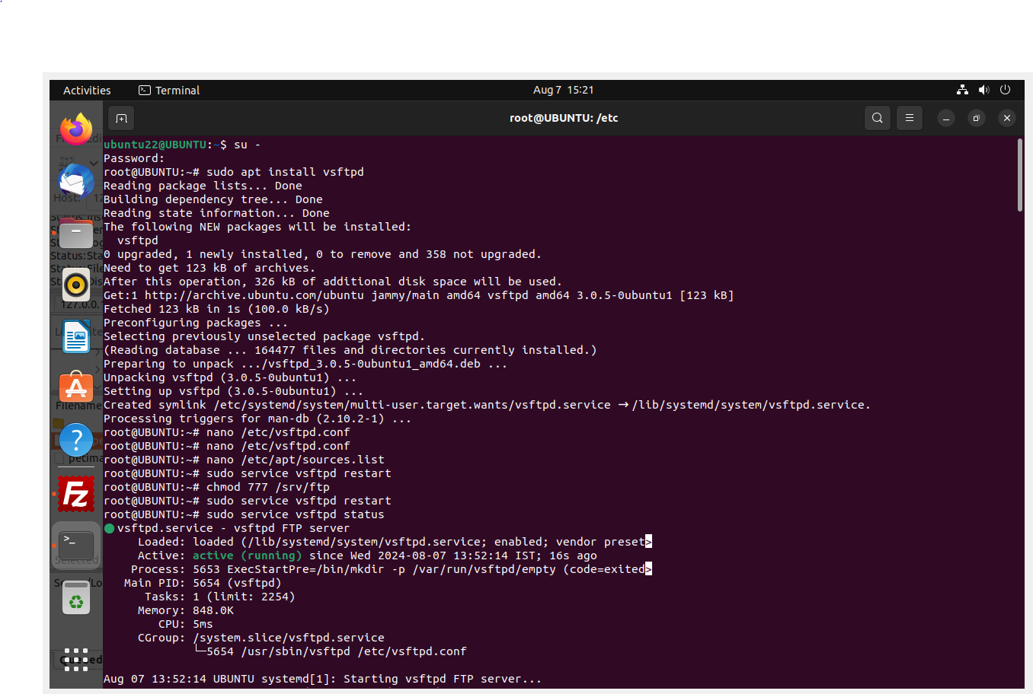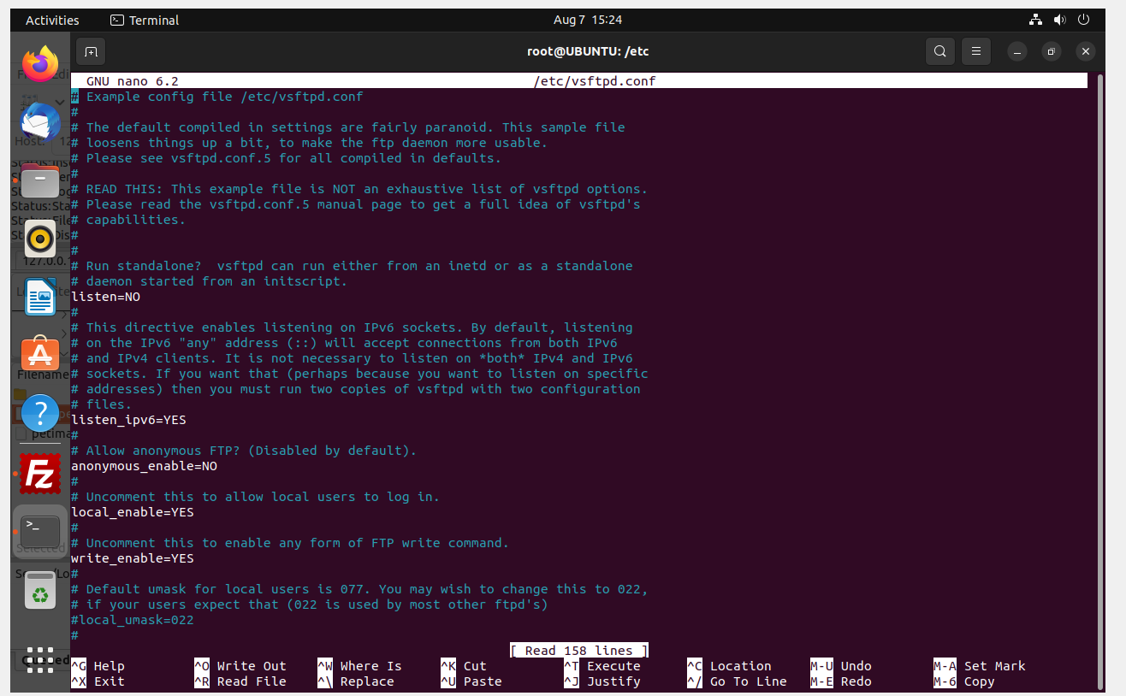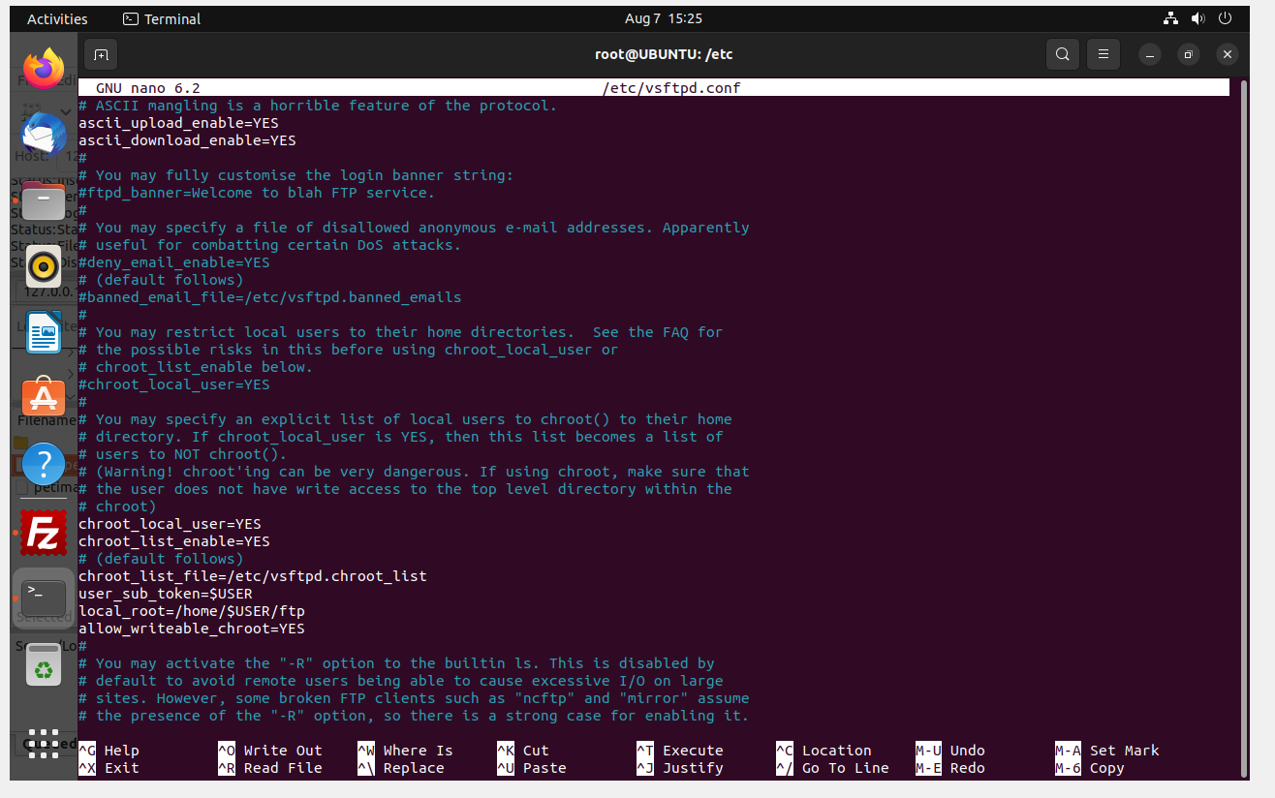

**Result:** All the commands have been executed and the output has been obtained successfully.