下载地址：<https://www.cnblogs.com/duanrantao/p/8988116.html>

[linux系统安装mysql数据库](https://www.cnblogs.com/duanrantao/p/8988116.html)

1、首先关闭linux的防火墙，执行命令

chkconfig iptables off

2、从mysql官网上下载自己适合的mysql版本https://dev.mysql.com/downloads/mysql/5.6.html#downloads，进入mysql官网，依次点击

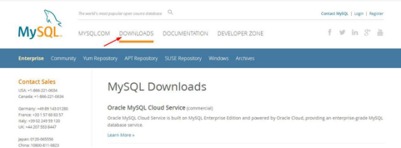

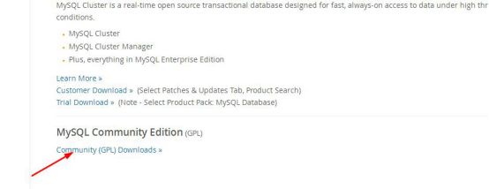

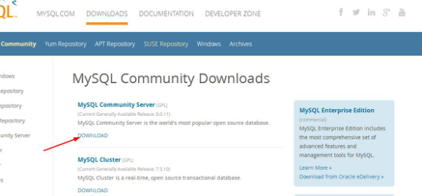

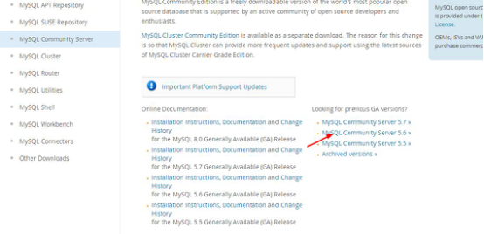

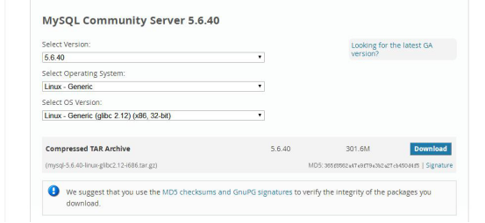

3、下载后的mysql文件

mysql-5.6.40-linux-glibc2.12-i686.tar.gz

 将下载好的mysql压缩文件放置在linux的/usr/local文件夹下，解压该压缩文件

tar -zxvf mysql-5.6.40-linux-glibc2.12-i686.tar.gz

将解压后的文件重命名为mysql

mv mysql-5.6.40-linux-glibc2.12-i686 mysql

4、创建mysql用户组及用户

groupadd mysql
useradd -r -g mysql mysql

5、进入到mysql目录，执行添加MySQL配置的操作

cp support-files/my-medium.cnf /etc/my.cnf
或：
cp support-files/my-default.cnf /etc/my.cnf

是否覆盖？按y 回车

6、编辑/etc/my.cnf文件；

vi /etc/my.cnf

在my.cnf文件中添加或者修改相关配置，更改完成后保存退出

copycode.gif

1 # For advice on how to change settings please see
2 # http://dev.mysql.com/doc/refman/5.6/en/server-configuration-defaults.html
3 # \*\*\* DO NOT EDIT THIS FILE. It's a template which will be copied to the
4 # \*\*\* default location during install, and will be replaced if you
5 # \*\*\* upgrade to a newer version of MySQL.
6
7 [mysqld]
8
9 # Remove leading # and set to the amount of RAM for the most important data
10 # cache in MySQL. Start at 70% of total RAM for dedicated server, else 10%.
11 # innodb\_buffer\_pool\_size = 128M
12
13 # Remove leading # to turn on a very important data integrity option: logging
14 # changes to the binary log between backups.
15 # log\_bin
16
17 # These are commonly set, remove the # and set as required.
18 basedir = /usr/local/mysql
19 datadir = /usr/local/mysql/data
20 port = 3306
21 # server\_id = .....
22 socket = /tmp/mysql.sock
23 character-set-server = utf8
24 skip-name-resolve
25 log-err = /usr/local/mysql/data/error.log
26 pid-file = /usr/local/mysql/data/mysql.pid
27
28 # Remove leading # to set options mainly useful for reporting servers.
29 # The server defaults are faster for transactions and fast SELECTs.
30 # Adjust sizes as needed, experiment to find the optimal values.
31 # join\_buffer\_size = 128M
32 # sort\_buffer\_size = 2M
33 # read\_rnd\_buffer\_size = 2M
34
35 sql\_mode=NO\_ENGINE\_SUBSTITUTION,STRICT\_TRANS\_TABLES

copycode.gif

7、在mysql当前目录下设定目录的访问权限（注意后面的小点，表示当前目录）

chown -R mysql .
chgrp -R mysql .
scripts/mysql\_install\_db --user=mysql

问题一：-bash: scripts//mysql\_install\_db: /usr/bin/perl: 坏的解释器: 没有那个文件或目录

解决方案：yum -y install perl perl-devel

问题二：FATAL ERROR: please install the following Perl modules before executing scripts//mysql\_install\_db:

Data::Dumper

解决方案：yum -y install autoconf

chown -R root .
chown -R mysql data

8、初始化数据（在mysql/bin或者mysql/scripts下有个 mysql\_install\_db 可执行文件初始化数据库），进入mysql/bin或者mysql/scripts目录下，执行下面命令

./mysql\_install\_db --verbose --user=root --defaults-file=/etc/my.cnf --datadir=/usr/local/mysql/data --basedir=/usr/local/mysql --pid-file=/usr/local/mysql/data/mysql.pid --tmpdir=/tmp

9、启动mysql，进入/usr/local/mysql/bin目录，执行下面命令

./mysqld\_safe --defaults-file=/etc/my.cnf --socket=/tmp/mysql.sock --user=root &

注意，如果光标停留在屏幕上，表示启动成功，需要我们先关闭shell终端，再开启一个新的shell终端，不要执行退出操作。如果出现 mysql ended这样的语句，表示Mysql没有正常启动，你可以到log中查找问题.

10、设置开机启动，新开启shell中断后，进入mysql目录，执行下面命令

copycode.gif

cp /usr/local/mysql/support-files/mysql.server /etc/init.d/mysqld
cp /usr/local/mysql/support-files/mysql.server /etc/rc.d/init.d/mysql

chmod 700 /etc/init.d/mysql
chkconfig --add mysqld
chkconfig --level 2345 mysqld on
chown mysql:mysql -R /usr/local/mysql/

copycode.gif

重启linux

reboot

查看mysql状态

service mysqld status

11、添加远程访问权限

　　（1）、添加mysql命令

ln -s /usr/local/mysql/bin/mysql /usr/bin （mysql的安装路径）

　　（2）、更改访问权限

登录mysql,执行下面命令
mysql -uroot -p
密码为空直接回车,运行以下两条命令

切换数据库

use mysql;

GRANT ALL PRIVILEGES ON \*.\* TO 'root'@'%' IDENTIFIED BY 'root' with grant option;

Flush privileges;

退出mysql

exit

重启linux,就完成了

reboot

注：本机访问mysql，root账户默认是没有密码的，端口号默认3306，如果需要修改root账户密码，在/usr/local/mysql/bin目录下，执行下面命令

./mysqladmin -h 127.0.0.1 -P3306 -uroot password 'root'exit

分类: [linux](https://www.cnblogs.com/duanrantao/category/1210273.html)

**好文要顶** **关注我** **收藏该文**

con_weibo_24.png

wechat.png

170601085130.png

[段然涛](http://home.cnblogs.com/u/duanrantao/)

[关注 - 22](http://home.cnblogs.com/u/duanrantao/followees)

[粉丝 - 18](http://home.cnblogs.com/u/duanrantao/followers)

+加关注

1

[«](https://www.cnblogs.com/duanrantao/p/8859001.html)上一篇：[laypage分页控件使用方法](https://www.cnblogs.com/duanrantao/p/8859001.html)

[»](https://www.cnblogs.com/duanrantao/p/8711781.html)下一篇：[linux下redis单机版搭建](https://www.cnblogs.com/duanrantao/p/8711781.html)

posted @ 2018-05-03 23:14 [段然涛](https://www.cnblogs.com/duanrantao/) 阅读(5135) 评论(4) [编辑](https://i.cnblogs.com/EditPosts.aspx?postid=8988116) [收藏](https://www.cnblogs.com/duanrantao/p/8988116.html#)

**FATAL ERROR: please install the following Perl modules before executing**

2017年08月26日 14:50:55 [lumingbiao123](https://me.csdn.net/u013761206) 阅读数：10662

 版权声明：本文为博主原创文章，未经博主允许不得转载。 https://blog.csdn.net/u013761206/article/details/77601227

运行安装mysql 报错

[root@localhost mysql-mult]# ./scripts/mysql\_install\_db  --defaults-file=conf/3306my.cnf

FATAL ERROR: please install the following Perl modules before executing ./scripts/mysql\_install\_db:

Data::Dumper

解决方法 ：安装autoconf库

命令：yum -y install autoconf

**libaio.so.1: cannot open shared object file解决方法**

2017年02月01日 11:40:26 [LzwGlory](https://me.csdn.net/a137268431) 阅读数：11804

出现下面情况：

linux libaio.so.1: cannot open shared object file: No such file or directory

缺少安装包libaio和libaio-devel.

命令行

yum install libaio\*。自动安装这两个包