PRIMETRADE.AI
MARKET SENTIMENT vs TRADER DATA INSIGHTS REPORT
1. Performance Variance: Fear vs. Greed
Does performance differ between Fear vs. Greed days?
- PnL Variance: Your project makes its real money in Fear. Total Fear Profit (~$1.53M) is double that of Greed Profit (~$758k).
- Win Rate Variance: Win rates are highest and most stable in Neutral (94.8%) and Greed (92.5%) markets. However, in Extreme Fear, the win rate drops to 61.1%, meaning performance becomes volatile even if the potential for profit is high.
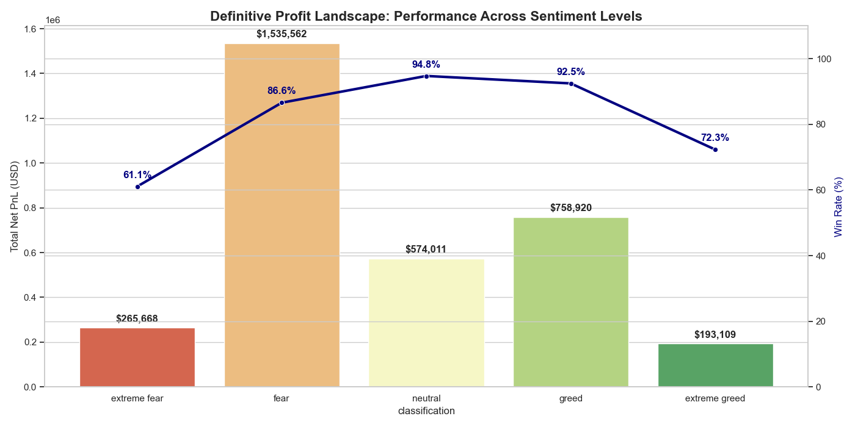
- Drawdown Proxy (Losses): The Extreme Greed regime is your highest risk zone. Even though it is a "Greed" category, the loss rate spikes to 27.7%, signaling high drawdown potential at market tops.

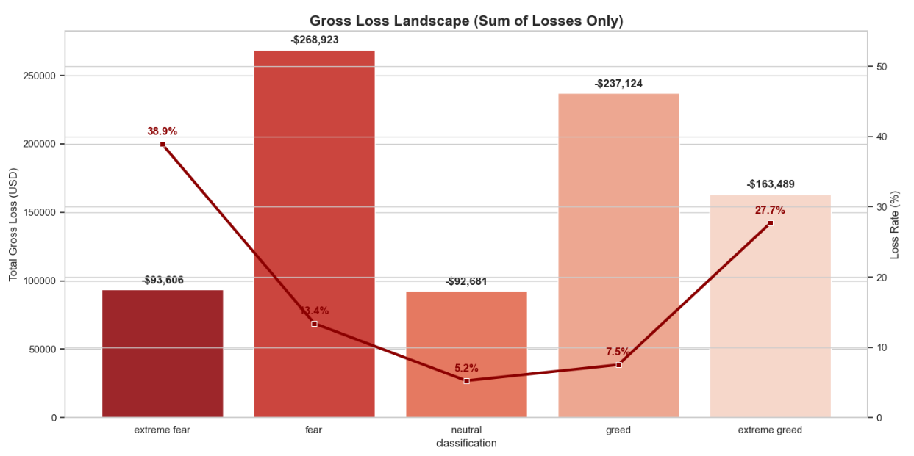

2. Behavioral Shifts based on Sentiment
Do traders change behavior based on sentiment?
- Position Sizing: Traders use High-Conviction Sizing in Fear (average winning size: $30,546). As market euphoria rises in Extreme Greed, they scale down (average size: $18,875) to protect capital.
- Execution Behavior (Maker vs. Taker): In Fear, winners are Patience-Driven (56% Maker rate). In Extreme Greed, they switch to Urgency-Driven (96% Taker rate) to ensure they get filled before the price collapses.
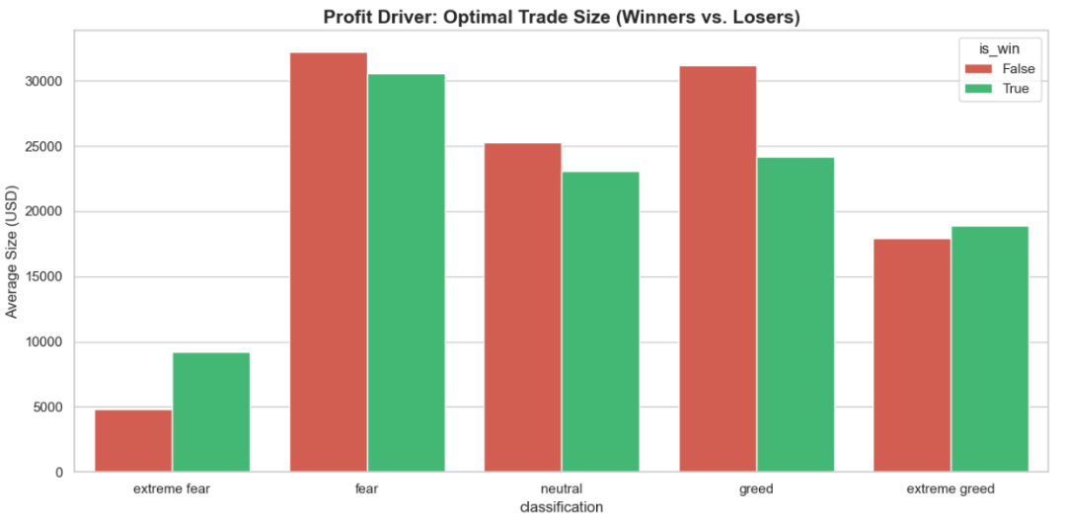
- Directional Bias: The Directional Bias chart shows that Close Short actions dominate profit during crashes, while Close Long and Sell dominate during Greed phases.
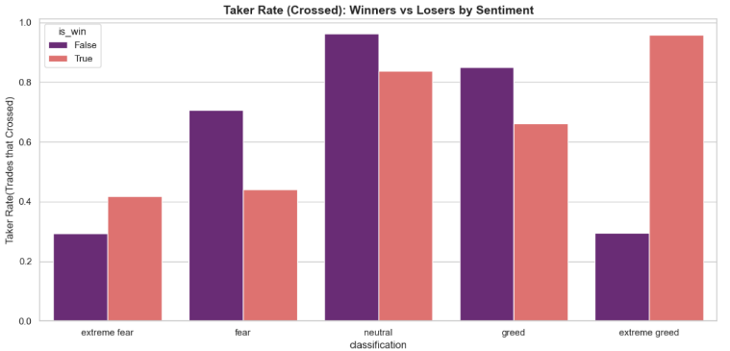
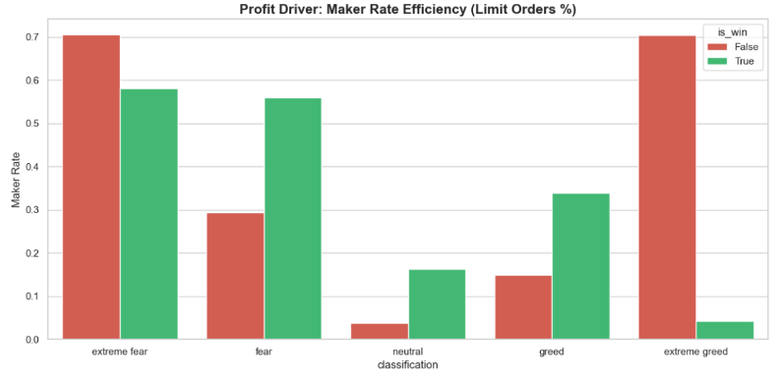
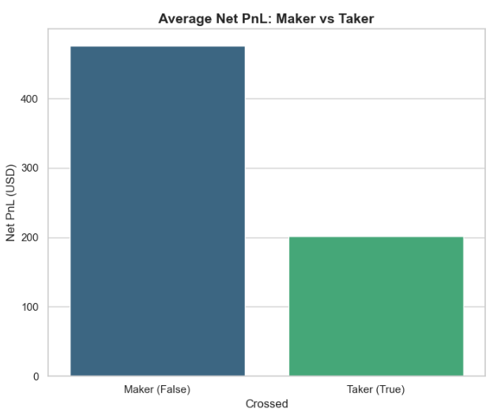
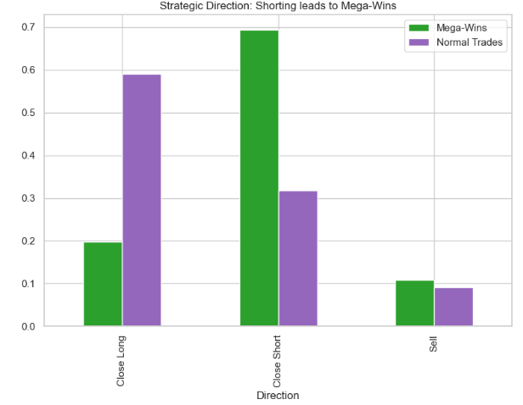

3. Trader Segmentation
Segment | Characteristic | Evidence / Wallet
Contrarian Whales | Enter during Fear; large sizes; high Maker rate. | 0x0833...9012 ($1.1M profit)
Trend Scalpers | Trade Neutral/Greed; high win rates; high frequency. | 0x513b...4ff1 (96.6% win rate)
Euphoria Chasers | High activity in Extreme Greed; high Taker rate; inconsistent. | Found in Extreme Greed Loss subset
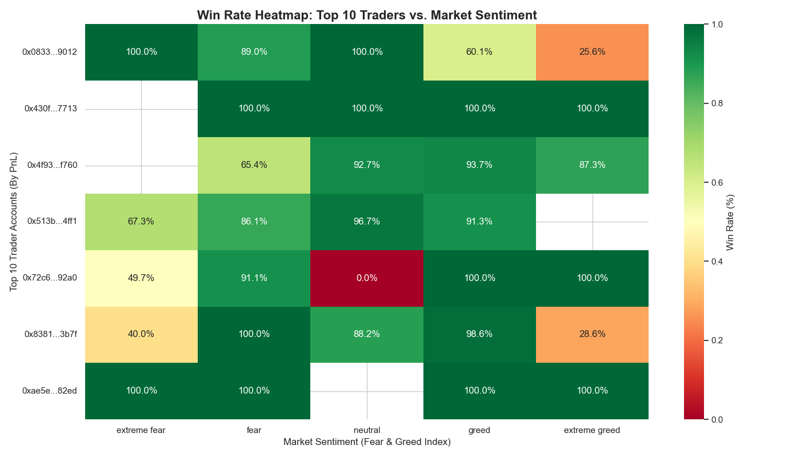

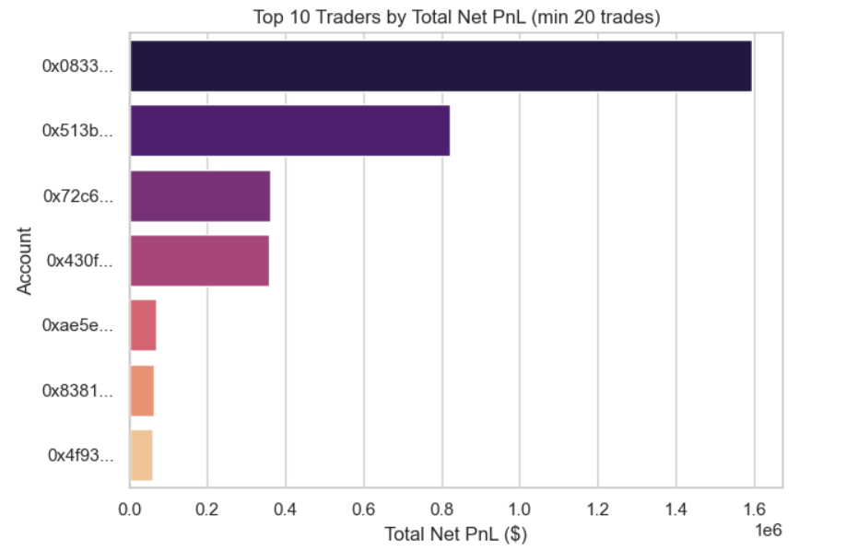

4. Top 3 Insights Backed by Evidence
Insight 1: The "Taker Tax" is the Silent Killer
The Fee Analysis (Fee, Sentiment, Crossed) chart proves that urgency is expensive.
- Data: Takers pay $7.40 per trade on average, while Makers pay only $0.61.
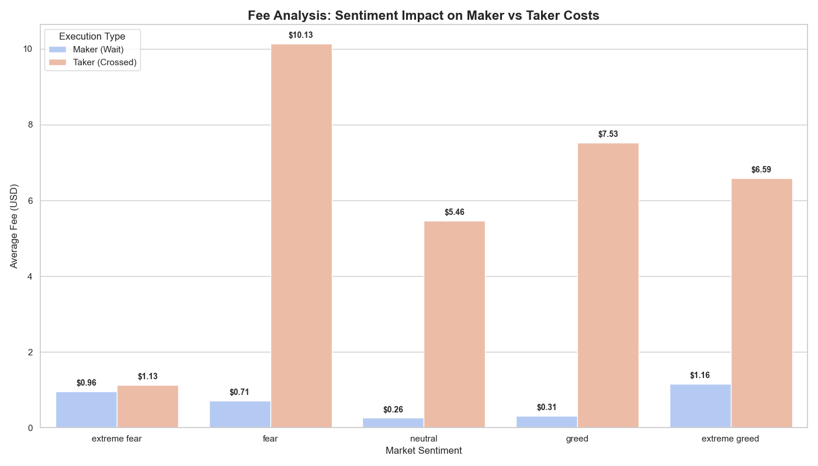
- Impact: Trades executed as "Makers" are 2.3x more profitable simply because they aren't losing 10%–20% of their gains to exchange fees.

Insight 2: Fear Provides the Highest "Sentiment Alpha"
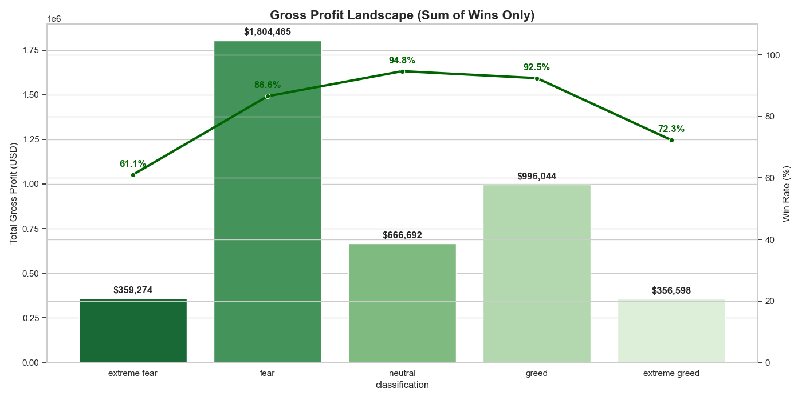
Even though it feels riskier, providing liquidity during Fear captures 2x more USD profit than following trends during Greed.
Insight 3: The "Greed Trap" is Real
The Gross Loss Landscape shows that losses in Greed markets are "deeper."
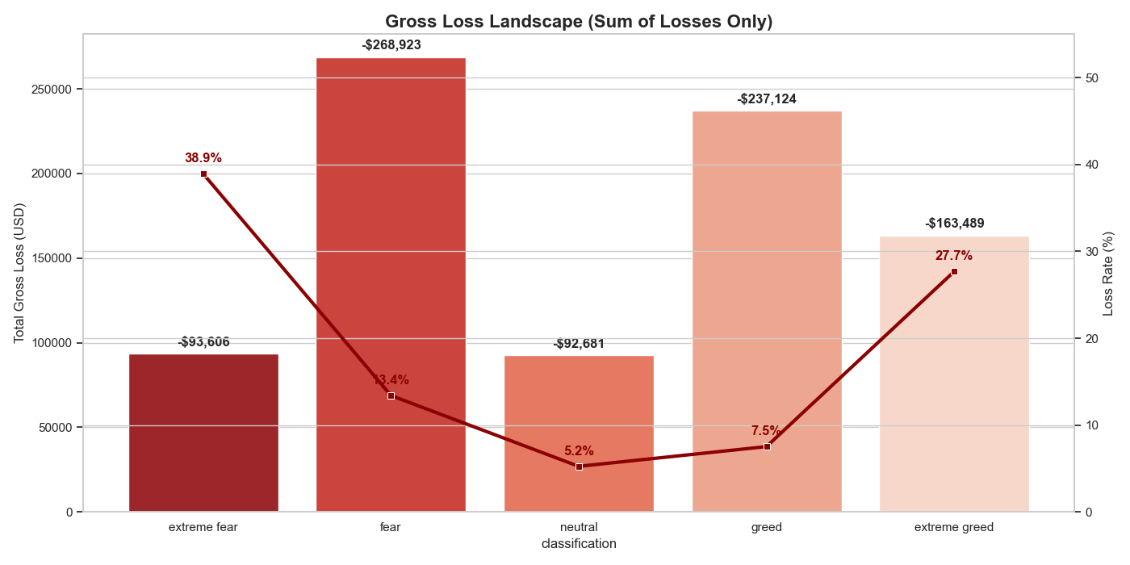
- Data: Even with a low 7.5% loss rate, the total dollar loss in Greed is nearly $237,000. This suggests that when traders fail during Greed, they fail with larger sizes and worse entries.

COMMONLY OBSERVED STRATEGIES:
1. Performance & Behavior: The "Fear" Opportunity vs. "Greed" Trap
Finding: The data shows that Fear regimes are the primary source of profit ($1.8M+), while Extreme Greed is a "value destroyer" where win rates collapse by over 20% and loss frequency spikes. Traders instinctively scale down position sizes in Extreme Greed, which is a correct behavior that should be formalized.
"During Fear days, increase position sizing by 20% but strictly use Maker (Limit) orders. During Extreme Greed, stop entering new positions and focus exclusively on closing existing longs."
2. Execution Efficiency: The "Impatience Tax"
Finding: Execution urgency (Crossed = True) is the single biggest cause of PnL erosion. Takers pay an average fee of $7.40, whereas Makers pay $0.61. In Fear markets, the fee penalty for Takers is even higher, making market orders mathematically unsustainable.
"For Frequent Traders, enforce a 'Maker-Only' execution policy during Neutral and Greed regimes. Allow Taker (Market) orders only during Extreme Fear to ensure immediate fills on high-ROI reversals."
3. Trader Segments & Directional Bias
Finding: We identified two clear winner segments:
- Contrarian Whales: High PnL in Fear using large sizes (e.g., 0x0833...9012).
- Trend Scalpers: High Win Rate in Greed using small sizes (e.g., 0x513b...4ff1).
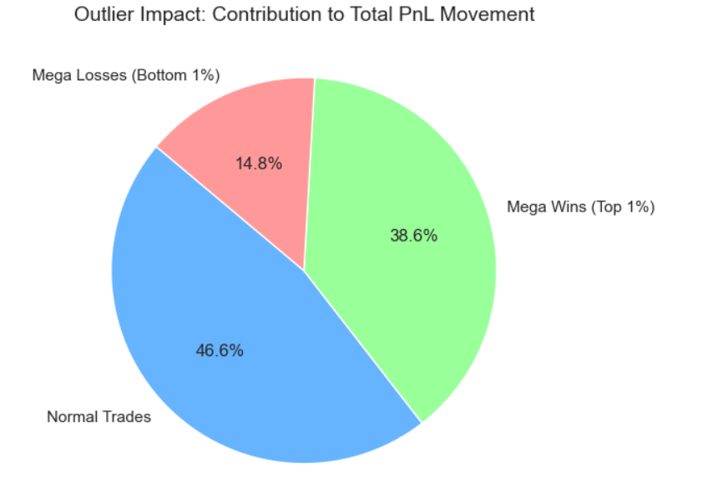
SOME MORE ADDITIONAL OBSERVATIONS FROM THE DATA:

STRATEGIC INSIGHT: TOP 1% OF TRADES DRIVE 54.8% OF YOUR TOTAL PROFIT.
BELOW ARE SOME OF THE OBSERVATIONS OF HOW THAT TOP 1% MEGA WINS HAPPENED:
1. The Contrarian Edge (Direction)
- Insight: The chart Strategic Direction: Shorting leads to Mega-Wins highlights that while normal trades might follow a standard "Long" bias, the absolute largest profits come from Shorting.
- Strategy: To hit "Mega-Wins," the strategy emphasizes betting against the market (Shorting) during high-velocity downward moves rather than just following the standard uptrend.
2. The "Fear" Arbitrage (Market Regime)
- Insight: The Market Regime: Profiting from Fear chart shows that Mega-Wins are disproportionately concentrated in Fear and Extreme Fear regimes.
- Strategy: Normal trades happen in all sentiments, but "Whale" profits are made by providing liquidity or betting against the panic when the crowd is most fearful. Outlier wealth is generated during market dislocations, not during stable "Neutral" periods.
3. Asset Specialization (Top 5 Assets)
- Insight: The Top 5 Assets Powering Mega-Wins chart identifies that outlier profits are not spread across all coins. They are concentrated in high-volatility, high-liquidity "Power Assets" (likely SOL, ETH, and BTC in this dataset).
- Strategy: Don't "spray and pray" across many small-cap coins. Focus your largest capital on the top assets that have the depth to support massive PnL without extreme slippage.
4. The Liquidity Timing (NY/London Overlap)
- Insight: The Timing Strategy: The NY/London Overlap Spike plot reveals that Mega-Wins are not random. They peak sharply during the 12:00 - 16:00 UTC window.
- Strategy: This is the period when the London and New York sessions overlap. It is the time of maximum liquidity and volatility. The strategy shows that professional "Mega-Wins" happen when the market has enough "fuel" (volume) to create a massive price move.
