Environmental context shapes the direction and predictability of functional succession in forests
Merlin Weiss^{1,2*} and Daniel S. Maynard¹
¹ Department of Genetics, Environment and Evolution, University College London, Gower Street, WC1E 6BT London, United Kingdom
² Department of Environmental Systems Science, ETH Zürich, Universitätstrasse 16, 8092 Zürich, Switzerland

*Corresponding author E-Mail: merlin.weiss@usys.ethz.ch

Potential journals (ladder):
- Ecology Letters (NEE as alternative, but would require some reframing)
- PNAS or Global Change Biology
- Global Ecology and Biogeography or Journal of Ecology
- Ecography or Functional Ecology

Potential Reviewers:
- Lourens Poorter (lourens.poorter@wur.nl); trait ecology and succession theory
- Martin Philippe-Lesaffre (martin.philippe@mncn.cisc.es); RF/ML in ecology
- Who else?

To do:
- Improve figure design (speaking of font size & layout, not content)
- Decide on journal & title
- Polishing, revising abstract and cover letter following journal selection

Abstract
Classical theory posits forest succession as a convergent process, in which communities sharing climatic conditions converge toward a common, predictable late-successional state. Whether the surrounding environment merely paces this process or actively redirects it, and whether late-successional communities genuinely become more predictable, has rarely been tested across broad environmental gradients. Here, using 49,377 permanent forest plots spanning the environmental breadth of United States forests, we modelled community-weighted mean expression of nine functional traits as a function of stand age and abiotic context. Using a machine-learning framework, we partitioned trait variation into environmental and successional filtering. Environmental context dominated across all traits and both broadleaf and coniferous forests, outweighing stand age roughly tenfold in importance on average and about twice as strongly in coniferous systems. Its influence extended well beyond mean trait values, with the environment determining the rate and direction of successional change, in which acquisitive traits shifted fastest under warm, productive conditions,and stress-tolerant traits shifted under cold. Trait predictability rose through succession, yet the gap in predictability between contrasting environments rarely closed. In most cases it narrowed as stands aged, but across temperature regimes it widened. This was the one instance where environmental context became a stronger determinant of predictability over time rather than a weaker one. This implies that the environment not only shapes trait expression but also governs how deterministic succession itself becomes. [...] Collectively, this work demonstrates that forest succession is not a universal process toward a shared endpoint, but rather an environmentally conditional process, whose direction and determinism are set by abiotic context. These results can provide important insight….
Keywords
Community Assembly, Environmental Filtering, Forest Succession, Functional Ecology, Random Forest, Shapley Values, Partial Dependence, Trait-Environment Interactions

Introduction
Forest succession describes the progressive reorganisation of tree communities following disturbance or stand initiation (Chang & HilleRisLambers 2016; Poorter et al. 2023). It is a fundamental concept in both theoretical and applied ecology (Chang & Turner 2019; Poorter et al. 2023), providing a framework for testing assembly theory and governing the recovery of forest biomass, carbon stocks, and biodiversity (Andrewsa et al. 2018; Chang & Turner 2019; Haeussler et al. 2021; Malhi et al. 2011; Sánchez-Pinillos et al. 2019) following widespread land-use change across global forest biomes (Besnard et al. 2021; Curtis et al. 2018). Succession is driven by plant–environment feedback loops, in which developing communities modify local conditions, leading to directional turnover in species composition as competitive hierarchies reorganise through time (van Breugel et al. 2024; Connell & Slatyer 1977). Classical theory predicts that this process becomes increasingly deterministic, with early-successional communities shaped by stochasticity and late-successional communities converging toward predictable endpoints as internal feedbacks stabilise (Clements 1916; Odum 1969; Poorter et al. 2023). However, empirical studies consistently report substantial variability in successional trajectories even among climatically similar stands, suggesting that the degree of determinism in succession itself is context dependent (Chase 2010; Fukami 2015; Norden et al. 2015). Predicting how and where succession proceeds therefore remains a central challenge, with direct implications for forecasting forest recovery under global change (Christensen 2014; Levine et al. 2025; Mori et al. 2017).
A key difficulty lies in disentangling the processes that drive directional change within stands from those that generate variation across stands. Directional succession is largely governed by internal dynamics, such as canopy closure and shifting competitive advantages toward shade-tolerant species. In contrast, regional climate and edaphic context act as external constraints that shape which species can establish and persist, without themselves being substantially modified by the developing community (van Breugel et al. 2024; Walker & Chapin 1987). Succession therefore reflects the interaction of two distinct filtering processes: Environmental filtering imposes abiotic constraints on trait expression across space (Grime 1988; Keddy 1992; Kraft et al. 2015), whereas successional filtering captures time-dependent biotic dynamics, including competition, facilitation, and priority effects, that drive turnover as stands mature (Chesson 2000; Kunstler et al. 2016; Mayfield & Levine 2010). Because these processes are difficult to observe directly, successional filtering is often operationalized through stand age, which integrates the cumulative outcome of biotic assembly dynamics (van Breugel et al. 2024; Oliver & Larson 1996).
Whether the environmental context merely sets the pace of succession or actively redirects its trajectory is a question with wide-ranging consequences. Classical theory holds that stands in the same broad climatic region converge toward a predictable endpoint regardless of local conditions, with environment affecting how fast but not where communities end up (Clements 1916; Oliver & Larson 1996). Yet both theory and empirical evidence point toward a more contingent picture, in which the prevailing abiotic regime amplifies, dampens, or redirects trait change through succession rather than simply scaling it (Boukili & Chazdon 2017; Chase 2010; Lebrija-Trejos et al. 2010a; Lohbeck et al. 2015; Walker & Chapin 1987). If trait trajectories diverge across environmental gradients, then the functional state of a recovering forest depends not only on time since disturbance but on the environmental context in which succession unfolds, and the degree to which succession produces predictable outcomes should itself vary systematically with that context. Testing this requires data that span broad environmental and temporal gradients simultaneously, a condition rarely met in studies confined to single biomes or short successional sequences (van Breugel et al. 2024; Meiners et al. 2015). Under global change, where shifting temperature and precipitation regimes may push recovering forests into novel conditions (Williams et al. 2007), understanding whether environmental context shapes the direction and predictability of succession is particularly consequential.
Functional traits offer a taxon-independent framework for making this question tractable. Because traits mediate how species respond to both abiotic conditions and biotic competition, they can be mapped continuously onto environmental and temporal gradients to test whether community change reflects primarily abiotic constraint, biotic turnover, or their interaction (Boukili & Chazdon 2017; Kraft & Ackerly 2010; Violle et al. 2007). Trait-based studies of forest succession have revealed directional shifts in plant strategies, including changes along resource acquisition-conservation axes and stature-recruitment trade-offs (Craven et al. 2015; Lai et al. 2021; Lasky et al. 2014). Yet these trajectories vary among systems and environmental settings, suggesting that functional succession itself may be contingent on the conditions under which communities assemble (van Breugel et al. 2024; Poorter et al. 2023). Tracking individual trait trajectories therefore allows the relative contributions of environmental and successional filtering to be compared along common functional axes. It also allows us to test whether environmental context shapes not only trait expression, but the rate, direction, and predictability of change through succession.
Here we address these questions using data from over 49,000 permanent forest plots spanning the United States and Alaska, drawn from the US Forest Inventory and Analysis programme. Using plot-level measuresments for tree size (basal area) and composition, we modelled community-weighted mean expression of nine functional traits spanning leaf economics (specific leaf area, leaf potassium, leaf density), hydraulics (conduit diameter), bark structure (bark thickness), whole-tree architecture (tree height), resource acquisition (root depth), reproduction (seed dry mass), and light competition (shade tolerance), as a function of stand age and abiotic predictors within a machine learning framework. We then decomposed the relative contributions of environmental and successional filtering to trait variation, quantified how environmental conditions modulate successional trait trajectories, and assessed how trait predictability evolves through succession across contrasting environmental contexts.
We propose three hypotheses: First, environmental filtering accounts for greater variation in functional traits than successional filtering across most traits, with the smallest environmental dominance expected for traits most directly related to light competition and whole-tree architecture, for which internal biotic dynamics are expected to play a greater role (Grime 1977; Kraft et al. 2015). Second, environmental and successional filtering interact such that trait trajectories diverge across abiotic gradients, with resource-acquisitive traits showing steeper successional change in productive environments and stress-tolerant traits showing the opposite pattern (Boukili & Chazdon 2017; Lohbeck et al. 2014; Walker & Chapin 1987). Third, trait predictability increases throigh succession but remains contingent on environmental context, such that differences in predictability between contrasting environments persist into later succession rather than converging toward zero (Chase 2010; HilleRisLambers et al. 2012; Poorter et al. 2023). By quantifying how environmental context shapes the magnitude, direction, and predictability of functional change, out study provides a continental-scale test of why forests of similiar successional age can follow different functional trajectories, with direct implications for forecasting forest recovery under global change.

Material and Methods
Forest Plots
We used data from the US Forest Inventory and Analysis (FIA) programme (Gray et al. 2012), a long-term monitoring dataset recording tree occurrences across standardised permanent plots throughout the United States. From the full FIA database, we retained plots meeting the following criteria: living trees identified to species level, measured under standard fixed-area plot designs (design codes 1, 501, and 505, the latter two extending coverage to California, Oregon, and Washington), recorded in a single homogeneous condition class, and inventoried from 1980 onwards. We excluded privately owned plots and plots under active forestry management to minimise the confounding influence of human intervention and plot-level obfuscation on successional dynamics. Where plots had been measured more than once, we retained up to three of the most recent measurements per plot to incorporate temporal replication and to limit autocorrelation. Stand age in the FIA is reported as the average total age of live trees within the plot's stand-size class (Gray et al. 2012), providing a widely used proxy for successional stage. We excluded plots in the upper 10% of the stand age distribution to focus on early-to-late succession (approximately 1–150 years) and to avoid the disproportionate influence of old-growth outliers with low sample size (Oliver & Larson 1996). We further restricted analyses to broadleaf and coniferous biomes, with broadleaf forests comprising temperate broadleaf and mediterranean woodland biomes, and coniferous forests comprising boreal and temperate conifer biomes. After filtering, the dataset comprised 49,377 plots across the contiguous United States and Alaska (Fig. 1). All analyses were conducted separately within the broadleaf and coniferous forest type.

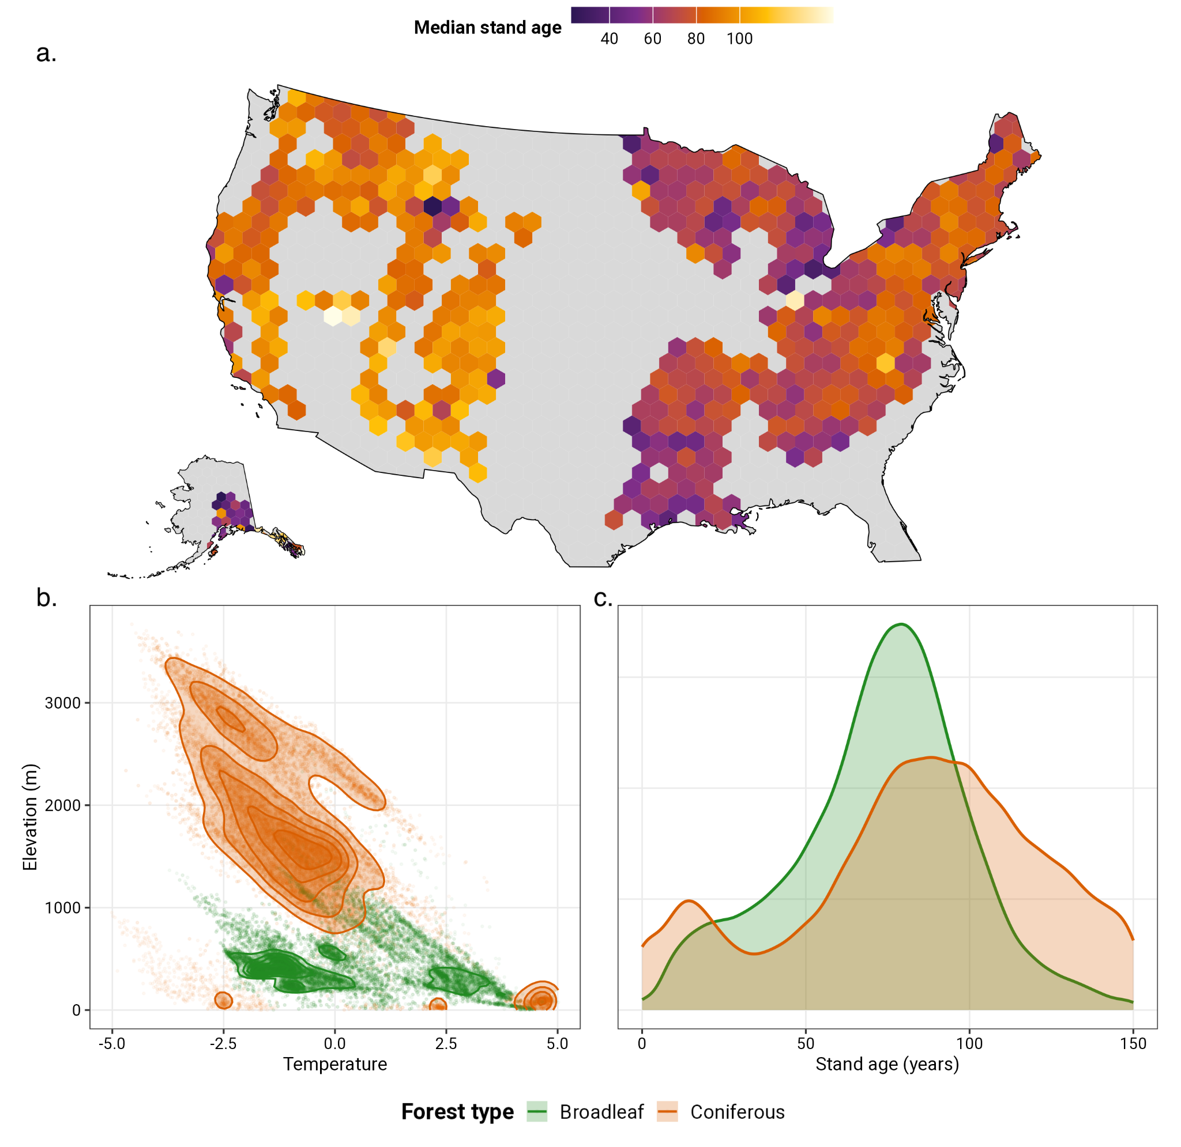
Figure 1. Spatial distribution, environmental space, and successional coverage of the forest plot dataset. (a) Median stand age per 100-km hexagonal cell (minimum three plots per cell), illustrating broad geographic variation in successional stage across the United States. (b) Environmental space occupied by broadleaf (green) and coniferous (orange) forests in temperature × elevation coordinates; points show individual plots and contours show 2D kernel density (normalised per forest type). Temperature is the first rotated environmental principal component (see Methods). (c) Stand age distributions of broadleaf and coniferous plots, showing broadly overlapping successional coverage across both forest types.

Tree Traits
We integrated species-level functional trait data to quantify trait expression at the plot level. Nine traits were selected to represent distinct functional clusters identified by (Maynard et al. 2022) to minimise redundancy across trait axes while maximising coverage of tree form and function. The selected traits spanned leaf economics (specific leaf area, leaf potassium, leaf density), hydraulic transport (conduit diameter), bark structure (bark thickness), whole-tree architecture (tree height), belowground resource acquisition (root depth), reproduction (seed dry mass), and light competition (shade tolerance). Species-level estimates for bark thickness, conduit diameter, leaf density, leaf potassium, root depth, seed dry mass, and specific leaf area were obtained from a phylogenetically imputed trait dataset (Maynard et al. 2022). Tree height was extracted directly from the FIA records where available. Shade tolerance was obtained from a species-level index of (Rueda et al. 2018), with missing values imputed via phylogenetic nearest-neighbour lookup using PhyloMaker in R (Jin & Qian 2019). All trait values were log-transformed and z-scored using grand means and standard deviations computed across the full assembled dataset. Trait expression per plot was summarised as a community-weighted mean (CWM). For each species within a plot, we calculated a basal-area-weighted mean of individual-level trait values across all trees of that species, where basal area was calculated from diameter at breast height and scaled by the trees-per-acre expansion factor to produce per-acre equivalents. Plot-level CWMs were then calculated as basal-area-weighted means of species-level trait values across all species in the plot, using scaled basal area as weights. This weighting scheme reflects the functional contribution of each species proportional to its structural dominance in the stand.
Environmental Features
We selected environmental predictors to capture the major abiotic axes affecting tree distribution and productivity (van den Hoogen et al. 2019; Maynard et al. 2022). Climate variables were obtained from the CHELSA dataset (Karger et al. 2017) and included annual mean temperature, minimum and maximum temperatures of the coldest and warmest months, annual precipitation, and precipitation of the wettest, driest, warmest, and coldest quarters. Soil characteristics were obtained from SoilGrids250m (Hengl et al. 2017) and included sand content and water capacity at 15 cm and 60 cm depths. Elevation data were obtained from (Amatulli et al. 2018). All environmental data were extracted at a 30 arcsecond resolution (~1 km²) for each plot coordinate (van den Hoogen et al. 2019). To reduce collinearity among climate and soil variables and to avoid unrealistic scenario combinations in subsequent analyses, we performed a principal component analysis (PCA) on the 14 temperature, precipitation, and soil texture variables. Suitability for PCA was confirmed using the Kaiser-Meyer-Olkin criterion (KMO > 0.8) and Bartlett's test of sphericity. We retained three components with eigenvalues greater than one and applied varimax rotation to improve interpretability, projecting plot observations onto the rotated axes to obtain scores used as predictors. The first rotated principal component (PC) was strongly associated with temperature variables; the second (soil water retention) was positively associated with water capacity and negatively with sand content; and the third (precipitation) was associated with precipitation variables (Fig. S-1a–d). Soil pH and elevation were excluded from the PCA; pH because it is orthogonal to the water retention axis, and elevation because its effect is best interpreted independently of the climatic gradient it partially encodes. Both were retained as direct predictors alongside the three PCs, yielding six predictors in total: temperature, soil water retention, precipitation, elevation, soil pH, and stand age. Collinearity among these six predictors was assessed prior to modelling and found to be low, with no pairwise Pearson correlation exceeding |0.5| (Fig. S-1f). We confirmed the interpretability of the rotated components by examining PC score distributions across biomes (Fig. S-1e), and the spatial distribution and feature-value ranges of the upper/lower quantile strata used for stratification (see below), for all five predictors, are shown in Fig. S-2.
Random Forest Models
We modelled CWM trait expression as a function of stand age and the five abiotic predictors using random forest regression implemented in the ranger package (Wright & Ziegler 2017) in R v.4.5.0. We used random forests because they can capture non-linear relationships and predictor interactions without explicit model specification, and provide out-of-bag error estimates that reflect genuine predictive performance (Breiman 2001). Consistent with this, several predictors showed weak or near-zero linear correlations with trait expression, indicating relationships a linear model could miss (Fig. S-4). Separate models were fitted for each trait within each forest type, yielding 18 models in total. For each forest type, data were split into training (80%) and held-out test (20%, capped at 5,000 plots) sets. Hyperparameters (number of trees, variables per split, minimum node size) were tuned via out-of-bag grid search on the training set, and the best-performing configuration was used to fit final models. Model performance was evaluated on the held-out test set using R² and root mean squared error (RMSE), providing out-of-fit estimates that are comparable with the cross-validated VEcv values reported in the predictability analysis (see below).

Relative Importance of Environmental and Successional Filtering
To quantify the relative contribution of environmental and successional filtering to trait variation, we computed SHAP values using the fastshap package (Greenwell 2024). SHAP values decompose model predictions by attributing an effect size to each predictor in a game-theoretic framework, providing a principled measure of variable importance that accounts for predictor interactions and non-linearities (Marcílio & Eler 2020; Štrumbelj & Kononenko 2014). SHAP values were computed on the held-out test set, using 100 Monte Carlo simulations per observation to ensure stable estimates. Feature importance was quantified as the sum of absolute SHAP values across all test observations; the full distribution of SHAP values per predictor and trait is shown as beeswarm plots (Fig. S-5). To enable direct comparison between environmental and successional filtering despite the unequal number of predictors in each category, we summed absolute SHAP importance within two ecological categories; i.e., environmental filtering (temperature, soil water retention, precipitation, elevation, soil pH) and successional filtering (stand age), and computed their ratio. A ratio greater than one indicates that environmental predictors collectively explain more trait variation than stand age; a ratio less than one indicates successional dominance. SHAP dependence plots illustrating the marginal relationship between each predictor and its attributed importance are provided in Fig. S-6.

Environmental Modulation of Successional Trait Trajectories

To test whether environmental conditions modulate successional trait trajectories, we compared the effect of stand age between contrastic environmental conditions. For each of the five environmental predictors in turn, plots were divided into lower and upper quartile strata, representing contrasting environmental contexts. This yielded two strata for each environmental predictor and forest type. Within each stratum, we fitted separate random forest models of the form trait ~ stand age + temperature + soil water retention + precipitation + elevation + soil pH, using the tuned hyperparameters from the corresponding global model. Fitting models separately within environmental strata reduced extrapolation across the focal environmental gradient while allowing the relationship between stand age and trait expression to vary with environmental context.
For each stratified model, we quantified the successional trait trajectory using partial dependence analysis. Stand age was fixed sequentially at 20 evenly spaced values across the analysed age range, while all other predictors retained their observed values, and predictions were averaged across plots within the stratum (Friedman 2001). This produced separate stand-age trajectories for the upper and lower quartiles of each environmental predictor. Uncertainty in these trajectories and their derived statistics was quantified using 100 bootstrap iterations. Within each iteration, plots were resampled with replacement separately within each forest type, after which environmental stratification, model fitting, and partial dependence estimation were repeated. The resulting bootstrap trajectories are shown in Fig. S-7.

We first asked whether environmental context altered the rate and direction of trait change through succession. For each partial depenedence trajectory, we fitted a linear trend against stand age and used its slope as a summray of average directional change across the successional gradient. We then calculated the difference between environmental strata as Δslope = slope_high − slope_low. Positive values therefore indicate steeper trait change in the upper environmental quartile, whereas negative values indicate steeper change in the lower quartile. We similarly calculated Δintercept = intercept_high − intercept_low to summarise differences in trait expression near the beginning of the fitted successional trajectory. FDifferences were considered robust when their 95% bootstrap confidence interval exclude zero.
We next asked whether contrasting environmental contexts converged or diverged functionally through succession. For each bootstrap iteration, we calculated the absolute difference in predicted trait expression between the upper and lower environmental strata ant the beginning of succession
(|Δ|₀) and at 100 years(|Δ|₁₀₀). Comparing these values provides a direct measure of how environmental differences change through time. |Δ|₁₀₀ > |Δ|₀ indicates that trait expression diverges between environments through succession, whereas |Δ|₁₀₀ < |Δ|₀ indicates convergence.
Finally, we tested whether conclusions about environmental differences in successional rates depended on the age range over which trajectories were summarised. We therefore recalculated Δslope across four alternative windows. The full successional range

(0–150 years), early succession (0–75 years), late succession (75–150 years), and a mid-succession window (25–125 years). The consistency of robust slope differences across these windows was used to assess the sensitivity of our conclusions to the linear approximation of potentially nonlinear trait trajectories (Fig. S-3c).

Trait Predictability Through Succession
To assess whether trait predictability increases through succession and whether it diverges across environmental gradients, we evaluated how accurately trait expression could be predicted from environmental and successional context on held-out data, as a function of stand age and environmental context. We used VEcv (Variance Explained by Cross-validation) as our primary skill metric (Li 2017), defined as:
VEcv = 1 − MSE / Var(obs)
where MSE is the mean squared error of out-of-fold predictions and Var(obs) is the variance of observed trait values. VEcv is a scale-free, cross-validated analogue of R² that is directly comparable across traits regardless of their measurement scale, and provides a conservative lower bound on predictive performance because predictions are generated on held-out data. We computed VEcv using repeated k-fold cross-validation (k = 10, 30 repeats) within each forest type. In each fold, random forest models were fitted on the training partition using pre-tuned hyperparameters and used to generate out-of-fold predictions on the held-out partition. Out-of-fold predictions were then stratified post-hoc into high and low environmental groups based on the upper and lower 25th percentile quantiles of each environmental predictor, and VEcv was computed separately within each group for each stand age bin (10-year intervals from 0–150 years). Stand age bins with fewer than 30 plots per environmental stratum were excluded. Repeating this procedure 30 times provided distributions of VEcv per bin, from which we computed medians and 95% confidence intervals. Absolute VEcv trajectories for all nine traits are shown in Fig. S-8.
To quantify divergence in predictability across environmental gradients, we computed ΔVEcv = VEcv_high − VEcv_low for each trait, environmental predictor, and stand age bin across repeat iterations. Positive values indicate greater predictability in high-environment plots; negative values indicate greater predictability in low-environment plots. Divergence was considered robust where the 95% confidence interval of ΔVEcv excluded zero across repeats. Per-trait divergence trajectories for all trait × variable combinations are shown in Fig. S-9. To assess sensitivity of the predictability divergence results to the choice of quantile threshold, we tested whether the magnitude of ΔVEcv scales monotonically with stratum separation across five alternative thresholds (10/90, 15/85, 20/80, 25/75, and 30/70 percentiles). Because full re-stratification of the repeated cross-validation would be computationally expensive, we approximated expected ΔVEcv at each threshold by scaling the observed 25/75 divergence by the ratio of stratum separation (Cohen's d) at each alternative threshold relative to 25/75. Stratum separation was computed as pooled Cohen's d between the high and low groups for each environmental variable and forest type. If divergence is driven by genuine environmental filtering, projected ΔVEcv should increase monotonically with threshold separation. Results of this analysis are shown in Fig. S-3a–b alongside the strata separation profiles and PDP slope sensitivity analysis.

Results
Model Performance
Random forest models explained a mean of 73.2% of variance in held-out test data (R² range: 0.576–0.890) across traits and forest types. Broadleaf models performed consistently better (mean R² = 0.789) than coniferous models (mean R² = 0.674). The weakest models were shade tolerance (R² = 0.576) and tree height (R² = 0.582) in coniferous forests.

Environmental Dominance of Functional Trait Variation

Environmental predictors collectively explained substantially more trait variation than stand age across all nine traits and both forest types (Fig. 2). Environmental-to-successional importance ratios ranged from 1.7× for tree height in coniferous forests to 30.5× for seed dry mass in coniferous forests. Only three trait–forest type combinations had ratios below 5×: tree height in broadleaf forests (2.3×), tree height in coniferous forests (1.7×), and shade tolerance in broadleaf forests (3.6×). Mean environmental dominance was approximately two-fold greater in coniferous forests (mean 20.8×, median 26.2×) than in broadleaf forests (mean 10.3×, median 11.2×). Decomposing environmental importance across individual predictors revealed a marked asymmetry between forest types (Fig. 2b; Fig. S-5). Temperature was the single leading predictor for all nine traits in broadleaf forests, accounting for between 19% and 55% of total |SHAP| importance per trait. In coniferous forests, temperature led for five traits (bark thickness, leaf density, root depth, seed dry mass, tree height), elevation was the primary predictor for three traits (conduit diameter, leaf potassium, specific leaf area), and soil pH led for shade tolerance. SHAP dependence plots showing the marginal relationship between each predictor and trait expression are provided in Fig. S-6.
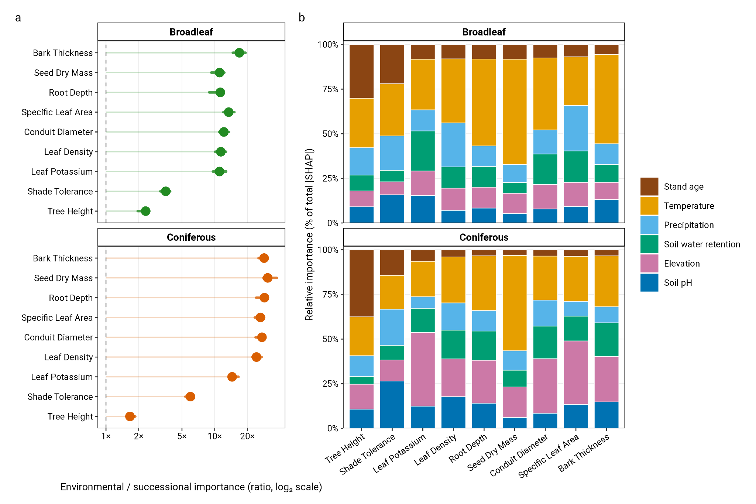

Figure 2. Environmental filtering dominates functional trait variation across forest succession. (a) Environmental-to-successional importance ratio per trait and forest type, expressed as the summed absolute SHAP importance of all five environmental predictors divided by the absolute SHAP importance of stand age (log₂ scale). Points show estimates from the original held-out test sets; horizontal coloured lines show empirical 95% intervals across five repeats of 10-fold cross-validation. The dashed vertical line at 1× indicates equal importance with larger values indicating greater environmental dominance. . Traits are ordered from most successional (top) to most environmental (bottom). (b) Relative contribution of each predictor to total absolute SHAP importance per trait, showing the decomposition of environmental dominance across individual predictors. Stand age (brown) is always shown at the top.

Environmental Modulation of Successional Trait Trajectories

Stand age interacted with environmental conditions to modulate the rate of trait change through succession (Fig. 3; Fig. S-7). Bootstrap 95% confidence intervals for Δslope excluded zero in 36 of 45 broadleaf and 30 of 45 coniferous trait–variable combinations. In broadleaf forests, temperature produced the largest and most consistent slope differences, with a median |Δslope| of 0.0043 across traits and eight of nine traits showing robust differences. Six traits; i.e., conduit diameter, tree height, leaf density, leaf potassium, seed dry mass, and specific leaf area, showed steeper successional trajectories in warmer plots (Δslope: +0.0027 to +0.0069), while bark thickness and shade tolerance showed steeper trajectories in colder plots (Δslope = −0.0016 and −0.0041 respectively). Precipitation and soil water retention produced robust differences in seven and eight of nine traits respectively, with broadly similar directional patterns. Elevation had the weakest effects in broadleaf forests (five robust slope differences; median |Δslope| = 0.0010). In coniferous forests, temperature produced the fewest robust slope differences of any variable × forest type combination, three of nine traits (leaf potassium, specific leaf area, and shade tolerance), with the smallest median |Δslope| (0.00029). Precipitation and soil water retention produced the most robust slope differences in coniferous forests (eight of nine traits each; median |Δslope| = 0.00096 and 0.00089 respectively). All environmental predictors produced robust intercept differences across both forest types, with median absolute intercept differences ranging from 0.24 to 0.46 across predictor × forest type combinations, consistently larger in magnitude than the corresponding slope differences (Fig. S-7). Comparing the absolute between-environment gap in predicted trait expression at succession onset with that in late succession (Fig. 3a) showed that these gaps were largely preserved through succession rather than opened or closed: most trait × predictor combinations fell close to the 1:1 line, with 30 of 45 broadleaf and 34 of 45 coniferous combinations widening (a larger gap in late succession) and the remainder stable or narrowing.

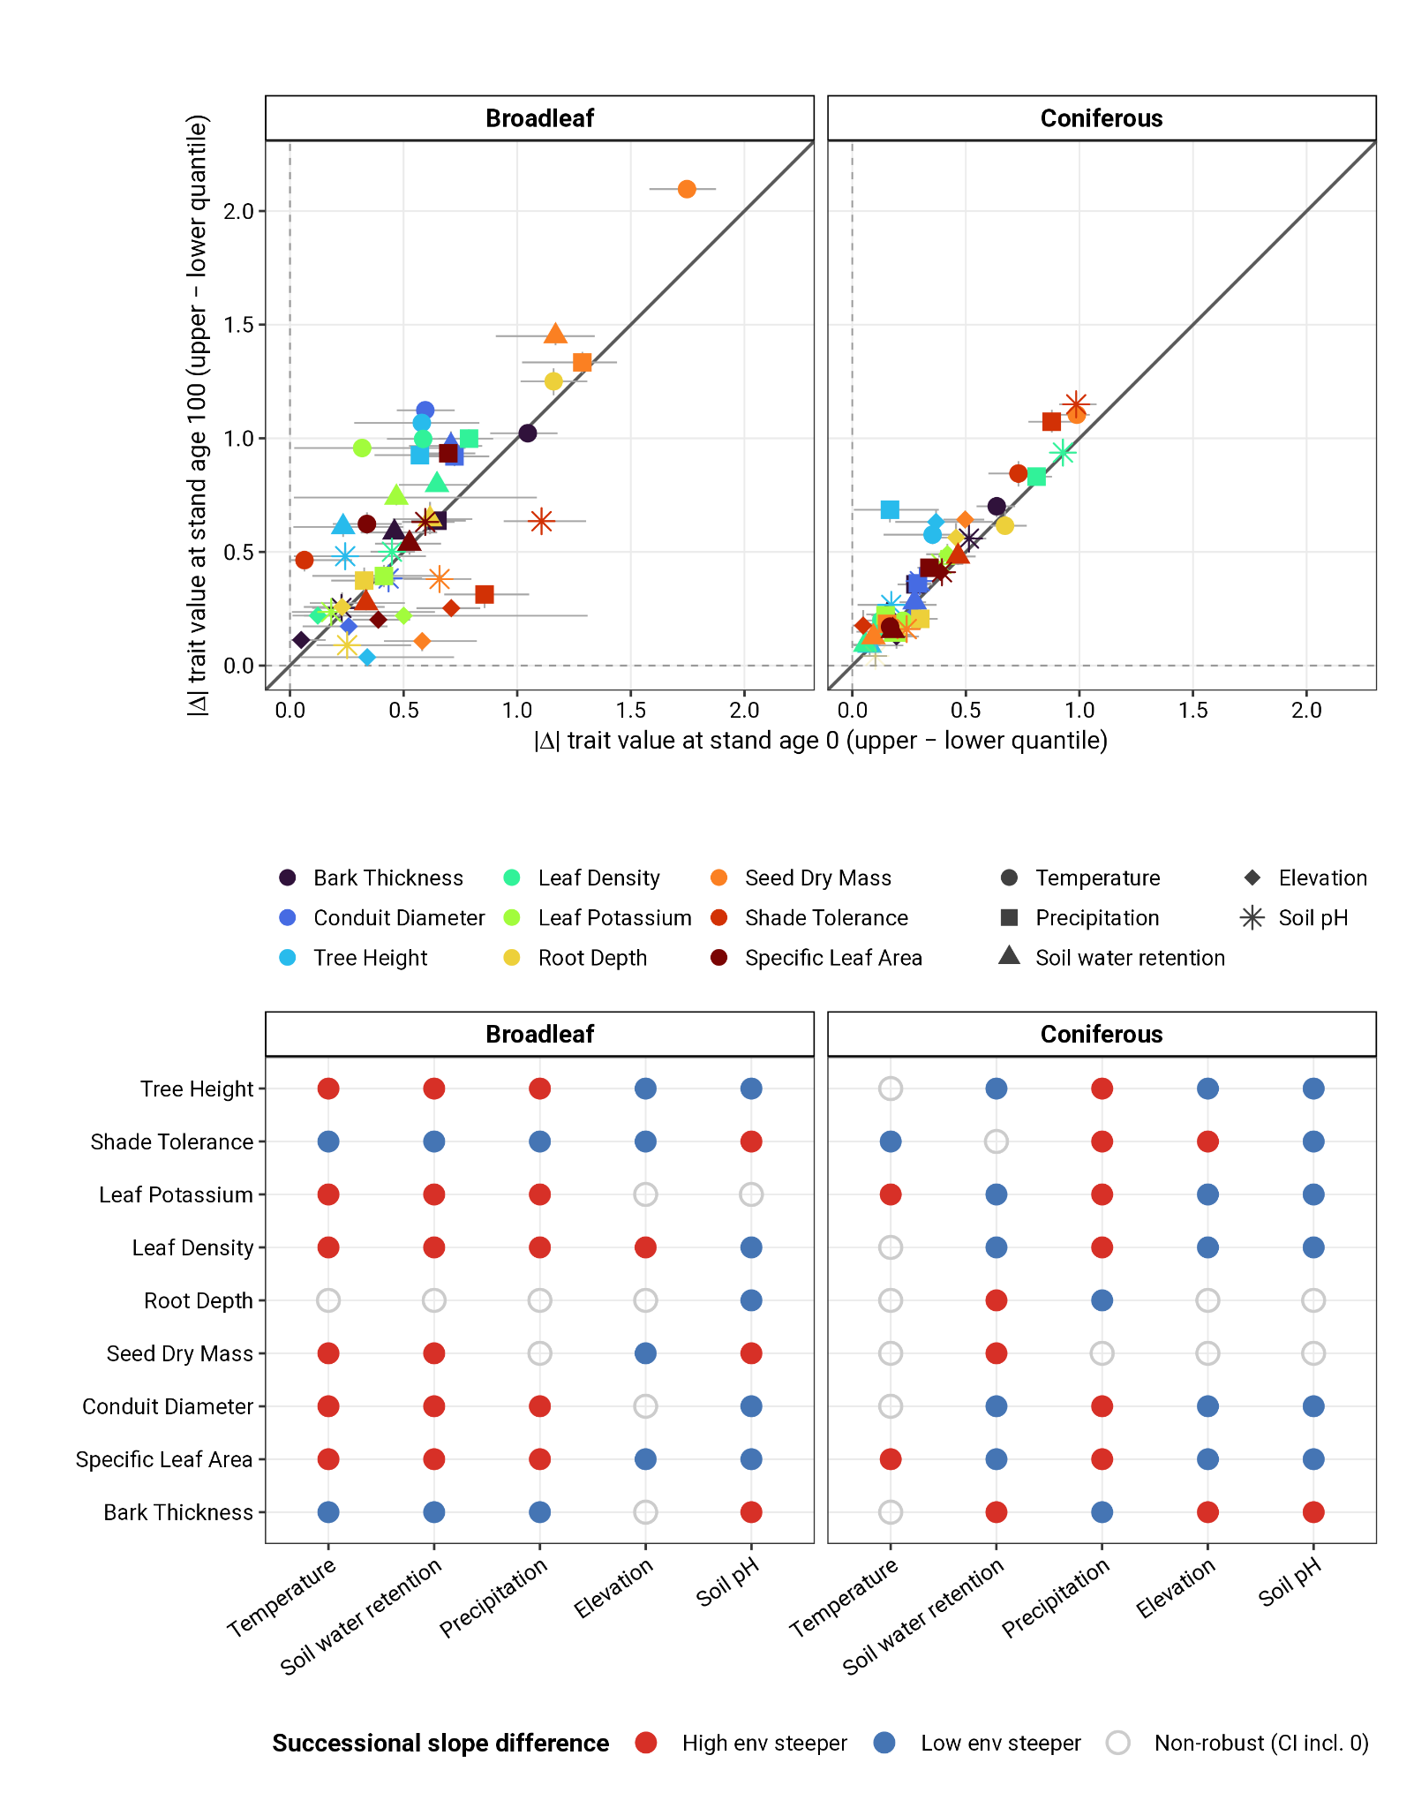Figure 3. Environmental context modulates the rate and origin of functional trait change through succession. (a) Absolute difference in community-weighted mean trait expression between the upper and lower environmental quantile groups (|Δ trait|, upper − lower) at succession onset (stand age 0, x-axis) versus late succession (stand age 100, y-axis), shown separately for broadleaf and coniferous forests. Each point is one trait × environmental-predictor combination (colour = trait, shape = environmental predictor). Crossbars are 95% bootstrap confidence intervals across 100 resampling iterations (horizontal = onset gap, vertical = late-succession gap). (b) Signed successional slope differences (Δslope = slope_high − slope_low) for every trait × environmental-predictor combination, shown separately for each forest type. Dot colour indicates direction, red where the successional trajectory is steeper in the high-environment group, blue where it is steeper in the low-environment group, and open grey circles mark non-robust combinations (95% bootstrap CI includes zero). Traits are ordered from most successional (top) to most environmental (bottom).

Predictability Divergence Through Succession

Trait predictability increased through succession in both forest types (Fig. 4; Fig. S-8). Mean predictability (VEcv) rose from 0.555 in early-successional broadleaf plots (stand age ≤ 30 years) to 0.814 in late-successional plots (stand age ≥ 100 years), and from 0.503 to 0.659 in coniferous forests. Mean predictability across all stand ages was higher in broadleaf forests (0.741) than coniferous forests (0.645), with the largest between-forest-type differences in shade tolerance (0.739 vs 0.540) and tree height (0.631 vs 0.466). Predictability diverged across environmental gradients throughout succession rather than converging toward zero (Fig. 4; Fig. S-9). Mean |ΔVEcv| was 0.084 in broadleaf forests and 0.116 in coniferous forests. Temperature drove the greatest predictability divergence in both forest types (mean |ΔVEcv| = 0.122 broadleaf, 0.163 coniferous), followed by elevation in coniferous forests (0.121) and soil water retention in broadleaf forests (0.080; Fig. S-9, inset). The sign of divergence was predominantly negative for temperature, though this varied across traits and variables (Fig. S-9). In 9 of 10 variable × forest type combinations, the magnitude of divergence decreased through succession. The single exception was temperature, where divergence increased through succession, visible as the widening band in especially coniferous systems (Fig. 4a). The proportion of stand-age bins with robust divergence (95% CI excluding zero) was 0.718 in broadleaf forests and 0.827 in coniferous forests (Fig. S-9). Across traits, coniferous tree height and seed dry mass showed the largest divergence (mean |ΔVEcv| = 0.141 and 0.130 respectively), while broadleaf shade tolerance was the most divergent broadleaf trait (0.116; Fig. S-9).
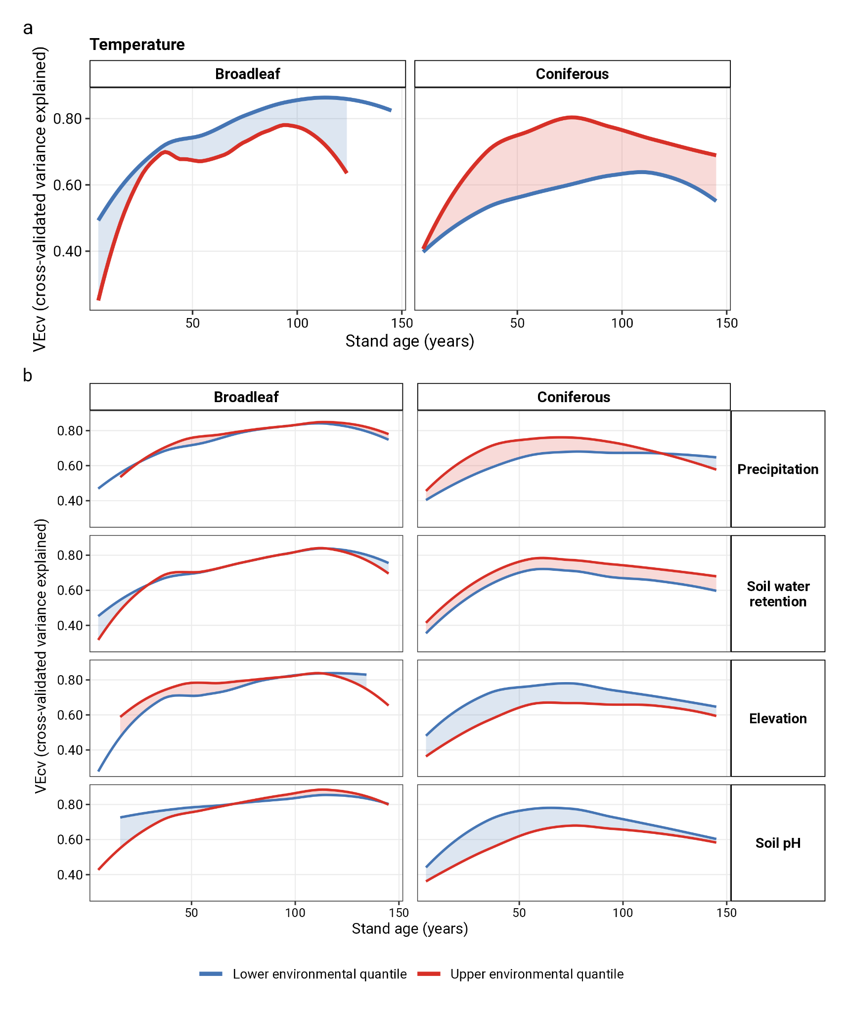
Figure 4. Trait predictability rises through succession but remains environmentally divergent. Out-of-fold predictive skill (VEcv) for community-weighted mean trait expression, averaged across the nine traits and smoothed over stand age, shown separately for the upper (red) and lower (blue) quantile of each environmental predictor. Lines are trait-averaged medians over 30 cross-validation repeats; the shaded band spans the gap between the two quantile groups and is tinted by sign (red where the upper-quantile group is more predictable, blue where the lower-quantile group is). A band that stays open through succession indicates persistent divergence in predictability across the environmental gradient; a band that closes indicates convergence. (a) Temperature , shown enlarged. (b) The four remaining predictors (precipitation, soil water retention, elevation, soil pH) crossed with forest type, on a common VEcv scale. Curves are not extrapolated beyond the observed stand-age range.
Discussion
Forest functional communities are widely assumed to follow broadly predictable successional trajectories, yet the degree to which these trajectories depend on local environmental context and to which late-successional communities converge toward predictable states has not been tested at continental scales. Using over 49,000 forest plots spanning the environmental breadth of US forest types, we provide a continental-scale test of these questions and show that environmental filtering dominates functional trait variation, systematically modifies the rate and direction of successional change, and generates persistent divergence in trait predictability across environmental gradients. Our results support an environmentally conditional model of succession in which both the trajectory and determinism of community assembly depend fundamentally on abiotic context.
The near-universal dominance of environmental over successional predictors, with importance ratios reaching 30× for bark thickness and seed dry mass in coniferous forests, extends findings that have emphasised the importance of climate in structuring functional communities (Laughlin et al. 2012; Maynard et al. 2022; Swenson & Enquist 2007). The two partial exceptions, tree height and shade tolerance, are both traits whose expression is most directly governed by competitive dynamics for light rather than direct abiotic constraints, consistent with theoretical predictions that biotic filtering dominates in trait axes most closely linked to competitive hierarchies (Grime 1977; Kunstler et al. 2016). The stronger environmental dominance in coniferous forests relative to broadleaf forests is consistent with the harsher and more variable abiotic conditions of boreal and montane conifer systems, where thermal and edaphic constraints are more severe and may more completely override biotic assembly dynamics (Engler et al. 2011; Körner 2012). The asymmetry in leading environmental predictors between forest types, i.e., temperature dominating all nine traits in broadleaf forests (Fig 2b) but elevation being the dominant driver for three traits in coniferous forests (Leaf P, SLA, and Conduit diameter), points to a fundamental difference in how these systems are organised along environmental gradients. In broadleaf forests, the dominant north–south thermal gradient imposes a coherent filtering axis on nearly all functional dimensions simultaneously. In coniferous forests, topographic position captures variation in growing season length, freeze-thaw cycles, snow duration, and disturbance return intervals that are only partially reflected in macroclimate variables, consistent with the known importance of fine-scale topographic controls on species distributions and trait expression in mountain forest systems (Dobrowski 2011; Mod et al. 2016).
The widespread robust differences in successional slopes between upper and lower environmental quantile groups, particularly in broadleaf forests, demonstrate that environmental conditions do not merely set the mean level of trait expression but actively modulate the rate of community change through succession. The alignment of directional slope differences with a resource-acquisitive versus stress-tolerant axis is consistent with the growth-survival trade-off framework and the prediction that productive environments amplify competitive dynamics, accelerating the turnover of functional strategies through succession (Grime 1988; Reich 2014; Wright et al. 2004). In warmer, wetter broadleaf forests, acquisitive traits, such as high-value expressions in conduit diameter, leaf potassium, leaf density, and specific leaf area, showed steeper successional increases, consistent with faster canopy closure and stronger competitive exclusion of stress-tolerant early-successional species under high-productivity conditions (Lebrija-Trejos et al. 2010b; Lohbeck et al. 2014). The opposite pattern for bark thickness and shade tolerance, i.e., steeper trajectories in colder broadleaf forests, suggests that as abiotic stress intensifies, biotic filtering through light competition and disturbance resistance may become the dominant assembly mechanism even as environmental conditions become more harsh, a pattern consistent with stress-gradient hypothesis predictions (Bertness & Callaway 1994; Michalet et al. 2006).
The strikingly weak modulation of successional slopes by temperature in coniferous forests (with only three of nine traits showing robust slope differences despite temperature being the dominant importance predictor) highlights another asymmetry between the role of temperature as a spatial filter and its role as a modulator of temporal dynamics. While temperature strongly constrains which functional strategies are viable across space in coniferous systems, it appears to exert comparatively little control over how communities change through time within those constrained ranges. This is consistent with the idea that coniferous forest communities operate closer to their physiological limits across the temperature gradient, leaving less room for temperature to differentiate successional trajectories (Körner 2021). Instead, moisture availability, which was captured here by precipitation and soil water retention, emerged as the primary modulator of successional dynamics in conifers, pointing to water as the more proximate driver of competitive turnover in these systems (McDowell et al. 2020; Poulter et al. 2014).
The finding that trait predictability increased through succession in both forest types is consistent with the idea of progressive determinism in succession, i.e., that biotic filtering should strengthen as competitive hierarchies stabilise in late succession (Chase 2010; Fukami 2015; HilleRisLambers et al. 2012). However, the persistent divergence in predictability across environmental gradients demonstrates that this determinism is not universal, but context dependent. Rather than converging toward a common late-successional state, communities retain environmentally structured differences in predictability throughout succession. This supports that environmental heterogeneity may maintain alternative assembly pathways even in mature communities (Chase 2010; Kraft et al. 2015), and aligns with empirical evidence from tropical forests showing that environmental context can sustain divergent successional trajectories across rainfall gradients (Boukili & Chazdon 2017). The single exception to the general pattern of decreasing divergence in this study was across temperature regimes, where predictability divergence markedly increased through succession, especially in coniferous forests. This suggests the thermal context to become a progressively stronger determinant of functional predictability as coniferous stands age, potentially reflecting the increasing importance of cold-adapted late-successional species assemblages that are more tightly filtered by thermal limits than early-successional communities (Körner 2021; Zhu et al. 2013). Under ongoing warming, this increasing thermal sensitivity through succession implies that the predictability of late-successional coniferous communities may be more sensitive to climate change than early-successional ones, with potentially important consequences for projections of forest recovery in e.g., mountain and boreal systems (Seidl et al. 2017; Thom et al. 2017). The greater overall predictability divergence in coniferous forests relative to broadleaf forests, despite weaker successional slope differences, suggests that environmental context influences functional predictability through a mechanism partially independent of trait trajectory slopes. One likely explanation is that coniferous forest communities occupy more environmentally extreme and heterogeneous positions along the temperature and elevation gradients, such that small differences in environmental context translate into larger differences in the set of viable functional strategies and thus in predictability. This interpretation aligns with evidence that community assembly in harsh environments is more strongly deterministic because the pool of functionally viable species is more restricted (Bernard-Verdier et al. 2012; Cornwell & Ackerly 2009).
In conclusion, we show that the environmental context does not merely modulate succession, but constrains the functional space within which succession unfolds, shaping where communities move, how quickly they change, and how predictable their trajectories become. However, there are several relevant limitations to consider when interpreting these results, most importantly that because stand age is inferred from the size of dominant trees, it is expected to correlate with site productivity, which in turn correlates with our environmental predictors. This could inflate the apparent dominance of environmental over successional filtering, and could in principle drive the overall rise in predictability with stand age if older stands simply occupy more homogeneous, higher-quality sites. However, the divergence of predictability across environmental gradients should be more robust to the confound, because any productivity signal carried by stand age is shared between the two strata at a given age and largely differences out.
The cross-sectional design means that apparent successional trajectories reflect compositional differences among stands of different ages rather than within-plot temporal change, and unmeasured variation in disturbance history, species pool composition, and land-use legacies may contribute to patterns we attribute to succession. Finally, community-weighted means capture the central tendency of functional composition but do not reflect intraspecific and ontogenic trait variation or functional diversity within plots, which may respond to environmental gradients and succession in ways CWMs cannot detect (Díaz et al. 2016).
These findings contribute to our understanding how functional recovery should be projected under climate change. Models used to forecast post-disturbance trajectories, from dynamic global vegetation models to restoration and carbon-accounting frameworks, typically represent succession as a function of time since disturbance, with climate modulating the rate at which a stand approaches a regionally fixed endpoint (Cook-Patton et al. 2020; Poorter et al. 2021; Pugh et al. 2019). Our results indicate that this structure might be misspecified: environmental context sets not only the pace but the direction and the determinism of trait change, so two same-aged stands recovering under different thermal or moisture regimes need not converge on the same functional composition, and the confidence with which either can be predicted is itself environment-dependent. A single successional trajectory fitted for a region will therefore be biased wherever the climate is shifting. The temperature-driven divergence in coniferous systems raises a specific concern: because the predictability of coniferous trait composition becomes more, not less, dependent on temperature as stands age, the oldest and most carbon-dense boreal and montane conifer forests are where late-successional functional outcomes will be hardest to anticipate under warming, and where prediction errors carry the largest consequences for projected carbon stocks. Compounding this, an environmentally conditional succession implies that the novel, no-analogue climates emerging this century will not merely accelerate movement along known trajectories but generate successional endpoints outside the range any space-for-time model has observed. Anticipating forest recovery under global change will therefore require succession models that carry environmental context as a primary axis, rather than as a correction to a universal successional clock.

Acknowledgements
We thank Alastair Pickering for his help in computing shade tolerance and we are grateful to the numerous people that collected data for the FIA. DM was supported by ERC Starting Grant (#101164911).
Data availability
The raw FIA, trait, and environmental data used in this study can be found in the online supplementary materials of the corresponding publications. All code and the processed data used for the analysis are openly available in the designated GitHub repository (+Zenodo later on).

Conflict of Interest

The authors declare they have no conflict of interest.

Author contribution
Conceptualization: MW, DM
Methodology: MW, DM
Formal Analysis: MW, DM
Writing (original draft): MW, DM
Writing – review & editing: MW, DM

All authors read, reviewed, and approved the final manuscript.
References

Amatulli, G., Domisch, S., Tuanmu, M.-N., Parmentier, B., Ranipeta, A., Malczyk, J., et al. (2018). A suite of global, cross-scale topographic variables for environmental and biodiversity modeling. Sci Data, 5, 180040.
Andrewsa, T., Dietzeb, M. & Boothc, R. (2018). Climate or disturbance: temperate forest structural change and carbon sink potential.
Bernard-Verdier, M., Navas, M.-L., Vellend, M., Violle, C., Fayolle, A. & Garnier, E. (2012). Community assembly along a soil depth gradient: contrasting patterns of plant trait convergence and divergence in a Mediterranean rangeland. Journal of Ecology, 100, 1422–1433.
Bertness, M.D. & Callaway, R. (1994). Positive interactions in communities. Trends in Ecology & Evolution, 9, 191–193.
Besnard, S., Koirala, S., Santoro, M., Weber, U., Nelson, J., Gütter, J., et al. (2021). Mapping global forest age from forest inventories, biomass and climate data. Earth System Science Data, 13, 4881–4896.
Boukili, V.K. & Chazdon, R.L. (2017). Environmental filtering, local site factors and landscape context drive changes in functional trait composition during tropical forest succession. Perspectives in Plant Ecology, Evolution and Systematics, 24, 37–47.
Breiman, L. (2001). Random Forests. Machine Learning, 45, 5–32.
van Breugel, M., Bongers, F., Norden, N., Meave, J.A., Amissah, L., Chanthorn, W., et al. (2024). Feedback loops drive ecological succession: towards a unified conceptual framework. Biological Reviews, 99, 928–949.
Chang, C. & HilleRisLambers, J. (2016). Integrating succession and community assembly perspectives.
Chang, C.C. & Turner, B.L. (2019). Ecological succession in a changing world. Journal of Ecology, 107, 503–509.
Chase, J.M. (2010). Stochastic Community Assembly Causes Higher Biodiversity in More Productive Environments. Science, 328, 1388–1391.
Chesson, P.L. (2000). Mechanisms of Maintenance of Species Diversity. Annual Review of Ecology and Systematics, 31, 343–366.
Christensen, N.L. (2014). An historical perspective on forest succession and its relevance to ecosystem restoration and conservation practice in North America. Forest Ecology and Management, 330, 312–322.
Clements, F.E. (1916). Plant succession: an analysis of the development of vegetation. Carnegie institution of Washington.
Connell, J.H. & Slatyer, R.O. (1977). Mechanisms of Succession in Natural Communities and Their Role in Community Stability and Organization. The American Naturalist, 111, 1119–1144.
Cook-Patton, S.C., Leavitt, S.M., Gibbs, D., Harris, N.L., Lister, K., Anderson-Teixeira, K.J., et al. (2020). Mapping carbon accumulation potential from global natural forest regrowth. Nature, 585, 545–550.
Cornwell, W.K. & Ackerly, D.D. (2009). Community assembly and shifts in plant trait distributions across an environmental gradient in coastal California. Ecological Monographs, 79, 109–126.
Craven, D., Hall, J.S., Berlyn, G.P., Ashton, M.S. & van Breugel, M. (2015). Changing gears during succession: shifting functional strategies in young tropical secondary forests. Oecologia, 179, 293–305.
Curtis, P.G., Slay, C.M., Harris, N.L., Tyukavina, A. & Hansen, M.C. (2018). Classifying drivers of global forest loss. Science, 361, 1108–1111.
Díaz, S., Kattge, J., Cornelissen, J.H.C., Wright, I.J., Lavorel, S., Dray, S., et al. (2016). The global spectrum of plant form and function. Nature, 529, 167–171.
Dobrowski, S.Z. (2011). A climatic basis for microrefugia: the influence of terrain on climate. Global Change Biology, 17, 1022–1035.
Engler, R., Randin, C.F., Thuiller, W., Dullinger, S., Zimmermann, N.E., Araújo, M.B., et al. (2011). 21st century climate change threatens mountain flora unequally across Europe. Global Change Biology, 17, 2330–2341.
Friedman, J.H. (2001). Greedy function approximation: A gradient boosting machine. The Annals of Statistics, 29, 1189–1232.
Fukami, T. (2015). Historical contingency in community assembly: integrating niches, species pools, and priority effects. Annual review of ecology, evolution, and systematics, 46, 1–23.
Gray, A.N., Brandeis, T.J., Shaw, J.D., McWilliams, W.H. & Miles, P. (2012). Forest Inventory and Analysis Database of the United States of America (FIA). In: Dengler, J.; Oldeland, J.; Jansen, F.; Chytry, M.; Ewald, J., Finckh, M.; Glockler, F.; Lopez-Gonzalez, G.; Peet, R. K.; Schaminee, J .H. J., eds. Vegetation databases for the 21st century. Biodiversity and Ecology. 4: 225-231., 225–231.
Greenwell, B. (2024). fastshap: Fast Approximate Shapley Values.
Grime, J.P. (1977). Evidence for the Existence of Three Primary Strategies in Plants and Its Relevance to Ecological and Evolutionary Theory. The American Naturalist, 111, 1169–1194.
Grime, J.P. (1988). The C-S-R model of primary plant strategies - origins , implications and tests.
Haeussler, S., Kabzems, R., McClarnon, J. & Bedford, L. (2021). Successional change, restoration success, and resilience in boreal mixedwood vegetation communities over three decades. Canadian Journal of Forest Research, 51, 766–780.
Hengl, T., Jesus, J.M. de, Heuvelink, G.B.M., Gonzalez, M.R., Kilibarda, M., Blagotić, A., et al. (2017). SoilGrids250m: Global gridded soil information based on machine learning. PLOS ONE, 12, e0169748.
HilleRisLambers, J., Adler, P.B., Harpole, W.S., Levine, J.M. & Mayfield, M.M. (2012). Rethinking community assembly through the lens of coexistence theory. Annual Review of Ecology, Evolution and Systematics, 43, 2012.
van den Hoogen, J., Geisen, S., Routh, D., Ferris, H., Traunspurger, W., Wardle, D.A., et al. (2019). Soil nematode abundance and functional group composition at a global scale. Nature, 572, 194–198.
Jin, Y. & Qian, H. (2019). V.PhyloMaker: an R package that can generate very large phylogenies for vascular plants. Ecography, 42, 1353–1359.
Karger, D.N., Conrad, O., Böhner, J., Kawohl, T., Kreft, H., Soria-Auza, R.W., et al. (2017). Climatologies at high resolution for the earth’s land surface areas. Sci Data, 4, 170122.
Keddy, P.A. (1992). Assembly and response rules: two goals for predictive community ecology. Journal of Vegetation Science, 3, 157–164.
Körner, C. (2012). Alpine Treelines. Springer, Basel.
Körner, C. (2021). Alpine treelines. In: Alpine Plant Life: Functional Plant Ecology of High Mountain Ecosystems (ed. Körner, C.). Springer International Publishing, Cham, pp. 141–173.
Kraft, N.J.B. & Ackerly, D.D. (2010). Functional trait and phylogenetic tests of community assembly across spatial scales in an Amazonian forest. Ecological Monographs, 80, 401–422.
Kraft, N.J.B., Adler, P.B., Godoy, O., James, E.C., Fuller, S. & Levine, J.M. (2015). Community assembly, coexistence and the environmental filtering metaphor. Functional Ecology, 29, 592–599.
Kunstler, G., Falster, D., Coomes, D.A., Hui, F., Kooyman, Robert, M., Laughlin, D.C., et al. (2016). Plant functional traits have globally consistent effects on competition. Nature, 529, 1–15.
Lai, H.R., Craven, D., Hall, J.S., Hui, F.K.C. & van Breugel, M. (2021). Successional syndromes of saplings in tropical secondary forests emerge from environment-dependent trait-demography relationships. Ecol Lett, 24, 1776–1787.
Lasky, J.R., Uriarte, M., Boukili, V.K. & Chazdon, R.L. (2014). Trait-mediated assembly processes predict successional changes in community diversity of tropical forests. Proc Natl Acad Sci U S A, 111, 5616–5621.
Laughlin, D.C., Joshi, C., van Bodegom, P.M., Bastow, Z.A. & Fulé, P.Z. (2012). A predictive model of community assembly that incorporates intraspecific trait variation. Ecology Letters, 15, 1291–1299.
Lebrija-Trejos, E., Meave, J.A., Poorter, L., Pérez-García, E.A. & Bongers, F. (2010a). Pathways, mechanisms and predictability of vegetation change during tropical dry forest succession. Perspectives in Plant Ecology, Evolution and Systematics, 12, 267–275.
Lebrija-Trejos, E., Pérez-García, E.A., Meave, J.A., Bongers, F. & Poorter, L. (2010b). Functional traits and environmental filtering drive community assembly in a species-rich tropical system. Ecology, 91, 386–398.
Levine, J.I., An, R., Kraft, N.J.B., Pacala, S.W. & Levine, J.M. (2025). Why ecologists struggle to predict coexistence from functional traits. Trends in Ecology & Evolution, 40, 147–158.
Li, J. (2017). Assessing the accuracy of predictive models for numerical data: Not r nor r2, why not? Then what? PLOS ONE, 12, e0183250.
Lohbeck, M., Lebrija-Trejos, E., Martínez-Ramos, M., Meave, J.A., Poorter, L. & Bongers, F. (2015). Functional Trait Strategies of Trees in Dry and Wet Tropical Forests Are Similar but Differ in Their Consequences for Succession. PLOS ONE, 10, e0123741.
Lohbeck, M., Poorter, L., Martínez-Ramos, M., Rodriguez-Velázquez, J., van Breugel, M. & Bongers, F. (2014). Changing drivers of species dominance during tropical forest succession. Functional Ecology, 28, 1052–1058.
Malhi, Y., Doughty, C. & Galbraith, D. (2011). The allocation of ecosystem net primary productivity in tropical forests. Philosophical Transactions of the Royal Society B: Biological Sciences, 366, 3225–3245.
Marcílio, W.E. & Eler, D.M. (2020). From explanations to feature selection: assessing SHAP values as feature selection mechanism. In: 2020 33rd SIBGRAPI Conference on Graphics, Patterns and Images (SIBGRAPI). Presented at the 2020 33rd SIBGRAPI Conference on Graphics, Patterns and Images (SIBGRAPI), pp. 340–347.
Mayfield, M.M. & Levine, J.M. (2010). Opposing effects of competitive exclusion on the phylogenetic structure of communities. Ecology Letters, 13, 1085–1093.
Maynard, D.S., Bialic-Murphy, L., Zohner, C.M., Averill, C., van den Hoogen, J., Ma, H., et al. (2022). Global relationships in tree functional traits. Nat Commun, 13, 3185.
McDowell, N.G., Allen, C.D., Anderson-Teixeira, K., Aukema, B.H., Bond-Lamberty, B., Chini, L., et al. (2020). Pervasive shifts in forest dynamics in a changing world. Science, 368, eaaz9463.
Meiners, S.J., Cadotte, M.W., Fridley, J.D., Pickett, S.T.A. & Walker, L.R. (2015). Is successional research nearing its climax? New approaches for understanding dynamic communities. Functional Ecology, 29, 154–164.
Michalet, R., Brooker, R.W., Cavieres, L.A., Kikvidze, Z., Lortie, C.J., Pugnaire, F.I., et al. (2006). Do biotic interactions shape both sides of the humped-back model of species richness in plant communities? Ecology Letters, 9, 767–773.
Mod, H.K., Scherrer, D., Luoto, M. & Guisan, A. (2016). What we use is not what we know: environmental predictors in plant distribution models. Journal of Vegetation Science, 27, 1308–1322.
Mori, A.S., Lertzman, K.P. & Gustafsson, L. (2017). Biodiversity and ecosystem services in forest ecosystems: a research agenda for applied forest ecology. Journal of Applied Ecology, 54, 12–27.
Norden, N., Angarita, H.A., Bongers, F., Martínez-Ramos, M., Granzow-de la Cerda, I., van Breugel, M., et al. (2015). Successional dynamics in Neotropical forests are as uncertain as they are predictable. Proceedings of the National Academy of Sciences, 112, 8013–8018.
Odum, E.P. (1969). The Strategy of Ecosystem Development. Science, 164, 262–270.
Oliver, C. & Larson, B. (1996). Forest Stand Dynamics, Update Edition. Yale School of the Environment Other Publications.
Poorter, L., Amissah, L., Bongers, F., Hordijk, I., Kok, J., Laurance, S.G.W., et al. (2023). Successional theories. Biological Reviews, 98, 2049–2077.
Poorter, L., Craven, D., Jakovac, C.C., van der Sande, M.T., Amissah, L., Bongers, F., et al. (2021). Multidimensional tropical forest recovery. Science, 374, 1370–1376.
Poulter, B., Frank, D., Ciais, P., Myneni, R.B., Andela, N., Bi, J., et al. (2014). Contribution of semi-arid ecosystems to interannual variability of the global carbon cycle. Nature, 509, 600–603.
Pugh, T.A.M., Lindeskog, M., Smith, B., Poulter, B., Arneth, A., Haverd, V., et al. (2019). Role of forest regrowth in global carbon sink dynamics. Proceedings of the National Academy of Sciences, 116, 4382–4387.
Reich, P.B. (2014). The world-wide ‘fast–slow’ plant economics spectrum: a traits manifesto. Journal of Ecology, 102, 275–301.
Rueda, M., Godoy, O. & Hawkins, B.A. (2018). Trait syndromes among North American trees are evolutionarily conserved and show adaptive value over broad geographic scales. Ecography, 41, 540–550.
Sánchez-Pinillos, M., De Cáceres, M., Ameztegui, A. & Coll, L. (2019). Temporal dimension of forest vulnerability to fire along successional trajectories. Journal of Environmental Management, 248, 109301.
Seidl, R., Thom, D., Kautz, M., Martin-Benito, D., Peltoniemi, M., Vacchiano, G., et al. (2017). Forest disturbances under climate change. Nature Clim Change, 7, 395–402.
Štrumbelj, E. & Kononenko, I. (2014). Explaining prediction models and individual predictions with feature contributions. Knowl Inf Syst, 41, 647–665.
Swenson, N.G. & Enquist, B.J. (2007). Ecological and evolutionary determinants of a key plant functional trait: wood density and its community-wide variation across latitude and elevation. American Journal of Botany, 94, 451–459.
Thom, D., Rammer, W. & Seidl, R. (2017). The impact of future forest dynamics on climate: interactive effects of changing vegetation and disturbance regimes. Ecological Monographs, 87, 665–684.
Violle, C., Navas, M.-L., Vile, D., Kazakou, E., Fortunel, C., Hummel, I., et al. (2007). Let the concept of trait be functional! Oikos, 116, 882–892.
Walker, L.R. & Chapin, F.S. (1987). Interactions among Processes Controlling Successional Change. Oikos, 50, 131–135.
Williams, J.W., Jackson, S.T. & Kutzbach, J.E. (2007). Projected distributions of novel and disappearing climates by 2100 AD. Proceedings of the National Academy of Sciences, 104, 5738–5742.
Wright, I.J., Reich, P.B., Westoby, M., Ackerly, D.D., Baruch, Z., Bongers, F., et al. (2004). The worldwide leaf economics spectrum. Nature, 428, 821–827.
Wright, M.N. & Ziegler, A. (2017). ranger: A Fast Implementation of Random Forests for High Dimensional Data in C++ and R. Journal of Statistical Software, 77, 1–17.
Zhu, S.-D., Song, J.-J., Li, R.-H. & Ye, Q. (2013). Plant hydraulics and photosynthesis of 34 woody species from different successional stages of subtropical forests. Plant Cell Environ, 36, 879–891.

