Environmental context shapes the direction and predictability of functional succession in forests
Merlin Weiss^{1,2*} and Daniel S. Maynard¹
¹ Department of Genetics, Environment and Evolution, University College London, Gower Street, WC1E 6BT London, United Kingdom
² Department of Environmental Systems Science, ETH Zürich, Universitätstrasse 16, 8092 Zürich, Switzerland

*Corresponding author E-Mail: merlin.weiss@usys.ethz.ch

Abstract
Successional theory predicts that forest communities become more predictable as stands mature, but whether this pattern persists across environmental contexts remains unclear. Using 49,377 inventory observations from 27,270 permanent plots spanning United States forests, we modelled community-weighted mean expression of nine functional traits as a function of stand age and abiotic context. Environmental predictors collectively received more SHAP attribution than stand age in every trait-forest combination (median environmental-to-age ratios 1.7-31.1; all empirical intervals from PID-grouped cross-validation exceeded one), although this comparison aggregates five environmental axes against one age variable. Environmental context also modified modelled successional rates in 61 of 90 trait-gradient-forest combinations, with stronger rate modification in broadleaf forests. These responses did not follow a universal convergence, divergence, or trait-syndrome pattern: environmental trait separation widened in 39 combinations, narrowed in 20, and remained uncertain in 31. PID-grouped cross-validation further showed that predictive skill was higher in later than early succession, while environmental differences in predictive skill persisted in most late-successional cells. Forest functional succession is therefore environmentally conditional, but the environment does not impose a single direction of change. Forecasts of forest recovery should represent stand age and environmental context jointly and retain context-specific uncertainty.
Keywords
Community Assembly, Environmental Filtering, Forest Succession, Functional Ecology, Random Forest, Shapley Values, Partial Dependence, Trait-Environment Interactions

Introduction
Forest succession describes the progressive reorganisation of tree communities following disturbance or stand initiation (Chang & HilleRisLambers 2016; Poorter et al. 2023). It is a fundamental concept in both theoretical and applied ecology (Chang & Turner 2019; Poorter et al. 2023), providing a framework for testing assembly theory and governing the recovery of forest biomass, carbon stocks, and biodiversity (Andrewsa et al. 2018; Chang & Turner 2019; Haeussler et al. 2021; Malhi et al. 2011; Sánchez-Pinillos et al. 2019) following widespread land-use change across global forest biomes (Besnard et al. 2021; Curtis et al. 2018). Succession is driven by plant–environment feedback loops, in which developing communities modify local conditions, leading to directional turnover in species composition as competitive hierarchies reorganise through time (van Breugel et al. 2024; Connell & Slatyer 1977). Classical theory predicts that this process becomes increasingly deterministic, with early-successional communities shaped by stochasticity and late-successional communities converging toward predictable endpoints as internal feedbacks stabilise (Clements 1916; Odum 1969; Poorter et al. 2023). However, empirical studies consistently report substantial variability in successional trajectories even among climatically similar stands, suggesting that the degree of determinism in succession itself is context dependent (Chase 2010; Fukami 2015; Norden et al. 2015). Predicting how and where succession proceeds therefore remains a central challenge, with direct implications for forecasting forest recovery under global change (Christensen 2014; Levine et al. 2025; Mori et al. 2017).
A key difficulty lies in disentangling the processes that drive directional change within stands from those that generate variation across stands. Directional succession is largely governed by internal dynamics, such as canopy closure and shifting competitive advantages toward shade-tolerant species. In contrast, regional climate and edaphic context act as external constraints that shape which species can establish and persist, without themselves being substantially modified by the developing community (van Breugel et al. 2024; Walker & Chapin 1987). Succession therefore reflects the interaction of two distinct filtering processes: Environmental filtering imposes abiotic constraints on trait expression across space (Grime 1988; Keddy 1992; Kraft et al. 2015), whereas successional filtering captures time-dependent biotic dynamics, including competition, facilitation, and priority effects, that drive turnover as stands mature (Chesson 2000; Kunstler et al. 2016; Mayfield & Levine 2010). Because these processes are difficult to observe directly, successional filtering is often operationalized through stand age, which integrates the cumulative outcome of biotic assembly dynamics (van Breugel et al. 2024; Oliver & Larson 1996).
Whether the environmental context merely sets the pace of succession or actively redirects its trajectory is a question with wide-ranging consequences. Classical theory holds that stands in the same broad climatic region converge toward a predictable endpoint regardless of local conditions, with environment affecting how fast but not where communities end up (Clements 1916; Oliver & Larson 1996). Yet both theory and empirical evidence point toward a more contingent picture, in which the prevailing abiotic regime amplifies, dampens, or redirects trait change through succession rather than simply scaling it (Boukili & Chazdon 2017; Chase 2010; Lebrija-Trejos et al. 2010a; Lohbeck et al. 2015; Walker & Chapin 1987). If trait trajectories diverge across environmental gradients, then the functional state of a recovering forest depends not only on time since disturbance but on the environmental context in which succession unfolds, and the degree to which succession produces predictable outcomes should itself vary systematically with that context. Testing this requires data that span broad environmental and temporal gradients simultaneously, a condition rarely met in studies confined to single biomes or short successional sequences (van Breugel et al. 2024; Meiners et al. 2015). Under global change, where shifting temperature and precipitation regimes may push recovering forests into novel conditions (Williams et al. 2007), understanding whether environmental context shapes the direction and predictability of succession is particularly consequential.
Functional traits offer a taxon-independent framework for making this question tractable. Because traits mediate how species respond to both abiotic conditions and biotic competition, they can be mapped continuously onto environmental and temporal gradients to test whether community change reflects primarily abiotic constraint, biotic turnover, or their interaction (Boukili & Chazdon 2017; Kraft & Ackerly 2010; Violle et al. 2007). Trait-based studies of forest succession have revealed directional shifts in plant strategies, including changes along resource acquisition-conservation axes and stature-recruitment trade-offs (Craven et al. 2015; Lai et al. 2021; Lasky et al. 2014). Yet these trajectories vary among systems and environmental settings, suggesting that functional succession itself may be contingent on the conditions under which communities assemble (van Breugel et al. 2024; Poorter et al. 2023). Tracking individual trait trajectories therefore allows the relative contributions of environmental and successional filtering to be compared along common functional axes. It also allows us to test whether environmental context shapes not only trait expression, but the rate, direction, and predictability of change through succession.
Here we address these questions using 49,377 inventory observations from 27,270 permanent forest plots spanning the United States and Alaska, drawn from the US Forest Inventory and Analysis programme. Using plot-level measurements of tree size and composition, we modelled community-weighted mean expression of nine functional traits spanning leaf economics (specific leaf area, leaf potassium, leaf density), hydraulics (conduit diameter), bark structure (bark thickness), whole-tree architecture (tree height), resource acquisition (root depth), reproduction (seed dry mass), and light competition (shade tolerance) as a function of stand age and abiotic predictors. We then compared environmental and age-related model attribution, quantified how environmental conditions modify modelled successional trait trajectories, and assessed how trait predictability changes through succession across contrasting environmental contexts.
We tested three predictions. First, environmental predictors should receive greater collective model attribution than stand age, with the weakest environmental dominance for traits most directly related to light competition and whole-tree architecture (Grime 1977; Kraft et al. 2015). Second, environmental context should modify successional trait trajectories; we specifically predicted faster change in resource-acquisitive traits under productive conditions and the converse for stress-tolerant traits (Boukili & Chazdon 2017; Lohbeck et al. 2014; Walker & Chapin 1987). Third, trait predictability should be higher in later succession but remain contingent on environmental context, such that predictability differences between contrasting environments persist rather than converge toward zero (Chase 2010; HilleRisLambers et al. 2012; Poorter et al. 2023).

Material and Methods
Forest Plots
We used data from the US Forest Inventory and Analysis (FIA) programme (Gray et al. 2012), a long-term monitoring dataset recording tree occurrences across standardised permanent plots throughout the United States. From the full FIA database, we retained living trees identified to species level, measured under standard fixed-area plot designs (design codes 1, 501, and 505), recorded in a single homogeneous condition class, and inventoried from 1980 onwards. We excluded privately owned plots and plots under active forestry management. Where plots had been measured more than once, we retained up to three of the most recent inventories per plot. Stand age is reported by FIA as the average total age of live trees within the plot's stand-size class (Gray et al. 2012) and was used as a proxy for successional stage. We excluded observations in the upper 10% of the stand age distribution to focus on approximately 1-150 years and reduce the influence of sparsely sampled old-growth stands. Broadleaf forests comprised temperate broadleaf and Mediterranean woodland biomes; coniferous forests comprised boreal and temperate conifer biomes. The final dataset contained 49,377 inventory observations from 27,270 permanent plots. Analyses were conducted separately for broadleaf and coniferous forests.

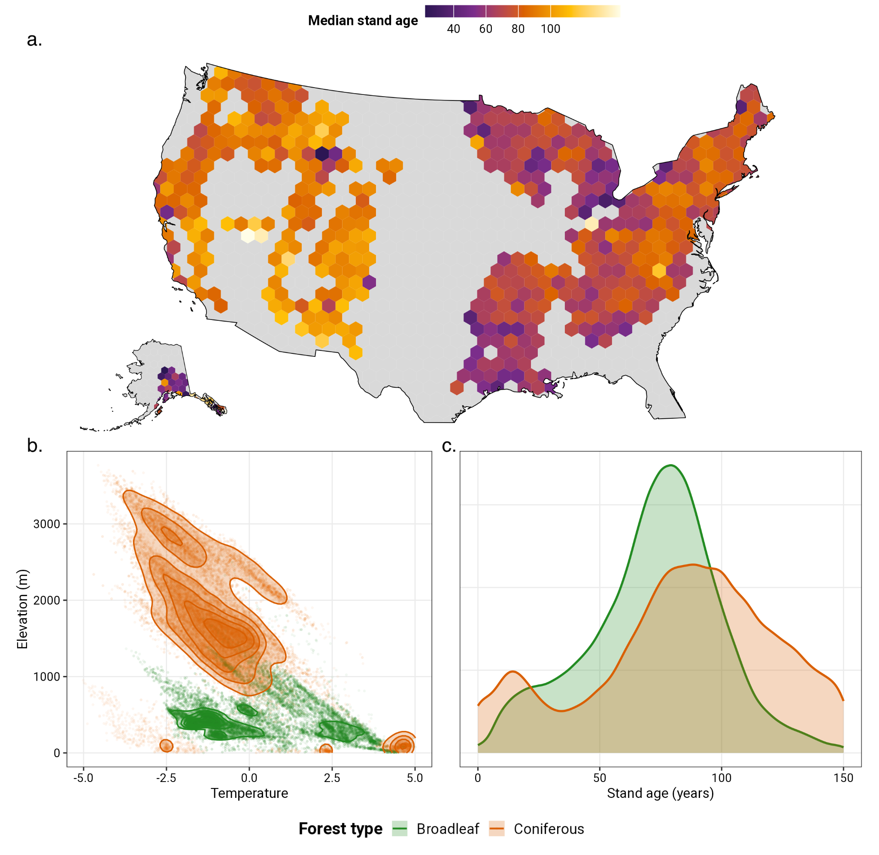
Figure 1. Spatial distribution, environmental space, and successional coverage of the forest plot dataset. (a) Median stand age per 100-km hexagonal cell (minimum three plots per cell), illustrating broad geographic variation in successional stage across the United States. (b) Environmental space occupied by broadleaf (green) and coniferous (orange) forests in temperature × elevation coordinates; points show individual plots and contours show 2D kernel density (normalised per forest type). Temperature is the first rotated environmental principal component (see Methods). (c) Stand age distributions of broadleaf and coniferous plots, showing broadly overlapping successional coverage across both forest types.

Tree Traits
We integrated species-level functional trait data to quantify trait expression at the plot level. Nine traits were selected to represent distinct functional clusters identified by (Maynard et al. 2022) to minimise redundancy across trait axes while maximising coverage of tree form and function. The selected traits spanned leaf economics (specific leaf area, leaf potassium, leaf density), hydraulic transport (conduit diameter), bark structure (bark thickness), whole-tree architecture (tree height), belowground resource acquisition (root depth), reproduction (seed dry mass), and light competition (shade tolerance). Species-level estimates for bark thickness, conduit diameter, leaf density, leaf potassium, root depth, seed dry mass, and specific leaf area were obtained from a phylogenetically imputed trait dataset (Maynard et al. 2022). Tree height was extracted directly from the FIA records where available. Shade tolerance was obtained from a species-level index of (Rueda et al. 2018), with missing values imputed via phylogenetic nearest-neighbour lookup using PhyloMaker in R (Jin & Qian 2019). All trait values were log-transformed and z-scored using grand means and standard deviations computed across the full assembled dataset. Trait expression per plot was summarised as a community-weighted mean (CWM). For each species within a plot, we calculated a basal-area-weighted mean of individual-level trait values across all trees of that species, where basal area was calculated from diameter at breast height and scaled by the trees-per-acre expansion factor to produce per-acre equivalents. Plot-level CWMs were then calculated as basal-area-weighted means of species-level trait values across all species in the plot, using scaled basal area as weights. This weighting scheme reflects the functional contribution of each species proportional to its structural dominance in the stand.
Environmental Features
We selected environmental predictors to capture the major abiotic axes affecting tree distribution and productivity (van den Hoogen et al. 2019; Maynard et al. 2022). Climate variables were obtained from the CHELSA dataset (Karger et al. 2017) and included annual mean temperature, minimum and maximum temperatures of the coldest and warmest months, annual precipitation, and precipitation of the wettest, driest, warmest, and coldest quarters. Soil characteristics were obtained from SoilGrids250m (Hengl et al. 2017) and included sand content and water capacity at 15 cm and 60 cm depths. Elevation data were obtained from (Amatulli et al. 2018). All environmental data were extracted at a 30 arcsecond resolution (~1 km²) for each plot coordinate (van den Hoogen et al. 2019). To reduce collinearity among climate and soil variables and to avoid unrealistic scenario combinations in subsequent analyses, we performed a principal component analysis (PCA) on the 14 temperature, precipitation, and soil texture variables. Suitability for PCA was confirmed using the Kaiser-Meyer-Olkin criterion (KMO > 0.8) and Bartlett's test of sphericity. We retained three components with eigenvalues greater than one and applied varimax rotation to improve interpretability, projecting plot observations onto the rotated axes to obtain scores used as predictors. The first rotated principal component (PC) was strongly associated with temperature variables; the second (soil water retention) was positively associated with water capacity and negatively with sand content; and the third (precipitation) was associated with precipitation variables (Fig. S-1a–d). Soil pH and elevation were excluded from the PCA; pH because it is orthogonal to the water retention axis, and elevation because its effect is best interpreted independently of the climatic gradient it partially encodes. Both were retained as direct predictors alongside the three PCs, yielding six predictors in total: temperature, soil water retention, precipitation, elevation, soil pH, and stand age. Collinearity among these six predictors was assessed prior to modelling and found to be low, with no pairwise Pearson correlation exceeding |0.5| (Fig. S-1f). We confirmed the interpretability of the rotated components by examining PC score distributions across biomes (Fig. S-1e), and the spatial distribution and feature-value ranges of the upper/lower quantile strata used for stratification (see below), for all five predictors, are shown in Fig. S-2.
Random Forest Models
We modelled CWM trait expression as a function of stand age and five abiotic predictors using random forest regression implemented in ranger (Wright & Ziegler 2017) in R v.4.5.0. Random forests accommodate nonlinear relationships and predictor interactions without prespecifying their form (Breiman 2001). Separate models were fitted for each trait and forest type (18 models). Hyperparameters (number of trees, variables per split, and minimum node size) were selected by out-of-bag grid search and used consistently in the grouped resampling analyses below. Final-model held-out R² and RMSE are reported as descriptive diagnostics; formal uncertainty and predictive-skill analyses kept all inventories from the same permanent plot together within resampling partitions.

Relative Importance of Environmental and Successional Filtering
To compare environmental and age-related model attribution, we computed SHAP values using fastshap (Greenwell 2024). For each trait and forest type, we summed absolute SHAP values for five environmental predictors (temperature, soil water retention, precipitation, elevation, and soil pH) and divided this sum by the absolute SHAP attribution of stand age. This ratio compares the combined attribution of five environmental axes with one age variable and should not be interpreted as a per-predictor contrast. To quantify partition stability, we repeated 10-fold cross-validation five times while assigning every inventory from the same permanent plot (PID) to the same fold. Models were fitted to nine folds and SHAP values were estimated for up to 1,500 observations in the held-out fold using 50 Monte Carlo simulations. Figure 2a shows the median ratio and empirical 2.5th-97.5th percentile interval across the 50 partitions. Figure 2b descriptively decomposes total absolute SHAP attribution across individual predictors in the final models.

Environmental Modulation of Successional Trait Trajectories

To test whether environmental conditions modify modelled successional trait trajectories, we used a PID-cluster bootstrap. Within each forest type, complete permanent plots were sampled with replacement, retaining every inventory from each selected plot. For each of the five environmental predictors in turn, the resampled data were divided into lower and upper quartiles. Separate random forest models were fitted within each stratum using stand age and all five abiotic predictors, with the tuned hyperparameters from the corresponding global model. Each trait-forest combination was repeated for 100 bootstrap draws.
For each stratified model, we estimated partial dependence on a common stand-age grid from 10 to 100 years in five-year increments while retaining the observed values of all other predictors. Every environmental stratum contained at least 50 inventory observations, at least 25 resampled PID clusters, and observed age support across the full grid. The resulting bootstrap trajectories are shown in Fig. S-7.

We summarised average directional change by fitting a linear trend to each partial-dependence trajectory. The signed contrast was Δslope = slope upper - slope lower; positive values indicate a more positive trajectory in the upper environmental quartile, not necessarily a faster absolute rate. We therefore used |Δslope| to quantify the magnitude of environmental rate modification and compared |slope upper| - |slope lower| when asking which stratum changed faster. Empirical 95% PID-cluster bootstrap intervals were the 2.5th and 97.5th percentiles across 100 draws.
We next asked whether environmental separation in modelled trait expression changed through succession. Within each bootstrap draw, we calculated the absolute upper-lower difference in predicted trait expression at stand ages 10 and 100. A positive paired change indicates widening environmental separation and a negative change indicates narrowing; change was classified as supported when its 95% bootstrap interval excluded zero.

Trait Predictability Through Succession
To assess whether trait predictability increases through succession and whether it diverges across environmental gradients, we evaluated how accurately trait expression could be predicted from environmental and successional context on held-out data, as a function of stand age and environmental context. We used VEcv (Variance Explained by Cross-validation) as our primary skill metric (Li 2017), defined as:
VEcv = 1 - sum[(observed - predicted)^2] / sum[(observed - mean observed)^2]
where the numerator is the out-of-fold sum of squared prediction errors and the denominator is the observed sum of squares around the mean. VEcv is a scale-free out-of-fold analogue of R². We used 30 repeats of 10-fold cross-validation within each forest type, assigning all inventories from the same PID to the same fold. Within each repeat, out-of-fold predictions were classified into lower and upper environmental quartiles and 10-year stand-age bins. Cells with fewer than 30 observations were excluded. Medians and empirical 95% repeated-partition intervals were calculated across repeats; these intervals quantify sensitivity to data partitioning rather than population sampling uncertainty. Legates-McCabe efficiency (E1), based on absolute rather than squared errors, was used as a robustness check.
For each trait, environmental gradient, age bin, and repeat, we calculated ΔVEcv = VEcv upper - VEcv lower and its absolute magnitude. Signed contrasts identify which stratum was more predictable; absolute contrasts measure the strength of environmental dependence without cancellation among traits. Figure 4 uses the common, well-supported age window of 15-125 years. Predictive skill was averaged with equal weight across traits after averaging their ten environmental strata. Environmental predictability gaps were paired within trait and repeat, converted to absolute differences, and then averaged across traits for each gradient.

Results
Model Performance
Final-model held-out diagnostics explained a mean of 73.2% of trait variance (R² range 0.576-0.890) across traits and forest types. Because these original train-test splits were not grouped by PID, we treat them as descriptive model diagnostics rather than inferential estimates; grouped out-of-fold predictive skill is reported below.

Environmental Dominance of Model Attribution

The combined SHAP attribution of the five environmental predictors exceeded that of stand age for all nine traits and both forest types (Fig. 2a). PID-grouped cross-validation medians ranged from 1.69 for coniferous tree height to 31.1 for coniferous seed dry mass, and every empirical 95% partition interval remained above one (minimum lower bound 1.58). Mean environment-to-age ratios were 10.1 in broadleaf and 20.5 in coniferous forests (medians 10.9 and 25.7). Individual-predictor decomposition remained heterogeneous (Fig. 2b): temperature contributed the largest share for all nine broadleaf traits, whereas coniferous traits were divided among temperature, elevation, and soil pH. Because the numerator combines five predictors, these results support strong collective environmental attribution rather than the dominance of every individual environmental variable.
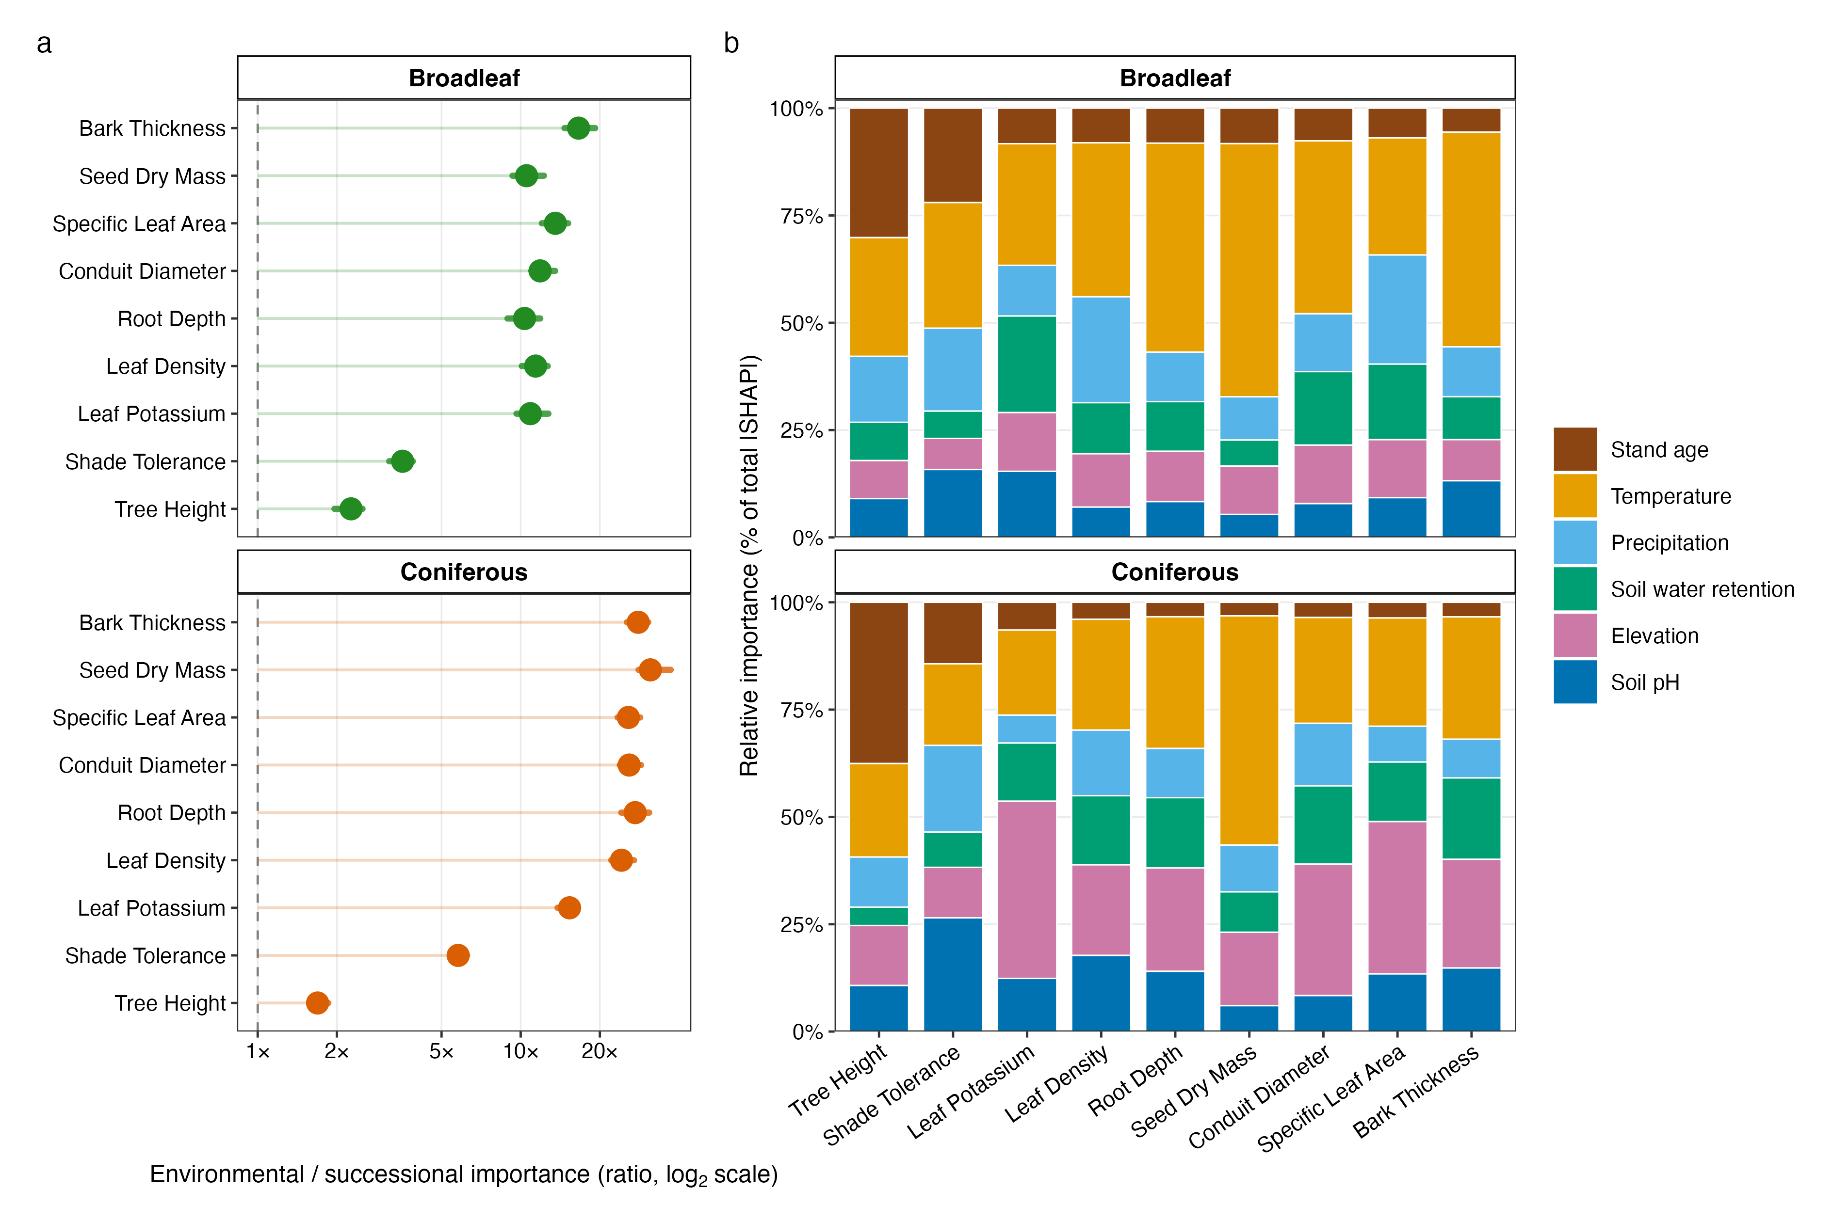
Figure 2. Environmental context dominates model attribution of functional trait variation. (a) Ratio of the summed absolute SHAP attribution of five environmental predictors to the absolute attribution of stand age (log₂ scale). Points are medians across five repeats of PID-grouped 10-fold cross-validation; horizontal lines are empirical 95% repeated-partition intervals. The dashed line at 1× denotes equal attribution. Traits are ordered from greatest to lowest environmental dominance. (b) Descriptive final-model decomposition of total absolute SHAP attribution among individual predictors. Stand age (brown) is shown at the top of each bar.

Environmental Modulation of Successional Trait Trajectories

Environmental context commonly modified modelled successional trajectories (Fig. 3; Fig. S-7). Empirical PID-cluster bootstrap intervals for the signed slope difference excluded zero in 34 of 45 broadleaf and 27 of 45 coniferous trait-gradient combinations. Median slope-modification magnitudes were larger in broadleaf forests for every environmental gradient, ranging from 0.154 to 0.711 trait SD per 100 years, compared with 0.047-0.133 in coniferous forests (Fig. 3b). However, the stratum with the faster absolute rate was not consistent: upper environmental quartiles changed faster in 17 combinations, lower quartiles in 29, and 44 were unresolved. Environmental separation in modelled trait expression likewise changed in both directions between ages 10 and 100 (Fig. 3a): 39 combinations widened, 20 narrowed, and 31 were uncertain. No environmental gradient produced a universal response across traits and forest types.

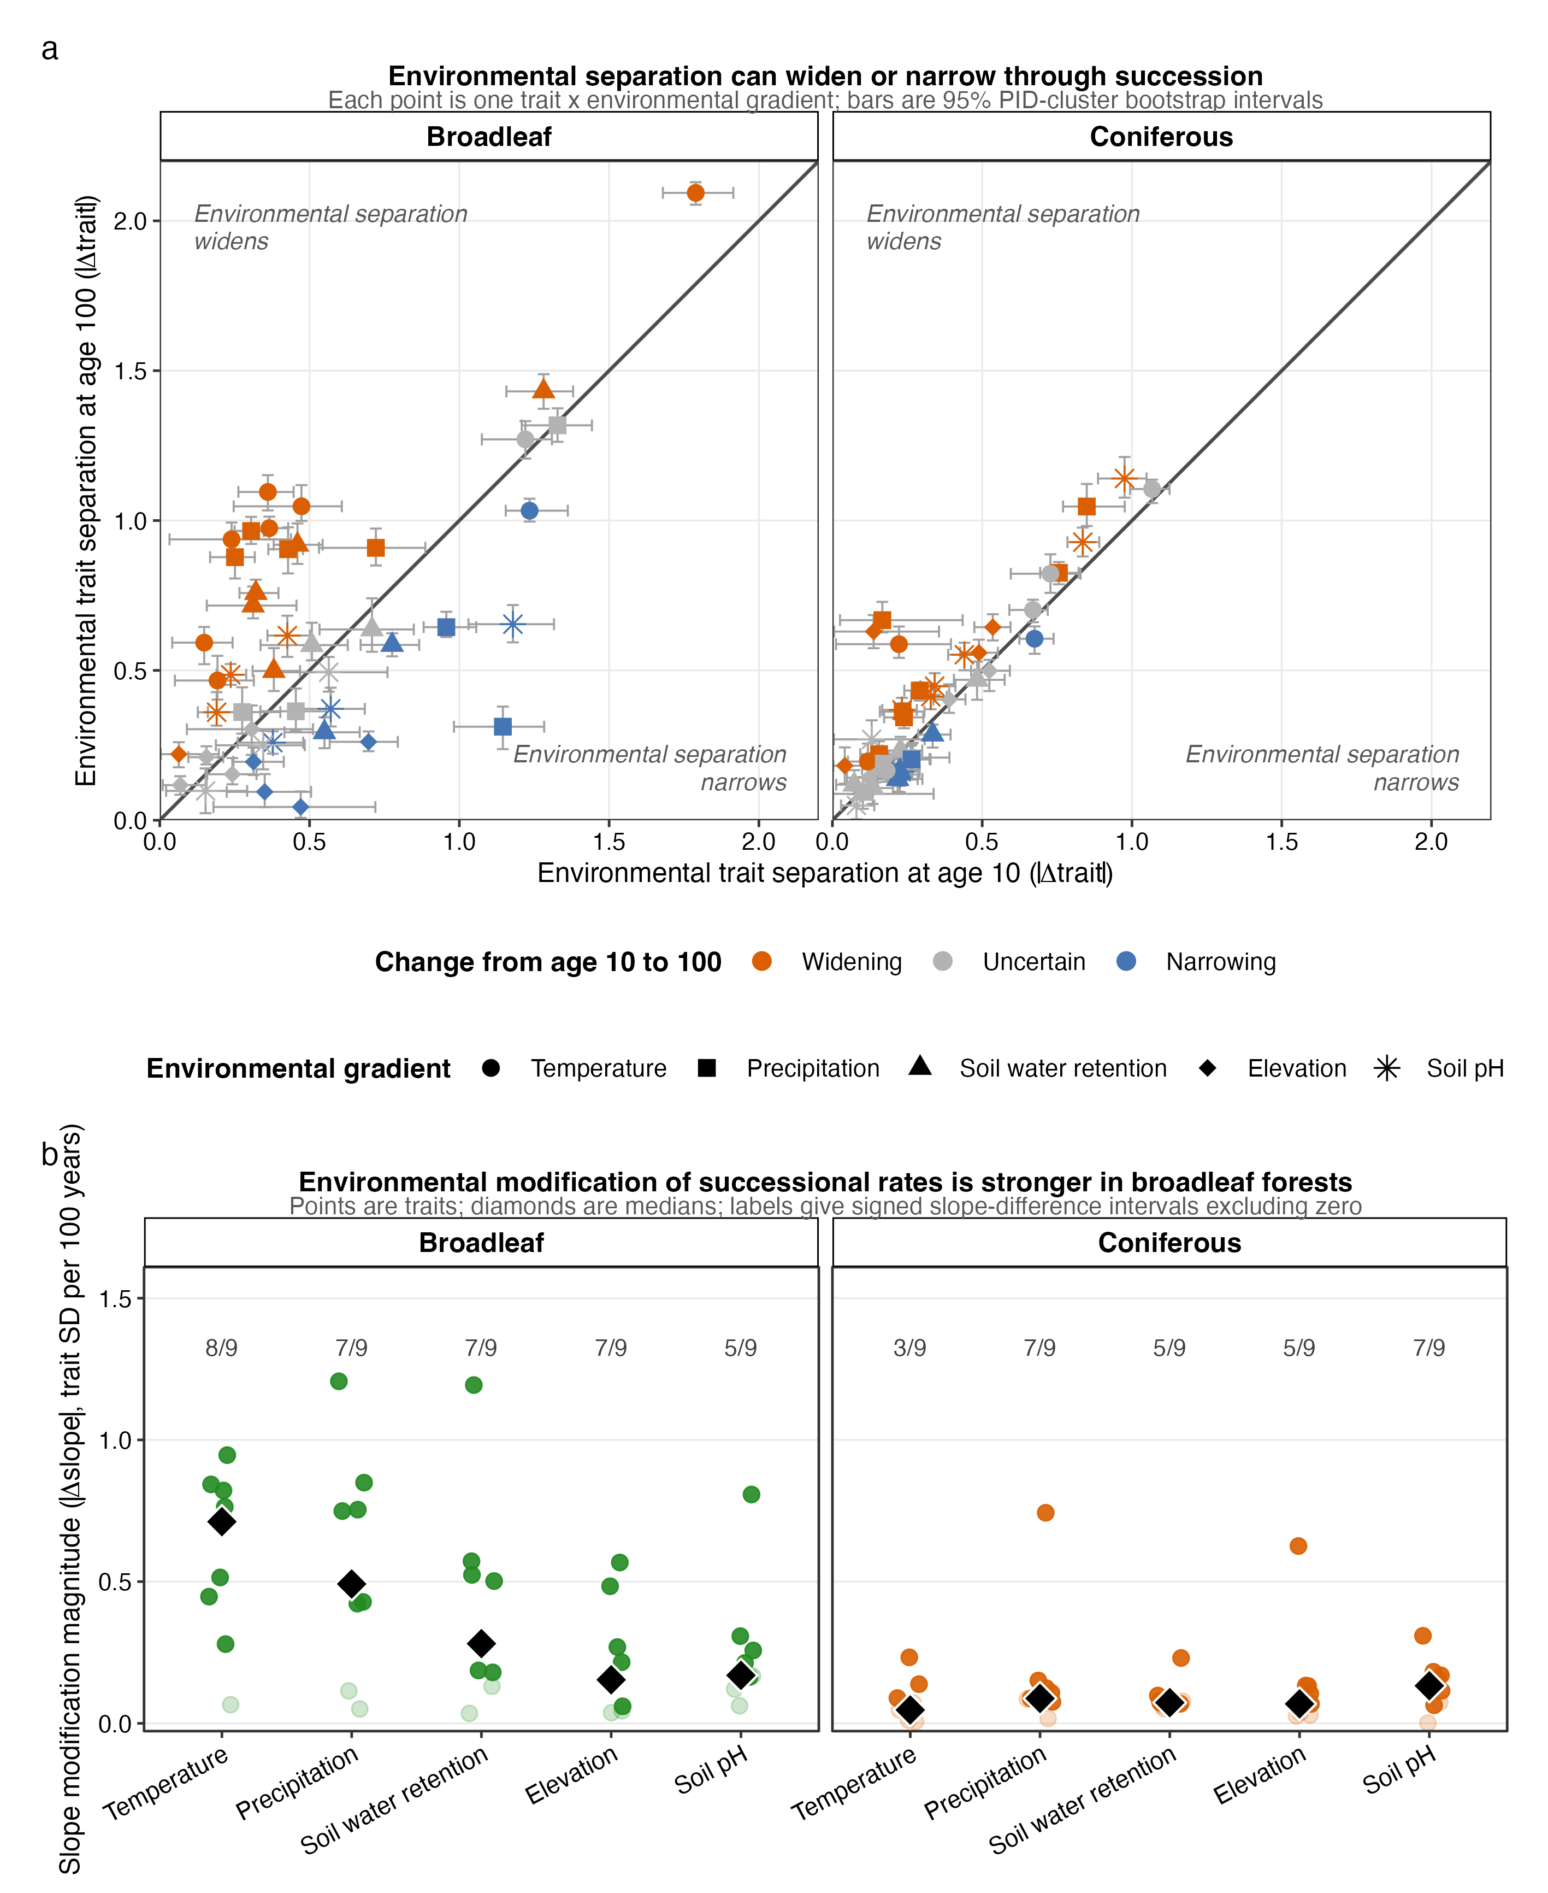
Figure 3. Environmental context modifies successional trait trajectories without imposing a universal direction. (a) Absolute difference in modelled trait expression between upper and lower environmental quartiles at stand ages 10 and 100. Points are trait-gradient combinations; shapes identify gradients and colours classify the paired change as widening, narrowing, or uncertain according to the 95% PID-cluster bootstrap interval. Horizontal and vertical bars show bootstrap intervals for early and late separation. (b) Magnitude of the signed slope difference between environmental quartiles, expressed in trait SD per 100 years. Points are traits, faded points have intervals including zero, diamonds are gradient medians, and labels give the number of supported signed contrasts out of nine traits.

Environmental Contingency of Trait Predictability

Trait predictive skill was higher in later than early succession in both forest types, although trajectories were non-monotonic (Fig. 4a; Fig. S-8). Across repeated PID-grouped partitions, mean VEcv increased from 0.171 at early ages to 0.346 at late ages in broadleaf forests (paired change 0.174, empirical 95% interval 0.170-0.183) and from 0.366 to 0.456 in coniferous forests (change 0.091, interval 0.087-0.094). Environmental dependence of predictive skill persisted through later succession (Fig. 4b): mean absolute upper-lower gaps across traits ranged from 0.090 to 0.243 among the ten gradient-forest combinations at late ages. Signed repeated-partition intervals excluded zero in 86.7% of broadleaf and 92.6% of coniferous trait-gradient-age cells at ages 105-125. Gap trajectories strengthened for some gradients and weakened for others; grouped resampling therefore did not support a general narrowing pattern or a unique temperature exception.
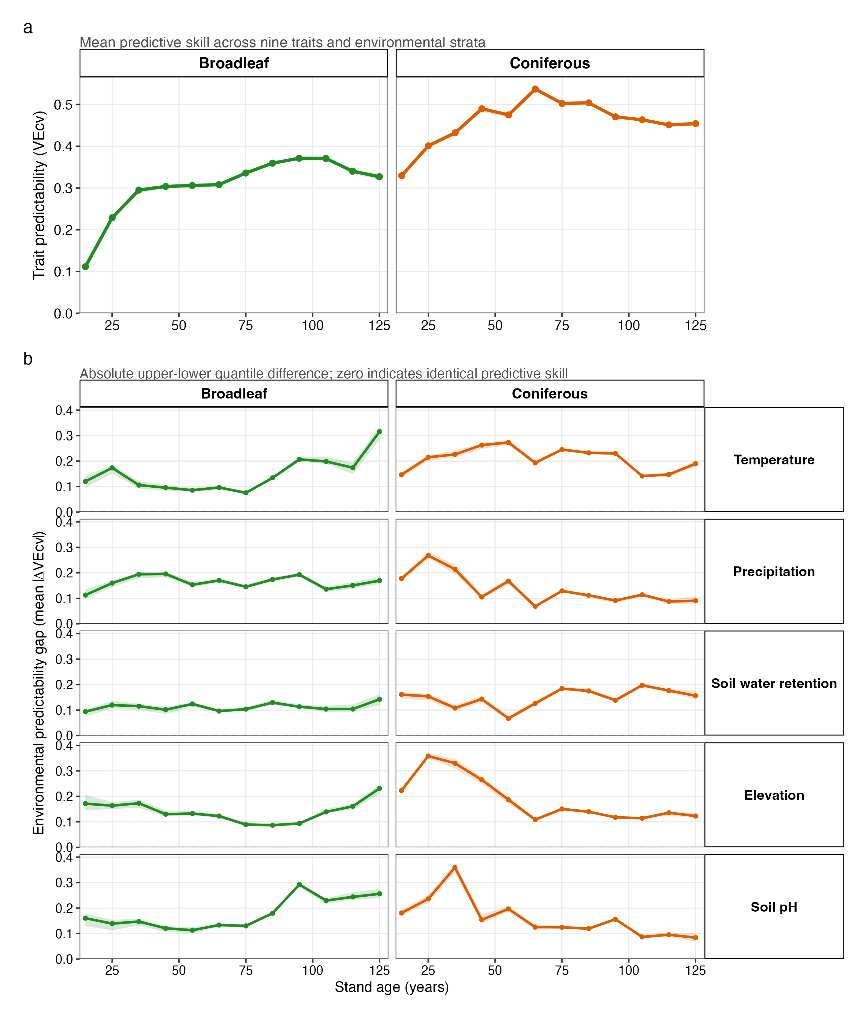
Figure 4. Trait predictive skill is higher later in succession but remains environmentally contingent. (a) Out-of-fold variance explained (VEcv), averaged with equal weight across nine traits after averaging their ten environmental strata. Points and lines are medians across 30 repeats of PID-grouped 10-fold cross-validation; ribbons are empirical 95% repeated-partition intervals. (b) Mean absolute upper-lower environmental difference in VEcv across traits for each gradient. Zero indicates identical predictive skill between environmental quartiles. Both panels use the common supported age-bin midpoint range of 15-125 years.
Discussion
Forest functional communities are expected to become more predictable as succession proceeds, yet their trajectories unfold within spatially variable environmental constraints. Across United States forests, environmental predictors collectively received substantially more model attribution than stand age, environmental context commonly modified modelled successional rates, and environmental differences in predictive skill persisted into later succession. At the same time, trajectory responses were directionally heterogeneous rather than organised around one universal convergence, divergence, or trait-syndrome pattern. The strongest supported synthesis is therefore not that the environment fixes a single alternative successional pathway, but that functional succession and its predictability remain conditional on environmental context.
The consistent environmental-to-age SHAP ratios extend evidence that climate and soils strongly structure forest functional composition (Laughlin et al. 2012; Maynard et al. 2022; Swenson & Enquist 2007). Tree height and shade tolerance had the lowest ratios, consistent with a comparatively large role for stand development and light competition. Ratios were generally larger in coniferous than broadleaf forests, but this descriptive contrast should not be assigned a mechanism from SHAP attribution alone. Moreover, the ratio compares five environmental predictors with one age variable. Its robust departure from one demonstrates collective environmental attribution, not that each environmental predictor individually dominates stand age or that the attributed relationships are causal.
The grouped bootstrap confirms that environmental context frequently changes modelled successional trajectories, especially in broadleaf forests. However, the direction of signed slope contrasts did not translate into a general difference in absolute rate between productive and stressful environments. This distinction matters because a more positive slope can still represent slower change when both trajectories are negative. The predicted universal acquisitive-versus-conservative response was therefore not supported across traits and gradients. Rather than weakening the main conclusion, this result shows that environmental modulation is widespread but functionally multidimensional, with its direction depending on the trait, gradient, and forest type.
Changes in environmental trait separation reinforce this heterogeneous view. Widening was more frequent than narrowing overall, but both outcomes were common and nearly one third of combinations remained uncertain. Broadleaf temperature and coniferous precipitation showed the most consistent widening, whereas coniferous soil water retention showed no supported widening. These patterns reject a single convergence rule while cautioning against replacing it with an equally simple divergence rule. Environmental context changes the functional distance between trajectories, but the direction of that change is not universal.
The higher predictive skill in later than early succession is consistent with increasing regularity as stands mature (Chase 2010; Fukami 2015; HilleRisLambers et al. 2012), although the non-monotonic age profiles do not support a continuous rise. Crucially, environmental predictability gaps remained substantial at late ages. Their trajectories differed among gradients and forest types rather than following a general narrowing pattern or a temperature-specific exception. We therefore interpret Figure 4 as evidence for persistent context dependence, not for a temperature-specific mechanism. VEcv measures out-of-fold predictive skill conditional on the measured predictors; it is informative about predictability but is not, by itself, a direct measure of ecological determinism.
Several limitations constrain interpretation. Stand age is inferred from the age of dominant trees and may covary with site productivity and the measured environmental predictors, potentially inflating apparent environmental-age contrasts. The cross-sectional design means that modelled trajectories compare different stands across ages rather than directly observing within-plot succession. PID-grouped cross-validation and cluster bootstrap prevent repeated inventories from crossing resampling partitions, but they do not remove confounding by disturbance history, species pools, land-use legacies, or unmeasured site conditions. Finally, community-weighted means describe central functional composition but omit functional diversity, intraspecific variation, and ontogenetic trait change.
These limitations make causal language inappropriate, but they do not erase the convergent evidence across three grouped analyses: environmental context dominates collective model attribution, commonly modifies modelled age relationships, and remains associated with predictive skill in later succession. Future longitudinal analyses can test whether the same patterns emerge from within-plot change and whether disturbance history explains the remaining heterogeneity among trait trajectories.
These findings have direct implications for forecasting forest recovery. Models that represent succession only as time since disturbance, with climate as a secondary correction to a regionally fixed trajectory, will miss environment-dependent differences in functional change and predictive uncertainty (Cook-Patton et al. 2020; Poorter et al. 2021; Pugh et al. 2019). Our results support treating environmental context as a primary axis alongside stand age while allowing response direction to vary among traits and forest types. This formulation is deliberately mechanism-neutral and provides a robust basis for evaluating recovery forecasts under changing climates.

Acknowledgements
We thank Alastair Pickering for his help in computing shade tolerance and we are grateful to the numerous people that collected data for the FIA. DM was supported by ERC Starting Grant (#101164911).
Data availability
The raw FIA, trait, and environmental data used in this study can be found in the online supplementary materials of the corresponding publications. All code and the processed data used for the analysis are openly available in the designated GitHub repository (+Zenodo later on).

Conflict of Interest

The authors declare they have no conflict of interest.

Author contribution
Conceptualization: MW, DM
Methodology: MW, DM
Formal Analysis: MW, DM
Writing (original draft): MW, DM
Writing – review & editing: MW, DM

All authors read, reviewed, and approved the final manuscript.
References

Amatulli, G., Domisch, S., Tuanmu, M.-N., Parmentier, B., Ranipeta, A., Malczyk, J., et al. (2018). A suite of global, cross-scale topographic variables for environmental and biodiversity modeling. Sci Data, 5, 180040.
Andrewsa, T., Dietzeb, M. & Boothc, R. (2018). Climate or disturbance: temperate forest structural change and carbon sink potential.
Bernard-Verdier, M., Navas, M.-L., Vellend, M., Violle, C., Fayolle, A. & Garnier, E. (2012). Community assembly along a soil depth gradient: contrasting patterns of plant trait convergence and divergence in a Mediterranean rangeland. Journal of Ecology, 100, 1422–1433.
Bertness, M.D. & Callaway, R. (1994). Positive interactions in communities. Trends in Ecology & Evolution, 9, 191–193.
Besnard, S., Koirala, S., Santoro, M., Weber, U., Nelson, J., Gütter, J., et al. (2021). Mapping global forest age from forest inventories, biomass and climate data. Earth System Science Data, 13, 4881–4896.
Boukili, V.K. & Chazdon, R.L. (2017). Environmental filtering, local site factors and landscape context drive changes in functional trait composition during tropical forest succession. Perspectives in Plant Ecology, Evolution and Systematics, 24, 37–47.
Breiman, L. (2001). Random Forests. Machine Learning, 45, 5–32.
van Breugel, M., Bongers, F., Norden, N., Meave, J.A., Amissah, L., Chanthorn, W., et al. (2024). Feedback loops drive ecological succession: towards a unified conceptual framework. Biological Reviews, 99, 928–949.
Chang, C. & HilleRisLambers, J. (2016). Integrating succession and community assembly perspectives.
Chang, C.C. & Turner, B.L. (2019). Ecological succession in a changing world. Journal of Ecology, 107, 503–509.
Chase, J.M. (2010). Stochastic Community Assembly Causes Higher Biodiversity in More Productive Environments. Science, 328, 1388–1391.
Chesson, P.L. (2000). Mechanisms of Maintenance of Species Diversity. Annual Review of Ecology and Systematics, 31, 343–366.
Christensen, N.L. (2014). An historical perspective on forest succession and its relevance to ecosystem restoration and conservation practice in North America. Forest Ecology and Management, 330, 312–322.
Clements, F.E. (1916). Plant succession: an analysis of the development of vegetation. Carnegie institution of Washington.
Connell, J.H. & Slatyer, R.O. (1977). Mechanisms of Succession in Natural Communities and Their Role in Community Stability and Organization. The American Naturalist, 111, 1119–1144.
Cook-Patton, S.C., Leavitt, S.M., Gibbs, D., Harris, N.L., Lister, K., Anderson-Teixeira, K.J., et al. (2020). Mapping carbon accumulation potential from global natural forest regrowth. Nature, 585, 545–550.
Cornwell, W.K. & Ackerly, D.D. (2009). Community assembly and shifts in plant trait distributions across an environmental gradient in coastal California. Ecological Monographs, 79, 109–126.
Craven, D., Hall, J.S., Berlyn, G.P., Ashton, M.S. & van Breugel, M. (2015). Changing gears during succession: shifting functional strategies in young tropical secondary forests. Oecologia, 179, 293–305.
Curtis, P.G., Slay, C.M., Harris, N.L., Tyukavina, A. & Hansen, M.C. (2018). Classifying drivers of global forest loss. Science, 361, 1108–1111.
Díaz, S., Kattge, J., Cornelissen, J.H.C., Wright, I.J., Lavorel, S., Dray, S., et al. (2016). The global spectrum of plant form and function. Nature, 529, 167–171.
Dobrowski, S.Z. (2011). A climatic basis for microrefugia: the influence of terrain on climate. Global Change Biology, 17, 1022–1035.
Engler, R., Randin, C.F., Thuiller, W., Dullinger, S., Zimmermann, N.E., Araújo, M.B., et al. (2011). 21st century climate change threatens mountain flora unequally across Europe. Global Change Biology, 17, 2330–2341.
Friedman, J.H. (2001). Greedy function approximation: A gradient boosting machine. The Annals of Statistics, 29, 1189–1232.
Fukami, T. (2015). Historical contingency in community assembly: integrating niches, species pools, and priority effects. Annual review of ecology, evolution, and systematics, 46, 1–23.
Gray, A.N., Brandeis, T.J., Shaw, J.D., McWilliams, W.H. & Miles, P. (2012). Forest Inventory and Analysis Database of the United States of America (FIA). In: Dengler, J.; Oldeland, J.; Jansen, F.; Chytry, M.; Ewald, J., Finckh, M.; Glockler, F.; Lopez-Gonzalez, G.; Peet, R. K.; Schaminee, J .H. J., eds. Vegetation databases for the 21st century. Biodiversity and Ecology. 4: 225-231., 225–231.
Greenwell, B. (2024). fastshap: Fast Approximate Shapley Values.
Grime, J.P. (1977). Evidence for the Existence of Three Primary Strategies in Plants and Its Relevance to Ecological and Evolutionary Theory. The American Naturalist, 111, 1169–1194.
Grime, J.P. (1988). The C-S-R model of primary plant strategies - origins , implications and tests.
Haeussler, S., Kabzems, R., McClarnon, J. & Bedford, L. (2021). Successional change, restoration success, and resilience in boreal mixedwood vegetation communities over three decades. Canadian Journal of Forest Research, 51, 766–780.
Hengl, T., Jesus, J.M. de, Heuvelink, G.B.M., Gonzalez, M.R., Kilibarda, M., Blagotić, A., et al. (2017). SoilGrids250m: Global gridded soil information based on machine learning. PLOS ONE, 12, e0169748.
HilleRisLambers, J., Adler, P.B., Harpole, W.S., Levine, J.M. & Mayfield, M.M. (2012). Rethinking community assembly through the lens of coexistence theory. Annual Review of Ecology, Evolution and Systematics, 43, 2012.
van den Hoogen, J., Geisen, S., Routh, D., Ferris, H., Traunspurger, W., Wardle, D.A., et al. (2019). Soil nematode abundance and functional group composition at a global scale. Nature, 572, 194–198.
Jin, Y. & Qian, H. (2019). V.PhyloMaker: an R package that can generate very large phylogenies for vascular plants. Ecography, 42, 1353–1359.
Karger, D.N., Conrad, O., Böhner, J., Kawohl, T., Kreft, H., Soria-Auza, R.W., et al. (2017). Climatologies at high resolution for the earth’s land surface areas. Sci Data, 4, 170122.
Keddy, P.A. (1992). Assembly and response rules: two goals for predictive community ecology. Journal of Vegetation Science, 3, 157–164.
Körner, C. (2012). Alpine Treelines. Springer, Basel.
Körner, C. (2021). Alpine treelines. In: Alpine Plant Life: Functional Plant Ecology of High Mountain Ecosystems (ed. Körner, C.). Springer International Publishing, Cham, pp. 141–173.
Kraft, N.J.B. & Ackerly, D.D. (2010). Functional trait and phylogenetic tests of community assembly across spatial scales in an Amazonian forest. Ecological Monographs, 80, 401–422.
Kraft, N.J.B., Adler, P.B., Godoy, O., James, E.C., Fuller, S. & Levine, J.M. (2015). Community assembly, coexistence and the environmental filtering metaphor. Functional Ecology, 29, 592–599.
Kunstler, G., Falster, D., Coomes, D.A., Hui, F., Kooyman, Robert, M., Laughlin, D.C., et al. (2016). Plant functional traits have globally consistent effects on competition. Nature, 529, 1–15.
Lai, H.R., Craven, D., Hall, J.S., Hui, F.K.C. & van Breugel, M. (2021). Successional syndromes of saplings in tropical secondary forests emerge from environment-dependent trait-demography relationships. Ecol Lett, 24, 1776–1787.
Lasky, J.R., Uriarte, M., Boukili, V.K. & Chazdon, R.L. (2014). Trait-mediated assembly processes predict successional changes in community diversity of tropical forests. Proc Natl Acad Sci U S A, 111, 5616–5621.
Laughlin, D.C., Joshi, C., van Bodegom, P.M., Bastow, Z.A. & Fulé, P.Z. (2012). A predictive model of community assembly that incorporates intraspecific trait variation. Ecology Letters, 15, 1291–1299.
Lebrija-Trejos, E., Meave, J.A., Poorter, L., Pérez-García, E.A. & Bongers, F. (2010a). Pathways, mechanisms and predictability of vegetation change during tropical dry forest succession. Perspectives in Plant Ecology, Evolution and Systematics, 12, 267–275.
Lebrija-Trejos, E., Pérez-García, E.A., Meave, J.A., Bongers, F. & Poorter, L. (2010b). Functional traits and environmental filtering drive community assembly in a species-rich tropical system. Ecology, 91, 386–398.
Levine, J.I., An, R., Kraft, N.J.B., Pacala, S.W. & Levine, J.M. (2025). Why ecologists struggle to predict coexistence from functional traits. Trends in Ecology & Evolution, 40, 147–158.
Li, J. (2017). Assessing the accuracy of predictive models for numerical data: Not r nor r2, why not? Then what? PLOS ONE, 12, e0183250.
Lohbeck, M., Lebrija-Trejos, E., Martínez-Ramos, M., Meave, J.A., Poorter, L. & Bongers, F. (2015). Functional Trait Strategies of Trees in Dry and Wet Tropical Forests Are Similar but Differ in Their Consequences for Succession. PLOS ONE, 10, e0123741.
Lohbeck, M., Poorter, L., Martínez-Ramos, M., Rodriguez-Velázquez, J., van Breugel, M. & Bongers, F. (2014). Changing drivers of species dominance during tropical forest succession. Functional Ecology, 28, 1052–1058.
Malhi, Y., Doughty, C. & Galbraith, D. (2011). The allocation of ecosystem net primary productivity in tropical forests. Philosophical Transactions of the Royal Society B: Biological Sciences, 366, 3225–3245.
Marcílio, W.E. & Eler, D.M. (2020). From explanations to feature selection: assessing SHAP values as feature selection mechanism. In: 2020 33rd SIBGRAPI Conference on Graphics, Patterns and Images (SIBGRAPI). Presented at the 2020 33rd SIBGRAPI Conference on Graphics, Patterns and Images (SIBGRAPI), pp. 340–347.
Mayfield, M.M. & Levine, J.M. (2010). Opposing effects of competitive exclusion on the phylogenetic structure of communities. Ecology Letters, 13, 1085–1093.
Maynard, D.S., Bialic-Murphy, L., Zohner, C.M., Averill, C., van den Hoogen, J., Ma, H., et al. (2022). Global relationships in tree functional traits. Nat Commun, 13, 3185.
McDowell, N.G., Allen, C.D., Anderson-Teixeira, K., Aukema, B.H., Bond-Lamberty, B., Chini, L., et al. (2020). Pervasive shifts in forest dynamics in a changing world. Science, 368, eaaz9463.
Meiners, S.J., Cadotte, M.W., Fridley, J.D., Pickett, S.T.A. & Walker, L.R. (2015). Is successional research nearing its climax? New approaches for understanding dynamic communities. Functional Ecology, 29, 154–164.
Michalet, R., Brooker, R.W., Cavieres, L.A., Kikvidze, Z., Lortie, C.J., Pugnaire, F.I., et al. (2006). Do biotic interactions shape both sides of the humped-back model of species richness in plant communities? Ecology Letters, 9, 767–773.
Mod, H.K., Scherrer, D., Luoto, M. & Guisan, A. (2016). What we use is not what we know: environmental predictors in plant distribution models. Journal of Vegetation Science, 27, 1308–1322.
Mori, A.S., Lertzman, K.P. & Gustafsson, L. (2017). Biodiversity and ecosystem services in forest ecosystems: a research agenda for applied forest ecology. Journal of Applied Ecology, 54, 12–27.
Norden, N., Angarita, H.A., Bongers, F., Martínez-Ramos, M., Granzow-de la Cerda, I., van Breugel, M., et al. (2015). Successional dynamics in Neotropical forests are as uncertain as they are predictable. Proceedings of the National Academy of Sciences, 112, 8013–8018.
Odum, E.P. (1969). The Strategy of Ecosystem Development. Science, 164, 262–270.
Oliver, C. & Larson, B. (1996). Forest Stand Dynamics, Update Edition. Yale School of the Environment Other Publications.
Poorter, L., Amissah, L., Bongers, F., Hordijk, I., Kok, J., Laurance, S.G.W., et al. (2023). Successional theories. Biological Reviews, 98, 2049–2077.
Poorter, L., Craven, D., Jakovac, C.C., van der Sande, M.T., Amissah, L., Bongers, F., et al. (2021). Multidimensional tropical forest recovery. Science, 374, 1370–1376.
Poulter, B., Frank, D., Ciais, P., Myneni, R.B., Andela, N., Bi, J., et al. (2014). Contribution of semi-arid ecosystems to interannual variability of the global carbon cycle. Nature, 509, 600–603.
Pugh, T.A.M., Lindeskog, M., Smith, B., Poulter, B., Arneth, A., Haverd, V., et al. (2019). Role of forest regrowth in global carbon sink dynamics. Proceedings of the National Academy of Sciences, 116, 4382–4387.
Reich, P.B. (2014). The world-wide ‘fast–slow’ plant economics spectrum: a traits manifesto. Journal of Ecology, 102, 275–301.
Rueda, M., Godoy, O. & Hawkins, B.A. (2018). Trait syndromes among North American trees are evolutionarily conserved and show adaptive value over broad geographic scales. Ecography, 41, 540–550.
Sánchez-Pinillos, M., De Cáceres, M., Ameztegui, A. & Coll, L. (2019). Temporal dimension of forest vulnerability to fire along successional trajectories. Journal of Environmental Management, 248, 109301.
Seidl, R., Thom, D., Kautz, M., Martin-Benito, D., Peltoniemi, M., Vacchiano, G., et al. (2017). Forest disturbances under climate change. Nature Clim Change, 7, 395–402.
Štrumbelj, E. & Kononenko, I. (2014). Explaining prediction models and individual predictions with feature contributions. Knowl Inf Syst, 41, 647–665.
Swenson, N.G. & Enquist, B.J. (2007). Ecological and evolutionary determinants of a key plant functional trait: wood density and its community-wide variation across latitude and elevation. American Journal of Botany, 94, 451–459.
Thom, D., Rammer, W. & Seidl, R. (2017). The impact of future forest dynamics on climate: interactive effects of changing vegetation and disturbance regimes. Ecological Monographs, 87, 665–684.
Violle, C., Navas, M.-L., Vile, D., Kazakou, E., Fortunel, C., Hummel, I., et al. (2007). Let the concept of trait be functional! Oikos, 116, 882–892.
Walker, L.R. & Chapin, F.S. (1987). Interactions among Processes Controlling Successional Change. Oikos, 50, 131–135.
Williams, J.W., Jackson, S.T. & Kutzbach, J.E. (2007). Projected distributions of novel and disappearing climates by 2100 AD. Proceedings of the National Academy of Sciences, 104, 5738–5742.
Wright, I.J., Reich, P.B., Westoby, M., Ackerly, D.D., Baruch, Z., Bongers, F., et al. (2004). The worldwide leaf economics spectrum. Nature, 428, 821–827.
Wright, M.N. & Ziegler, A. (2017). ranger: A Fast Implementation of Random Forests for High Dimensional Data in C++ and R. Journal of Statistical Software, 77, 1–17.
Zhu, S.-D., Song, J.-J., Li, R.-H. & Ye, Q. (2013). Plant hydraulics and photosynthesis of 34 woody species from different successional stages of subtropical forests. Plant Cell Environ, 36, 879–891.

