安装指南
Installation Guide
1.右击电脑桌面打开个性化，搜索鼠标指针，更改大小为3。
Right-click on the computer desktop to open Personalization, search for mouse pointers, and change the size to 3.
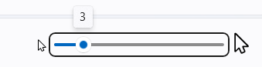

2.右击安装程序，点击安装，在方案中选择JR Cursor，确认应用。
Right-click on the installer, click Install, select JR Cursor in the scheme, and confirm to apply.
