**WEEK 5 HANDS-ON EXERCISES:**

* **MICROSERVICES WITH SPRING BOOT3 AND SPRING CLOUD:**
* **MICROSERVICES WITH API GATE:**
* **CREATING MICROSERVICES FOR ACCOUNT AND LOAN**

**CODE:**

//AccountApplication .java

package com.cognizant.account;

import org.springframework.boot.SpringApplication;

import org.springframework.boot.autoconfigure.SpringBootApplication;

@SpringBootApplication

public class AccountApplication {

public static void main(String[] args) {

SpringApplication.run(AccountApplication.class, args);

}

}

//AccountController.java

package com.cognizant.account.controller;

import org.springframework.web.bind.annotation.*;

import java.util.Map;

@RestController

@RequestMapping("/accounts")

public class AccountController {

@GetMapping("/{number}")

public Map<String, Object>getAccount(@PathVariable String number) {

return Map.of(

"number", number,

"type", "savings",

"balance", 234343

);

}

}

**OUTPUT:**

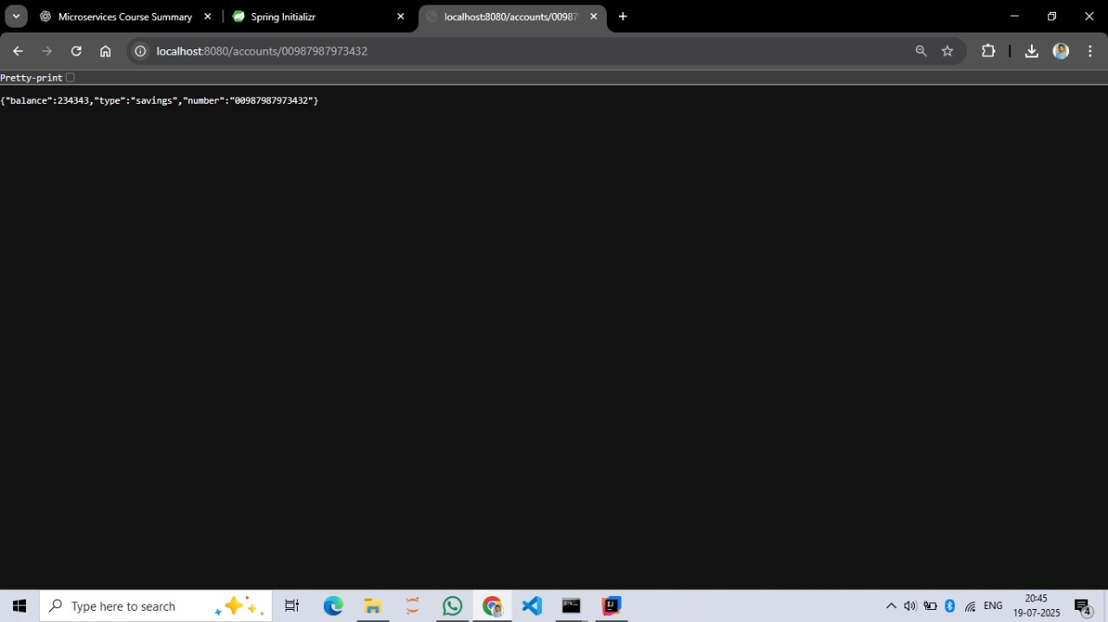

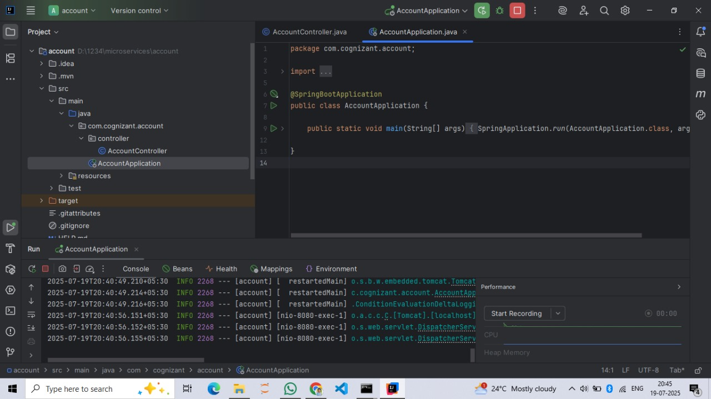

//LoanController.java

package com.cognizant.loan.controller;

import org.springframework.web.bind.annotation.*;

import java.util.Map;

@RestController

@RequestMapping("/loans")

public class LoanController {

@GetMapping("/{number}")

public Map<String, Object>getLoan(@PathVariable String number) {

return Map.of(

"number", number,

"type", "car",

"loan", 400000,

"emi", 3258,

"tenure", 18

);

}

}

//LoanApplication.java

package com.cognizant.loan;

import org.springframework.boot.SpringApplication;

import org.springframework.boot.autoconfigure.SpringBootApplication;

@SpringBootApplication

public class LoanApplication {

public static void main(String[] args) {

SpringApplication.run(LoanApplication.class, args);

}

}

//application.properties

spring.application.name=loan

server.port=8081

**OUTPUT:** 