**WEEK 7 HANDS -ON EXERCISES:**

**EXERCISE :9**

**CODE:**

//app.jsx

import ListofPlayers from './ListofPlayers';

import IndianPlayers from './IndianPlayers';

function App() {

const flag = true; // change to false to switch

return (

<div>

<h1>Cricket App</h1>

{flag ?<ListofPlayers /> :<IndianPlayers />}

</div>

);

}

export default App;

//ListofPlayers.jsx

function ListofPlayers() {

const players = [

{ name: "Virat", score: 85 },

{ name: "Rohit", score: 90 },

{ name: "Rahul", score: 68 },

{ name: "Shreyas", score: 72 },

{ name: "Hardik", score: 45 },

{ name: "Pant", score: 76 },

{ name: "Bumrah", score: 34 },

{ name: "Jadeja", score: 83 },

{ name: "Ashwin", score: 61 },

{ name: "Surya", score: 97 },

{ name: "Gill", score: 52 }

];

const below70 = players.filter(p =>p.score< 70);

return (

<div>

<h2>All Players</h2>

{players.map((p, index) => (

<p key={index}>{p.name}: {p.score}</p>

))}

<h3>Players with Score Below 70</h3>

{below70.map((p, index) => (

<p key={index}>{p.name}: {p.score}</p>

))}

</div>

);

}

export default ListofPlayers;

//IndianPlayers.jsx

function IndianPlayers() {

constallPlayers = ["Virat", "Rohit", "Rahul", "Shreyas", "Hardik", "Pant"];

constoddTeam = allPlayers.filter((_, i) =>i % 2 === 1);

constevenTeam = allPlayers.filter((_, i) =>i % 2 === 0);

const T20players = ["Bumrah", "Chahal", "Surya"];

constRanjiTrophy = ["Pujara", "Rahane"];

constmergedPlayers = [...T20players, ...RanjiTrophy];

return (

<div>

<h2>Odd Team</h2>

{oddTeam.map((p, index) =><p key={index}>{p}</p>)}

<h2>Even Team</h2>

{evenTeam.map((p, index) =><p key={index}>{p}</p>)}

<h2>Merged Players</h2>

{mergedPlayers.map((p, index) =><p key={index}>{p}</p>)}

</div>

);

}

export default IndianPlayers;

**OUTPUT:**

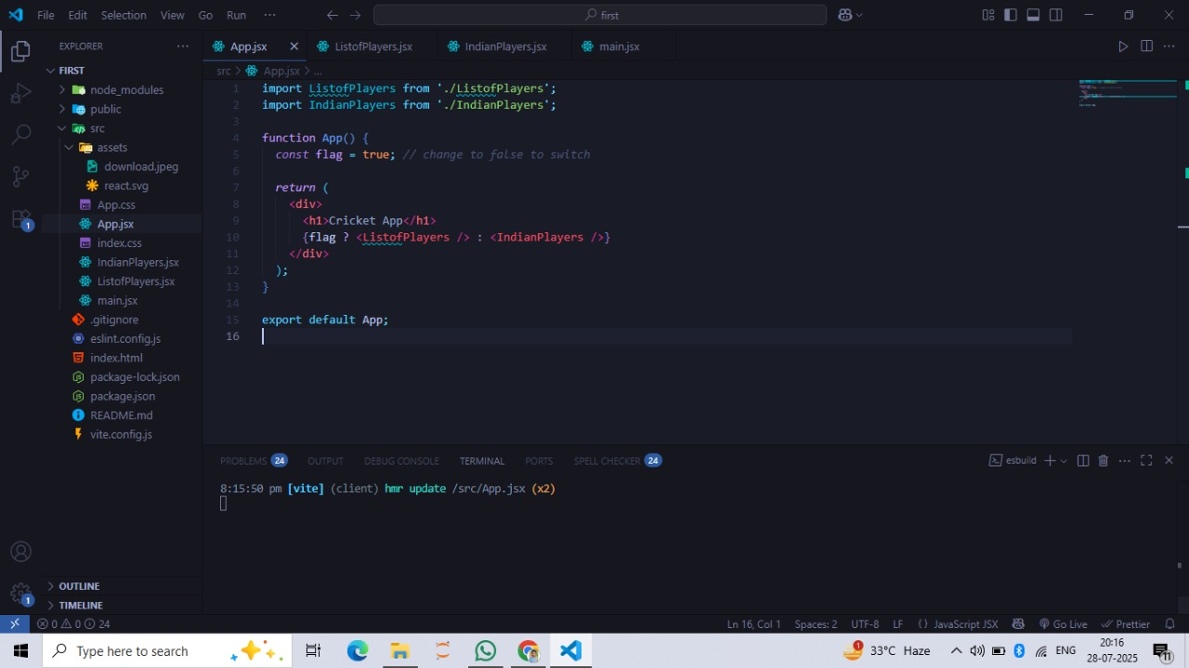

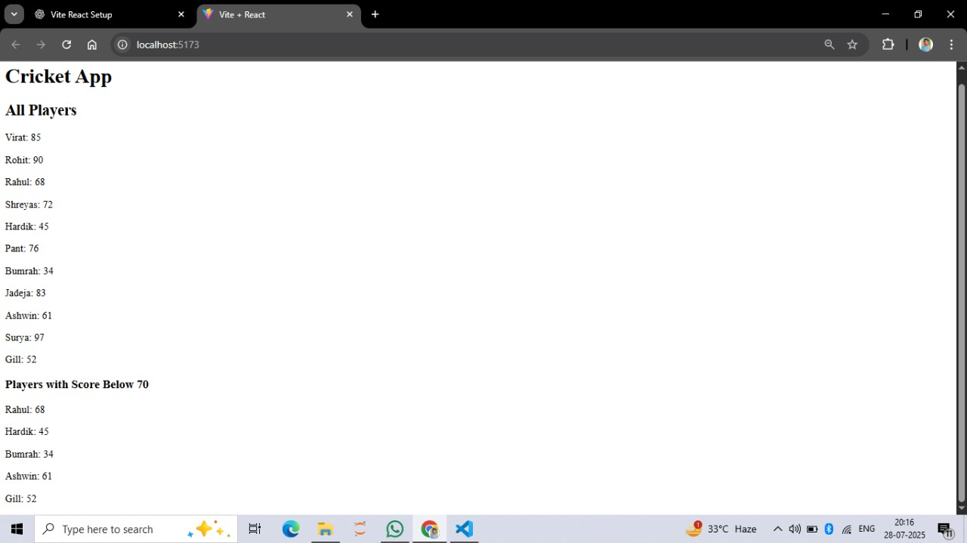

**EXERCISE 10:**

**CODE:**

//app.jsx

import OfficeList from './OfficeList';

function App() {

return (

<div>

<OfficeList />

</div>

);

}

export default App;

//officelist.jsx

function OfficeList() {

const offices = [

{

name: "Green Tower",

rent: 55000,

address: "Anna Nagar, Chennai",

image: "https://via.placeholder.com/200x100"

},

{

name: "Sky View",

rent: 70000,

address: "T Nagar, Chennai",

image: "https://via.placeholder.com/200x100"

},

{

name: "Ocean Plaza",

rent: 60000,

address: "Besant Nagar, Chennai",

image: "https://via.placeholder.com/200x100"

}

];

return (

<div>

<h1 style={{ textAlign: "center", color: "darkblue" }}>Office Space Rental</h1>

{offices.map((office, index) => {

constrentStyle = {

color: office.rent<60000 ? "red" : "green"

};

return (

<div key={index} style={{

border: "1px solid gray",

margin: "15px",

padding: "10px",

borderRadius: "8px"

}}>

<imgsrc={office.image} alt={office.name} style={{ width: "100%" }} />

<h2>{office.name}</h2>

<p><strong>Address:</strong> {office.address}</p>

<p><strong>Rent:</strong><span style={rentStyle}>₹{office.rent}</span></p>

</div>

);

})}

</div>

);

}

export default OfficeList;

**OUTPUT:**

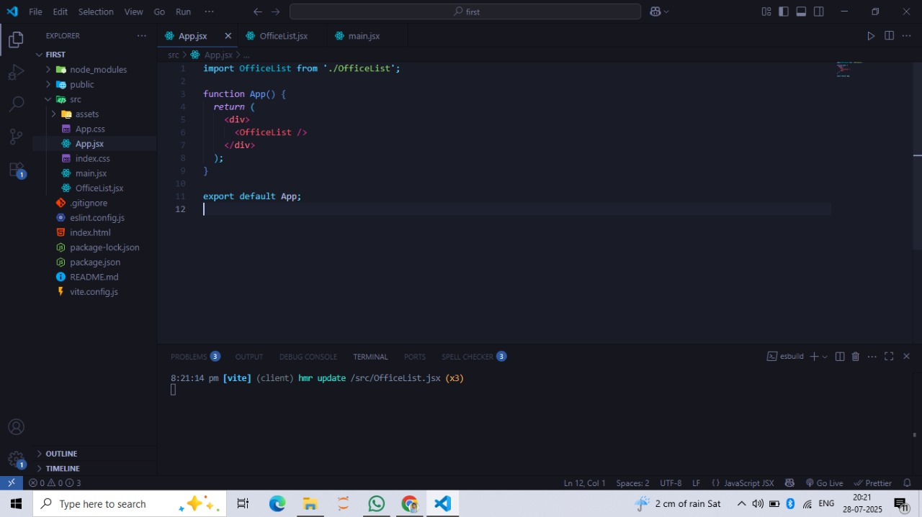

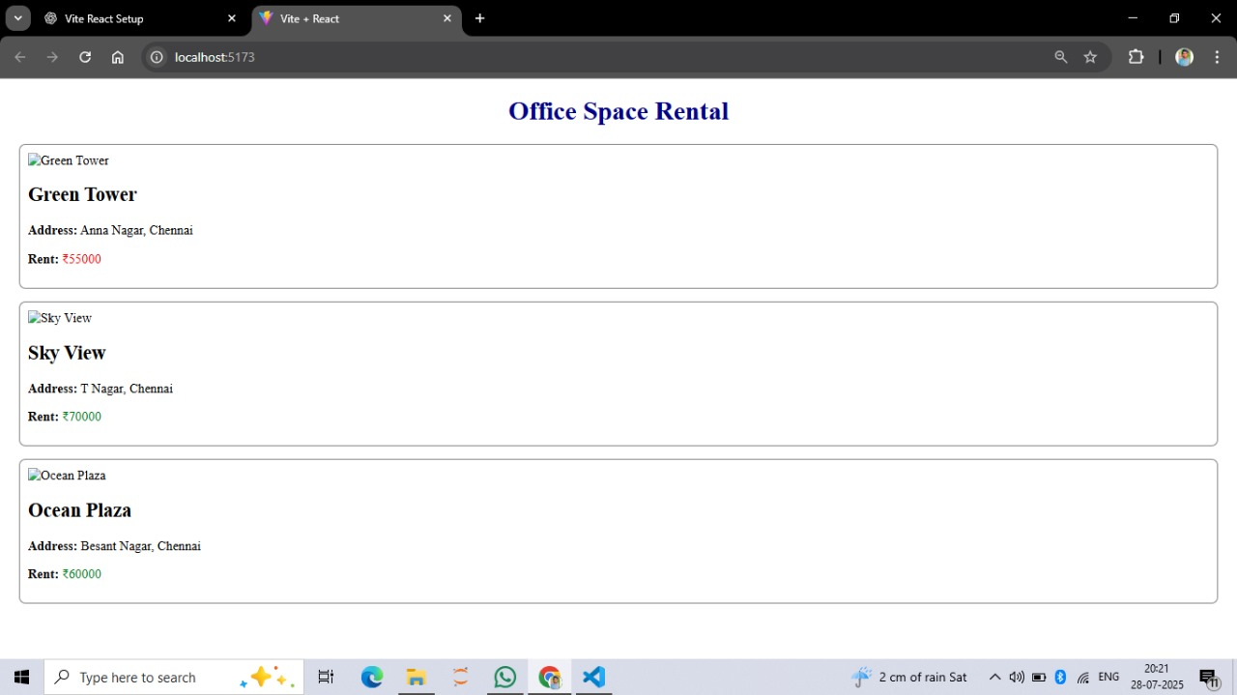

**EXERCISE 11:**

**CODE:**

//app.jsx

import EventExamples from './EventExamples';

function App() {

return (

<div>

<EventExamples />

</div>

);

}

export default App;

//eventexample.jsx

import { useState } from 'react';

function EventExamples() {

const [count, setCount] = useState(0);

const [amount, setAmount] = useState('');

const [converted, setConverted] = useState('');

// Method 1: Increment handlers

const increment = () => {

setCount(prev =>prev + 1);

};

constsayHello = () => {

alert("Hello! You've just clicked increment.");

};

consthandleIncrement = () => {

increment();

sayHello();

};

const decrement = () => {

setCount(prev =>prev - 1);

};

// Method 2: Say welcome

constsayWelcome = (msg) => {

alert(msg);

};

// Method 3: Synthetic event

consthandleClick = (e) => {

alert("I was clicked!");

console.log("Synthetic Event Type:", e.type);

};

// Method 4: Currency Converter

consthandleSubmit = () => {

const euro = parseFloat(amount) / 90; // 1 EUR = ₹90 (example rate)

setConverted(euro.toFixed(2));

};

return (

<div style={{ padding: '20px' }}>

<h2>React Event Handling</h2>

<h3>Counter: {count}</h3>

<button onClick={handleIncrement}>Increment</button>

<button onClick={decrement}>Decrement</button>

<br /><br />

<button onClick={() =>sayWelcome("Welcome to React Event Handling!")}>Say Welcome</button>

<br /><br />

<button onClick={handleClick}>Click Me (Synthetic Event)</button>

<br /><br />

<h3>Currency Converter</h3>

<input

type="text"

placeholder="Enter INR"

value={amount}

onChange={(e) =>setAmount(e.target.value)}

/>

<button onClick={handleSubmit}>Convert</button>

{converted &&<p>€ {converted}</p>}

</div>

);

}

export default EventExamples;

**OUTPUT:**

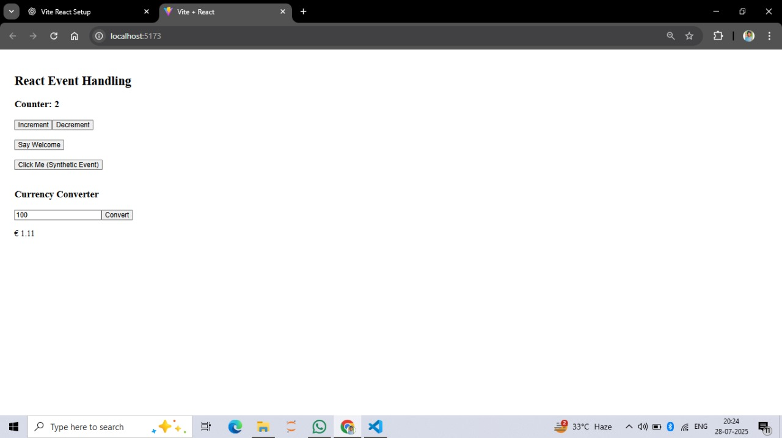

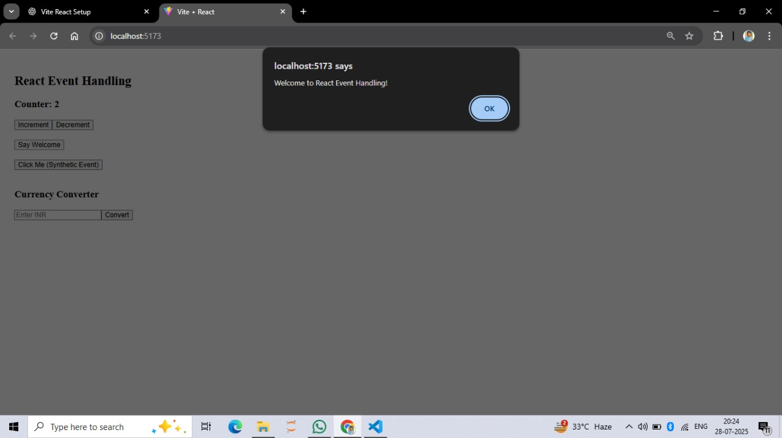

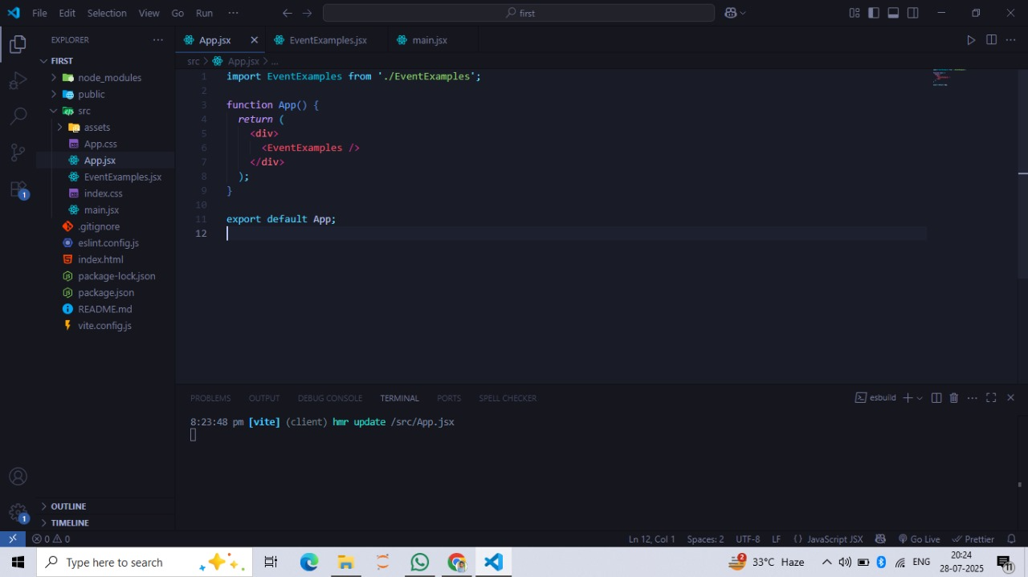

**EXERCISE 12:**

**CODE:**

//app.jsx

import { useState } from 'react';

import GuestPage from './GuestPage';

import UserPage from './UserPage';

function App() {

const [isLoggedIn, setIsLoggedIn] = useState(false);

consthandleLogin = () => {

setIsLoggedIn(true);

};

consthandleLogout = () => {

setIsLoggedIn(false);

};

let page;

if (isLoggedIn) {

page = <UserPage />;

} else {

page = <GuestPage />;

}

return (

<div style={{ padding: '20px' }}>

<h1>Flight Ticket Booking</h1>

{page}

<br />

{isLoggedIn ? (

<button onClick={handleLogout}>Logout</button>

) : (

<button onClick={handleLogin}>Login</button>

)}

</div>

);

}

export default App;

//guestpage.jsx

function GuestPage() {

return (

<div>

<h2>Welcome, Guest!</h2>

<p>You can view flight details but need to log in to book tickets.</p>

</div>

);

}

export default GuestPage;

//userpage.jsx

function UserPage() {

return (

<div>

<h2>Welcome, User!</h2>

<p>You can now book your flight tickets.</p>

</div>

);

}

export default UserPage;

**OUTPUT:**

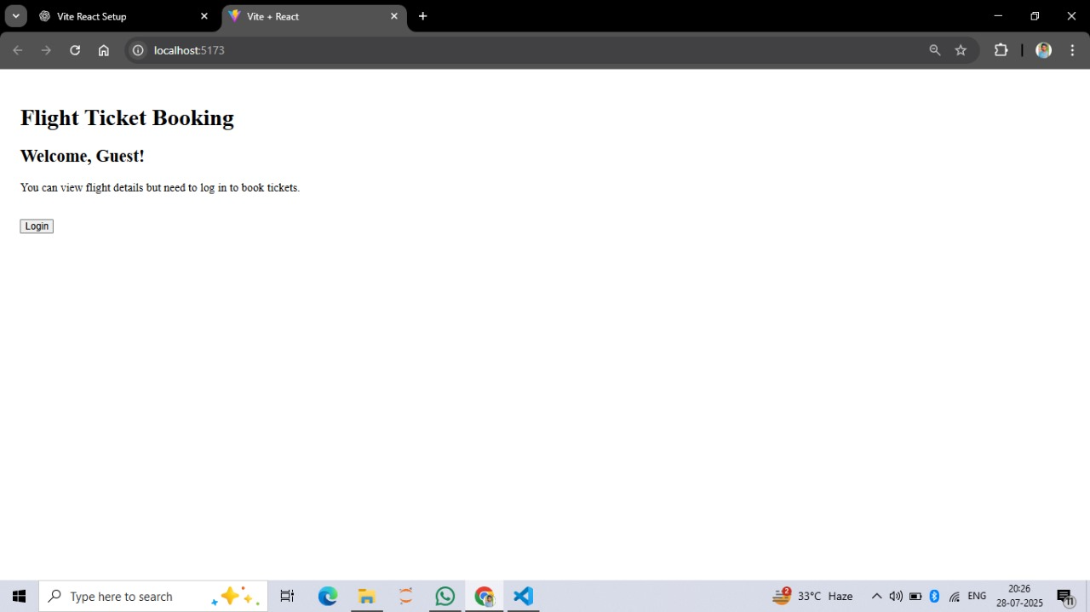

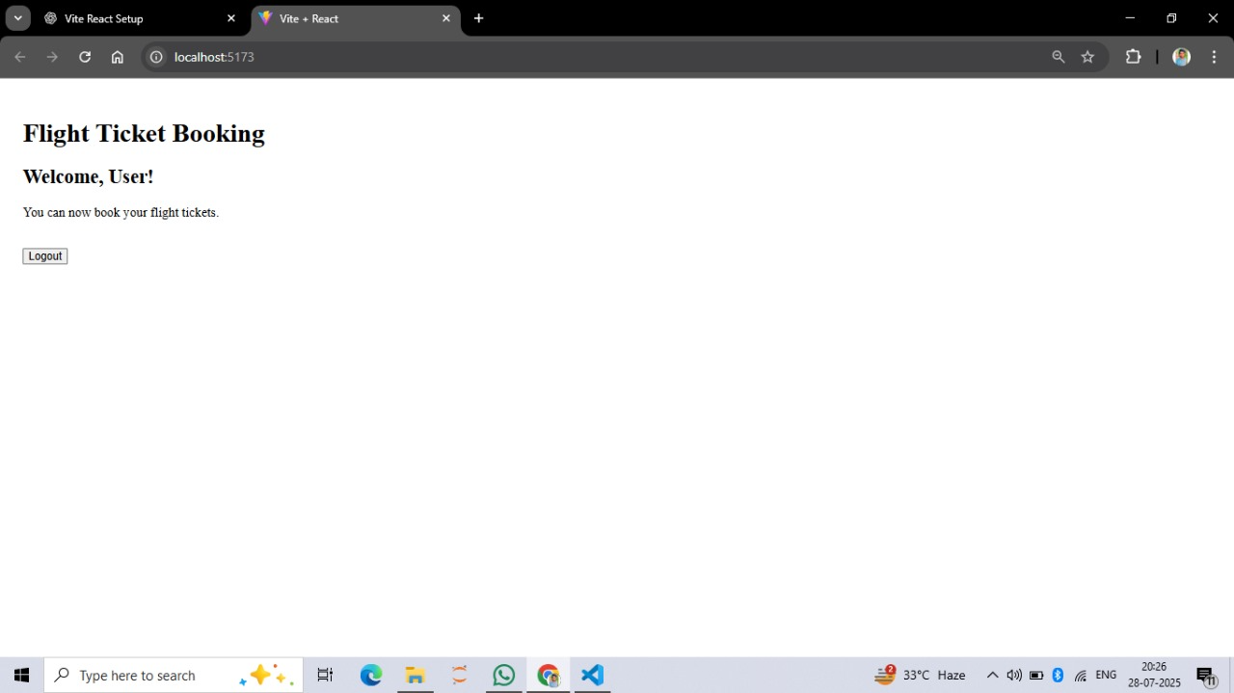



**EXERCISE 13:**

**CODE:**

//app.jsx

import { useState } from 'react';

import BookDetails from './Components/BookDetails';

import BlogDetails from './Components/BlogDetails';

import CourseDetails from './Components/CourseDetails';

function App() {

const [view, setView] = useState("book"); // 'book' | 'blog' | 'course'

let componentToRender;

if (view === "book") {

componentToRender = <BookDetails />;

} else if (view === "blog") {

componentToRender = <BlogDetails />;

} else {

componentToRender = <CourseDetails />;

}

return (

<div style={{ padding: "20px" }}>

<h1>Blogger App</h1>

{/* Change view using buttons */}

<button onClick={() =>setView("book")}>Show Books</button>

<button onClick={() =>setView("blog")}>Show Blogs</button>

<button onClick={() =>setView("course")}>Show Courses</button>

<hr />

{/* Rendering using variable */}

{componentToRender}

{/* Additional conditional rendering using && */}

{view === "course" &&<p>You are viewing Course details (Rendered using &&)</p>}

{/* Rendering using ternary */}

<p>

Current View: {

view === "book" ? "Books" :

view === "blog" ? "Blogs" : "Courses"

}

</p>

</div>

);

}

export default App;

//bookdetail.jsx

function BookDetails() {

const books = ["React Guide", "JavaScript Mastery", "Clean Code"];

return (

<div>

<h2>Book List</h2>

<ul>

{books.map((book, index) => (

<li key={index}>{book}</li>

))}

</ul>

</div>

);

}

export default BookDetails;

//blobdetail.jsx

function BlogDetails() {

const blogs = [

{ title: "React Tips", author: "John" },

{ title: "JS Deep Dive", author: "Sara" },

{ title: "UI Best Practices", author: "Ava" }

];

return (

<div>

<h2>Blog Posts</h2>

{blogs.map((blog, i) => (

<div key={i}>

<h4>{blog.title}</h4>

<p>by {blog.author}</p>

</div>

))}

</div>

);

}

export default BlogDetails;

//coursedetail.jsx

function CourseDetails() {

const courses = [

{ name: "React", duration: "1 month" },

{ name: "NodeJS", duration: "2 months" }

];

return (

<div>

<h2>Courses</h2>

{courses.length> 0 && (

<ul>

{courses.map((course, index) => (

<li key={index}>{course.name} - {course.duration}</li>

))}

</ul>

)}

</div>

);

}

export default CourseDetails;

**OUTPUT:**

