MOP HISTORY
MOST RECENT VERSION | REVISION DETAIL/S | AUTHOR | APPROVED BY | DATE APPROVED
1.0 | 1st DRAFT | John Carlo Rabanes

1. DESCRIPTION
- Power tapping of Site Nokia OLT PAGATPATCDOMISOR System

2. PURPOSE AND SCOPE
PURPOSE

- To power on PAGATPATCDOMISOR(mini OLT) for B2B as a pre-requisite of Site deployment.

SCOPE
- Nokia Lightspan MF-2 (Mini OLT power tapping of DC +48Vdc breakers/panels.

PROPOSED RECTIFIER SYSTEM LOAD BREAKER FUSE: (RECTIFIER 1 – ELTEK / MAIN: F1 / RDNT: F2)

FUSE No: F1 OLT MF-2 – (Nokia Lightspan MF-2 Power tapping point) – MAIN
FUSE No: F2 OLT MF-2 – (Nokia Lightspan MF-2 Power tapping point) – RDNT

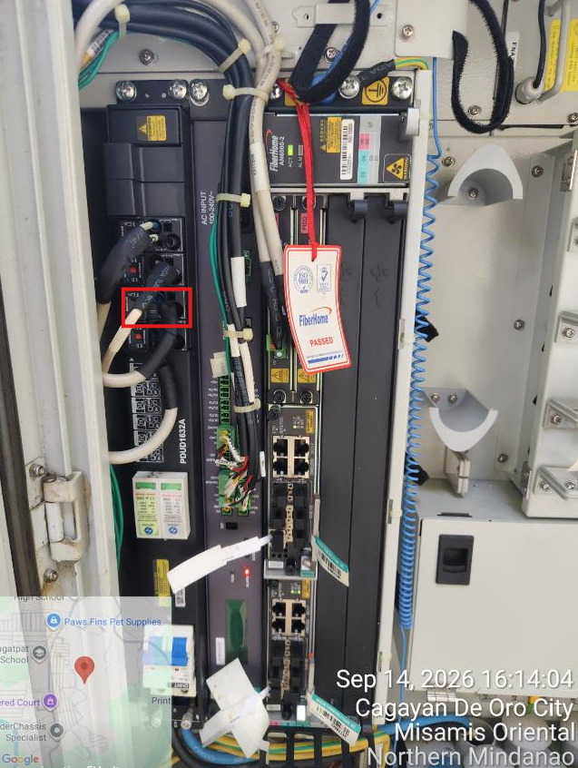

3. BACKGROUND
- This activity will support the Blaine Plus Project for additional OLT GPON/VOICE deployment of Nokia OLT MF-2 equipment for the Globe Project

4. PROPONENT
Name | Position | Dept./Div. | Signature | Date
Dhenver Santos | Technical Team Head | Nokia / OLT MF-2
Edgar Peralta | OLT Supervisor | Nokia / OLT MF-2
John Carlo Rabanes | OLT Rollout Engineer | Nokia / OLT MF-2
Kristy Mae Dela Torre
Butch Doble

Note: Required Signatories Minor – up to Section Head Major – up to Department Head Critical – up to Division Head

5. Target Date and Time of Implementation: May 19- June 19, 2026 10:00AM-6:00PM

6. CHANGE CATEGORY
Minor | Major | Critical

7. TYPE OF SERVICES AFFECTED
Service :  (None Service Affecting) | Product : | MVNO /IR/Others :

8. SITE AND E2E SYSTEM AFFECTED
Site(Location) | System (E2E)
PAGATPATCDOMISOR_MIN2250 | OLT MF-2

9. E2E SYSTEMS BLOCK DIAGRAM

10. WITH OTHER RELATED ACTIVITY: YES NO
Description
SO REF#
MOP REF#
Other Network Element (NE) Affected
Remarks:

11. SPECIFIC NODE AFFECTED IN THIS MOP
HARDWARE
System Name | Product | Version | Remarks
N/A | N/A | N/A
SOFTWARE
System Name | Product | Version | Remarks
N/A | N/A | N/A

12. PEOPLE INVOLVED DURING IMPLEMENTATION OF THE ACTIVITY
Company | Department | Name | Role | Contact Number
Nokia | FN Access Project | Edgar Peralta Jr. | Engineer / implementer | +63 9260895345
Nokia | FN Access Project | Jay Palasol | Engineer / implementer | +63 9175520623
Nokia | FN Access Project | Mark Inovero | Engineer / implementer | +63 9354376033
Nokia | FN Access Project | Mark Brillantes | Engineer / implementer | +63 9562570282
Nokia | FN Access Project | John Carlo Rabanes | Engineer / implementer | +63 9669343065
ESCALATION PROCEDURE
Company | Department | Name | Role | Contact Number
Globe |  | Kristy Mae Dela  Torre | Engineering
Globe |  | Edward Ian Oria | Engineering
Globe | SICE | LA Tan | Implement Engineering | +63 9178382974

13. INVENTORY
HARDWARE
System Name | Product | Version | Remarks

PAGATPATCDOMISOR | OLT MF-2 | L6GQFC24.298
SOFTWARE
System Name | Product | Version | Remarks
PAGATPATCDOMISOR | OLT MF-2 | L6GQFC24.298

14. SUPPORTING DOCUMENTS
TSSR: MIN2250_PAGATPATCDOMISOR_ONE_TSSR_09-15-26_1_1_01 (1) (1).pdf
Reference Number | Description
Approved TSSR / Technical power proposal | Please see attached signed tssr.    MIN2250_PAGATPATCDOMISOR

15. WORK BREAKDOWN SCHEDULE
Start Time | End Time | Activity | Responsible | Remarks
09:00 | 10:15 | Pre-activity procedure | FAPE/ Nokia Engineer
10:15 | 12:30 | Activity Proper | Nokia Engineer
12:30 | 18:00 | Post-activity procedure | FAPE/ Nokia Engineer

16. KNOWN ISSUES, RISKS AND MITIGATIONS (Preventive)
MITIGATIONS
- Insulation testing should be done prior activity
- Spare breaker should be available
- Power cable route are inspected prior activity

RISKS
- Power cables & DC Breakers are faulty

KNOWN ISSUES
- N/A

17. PRE-REQUISITES PRIOR IMPLEMENTATION
SAT / ISAT / IOT Tests : N/A

Permit to Work: Yes RAAWA: Yes
HEO/FO Resource Availability/ Test Callers Availability: N/A
Vendor Support: Yes
No Existing Fault: Yes
Availability of Spare Modules, Patch Cords , etc: N/A
Section/Dept/Division Head Approval: N/A
Business Approval: N/A
Baseline stats: N/A

18. SUCCESS, ABORT AND REVERT BACK CRITERIA
SUCCESS CRITERIA
- OLT MF-2 is powered-on without interruption.
- No alarms are observed during the activity.

ABORT CRITERIA
  - There are existing faults in rectifier or DCDU.

REVERT CRITERIA
    - Unexpected outage occurred on GAIN network caused by the activity. (Please call Proponent first before revert to verify).

19. PRE-ACTIVITY PROCEDURES
- SCC Wireline to check and validate existing alarms on NMS.
- Visual inspection of power cables (labels, breakers, rectifier loadings, etc.)
- Assistance from Globe proponent/Facilities for checking of rectifier and PDF status.
20. PLANNED ACTIVITY PROCEDURES
1. Aligned the breaker assignment as follows :

Fuse F1 (16A) : Nokia Lightspan MF-2 Power Tapped – MAIN [ELTEK]
Fuse F2 (16A) : Nokia Lightspan MF-2 Power Tapped – RDNT [ELTEK]

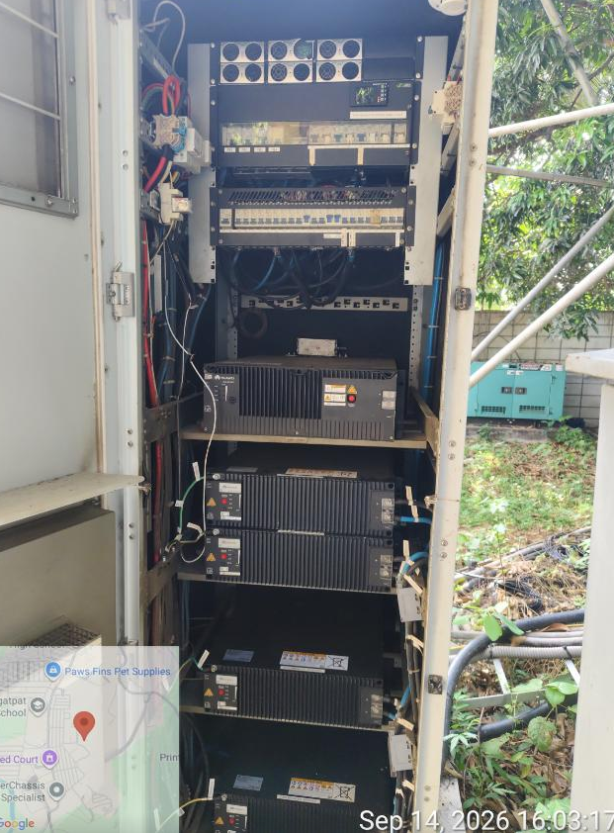
RECTIFIER 1 – ELTEK (MAIN: F1 / RDNT: F2)

A. Tap the power cables on the PDF breakers with respect to equipment power modules.

- Make sure power tapping of the breaker is for the terminals of the equipment. Also the breaker should be switched off prior to the tapping of cable/s.

- One by one, tap the cable/s to their respective breakers. Be sure not to cause any short circuit in the cables being tapped or any other cables in the power panel. Make sure that the cable/s is properly terminated to their terminals (with the appropriate terminal lugs) and all terminations are properly tightened.
- Apply the corresponding label after the said activity.
20. POST ACTIVITY CHECKING AND VALIDATION
- NOC Wireline to check and validate existing alarms on NMS.
- Visual inspection of power cables (labels, breakers, rectifier loadings, etc.)
- Assistance from Globe proponent/Facilities for checking of rectifier and PDF status.
- Visual inspection of AMS server power LED.
- Visual inspection of SWITCH power LED.

21. REVERT BACK PROCEDURES
In case of revert, power off the breakers.

22. POST REVERT BACK SUCCESS CRITERIA
- NOC Wireline to check and validate existing alarms on NMS.
- Visual inspection of power cables (labels, breakers, rectifier loadings, etc.)
- Assistance from Globe Proponent/Facilities for checking of rectifier and PDF status.

23. CONTINGENCY (If Revert Procedure Fails)
- Contact GT proponent / Nokia proponent (refer to escalation procedure)

24. MOP REVISION DETAILS (to be filled in by SEI reviewing engr)
REVISION 1 : (indicate reason)








Lack of Mandatory Information Configuration not aligned with standard / LLD
Confusing instruction in the procedure Missing Configuration
Missing step in procedure Wrong Configuration
Typing Error Incorrect Data
REVISION 2 : (indicate reason based on same list above)
REVISION 3 : (indicate reason based on same list above)

