MOP HISTORY
MOST RECENT VERSION | REVISION DETAIL/S | AUTHOR | APPROVED BY | DATE APPROVED
 |  | Engr. Edgar Peralta

- DESCRIPTION
Nokia Lightspan {{OLT_PRODUCT}} Mini OLT {{OLT_SITE}} Integration in LCGCDO.

- PURPOSE AND SCOPE
PART 1 LOGICAL CONFIGURATIONS
- To activate 1x10GE trunk between NOKIA LIGHTSPAN {{OLT_PRODUCT}} MINI OLT and its facing {{AN_SITE}}
- VLAN Definition on ATN/OLT on the ring
PART 2 PHYSICAL PATCHING
PART 3 NE uploading via Altiplano
PART 4 NE Configuration via Altiplano

- BACKGROUND
New OLT will be activated to serve FTTH facilities in {{OLT_SITE}}. Thus, configuration in the equipment is necessary to ensure availability of services (both voice and data) once integrated in the network.

- PROPONENT
Name | Position | Dept./Div. | Signature | Date
Ria Marquez | Proponent | B&D – AT&B
Rennel Alvero | IS - Proponent | B&D – AT&B
Jhong Maputi | Engineer | NTG/AEPM/RWE-MIN
Fritzyl Cepeda | Head | AEPM/WLN

- TARGET DATE OF IMPLEMENTATION: Primary: {{DATE_PRIMARY}}; <0800H-2000H>
Secondary: {{DATE_SECONDARY}}; <0800H-2000H >

- CHANGE CATEGORY
 | Minor |  | Major |  | Critical

- TYPE OF SERVICES AFFECTED
Service: Wireline voice and data  (Non-service affecting) | Product: Voice and Broadband | MVNO/IR/ Others: NA4
  VLANs
  MANAGEMENT | {{OLT_OM_VLAN}}
  DATA | {{VLAN_HSI}}
  SIP | {{VLAN_SIP}}
  IPOE DYNAMIC | {{VLAN_IPOE1}}, 800, 801
  IPOE STATIC | {{VLAN_IPOE2}}, 850, 815

- SITE AND E2E SYSTEM AFFECTED
Site (Location) | System (E2E)
{{OLT_SITE}} | Lightspan {{OLT_PRODUCT}}
{{AG1_NODE}} | {{AG_SYSTEM}}
{{AG2_NODE}} | {{AG_SYSTEM}}
{{AN_SITE}} | {{AN_PRODUCT}}

- E2E SYSTEMS BLOCK DIAGRAM
{{ewp_image}}

- WITH OTHER RELATED ACTIVITY: YES NO
Description
SO REF#
MOP REF#
Network Element (NE) Affected
Remarks:
- SPECIFIC NODE AFFECTED IN THIS MOP
HARDWARE
System Name | Product | Version | Remarks
{{OLT_SITE}} | Lightspan {{OLT_PRODUCT}} | {{OLT_PRODUCT}} | {{OLT_MGMT_IP}}
{{AG1_NODE}} | {{AG_PRODUCT}} | {{AG_MODEL}} | L0: {{AG1_LOOPBACK0}}  L1: {{AG1_LOOPBACK1}}
{{AG2_NODE}} | {{AG_PRODUCT}} | {{AG_MODEL}} | L0: 1 {{AG2_LOOPBACK0}}  L1: {{AG2_LOOPBACK1}}
{{AN_SITE}} | ATN Series Equipment | {{AN_PRODUCT}} | L0: {{AN_LOOPBACK0}}  L1: {{AN_LOOPBACK1}}
SOFTWARE
System Name | Product | Version | Remarks
{{OLT_SITE}} | Lightspan {{OLT_PRODUCT}} | {{OLT_SW_VERSION}} | {{OLT_MGMT_IP}}
{{AG1_NODE}} | {{AG_PRODUCT}} | {{AG_SW_VERSION}} | L0: {{AG1_LOOPBACK0}}  L1: {{AG1_LOOPBACK1}}
{{AG2_NODE}} | {{AG_PRODUCT}} | {{AG_SW_VERSION}} | L0: 1 {{AG2_LOOPBACK0}}  L1: {{AG2_LOOPBACK1}}
{{AN_SITE}} | {{AN_PRODUCT_FAMILY}} | {{AN_PRODUCT}} | L0: {{AN_LOOPBACK0}}  L1: {{AN_LOOPBACK1}}

- PEOPLE INVOLVED DURING IMPLEMENTATION OF THE ACTIVITY
Company | Department | Name | Role | Contact Number
NOKIA | FN/OLT | Dhenver Santos | Technical Suppport/Implementer/OLT | 091208604984
NOKIA | FN/OLT | Jay Palasol | Technical Suppport/Implementer/OLT | 09956388538
NOKIA | FN/OLT | Calvin Quidato | Technical Suppport/Implementer/OLT | 09369593326
NOKIA | FN/OLT | Edgar Peralta, Jr. | Technical Suppport/Implementer/OLT | 09260895345
NOKIA | FN/OLT | Angielica Lancita | Technical Suppport/Implementer/OLT | 09950945402
GT | DSOC | DSOC Wireline | Implementer | 09062592532

12.1 Escalation Procedure
Company | Department | Name | Role | Contact Number
GT | AT&B | Kristy Dela Torre | Activity Proponent | 09165534373
GT | BAPE | Christian Jhenric Linao | Proponent | 09639749843
GT | AT&B | Butch Doble | IS Act Proponent | 09175880517
GT | AEPM | Angelica Tenorio | BAPE- Engineer | 09176884673
GT | SICE | Charlene Cabingao | SICE engineer (reviewer) | 09176881403
GT | SICE | Marie Carl Macaraeg | SICE engineer (reviewer) | 09176880628
GT | SICE | Narciso Del Rosario Jr | SICE engineer (reviewer) | 09175885493
GT | SICE | Lorna Tan | SICE engineer IS | 09178382974
GT | SICE | Katherine Macasling | SICE Unit Head | 09177975388

- SUPPORTING DOCUMENTS
Reference Number | Description
Attach FIO for preconfigurations | {{FIO_REF}}
- WORK BREAKDOWN SCHEDULE
Start Time | End Time | Activity | Responsible | Remarks
0800H | 1000H | Notify DSOC before the start of activity | NOKIA | No downtime
1000H | 1100H | Check IP and VLAN | DSOC/NOKIA | No downtime
1100H | 1500H | Configure IP and VLAN at MF-2 Mini OLT  Insertion of patch chord | NOKIA | No downtime
1500H | 1700H | POST Validation - Test calls and test browse  Ping and connectivity test | DSOC/NOKIA | No downtime
1700H | 2000H | Revert and post revert (if necessary) | NOKIA | No downtime
- KNOWN ISSUES, RISKS AND MITIGATIONS
KNOWN ISSUES: IP conflict; OLT not manageable.
RISKS involve: No services after integration.
WORST CASE Scenario/s: No services after integration.
RISK MITIGATION: Check all parameters if properly configured (OLT, AG, AGG, 3464, 7450).

- PRE-REQUISITES PRIOR IMPLEMENTATION
  - Work permit/ RAAWA if necessary
  - Test accounts for SIP voice and data
  - Materials (e.g modules, cables, modem, telephone handset)
  - KNL Generator
  - Cabin Keys (SITE KEYS and KNL)

- SUCCESS, ABORT AND REVERT BACK CRITERIA
SUCCESS CRITERIA
  - No major alarms related to the activity.
  - All involved NEs are manageable/UP.
  - Voice and data service are successful
DEFERRED CRITERIA
- One of the Pre-activity procedures has not been met.
REVERT CRITERIA
- Activity caused unexpected major alarm

- PRE-ACTIVITY PROCEDURES
- Any incident/s that may directly and indirectly affect this activity should be cleared prior the start.
Reason: To ensure that this activity is clear from any outstanding incident/s that could complicate and/or impact the activity.
- DSOC Wireline to check alarm at NMS, there should be no major/critical alarm on nodes involved in the activity
- DSOC Wireline to ensure that the IP provided is unallocated.
Ping and/or telnet OM IP provided from {{AGG_NODE}}. IP address should not be reachable/accessible

#ping -vpn-instance OM_MSAN -a {{OLT_OM_GW}} {{OLT_MGMT_IP}}

Site Name/ Device Name | IP ADD
{{OLT_SITE}} | {{OLT_MGMT_IP}}

- DSOC Validation of OLT Services’ VSI and its peer pre-definition on AG and VCID availability on AN
DSOC to ensure as well that VLANs are aligned on AG ports.

 |  | ATN |  | Facing BNG/NMS/Voice Server
AG Node | VSI name | Peer IP | VC ID | Peer IP
{{AG1_NODE}} | OM-90000{{OLT_OM_VLAN}} | {{AG1_IP}} | {{VCID_OM_PRIMARY}} | {{BNG_PEER_OM}}
{{AG1_NODE}} | SIP-9000{{VLAN_SIP}} | {{AG1_IP}} | {{VCID_SIP_PRIMARY}} | {{BNG_PEER_SIP}}
{{AG1_NODE}} | HSI-9000{{VLAN_HSI}} | {{AG1_IP}} | {{VCID_HSI_PRIMARY}} | {{BNG_PEER_SIP}}
{{AG1_NODE}} | IPOE-19{{VLAN_IPOE1}}368 | {{AG1_IP}} | {{VCID_IPOE1_PRIMARY}} | {{BNG_PEER_IPOE1}}
{{AG1_NODE}} | IPOE-29{{VLAN_IPOE2}}368 | {{AG1_IP}} | {{VCID_IPOE2_PRIMARY}} | {{BNG_PEER_IPOE2}}
{{AG2_NODE}} | OM-90000{{OLT_OM_VLAN}} | {{AG2_IP}} | {{VCID_OM_PRIMARY}} | {{BNG_PEER_OM}}
{{AG2_NODE}} | SIP-9000{{VLAN_SIP}} | {{AG2_IP}} | {{VCID_SIP_PRIMARY}} | {{BNG_PEER_SIP}}
{{AG2_NODE}} | HSI-9000{{VLAN_HSI}} | {{AG2_IP}} | {{VCID_HSI_PRIMARY}} | {{BNG_PEER_SIP}}
{{AG2_NODE}} | IPOE-19{{VLAN_IPOE1}}368 | {{AG2_IP}} | {{VCID_IPOE1_PRIMARY}} | {{BNG_PEER_IPOE1}}
{{AG2_NODE}} | IPOE-29{{VLAN_IPOE2}}368 | {{AG2_IP}} | {{VCID_IPOE2_PRIMARY}} | {{BNG_PEER_IPOE2}}
Note: Please execute below commands on indicated CX600 and per VSI
CX600# display vsi name <vsi name> peer-info 🡪 Peer IPs should be complete, VC ID should be correct

AN | Role | Access Circuit | Peer IP | VC ID
{{AN_SITE}}  {{AN_TRUNK_ID}} | Primary | {{AN_TRUNK_ID}}.{{OLT_OM_VLAN}} | {{AG1_IP}} | {{VCID_OM_PRIMARY}}
{{AN_SITE}}  {{AN_TRUNK_ID}} | Primary | {{AN_TRUNK_ID}}.{{VLAN_SIP}} | {{AG1_IP}} | {{VCID_SIP_PRIMARY}}
{{AN_SITE}}  {{AN_TRUNK_ID}} | Primary | {{AN_TRUNK_ID}}.{{VLAN_HSI}} | {{AG1_IP}} | {{VCID_HSI_PRIMARY}}
{{AN_SITE}}  {{AN_TRUNK_ID}} | Primary | {{AN_TRUNK_ID}}.{{VLAN_IPOE1}} | {{AG1_IP}} | {{VCID_IPOE1_PRIMARY}}
{{AN_SITE}}  {{AN_TRUNK_ID}} | Primary | {{AN_TRUNK_ID}}.{{VLAN_IPOE2}} | {{AG1_IP}} | {{VCID_IPOE2_PRIMARY}}
{{AN_SITE}}  {{AN_TRUNK_ID}} | Secondary | {{AN_TRUNK_ID}}.{{OLT_OM_VLAN}} | {{AG2_IP}} | {{VCID_OM_SECONDARY}}
{{AN_SITE}}  {{AN_TRUNK_ID}} | Secondary | {{AN_TRUNK_ID}}.{{VLAN_SIP}} | {{AG2_IP}} | {{VCID_SIP_SECONDARY}}
{{AN_SITE}}  {{AN_TRUNK_ID}} | Secondary | {{AN_TRUNK_ID}}.{{VLAN_HSI}} | {{AG2_IP}} | {{VCID_HSI_SECONDARY}}
{{AN_SITE}}  {{AN_TRUNK_ID}} | Secondary | {{AN_TRUNK_ID}}.{{VLAN_IPOE1}} | {{AG2_IP}} | {{VCID_IPOE1_SECONDARY}}
{{AN_SITE}}  {{AN_TRUNK_ID}} | Secondary | {{AN_TRUNK_ID}}.{{VLAN_IPOE2}} | {{AG2_IP}} | {{VCID_IPOE2_SECONDARY}}
FOR WIRELINE AN
# disp mpls l2vpn vpws VC IDs should not have conflict configuration
FOR IPRAN AN
# disp mpls l2vc remote-info VC IDs should be predefined

- DSOC Validation of OLT Services’ VSI and its AG peer pre-definition on AGG.

OLT Location | Bridging CX600 facing BNG or 7450 | VSI name | Peer IP | VLAN/VC ID
{{OLT_REGION}} | {{BNG_NODE_SIP_HSI}} | SIP-9000{{VLAN_SIP}} | {{AG1_IP}}  {{AG2_IP}} | {{VLAN_SIP}}
{{OLT_REGION}} | {{BNG_NODE_SIP_HSI}} | HSI-9000{{VLAN_HSI}} | {{AG1_IP}}  {{AG2_IP}} | {{VLAN_HSI}}
{{OLT_REGION}} | {{AGG_NODE_OM}} | OM-90000{{OLT_OM_VLAN}} | {{AG1_IP}}  {{AG2_IP}} | {{OLT_OM_VLAN}}
{{OLT_REGION}} | {{AGG_NODE_IPOE1}} | IPOE-19{{VLAN_IPOE1}}368 | {{AG1_IP}}  {{AG2_IP}} | {{VLAN_IPOE1}}
{{OLT_REGION}} | {{BNG_NODE_IPOE2}} | IPOE-29{{VLAN_IPOE2}}368 | {{AG1_IP}}  {{AG2_IP}} | {{VLAN_IPOE2}}
Note: Please execute below commands on indicated CX600 based on OLT Location and per VSI
CX600# display vsi name <vsi name> peer-info 🡪 Peer IPs should be complete, VC ID should be correct and VC state should be Up

- DSOC to check CX pre definition for OM and HSI (Bridging to 7450/BNG) – VLAN {{OLT_OM_VLAN}} and {{VLAN_HSI}} should be defined. Execute below on CX based on the OLT location

OLT Location | Bridging CX600 | Port X/Y/Z facing BNG or facing 7450 | Sub-interface | VSI L2 binding
MIN | {{BNG_NODE_SIP_HSI}} | {{CX600_UPLINK_PORT}} | {{CX600_UPLINK_PORT}}.{{VLAN_HSI}} | HSI-9000{{VLAN_HSI}}
MIN | {{AGG_NODE_OM}} | VE interface: {{CX600_VE}} | {{CX600_VE}}.{{OLT_OM_VLAN}} | OM-90000{{OLT_OM_VLAN}}
Note: Please execute below commands on indicated CX600 based on OLT Location and per interface
CX600# display vsi services interface GigabitEthernet X/Y/Z 🡪sub-interfasce indicated above is defined, l2 binding should be aligned with vsi name and status should be Up/Up

- DSOC Validation of AGG interface towards NCE and VIMS pre-definition

SERVING AREA | NE Name | NE IP Address | VE Assignment |  | VLAN
SERVING AREA | NE Name | NE IP Address | Layer 2 | Layer 3 | VLAN
{{OLT_REGION}} | {{AGG_NODE_SIP_HSI_L2}} | {{BNG_PEER_SIP_HSI}} | Virtual-Ethernet1/0/0 | Virtual-Ethernet1/0/1 | {{VLAN_SIP}}
{{OLT_REGION}} | {{AGG_NODE_OM}} | {{BNG_PEER_OM}} | Virtual-Ethernet3/0/0 | Virtual-Ethernet3/0/1 | {{OLT_OM_VLAN}}
MSAN Location | Bridging CX600 | VE Assignment | VE Subinterface | VSI L2 binding | IP Block
 |  |  |  |  | Gateway
{{OLT_REGION}} | {{AGG_NODE_SIP_HSI_L2}} | Layer 2:{{CX600_VE_L2}} | {{CX600_VE_L2}}.{{VLAN_SIP}} | SIP-9000{{VLAN_SIP}} | -
{{OLT_REGION}} | {{AGG_NODE_SIP_HSI_L2}} | Layer 3:{{CX600_VE_L3}} | {{CX600_VE_L3}}.{{VLAN_SIP}} | SIP-9000{{VLAN_SIP}} | DHCP  {{DHCP_BLOCK_SIP}}  {{DHCP_GW_SIP}}
{{OLT_REGION}} | {{AGG_NODE_OM}} | Layer 2:{{CX600_VE}} | {{CX600_VE}}.{{OLT_OM_VLAN}} | OM-90000{{OLT_OM_VLAN}} | -
{{OLT_REGION}} | {{AGG_NODE_OM}} | Layer 3:{{CX600_VE_L3}} | {{CX600_VE_L3}}.{{OLT_OM_VLAN}} | OM-90000{{OLT_OM_VLAN}} | {{DHCP_BLOCK_OM}}  {{OLT_OM_GW}}

Note: Please execute below commands on indicated CX600 based on MSAN Location and per interface (FOR L2 checking)
CX600# display vsi services interface Virtual-EthernetX/Y/Z.xxxx 🡪subinterface indicated above is defined, l2 binding should be aligned with vsi name and status should be Up/Up
Note: Please execute below commands on indicated CX600 based on MSAN Location and per interface (FOR L3 checking)
CX600# display ip interface brief Virtual-EthernetX/Y/Z.xxxx 🡪subinterface indicated above is defined, IP address should be correct and status should be Up/Up
- DSOC to validate that port {{AN_UPLINK_PORT}} (10G) and {{AN_TRUNK_ID}} in {{AN_SITE}} is/are not yet used
#display int bri. ports indicated above is down
#display current-configuration interface GigabitEthernetx/y/z with no conflict configuration
#display current interface-configuration {{AN_TRUNK_ID}} with no conflict configuration

- IMPLEMENTER ON SITE to send result of the following commands to PD (orchestrator).
Note:PD/IMPLEMENTER ON SITE to ensure correctness of sw version+patch, equipment hardware components status.
#show hardware-state component Chassis software software
#show alarms alarm-list alarm
- PD/IMPLEMENTER ON SITE to ensure that Software and patch version is correct prior to integration. All equipment hardware components are enabled
Lightspan {{OLT_PRODUCT}}:
#show hardware-state component Chassis software software current active SW of {{OLT_PRODUCT}} is {{OLT_SW_VERSION}}
#show hardware-state component state

Software Version:`
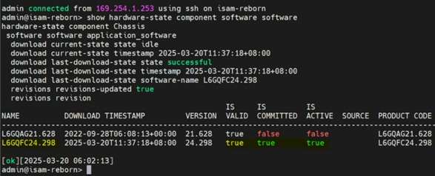
MF-2 Hardware Components:
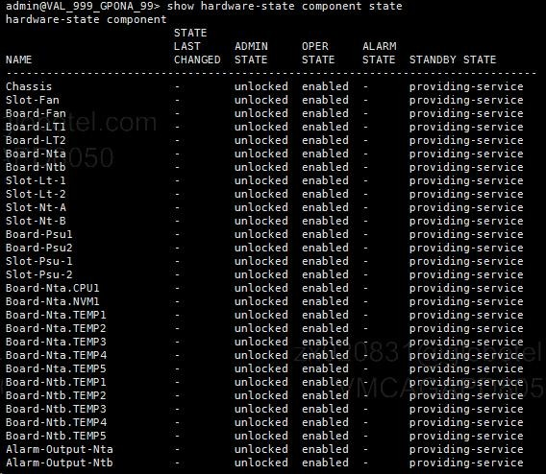
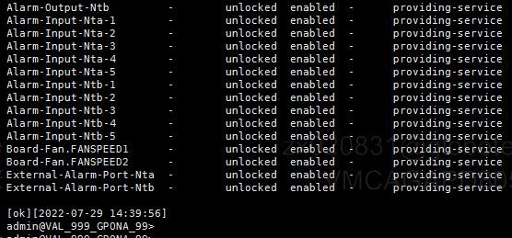
- PD/IMPLEMENTER ON SITE to ensure OLT uplink lag is enabled for trunk enabled transport or no lag configured for linear uplink connection as below:
  - Connect LAN cable from laptop to {{OLT_PRODUCT}} (LEMI).
  - Set the IP address 169.254.0.111/24 in IPV4 properties on your laptop.
  - Using Putty or any terminal emulator, enter the LEMI IP address 169.254.0.1 on port 2222.
  - Login in NE:
User: root
Password: 2x2=4
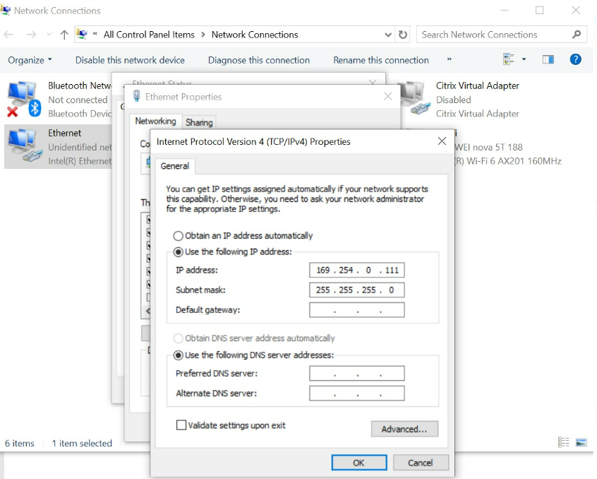
  - Then login to IHUB
#ssh -oHostKeyAlgorithms=+ssh-rsa cli_user@169.254.1.251 -o "StrictHostKeyChecking no"
Password: <****cli!>
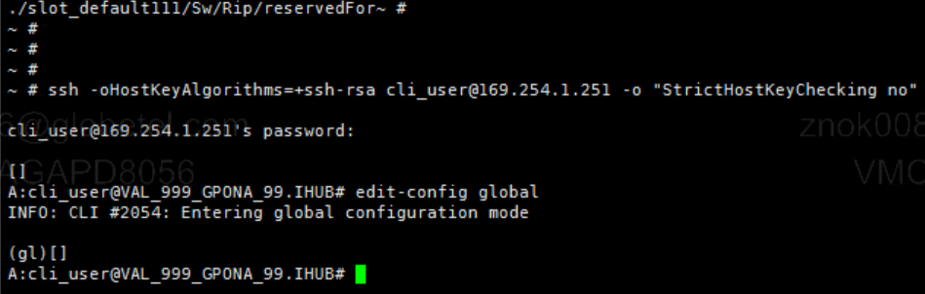
  - Check lag or no lag configured on OLT uplink.
Sample screenshot:
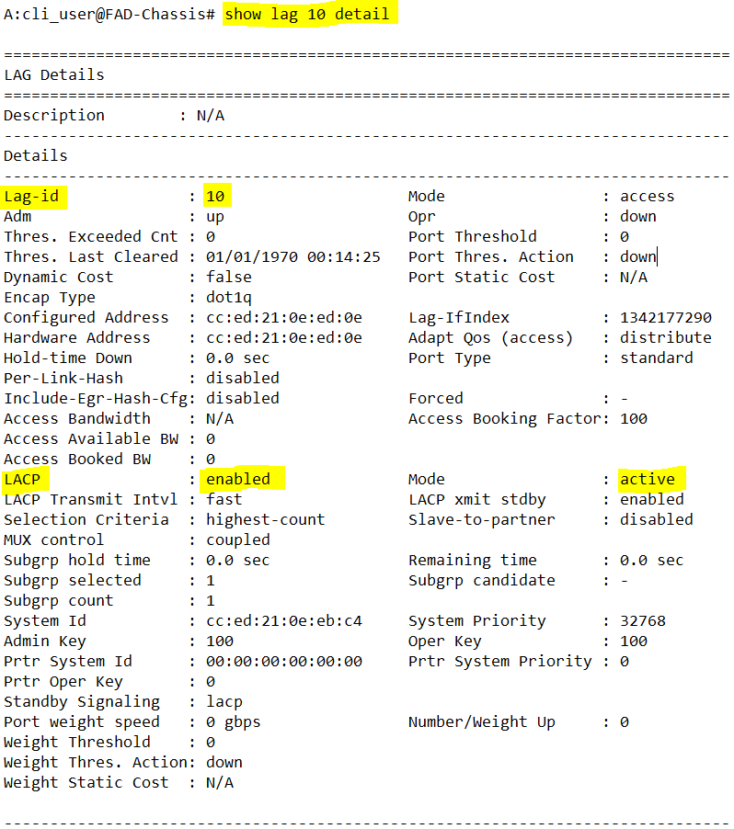

  - PD/IMPLEMENTER ON SITE and DSOC Wireline to send all the logs showing the implementation (command level and system results) and physical data cables are properly labeled prior to OLT insertion to {{OLT_SITE}}.

- PLANNED ACTIVITY PROCEDURES
On Site Procedure- PD/ implementer on site to coordinate with DSOC to start the activity.

Part 1: LOGICAL DEFINITION
1.1 Upon approval, (PD/Implementer on site) will do the following:
a. Configure device OM VLAN ID, IP address and default route as attached file:
Site Name/ Device Name
{{OLT_SITE}}

Refer to #11 on pre-activity for detailed steps:
- Login to MF2, username: root password: <*****>
- Then login to IHUB
#ssh -oHostKeyAlgorithms=+ssh-rsa cli_user@169.254.1.251 -o "StrictHostKeyChecking no"
Password: <****cli!>

- See sample attached inband configuration:
- Modify highlighted management parameters and run below script on sample inband configuration.

- To display the configuration of Management IP, OM VLAN and gateway, do the below command on IHUB.
#edit-config global
#configure service ies 2
#info
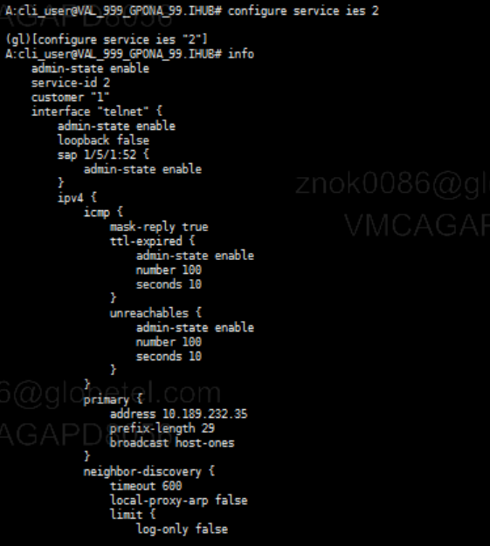
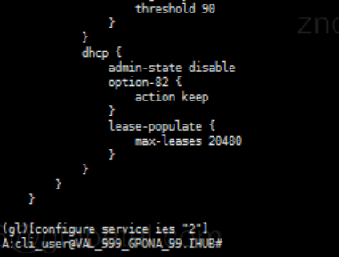

{{ewp_image}}

- DSOC to ensure that ports and sub interfaces {{AN_SITE}} {{AN_UPLINK_PORT}} (10G) for the newly inserted OLT, should be enabled. Otherwise, enable the ports and sub interfaces.

Sample config for enabling the port in CX and ATN9100C:
sys
interface x/y/z replace x/y/z with ports above
undo shutdown
commit for X2-M8A or X8A only
quit
save
Sample config for enabling the subinterfaces in CX
sys
interface x/y/z.AAA replace x/y/z with ports above and AAA with the VLAN
undo shutdown
commit for X2-M8A or X8A only
quit
save

Part 2: PHYSICAL Patching

  - PHYSICAL Patching - Once vlans are configured and enabled, DSOC to advise implementer on site to patch the
{{OLT_SITE}} port {{OLT_UPLINK_PORT}} {{AN_SITE}} port {{AN_UPLINK_PORT}}

Note: Link should be Up. Else, check the SFP, patch cord and/or the auto negotiation settings of both OLT and CX. Modify the setting if needed
@{{AN_SITE}}
#display interface brief
#display interface {{AN_TRUNK_ID}}

Part 3: Altiplano UPLOADING

  - PD/Implementer on site – To conduct ping test from OLT Lightspan {{OLT_PRODUCT}} to the NOKIA ALTIPLANO server IP (10.203.214.40).
3.2 Nokia DSOC to add network elements {{OLT_SITE}} at NOKIA ALTIPLANO. Coordinate with PD the correct OLT name and IPs (data, SIP voice and management) to be used.
Site Name/ Device Name | IP Add
{{OLT_SITE}} | {{OLT_MGMT_IP}}

3.3 Please execute and follow procedures on attached file below.

Part 4: NE Configuration via Altiplano

4.1 Device-config-fx Intent Configuration in Altiplano, execute and follow procedures on attached file below

4.2. Uplink-connection Intent Configuration via Altiplano, execute and follow procedures on attached file below

4.3 L2-infra Intent Configuration (VLAN Configuration) via Altiplano for Service Validation, execute and follow procedures on attached file below
  - Fiber Intent Configuration (PON Port Configuration) via Altiplano, execute and follow procedures on attached file below

4.5 ONT Intent Configuration (part from ONT Authentication / ONT Service Configuration) via Altiplano, execute and follow procedures on attached file below

4.6 L2-user Intent Configuration (Bridge port configuration) via Altiplano, execute and follow procedures on attached file below

Note: DSOC TO CALL SICE REVIEWER FOR CONSULTATION PRIOR REVERT OF ACTIVITY.

- POST ACTIVITY CHECKING AND VALIDATION
  - DSOC can manage {{OLT_SITE}} at NOKIA ALTIPLANO with the correct naming convention and with the links updated. (Refer to topology above ITEM 9 E2E SYSTEMS BLOCK DIAGRAM.)

  - {{OLT_SITE}} port {{OLT_UPLINK_PORT}} and {{AN_SITE}} port {{AN_UPLINK_PORT}} are up.

For {{OLT_PRODUCT}} OLT checking, Refer to #11 on pre-activity for detailed steps to login IHUB:
- Login to MF2, username: root password: <*****>
- Then login to IHUB
#ssh -oHostKeyAlgorithms=+ssh-rsa cli_user@169.254.1.251 -o "StrictHostKeyChecking no"
Password: <****cli!>

#show port 1/1/1

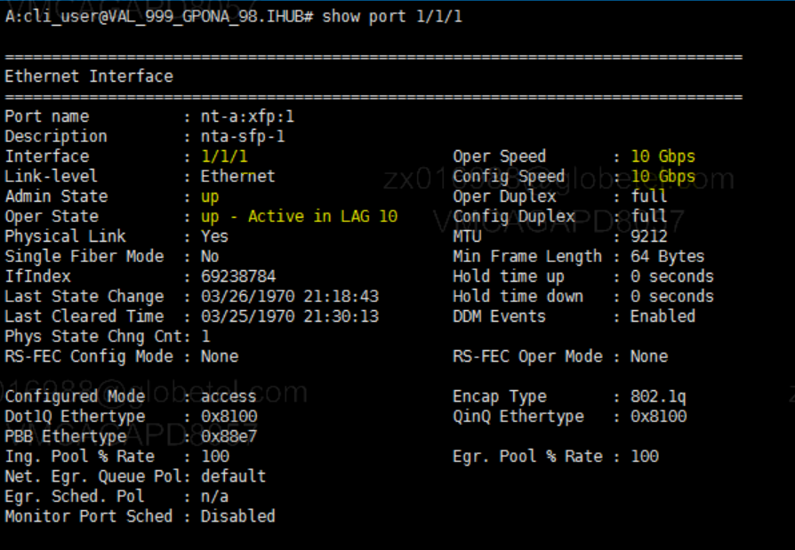

  - DSOC and Implementer on site to verify the trunk/lag status
@ {{AN_SITE}}
#display interface {{AN_TRUNK_ID}} {{AN_TRUNK_ID}} and port {{AN_UPLINK_PORT}} be Up
#display interface GigabitEthernet {{AN_UPLINK_PORT}} Physical member port should be Up

@{{OLT_SITE}}
#show lag 10 detail should be Adm Up Opr Up and port {{OLT_UPLINK_PORT}} is binded
Login to {{OLT_PRODUCT}}, username: root password: <*****>
Then login to IHUB
#ssh -oHostKeyAlgorithms=+ssh-rsa cli_user@169.254.1.251 -o "StrictHostKeyChecking no"
Password: <****cli!>

#show LAG {{OLT_LAG_ID}} detail

Sample Screenshot:

  - PD must successfully conduct test call and test data browsing at {{OLT_SITE}} (NEWLY INSERTED OLT)

Test Scenario | Expected Result
Test call  Test browse | Voice test -> Successful, there should be ring back tone, answered with no muting, no drop call, no robotic/echo, no communication cut off (established call for at least 10 seconds or more)  Data Validation ->Browsing should be normal  Browsing (yahoo, google, facebook, speedtest.net)  Video streaming (youtube)  Ping test and traceroute (as baseline) to yahoo & google  ping www.google.com –t  ping www.yahoo.com –t  ping www.facebook.com –t  ping www.spotify.com.ph -t  Ping test to DNS – 202.126.40.5  Capture the result of upload and download of speedtest.net, on top of data browsing.  As baseline.

  - DSOC Wireline to check alarm at NMS/Altiplano, there should be no major/critical alarm after insertion. All NEs must be manageable and UP. Refer to below network topology.

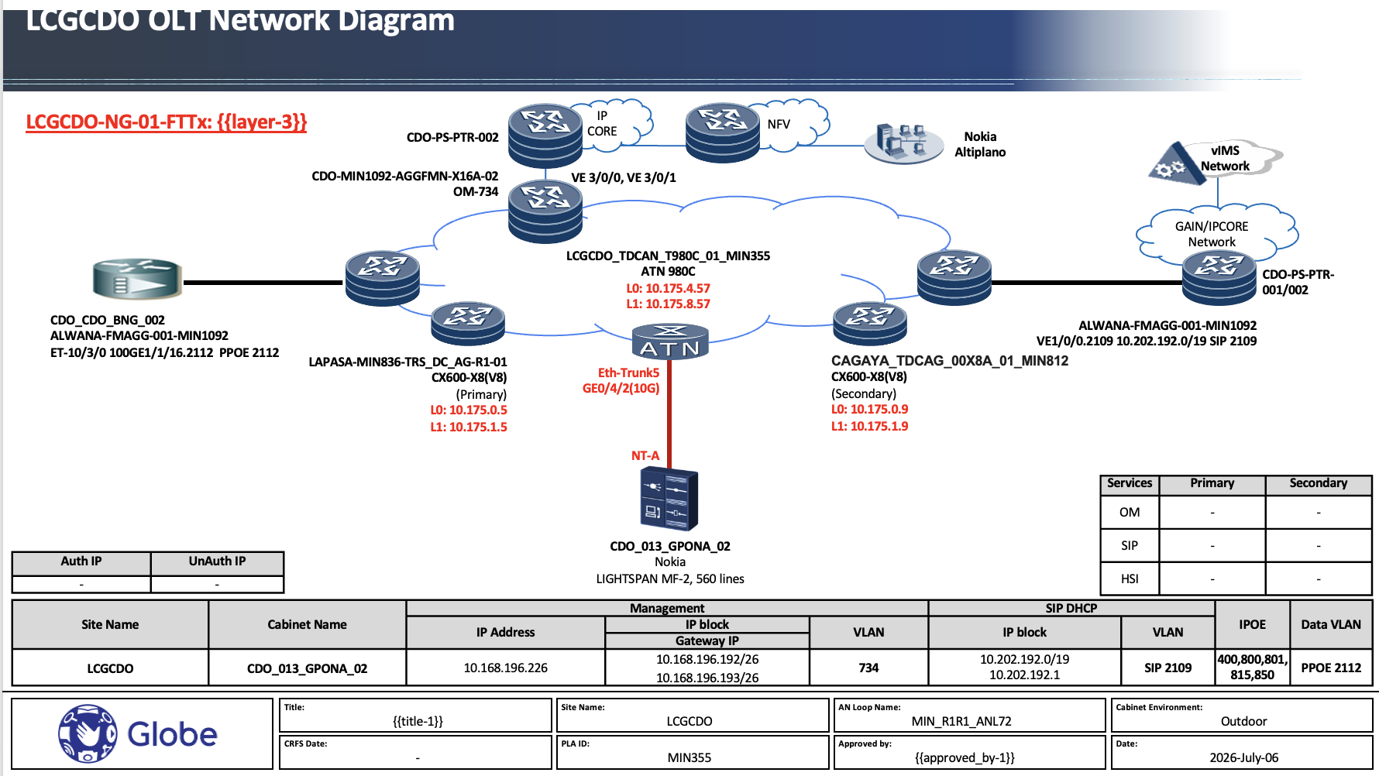

  - PD/IMPLEMENTER ON SITE to ensure that version of the OLT is below:
#show hardware-state component Chassis software software SW active must be {{OLT_SW_VERSION}}

Sample screenshot {{OLT_SW_VERSION_SHORT}} Software Version:

  - IMPLEMENTER ON SITE to send logs (notepad) to PD, DSOC and SICE
Note:PD/IMPLEMENTER ON SITE and DSOC to validate hardware, software + patch and VLANs are all correct according to planned.
#show hardware-state component Chassis software software
#show hardware-state component state
#show alarm

  - DSOC to check the status of the VLANs ({{OLT_OM_VLAN}}, {{VLAN_HSI}}, {{VLAN_SIP}}, {{VLAN_IPOE1}}, {{VLAN_IPOE2}}) on {{CX600_NODE}} facing Access and on {{AN_SITE}}
 |  | ATN |  | Facing BNG/NMS/Voice Server
AG Node | VSI name | Peer IP | VC ID | Peer IP
{{AG1_NODE}} | OM-90000{{OLT_OM_VLAN}} | {{AG1_IP}} | {{VCID_OM_PRIMARY}} | {{BNG_PEER_OM}}
{{AG1_NODE}} | SIP-9000{{VLAN_SIP}} | {{AG1_IP}} | {{VCID_SIP_PRIMARY}} | {{BNG_PEER_SIP}}
{{AG1_NODE}} | HSI-9000{{VLAN_HSI}} | {{AG1_IP}} | {{VCID_HSI_PRIMARY}} | {{BNG_PEER_SIP}}
{{AG1_NODE}} | IPOE-19{{VLAN_IPOE1}}368 | {{AG1_IP}} | {{VCID_IPOE1_PRIMARY}} | {{BNG_PEER_IPOE1}}
{{AG1_NODE}} | IPOE-29{{VLAN_IPOE2}}368 | {{AG1_IP}} | {{VCID_IPOE2_PRIMARY}} | {{BNG_PEER_IPOE2}}
{{AG2_NODE}} | OM-90000{{OLT_OM_VLAN}} | {{AG2_IP}} | {{VCID_OM_PRIMARY}} | {{BNG_PEER_OM}}
{{AG2_NODE}} | SIP-9000{{VLAN_SIP}} | {{AG2_IP}} | {{VCID_SIP_PRIMARY}} | {{BNG_PEER_SIP}}
{{AG2_NODE}} | HSI-9000{{VLAN_HSI}} | {{AG2_IP}} | {{VCID_HSI_PRIMARY}} | {{BNG_PEER_SIP}}
{{AG2_NODE}} | IPOE-19{{VLAN_IPOE1}}368 | {{AG2_IP}} | {{VCID_IPOE1_PRIMARY}} | {{BNG_PEER_IPOE1}}
{{AG2_NODE}} | IPOE-29{{VLAN_IPOE2}}368 | {{AG2_IP}} | {{VCID_IPOE2_PRIMARY}} | {{BNG_PEER_IPOE2}}

Note: Please execute below commands on indicated CX600 and per VSI
CX600# display vsi name <vsi name> peer-info 🡪 Peer IPs should be complete, VC ID should be correct

AN | Role | Access Circuit | Peer IP | VC ID
{{AN_SITE}}  {{AN_TRUNK_ID}} | Primary |  | {{AG1_IP}}
{{AN_SITE}}  {{AN_TRUNK_ID}} | Primary | {{AN_TRUNK_ID}}.{{OLT_OM_VLAN}} | {{AG1_IP}} | {{VCID_OM_PRIMARY}}
{{AN_SITE}}  {{AN_TRUNK_ID}} | Primary | {{AN_TRUNK_ID}}.{{VLAN_SIP}} | {{AG1_IP}} | {{VCID_SIP_PRIMARY}}
{{AN_SITE}}  {{AN_TRUNK_ID}} | Primary | {{AN_TRUNK_ID}}.{{VLAN_HSI}} | {{AG1_IP}} | {{VCID_HSI_PRIMARY}}
{{AN_SITE}}  {{AN_TRUNK_ID}} | Primary | {{AN_TRUNK_ID}}.{{VLAN_IPOE1}} | {{AG1_IP}} | {{VCID_IPOE1_PRIMARY}}
{{AN_SITE}}  {{AN_TRUNK_ID}} | Secondary | {{AN_TRUNK_ID}}.{{VLAN_IPOE2}} | {{AG2_IP}} | {{VCID_IPOE2_PRIMARY}}
{{AN_SITE}}  {{AN_TRUNK_ID}} | Secondary | {{AN_TRUNK_ID}}.{{OLT_OM_VLAN}} | {{AG2_IP}} | {{VCID_OM_SECONDARY}}
{{AN_SITE}}  {{AN_TRUNK_ID}} | Secondary | {{AN_TRUNK_ID}}.{{VLAN_SIP}} | {{AG2_IP}} | {{VCID_SIP_SECONDARY}}
{{AN_SITE}}  {{AN_TRUNK_ID}} | Secondary | {{AN_TRUNK_ID}}.{{VLAN_HSI}} | {{AG2_IP}} | {{VCID_HSI_SECONDARY}}
{{AN_SITE}}  {{AN_TRUNK_ID}} | Secondary | {{AN_TRUNK_ID}}.{{VLAN_IPOE1}} | {{AG2_IP}} | {{VCID_IPOE1_SECONDARY}}

Note: Please execute below commands on indicated AN
FOR WIRELINE AN
# disp mpls l2vpn vpws Access Circuit and Virtual Circuit should be aligned and Up on both Primary and Secondary Role (if homed to 2 AGs)

FOR IPRAN AN
# disp mpls l2vc remote-info VCID and IP should be aligned

  - DSOC to validate that VLANs ({{OLT_OM_VLAN}}, {{VLAN_SIP}}, {{VLAN_HSI}}, 800, 801, 815, 850) of the newly integrated OLT are defined and enabled in the ring

@{{AN_SITE}}: (not applicable for VLL)
display vlan brief vlans should be define on uplink ports

@{{CX600_NODE}}
display interface brief | i x/y/z replace x/y/z with actual ports
  - DSOC and NOKIA to validate that subscriber ports of OLT are tagged with HSI {{VLAN_HSI}}, IPOE 800, 801, 815, 850, SIP {{VLAN_SIP}}.
  - DSOC and Nokia to validate that OM IP address of OLT and its subnet is based on EWP and static route for OM is correct and in place

OM Vlan | Interface vlan | OLT OM IP | OM GW IP
{{OLT_OM_VLAN}} | Vlanif{{OLT_OM_VLAN}} | {{OLT_MGMT_IP}} | {{OLT_OM_GW}}/26
# show routing control-plane-protocols control-plane-protocol static inband
🡪default route’s next hop should be the OM GW IP
  - PD/IMPLEMENTER ON SITE and DSOC Wireline to send all the logs showing the implementation (command level, system results for post logs template) on the same activity email trail endorsement from SICE.

13. IMPLEMENTER ON SITE to send screenshot of IPV6 Secure forwarding of the OLT integrated (note: IPV6-secure forwarding is global push in Altiplano prior to the implementation of the new OLTs integrated)

Sample Screenshots:
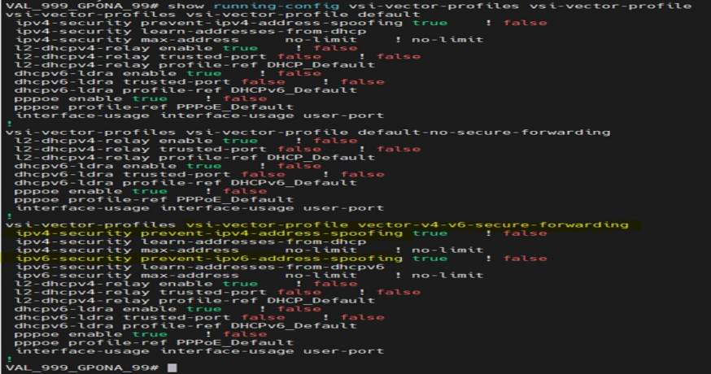

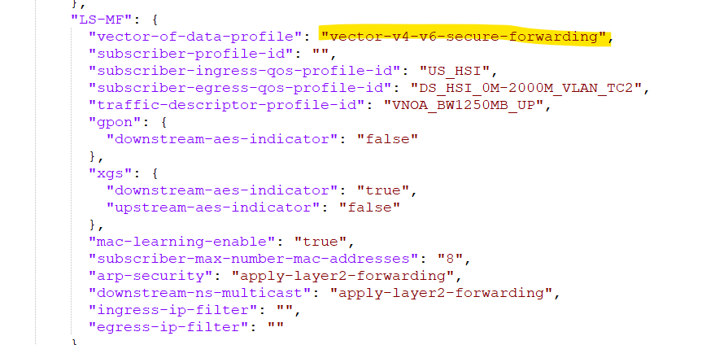

14. Confirmation of Configuration file is loaded on OLT LT.
- ssh root@10.189.232.35 -p 923
- ssh root@169.254.1.3 -p 2222
- ls -lrt /isam/slot_default/onu_engine/run

Sample result:
lrwxrwxrwx 1 root root 42 Aug 20 03:48 def -> /mnt/persistent/app-overlay/onu_engine/def

Note: Activity screenshot to be sent by implementer to be reviewed by DSOC WLN to check completeness and accuracy of data before implementer onsite leaves the premises.

- REVERT BACK PROCEDURES
- SSC WLN in coordination with PD/IMPLEMENTER ON SITE to specify which are items are implemented, partial, reverted.
- SSC WLN/PD/IMPLEMENTER ON SITE on site will:
OPTION 1 LOGICAL- Shutdown in ATN (if subtended)
OPTION 2 PHYSICAL Patching - remove inserted fiber patch cord from MF-2 to fiber tray.

- POST REVERT BACK SUCCESS CRITERIA
  - Alarms incurred by the activity should be cleared
  - OLT for integration should be isolated from the network.
  - Collect all the logs showing the implementation (command level and system results)
  - Proponent to issue IR of the activity prior re-attempt/re-endorsement of activity.

Note: Escalate to /coordinate with the SICE in-Charge when criteria for revert has been met to check if additional tests should be performed based on the reason for revert.

- CONTINGENCY (If Revert Procedure PDls)
- Service Recovery Procedures
- Business Continuity Management

- MOP REVISION DETAILS (to be filled in by SICEI reviewing engr)
_{REVISION 1 : (indicate reason)}
Lack of Mandatory Information Configuration not aligned with standard/LLD

Confusing instruction in the procedure Missing Configuration

Missing step in procedure Wrong Configuration

Typing Error Incorrect Data

REVISION 2 : (indicate reason based on same list above)
REVISION 3 : (indicate reason based on same list above)

Guide on Concurrence:
Minor – up to Section Head
Major – up to Department Head
Critical –up to Division

