TECHNICAL SITE SURVEY REPORT
FTTH HORIZONTAL

PROJECT | FTTH HORIZANTAL
SCOPE | NEW BUILD
SOLUTION | MF2 – 1 CARD
SITE NAME | {{ site_name }}
PLAID | {{ site_id }}
TERRITORY | T7
REGION | MINDANAO
SITE ADDRESS | {{ site_address }}
TOWERCO | {{ tco_name }}
Contents
1 Revision/Approvals / Remarks 3
2 Site Information 4
2.1 Site Vicinity Map 5
3 Proposed Space for Nokia OLT 6
4 Proposed tapping for Nokia OLT 7
5 Transport 9
6 Equipment lay out 10
7 Materials / Inventory 11
8 Technical Specifications 12
9 Change history 13

Revision/Approvals / Remarks
SITE NAME | {{ site_name }} | PLAID | {{ site_id }}
REGION | {{ region }}
SITE ADDRESS | {{ site_address }}
APPROVALS
BAPE | ☐ SOLUTION APPROVED |  | ☐ FULLY APPROVED | ☐ DISAPPROVED
REMARKS
RRE | ☐ SOLUTION APPROVED |  | ☐ FULLY APPROVED | ☐ DISAPPROVED
REMARKS
RFE ( POWER AND SPACE) | ☐ SOLUTION APPROVED |  | ☐ FULLY APPROVED | ☐ DISAPPROVED
REMARKS
RFE - STRUCTURAL | ☐ SOLUTION APPROVED |  | ☐ FULLY APPROVED | ☐ DISAPPROVED
REMARKS
Name of Vendor/Reviewer
CONTRACTOR |  |  | Date
NAME & MOBILE |  |  | Signature
NOKIA REVIEWER |  |  | Date
MOBILE # |  |  | Signature

Site Information
A.1 | SITE INFORMATION
A1. 1 | Site Location Details
Site Address | {{ site_address }}
Site Coordinates | {{ site_coords }}
Site owner | {{ owner_globe }}Globe {{ owner_private }}Private {{ owner_govt }}Government {{ owner_tco }}TCO ________
Site Contact person | {{ site_contact_person }} | Mobile # | {{ site_contact_mobile }}
Lessor Details | {{ lessor_details }} | Mobile # | {{ lessor_mobile }}
TCO Name | {{ tco_name }} | Site Class | {{ site_class }}
Site Type | {{ site_type_greenfield }}Greenfield/ Outdoor {{ site_type_street }}Street Cabinet {{ site_type_indoor }}Indoor {{ site_type_others }}Others ______
Room Access | {{ room_access }} | Cabin Location | {{ cabin_location }}
Flood History | {{ flood_history }} | Hauling Remarks | {{ hauling_remarks }}
Site profile | {{ site_profile }}
Site key Location |  | Site Security | ☐E-LOCK ______________
Security | {{ sec_caretaker }}Caretaker {{ sec_manned }}Manned {{ sec_roving }}Roving Security {{ sec_others }}Others
FO Name | {{ fo_name }} | Mobile # | {{ fo_mobile }}
Work permit | {{ workpermit_raawa }}RAAWA {{ workpermit_others }}others:
Site Access Requirement | {{access_requirement}}
Accessible to Vehicle |  | Not accessible to Vehicle
No. of Bridge: | {{ no_bridge }} | Foot Trail | {{ foot_trail }}
Bridge (ton) | {{ bridge_ton }} | Foot Bridge | {{ foot_bridge }}
Distance (m) | {{ distance_m }}
By Boat | {{ by_boat }}

{{ site_remarks }}

Site Vicinity Map
Vicinity Map
{{ img_vicinity_map }}
Site Photo
{{ img_site_photo_1 }} | {{ img_site_photo_2 }}
{{ img_site_photo_3 }} | {{ img_site_photo_4 }}

Proposed Space for Nokia OLT
- Reference Photos from Ericsson TSSR
Existing and proposed location for Nokia OLT
{{ img_olt_existing }} | {{ img_olt_proposed }}
Remarks: based on Ericsson TSSR, new 6150 will be installed. Nokia Olt will utilize the existing space
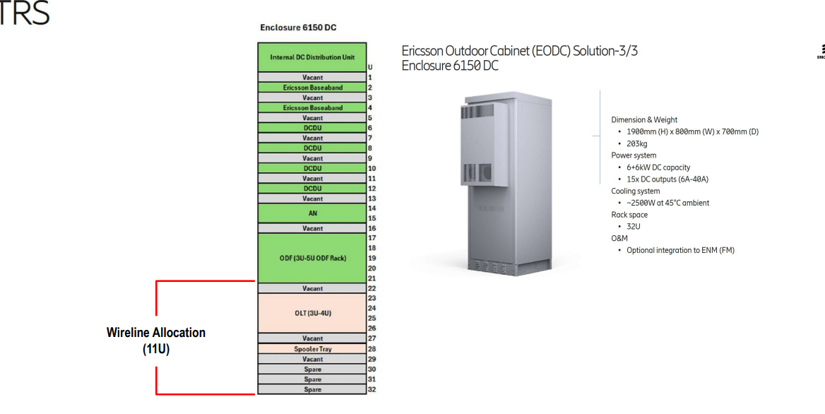

Proposed tapping for Nokia OLT
{{RS1_load_sched_img}}
{{RS1_load_calc_img }}
{{RS2_load_sched_img }}
{{RS2_load_calc_img }}

PROPOSED TAPPING POINT
RS1  {{RS1_tapping_img}} | RS2  {{RS2_tapping_img}}

Transport
Existing | proposed
{{transport_existing_1}}

{{transport_existing_2}}

{{transport_existing_3}}

Equipment layout
Room lay out
{{equipment_room_layout_img}}
Cable routing and layout
{{equipment_cable_routing_img}}

Materials / Inventory
Materials needed | unit | Proposed length / pcs
Proposed length of grounding (OLT MF-2 to Existing ground ) #8 | {{ mat_grounding_unit }} | {{ mat_grounding_qty }}
Proposed length of patchcord (OLT to Transport) | {{ mat_patchcord_unit }} | {{ mat_patchcord_qty }}
Proposed length of Power Cable #14/2c (Blue/Black) | {{ mat_powercable_unit }} | {{ mat_powercable_qty }}
Terminal lugs (#12 AWG) | {{ mat_lugs_unit }} | {{ mat_lugs_qty }}
Shrinkable tube | {{ mat_tube_unit }} | {{ mat_tube_qty }}
Tie wrap x 8 inches | {{ mat_tiewrap_unit }} | {{ mat_tiewrap_qty }}
Terminal Log #14-8 | {{ mat_termlog_unit }} | {{ mat_termlog_qty }}
Liquid-tight Flexible Steel Conduit | {{ mat_conduit_unit }} | {{ mat_conduit_qty }}
DC breaker | {{ mat_dcbreaker_unit }} | {{ mat_dcbreaker_qty }}

Technical Specifications

Change history
2. Change history
Ver | Status | Date | Author | Owner | Reviewed by | Reviewed date | Approver | Approval date | Description of changes
0.1 | Draft | YYYY.MM.DD | Name | Name | Name | YYYY.MM.DD | Name | YYYY.MM.DD | Comments
0.2 | Draft | YYYY.MM.DD | Name | Name | Name | YYYY.MM.DD | Name | YYYY.MM.DD | Comments
1.0 | Draft | YYYY.MM.DD | Name | Name | Name | YYYY.MM.DD | Name | YYYY.MM.DD | Comments

