| **group** | **video_set** | **surprise** | **anger** | **disgust** | **sadness** | **fear** | **happiness** |
| --- | --- | --- | --- | --- | --- | --- | --- |
| control | ADFES | 0.99 | 0.81 | 0.80 | 0.72 | 0.64 | 0.70 |
| JeFEE | 0.60 | 0.61 | 0.39 | 0.38 | 0.59 | 0.39 |
| moebius | ADFES | 0.95 | 0.81 | 0.67 | 0.81 | 0.66 | 0.75 |
| JeFEE | 0.63 | 0.47 | 0.53 | 0.38 | 0.46 | 0.40 |
|  | ADFES | 1.00 | 0.62 | 0.38 | 0.88 | 0.50 | 0.75 |
| JeFEE | 0.50 | 0.25 | 0.75 | 0.25 | 0.25 | 0.25 |

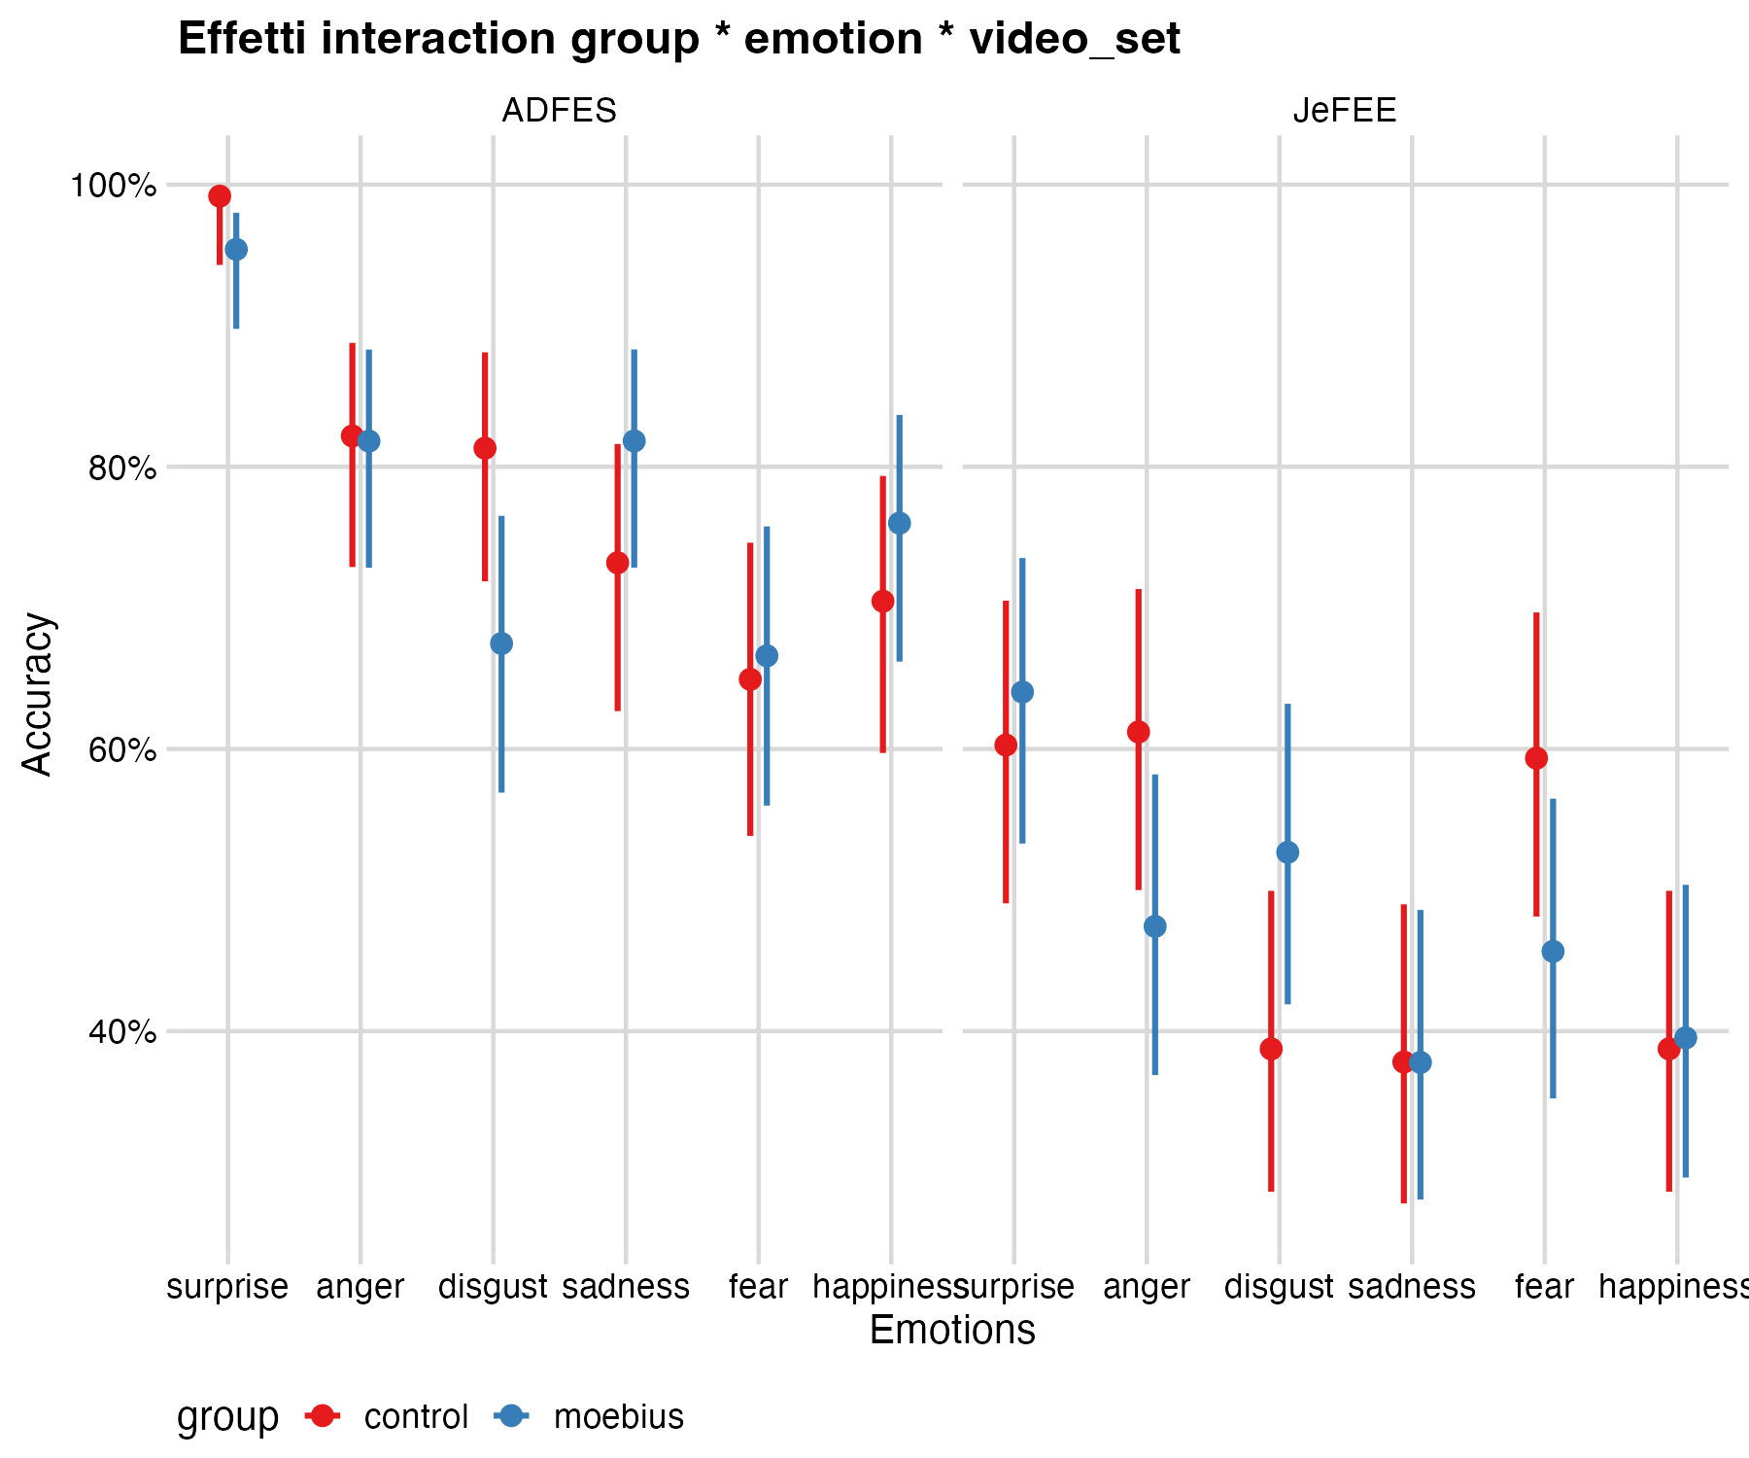

Full vars

| **Effect** | **Chisq** | **Df** | **Pr(>Chisq)** |
| --- | --- | --- | --- |
| (Intercept) | 22.29 | 1.00 | 0.00 |
| emotion | 25.94 | 5.00 | 0.00 |
| group | 2.55 | 1.00 | 0.11 |
| video_set | 18.15 | 1.00 | 0.00 |
| emotion:group | 11.67 | 5.00 | 0.04 |
| emotion:video_set | 27.98 | 5.00 | 0.00 |
| group:video_set | 2.92 | 1.00 | 0.09 |
| emotion:group:video_set | 18.54 | 5.00 | 0.00 |

| **effect** | **video_set** | **emotion** | **contrast** | **estimate** | **SE** | **df** | **z.ratio** | **p.value** |
| --- | --- | --- | --- | --- | --- | --- | --- | --- |
| emotion | all |  | surprise - anger | 1.36 | 0.30 | Inf | 4.50 | 0.00 |
| emotion | all |  | surprise - disgust | 1.75 | 0.30 | Inf | 5.81 | 0.00 |
| emotion | all |  | surprise - sadness | 1.83 | 0.30 | Inf | 6.08 | 0.00 |
| emotion | all |  | surprise - fear | 1.83 | 0.30 | Inf | 6.13 | 0.00 |
| emotion | all |  | surprise - happiness | 1.92 | 0.30 | Inf | 6.41 | 0.00 |
| emotion | all |  | anger - disgust | 0.38 | 0.15 | Inf | 2.55 | 0.11 |
| emotion | all |  | anger - sadness | 0.47 | 0.15 | Inf | 3.08 | 0.02 |
| emotion | all |  | anger - fear | 0.47 | 0.15 | Inf | 3.20 | 0.02 |
| emotion | all |  | anger - happiness | 0.56 | 0.15 | Inf | 3.76 | 0.00 |
| emotion | all |  | disgust - sadness | 0.08 | 0.15 | Inf | 0.57 | 0.99 |
| emotion | all |  | disgust - fear | 0.08 | 0.14 | Inf | 0.59 | 0.99 |
| emotion | all |  | disgust - happiness | 0.18 | 0.15 | Inf | 1.22 | 0.83 |
| emotion | all |  | sadness - fear | 0.00 | 0.14 | Inf | 0.00 | 1.00 |
| emotion | all |  | sadness - happiness | 0.09 | 0.15 | Inf | 0.64 | 0.99 |
| emotion | all |  | fear - happiness | 0.09 | 0.14 | Inf | 0.66 | 0.99 |
| video_set |  | all | ADFES - JeFEE | 1.63 | 0.12 | Inf | 13.36 | 0.00 |
| emotion|video_set |  | surprise | ADFES - JeFEE | 3.42 | 0.56 | Inf | 6.06 | 0.00 |
| emotion|video_set |  | anger | ADFES - JeFEE | 1.34 | 0.22 | Inf | 6.14 | 0.00 |
| emotion|video_set |  | disgust | ADFES - JeFEE | 1.28 | 0.21 | Inf | 6.14 | 0.00 |
| emotion|video_set |  | sadness | ADFES - JeFEE | 1.75 | 0.21 | Inf | 8.28 | 0.00 |
| emotion|video_set |  | fear | ADFES - JeFEE | 0.55 | 0.20 | Inf | 2.81 | 0.00 |
| emotion|video_set |  | happiness | ADFES - JeFEE | 1.45 | 0.20 | Inf | 7.12 | 0.00 |
| group|emotion|video_set | ADFES | surprise | control - moebius | 1.77 | 1.11 | Inf | 1.60 | 0.11 |
| group|emotion|video_set | ADFES | anger | control - moebius | 0.02 | 0.38 | Inf | 0.06 | 0.95 |
| group|emotion|video_set | ADFES | disgust | control - moebius | 0.74 | 0.36 | Inf | 2.08 | 0.04 |
| group|emotion|video_set | ADFES | sadness | control - moebius | -0.50 | 0.36 | Inf | -1.38 | 0.17 |
| group|emotion|video_set | ADFES | fear | control - moebius | -0.07 | 0.33 | Inf | -0.22 | 0.82 |
| group|emotion|video_set | ADFES | happiness | control - moebius | -0.28 | 0.35 | Inf | -0.82 | 0.41 |
| group|emotion|video_set | JeFEE | surprise | control - moebius | -0.16 | 0.33 | Inf | -0.49 | 0.62 |
| group|emotion|video_set | JeFEE | anger | control - moebius | 0.56 | 0.32 | Inf | 1.74 | 0.08 |
| group|emotion|video_set | JeFEE | disgust | control - moebius | -0.57 | 0.32 | Inf | -1.75 | 0.08 |
| group|emotion|video_set | JeFEE | sadness | control - moebius | 0.00 | 0.33 | Inf | 0.00 | 1.00 |
| group|emotion|video_set | JeFEE | fear | control - moebius | 0.55 | 0.32 | Inf | 1.72 | 0.09 |
| group|emotion|video_set | JeFEE | happiness | control - moebius | -0.03 | 0.32 | Inf | -0.10 | 0.92 |

JeFEE sub_dataset

| **Effect** | **Chisq** | **Df** | **Pr(>Chisq)** |
| --- | --- | --- | --- |
| (Intercept) | 3.43 | 1.00 | 0.06 |
| emotion | 29.70 | 5.00 | 0.00 |
| group | 0.25 | 1.00 | 0.62 |
| emotion:group | 12.46 | 5.00 | 0.03 |

| **effect** | **video_set** | **emotion** | **contrast** | **estimate** | **SE** | **df** | **z.ratio** | **p.value** |
| --- | --- | --- | --- | --- | --- | --- | --- | --- |
| emotion | JeFEE |  | surprise - anger | 0.32 | 0.19 | Inf | 1.64 | 0.57 |
| emotion | JeFEE |  | surprise - disgust | 0.66 | 0.19 | Inf | 3.43 | 0.01 |
| emotion | JeFEE |  | surprise - sadness | 0.98 | 0.19 | Inf | 5.04 | 0.00 |
| emotion | JeFEE |  | surprise - fear | 0.39 | 0.19 | Inf | 2.02 | 0.33 |
| emotion | JeFEE |  | surprise - happiness | 0.93 | 0.19 | Inf | 4.77 | 0.00 |
| emotion | JeFEE |  | anger - disgust | 0.35 | 0.19 | Inf | 1.80 | 0.46 |
| emotion | JeFEE |  | anger - sadness | 0.66 | 0.19 | Inf | 3.44 | 0.01 |
| emotion | JeFEE |  | anger - fear | 0.07 | 0.19 | Inf | 0.38 | 1.00 |
| emotion | JeFEE |  | anger - happiness | 0.61 | 0.19 | Inf | 3.16 | 0.02 |
| emotion | JeFEE |  | disgust - sadness | 0.32 | 0.19 | Inf | 1.65 | 0.56 |
| emotion | JeFEE |  | disgust - fear | -0.27 | 0.19 | Inf | -1.42 | 0.71 |
| emotion | JeFEE |  | disgust - happiness | 0.26 | 0.19 | Inf | 1.37 | 0.75 |
| emotion | JeFEE |  | sadness - fear | -0.59 | 0.19 | Inf | -3.07 | 0.03 |
| emotion | JeFEE |  | sadness - happiness | -0.06 | 0.19 | Inf | -0.29 | 1.00 |
| emotion | JeFEE |  | fear - happiness | 0.54 | 0.19 | Inf | 2.79 | 0.06 |
| emotion|group | JeFEE | surprise | control - moebius | -0.16 | 0.31 | Inf | -0.50 | 0.62 |
| emotion|group | JeFEE | anger | control - moebius | 0.56 | 0.31 | Inf | 1.80 | 0.07 |
| emotion|group | JeFEE | disgust | control - moebius | -0.55 | 0.31 | Inf | -1.80 | 0.07 |
| emotion|group | JeFEE | sadness | control - moebius | 0.01 | 0.31 | Inf | 0.02 | 0.98 |
| emotion|group | JeFEE | fear | control - moebius | 0.55 | 0.31 | Inf | 1.78 | 0.07 |
| emotion|group | JeFEE | happiness | control - moebius | -0.03 | 0.31 | Inf | -0.09 | 0.93 |

ADFES sub_dataset

| Effect | Chisq | Df | Pr(>Chisq) |
| --- | --- | --- | --- |
| (Intercept) | 23.70 | 1.00 | 0.00 |
| emotion | 27.18 | 5.00 | 0.00 |
| group | 2.75 | 1.00 | 0.10 |
| emotion:group | 12.06 | 5.00 | 0.03 |

| **effect** | **video_set** | **emotion** | **contrast** | **estimate** | **SE** | **df** | **z.ratio** | **p.value** |
| --- | --- | --- | --- | --- | --- | --- | --- | --- |
| emotion | ADFES |  | surprise - anger | 0.32 | 0.19 | Inf | 1.64 | 0.57 |
| emotion | ADFES |  | surprise - disgust | 0.66 | 0.19 | Inf | 3.43 | 0.01 |
| emotion | ADFES |  | surprise - sadness | 0.98 | 0.19 | Inf | 5.04 | 0.00 |
| emotion | ADFES |  | surprise - fear | 0.39 | 0.19 | Inf | 2.02 | 0.33 |
| emotion | ADFES |  | surprise - happiness | 0.93 | 0.19 | Inf | 4.77 | 0.00 |
| emotion | ADFES |  | anger - disgust | 0.35 | 0.19 | Inf | 1.80 | 0.46 |
| emotion | ADFES |  | anger - sadness | 0.66 | 0.19 | Inf | 3.44 | 0.01 |
| emotion | ADFES |  | anger - fear | 0.07 | 0.19 | Inf | 0.38 | 1.00 |
| emotion | ADFES |  | anger - happiness | 0.61 | 0.19 | Inf | 3.16 | 0.02 |
| emotion | ADFES |  | disgust - sadness | 0.32 | 0.19 | Inf | 1.65 | 0.56 |
| emotion | ADFES |  | disgust - fear | -0.27 | 0.19 | Inf | -1.42 | 0.71 |
| emotion | ADFES |  | disgust - happiness | 0.26 | 0.19 | Inf | 1.37 | 0.75 |
| emotion | ADFES |  | sadness - fear | -0.59 | 0.19 | Inf | -3.07 | 0.03 |
| emotion | ADFES |  | sadness - happiness | -0.06 | 0.19 | Inf | -0.29 | 1.00 |
| emotion | ADFES |  | fear - happiness | 0.54 | 0.19 | Inf | 2.79 | 0.06 |
| emotion|group | ADFES | surprise | control - moebius | 1.83 | 1.10 | Inf | 1.66 | 0.10 |
| emotion|group | ADFES | anger | control - moebius | 0.07 | 0.42 | Inf | 0.18 | 0.86 |
| emotion|group | ADFES | disgust | control - moebius | 0.80 | 0.39 | Inf | 2.02 | 0.04 |
| emotion|group | ADFES | sadness | control - moebius | -0.47 | 0.40 | Inf | -1.18 | 0.24 |
| emotion|group | ADFES | fear | control - moebius | -0.05 | 0.37 | Inf | -0.14 | 0.89 |
| emotion|group | ADFES | happiness | control - moebius | -0.25 | 0.38 | Inf | -0.66 | 0.51 |