| **group** | **video_set** | **surprise** | **anger** | **disgust** | **sadness** | **fear** | **happiness** |
| --- | --- | --- | --- | --- | --- | --- | --- |
| control | ADFES | 178.89 | 148.62 | 169.87 | 160.89 | 165.10 | 168.03 |
| JeFEE | 139.70 | 148.76 | 147.32 | 139.82 | 136.75 | 155.13 |
| moebius | ADFES | 175.22 | 149.53 | 174.04 | 150.20 | 169.54 | 169.11 |
| JeFEE | 135.70 | 132.90 | 135.33 | 119.76 | 120.73 | 149.71 |

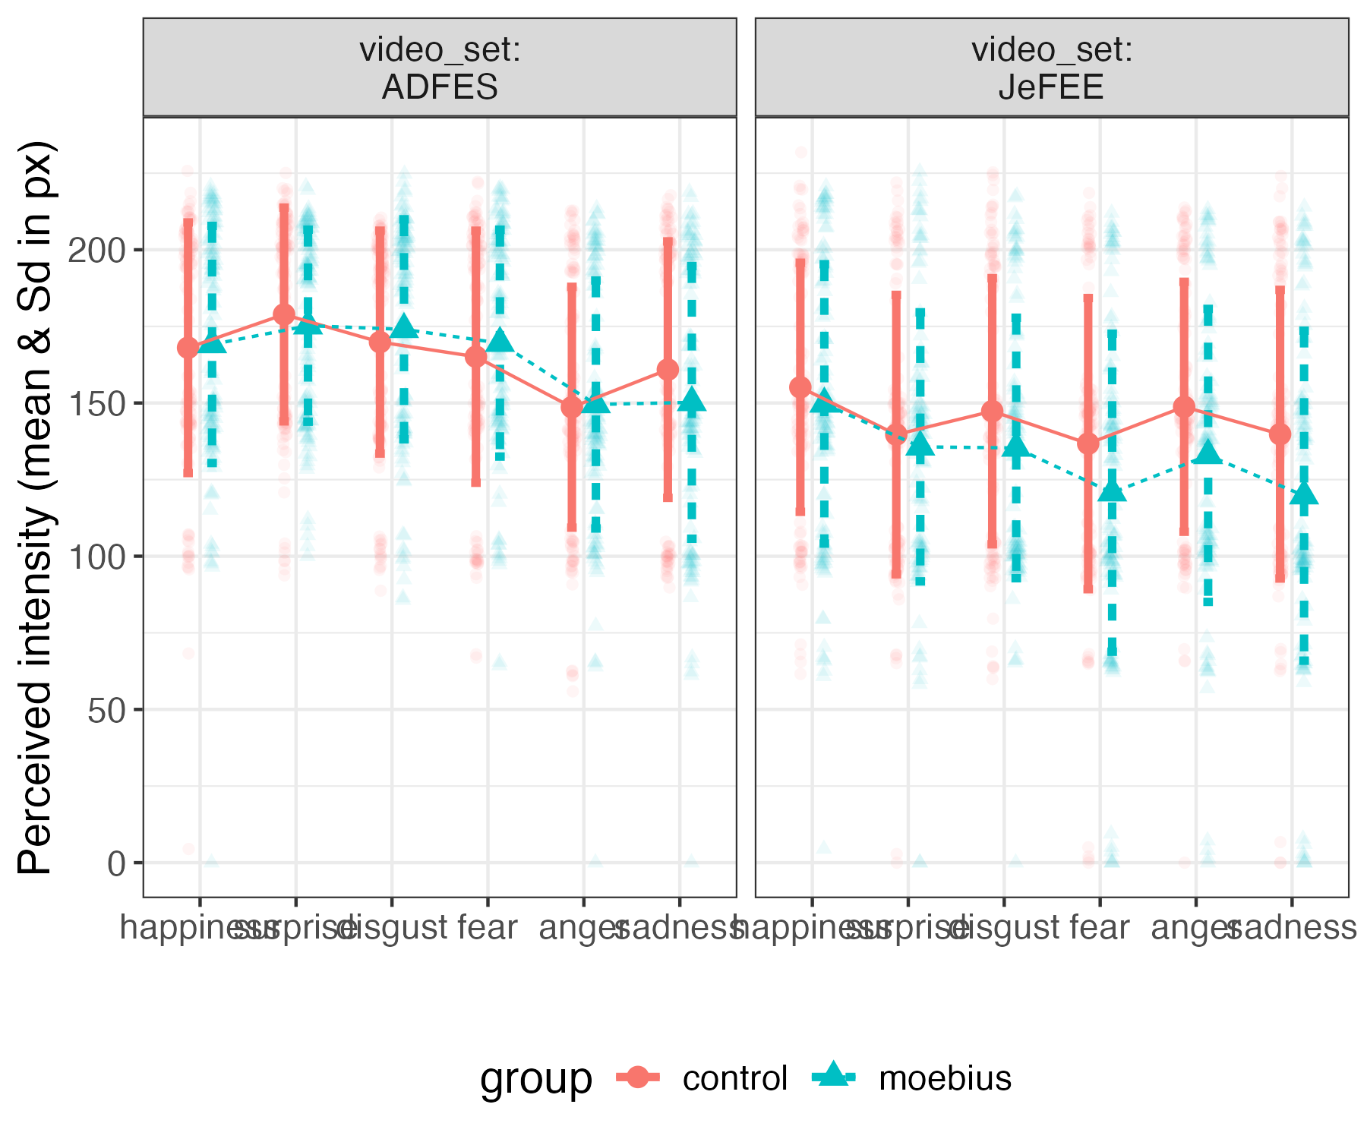

Full vars

| **Effect** | **Chisq** | **Df** | **Pr(>Chisq)** |
| --- | --- | --- | --- |
| (Intercept) | 698.44 | 1.00 | 0.00 |
| emotion | 41.81 | 5.00 | 0.00 |
| group | 0.03 | 1.00 | 0.86 |
| video_set | 60.23 | 1.00 | 0.00 |
| emotion:group | 6.16 | 5.00 | 0.29 |
| emotion:video_set | 23.97 | 5.00 | 0.00 |
| group:video_set | 0.27 | 1.00 | 0.60 |
| emotion:group:video_set | 4.42 | 5.00 | 0.49 |

| **effect** | **video_set** | **emotion** | **contrast** | **estimate** | **SE** | **df** | **t.ratio** | **p.value** |
| --- | --- | --- | --- | --- | --- | --- | --- | --- |
| emotion | all |  | surprise - anger | 12.27 | 2.48 | 1,757.52 | 4.94 | 0.00 |
| emotion | all |  | surprise - disgust | 1.35 | 2.56 | 1,757.23 | 0.53 | 1.00 |
| emotion | all |  | surprise - sadness | 9.66 | 2.65 | 1,757.55 | 3.65 | 0.00 |
| emotion | all |  | surprise - fear | 5.53 | 2.56 | 1,757.64 | 2.16 | 0.26 |
| emotion | all |  | surprise - happiness | -3.87 | 2.64 | 1,757.01 | -1.47 | 0.69 |
| emotion | all |  | anger - disgust | -10.92 | 2.67 | 1,757.63 | -4.10 | 0.00 |
| emotion | all |  | anger - sadness | -2.62 | 2.73 | 1,756.76 | -0.96 | 0.93 |
| emotion | all |  | anger - fear | -6.75 | 2.66 | 1,757.74 | -2.53 | 0.12 |
| emotion | all |  | anger - happiness | -16.14 | 2.74 | 1,757.46 | -5.89 | 0.00 |
| emotion | all |  | disgust - sadness | 8.31 | 2.82 | 1,757.29 | 2.95 | 0.04 |
| emotion | all |  | disgust - fear | 4.18 | 2.74 | 1,757.74 | 1.52 | 0.65 |
| emotion | all |  | disgust - happiness | -5.22 | 2.82 | 1,757.72 | -1.85 | 0.43 |
| emotion | all |  | sadness - fear | -4.13 | 2.81 | 1,757.07 | -1.47 | 0.68 |
| emotion | all |  | sadness - happiness | -13.53 | 2.89 | 1,757.42 | -4.68 | 0.00 |
| emotion | all |  | fear - happiness | -9.40 | 2.82 | 1,757.69 | -3.34 | 0.01 |
| video_set |  | all | ADFES - JeFEE | 25.94 | 1.56 | 1,756.93 | 16.63 | 0.00 |
| emotion|video_set |  | surprise | ADFES - JeFEE | 38.76 | 3.35 | 1,756.77 | 11.57 | 0.00 |
| emotion|video_set |  | anger | ADFES - JeFEE | 10.84 | 3.65 | 1,757.35 | 2.97 | 0.00 |
| emotion|video_set |  | disgust | ADFES - JeFEE | 26.28 | 3.87 | 1,756.94 | 6.79 | 0.00 |
| emotion|video_set |  | sadness | ADFES - JeFEE | 24.21 | 4.08 | 1,756.85 | 5.94 | 0.00 |
| emotion|video_set |  | fear | ADFES - JeFEE | 36.95 | 3.86 | 1,756.92 | 9.58 | 0.00 |
| emotion|video_set |  | happiness | ADFES - JeFEE | 18.60 | 4.08 | 1,757.08 | 4.56 | 0.00 |

JeFEE sub_dataset

| **Effect** | **Chisq** | **Df** | **Pr(>Chisq)** |
| --- | --- | --- | --- |
| (Intercept) | 305.06 | 1.00 | 0.00 |
| emotion | 6.88 | 5.00 | 0.23 |
| group | 0.25 | 1.00 | 0.62 |
| emotion:group | 6.63 | 5.00 | 0.25 |

ADFES sub_dataset

| Effect | Chisq | Df | Pr(>Chisq) |
| --- | --- | --- | --- |
| (Intercept) | 764.57 | 1.00 | 0.00 |
| emotion | 47.18 | 5.00 | 0.00 |
| group | 0.03 | 1.00 | 0.85 |
| emotion:group | 6.79 | 5.00 | 0.24 |

| **effect** | **video_set** | **emotion** | **contrast** | **estimate** | **SE** | **df** | **t.ratio** | **p.value** |
| --- | --- | --- | --- | --- | --- | --- | --- | --- |
| emotion | ADFES |  | surprise - anger | 26.46 | 2.95 | 1,073.82 | 8.96 | 0.00 |
| emotion | ADFES |  | surprise - disgust | 7.39 | 3.06 | 1,074.24 | 2.42 | 0.15 |
| emotion | ADFES |  | surprise - sadness | 17.15 | 2.99 | 1,073.54 | 5.74 | 0.00 |
| emotion | ADFES |  | surprise - fear | 7.45 | 3.15 | 1,074.40 | 2.36 | 0.17 |
| emotion | ADFES |  | surprise - happiness | 6.18 | 3.04 | 1,073.92 | 2.03 | 0.32 |
| emotion | ADFES |  | anger - disgust | -19.07 | 3.19 | 1,074.29 | -5.98 | 0.00 |
| emotion | ADFES |  | anger - sadness | -9.31 | 3.12 | 1,073.58 | -2.98 | 0.03 |
| emotion | ADFES |  | anger - fear | -19.01 | 3.29 | 1,074.64 | -5.79 | 0.00 |
| emotion | ADFES |  | anger - happiness | -20.28 | 3.19 | 1,074.62 | -6.37 | 0.00 |
| emotion | ADFES |  | disgust - sadness | 9.76 | 3.22 | 1,074.29 | 3.03 | 0.03 |
| emotion | ADFES |  | disgust - fear | 0.06 | 3.38 | 1,074.94 | 0.02 | 1.00 |
| emotion | ADFES |  | disgust - happiness | -1.21 | 3.28 | 1,075.22 | -0.37 | 1.00 |
| emotion | ADFES |  | sadness - fear | -9.70 | 3.32 | 1,074.65 | -2.92 | 0.04 |
| emotion | ADFES |  | sadness - happiness | -10.97 | 3.21 | 1,073.91 | -3.42 | 0.01 |
| emotion | ADFES |  | fear - happiness | -1.27 | 3.37 | 1,074.92 | -0.38 | 1.00 |