20200409 Homework

***1. Use the information in the table below to calculate the working capital of Home Depot in 2011 and 2012.***

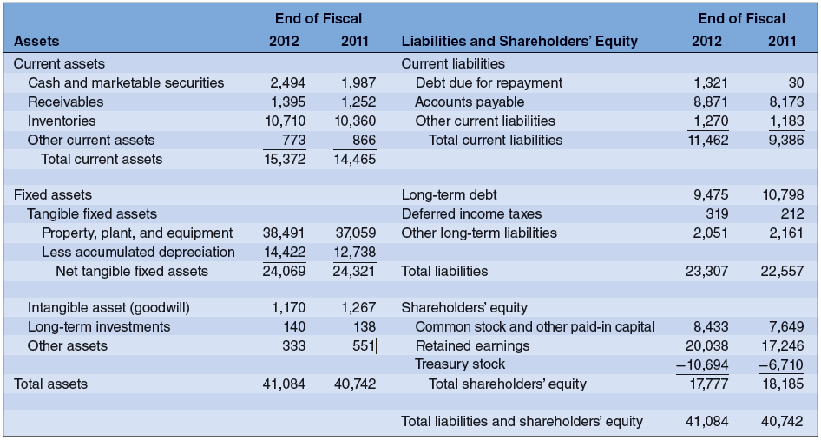

2. ***According to GAAP, your firm has equity worth $6billion, debt worth $4 billion, assets worth $10billion. The market values your firm’s 100 million shares at $75 per share and the debt at $4 billion.***

**Q: What is the market value of your assets?**

A: Assets = liabilities + equity

Your assets must have a market value of $11.5 billion

**3. What causes the difference between the market value and the book value of the enterprise? (Discuss at least three reasons**

# It **is** quite common to see the **book value** and **market value** differ significantly. The **difference is** attributed to several **factors**, including the company's operating model, its industrial sector, the nature of a company's assets and liabilities, and the company's specific attributes.

# Key Differences

# Most investors and traders use both values; there can be three different scenarios while comparing the book value and market value.

# Book Value Greater Than Market Value

# If a company is trading at a market value which is lower than its book value, it usually indicates that the market has momentarily lost confidence in the company. It may be due to problems with the business, loss of important business-related lawsuits, or chances of financial anomalies. In other words, the market doesn't believe that the company is worth the value on its books or that there are enough assets to generate future profits and [cash flows](https://www.investopedia.com/terms/c/cashflow.asp).

# [Value investors](https://www.investopedia.com/terms/v/valueinvesting.asp) often like to seek out companies in this category in hopes that the market perception turns out to be incorrect in the future. In this scenario, the market is giving investors an opportunity to buy a company for less than its stated net worth, meaning the stock price is lower than the company's book value. However, there is no guarantee that the price will rise in the future.

# Market Value Greater Than Book Value

# When the market value exceeds the book value, the stock market is assigning a higher value to the company due to the potential of it and its assets' [earnings power](https://www.investopedia.com/terms/e/earnings-power.asp). It indicates that investors believe the company has excellent future prospects for growth, expansion, and increased profits that will eventually raise the book value of the company. They may also believe the value of the company is higher than what the current book value calculation shows.

# Consistently, profitable companies typically have market values greater than book values, and most of the companies in the top indexes meet this criterion, as seen from the examples of Microsoft and Walmart mentioned above. Growth investors may find such companies promising. However, it may also indicate overvalued or overbought stocks trading at a high price.

# Book Value Equals Market Value

# When book value and market value are equal to each other, the market sees no compelling reason to believe the company's assets are better or worse than what is stated on the balance sheet.

# A popular ratio that is used to compare market and book values is the price-to-book (P/B) ratio, which is calculated as the price per share divided by the book value per share. For example, a company has a P/B of 1, meaning that the book value and market value are equal. The next day, the market price drops and the P/B ratio becomes less than 1, meaning the market value is less than the book value (undervalued). The following day the market price zooms higher and creates a P/B ratio greater than 1, meaning market value now exceeds book value (overvalued). Since prices change every second, it is possible to track and spot stocks that move from a P/B ratio of less than one to more than one and time the trades to maximize the profits.