CRISP-DM DATA SCIENCE REPORT
Predicting NBA MVP Vote Share
  - Regression, season-level ranking, and era-aware evaluation using player-season data from 1982–2022

Central finding: Regular-season player and team statistics provide useful predictive signal. The locked Histogram Gradient Boosting model achieved 0.0263 all-player RMSE, 0.8934 NDCG@5, and ranked the actual MVP first in three of four final-test seasons.

Final analytical report | September 2026

Executive summary
This project evaluated whether regular-season performance can predict the numerical MVP voting target, award_share, and rank leading candidates within each season. The analysis treated MVP prediction as both a regression problem and a season-level information-retrieval problem because most players receive no votes and the practical question concerns ordering the small group of serious candidates.
The final design used chronological development through 2018 and an untouched 2019–2022 test. Histogram Gradient Boosting was locked as the official model before the final test, with an Extra Trees hurdle model retained as the principal structural challenger. The champion passed all six prespecified success criteria.
Final-test measure | Histogram GB | Interpretation
All-player RMSE | 0.0263 | Best numerical error
Vote-recipient RMSE | 0.1553 | Best recipient error
R² | 0.8033 | Strong explained variation
NDCG@5 | 0.8934 | Strong top-candidate ordering
Actual MVP mean rank | 1.25 | Winner never below second
Top-1 accuracy | 75% | Three of four winners

Decision: Use Histogram GB for numerical vote-share forecasts and require the Extra Trees hurdle ranking as a calibration and disagreement check.

1. Business understanding

1.1 Research question
Can regular-season player statistics and team performance predict MVP vote share and correctly rank the leading MVP candidates within each season?

1.2 Analytical framing
- Regression: predict the continuous award_share target.
- Ranking: order candidates separately within each season.
- Chronological generalization: train on the past and evaluate on later seasons.
- Decision support: produce forecasts and candidate rankings, not causal judgments about who deserves the award.

1.3 Success criteria
The champion was required to outperform the Win Shares baseline on all-player RMSE, recipient RMSE, NDCG@5, and season-total calibration; achieve a mean winner rank no worse than third; and obtain at least 50% top-1 accuracy. All six criteria passed on the locked test.

2. Data understanding
The uploaded dataset contains 17,697 player-team-season rows, 55 columns, and 41 seasons from 1982 through 2022. The target is extremely zero-heavy: meaningful MVP support is concentrated among a small number of candidates each season. Repeated names are expected because players appear across seasons and traded players may have team-specific and combined TOT records.
Audit item | Observed result | Treatment
Temporal coverage | 1982–2022 | Preserve chronological order
Rows / columns | 17,697 / 55 | Retain raw source identity
TOT rows | 1,954 | Retain; mark is_tot
Repeated season-player rows | 44 | Investigate, do not auto-delete
One repeated season-player-team key | 1989 Charles Jones, WSB | Retain as audited exception
Target distribution | Large zero mass | Use weighted regression and ranking metrics

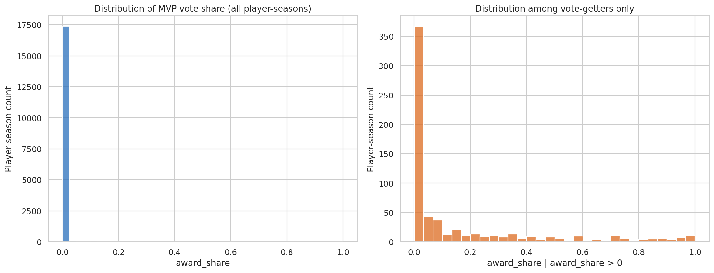
Figure 1. The MVP target is dominated by zero-share player-seasons, motivating candidate-sensitive metrics.

3. Data preparation
Preparation decisions were investigated before modification. The analysis retained repeated players, TOT records, and statistical outliers because these can represent legitimate player-season structure or historically exceptional performance.
Issue | Final decision | Rationale
Minimum minutes | mp ≥ 100 | Broad coverage; all recipients retained
Sensitivity threshold | mp ≥ 500 | Tests robustness to fringe players
TOT team context | Team variables set missing | Combined row has no single team context
Missing shooting percentages | Zero plus indicator | Represents no attempts without hiding structure
Remaining numerical missingness | Training median | Prevents future-information leakage
Outliers | Retain | Extreme excellence is central to MVP prediction
Position | Primary position; one-hot | Stable categorical representation

4. Era-aware feature engineering
Raw NBA statistics are not directly comparable across eras because pace, role specialization, shooting efficiency, schedule structure, and league strategy change. The final pipeline therefore combines raw measurements with within-season percentile ranks.
Season percentiles were generated for points, minutes, true shooting, PER, Win Shares, WS/48, BPM, VORP, and team winning percentage. The target was removed before these features were computed, preventing target leakage.
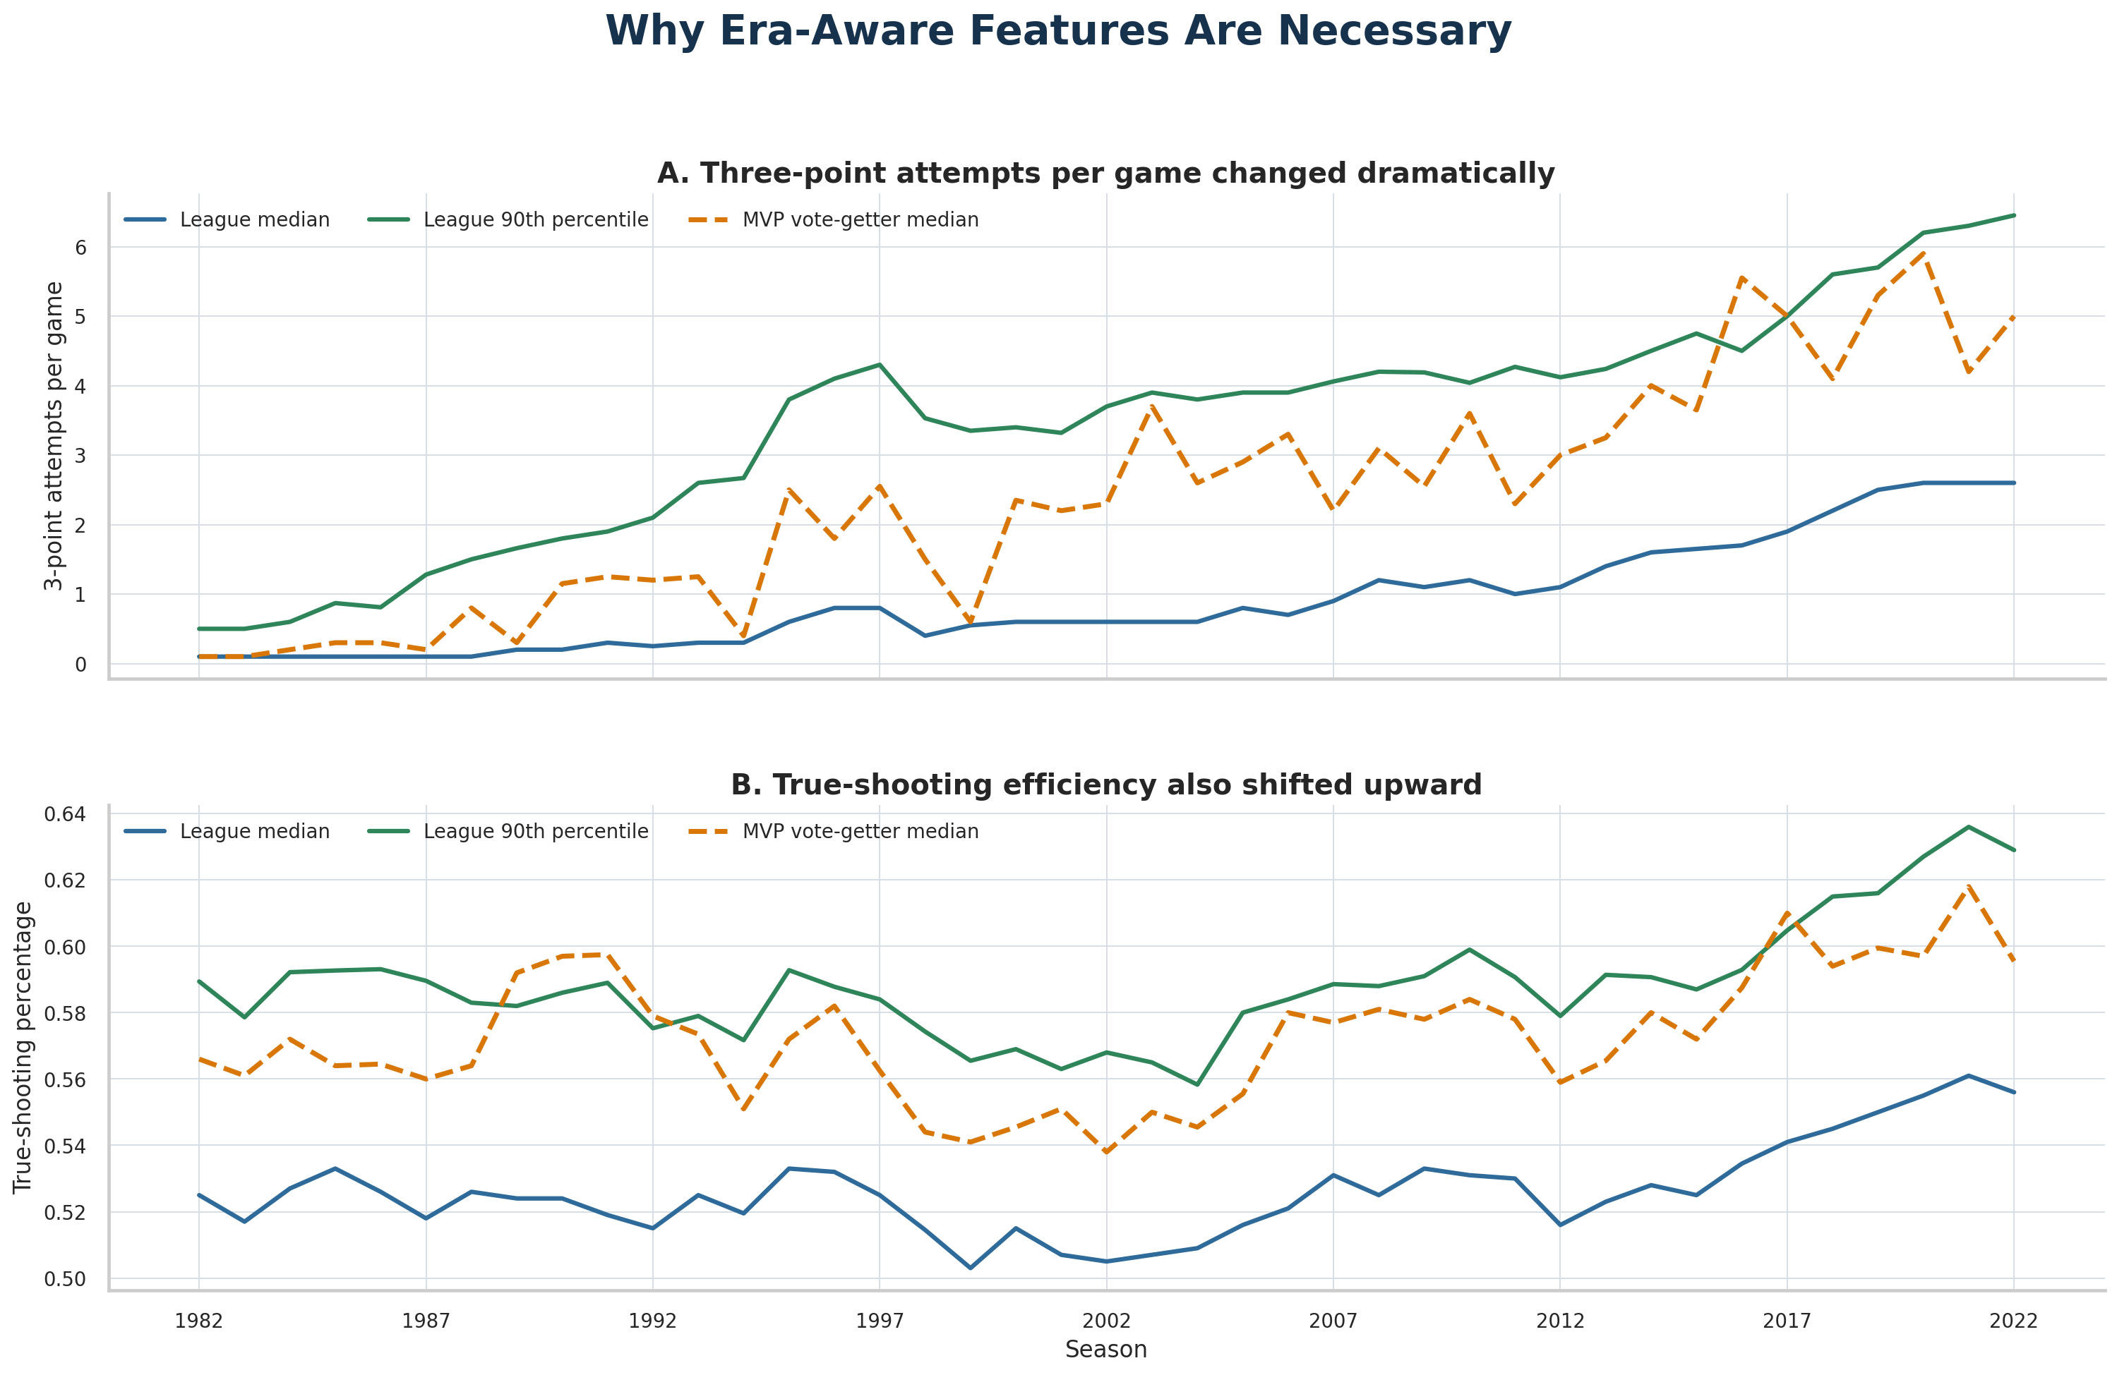
Figure 2. Selected league statistics change materially over time, supporting era-aware feature engineering.

5. Validation design and leakage control
All modeling decisions were made chronologically. Development used seasons through 2014, validation used 2015–2018, and final testing used 2019–2022. The locked final model was not altered after test outcomes were viewed.
- Player identity was excluded to prevent reputation memorization.
- Calendar season was excluded; era information entered through within-season comparisons.
- Imputation and categorical encoding were fitted on training data only.
- award_share was excluded from every predictor transformation.
- No model or hyperparameter was changed after the final test was opened.
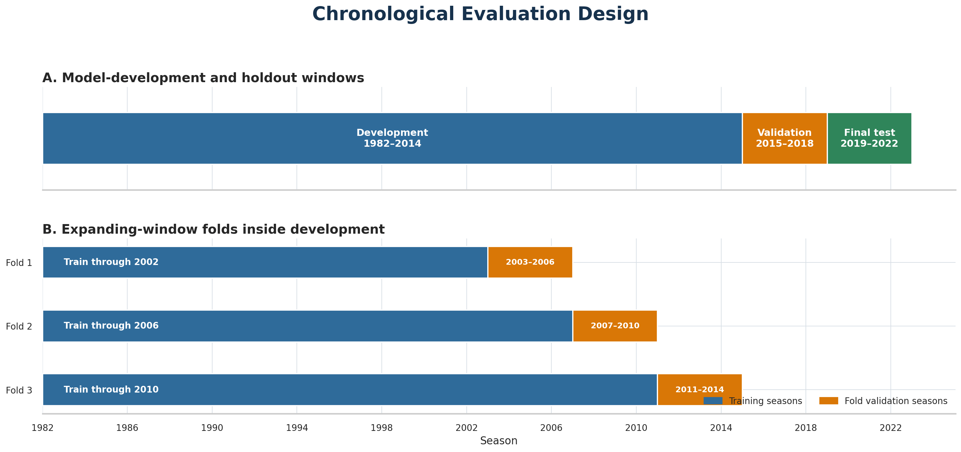
Figure 3. Chronological separation used for development, validation, and final testing.

6. Modeling
The candidate set progressed from trivial and domain baselines to regularized linear models, nonlinear ensembles, and explicit hurdle structures. Cluster assignments were evaluated but excluded from the final predictor because they did not provide stable incremental value.
Model | Role | Benefit | Main risk
Zero / historical mean | Trivial baselines | Sanity checks | No useful ranking
WS OLS | Domain baseline | Transparent | Weak numerical calibration
Weighted Ridge | Ranking comparator | Interpretable | Overallocates vote share
Histogram GB | Official model | Best RMSE and R² | High zero-boundary clipping
Extra Trees hurdle | Required challenger | Best NDCG and totals | More complex; lower numerical accuracy

The Histogram GB training weight was w = 1 + 5 × award_share. This preserves all zero-share players while giving progressively more influence to serious candidates. Predictions were bounded to [0,1].

7. Locked final-test results
Model | RMSE | Recipient RMSE | NDCG@5 | Winner rank | Top-1
Histogram GB | 0.0263 | 0.1553 | 0.8934 | 1.25 | 75%
Extra Trees hurdle | 0.0284 | 0.1688 | 0.9219 | 1.25 | 75%
Weighted Ridge | 0.0478 | 0.2108 | 0.8739 | 1.25 | 75%
WS OLS | 0.0583 | 0.3460 | 0.7195 | 2.00 | 50%
Historical mean | 0.0592 | 0.3566 | 0.0093 | 234.75 | ≈0%
Zero | 0.0595 | 0.3604 | 0.0093 | 234.75 | ≈0%

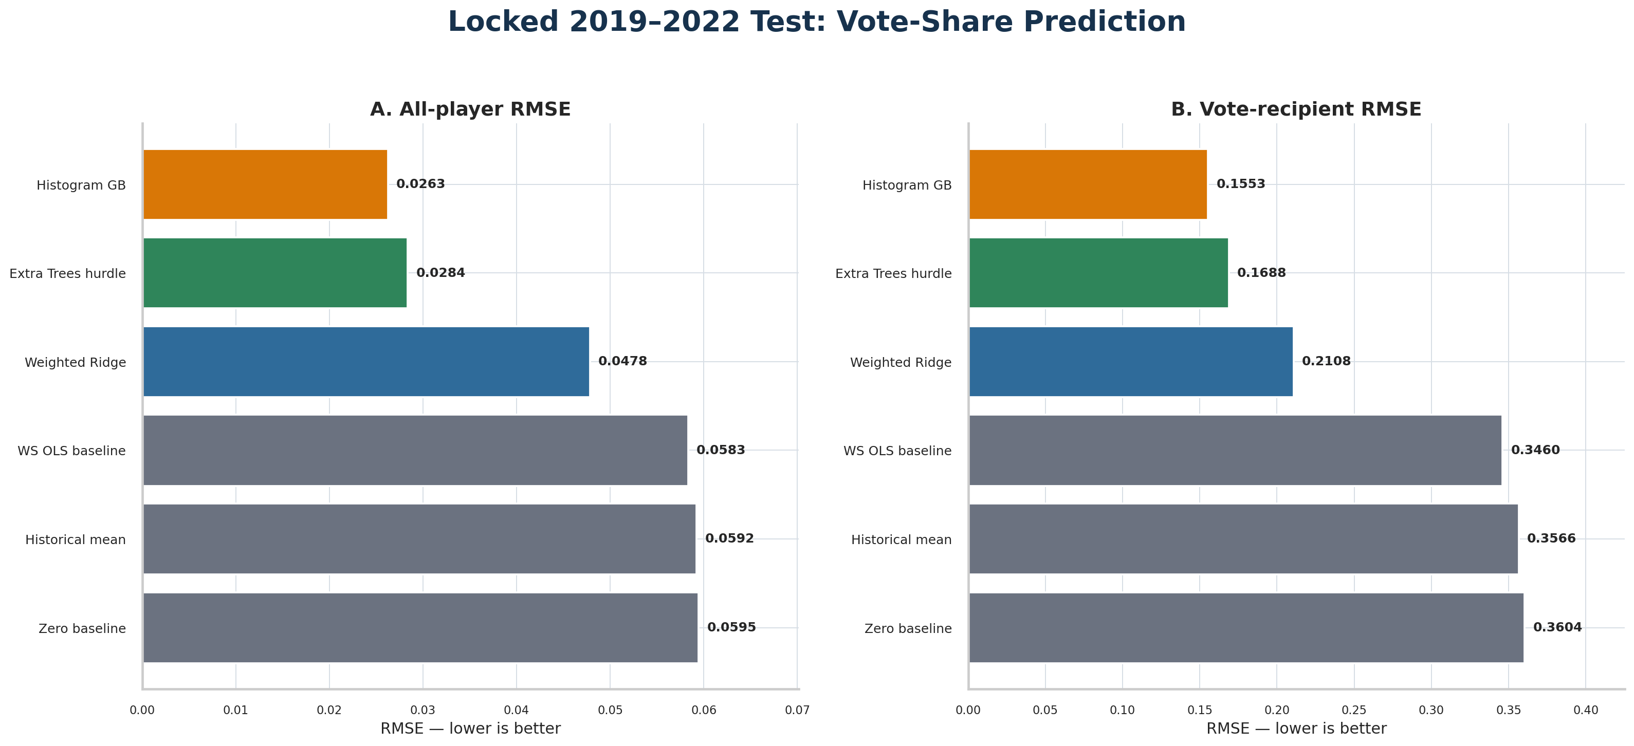
Figure 4. Locked 2019–2022 vote-share error comparison. Lower RMSE is better.
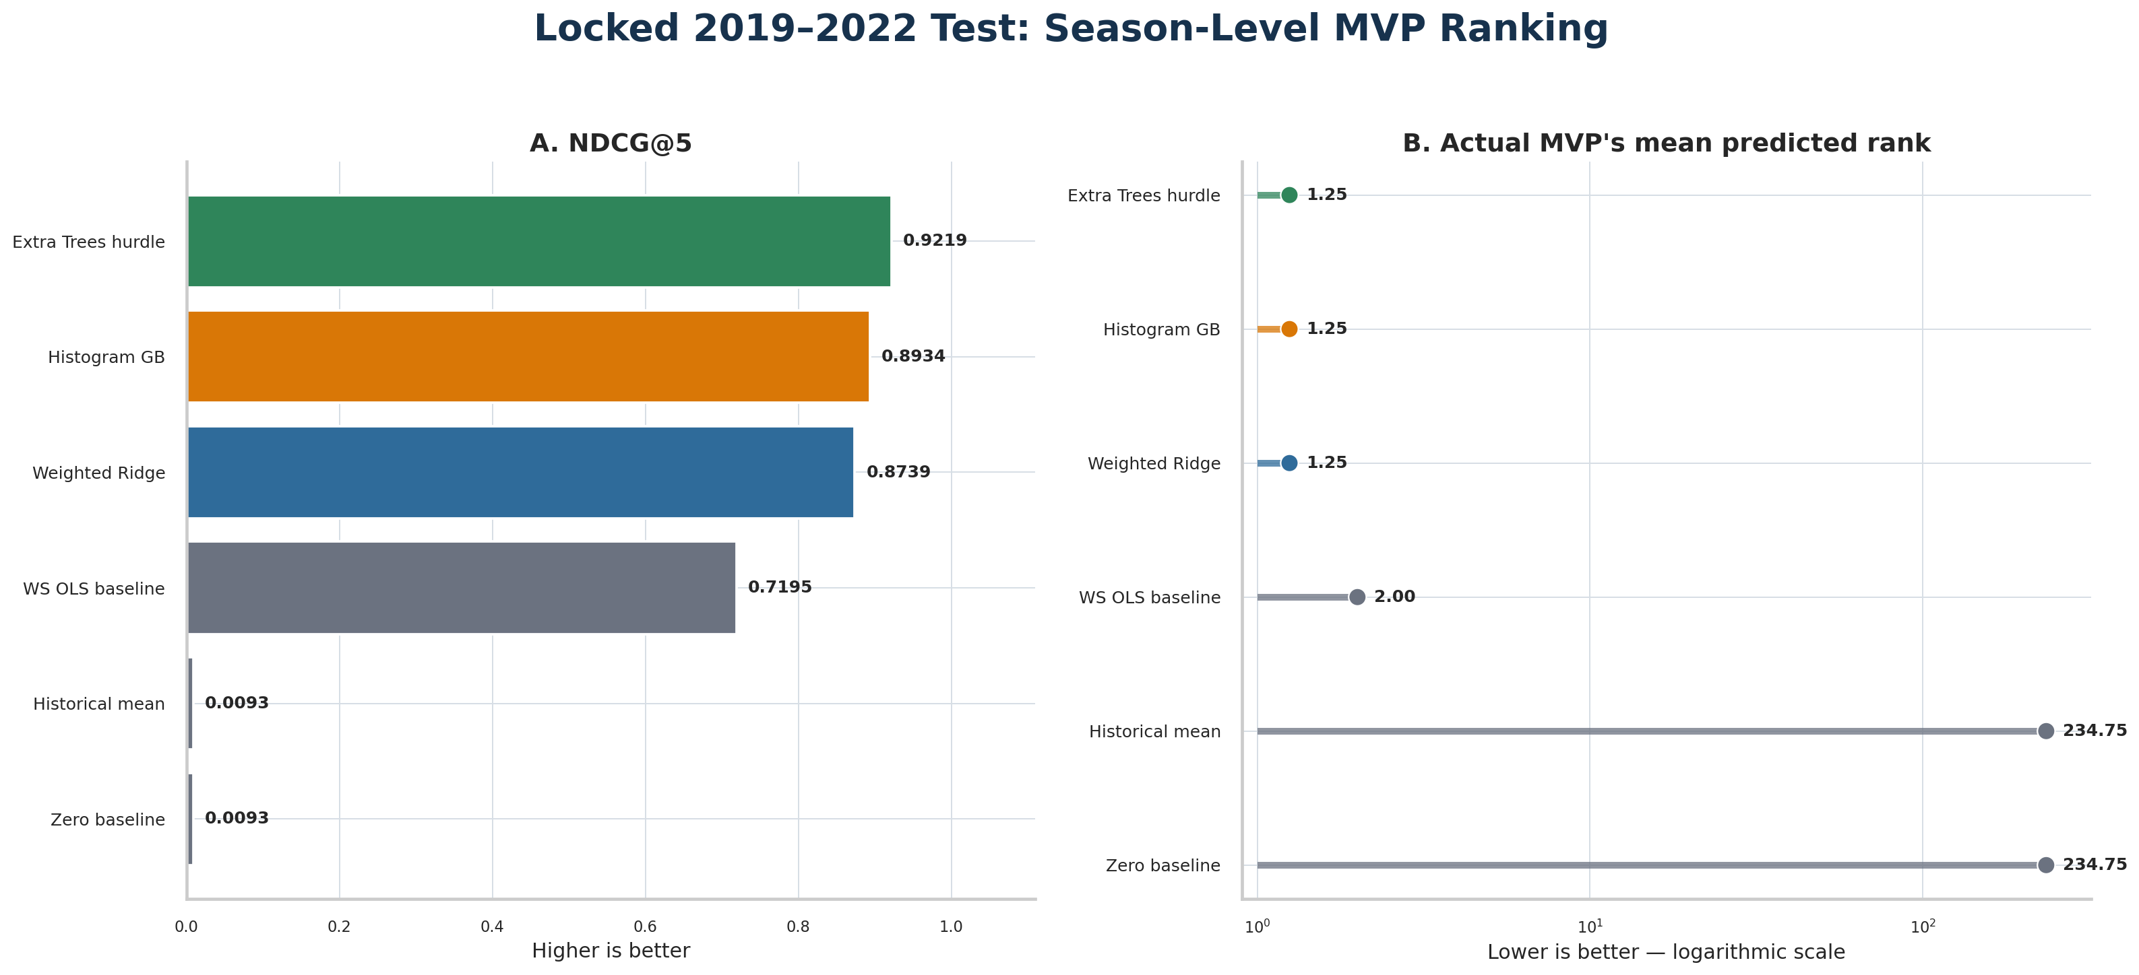
Figure 5. Locked season-level ranking results. Higher NDCG and lower winner rank are better.

7.1 Winner audit
Season | Actual MVP | HGB leader | Winner rank | NDCG@5
2019 | Giannis Antetokounmpo | Giannis Antetokounmpo | 1 | 0.9590
2020 | Giannis Antetokounmpo | Giannis Antetokounmpo | 1 | 0.9284
2021 | Nikola Jokić | Nikola Jokić | 1 | 0.8050
2022 | Nikola Jokić | Giannis Antetokounmpo | 2 | 0.8812

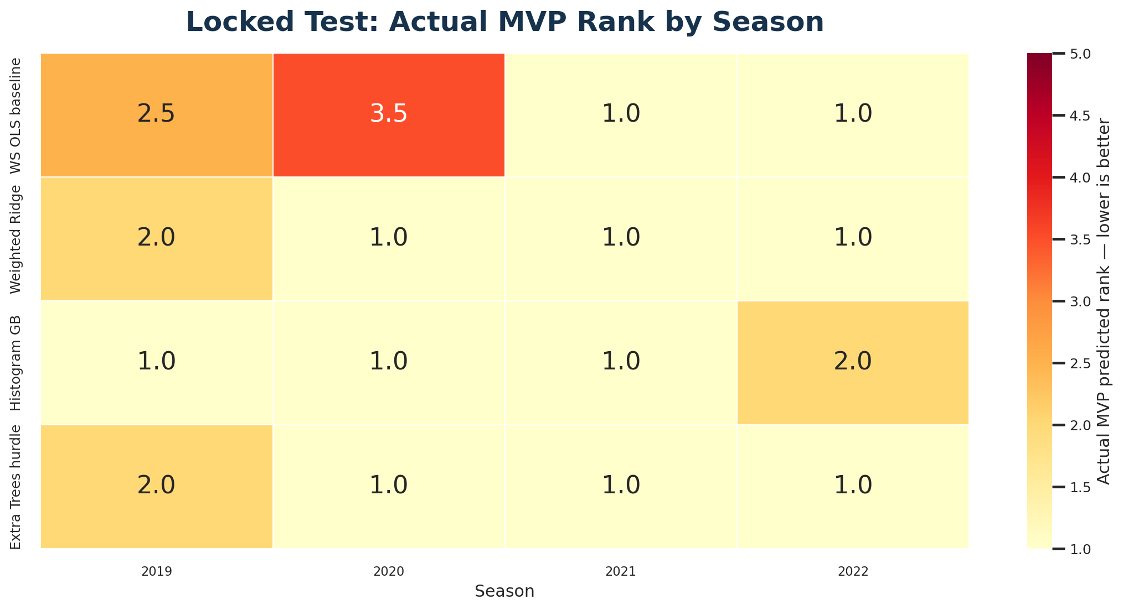
Figure 6. Actual MVP rank by season for the domain baseline and three learned models.

8. Calibration and imbalance
The official model’s numerical accuracy is strong, but its boundary behavior requires explicit disclosure. Histogram GB clipped 84.31% of raw predictions, mainly small negative values among zero-share players, and underestimated winning shares by 0.217 on average. The hurdle model required no final clipping and produced the best season-total calibration.
Model | Season-total MAE | Winner bias | Clipped
Histogram GB | 0.4143 | −0.2170 | 84.31%
Extra Trees hurdle | 0.1320 | −0.3442 | 0%
Weighted Ridge | 6.6588 | −0.3277 | 62.75%
WS OLS | 1.6405 | −0.9031 | 32.71%

Operational rule: Report HGB and hurdle rankings together. Any disagreement about the top candidate should trigger analyst review rather than silent model selection.

9. Sensitivity analysis
The 500-minute sensitivity cohort retained every test vote recipient and all four winners. Histogram GB’s mean winner rank and top-1 accuracy were unchanged, while numerical and ranking metrics moved only modestly. This supports the broader 100-minute cohort as the primary design.
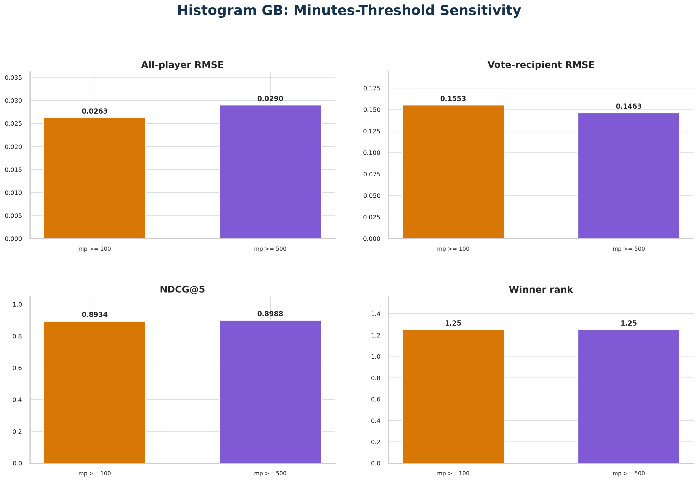
Figure 7. Histogram GB performance under the 100- and 500-minute eligibility thresholds.

10. Final recommendations
Recommendation | Implementation
Primary forecast | Use weighted Histogram GB for numerical award_share
Ranking check | Always publish Extra Trees hurdle beside HGB
Baseline | Retain WS percentile OLS in every evaluation
Candidate list | Use mp ≥ 100; retain mp ≥ 500 sensitivity
Communication | Present top five, shares, rank disagreement, and warnings
Monitoring | Track clipping, missingness, drift, NDCG, recipient RMSE, and winner rank
Retraining | Review only after sustained degradation or compatible new seasons

11. Limitations
- The locked test contains four seasons and only two distinct winners.
- A larger untouched modern test window would have produced stronger external evidence.
- The target reflects human voting and therefore includes narratives not represented in the table.
- The final model is predictive, not causal; it cannot determine who objectively deserves the award.
- Modern award-eligibility rules differ from much of the historical period.
- No post-2022 dataset was accepted because exact schema compatibility was not verified.
A future extension remains appropriate if a candidate source reproduces an overlapping season and preserves the required advanced-statistic definitions. The present conclusions do not depend on such an extension.

12. Conclusion
Regular-season statistics and team performance can predict MVP vote share with useful accuracy and rank the principal candidates effectively. Histogram GB provided the strongest balance of numerical accuracy and winner identification, while the Extra Trees hurdle model supplied superior top-five ranking and season-total calibration. The combined workflow is most appropriate as transparent decision support, with model disagreement and calibration limitations shown rather than concealed.
Final answer: The evidence supports the project hypothesis, but not the stronger claim that MVP voting is completely determined by the available statistics.

Appendix A. Locked official model
Component | Locked specification
Estimator | HistGradientBoostingRegressor
Learning rate | 0.08
Maximum leaf nodes | 31
L2 regularization | 1.0
Iterations | 200
Min. samples per leaf | 20
Training weights | 1 + 5 × award_share
Final bounds | Clip predictions to [0,1]
Random state | 42

Appendix B. Reproducibility assets
- final_locked_test_evaluation.py — complete locked evaluation and figures
- future_data_schema_audit.py — compatibility gate for prospective datasets
- NBA_MVP_PROJECT_HANDOFF.md — reproduction and extension protocol
- chunk1_outputs through chunk19_outputs — verified analytical figures

