Coder Journal

By Andrew Hilton 2131H

Table of Contents

Planned – 2

Utilities - 3

Terminal Logger – 3

The Problem – 3

The Fix – 3

Geometry – 4

Drivetrain – 5

Motion Profiles – 5

What is a motion profile? – 5

PID / Forward Feed Turning – 5

PID / Forward Feed Movement – 5

Puncher – 6

Fire Control – 6

Collection – 6

Possession Control – 6

Climbing Arm - 6

Brain Screen – 7

Layout – 7

Autonomous selector – 7

Grapher – 7

Tuner – 7

Driver Control – 8

Drive Ramping – 8

Autonomous – 9

Left Side – 9

Right Side – 9

Skills – 9

# Planned –

1. Utilities
   1. Terminal Logger
   2. Geometry
      1. Points
      2. Rectangles
      3. Circles
      4. Triangles?
2. Drivetrain
   1. Ramping Forward / Backward
   2. PID/FF Turns
   3. PID/FF Movement
3. Puncher
   1. Fire Control
4. Collection
   1. Possession Control
5. Climbing Arm
6. Brain Screen
   1. Autonomous selector
   2. Grapher
   3. Tuner
   4. Layout
7. Driver Control
   1. Ramping
8. Autonomous
   1. Right side
   2. Left side.
   3. Skills

# Utilities -

The Utilities section includes all the “way of life improvements.” For example, something such as a point or vector type or structure.

## Terminal Logger –

### The Problem –

To print or log to the terminal a “cout” (Character out) is used. These prints are very important for logging numbers and other info that may be needed for debug or tuning. However, a “cout” may end up looking like the ones below. This is still readable, but it could be simplified.



### The Fix –

A simple function can be used to fix this problem. To organize the logs there will be a “level.” This level is just a tag of sorts that can go before the print to help distinguish information from multiple logs. The Log function should also take multiple of all the main data types (int, double, char, bool).

The Level Tag:



The “Log” Function:

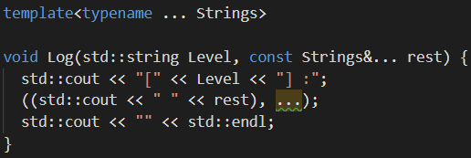

When it is being called it looks something like this:



Note: Terminal is an object for all Terminal Controls.

## Geometry –

# Drivetrain –

## Motion Profiles –

### What is a motion profile? –

In simple terms a motion profile is a path that your motor velocities follow. Generally, a motion profile is to provide smooth motion and move a motor to a specified location. This is generally done by “Ramping” the velocity to a specified target.

### Common Motion Profiles –

#### Linear Ramp –

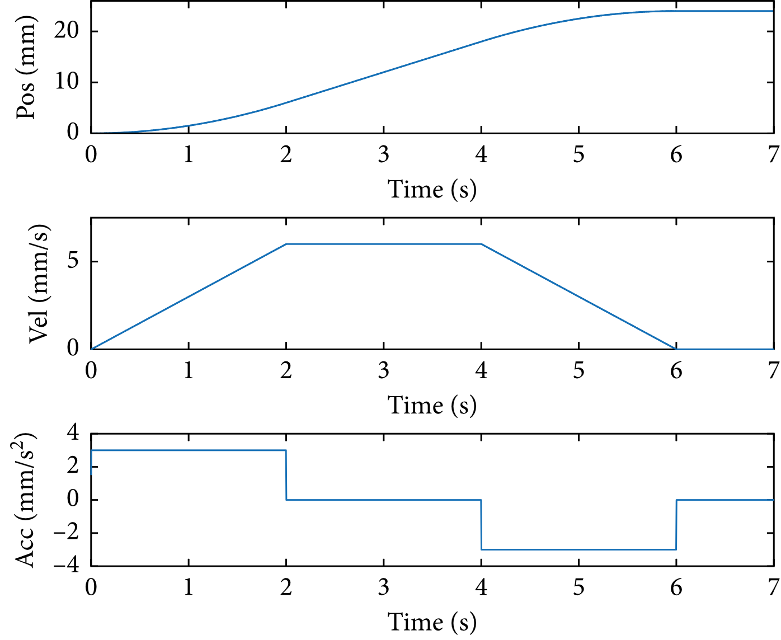

[This Photo](https://www.hindawi.com/journals/sv/2018/4173253/) by Unknown Author is licensed under [CC BY](https://creativecommons.org/licenses/by/3.0/)

#### S-Curve Ramp –

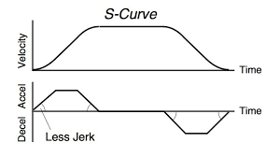

## PID / Forward Feed Turning –

## PID / Forward Feed Movement –

# Puncher –

## Fire Control –

# Collection –

## Possession Control –

# Climbing Arm -

# Brain Screen –

## Layout –

## Autonomous selector –

## Grapher –

## Tuner –

# Driver Control –

## Drive Ramping –

# Autonomous –

## Left Side –

## Right Side –

## Skills –