Change Control Board (CCB) – ICT Change Submission: Medium Risk
West Gippsland Healthcare Group (WGHG) – Information & Communication Technology
Single change submission for Medium risk changes – aligned to ITIL 4 Change Enablement
How to use this template: Use this form for one Medium risk ICT change: low impact but high probability. Every section is mandatory. Replace each [Enter …] placeholder and mark selections by replacing ☐ with ☒. Attach the ICT Change Run Sheet (Excel) and present the A3 Plan on a Page to the CCB: use the run sheet's Plan on a Page tab, or page 2 of the Word version of this template. If any High-Impact criterion in Section 3 applies, use the High / Critical template instead. Section 7 is completed by the CCB.

Which Change Process Should I Follow?
Use this flowchart and the impact and probability criteria to decide whether the work is a change, which type of change it is, its risk level, and which CCB submission template to use.
Impact | Probability | Risk Level | Template to Use | Attachments
Low | Low | Low | Minor | None – implementation and backout steps are written in the form
Low | High | Medium | Medium | Run Sheet (Excel) and A3 Plan on a Page
High | Low | High | High / Critical | Run Sheet (Excel) and A3 Plan on a Page; PIR always required
High | High | Critical | High / Critical | Run Sheet (Excel) and A3 Plan on a Page; PIR always required; [Enter any extra endorsement WGHG requires, e.g. Executive sponsor]

Risk levels follow the ITIL approach of assessing a change's impact and the probability of the risk occurring. The High / Low criteria below and the mapping to Low / Medium / High / Critical are a WGHG starting point, to be refined.
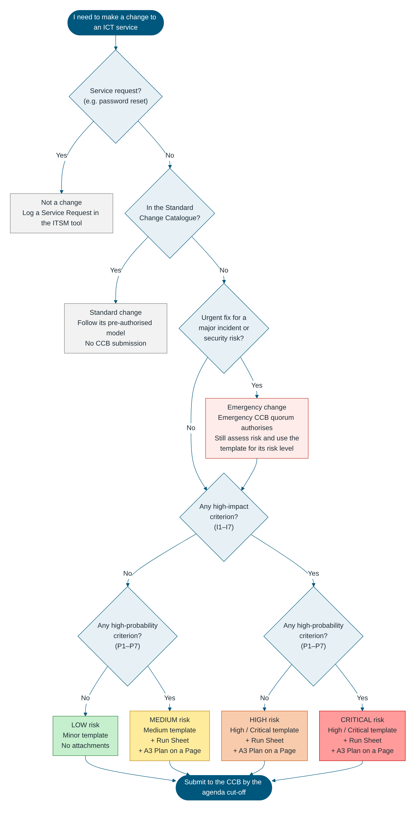

Plan on a Page Change [CHG0001234] – [Enter change title] For CCB meeting: [DD/MM/YYYY]
Change Type | [Normal / Emergency] | Overall Risk Rating | Medium | Decision Requested | [Approve for implementation] | Change Owner | [Name, position]
Approved Window | [DD/MM/YYYY HH:MM – HH:MM] | Expected Outage | [Duration; services affected] | Go / No-Go Decision | [DD/MM HH:MM] | Backout Decision Point | [DD/MM HH:MM]

What is changing  [Enter a plain-language description of the change.]  [Services / CIs being changed.] | Why it is needed  [Driver, e.g. vendor end-of-support, security vulnerability, incident / problem resolution.]  [Consequence of not proceeding.] | Success criteria and benefits  [Measurable success criterion 1]  [Measurable success criterion 2]  [Benefit to patients / staff / WGHG]

Timeline
Phase | Key Activities | Owner | Planned Start | Planned End | Readiness / Notes
1. Pre-Implementation | [Backups / snapshots, notifications, pre-checks, downtime procedures started] | [Name] | [HH:MM] | [HH:MM] | [Enter]
2. Go / No-Go | Go / No-Go decision – all pre-implementation steps complete and no blocking issues | [Change Manager] | [HH:MM] | [HH:MM] | [Enter]
3. Implementation | [Enter key implementation activities] | [Name] | [HH:MM] | [HH:MM] | [Enter]
4. Verification | [Technical verification; interface checks; clinical / business user verification] | [Name] | [HH:MM] | [HH:MM] | [Enter]
◆ Backout decision point | Latest time a backout can start and still finish inside the approved window | [Change Manager] | [HH:MM] | — | [Enter]
5. Post-Implementation | [Notify completion, end downtime procedures, monitoring, update records] | [Name] | [HH:MM] | [HH:MM] | [Enter]
6. Backout (only if invoked) | [Enter backout summary, e.g. restore snapshot and re-verify] | [Name] | [HH:MM] | [HH:MM] | [Enter]

Impacted services, sites and users  Services / CIs: [Enter]  Sites / departments: [Enter]  Users affected: [Enter number]  Clinical impact: [Enter]  Downtime procedures: [Enter reference] | Top risks and mitigations  R1: [Risk] – [Rating] – [Mitigation]  R2: [Risk] – [Rating] – [Mitigation]  R3: [Risk] – [Rating] – [Mitigation] | Backout plan  Trigger(s): [Enter]  Decision point: [HH:MM] Decision maker: [Name]  Estimated backout duration: [Enter]  Backout tested: ☐ Yes ☐ No  Data restore required: ☐ Yes ☐ No

Communications  ICT Service Desk – [when, channel]  Clinical areas / NUMs – [when, channel]  After-Hours Hospital Coordinator – [when, channel]  Vendors – [when, channel]  All affected users – start and completion | Readiness checklist  ☐ Pre-CCB endorsements obtained  ☐ Testing complete (Test / UAT)  ☐ Backup / snapshot plan confirmed  ☐ Run Sheet finalised  ☐ Downtime procedures confirmed with clinical areas  ☐ Vendor support confirmed  ☐ Service Desk briefed | Key contacts  Change Manager: [Name] [Mobile]  Implementation Lead: [Name] [Mobile]  Business / Clinical Owner: [Name] [Mobile]  After-Hours Hospital Coordinator: [Phone]  Vendor support: [Phone]

1. Change Details
Field | Value
Change ID / RFC Number | [Enter ITSM ticket number, e.g. CHG0001234]
Change Title | [Enter short descriptive title]
CCB Meeting Date | [DD/MM/YYYY]
Decision Requested | ☐ Approve for implementation ☐ Note – retrospective review of an emergency change
Change Requester | [Name, position, department]
Change Owner | [Name, position]
Implementation Lead | [Name, team]
Business / Clinical Owner | [Name, position]
Service(s) / CI(s) Affected | [Enter]
Site(s) / Department(s) Affected | [Enter]
Number of Users Affected | [Enter]
Change Type | ☐ Normal ☐ Emergency
Proposed Implementation Window | Start: [DD/MM/YYYY HH:MM] – End: [DD/MM/YYYY HH:MM]
Expected Service Outage | ☐ No outage ☐ Degraded service ☐ Full outage. Duration: [Enter]
Related Records | [Enter related incident / problem / project IDs]

2. Description and Justification
Item | Details
What is changing | [Enter, in plain language]
Why it is needed | [Enter the driver]
Benefits and success criteria | [Enter measurable success criteria]
Consequence of not implementing | [Enter]

3. Risk Assessment (ITIL Impact and Probability)
Guidance: A Medium change answers No to every High-Impact criterion and Yes to at least one High-Probability criterion. If any High-Impact criterion applies, use the High / Critical template.

Impact and Probability Assessment
Impact is High if ANY of these apply:
# | High-Impact Criterion | Applies? | Details
I1 | Affects a clinical system, patient care, or the availability of patient information | ☐ Yes ☐ No | [Enter]
I2 | Affects a medical device or a medical device interface | ☐ Yes ☐ No | [Enter]
I3 | Affects a 24/7 critical area (e.g. Emergency, ICU / HDU, Maternity, Theatres) | ☐ Yes ☐ No | [Enter]
I4 | Causes a user-facing outage or degraded service during clinical or business hours | ☐ Yes ☐ No | [Enter]
I5 | Affects more than [Enter threshold, e.g. 50] users, or more than one site | ☐ Yes ☐ No | [Enter]
I6 | Changes security controls, access, firewall rules, or how health or personal information is handled | ☐ Yes ☐ No | [Enter]
I7 | Affects integrations or interfaces with other systems | ☐ Yes ☐ No | [Enter]

Probability is High if ANY of these apply:
# | High-Probability Criterion | Applies? | Details
P1 | The change has not been done before at WGHG | ☐ Yes ☐ No | [Enter]
P2 | The change has not been tested in a test / UAT environment | ☐ Yes ☐ No | [Enter]
P3 | The change is complex: many steps, several teams or several CIs | ☐ Yes ☐ No | [Enter]
P4 | Success depends on a vendor or third party | ☐ Yes ☐ No | [Enter]
P5 | A similar change has failed or caused an incident before | ☐ Yes ☐ No | [Enter]
P6 | The backout has not been tested, or the change cannot be backed out | ☐ Yes ☐ No | [Enter]
P7 | The implementation window is tight for the work plus a full backout | ☐ Yes ☐ No | [Enter]

Impact ↓ / Probability → | Low Probability | High Probability
High Impact | High | Critical
Low Impact | Low | Medium

Key Risks and Mitigations
# | Risk | Mitigation | Owner
R1 | [Enter risk] | [Enter] | [Name]
R2 | [Enter risk] | [Enter] | [Name]
R3 | [Enter risk] | [Enter] | [Name]

Overall risk level: ☐ Medium (low impact, high probability)

4. Implementation, Testing and Backout
Field | Details
Run Sheet attached | ☐ Yes – [Enter file name or link]
Implementation summary | [Enter key steps; detail in the Run Sheet]
Pre-implementation testing | ☐ Yes ☐ No ☐ Not applicable. [Enter evidence]
Post-implementation verification (technical and user) | [Enter]
Backout trigger(s) | [Enter]
Backout decision point (latest time) | [DD/MM/YYYY HH:MM]
Estimated backout duration | [Enter]
Backout tested | ☐ Yes ☐ No. [Enter details]

5. Schedule and Communication
Field | Details
Rationale for the window | [Enter, e.g. lowest activity, vendor availability]
Change Schedule and freeze periods checked | ☐ Yes – no conflicts ☐ Conflict: [Enter details]

Audience | When | Channel | Sender
ICT Service Desk | [Enter] | [Enter] | [Name]
Affected departments / users | [Enter] | [Enter] | [Name]
After-Hours Hospital Coordinator (after-hours changes) | [Enter] | [Enter] | [Name]
Vendors / third parties (if involved) | [Enter] | [Enter] | [Name]

6. Endorsements Required Before the CCB Meeting
Role | Name | Endorsed (Yes / No) | Date
Change Owner | [Name] | [Select] | [DD/MM/YYYY]
Technical Approver | [Name] | [Select] | [DD/MM/YYYY]
Business / Clinical Owner | [Name] | [Select] | [DD/MM/YYYY]
ICT Change Manager | [Name] | [Select] | [DD/MM/YYYY]

7. CCB Decision (completed by the CCB)
Field | Details
CCB meeting date | [DD/MM/YYYY]
CCB Chair | [Name, position]
Quorum met | ☐ Yes
CCB decision | ☐ Approved ☐ Approved with conditions ☐ Deferred – more information required ☐ Rejected ☐ Noted (retrospective emergency change)
Conditions of approval | [Enter conditions, or "Nil"]
Approved implementation window | [DD/MM/YYYY HH:MM – HH:MM]
Actions (owner / due date) | [Enter, or "Nil"]
CCB Chair sign-off | [Name] – [DD/MM/YYYY]
Minutes reference | [Enter]

8. Implementation Record
Field | Details
Actual start / end | [DD/MM/YYYY HH:MM] – [DD/MM/YYYY HH:MM]
Outcome | ☐ Successful ☐ Successful with issues ☐ Failed – backed out ☐ Failed – not backed out
Deviations from the approved plan or CCB conditions | [Enter, or "Nil"]
Incidents raised as a result | [Enter incident IDs, or "Nil"]

9. PIR and Closure
Field | Details
PIR required? | ☐ No ☐ Yes – the change failed, was an emergency change, or the CCB requested one
PIR summary and lessons learned (if required) | [Enter]
Follow-up actions (owner / due date) | [Enter, or "Nil"]
CMDB / documentation updated | ☐ Yes ☐ Not applicable
Final Run Sheet attached to the ITSM record | ☐ Yes
Closed by / date | [Name] – [DD/MM/YYYY]

West Gippsland Healthcare Group – CCB ICT Change Submission: Medium Risk – Version 1.0 – Uncontrolled when printed.

