Change Control Board (CCB) – ICT Change Submission: Minor (Low Risk)
West Gippsland Healthcare Group (WGHG) – Information & Communication Technology
Short-form single change submission for Low risk changes – aligned to ITIL 4 Change Enablement
How to use this template: Use this form for one Low risk ICT change: low impact and low probability. Every field is mandatory. Replace each [Enter …] placeholder and mark selections by replacing ☐ with ☒. If any criterion in Section 3 applies, stop and use the Medium or High / Critical template instead. No attachments are required; the implementation and backout steps go in Section 4. Section 6 is completed by the CCB. The full process is in the ICT Change Control Process document.

Which Change Process Should I Follow?
Use this flowchart and the impact and probability criteria to decide whether the work is a change, which type of change it is, its risk level, and which CCB submission template to use.
Impact | Probability | Risk Level | Template to Use | Attachments
Low | Low | Low | Minor | None – implementation and backout steps are written in the form
Low | High | Medium | Medium | Run Sheet (Excel) and A3 Plan on a Page
High | Low | High | High / Critical | Run Sheet (Excel) and A3 Plan on a Page; PIR always required
High | High | Critical | High / Critical | Run Sheet (Excel) and A3 Plan on a Page; PIR always required; [Enter any extra endorsement WGHG requires, e.g. Executive sponsor]

Risk levels follow the ITIL approach of assessing a change's impact and the probability of the risk occurring. The High / Low criteria below and the mapping to Low / Medium / High / Critical are a WGHG starting point, to be refined.
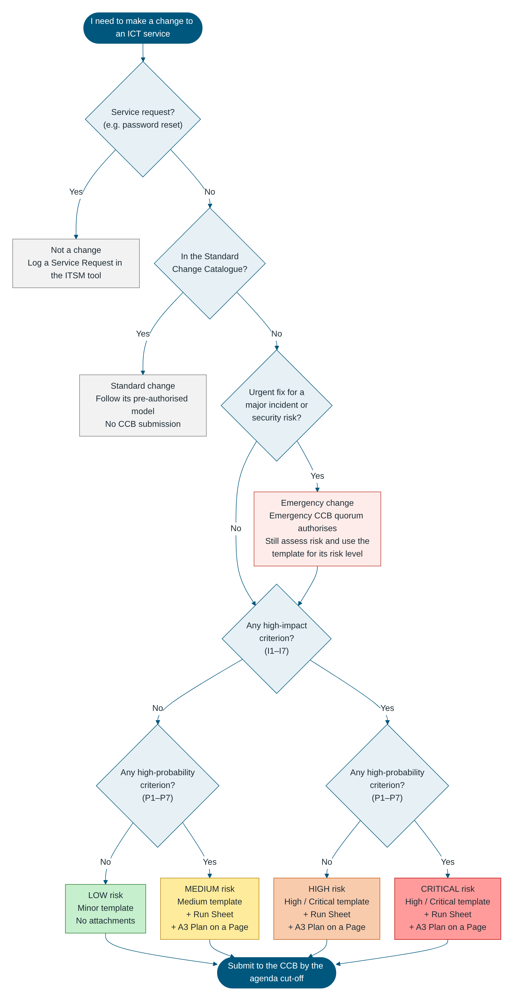

1. Change Details
Field | Value
Change ID / RFC Number | [Enter ITSM ticket number, e.g. CHG0001234]
Change Title | [Enter short descriptive title]
Change Requester | [Name, position, department]
Change Owner | [Name, position]
Implementer | [Name, team]
Service(s) / CI(s) Affected | [Enter]
Site(s) / Department(s) Affected | [Enter]
Change Type | ☐ Normal ☐ Emergency
CCB Meeting Date | [DD/MM/YYYY]
Proposed Implementation Window | Start: [DD/MM/YYYY HH:MM] – End: [DD/MM/YYYY HH:MM]
Expected Service Outage | ☐ No outage ☐ Degraded service ☐ Full outage. Duration: [Enter]

2. Description and Reason
Item | Details
What is changing | [Enter, in plain language]
Why it is needed | [Enter]
Consequence of not implementing | [Enter]

3. Risk Assessment (ITIL Impact and Probability)
Guidance: A Minor change must answer No to every criterion. If any High-Probability criterion applies, use the Medium template. If any High-Impact criterion applies, use the High / Critical template.

Impact and Probability Assessment
Impact is High if ANY of these apply:
# | High-Impact Criterion | Applies? | Details
I1 | Affects a clinical system, patient care, or the availability of patient information | ☐ Yes ☐ No | [Enter]
I2 | Affects a medical device or a medical device interface | ☐ Yes ☐ No | [Enter]
I3 | Affects a 24/7 critical area (e.g. Emergency, ICU / HDU, Maternity, Theatres) | ☐ Yes ☐ No | [Enter]
I4 | Causes a user-facing outage or degraded service during clinical or business hours | ☐ Yes ☐ No | [Enter]
I5 | Affects more than [Enter threshold, e.g. 50] users, or more than one site | ☐ Yes ☐ No | [Enter]
I6 | Changes security controls, access, firewall rules, or how health or personal information is handled | ☐ Yes ☐ No | [Enter]
I7 | Affects integrations or interfaces with other systems | ☐ Yes ☐ No | [Enter]

Probability is High if ANY of these apply:
# | High-Probability Criterion | Applies? | Details
P1 | The change has not been done before at WGHG | ☐ Yes ☐ No | [Enter]
P2 | The change has not been tested in a test / UAT environment | ☐ Yes ☐ No | [Enter]
P3 | The change is complex: many steps, several teams or several CIs | ☐ Yes ☐ No | [Enter]
P4 | Success depends on a vendor or third party | ☐ Yes ☐ No | [Enter]
P5 | A similar change has failed or caused an incident before | ☐ Yes ☐ No | [Enter]
P6 | The backout has not been tested, or the change cannot be backed out | ☐ Yes ☐ No | [Enter]
P7 | The implementation window is tight for the work plus a full backout | ☐ Yes ☐ No | [Enter]

Impact ↓ / Probability → | Low Probability | High Probability
High Impact | High | Critical
Low Impact | Low | Medium

Main Risk
Main Risk | Mitigation
[Enter the most likely thing that could go wrong] | [Enter how it is prevented or managed]

Overall risk level: ☐ Low (all criteria answered No)

4. Implementation, Verification and Backout

4.1 Implementation Steps
# | Step | Who | Est. Duration (mins)
1 | [Enter step] | [Name] | [Enter]
2 | [Enter step] | [Name] | [Enter]
3 | [Enter step] | [Name] | [Enter]
4 | [Enter step] | [Name] | [Enter]

4.2 Verification and Backout
Field | Details
Pre-implementation testing | ☐ Done ☐ Not required. [Enter evidence or reason]
How success is verified | [Enter checks after the change]
Backout steps | [Enter]
Backout trigger and latest backout time | [Enter trigger]; latest time [HH:MM]
Estimated backout duration | [Enter]

5. Communication and Endorsement
Field | Details
ICT Service Desk notified | ☐ Yes. Date: [DD/MM/YYYY]
Affected users / department notified | ☐ Yes ☐ Not required. Date: [DD/MM/YYYY]
After-Hours Hospital Coordinator notified (after-hours changes only) | ☐ Yes ☐ Not required
Change Owner endorsement | [Name] – [DD/MM/YYYY]
ICT Change Manager review | [Name] – [DD/MM/YYYY] ☐ Confirmed as Low risk (Minor)

6. CCB Decision (completed by the CCB)
Field | Details
CCB meeting date | [DD/MM/YYYY]
CCB decision | ☐ Approved ☐ Approved with conditions ☐ Deferred – more information required ☐ Rejected ☐ Noted (retrospective emergency change)
Conditions of approval | [Enter conditions, or "Nil"]
Approved implementation window | [DD/MM/YYYY HH:MM – HH:MM]
CCB Chair | [Name] – [DD/MM/YYYY]
Minutes reference | [Enter]

7. Outcome and Closure
Field | Details
Actual start / end | [DD/MM/YYYY HH:MM] – [DD/MM/YYYY HH:MM]
Outcome | ☐ Successful ☐ Successful with issues ☐ Failed – backed out ☐ Failed – not backed out
Incidents raised as a result | [Enter incident IDs, or "Nil"]
CMDB / documentation updated | ☐ Yes ☐ Not applicable
Lessons learned (required if the change failed or the CCB requests a PIR) | [Enter]
Closed by / date | [Name] – [DD/MM/YYYY]

West Gippsland Healthcare Group – CCB ICT Change Submission: Minor (Low Risk) – Version 1.0 – Uncontrolled when printed.

