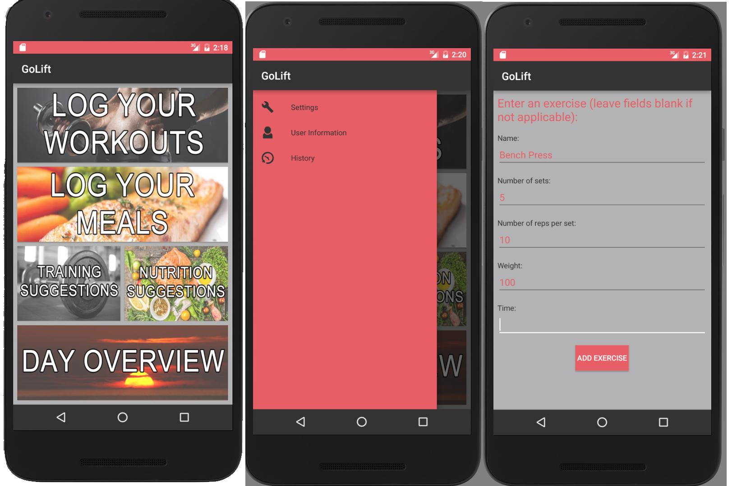

Home page Navigation Menu Log Your Workouts

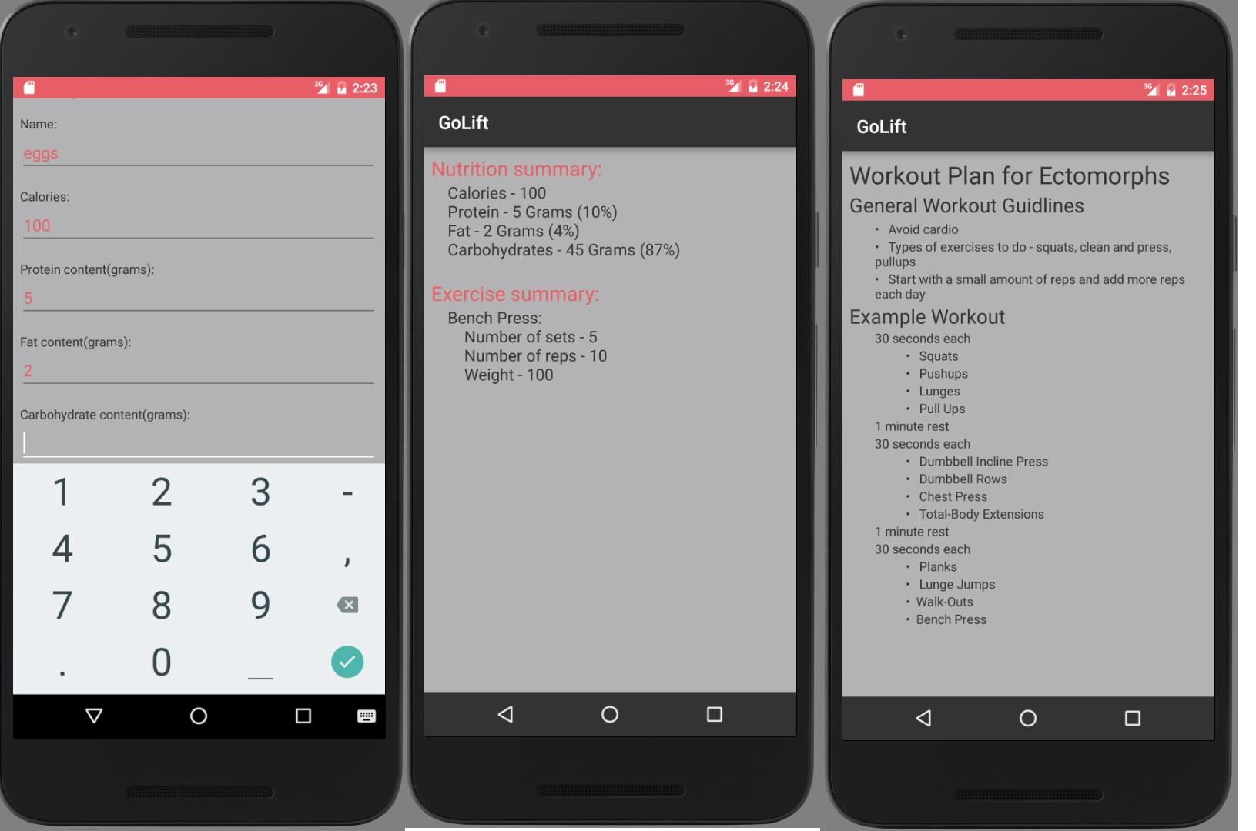

Log Your Meals Day Overview Workout Suggestions