Zachary Johnson
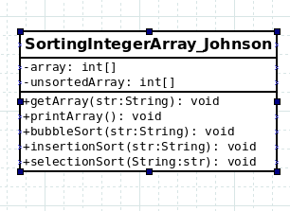
UML and Psuedocode

Psuedocode

main():
create Scanner object
enter do-while loop:
get user input for choice
test for out of bounds error

get user to enter string of numbers
create SortingIntegerArray_Johnson object
print sorting method corresponding to choice
continue loop

