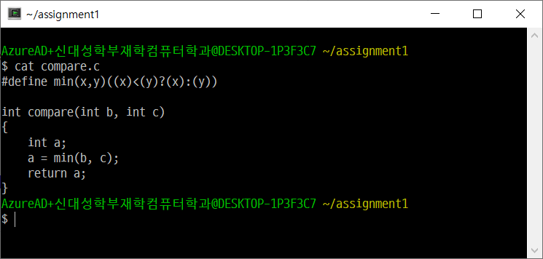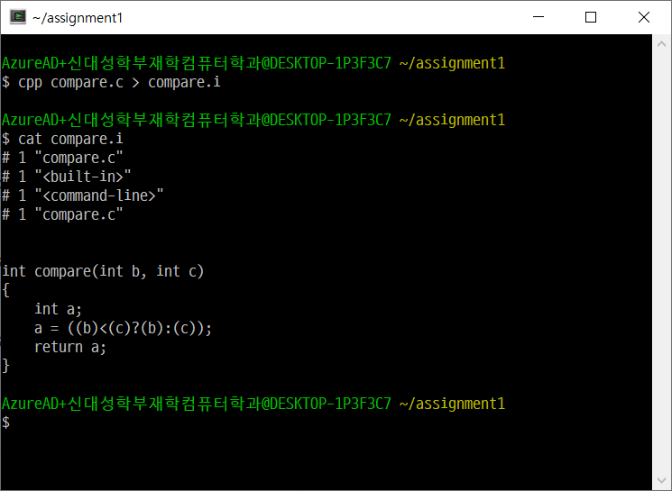

$gcc -S compare.i

.file "compare.c"

.text

.globl _compare

.def _compare; .scl 2; .type 32; .endef

_compare:

LFB0:

.cfi_startproc

pushl %ebp

.cfi_def_cfa_offset 8

.cfi_offset 5, -8

movl %esp, %ebp

.cfi_def_cfa_register 5

subl $16, %esp

movl 8(%ebp), %eax

cmpl %eax, 12(%ebp)

cmovle 12(%ebp), %eax

movl %eax, -4(%ebp)

movl -4(%ebp), %eax

leave

.cfi_restore 5

.cfi_def_cfa 4, 4

ret

.cfi_endproc

LFE0:

.ident "GCC: (GNU) 7.4.0"

$as compare.s -o compare.o

$objdump -SD compare.o

compare.o: file format pe-i386

Disassembly of section .text:

00000000 <_compare>:

0: 55 push %ebp

1: 89 e5 mov %esp,%ebp

3: 83 ec 10 sub $0x10,%esp

6: 8b 45 08 mov 0x8(%ebp),%eax

9: 39 45 0c cmp %eax,0xc(%ebp)

c: 0f 4e 45 0c cmovle 0xc(%ebp),%eax

10: 89 45 fc mov %eax,-0x4(%ebp)

13: 8b 45 fc mov -0x4(%ebp),%eax

16: c9 leave

17: c3 ret

Disassembly of section .rdata$zzz:

00000000 <.rdata$zzz>:

0: 47 inc %edi

1: 43 inc %ebx

2: 43 inc %ebx

3: 3a 20 cmp (%eax),%ah

5: 28 47 4e sub %al,0x4e(%edi)

8: 55 push %ebp

9: 29 20 sub %esp,(%eax)

b: 37 aaa

c: 2e 34 2e cs xor $0x2e,%al

f: 30 00 xor %al,(%eax)

11: 00 00 add %al,(%eax)

...

Disassembly of section .eh_frame:

00000000 <.eh_frame>:

0: 14 00 adc $0x0,%al

2: 00 00 add %al,(%eax)

4: 00 00 add %al,(%eax)

6: 00 00 add %al,(%eax)

8: 01 7a 52 add %edi,0x52(%edx)

b: 00 01 add %al,(%ecx)

d: 7c 08 jl 17 <.eh_frame+0x17>

f: 01 1b add %ebx,(%ebx)

11: 0c 04 or $0x4,%al

13: 04 88 add $0x88,%al

15: 01 00 add %eax,(%eax)

17: 00 1c 00 add %bl,(%eax,%eax,1)

1a: 00 00 add %al,(%eax)

1c: 1c 00 sbb $0x0,%al

1e: 00 00 add %al,(%eax)

20: 04 00 add $0x0,%al

22: 00 00 add %al,(%eax)

24: 18 00 sbb %al,(%eax)

26: 00 00 add %al,(%eax)

28: 00 41 0e add %al,0xe(%ecx)

2b: 08 85 02 42 0d 05 or %al,0x50d4202(%ebp)

31: 54 push %esp

32: c5 0c 04 lds (%esp,%eax,1),%ecx

35: 04 00 add $0x0,%al

...

$ld compare.o -o compare

$objdump -SD compare > compare.dump

compare: file format pei-i386

Disassembly of section .text:

00401000 <_compare>:

401000: 55 push %ebp

401001: 89 e5 mov %esp,%ebp

401003: 83 ec 10 sub $0x10,%esp

401006: 8b 45 08 mov 0x8(%ebp),%eax

401009: 39 45 0c cmp %eax,0xc(%ebp)

40100c: 0f 4e 45 0c cmovle 0xc(%ebp),%eax

401010: 89 45 fc mov %eax,-0x4(%ebp)

401013: 8b 45 fc mov -0x4(%ebp),%eax

401016: c9 leave

401017: c3 ret

00401018 <__CTOR_LIST__>:

401018: ff (bad)

401019: ff (bad)

40101a: ff (bad)

40101b: ff 00 incl (%eax)

40101d: 00 00 add %al,(%eax)

...

00401020 <__DTOR_LIST__>:

401020: ff (bad)

401021: ff (bad)

401022: ff (bad)

401023: ff 00 incl (%eax)

401025: 00 00 add %al,(%eax)

...

Disassembly of section .rdata:

00402000 <__data_end__>:

402000: 47 inc %edi

402001: 43 inc %ebx

402002: 43 inc %ebx

402003: 3a 20 cmp (%eax),%ah

402005: 28 47 4e sub %al,0x4e(%edi)

402008: 55 push %ebp

402009: 29 20 sub %esp,(%eax)

40200b: 37 aaa

40200c: 2e 34 2e cs xor $0x2e,%al

40200f: 30 00 xor %al,(%eax)

402011: 00 00 add %al,(%eax)

...

Disassembly of section .eh_fram:

00403000 <.eh_frame>:

403000: 14 00 adc $0x0,%al

403002: 00 00 add %al,(%eax)

403004: 00 00 add %al,(%eax)

403006: 00 00 add %al,(%eax)

403008: 01 7a 52 add %edi,0x52(%edx)

40300b: 00 01 add %al,(%ecx)

40300d: 7c 08 jl 403017 <.eh_frame+0x17>

40300f: 01 1b add %ebx,(%ebx)

403011: 0c 04 or $0x4,%al

403013: 04 88 add $0x88,%al

403015: 01 00 add %eax,(%eax)

403017: 00 1c 00 add %bl,(%eax,%eax,1)

40301a: 00 00 add %al,(%eax)

40301c: 1c 00 sbb $0x0,%al

40301e: 00 00 add %al,(%eax)

403020: e0 df loopne 403001 <.eh_frame+0x1>

403022: ff (bad)

403023: ff 18 lcall *(%eax)

403025: 00 00 add %al,(%eax)

403027: 00 00 add %al,(%eax)

403029: 41 inc %ecx

40302a: 0e push %cs

40302b: 08 85 02 42 0d 05 or %al,0x50d4202(%ebp)

403031: 54 push %esp

403032: c5 0c 04 lds (%esp,%eax,1),%ecx

403035: 04 00 add $0x0,%al

...

Disassembly of section .idata:

00404000 <__bss_end__>:

...