REVISION HISTORY

|  |  |  |  |
| --- | --- | --- | --- |
| Date | Version | Description | Author |
| 07.03.2025 | 0.1 | User requirements specifications have been added in the Section 2.1 | Emre Tekin |
| 08.03.2025 | 0.2 | UML Use Case Diagram have been added in the Section 2.3 | İrem Akova,  İris Akdemir,  Mert Turan,  Tahsin Karcı |
| 08.03.2025 | 0.3 | User requirements specifications have been updated in the Section 2.1 | İrem Akova,  İris Akdemir,  Mert Turan,  Tahsin Karcı |
| 08.03.2025 | 0.4 | UML Activity Diagram have been added in the Section 2.3 | Emre Tekin |
| 08.03.2025 | 0.5 | UML Deployment Diagram have been added in the Section 2.2 | Mert Turan,  Tahsin Karcı |
| 09.03.2025 | 0.6 | Document overview, system overview, abbreviations, references and conventions has been written and finalized in Section 1 | Elifnur Boncuk |
| 09.03.2025 | 1.0 | The last touch has been done in the document. | Tahsin Karcı |
| 16.03.2025 | 1.1 | UML Activity Diagram has been updated, the font size increased to make it more visible. | Emre Tekin |
| 17.03.2025 | 1.2 | 2.2 UML Deployment Diagram has been updated as detailed and advanced. | Tahsin Karcı |
| 17.03.2025 | 1.3 | Use Case Diagram has been updated and include and extend tags have been added. | İris Akdemir,  İrem Akova |
| 17.03.2025 | 1.4 | Additions and rearrangements have been made to User and System Requirements. | İris Akdemir,  İrem Akova |
| 17.03.2025 | 1.5 | User Requirements and System Requirement specifications have been updated. | Mert Turan |
| 17.03.2025 | 2.0 | The last touch has been done in the document. | Mert Turan |

TABLE OF CONTENTS

1 INTRODUCTION 3

1.1 Document overview 3

1.2 System overview 3

1.3 Abbreviations 3

1.4 References 3

1.5 Conventions 3

2 REQUIREMENTS 4

2.1 User Requirements Specification 4

2.2 System Architecture 5

2.3 Use Cases and Usage Scenarios 5

2.4 System Requirements Specification 6

# INTRODUCTION

## Document overview

This document presents the software requirements specifications of RMS (Restaurant Management System) development project.

It describes functional requirements, user requirements, and constraints of the RMS. Additionally, it includes use cases, system architecture, and references to relevant diagrams.

## System overview

RMS (Restaurant Management System) is a desktop application that digitizes table reservations, order management and payment processes in restaurants. With RMS, customers can reserve a table and view its location, view the menu, place an order and make the payment, while restaurant employees can follow and manage operations with incoming notifications.

## Abbreviations

RMS: Restaurant Management System

SRS: Software Requirements Specification

SDD: Software Design Document

STP: Software Test Plan

STR: Software Test Report

VS: Visual Studio

UML: Unified Modeling Language

IDE: Integrated Development Environment

JDK: Java Development Kit

SQL: Structured Query Language

JVM: Java Virtual Machine

## References

|  |  |  |
| --- | --- | --- |
| # | Document Identifier | Document Title |
| [SDP] | RMS-SDP-v2.0 | RMS Software Development Plan |

## Conventions

Requirements listed in this document are constructed according to the following structure:

SRS-RMS-001

Description of RMS-001 requirement

Every system requirement id includes the id of the corresponding user requirement as a prefix.

SRS-SIS-001.1

Description of SRS-SIS-001.1 system requirement, which is related to the user requirement SRS-SIS-001.

# REQUIREMENTS

## User Requirements Specification

SRS-RMS-001

RMS shall enable customers, supervisors and waiters to log into the system with userID and a password.

SRS-RMS-002

RMS shall enable customers to check the availability of the tables for the specified date and time.

SRS-RMS-003

RMS shall enable customers to reserve tables in the restaurant for the specified date and time.

SRS-RMS-004

RMS shall enable customers to get their table’s location and other information ahead of reservation date and time.

SRS-RMS-005

RMS shall enable customers to view the menu.

SRS-RMS-006

RMS shall enable customers to place an order from the menu.

SRS-RMS-007

RMS shall enable the waiter and supervisor to view the status of an order.

SRS-RMS-008

RMS shall enable customers to pay for their meal from the system.

SRS-RMS-009

RMS shall enable supervisors to close the paid orders.

## System Architecture

Deployment Diagram for RMS:

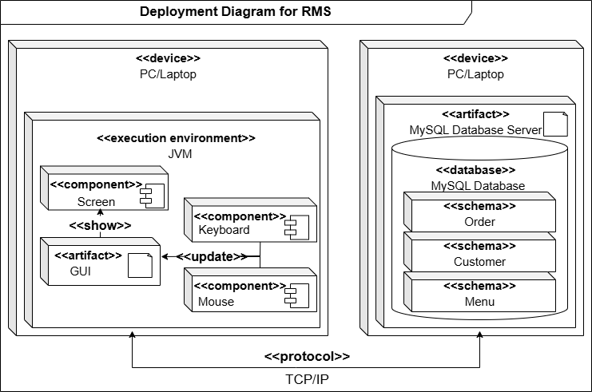

## Use Cases and Usage Scenarios

UML Use Case Diagram:

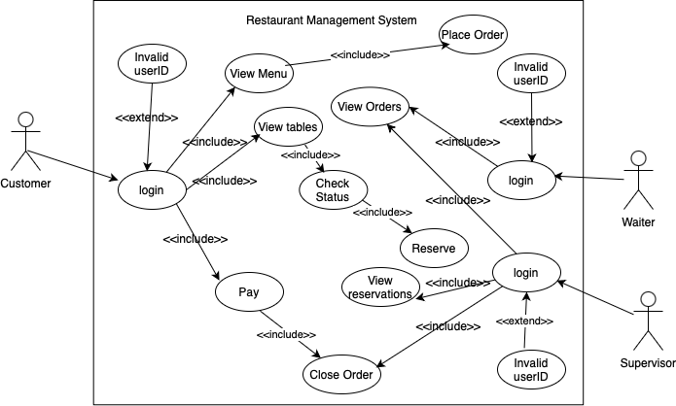

UML Activity Diagram:

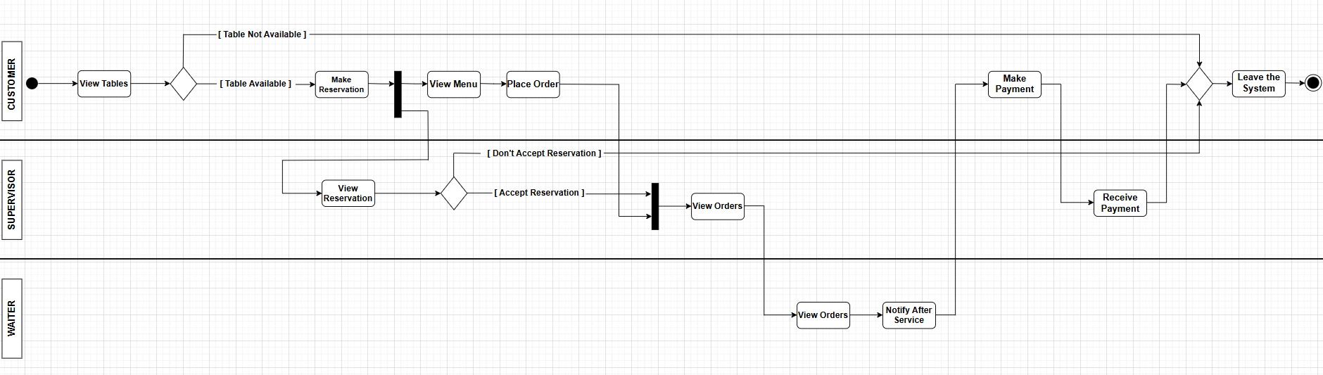

## System Requirements Specification

SRS-RMS-001.1

The system shall prevent users with non-existent IDs or incorrect passwords from logging in.

SRS-RMS-002.1

RMS shall enable customers to view the availability of tables for a specified date and time, up to one week in advance.

SRS-RMS-003.1

RMS shall prevent customers from making reservations for tables that are not available in the specified time.

SRS-RMS-004.1

RMS shall send notification to the customer which includes the table's location and other information ahead of the reservation date and time.

SRS-RMS-005.1

RMS shall generate a display of menu to customer with prices.

SRS-RMS-007.1

RMS shall send notifications to the waiter and supervisor for orders and reservations.

SRS-RMS-008.1

RMS shall ensure that the total payment amount will be calculated according to the customer's selections.

SRS-RMS-009.1

The system shall prevent the supervisor from closing an order if the customer does not pay.