Revision History
Date | Version | Description | Author
15.02.2025 | 0.1 | Name and description of the project, Gantt chart and an abbreviation have been added. 2.2.2 has been filled. | Tahsin Karcı
15.02.2025 | 0.2 | Risks have been analyzed with its probabilities and effects. Potential indicators and strategies have been decided. | İrem Akova,  İris Akdemir
16.02.2025 | 0.3 | Activities and comments are added in section 3. | Emre Tekin, Elif Nur Boncuk
16.02.2025 | 0.4 | GitHub repository and software development tools have been added. 2.2.2 has been updated. | Mert Turan
16.02.2025 | 0.5 | Responsibilities are added in section 3. | Emre Tekin, Elif Nur Boncuk
16.02.2025 | 1.0 | Table of contents page’s numbers have been updated, transferring from Google Docs to Microsoft Word has been made, last touch has been done in the document. | Tahsin Karcı
23.02.2025 | 2.0 | Revisions in Gantt Chart according to the feedback have been done; the watermark, report writing, responsibility sharing have been deleted and other work packets explained more detailed. Revisions in reports changed as revisions in different work packets because they are needed. Ramadan Feast has been added as holiday. The document has been revised as well. | Tahsin Karcı

TABLE OF CONTENTS

Revision History 1
1 Identification 3
1.1 Document overview 3
1.2 Abbreviations 3
1.2.1 Abbreviations 3
1.3 References 3
1.3.1 Project References 3
2 Software Development Activities 3
2.1 Software development process 3
2.1.1 Overview of process phases 3
2.1.2 Technical documentation 4
2.1.3 Deliverables 4
2.2 Software development tools 5
2.2.1 Workstation 5
2.2.2 Requirements management and documentation 5
2.2.3 Software Design 5
2.2.4 Coding and automated tests 5
2.2.5 Configuration management 5
2.3 Software development rules and standards 5
3 Responsibilities 6
3.1 Activities and responsibilities 6
4 Risk Assessment 6
4.1 Risk Analysis 6
4.2 Risk Planning 7

Identification

Document overview

This document contains the software development plan of software RMS.

RMS is a restaurant management system which manages the reservation of the tables, orders and payments. This desktop application can be used by both staff and customers. Customers can order entries, make reservations, pay the bills while the staff can organize the background work according to that, checking the supply chain, scheduling the works and monitoring the demands.

Abbreviations

Abbreviations

RMS: Restaurant Management System
VS: Visual Studio
UML: Unified Modeling Language
IDE: Integrated Development Environment
JDK: Java Development Kit
SRS: Software Requirement Specification
STP: Software Test Plan
SDD: Software Design Document
STR: Software Test Report

References

Project References

# | Document Identifier | Document Title

Software Development Activities

The section lists and describes the software development activities of RMS software development project.

Software development process

This is a course project, which adopts the waterfall model as the software development process.

Overview of process phases

The software development process for the project will be composed of the following phases:
- Planning
- Requirements Analysis
- Design
- Implementation
- Testing and Analysis

These phases will follow each other sequentially, where each phase starts just after the completion of the previous one. The following Gantt chart depicts the planned start date and duration for the phases.

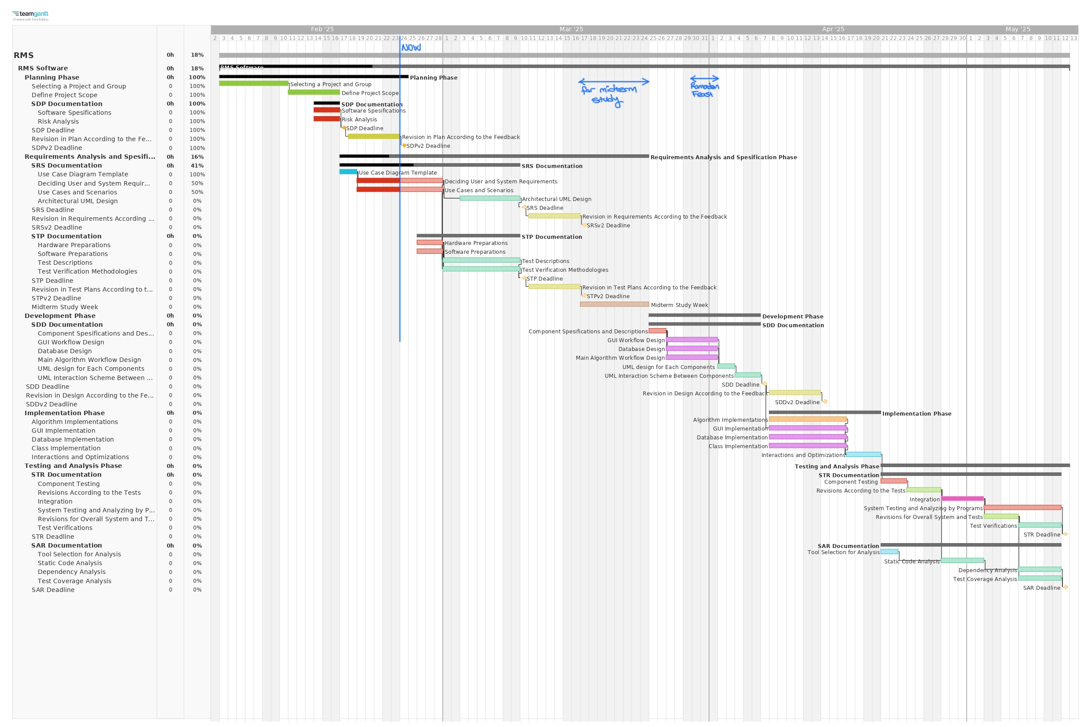

Technical documentation

The following documentation is produced during the software development phases:
- Software specification: SRS, STP
- Software detailed conception: SDD
- Software tests phases : STR
- Software analysis: SAR

Deliverables

The following items will be delivered at the end of the process:
- Technical documentation as outlined in Section 2.1.2
- Software and its configuration files

Software development tools

Workstation
6 Laptops:
- 32 GB RAM, 1TB SSD, Intel Core i5 11300H @3.10 GHz, RTX 3050 Ti, Windows 11
- 8 GB RAM, 475 GB SSD, AMD Ryzen 5 4600H @3 GHz, GTX 1650, Windows 11
- 16GB RAM, 926 GB SSD, Apple M2 Pro, macOS 15.2
- 24GB RAM, 512 GB SSD, Apple M3, macOS 15.2
- 8GB RAM, 256GB SSD, Intel Core i5-1035G1 @1.00GHz (1.19GHz), Windows 11
- 16 GB RAM, 512GB SSD, Intel Core i7-9750H CPU @ 2.60GHz 2.60 GHz, NVIDIA GeForce GTX 1650, Windows 10

Requirements management and documentation
- Microsoft Word
- Google Docs
- Microsoft Excel
- GitHub Projects

Software Design
- Argo UML open source tool
- Microsoft Visio

Coding and automated tests
- Java 21
- SQL 15.0
- İntelliJ IDEA 2024.1
- JDK 21
- Docker 26.1.1
- GitHub Repository: https://github.com/Mert-Turan/RMS

Configuration management
GitHub will be used for software configuration management and tracking issues regarding the software development. A public repository will be created for this purpose.

Software development rules and standards
UML will be used for software design documentation.

Responsibilities

Activities and responsibilities

Activity | Responsibility | Comment
Project management | Tahsin Karcı | Responsible for requirement analysis (understanding restaurant needs) & risk assessment
Configuration tools management | Mert Turan | Responsible for the GitHub repository
Setting up the Development tools | Everybody | Responsible for setting up VS Code or Intellij
Database design | İrem Akova & İris Akdemir | Responsible for creating a relational schema for orders, menus, customers & reservations (ER Design)
Frontend  development | Tahsin Karcı & Emre Tekin & Elif Nur Boncuk | Responsible for designing the Frontend of RMS
Backend development | Everybody | Responsible for writing the Backend of RMS

Risk Assessment

Risk Analysis

Risk | Probability | Effect
Key staff are unavailable at crucial situations | High | Serious
The organization is restructured | Moderate | Tolerable
The time required to develop the software is underestimated. | Moderate | Serious
Software tools cannot be integrated. | High | Tolerable
The size of the software is underestimated. | High | Tolerable
Customers are not able to understand the effect of requirements changes. | Moderate | Tolerable

Risk Planning

Risk | Strategy
Staff unavailability | Reorganize team so that there is more overlap of work and  people therefore understand each other’s jobs.
Organizational  problems | Engage with new management to show how the project contributes business goals.
Unrealistic deadlines | Reevaluate project deadlines and milestones with the team, reorganizing them as necessary to make it manageable.
Defective tools | Replace potentially defective tools or investigate new integration methods.
Underestimated size of software | Re-evaluate the scope and size of the software. Reorganize the workload.
Requirements changes | Derive traceability knowledge to determine requirements change effect; maximize knowledge underlying in the design.

Risk type | Potential indicators
People | Lack of staff motivation; lack of work due to poor health conditions.
Organizational | Lack of action by senior management.
Estimation | Failure to meet the agreed schedule.
Tools | Inefficient software tools.
Requirements | Requests may change regarding too many requirements; negative feedback from customers.

http://www.github.com
http://www.uml.org/

