Revision History
Date | Version | Description | Author
07.03.2025 | 0.1 | User requirements specifications have been added in the Section 2.1 | Emre Tekin
08.03.2025 | 0.2 | UML Use Case Diagram have been added in the Section 2.3 | İrem Akova,  İris Akdemir,  Mert Turan,  Tahsin Karcı
08.03.2025 | 0.3 | User requirements specifications have been updated in the Section 2.1 | İrem Akova,  İris Akdemir,  Mert Turan,  Tahsin Karcı
08.03.2025 | 0.4 | UML Activity Diagram have been added in the Section 2.3 | Emre Tekin
08.03.2025 | 0.5 | UML Deployment Diagram have been added in the Section 2.2 | Mert Turan,  Tahsin Karcı
09.03.2025 | 0.6 | Document overview, system overview, abbreviations, references and conventions has been written and finalized in Section 1 | Elifnur Boncuk
09.03.2025 | 1.0 | The last touch has been done in the document. | Tahsin Karcı

TABLE OF CONTENTS
Revision History 1
1 INTRODUCTION 3
1.1 Document overview 3
1.2 System overview 3
1.3 Abbreviations 3
1.4 References 3
1.5 Conventions 3
2 REQUIREMENTS 4
2.1 User Requirements Specification 4
2.2 System Architecture 4
2.3 Use Cases and Usage Scenarios 5
2.4 System Requirements Specification 6

INTRODUCTION

Document overview

This document presents the software requirements specifications of RMS (Restaurant Management System) development project.

It describes functional requirements, user requirements, and constraints of the RMS. Additionally, it includes use cases, system architecture, and references to relevant diagrams.

System overview
RMS (Restaurant Management System) is a desktop application that digitizes table reservations, order management and payment processes in restaurants. With RMS, customers can reserve a table and view its location, view the menu, place an order and make the payment, while restaurant employees can follow and manage operations with incoming notifications.

Abbreviations
RMS: Restaurant Management System
SRS: Software Requirements Specification
SDD: Software Design Document
STP: Software Test Plan
STR: Software Test Report
VS: Visual Studio
UML: Unified Modeling Language
IDE: Integrated Development Environment
JDK: Java Development Kit
SQL: Structured Query Language
JVM: Java Virtual Machine

References

# | Document Identifier | Document Title
[SDP] | RMS-SDP-v2.0 | RMS Software Development Plan

Conventions
Requirements listed in this document are constructed according to the following structure:

SRS-RMS-001
Description of RMS-001 requirement

Every system requirement id includes the id of the corresponding user requirement as a prefix.

SRS-SIS-001.1
Description of SRS-SIS-001.1 system requirement, which is related to the user requirement SRS-SIS-001.

REQUIREMENTS

User Requirements Specification
SRS-RMS-001
RMS shall enable customers to check the availability of the tables for the specified date and time.

SRS-RMS-002
RMS shall enable customers to reserve any table in the restaurant that is available for the specified date and time.

SRS-RMS-003
RMS shall enable customers to view the menu.

SRS-RMS-004
RMS shall enable customers to place an order that is available in the menu.

SRS-RMS-005
RMS shall send notifications to the waiter and supervisor for orders and reservations.

SRS-RMS-006
RMS shall enable customers to pay for their meal from the system.

SRS-RMS-007
RMS shall enable customers to get their table’s location and other information ahead of reservation date and time.

SRS-RMS-008
RMS shall enable supervisors to close the paid orders.

System Architecture

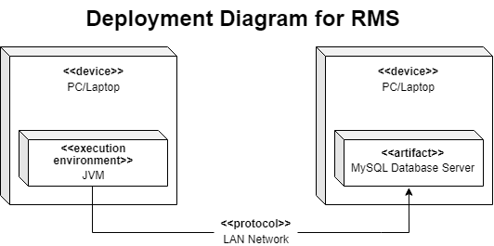
Deployment Diagram for RMS:

Use Cases and Usage Scenarios

UML Use Case Diagram:
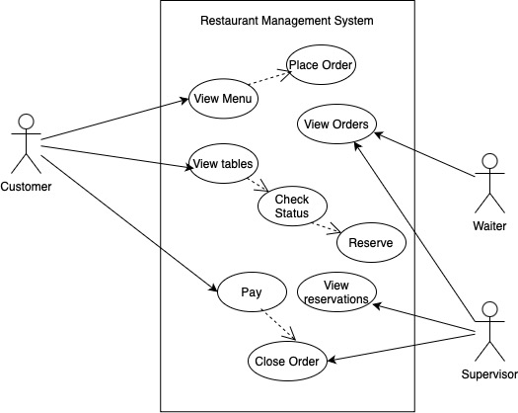

UML Activity Diagram:

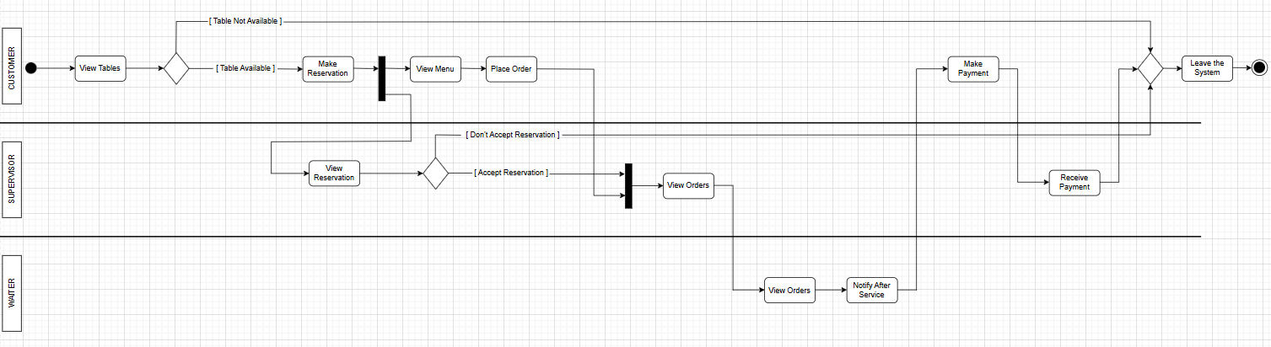

System Requirements Specification

SRS-RMS-001.1
RMS shall enable customers to view the availability of tables until one week later.

SRS-RMS-001.2
RMS shall enable customers to view the features of the tables for reservation.

SRS-RMS-002.1
RMS shall ensure that userID that entered must be an existing userID.

SRS-RMS-003.1
RMS shall enable customers to view the following information regarding tables:
- real-time availability
- table view
- table capacity

SRS-RMS-003.2
RMS shall prevent the customer from reserving a table that is not available at the current time.

SRS-RMS-004.1
RMS shall ensure that the total payment amount will be calculated according to the customer's selections.

SRS-RMS-004.2
The system shall prevent the supervisor from closing an order if the customer does not pay.

SRS-RMS-005.1
RMS shall enable the waiter and supervisor to view the status of an order.

