NovaStore E-Ticaret Veri Yonetim Sistemi
SQL Server proje raporu
Bilgi | Deger
Hazirlayan | Mert Gulseren
Veri tabani | NovaStoreDB
Platform | Microsoft SQL Server
Kapsam | DDL, DML, raporlama sorgulari, VIEW ve yedekleme
Bu rapor, NovaStore icin iliskisel veri tabanini kurar, ornek verilerle doldurur ve yonetim raporlarini hazirlar. Ekli SQL dosyasi butun adimlari yorum satirlariyla aciklar; asagidaki bolumler tasarim kararlarini ve ornek sorgu sonuclarini ozetler.

1. Veri modeli
Kategoriler urunleri, musteriler siparisleri, siparisler de siparis detaylarini baglar. OrderDetails tablosu siparisler ile urunler arasindaki coktan-coka iliskiyi cozerek her siparisteki urun ve miktari tutar. Kimlik alanlari IDENTITY(1,1) ile otomatik artar; e-posta benzersizdir.

Tablo ve iliski ozeti
Tablo | Birincil anahtar | Yabanci anahtar / kural
Categories | CategoryID | CategoryName benzersiz
Products | ProductID | CategoryID -> Categories
Customers | CustomerID | Email benzersiz
Orders | OrderID | CustomerID -> Customers
OrderDetails | DetailID | OrderID -> Orders; ProductID -> Products

2. Ornek veri
Ornek veri setinde 5 kategori, 12 urun, 6 musteri, farkli tarihlerde 10 siparis ve 16 siparis detayi bulunur. Siparis tutarlari ilgili urun fiyatlari ve miktarlariyla uyumludur. Script, kategori ve musteri eklemelerinde tekrar calistirmaya karsi kontrol icerir; ancak siparis tarihleri degistirilmedikce ayni seed kayitlari tekrar eklenmez.
Veri grubu | Adet
Kategori | 5
Urun | 12
Musteri | 6
Siparis | 10
Siparis detayi | 16

3. Raporlama sorgulari

Stok miktari 20 altinda olan urunler
WHERE kosulu stok miktarini 20 altinda tutar; ORDER BY Stock DESC dusuk stoklu urunleri once gosterir.
SELECT ProductName AS UrunAdi, Stock AS StokMiktari
FROM dbo.Products
WHERE Stock < 20
ORDER BY Stock DESC;

Musteri ve siparis listesi
INNER JOIN, sadece siparisi bulunan musterilerin kayitlarini getirir; musteri adi, sehir, tarih ve tutar birlikte goruntulenir.
SELECT c.FullName, c.City, o.OrderDate, o.TotalAmount
FROM dbo.Customers c
INNER JOIN dbo.Orders o ON o.CustomerID = c.CustomerID;

Ahmet Yilmaz urun raporu
Bes tablo zincirleme birlestirilerek musterinin siparis ettigi urun, birim fiyat ve kategori bulunur.
Customers -> Orders -> OrderDetails -> Products -> Categories

Kategori bazinda urun sayisi
LEFT JOIN urunu olmayan kategorileri de korur; COUNT(ProductID) ilgili kategoriye bagli urunleri sayar.

Musteri bazinda toplam ciro
SUM(TotalAmount), her musterinin siparis tutarlarini toplar. LEFT JOIN ve COALESCE, siparisi olmayan musterilerin de sifir ciro ile listelenmesini saglar.

Gecen gun hesabı
DATEDIFF(DAY, OrderDate, GETDATE()) her siparis tarihinden bugune kadar gecen gun sayisini hesaplar. Sonuc, scriptin calistirildigi gune gore degisir.
SELECT OrderID, OrderDate, DATEDIFF(DAY, OrderDate, GETDATE()) AS GecenGun
FROM dbo.Orders;

4. VIEW ve yedekleme

vw_SiparisOzet
View; musteri adi, siparis tarihi, urun adi ve adet alanlarini tek sorgulanabilir nesnede toplar.
CREATE OR ALTER VIEW dbo.vw_SiparisOzet AS
SELECT c.FullName, o.OrderDate, p.ProductName, od.Quantity
FROM dbo.Customers c
JOIN dbo.Orders o ON o.CustomerID = c.CustomerID
JOIN dbo.OrderDetails od ON od.OrderID = o.OrderID
JOIN dbo.Products p ON p.ProductID = od.ProductID;

Veri tabani yedegi
C:\Yedek klasoru SQL Server makinesinde onceden bulunmali ve SQL Server servis hesabinin klasore yazma izni olmalidir. Sonra asagidaki komut calistirilabilir:
BACKUP DATABASE NovaStoreDB
TO DISK = N'C:\Yedek\NovaStoreDB.bak'
WITH INIT, NAME = N'NovaStoreDB Full Backup';

5. SQL Server ekran goruntuleri
Yonergeteki teslim icin SSMS ekranindan tablo kayitlari ve sorgu sonuclari goruntulenmelidir. Asagidaki kontrol listesi, calistirmadan sonra alinacak ekran goruntulerini belirler:
Goruntu | SSMS ekraninda gosterilecek icerik
Tablo kayitlari | Categories, Products, Customers, Orders ve OrderDetails sorgu sonuclari
Rapor sorgulari | Bilesik JOIN, kategori urun sayisi, musteri cirosu ve DATEDIFF sonuclari
Iliskisel yapi | SSMS Database Diagrams ekraninda bes tablo ve PK/FK iliskileri
NovaStoreDB scripti MERT\SQLEXPRESS uzerinde calistirildi. Gercek sorgu sonuc gridleri ve SSMS Database Diagrams iliski gorunumu asagida sunulmustur.

Gercek SSMS calistirma sonuclari
Gonderilen ekran goruntuleri, NovaStoreDB scripti MERT\SQLEXPRESS uzerinde calistirildiktan sonra alinan gercek SSMS sorgu sonuclarini gosterir. Veritabani iliski diyagrami sonraki sayfada sunulmustur.
SSMS sorgu sonuclari 1 - stok, musteri siparisleri, Ahmet Yilmaz urunleri ve kategori sayilari
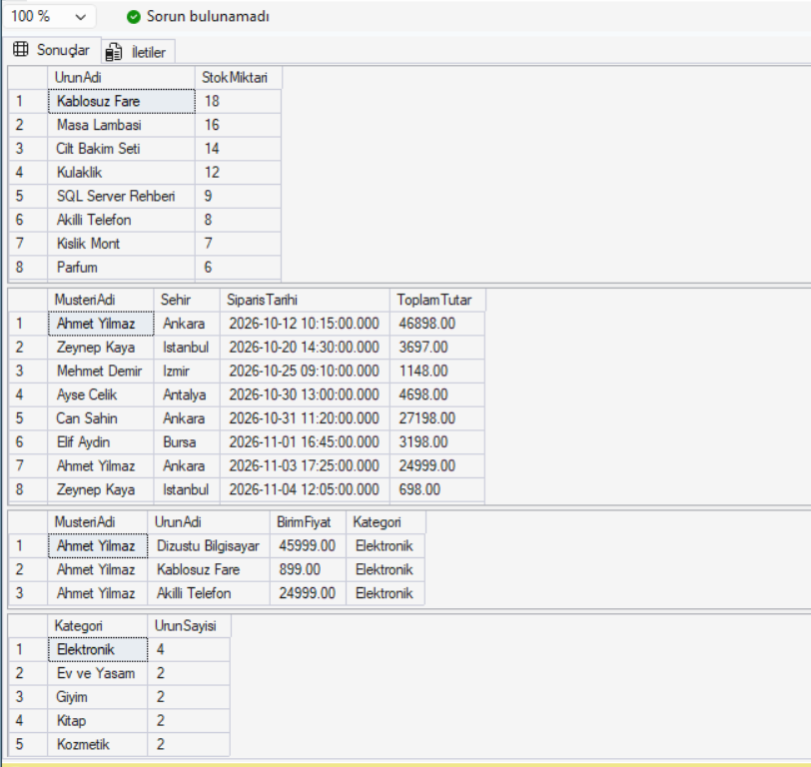
SSMS sorgu sonuclari 2 - musteri cirolari, gecen gun ve vw_SiparisOzet
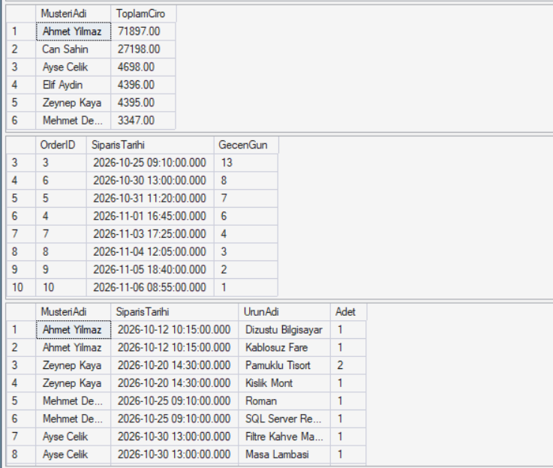
SSMS veritabani iliski diyagrami - Categories, Customers, Products, Orders ve OrderDetails
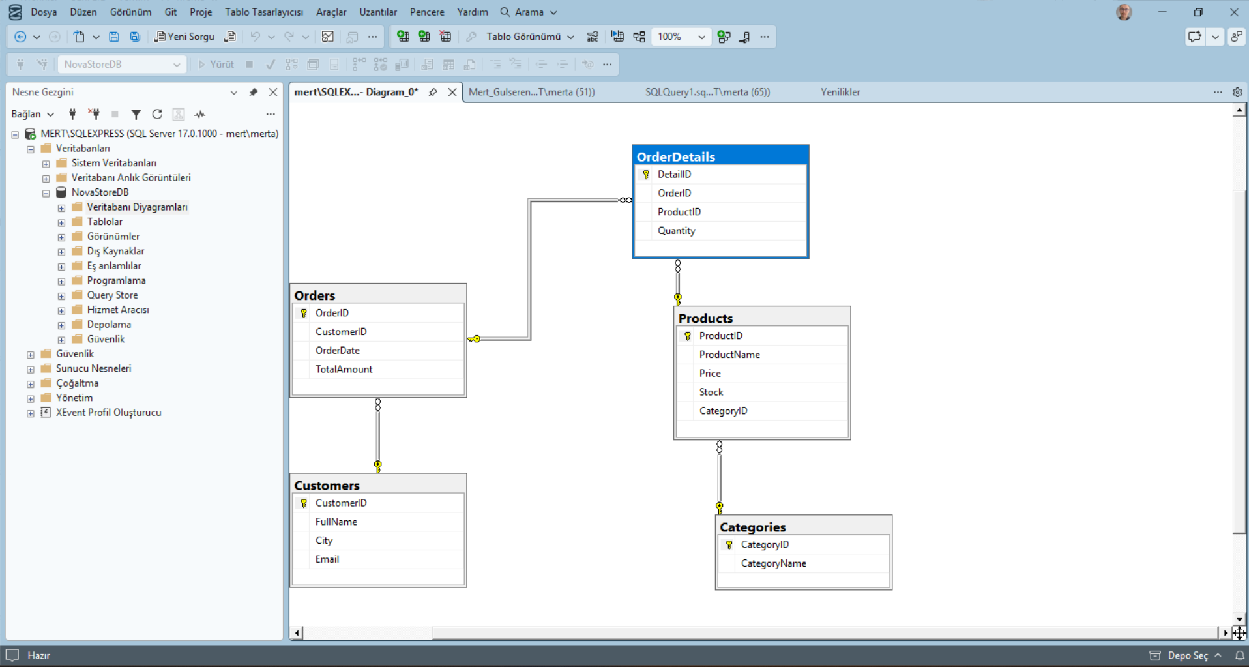

Ek A. Tum SQL kodu
Asagidaki kod, teslim edilecek .sql dosyasinin tam icerigidir. Kod kutusu biciminde duzenlenmistir; calistirilacak asil dosya .sql uzantisindaki teslim dosyasidir.
/* ================================================================
NovaStore E-Ticaret Veri Yonetim Sistemi
Hazirlayan: Mert Gulseren
Platform: Microsoft SQL Server
Calistirma: Bu dosyayi SSMS'te tek seferde calistirin.
================================================================ */
-- Bolum 1 - Veri tabanini olustur
IF DB_ID(N'NovaStoreDB') IS NULL
CREATE DATABASE NovaStoreDB;
GO
USE NovaStoreDB;
GO
-- Bolum 1 - Ana tablolar: Categories ve Customers
IF OBJECT_ID(N'dbo.Categories', N'U') IS NULL
BEGIN
CREATE TABLE dbo.Categories (
CategoryID int IDENTITY(1,1) NOT NULL CONSTRAINT PK_Categories PRIMARY KEY,
CategoryName varchar(50) NOT NULL CONSTRAINT UQ_Categories_CategoryName UNIQUE
);
END;
GO
IF OBJECT_ID(N'dbo.Customers', N'U') IS NULL
BEGIN
CREATE TABLE dbo.Customers (
CustomerID int IDENTITY(1,1) NOT NULL CONSTRAINT PK_Customers PRIMARY KEY,
FullName varchar(50) NOT NULL,
City varchar(20) NOT NULL,
Email varchar(100) NOT NULL CONSTRAINT UQ_Customers_Email UNIQUE
);
END;
GO
-- Bolum 1 - Categories tablosuna bagli urunler
IF OBJECT_ID(N'dbo.Products', N'U') IS NULL
BEGIN
CREATE TABLE dbo.Products (
ProductID int IDENTITY(1,1) NOT NULL CONSTRAINT PK_Products PRIMARY KEY,
ProductName varchar(100) NOT NULL,
Price decimal(10,2) NOT NULL CONSTRAINT CK_Products_Price CHECK (Price >= 0),
Stock int NOT NULL CONSTRAINT DF_Products_Stock DEFAULT (0),
CategoryID int NOT NULL,
CONSTRAINT FK_Products_Categories FOREIGN KEY (CategoryID)
REFERENCES dbo.Categories(CategoryID)
);
END;
GO
-- Bolum 1 - Siparis ana tablosu
IF OBJECT_ID(N'dbo.Orders', N'U') IS NULL
BEGIN
CREATE TABLE dbo.Orders (
OrderID int IDENTITY(1,1) NOT NULL CONSTRAINT PK_Orders PRIMARY KEY,
CustomerID int NOT NULL,
OrderDate datetime NOT NULL CONSTRAINT DF_Orders_OrderDate DEFAULT (GETDATE()),
TotalAmount decimal(10,2) NOT NULL CONSTRAINT CK_Orders_TotalAmount CHECK (TotalAmount >= 0),
CONSTRAINT FK_Orders_Customers FOREIGN KEY (CustomerID)
REFERENCES dbo.Customers(CustomerID)
);
END;
GO
-- Bolum 1 - Siparis ile urun arasindaki coktan-coka iliski
IF OBJECT_ID(N'dbo.OrderDetails', N'U') IS NULL
BEGIN
CREATE TABLE dbo.OrderDetails (
DetailID int IDENTITY(1,1) NOT NULL CONSTRAINT PK_OrderDetails PRIMARY KEY,
OrderID int NOT NULL,
ProductID int NOT NULL,
Quantity int NOT NULL CONSTRAINT CK_OrderDetails_Quantity CHECK (Quantity > 0),
CONSTRAINT FK_OrderDetails_Orders FOREIGN KEY (OrderID)
REFERENCES dbo.Orders(OrderID),
CONSTRAINT FK_OrderDetails_Products FOREIGN KEY (ProductID)
REFERENCES dbo.Products(ProductID),
CONSTRAINT UQ_OrderDetails_Order_Product UNIQUE (OrderID, ProductID)
);
END;
GO
-- Bolum 2 - 5 kategori
INSERT INTO dbo.Categories (CategoryName)
SELECT v.CategoryName
FROM (VALUES ('Elektronik'), ('Giyim'), ('Kitap'), ('Kozmetik'), ('Ev ve Yasam')) v(CategoryName)
WHERE NOT EXISTS (SELECT 1 FROM dbo.Categories c WHERE c.CategoryName = v.CategoryName);
GO
-- Bolum 2 - 12 urun, her kategoriye en az iki urun
INSERT INTO dbo.Products (ProductName, Price, Stock, CategoryID)
SELECT v.ProductName, v.Price, v.Stock, c.CategoryID
FROM (VALUES
('Akilli Telefon', 24999.00, 8, 'Elektronik'),
('Dizustu Bilgisayar', 45999.00, 5, 'Elektronik'),
('Kablosuz Fare', 899.00, 18, 'Elektronik'),
('Kulaklik', 2199.00, 12, 'Elektronik'),
('Pamuklu Tisort', 599.00, 25, 'Giyim'),
('Kislik Mont', 2499.00, 7, 'Giyim'),
('Roman', 349.00, 30, 'Kitap'),
('SQL Server Rehberi', 799.00, 9, 'Kitap'),
('Cilt Bakim Seti', 1299.00, 14, 'Kozmetik'),
('Parfum', 1899.00, 6, 'Kozmetik'),
('Filtre Kahve Makinesi', 3499.00, 4, 'Ev ve Yasam'),
('Masa Lambasi', 1199.00, 16, 'Ev ve Yasam')
) v(ProductName, Price, Stock, CategoryName)
JOIN dbo.Categories c ON c.CategoryName = v.CategoryName
WHERE NOT EXISTS (SELECT 1 FROM dbo.Products p WHERE p.ProductName = v.ProductName);
GO
-- Bolum 2 - 6 musteri
INSERT INTO dbo.Customers (FullName, City, Email)
SELECT v.FullName, v.City, v.Email
FROM (VALUES
('Ahmet Yilmaz', 'Ankara', 'ahmet.yilmaz@example.com'),
('Zeynep Kaya', 'Istanbul', 'zeynep.kaya@example.com'),
('Mehmet Demir', 'Izmir', 'mehmet.demir@example.com'),
('Elif Aydin', 'Bursa', 'elif.aydin@example.com'),
('Can Sahin', 'Ankara', 'can.sahin@example.com'),
('Ayse Celik', 'Antalya', 'ayse.celik@example.com')
) v(FullName, City, Email)
WHERE NOT EXISTS (SELECT 1 FROM dbo.Customers c WHERE c.Email = v.Email);
GO
-- Bolum 2 - 10 siparis, farkli tarihlerde
INSERT INTO dbo.Orders (CustomerID, OrderDate, TotalAmount)
SELECT c.CustomerID, v.OrderDate, v.TotalAmount
FROM (VALUES
('ahmet.yilmaz@example.com', CONVERT(datetime,'2026-10-12T10:15:00',126), 46898.00),
('zeynep.kaya@example.com', CONVERT(datetime,'2026-10-20T14:30:00',126), 3697.00),
('mehmet.demir@example.com', CONVERT(datetime,'2026-10-25T09:10:00',126), 1148.00),
('elif.aydin@example.com', CONVERT(datetime,'2026-11-01T16:45:00',126), 3198.00),
('can.sahin@example.com', CONVERT(datetime,'2026-10-31T11:20:00',126), 27198.00),
('ayse.celik@example.com', CONVERT(datetime,'2026-10-30T13:00:00',126), 4698.00),
('ahmet.yilmaz@example.com', CONVERT(datetime,'2026-11-03T17:25:00',126), 24999.00),
('zeynep.kaya@example.com', CONVERT(datetime,'2026-11-04T12:05:00',126), 698.00),
('elif.aydin@example.com', CONVERT(datetime,'2026-11-05T18:40:00',126), 1198.00),
('mehmet.demir@example.com', CONVERT(datetime,'2026-11-06T08:55:00',126), 2199.00)
) v(Email, OrderDate, TotalAmount)
JOIN dbo.Customers c ON c.Email = v.Email
WHERE NOT EXISTS (
SELECT 1 FROM dbo.Orders o
WHERE o.CustomerID = c.CustomerID AND o.OrderDate = v.OrderDate
);
GO
-- Bolum 2 - Siparis detaylari; tutarlar Orders.TotalAmount ile uyumludur
INSERT INTO dbo.OrderDetails (OrderID, ProductID, Quantity)
SELECT o.OrderID, p.ProductID, v.Quantity
FROM (VALUES
('ahmet.yilmaz@example.com', '2026-10-12T10:15:00', 'Dizustu Bilgisayar', 1),
('ahmet.yilmaz@example.com', '2026-10-12T10:15:00', 'Kablosuz Fare', 1),
('zeynep.kaya@example.com', '2026-10-20T14:30:00', 'Kislik Mont', 1),
('zeynep.kaya@example.com', '2026-10-20T14:30:00', 'Pamuklu Tisort', 2),
('mehmet.demir@example.com', '2026-10-25T09:10:00', 'SQL Server Rehberi', 1),
('mehmet.demir@example.com', '2026-10-25T09:10:00', 'Roman', 1),
('elif.aydin@example.com', '2026-11-01T16:45:00', 'Cilt Bakim Seti', 1),
('elif.aydin@example.com', '2026-11-01T16:45:00', 'Parfum', 1),
('can.sahin@example.com', '2026-10-31T11:20:00', 'Akilli Telefon', 1),
('can.sahin@example.com', '2026-10-31T11:20:00', 'Kulaklik', 1),
('ayse.celik@example.com', '2026-10-30T13:00:00', 'Filtre Kahve Makinesi', 1),
('ayse.celik@example.com', '2026-10-30T13:00:00', 'Masa Lambasi', 1),
('ahmet.yilmaz@example.com', '2026-11-03T17:25:00', 'Akilli Telefon', 1),
('zeynep.kaya@example.com', '2026-11-04T12:05:00', 'Roman', 2),
('elif.aydin@example.com', '2026-11-05T18:40:00', 'Pamuklu Tisort', 2),
('mehmet.demir@example.com', '2026-11-06T08:55:00', 'Kulaklik', 1)
) v(Email, OrderDateText, ProductName, Quantity)
JOIN dbo.Customers c ON c.Email = v.Email
JOIN dbo.Orders o ON o.CustomerID = c.CustomerID
AND o.OrderDate = CONVERT(datetime, v.OrderDateText, 126)
JOIN dbo.Products p ON p.ProductName = v.ProductName
WHERE NOT EXISTS (
SELECT 1 FROM dbo.OrderDetails od
WHERE od.OrderID = o.OrderID AND od.ProductID = p.ProductID
);
GO
-- Bolum 3.1 - Stoku 20'den az urunleri stok miktarina gore azalan sirala
SELECT ProductName AS UrunAdi, Stock AS StokMiktari
FROM dbo.Products
WHERE Stock < 20
ORDER BY Stock DESC;
GO
-- Bolum 3.2 - Musteri ve siparis bilgileri
SELECT c.FullName AS MusteriAdi, c.City AS Sehir,
o.OrderDate AS SiparisTarihi, o.TotalAmount AS ToplamTutar
FROM dbo.Customers c
INNER JOIN dbo.Orders o ON o.CustomerID = c.CustomerID
ORDER BY o.OrderDate;
GO
-- Bolum 3.3 - Ahmet Yilmaz'in aldigi urunler ve kategoriler
SELECT c.FullName AS MusteriAdi, p.ProductName AS UrunAdi,
p.Price AS BirimFiyat, cat.CategoryName AS Kategori
FROM dbo.Customers c
INNER JOIN dbo.Orders o ON o.CustomerID = c.CustomerID
INNER JOIN dbo.OrderDetails od ON od.OrderID = o.OrderID
INNER JOIN dbo.Products p ON p.ProductID = od.ProductID
INNER JOIN dbo.Categories cat ON cat.CategoryID = p.CategoryID
WHERE c.FullName = 'Ahmet Yilmaz'
ORDER BY o.OrderDate, p.ProductName;
GO
-- Bolum 3.4 - Kategorilere gore urun sayisi (urunsuz kategoriler de gorunur)
SELECT c.CategoryName AS Kategori, COUNT(p.ProductID) AS UrunSayisi
FROM dbo.Categories c
LEFT JOIN dbo.Products p ON p.CategoryID = c.CategoryID
GROUP BY c.CategoryID, c.CategoryName
ORDER BY c.CategoryName;
GO
-- Bolum 3.5 - Musteri bazinda toplam ciro; siparisi olmayanlar da 0 ile listelenir
SELECT c.FullName AS MusteriAdi,
COALESCE(SUM(o.TotalAmount), 0.00) AS ToplamCiro
FROM dbo.Customers c
LEFT JOIN dbo.Orders o ON o.CustomerID = c.CustomerID
GROUP BY c.CustomerID, c.FullName
ORDER BY ToplamCiro DESC, c.FullName;
GO
-- Bolum 3.6 - Her siparisin bugune gore kac gun once verildigi
SELECT o.OrderID, o.OrderDate AS SiparisTarihi,
DATEDIFF(DAY, o.OrderDate, GETDATE()) AS GecenGun
FROM dbo.Orders o
ORDER BY o.OrderDate;
GO
-- Bolum 4.1 - Siparis ozet gorunumu
CREATE OR ALTER VIEW dbo.vw_SiparisOzet
AS
SELECT c.FullName AS MusteriAdi, o.OrderDate AS SiparisTarihi,
p.ProductName AS UrunAdi, od.Quantity AS Adet
FROM dbo.Customers c
INNER JOIN dbo.Orders o ON o.CustomerID = c.CustomerID
INNER JOIN dbo.OrderDetails od ON od.OrderID = o.OrderID
INNER JOIN dbo.Products p ON p.ProductID = od.ProductID;
GO
-- View'i goruntulemek icin:
SELECT * FROM dbo.vw_SiparisOzet ORDER BY SiparisTarihi, MusteriAdi;
GO
-- Bolum 4.2 - Yedekleme
-- Once C:\Yedek klasorunu olusturun ve SQL Server servis hesabina yazma izni verin.
-- Ardindan asagidaki komutun yorum isaretlerini kaldirip calistirin:
-- BACKUP DATABASE NovaStoreDB
-- TO DISK = N'C:\Yedek\NovaStoreDB.bak'
-- WITH INIT, NAME = N'NovaStoreDB Full Backup';
GO

