Report

PID 4996

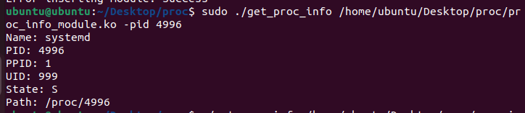
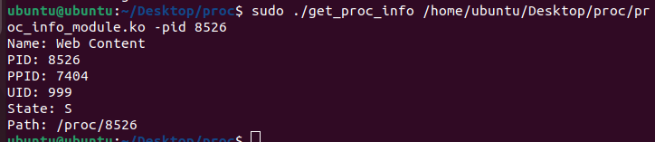
PID 8526

PID 1149

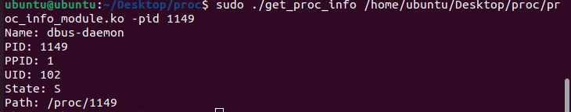

PID 1306

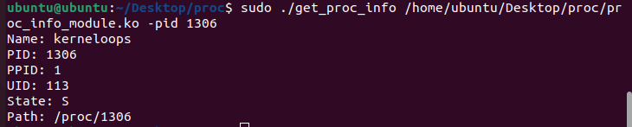
PID 1118

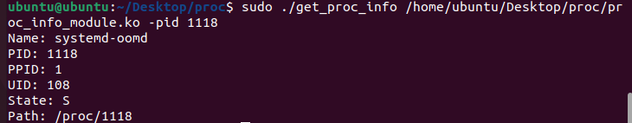
PID 1145
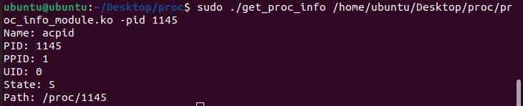

ps aux (all running commands)(Some part)

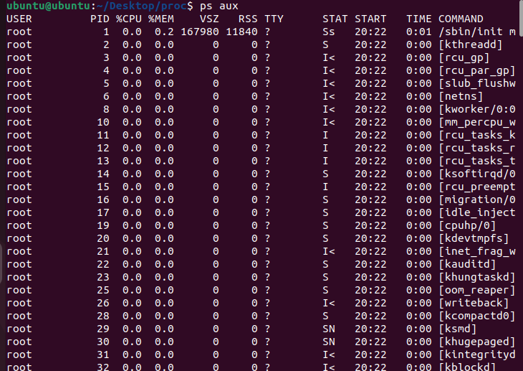

Step By Step Implementation

1- Use make command in your /proc directory where both of the c files are located

2- Upon using make command there must be a file that has .ko extension

3- Use gcc get_proc_info.c -o get_proc_info command to create executable file

4- Use ./get_proc_info /path/to/proc_info_module.ko -pid 1234 command to execute the .ko file to get process’ information to the console,

*Note please be aware that if you do not give executable a permission it will not work use chmod +x or sudo command usually insmod requires a root permisson so using sudo is recommended.

proc_info_module:

Linux Kernel Module written in C language, creates a file under the /proc directory named "proc_info_module" upon initialization. The /proc directory is a pseudo-file system in Linux that holds information about system properties, including the currently running processes. This file can be used to get information about a particular process either by its PID (Process ID) or by its name.

1. **Module Parameters (PID or Process Name)**: At the beginning of the file, two module parameters are declared, `upid` and `upname`, which represent the User Process ID and User Process Name, respectively. These can be passed as arguments when loading the module with the `insmod` command.

2. **Process Information Display**: The `proc_info_module_show` function prints the process's name, PID, Parent PID, User ID, Memory usage (if it's currently running), its state, and the path to its proc file to the proc file created by this module.

3. **Opening the proc file**: The `proc_info_module_open` function is used as the handler when the proc file created by this module is opened.

4. **proc_ops struct**: The `proc_info_module_fops` struct contains the function pointers needed for handling operations on the proc file created by this module.

5. **Module Initialization**: The `proc_info_module_init` function is called when the module is loaded into the kernel. This function first checks if a PID or process name is given and tries to find the task with the given PID or name. If a process with the given PID or name is not found, it returns an error. After that, it creates a proc file named "proc_info_module". If the proc file cannot be created, it also returns an error.

6. **Module Exit**: The `proc_info_module_exit` function is called when the module is removed from the kernel. This function removes the proc file created by the module.

get_proc_info:

C program that acts as a wrapper for interacting with a hypothetical Linux Kernel Module, named `proc_info_module`. This module is presumably designed to provide some information about a specific process. The interaction can be done either via the process ID (PID) or the process name. The code works as follows:

1. Checks the number of command-line arguments. It expects four arguments, including the executable itself.

2. If the number of arguments is not four, it returns an error message and exits with a status code of 1.

3. It checks if the second argument (argv[2]) is "-pid" or "-pname". These are options specifying whether the user wants to interact with the module using the PID or the process name.

4. Depending on the option, it builds a command string `cmd` to insert the kernel module with the corresponding option and argument. The command will look like `insmod [module name] upid=[PID]` or `insmod [module name] upname=[pname]`.

5. It then tries to execute the command using the `system()` function. If the command fails, it prints an error message and exits with a status code of 1.

6. After successfully inserting the module, it tries to open the `/proc/proc_info_module` file. This file is assumed to be created by the kernel module to provide the requested process information.

7. It then reads this file line by line and prints each line to the standard output.

8. Once it's done reading, it closes the file and attempts to remove the module using the `rmmod` command.

9. If removing the module fails, it prints an error message and exits with a status code of 1.

10. If everything completes successfully, the program exits with a status code of 0, indicating success.

