# Lab: Polymorphism

Problems for the ["C# OOP Basics" course @ SoftUni](https://softuni.bg/trainings/2084/csharp-oop-basics-october-2018)".

You can check your solutions here: <https://judge.softuni.bg/Contests/680/Polymorphism-Lab>.

## MathOperation

**NOTE**: You need a public StartUp class with the namespace Operations.

Create a class **MathOperations**, which should have 3 times method Add(). Method Add() has to be invoked with:

* Add(int, int): **int**
* Add(double, double, double): **double**
* Add(decimal, decimal, decimal): **decimal**

You should be able to use the class like this:

|  |
| --- |
| StartUp.cs |
| public static void Main()  {  MathOperations mo = new MathOperations();  Console.WriteLine(mo.Add(2, 3));  Console.WriteLine(mo.Add(2.2, 3.3, 5.5));  Console.WriteLine(mo.Add(2.2m, 3.3m, 4.4m));  } |

### Examples

|  |
| --- |
| Output |
| 5  11  9.9 |

### Solution

Created MathOperation class should look like this:

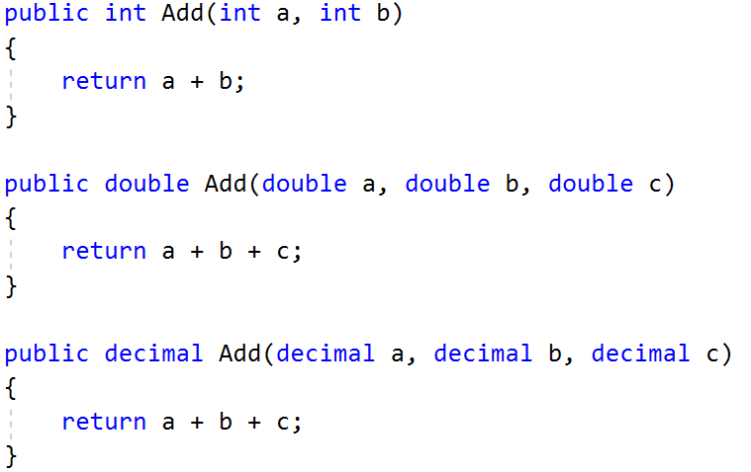

## Animals

**NOTE**: You need a public StartUp class with the namespace Animals.

Create a class Animal, which holds two fields:

* name: string
* favouriteFood: string

Animal has one virtual method ExplainSelf()**: string.**You should add two new classes - **Cat** and **Dog. Override** the ExplainSelf() method by adding concrete animal sound on a new line. (Look at examples below)

You should be able to use the class like this:

|  |
| --- |
| StartUp.cs |
| Animal cat = new Cat("Pesho", "Whiskas");  Animal dog = new Dog("Gosho", "Meat");  Console.WriteLine(cat.ExplainSelf());  Console.WriteLine(dog.ExplainSelf()); |

### Examples

|  |  |
| --- | --- |
| **Input** | **Output** |
|  | I am Pesho and my fovourite food is Whiskas  MEEOW  I am Gosho and my fovourite food is Meat  DJAAF |

### Solution

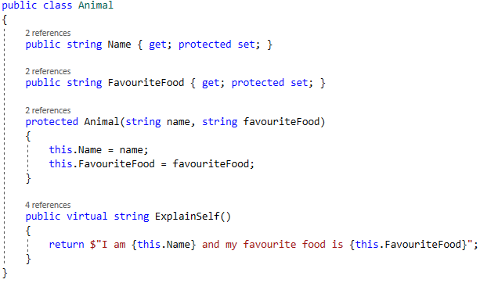

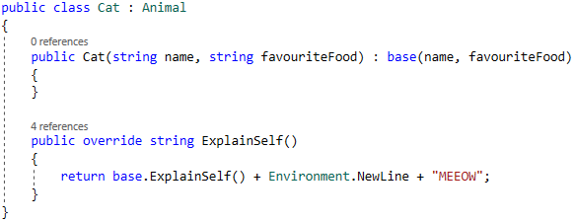

## Shapes

**NOTE**: You need a public StartUp class with the namespace Shapes.

Create a class hierarchy, starting with **abstract** class Shape:

* **Abstract methods:**
  + CalculatePerimeter(): double
  + CalculateArea(): double
* **Virtual methods**:
  + Draw(): string

Extend the Shape class with two children:

* **Rectangle**
* **Circle**

Each of them need to have:

* **Fields:** 
  + **height and width for Rectangle**
  + **radius for Circle**
* **Encapsulation for these fields**
* **A public constructor**
* **Concrete methods for calculations (perimeter and area)**
* **Override methods for drawing**