**CSE581 Project Assignment Phase 2 Report**

**Hazırlayanlar:** 20COMP5004 Özay Ezerceli – 20COMP5003 Mertali Köprülü

For the second phase of the software testing project, we have set up BDD (Behavior-driven Development) Framework with Cucumber. Cucumber provided us to test our project by using text language. Therefore, tests are easy to understand. We have used Gherkin and it makes the text structured as understandable for Cucumber. The following is the structure of our project (Figure 1).

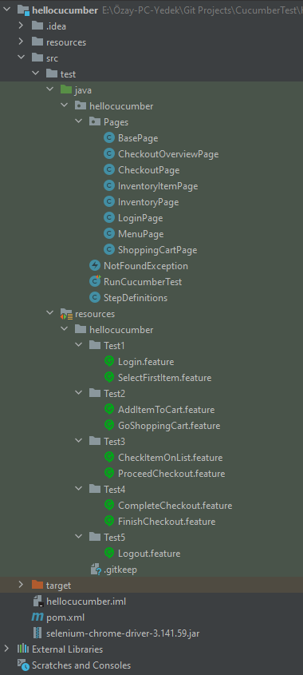

Figure File Structure of the Project

We have pages that done from the phase one. After we build the BDD framework, we have continued by creating our .feature files. Since we have recognized that feature files run in lexical order, we have packaged all of them to make them run in the order of we want when we start to test. In the each .feature file, we have typed Feature in which shows the functionality will be tested. We have scenario and depending on the scenario, we have Given, When, and Then statements to define steps of the test process. Because for each statement we have defined, we would implement a method for the test. We have completed to write .feature files according to the given scenario of the project. Then, we continued with creating step definitions. We have crated class for it and started to implement methods. In the step definitions, we have used some operations that we have already implemented for the phase one. Each .feature file we have implemented three methods which are with three different annotations (@Given, @When, @Then). We have declared some attributes as classes attributes to use them in the methods that wherever we need like driver, currentURL, generally pages etc. All methods are related with the context that written in the scenarios. Finally, we have created “RunCucumberTest” class which we can run the class and test our methods in the step definitions in order. We have tested our methods correctly and showed in the Figure 2 below:

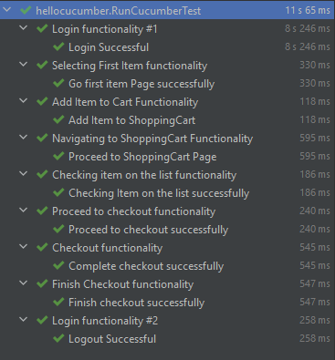

Figure Test Results of Projects