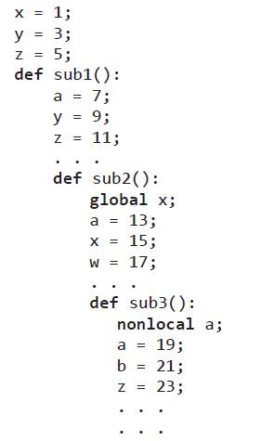**1-)**

For Sub1: The variables that can be visible in sub1 is basically local variables of itself in additionally upper(main’s) variable if the names are same and no called the variable as global so take the local ones. Therefore; x = 1(main), y = 9 (sub1), z = 11(sub1), a = 7(sub1)

For Sub2: As I explained in above the locals has to be taken it there is no global calling, but the x is in here. Therefore: x =15(sub2), a = 13(sub2), w = 17(sub2), y = 9(sub1), z=11(sub1).

For Sub3: Well in here we have declared the a is non-local so need to consider its value b = 21(sub3), a = 19(sub3), z = 23(sub3), w = 17(sub 2), x = 15(sub2), y=9(sub1).

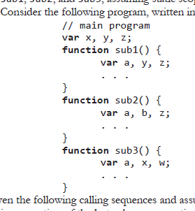2-)

a**) main calls sub1; sub1 calls sub2; sub2 calls sub3**;

So, we need to look at the variables that can be seen by last called function.

A(sub3), b(sub2), z(sub2), w(sub3), x(sub3), y(sub1)

**b) main calls sub1; sub1 calls sub3;**

So again the because of the same reason we need to look through variables that declared on last function which is sub3.

A(sub3),x(Sub3),W(sub3),y(sub1),z(sub1).