Small-scale Remote Controlled RC Car

Inhoud

Voorwoord 3

inleiding 3

Blokschemas 3

Controller 3

Truck 3

Voltage levels 4

Hardware 4

Schematics 4

Electrical 4

PCB 4

CAD 4

RF module 5

Micro controler 5

Drive 5

ESC 5

Motor 5

Servo 5

Mechanische realisatie 5

Band overbrenging 5

Wielen 5

Hexdrive 5

Behuizing 5

Software 5

Testing modules 5

Flowchart 5

Logic 5

I/O 5

PWM 5

I²C SPI 5

RF 5

Besluit 6

Datasheets 6

Bronnen 6

# Voorwoord

# inleiding

# Blokschemas

## Controller

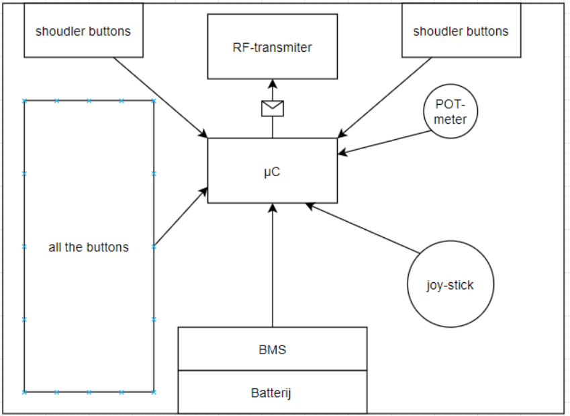

## Truck

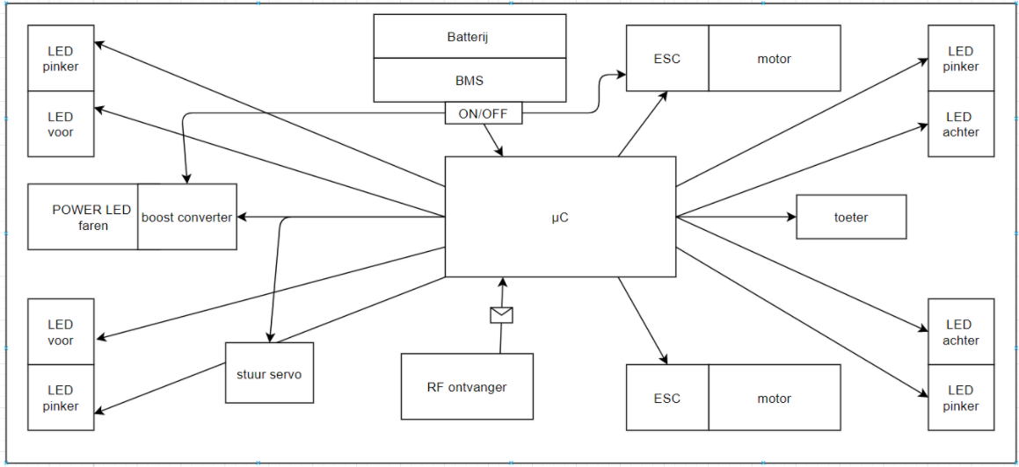

## Voltage levels

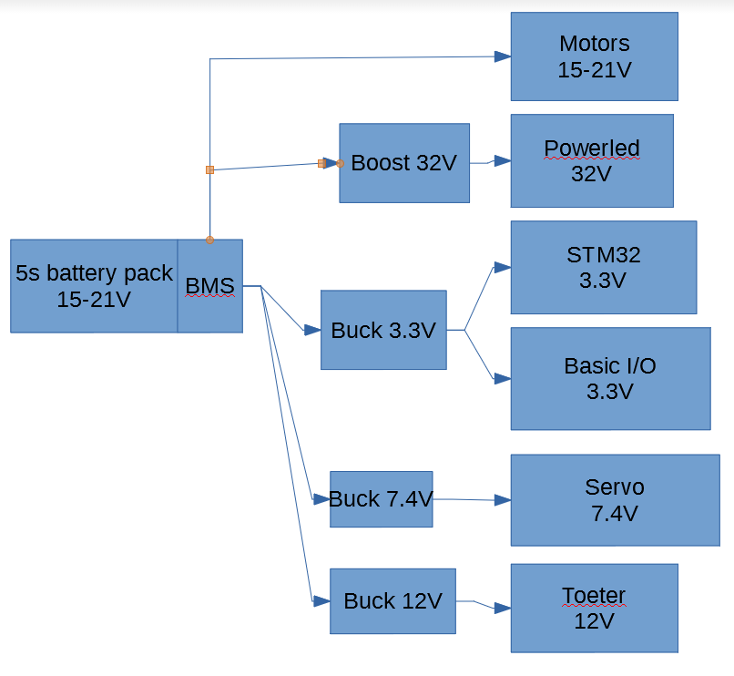

# Hardware

## Schematics

### Electrical

#### Controller

#### Truck

### PCB

#### Controller

#### Truck

### CAD

#### Controller

#### Truck

## RF module

NRF24L01+

## Micro controler

STM32F303R8T6

## Drive

### ESC

### Motor

### Servo

## Mechanische realisatie

### Band overbrenging

### Wielen

### Hexdrive

### Behuizing

# Software

## Testing modules

## Flowchart

## Logic

## I/O

### PWM

### I²C SPI

### RF

Eigen protocol  
voor langere range dan enhanced shockburst

# Besluit

# Datasheets

# Bronnen