**Consilium**

**Functional Requirements Document**

|  |  |  |  |
| --- | --- | --- | --- |
| **Version** | **Description of Change** | **Author** | **Date** |
| 1.0.0 | Functional requirements created | N/A | 10/21/2019 |
| 1.0.1 | Provided more context to the general user |  | 10/22/2019 |

**CONTENTS**

1 INTRODUCTION 4

1.1 Purpose 4

1.2 Scope 4

1.3 Background 4

1.4 References 4

1.5 Assumptions and Constraints 4

1.6 Document Overview 5

2 METHODOLOGY 5

3 FUNCTIONAL REQUIREMENTS 5

4.1 Context 5

4.2 User Requirements 5

4.3 Data Flow Diagrams 6

4.4 Logical Data Model/Data Dictionary 6

4.5 Functional Requirements 6

5 OTHER REQUIREMENTS 6

5.1 Interface Requirements 6

5.2 Data Conversion Requirements 7

5.3 Hardware/Software Requirements 7

5.4 Operational Requirements 7

APPENDIX A - GLOSSARY 11

1. **INTRODUCTION**

Procrastination and bad time management are the two most detrimental habits that inhibits or slows down your potential of achieving a successful life.The Consilium mobile application will enable you to add events and keep track of them by being notified.This will allow you to achieve maximum productivity daily and help develop better habits that will enhance your life.

## **Purpose**

The purpose of this document is to allow the stakeholder(s) to have an overview of the software’s usability requirements for full functionality and its utility that it will provide.

The Consilium mobile application will provide the user with a planning experience that will boost their productivity and time management skills. Through a To-do/Task orientated environment.

## **Scope**

This document deals with a consilium mobile planner application, this document ensures our project’s scope is accurately defined and mapped. The detailed set of deliverables are derived from the project and these deliverables are derived from project’s requirement. The processes used to accomplish its purpose were planning, controlling and finalizing ideas.

## **Background**

This document is being produced by the development team for the stakeholders/users that will be using the Consilium mobile application. This document is being produced to outline the method of designing this application and its limitations that will inhibit this application from functioning. This document will also outline the requirements for safe and friendly experience by having use cases.

## **References**

Github, Google Drive, Discord

## **Assumptions and Constraints**

### **Assumptions**

* Design/requirement changes to the applications that may happen. Delay deployment.
* Software and frameworks functionality may stop working. This will cause the application to be only on either iOS or Android platform rather than cross platform.

### **Constraints**

* Time constraint for completion. The overall time to complete this project from design,coding, and testing. Not having full functionality of functions other than the main ones.
* Knowledge of code. Using different coding languages and frameworks to develop the software.
* Resources: In terms of the amount of people writing clean and efficient code. This will also influence the time constraint.

## **Document Overview**

[Provide a description of the document organization.]

1. **METHODOLOGY**

[Describe the overall approach used in the determination of the FRD contents. Describe the modeling method(s) so non-technical readers can understand what they are conveying.]

The overall approach

1. **FUNCTIONAL REQUIREMENTS**

## **Context**

[Provide a context diagram of the system, with explanations as applicable. The context of a system refers to the connections and relationships between the system and its environment.]

**Exhibit 2 - Generic Context Diagram**

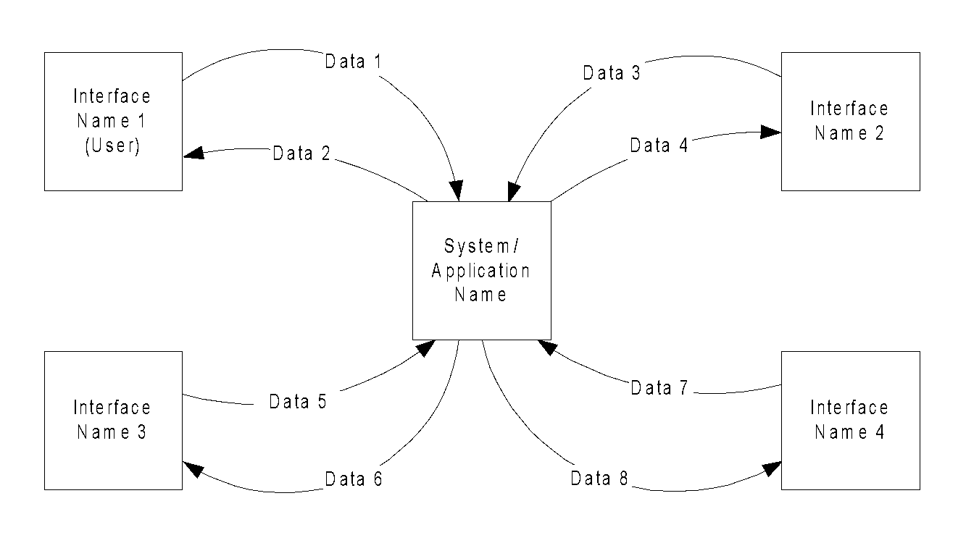

## **User Requirements**

A user of Consilium is a person that has busy days and needs something to keep track of their activities. Examples of users are: Students, Freelancers, and managers. A student may want to use the To-do list as a way to track what dealines to prioritize. A freelancer may use Consilium as a way to schedule their jobs and projects. A manager may use the calendar function to schedule meetings and may use the To-do list to track what needs to be prepared. All users will only be able to manipulate their own events/to-do lists.

A user can expect to enter their basic information such as their username and email to be given their calendar. A user can input a task or event and be expected to view their event in the calendar or to-do interface.

## **Data Flow Diagrams**

[Decompose the context level diagrams to determine the functional requirements. Data flow diagrams should be decomposed down to the functional primitive level. These diagrams are further decomposed during design.]

## **Logical Data Model/Data Dictionary**

[Create the initial Logical Data Model. Describe data requirements by providing data entities, decomposition, and definitions in a data dictionary. The data requirements describe the business data needed by the application system. Data requirements do not describe the physical database and are not at the level of identifying field names.]

## **Functional Requirements**

[List the functional requirements of the system.]

### **Functional Requirements Group 1**

[List the functional requirements for each functional requirements group.]

**Exhibit 4 - Sample Requirements Group 1**

|  |  |
| --- | --- |
| **Section/ Requirement ID** | **Requirement Definition** |
| FR1.0. | The system shall [parent requirement group 1]. |
| FR1.1 | The system shall [child/parent requirement]. |
| FR1.1.1 | The system shall [child requirement]. |
| FR1.1.2 | The system shall [child requirement]. |

### **Functional Requirements Group 2, Etc.**

1. **OTHER REQUIREMENTS**

[Describe the non-behavioral requirements.]

## **Interface Requirements**

The user interface that will be implemented are the list of *To Do’s / Events , Calendar , User Profile*. User can interact with the interface by adding the event thus the modal can update the view on the *To Do’s and Calendar* interfaces. The *User profile* will give the user the customizability of the overall UI .

### **Hardware Interfaces**

This mobile application will be cross platform, thus will be available for iOS and Android users.

### **Software Interfaces**

[Name the applications with which the subject application must interface. State the following for each such application: name of application, external owner of application, interface details (only if determined by the other application).

It is acceptable to reference an interface control document for details of the interface interactions.]

### **Communications Interfaces**

Possibility: Communicate with UR self service.

## **Data Conversion Requirements**

To have the user to agree to display their email and name onto the app.

## **Hardware/Software Requirements**

To make this application functional for both iOS and Android this will be developed using Ionic Framework , Cordova , Angular JS, CSS. This cross platform application can access some of the mobile devices built in functions such as calendar, camera, etc.. . Cordova allows us to develop applications with HTML5, CSS, and javascript. Though we will be using AngularJS to make the application more functional and design wise better. Backend we will be using MySQL and PHP.

## **Operational Requirements**

[Provide the operational requirements in this section.

Do not state how these requirements will be satisfied. For example, in the Reliability section, answer the question, “How reliable must the system be”? Do not state what steps will be taken to provide reliability.

Distinguish preferences from requirements. Requirements are based on business needs, preferences are not. If, for example, the user requires a special response but does not have a business-related reason for it, that requirement is a preference.

Other applicable requirements on system attributes may be added to the list of subsections below.]

### **Security and Privacy**

A. State the consequences of the following breaches of security in the subject application:

1. Loss or corruption of data

Loss or corruption of data will clear their future events, thus nothing will show in the calendar or the list of events.Also may lose account information.

1. Disclosure of secrets or sensitive information

This application will only require the sensitive information of the user’s email address, thus the consequences may be spam sent to their email. If the user’s account is hacked then information about the user’s schedule will have the possibility of being leaked.

1. Disclosure of privileged/privacy information about individuals

Email and first name will be exposed

1. Corruption of software or introduction of malware, such as viruses

If this software is introduced to viruses or malware this will affect the user’s OS on their mobile device.

1. State the type(s) of security required. Include the need for the following as appropriate:
2. Physical security.

N/A

1. Access by user role or types.

To access this application users can sign up for this application. Signing up is not mandatory for operational use.

1. State access control requirements by data attribute. For example, one group of users has permission to view an attribute but not update it while another group of users has permissions to update or view it.

This application will be independent thus other users will not be able to interact with other user’s schedule.

1. State access requirements based on system function. For example, if there is a need to grant access to certain system functions to one group of users, but not to another. For example, "The system shall make Function X available to the System Administrator only". The functionality of this such as the *Add Event* , and *Calendar* can be accessed by user.
2. State if there is a need for certification and accreditation of the security measures adopted for this application] N/A

*The Security Section describes the need to control access to the data. This includes controlling who may view and alter application data.*

### **Audit Trail**

[List the activities recorded in the application’s audit trail. For each activity, list the data recorded.]

**Add_Event** function will record the following data:

* Title of event
* description of event
* date-start and date-end
* tag
* priority
* location

**Sign up** function will record the following data:

* Name
* Email
* Password
* Confirm password

**edit Event** function will record the following data:

* New title of event
* New description of event
* New date-start and date-end
* New tag
* New priority
* New location

### **Reliability**

A. [State the following in this section:

1. State the damage can result from failure of this system—indicate the criticality of the software, such as:
2. Loss of human life N/A
3. Complete or partial loss of the ability to perform a mission-critical function

N/A

1. Loss of revenue

N/A

1. Loss of employee productivity

No damage to the mobile device or user if the system fails

1. What is the minimum acceptable level of reliability?

The minimum acceptable level of reliability is 0.7.

B. State required reliability:

1. Mean-Time-Between-Failure is the number of time units the system is operable before the first failure occurs.
2. Mean-Time-To-Failure is the number of time units before the system is operable divided by the number of failures during the time period.
3. Mean-Time-To-Repair is the number of time units required to perform system repair divided by the number of repairs during the time period.]

*Reliability is the probability that the system processes work correctly and completely without being aborted.*

### **Recoverability**

A. In the event the application is unavailable ```````````````````````````````````````````````````````````````````````````` ` to users (down) because of a system failure, how soon after the failure is detected must function be restored? If the system fails then the time frame for the system to be running again should be within an hour being the best case, the worst case would be a day.

B. In the event the database is corrupted, to what level of currency must it be restored? For example “The database must be capable of being restored to its condition of no more than 1 hour before the corruption occurred”.

If the database becomes corrupted then the previous version that the application can return would be a complete wipe since you can go back to previous version though events from the past will be there which will be a hindrance.

C. If the processing site (hardware, data, and onsite backup) is destroyed, how soon must the application be able to be restored?]

*Recoverability is the ability to restore function and data in the event of a failure.*

### **System Availability**

System availability will be everyday 24 hours since this will allow the user to add events whenever they want and will be able to see the events on the calendar or the list display.

### **General Performance**

[Describe the requirements for the following:

A. Response time for queries and updates

Response times should be fast pulling and pushing information out would require resources and knowledge.

B. Throughput

C. Expected rate of user activity (for example, number of transactions per hour, day, or month, or cyclical periods)Users can add up an infinite events per day. Thus the expected user rate will be high. Detrimental to the speed of the application. This would require further research on daily planners.

Specific performance requirements, related to a specific functional requirement, should be listed with that functional requirement.]

### **Capacity**

[List the required capacities and expected volumes of data in business terms. Do not state capacities in terms of system memory requirements or disk space—if growth trends or projections are available, provide the]

The users for this app are for university students at the U of R and will cater to every student if possible to scale larger with the resources we have. The capacity hopefully can be of general purpose use for everybody.

### **Data Retention**

[Describe the length of time various forms of data must be retained and the requirements for its destruction.

For example, “The system shall retain application information for 3 years”. Different forms of data include: system documentation, audit records, database records, access records.]

Data that will be retained are events the user adds. These will show until the user is able to validate that they have completed the task/event. These events will also expire when the date has passed (24 hours after the scheduled event )

### **Error Handling**

Error handling system will be red text over form inputs if they are required and are empty then the user will not be able to proceed with the operation. This will occur in the function of adding events to their To Do’s/Calendar display. Error handling will also occur in sign up and login forms where required fields must be field to continue , in turn linked to validation.

### **Validation Rule**s

Validation of users’ login information:

Email and Passwords are required information to proceed to login.

Validation for Signing up

User has to enter their email, name ,password, and confirm password

Email will have to follow a specific format using Regex. Email cannot be null/empty and will have to contain ‘@’ sign.

Password will have to follow a specific format using Regex. One capital letter, minimum 8 characters long and a non-character.

Confirm password will have to match the password.

To *AddEvent* function the user will have to fill out the form given.

Title , description,tag ,date ,priority level,location.

### **Conventions/Standards**

[Describe system conventions and standards followed.

For example: Microsoft standards are followed for windows, Institute of Electrical and Electronics Engineers (IEEE) for data formats, etc.]

**APPENDIX A - GLOSSARY**

[Define terms, acronyms, and abbreviations used in the FRD.]

Regex: Regular Expressions

JS: Java script

UI:User interface

N/A: Not applicable

UR: University of Regina