Our code takes form in ionic and angular javascript; a variation of HTML and javascript. As a group we tried our best to follow the style guide given to us. We also implemented some web development formatting principles from other classes to keep the code clean. However, despite our best efforts our code is not as clean as we would have liked it to be.

To keep our code Orthogonal we separated each of the page components in their different files. This promotes Decoupling as we can make changes in any file and it will not affect the base functionality of the other files.

Knowing that the programming language was unfamiliar to all of us we pushed our focus on the functionality of the app and creating our MVPs. We tested different styles in our html files with inline styling. We attempted to separate some of the styling from the html file however, we kept the majority of our inline styling as delivering the needs for the MVPs was a higher priority. Some of the tutorial comments were left for all of us to reference when coding. Features that were first coded into our application were left with non-descriptive names such as tab1, tab2, and tab3 etc.

An improvement from the last Milestone was that new features are more readable as they are more spaced out and page components have more descriptive names. We have also added more consistency with our naming convention as we labeled most of our variables in camel case. In addition to adding consistency we adhered to modern html programming by organizing our html content in div tags and only formatting content in a table format when it is sensible to.

Fig. 1 example of milestone 3 Div Fig. 2 example of milestone 4 Div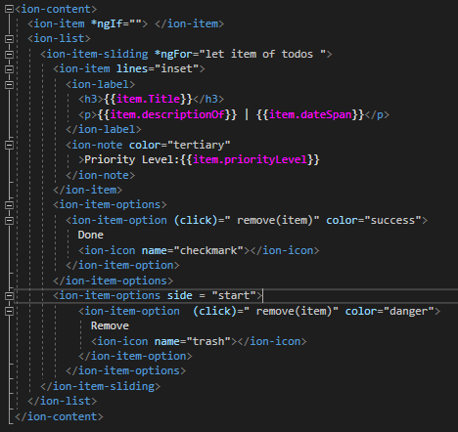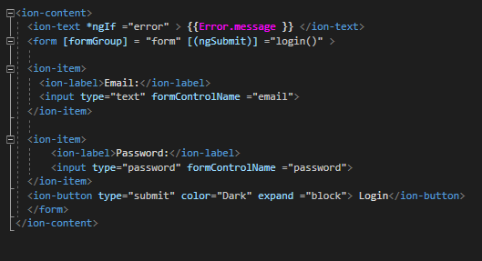

In conclusion, due to our unfamiliarity of the coding language and time constraints we were not able to write clean code as demonstrated in our classes. Our code adheres to some of the good practices of modern web development. We embraced the scrum MVP mindset and heavily prioritized reaching our MVP goals. However we left inconsistencies in our code and left some of our styling coupled. We acknowledge our mistakes and if given more time to work on this project we would have a dedicated person in charge of quality control. This would result in more reusable code and less time in the future debugging