IT Security and Threat Modelling
Securing, Attacking, and Defending an E-Commerce Order Protocol
Use Case: Shop-Td-Nexus — Critical Digital Infrastructure Exercise
Prepared by: Mert UCAR - 86049257
Role: Individual submission (Red Team & Blue Team)
Tools: Python, Scapy, PyCryptodome (RSA), Wireshark
PS: Every screenshot that has been used in this report is also accessible in screenshots file within the ZIP.

1. Problem Statement and Use-Case Story
Shop-Td-Nexus is a global e-commerce platform that processes millions of digital orders every day. Because it supports financial transactions, supply chains, and identity services, it is officially classified as critical digital infrastructure. The platform recently detected suspicious activity targeting its order-processing system, including fake customer identities submitting fraudulent orders, modified order details, replayed transactions, and traffic bursts just like denial-of-service attempts.
To assess risk exposure, this project carries out a controlled internal exercise in which a Red Team simulates realistic cyberattacks and a Blue Team designs protections, validates messages, and detects harmful activity. As an individual submission, both roles are performed by me, and the final report reflects on the work from both perspectives, as well as a combined risk evaluation.
The mission was to build, attack, and defend a secure order-communication protocol using Python, Scapy, RSA, and Wireshark, and to evaluate how these attacks expose risks to critical e-commerce infrastructure.

Tools and Technologies Used
- Python 3 — core implementation language
- Scapy — custom packet crafting and injection
- PyCryptodome — RSA key generation, signing, and verification
- Wireshark + Npcap — loopback traffic capture and analysis

2. System Design
The system centers on a custom OrderPacket format sent over UDP to 127.0.0.1 (loopback), representing communication within the Shop-Td-Nexus order-processing system. The workflow below summarises the end-to-end design used throughout this project.

Workflow
- 1. Customer builds an order (customer_id, order_id, item_id, quantity, timestamp).
- 2. The order data is signed with the customer's RSA private key, producing a signature.
- 3. The signed OrderPacket is sent over the network using Scapy.
- 4. Wireshark captures the traffic for inspection and evidence.
- 5. The receiving side (verify_order_packet) checks identity, signature, timestamp freshness, replay history, and request rate before accepting or rejecting the order.

3. Project Plan
The project was completed over a compressed multi-day schedule, following the natural dependency order of the assignment's nine tasks (each task builds on the previous one).
Day | Tasks completed | Weight
Day 1 | Task 1 (Environment Setup), Task 2 (Protocol Design), Task 3 (RSA Keys & Crypto Functions) | 25%
Day 2 | Task 4 (Scapy Implementation), Task 5 (Wireshark Capture & Analysis) | 30%
Day 3 | Task 6 (Attack Simulations), Task 7 (Security Controls), Task 8 (Evidence Collection), Task 9 (Final Report) | 45%

4. Task 1 — Environment Setup
What: Installed and verified all tools required for the exercise: Python 3, Scapy, PyCryptodome, and Wireshark with the Npcap driver.
Why: Every subsequent task depends on Scapys being able to craft and send raw packets, and on Wireshark being able to capture them; both require the Npcap packet-capture driver on Windows.
How: Installed Wireshark with the Npcap component enabled, then ran "pip install scapy pycryptodome" inside the project's Python environment. Verified Scapy by sending a test ICMP packet to 127.0.0.1 and confirmed Wireshark captured it on the loopback adapter.
Result: Scapy successfully sent a test packet ("Sent 1 packets."), and Wireshark's loopback capture, filtered with "icmp", showed the Echo Request/Reply pair, confirming the full toolchain was working end-to-end.
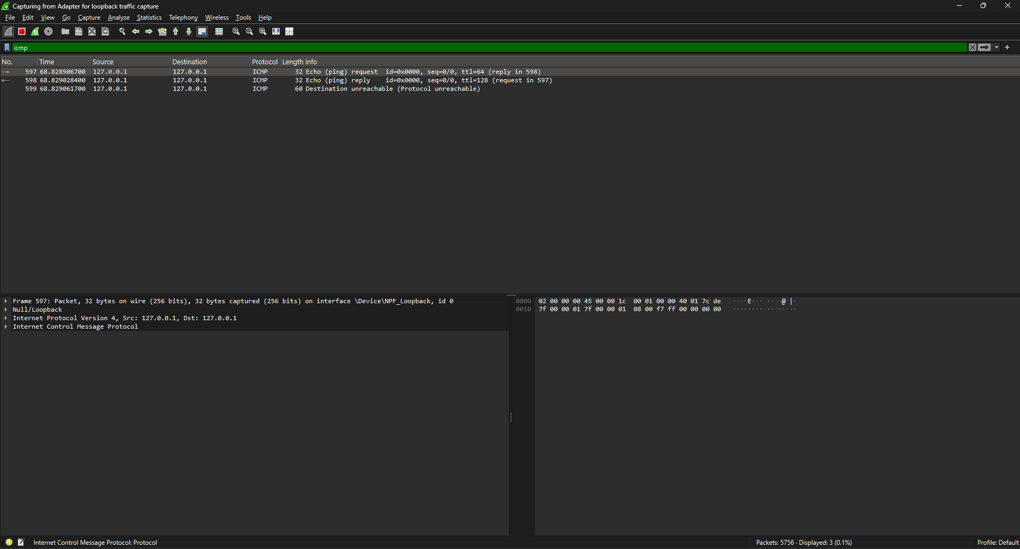
Figure 1. Wireshark capturing loopback ICMP traffic (Task 1 verification).

5. Task 2 — Protocol Design

Blue Team — Protocol Description
The OrderPacket consists of six fields: customer_id, order_id, item_id, quantity, timestamp, and signature. Before an order packet is sent, the customer_id, order_id, item_id, quantity, and timestamp fields are signed using the sender's RSA private key. On the receiving end, the signature is verified using the corresponding RSA public key, which confirms that the packet has not been tampered with and genuinely originates from the claimed customer.

Blue Team — Signed Data Definition
- Signed fields: customer_id, order_id, item_id, quantity, timestamp.
- Not signed: signature (this field is the signature itself and cannot sign itself).
- All fields that could be exploited by an attacker if altered — identity, order details, and freshness — are included in the signed data.

Red Team — Weakness Analysis
Signing the packet prevents tampering and spoofing, since any modification to a signed field invalidates the signature. However, signing alone does not protect against a replay attack: an attacker can capture a valid, correctly signed packet and resend it unchanged at a later time. Because the content is identical, the signature remains valid, and the system may accept the duplicate order as legitimate. Mitigating this requires a timestamp freshness check, implemented in Task 7.

6. Task 3 — RSA Key Generation and Crypto Functions
What: Generated RSA-2048 key pairs for two customers (Customer A and Customer B), and implemented sign_data() and verify_signature() functions using PyCryptodome (PKCS#1 v1.5 with SHA-256).
Why: Digital signatures are the mechanism by which the receiver can confirm both the integrity of the order data and the identity of the sender, without relying on a shared secret.
How: RSA.generate(2048) produced each key pair; sign_data() hashes the input with SHA-256 and signs the hash with the private key; verify_signature() recomputes the hash and verifies it against the public key, returning True or False.
Result: A signed test message verified successfully against the correct public key (True), and correctly failed verification when checked against the wrong customer's public key (False), confirming the sign/verify pair works as intended.
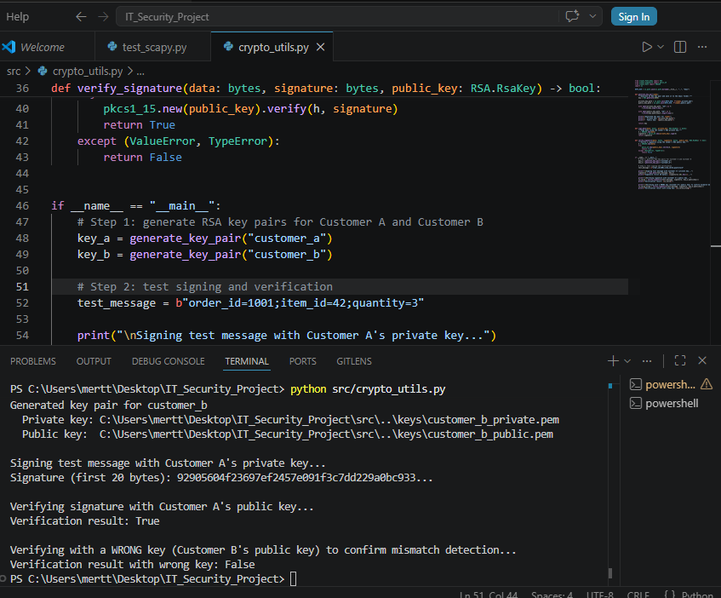
Figure 2. RSA key generation, signing, and both correct and incorrect signature verification.

Red Team — Analysis of Signature Misuse
- Missing signature: a packet with an empty signature field cannot be verified and must be rejected outright.
- Mismatched signature: verifying against the wrong public key (as demonstrated above) correctly returns False.
- Reused signature: a valid signature can be replayed unchanged; signature verification alone cannot detect this, which motivates the timestamp and replay checks in Task 7.

7. Task 4 — Scapy Implementation
What: Implemented a custom Scapy Packet subclass, OrderPacket, with fields matching the protocol design, and a script that builds a legitimately signed order and sends it to 127.0.0.1 over UDP port 9999.
Why: Scapy allows crafting packets at a low level, which is necessary both to build a realistic custom protocol and, later, to simulate an attacker tampering with individual fields.
How: OrderPacket defines customer_id, order_id, and item_id as 4-byte integer fields, quantity as a 2-byte field, timestamp as a 4-byte integer, and signature as a fixed 256-byte field sized for an RSA-2048 signature. build_signable_data() packs the signed fields in a fixed order using struct.pack so that signing and verification always operate on identical byte layouts.
Result: The script built an OrderPacket for Customer A, verified its own signature locally as a sanity check (result: True), and successfully sent it to 127.0.0.1:9999.
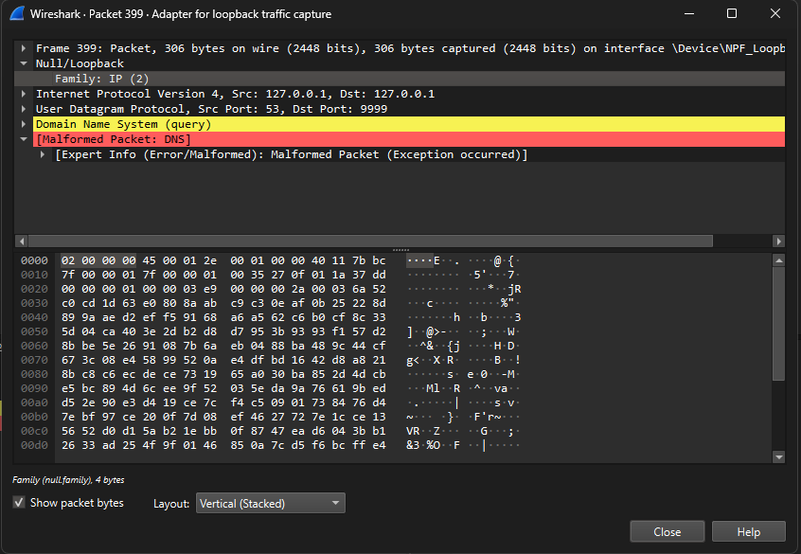
Figure 3. Wireshark view of the legitimate OrderPacket sent to UDP port 9999.

8. Task 5 — Wireshark Capture and Analysis
What: Captured the legitimate OrderPacket transmission on the loopback interface and inspected its fields.
Why: Capturing traffic confirms the packet is actually transmitted as designed and provides a baseline capture to compare against the attack traffic captured in Task 6.
How: Wireshark's loopback adapter was used with the display filter "udp.port == 9999" to isolate OrderPacket traffic from unrelated background traffic.
Result: The capture (Figure 3) shows the packet traveling from 127.0.0.1 to 127.0.0.1 over UDP, destination port 9999. Since OrderPacket is a custom, non-standard protocol, Wireshark has no dissector for it and mislabels the payload as a malformed DNS query; this is expected and does not indicate a problem with the packet itself — it simply reflects that Wireshark is guessing at an unrecognised protocol. A companion ICMP "Port unreachable" message also appears, because no process was listening on port 9999 at the time; this is expected operating-system behaviour, not part of the protocol under test. The capture was saved as task4_5_.pcapng.

9. Task 6 — Attack Simulations
Four attacks were implemented in attacks.py and executed against the legitimate protocol, in line with the Task 2 weakness analysis.

Attack 1 — Spoofing
A legitimate OrderPacket was signed by Customer A, then the customer_id field was modified from 1 to 999 after signing, before sending. This simulates an attacker trying to act like a different customer. Since the signature was computed over the original data, this tampering is detectable by signature verification.

Attack 2 — Tampering
A legitimate signed OrderPacket had its item_id and quantity fields altered after signing (item_id changed from 10 to 77, quantity from 1 to 100), simulating an attacker modifying order details such as swapping items or inflating quantities. As with spoofing, this invalidates the original signature.

Attack 3 — Replay
A valid, correctly signed OrderPacket was sent once, then the exact same, unmodified packet was captured and resent three seconds later. Because nothing was altered, the signature remains valid on both transmissions, meaning signature verification alone cannot detect this attack; detection requires a timestamp freshness check.

Attack 4 — Flooding
Fifty copies of a valid signed packet were sent to the same destination in rapid succession with no delay between them, simulating a denial-of-service style flood. This attack does not rely on breaking the signature scheme at all, but on overwhelming the receiver with volume; detection requires rate limiting rather than signature or timestamp checks.
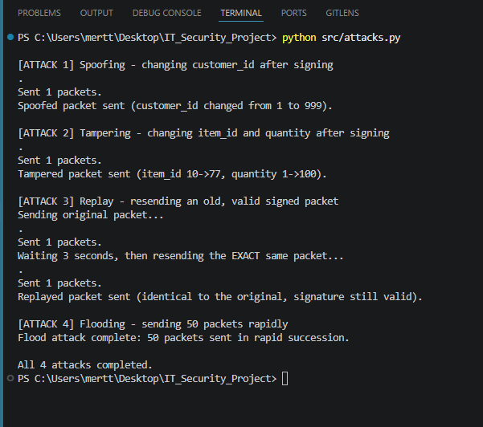
Figure 4. Terminal output of all four attacks executing successfully.
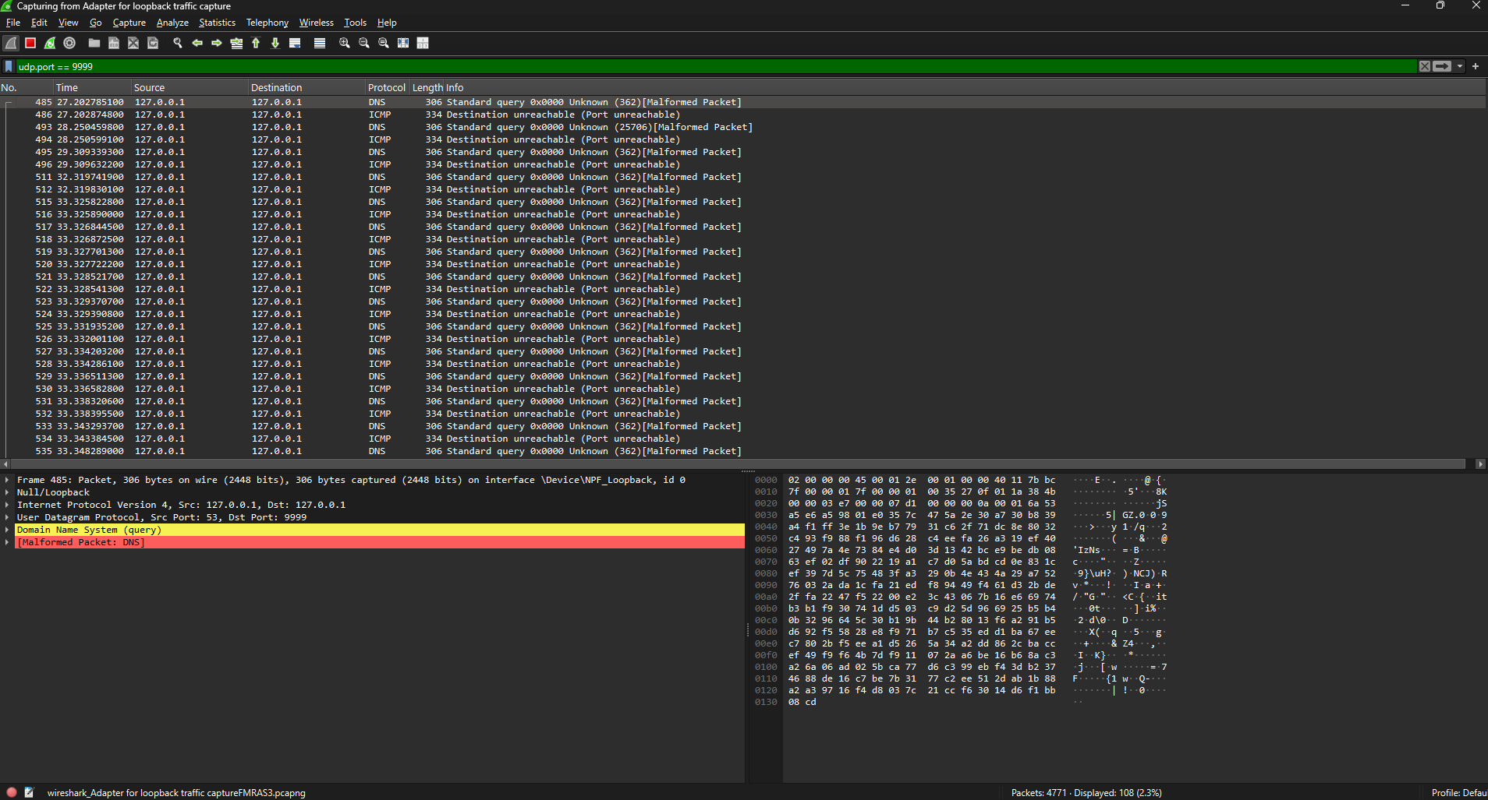
Figure 5. Wireshark capture of attack traffic, including the flooding burst (saved as task6_attacks.pcapng).

10. Task 7 — Security Controls
The verify_order_packet() function implements the Blue Team defences, applying five checks in order to every incoming OrderPacket:
- Identity binding — the customer_id must belong to a known, registered customer.
- Signature verification — the packet's signature must match its signed fields using the sender's public key. This catches both spoofing and tampering.
- Timestamp freshness check — the packet's timestamp must be within a 30-second window of the current time.
- Replay protection — each (customer_id, order_id) pair is tracked; a repeated pair is rejected even if the signature is valid. This catches the replay attack, which signature verification alone cannot detect.
- Rate limiting — no more than 10 requests are accepted within a 5-second window. This catches the flooding attack, which does not rely on breaking the signature at all.

Test Results
- Legitimate order: ACCEPTED — all checks passed.
- Spoofed order: REJECTED — unknown customer_id (identity binding failed).
- Tampered order: REJECTED — invalid signature (tampering detected).
- Replayed order: ACCEPTED on first send, REJECTED on resend (duplicate order detected).
- Flooding (12 rapid requests): first 8 ACCEPTED, remaining 4 REJECTED (rate limit exceeded).
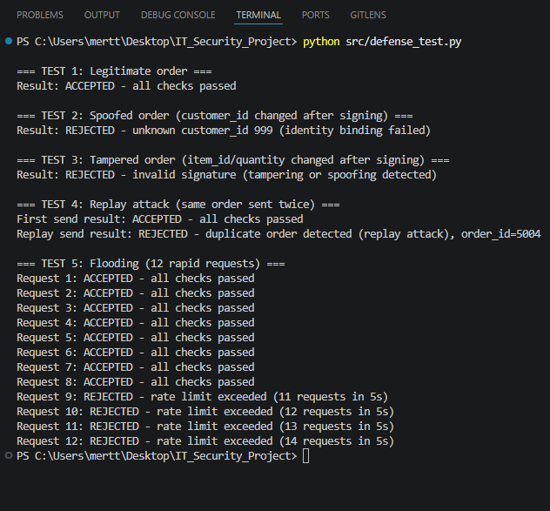
Figure 6. verify_order_packet() correctly accepting the legitimate order and rejecting all four simulated attacks.
All results were additionally written to logs/verification_log.txt, providing a persistent, timestamped audit trail of every accept/reject decision.

11. Task 8 — Evidence Collection
Evidence for every stage of the exercise was collected and organised into the project repository:
- Screenshots: six annotated screenshots covering environment verification, RSA signing/verification, legitimate packet transmission, all four attacks, and defence verification (screenshots/).
- Packet captures: two Wireshark .pcapng files — one for the legitimate OrderPacket exchange, one for the four attack simulations (captures/).
- Logs: a text log of every verify_order_packet() decision, generated automatically during the defence tests (logs/verification_log.txt).
- Source code: crypto_utils.py, order_packet.py, attacks.py, and defense.py, each well-commented (src/).

12. Conclusion: Combined Red Team / Blue Team Reflection

How the attacks worked (Red Team mindset)

Basically all 4 attacks worked just fine when I sent them, nothing stopped them at the network level. This is what I was expecting for spoofing and tampering because at that point there was no checking happening at all, i literally just changed a field after signing and sent it and it went through just fine. The replay one was kind of interesting because even though the packet was 100% valid (same signature, nothing changed), sending it twice still worked, which showed me that a signature only proves the data wasn't changed, it doesn't prove the message is new, that’s why we use ‘’timestamps’’. The flooding attack was different from the other 3, it didn't even try to mess with the signature, it just sent a ton of packets fast, so it's really a different kind of problem (volume, not correctness).

How protections were designed (Blue Team mindset)

For the defense side I basically made one check for each attack I did in Task 6. Signature verification handles spoofing and tampering since changing anything after signing breaks the signature. The timestamp check handles replay, because now an old packet (even a valid one) gets rejected if it's too old. And rate limiting handles flooding, since that attack doesn't care about signatures at all, it's just too many requests. I put the checks in an order that makes sense (cheap checks like checking the customer_id first, then the more expensive signature check, and then freshness,replay.rate) so the system isn't wasting time on packets that are obviously bad.

Evaluating risk exposure (combined perspective)
Being on the both sides of this project made it pretty clear that one single check is never really enough by itself. So the signatures are great for proving a message wasn't tampered, changed, but they say nothing about timing, so replay attacks slip right through unless you add timestamps. Same thing with flooding, no amount of cryptography stops someone from just sending a lot of traffic, you also need rate limiting for that. For something like Shop-Td-Nexus that's actually a critical infrastructure, I think this shows that security can't just be "One Big Lock", it has to be multiple smaller checks stacked on top of each other, and you also need logging (like verification_log.txt) so if something does get through, at least there's a record of it.

