板壳理论 TD3

1. 如图所示一块矩形薄板，尺寸为2L×b×h（b >> L）。薄板弹性模量为E，泊松比为 ，密度为，抗弯刚度为D。薄板左边OO’(x = 0)为固定约束，BB’(x = L)处为滑动铰支座约束，右端CC’(x = 2L)受到竖直向下的载荷F(N/m)，不考虑重力作用。
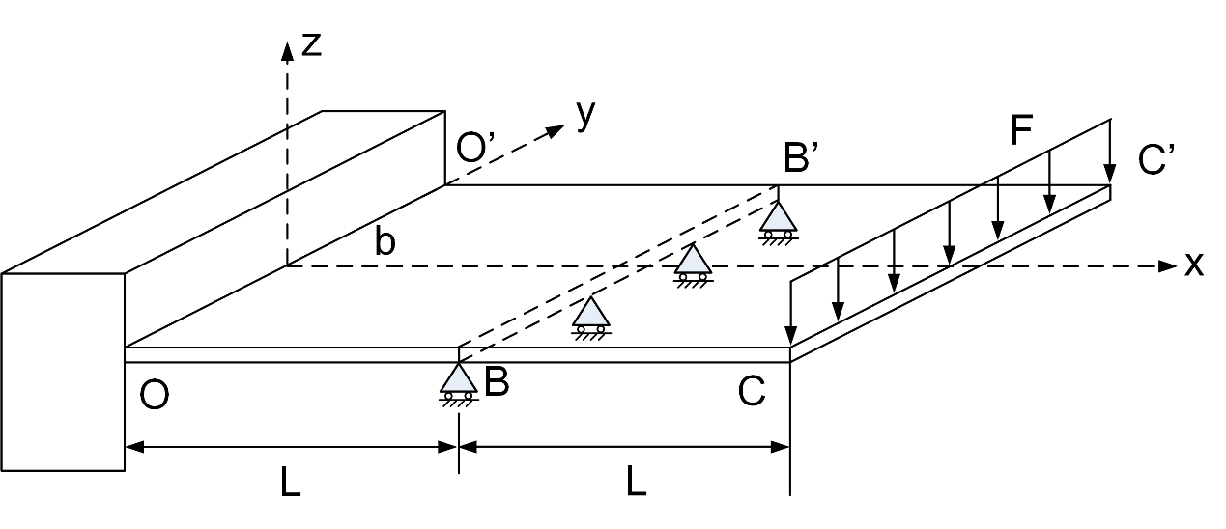

（1）写出薄板左边OO’受到的约束反力的表达式X₀(N/m), Z₀(N/m), M₀(N)；
（2）求薄板的内力Q_{x}(N/m), M_{x}(N)；
（3）写出关于挠度的平衡微分方程；
（4）求解平衡微分方程，给出挠度的通解；
（5）通过边界条件求待定参数。

（1）写出薄板左边OO’受到的约束反力的表达式X₀(N/m), Z₀(N/m), M₀(N)；
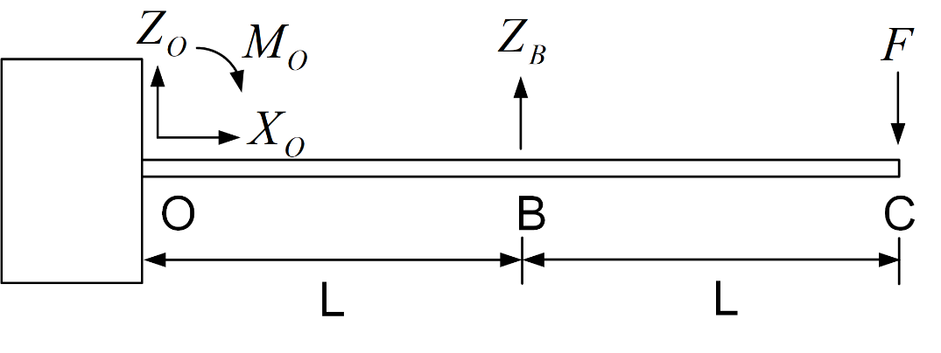
Equation 1:
Equation 2:
Equation 3:

（2）求薄板的内力Q_{x}(N/m), M_{x}(N)；
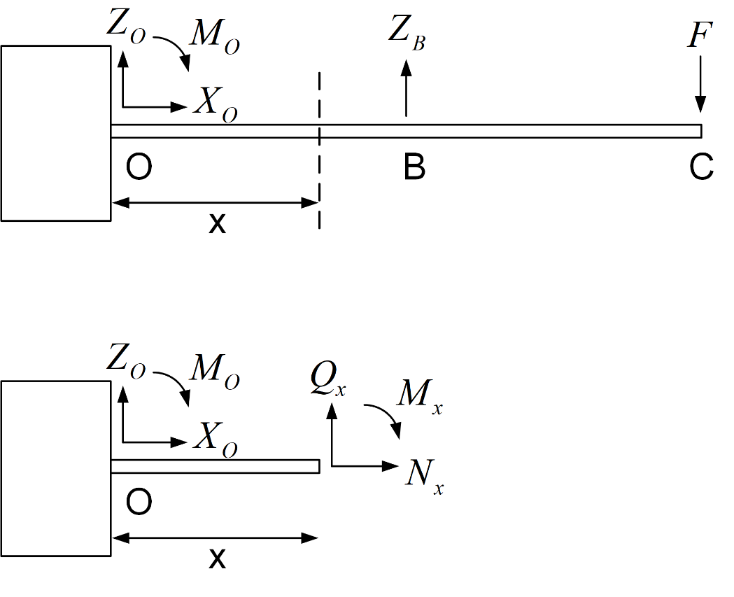

①
取左边部分受力分析

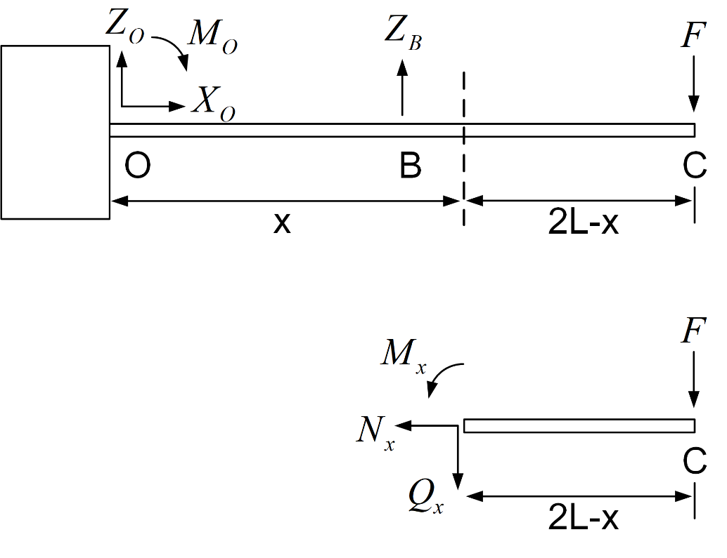
②
取右边部分受力分析

（3）写出关于挠度的平衡微分方程；

（4）求解平衡微分方程，给出挠度的通解；

（5）通过边界条件求待定参数。

2. As shown in Fig.2, a rectangle thin plate, with the length of x=L, the width of y=b and the thickness of z=h (h<<L, b), is simple supported at edge OO’ (x=0), sliding bearing at edge AA’ (x=L). A uniform load F [N/m] is applied on edge AA’ (x=L). Assume that the material of plate is isotropic and homogeneous, with the elasticity modulus of E, and the Poisson's ratio of.
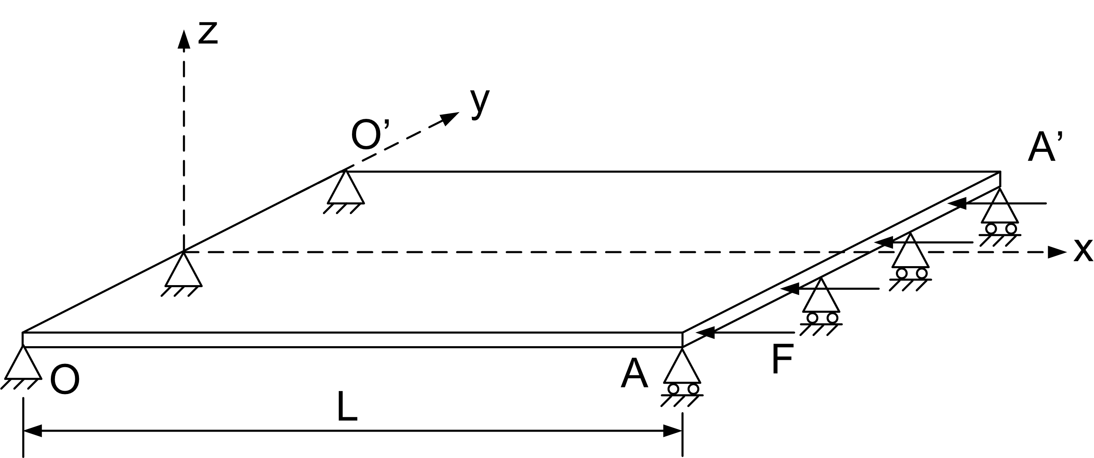
Fig. 2
Questions：
1). Write the equilibrium equations of the plate (ignore the self-weight), and give the expressions of constraint reaction
2). Calculate
3). Write the differential equation between bending momentand deflection
4). Solve the differential equation
5). Give the boundary condition equations
6). Determine the critical load

Questions：
1. Write the equilibrium equations of the plate (ignore the self-weight), and give the expressions of constraint reaction

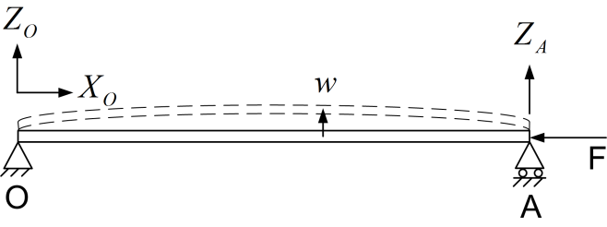

Equation 1:
Equation 2:
Equation 3:

2). Calculate

3). Write the differential equation between bending momentand deflection

4). Solve the differential equation

5). Give the boundary condition equations

6). Determine the critical load

