Page 118 of Basics of Web Design 3rd ed. by Terry Felke-Morris

Configure Embedded CSS

The Style Element

Embedded styles apply to the entire document and are placed within a **style element** located in the head section of a web page. The opening <style> tag begins the area with embedded style rules, and the closing </style> tag ends the area containing embedded style rules. When using XHTML syntax, the <style> tag requires a type attribute that should have the value of "text/css" to indicate the CSS MIME type. HTML5 syntax does not require the type attribute.

The web page in [**Figure 4.8**](https://jigsaw.vitalsource.com/books/9780133971026/epub/OPS/xhtml/fileP700049506200000000000000000112A.xhtml#P7000495062000000000000000001136) uses embedded styles to set the text color and background color of the web page document with the body element selector. See the example in the student files at chapter4/embed.html.

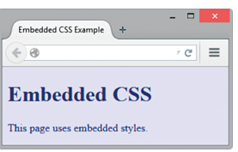

**Figure 4.8 *Web page using embedded styles.***

<!DOCTYPE html>

<html lang="en">

<head>

<title>Embedded CSS Example</title>

<meta charset="utf-8">

<style>

body { background-color: #E6E6FA;

color: #191970;

}

</style>

</head>

<body>

 <h1>Embedded CSS</h1>

 <p>This page uses embedded styles.</p>

</body>

</html>

Notice the way the style rules were coded with each rule on its own line. This makes the styles more readable and easier to maintain than one long row of text. The styles are in effect for the entire web page document because they were applied to the <body> tag using the body element selector.