## Tables Practice elements and attributes

(And merging cells)

This exercise references the use of Komodo Edit but any editor is fine. In the exercise you will practice making tables and also merging cells of a table. Open a blank HTML5 page in Komodo Edit. (File > New > File from template. Select HTML5.) **ONLY COMPLETE steps #1, 2, 3, 7, 8 and 9.** The other steps are optional and use deprecated attributes.

1. **Create a 2x2 (row by column) TABLE.** Position your cursor inside the <body></body> and type:



<table border=**"**5**"**>

<tr> renders as:

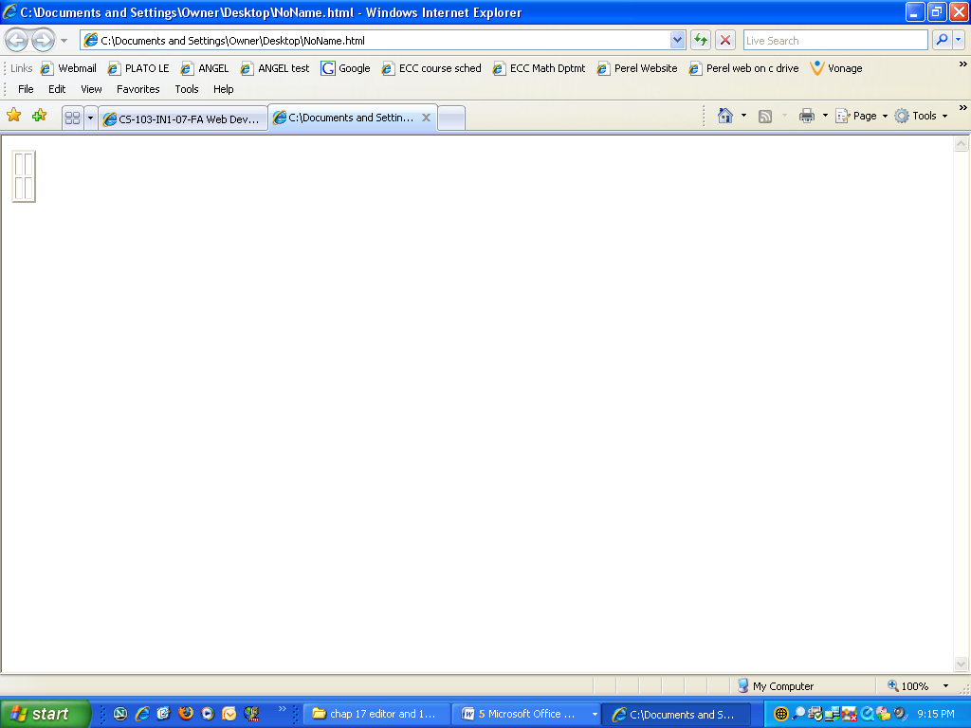 <td>&nbsp;</td>

<td>&nbsp;</td>

</tr>

<tr>

<td>&nbsp;</td>

<td>&nbsp;</td>

</tr>

</table>

**Save the page as** table_practice_intro.htm**.** Insert an appropriate title such as “Table Practice Intro”, in between the <title> and </title> tags and re-save the file. Now **render it in a browser**. That is, click the “View in Browser” button and select “In Komodo Tab” or select your preferred browser from the list. Instead of “View in Browser” button, let’s refer to it as the “Preview” button.

Also, if your menu bar is not showing, to get it to show, right-click anywhere on the toolbar at the top of the window as pictured below, and then check the box “Show Menubar”.

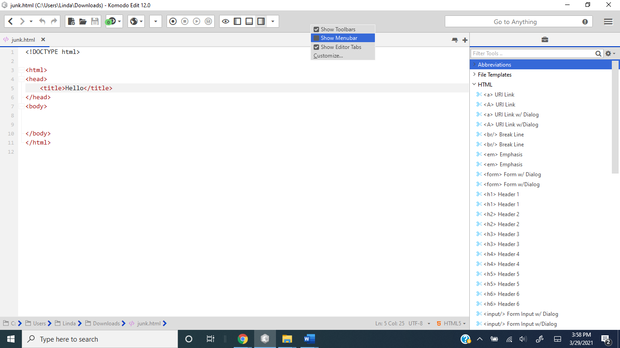

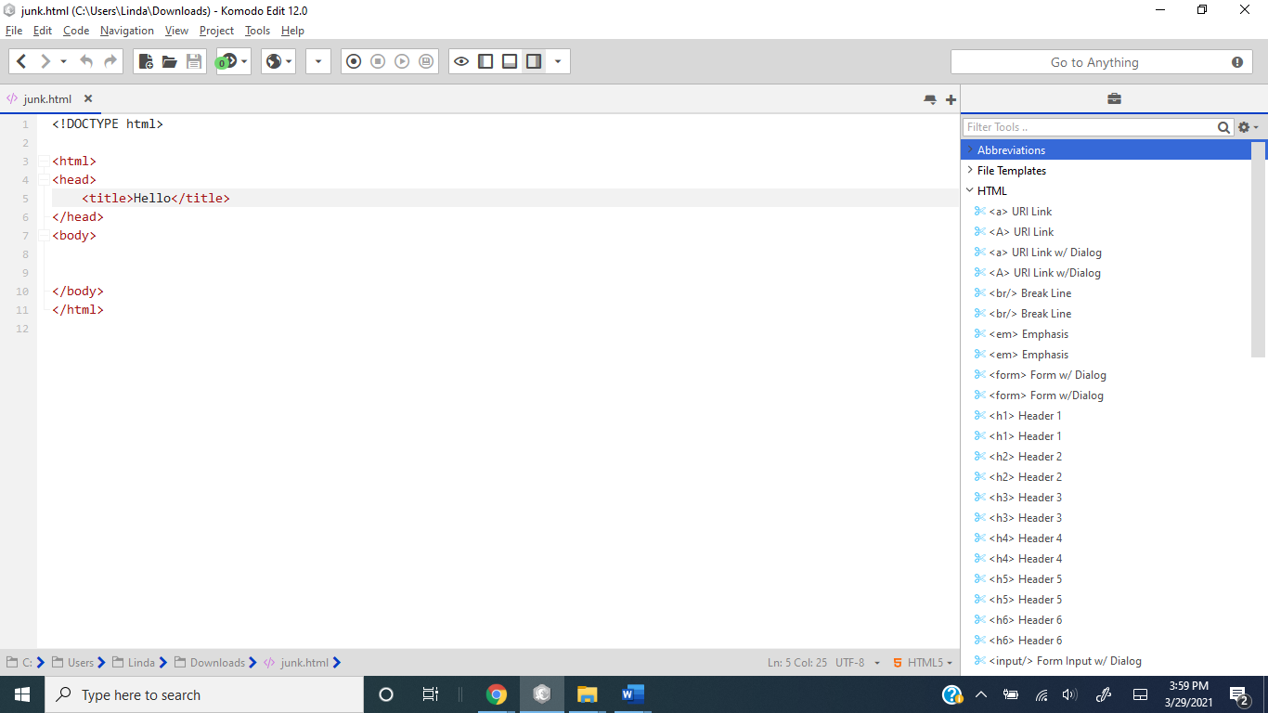



If the “Preview” button is not showing, even though your menu bar is showing, click anywhere in the HTML code of the page first and it should then appear.

2. **Type the content into the cells**. That is, replace the non-breaking spacebars (&nbsp;) with the data: cell 1, cell 2, cell 3, cell 4 as follows:



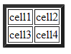

For steps 3 through 6, the deprecated language is highlighted in gray. The border attribute is deprecated but I still like to use it to make a quickie table. Then later I would replace it with the CSS border style instead.

3. **width** and **height** attributes. Edit the opening <table> tag such that it appears as:



**<table border=“2” width=“75%”>.**

**Save the page and render it in your browser.** Observe how the table readjusts in size, and the thinner border.



4. [OPTIONAL] **cellspacing** and **cellpadding**

a. Add **cellspacing**, (the spacing between cells), equal to 10 pixels. Edit the opening <table> tag such that it appears as <table border=”2” width= “75%” **cellspacing=”10”**>.

**Save the page and render it in your browser. Observe how the table has changed.**

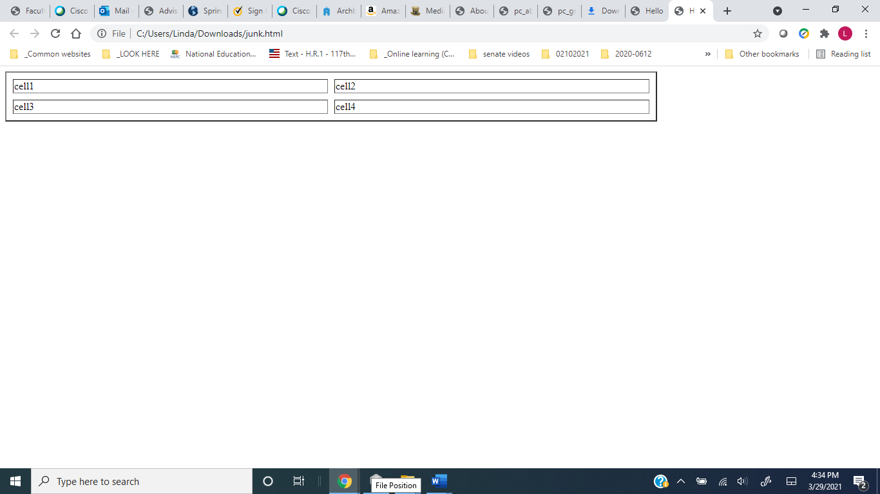

b. Decrease the **cellspacing** to 3 pixels. In the previous step, replace **cellspacing=“10”**with **cellspacing**=“**3”**.

**Save the page and render it in your browser. Observe how the table has changed.**

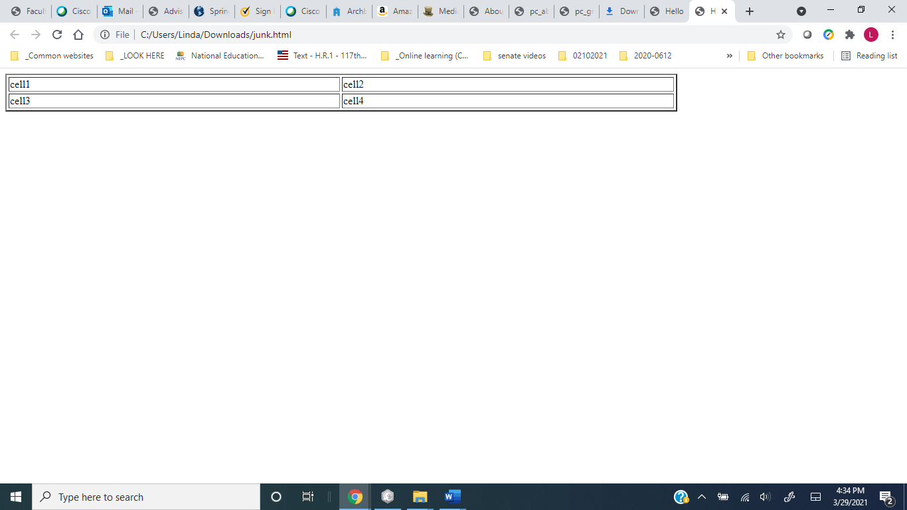

c. Add **cellpadding**, (the margin in the cell), equal to 10 pixels. Edit the opening <table> tag such that it appears as <table border=”2” width= “75%” cellspacing=”3” **cellpadding =”10”**>.

**Save the page and render it in your browser. Observe how the table has changed.**

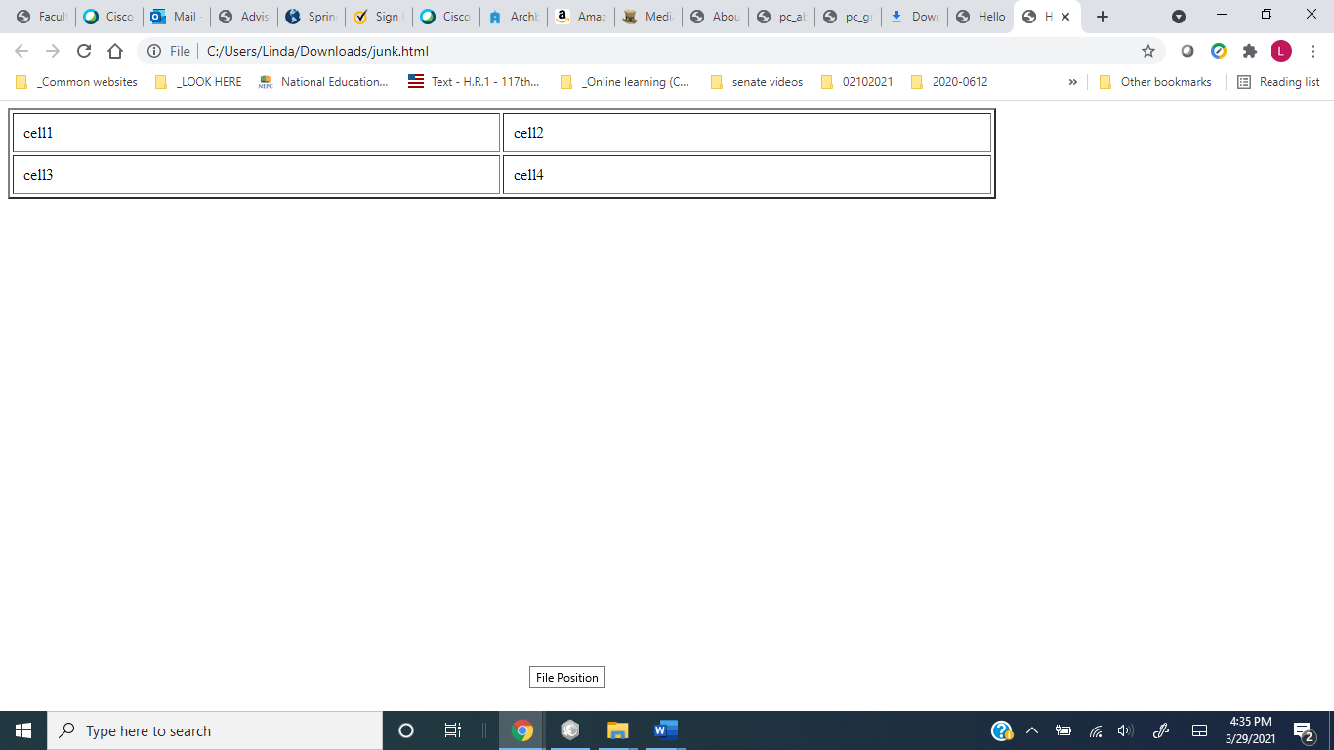

d. Decrease the **cellpadding** to3 pixels. In the previous step, replace **cellpadding=“10”**with **cellpadding**=“**3”**.

**Save the page and render it in your browser. Observe how the table has changed.**

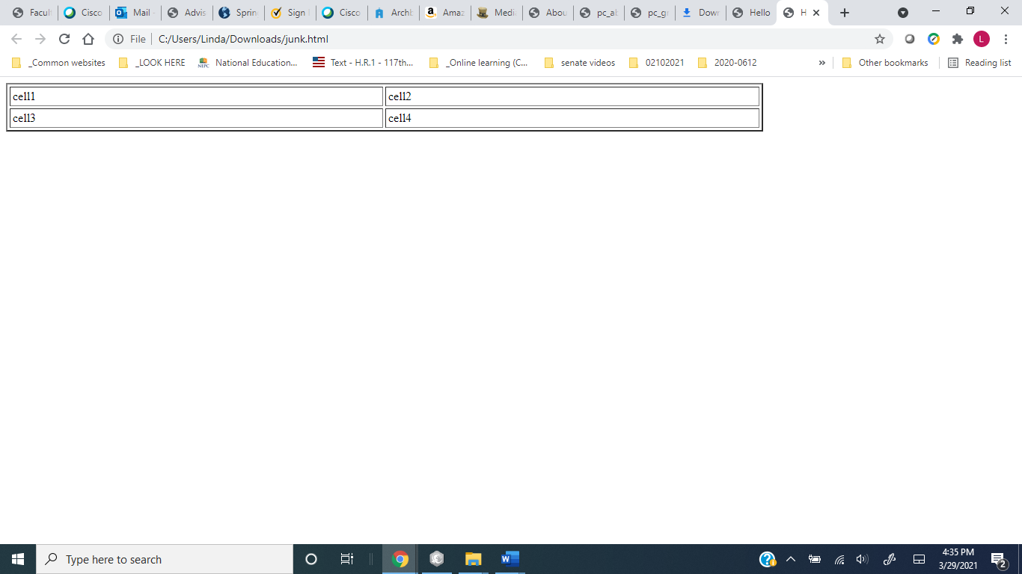

5. [OPTIONAL]Alignment, height

a. **Align** the table **to the center**. Edit the opening <table> tag such that it appears as

<table border=“2” width=“75%” cellspacing=“3” **align=**“**center”**>.

**Save the page and render it in your browser. Observe how the table has changed.**  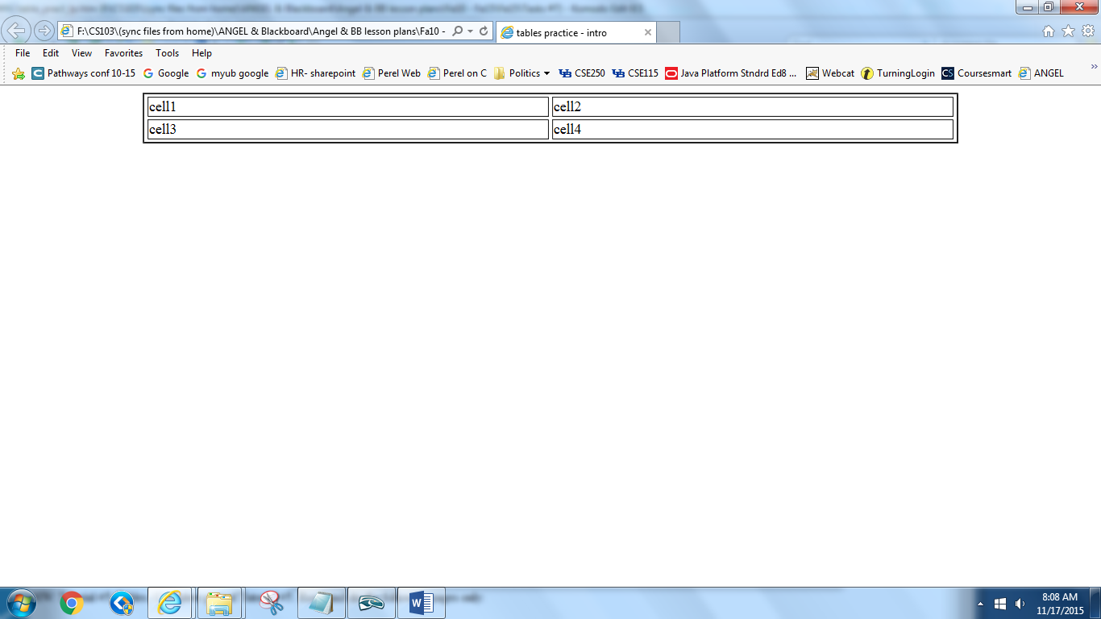

b. Set the **table height**. In the previous step, **set table height to 100 pixels,** and **remove align=“center”** to appear as follows:

<table border=“2” width=“75%” cellspacing=“3” **height=“100”**>.

**Save the page and render it in your browser. Observe how the table has changed.**

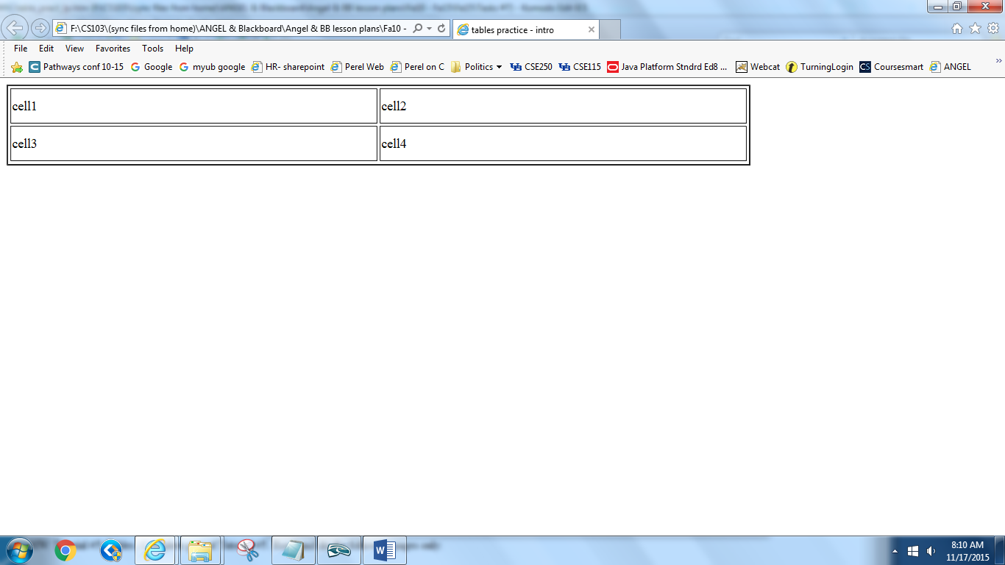

c. Set the **cell height**. In the previous step, move the **height=”100”** to the first td tag to appear as follows. Notice how the cell next to it also changes.

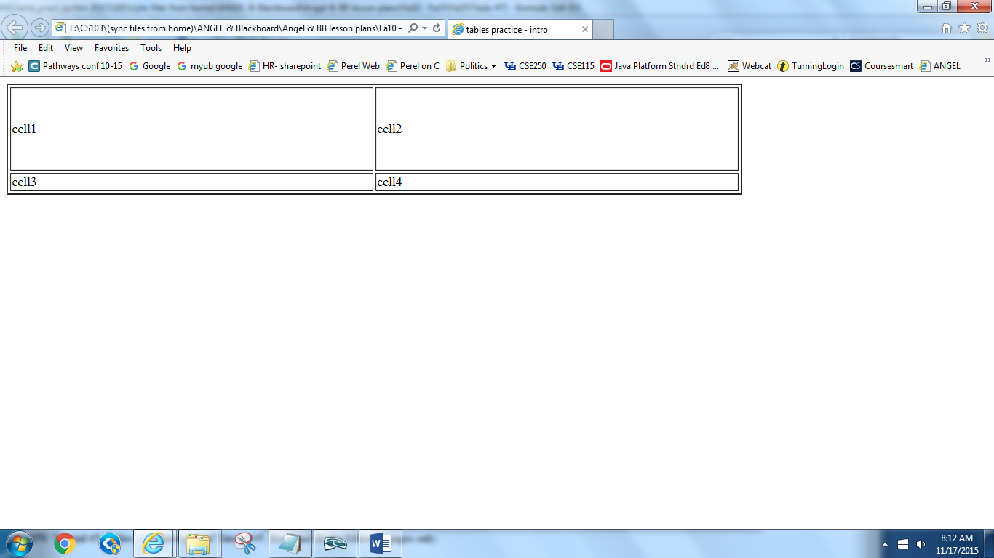

6. [OPTIONAL] Vertical and horizontal Alignment –

**Vertically and horizontally align each row**. Edit each of the 2 opening <tr> tags as follows:

<tr **align=“center”** **valign=“bottom”>**.

**Save the page and render it in your browser. Observe how the table has changed** 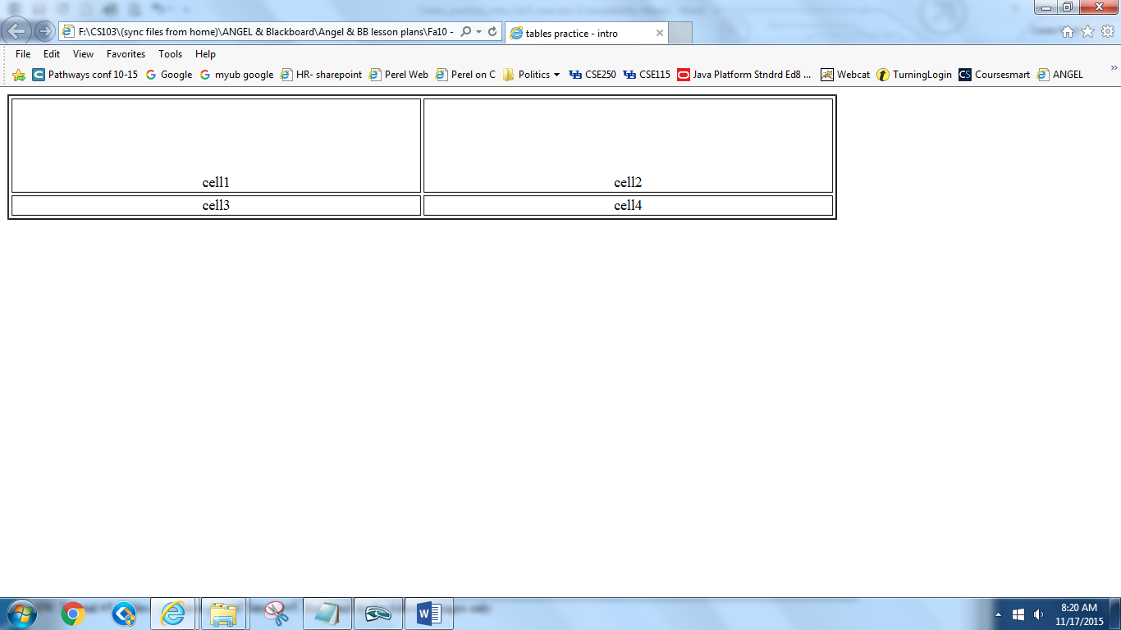

* Go to next page

## Merging cells:

7. Insert a line break: <br />. Then create the following table (2x4) on the next line:



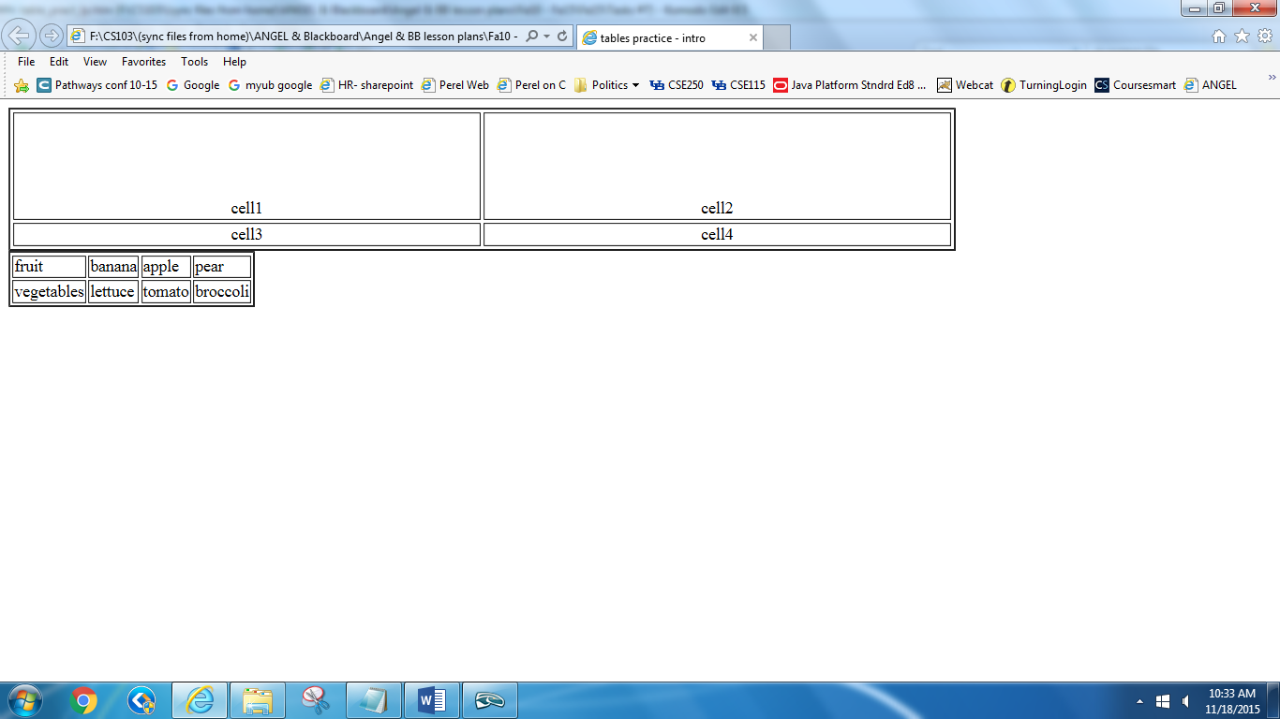

**By typing** :

**<table border="2">**

**<caption>table with column 1 fruits, column 2 vegetables</caption>**

**<tr>**

**<td>fruit</td>**

**<td>banana</td>**

**<td>apple</td>**

**<td>pear</td>**

**</tr>**

**<tr>**

**<td>vegetables</td>**

**<td>lettuce</td>**

**<td>tomato</td>**

**<td>broccoli</td>**

**</tr>**

**</table>**

**Save the page and render it in your browser. Observe. You should see the table above.**

*In the following steps with merging, the resulting tables’ contents will not necessarily make sense, but nonetheless you will get practice with merging cells.*

8. **colspan** (merge cells that **span** across **col**umns)



a. Insert a line break <br />. Copy and paste this 2x4 table from **step 7** on the next line. Change it as follows.

Merge the 3 cells of the first row:

replace: **<td>fruit</td>**  with **<td colspan=”3”>fruit</td>**

**Save the page and render it in your browser. Note the “extra” cells protruding toward the right.**

b. Delete the “extra“ protruding cells:

* delete <td>apple</td>
* delete <td>pear</td>

**Save the page and render it in your browser. Observe that it is squared off again. Compare the tables.**

Result:

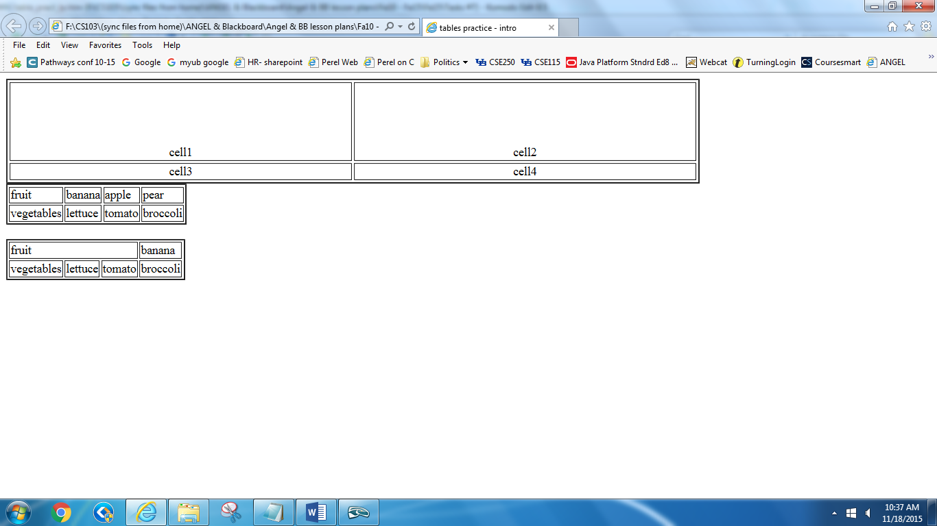

9. **rowspan** (merge cells that **span** across **row**s)



a. Insert a line break <br />. Copy and paste the 2x4 table of **step 7** again on the next line. Change it as follows. Merge all 2 cells of the first column going down:

replace **<td>fruit</td>** with **<td rowspan=”2”>fruit</td>**

**Save the page and render it in your browser. Note the “extra” cells protruding.**

b. Delete the “extra “ cells:

* delete <td>broccoli</td>

**Save the page and render it in your browser. Observe that it is squared off again. Compare the tables.**

Result:

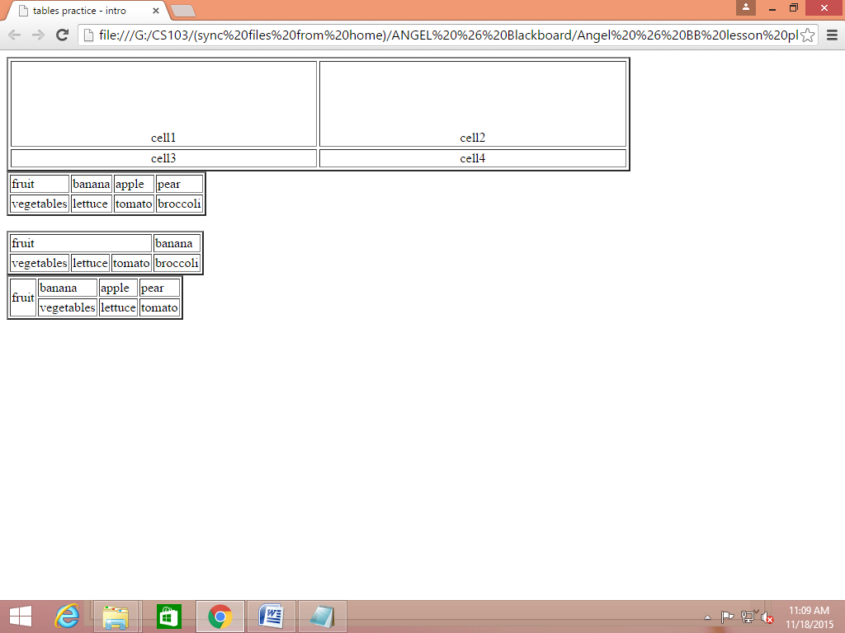

10. [OPTIONAL] **width** attributes

a. Insert a line break <br />. Copy and paste the 2x4 table of **step 7** again on the next line.

**Save the page and render it in your browser. Observe the table (as in step 7)**

Result:

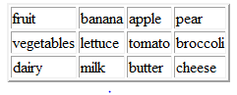

b. Change it as follows. Replace “**vegetables**” with “**veggy veggy veggy veggy**”. Insert **width=“400” into the table tag**:

<table border="2" **width="400"**>

**Save the page and render it in your browser. Observe that the table is restricted to 400 px wide but the 1st column expanded to make room for veggy veggy veggy veggy.**

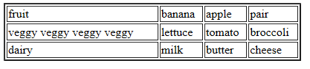

---------------------------------400px -------------------------------------------------

c. Additionally, insert **width=“50”** into the first td tag where fruit is:

<td width="50">fruit</td>.

**Save the page and render it in your browser. Observe the table is restricted to 400px wide but also the 1st column (where fruit is) is also restricted to 50px wide and thus you see wrapping of its cell.**

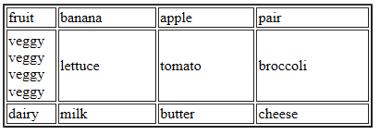

---50px---

----------------------------------------400px ----------------------------------------

* go to next page

Optional activity: The toolbox in Komodo Edit

To insert some tags by “clicking” you can use the side pane called toolbox. To do so, click on the **View** menu, slide down to **Tabs & Sidebars** and over to and click on **Toolbox**. The toolbox pane opens on the right side of the window. See pictures below.

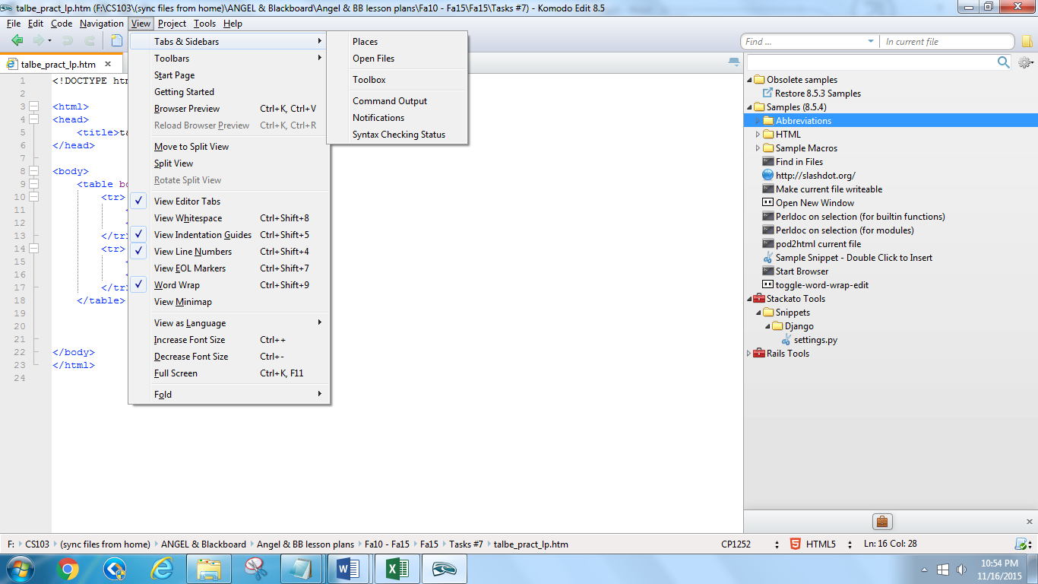

|  |  |
| --- | --- |
|  |  |

Click on a tag listed in the toolbox and it gets inserted where your cursor is in the page.

Then drag on toolbox pane’s left border toward the right to close the pane.